**Installing Ansible:**

sudo apt install ansible

**Creating hosts.txt file:**

mkdir ansible

cd ansible

nano hosts.ini

[ubuntu]

10.0.2.6 ansible_user=dariagory

**Testing the connection**:

ssh 10.0.2.6

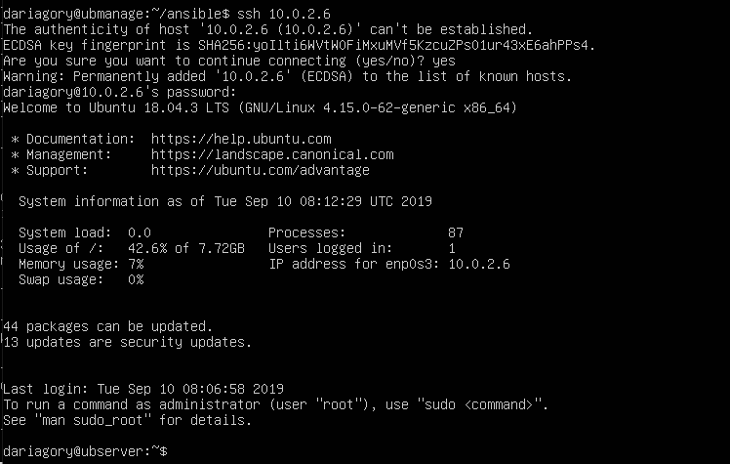

**Ping via ansible**:

On the managed node:

sudo apt install python

On the managing node:

sudo apt-get install sshpass

ansible ubuntu -m ping -i hosts.ini --ask-pass

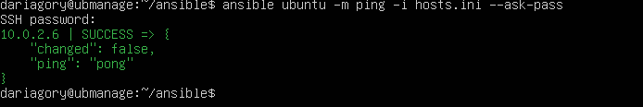

**Show processes list**:

Via htop:

On managed node:

sudo apt-get install htop

On management node:

cd ansible

ansible -m shell -a ‘htop’ -i hosts.ini ubuntu -u dariagory --become --ask-sudo-pass

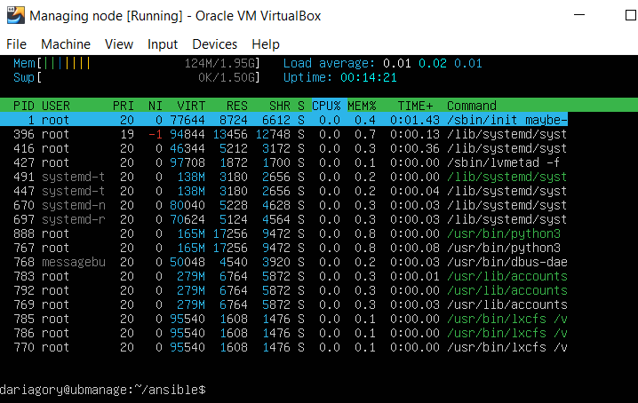

Via ps:

On managing node:

cd ansible

ansible -m shell -a ‘ps -A’ -i hosts.ini ubuntu -u dariagory --become --ask-sudo-pass

