Student Name: Daria Khotunitskaya

Tuesday, April 29, 2025 (introduction)

Class Example:
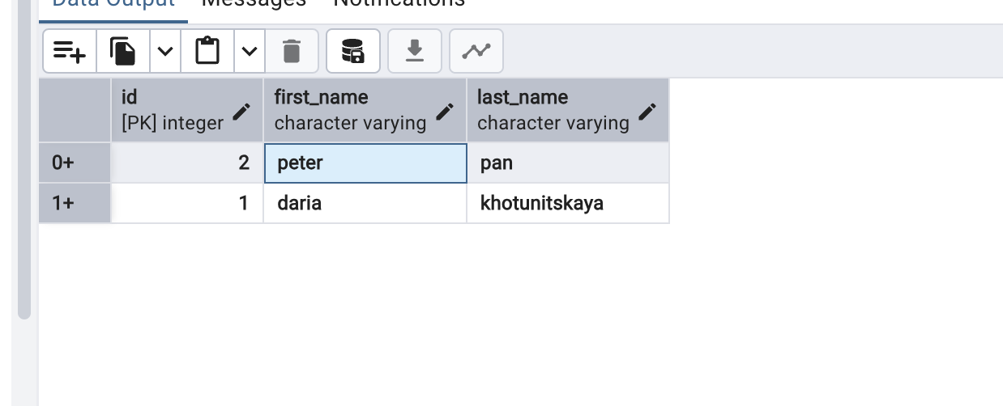
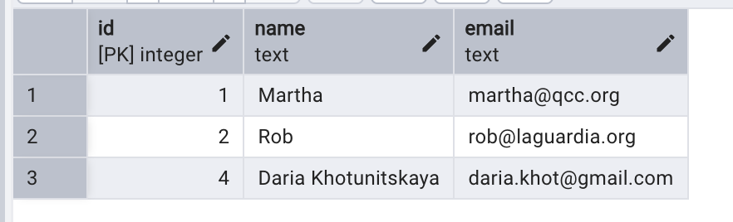

Lab 12A Exercise:

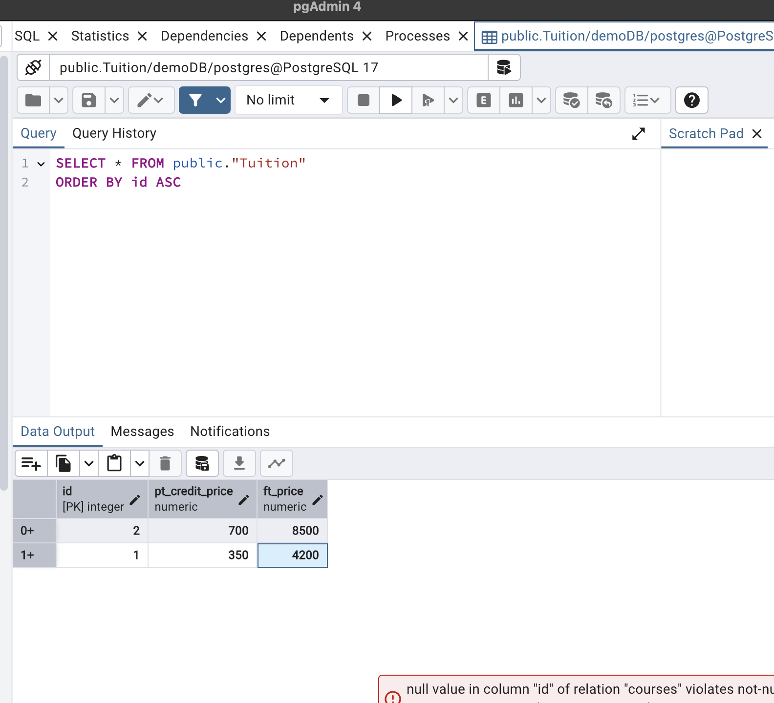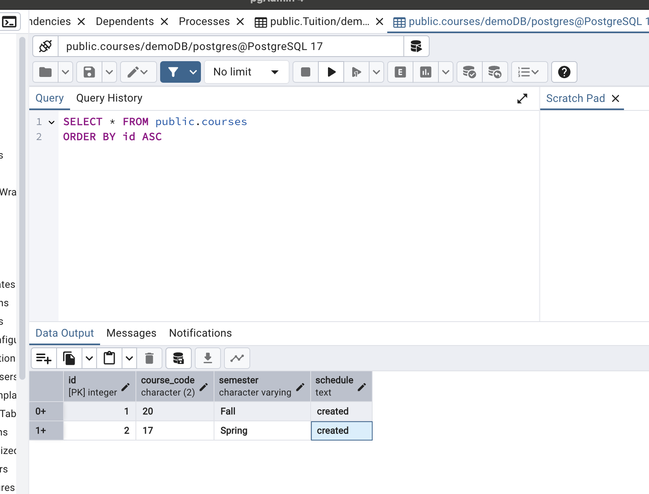

Thursday, May 1, 2025

Class Example:
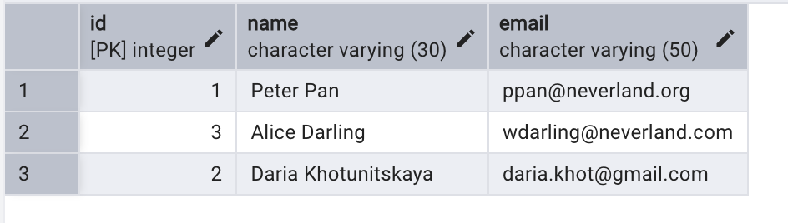
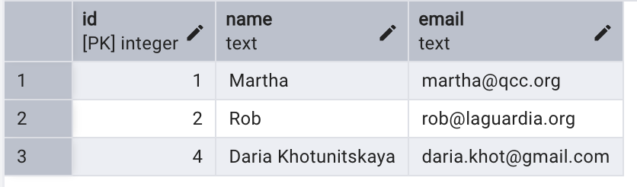

Lab12B exercise:

--1. Creating table
CREATE TABLE books (
id SERIAL PRIMARY KEY,
title VARCHAR(100) NOT NULL,
author VARCHAR(100) NOT NULL,
year_published INT
);

--2.Inserting values
INSERT INTO books (title, author, year_published)
VALUES
('The Great Gatsby', 'F. Scott Fitzgerald', 1925),
('Animal Farm', 'George Orwell', 1945),
('To Kill a Mockingbird', 'Harper Lee', 1960),
('Brave New World', 'Aldous Huxley', 1932);

--3.Read data
-- Select all books
SELECT * FROM books;

-- Select books by George Orwell
SELECT * FROM books WHERE author = 'George Orwell';

--4.Update data
UPDATE books
SET year_published = 1931
WHERE title = 'Brave New World';

--5.delete data
DELETE FROM books
WHERE title = 'To Kill a Mockingbird';

--6.Final Table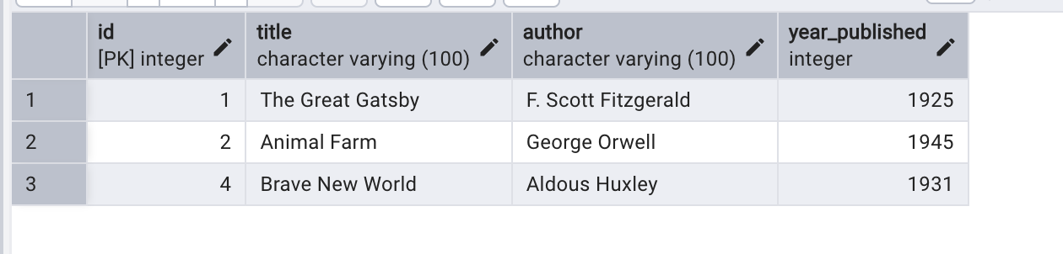

Bonus Challenge:
ALTER TABLE books
ADD COLUMN genre VARCHAR(50);

UPDATE books SET genre = 'Classic Fiction' WHERE title = 'The Great Gatsby';
UPDATE books SET genre = 'Political Satire' WHERE title = 'Animal Farm';
UPDATE books SET genre = 'Dystopian' WHERE title = 'Brave New World';

SELECT genre, COUNT(*) AS total_books
FROM books
GROUP BY genre;

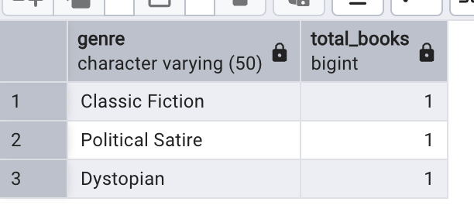

Friday, May 2, 2025
Class Example:
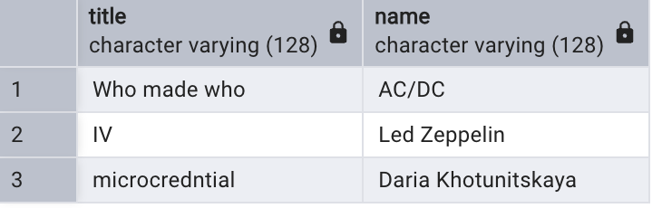
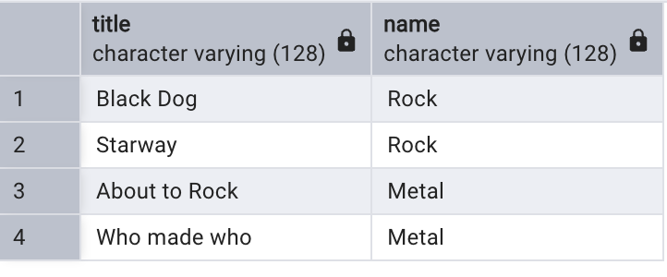
Lab12C exercise:

SQL Queries:

1. Creating tables
-- Drop existing tables
DROP TABLE IF EXISTS courses;
DROP TABLE IF EXISTS students;

-- Students Table
CREATE TABLE Student (
id SERIAL PRIMARY KEY,
name VARCHAR(100),
major VARCHAR(100)
);

-- Courses Table
CREATE TABLE courses (
id SERIAL PRIMARY KEY,
title VARCHAR(100),
department VARCHAR(100)
);

-- Enrollments Table
CREATE TABLE enrollments (
id SERIAL PRIMARY KEY,
grade CHAR(2),
student_id INTEGER REFERENCES students(id),
courses_id INTEGER REFERENCES courses(id)
);

2. Inserting Values
-- Students
INSERT INTO students (name, major)
VALUES
('Alice Brown', 'Computer Science'),
('Peter Pan', 'Mathematics'),
('Annie Chen', 'Physics'),
('Daria Khotunitskaya', 'Mathematics');

-- Courses
INSERT INTO courses (title, department)
VALUES
('Database Systems', 'Computer Science'),
('Linear Algebra', 'Mathematics'),
('Quantum Mechanics', 'Physics'),
('Python Programming', 'Computer Science'),
('Calculus III', 'Mathematics');

--Enrollments
INSERT INTO enrollments (grade, student_id, courses_id)
VALUES
('B+', 1, 1), -- Alice → Database Systems
('C', 2, 5), -- Peter → Calculus III
('B', 3, 3), -- Annie → Quantum Mechanics
('A', 4, 2); -- You → Linear Algebra

Queries to practice:

SELECT name, major FROM students;
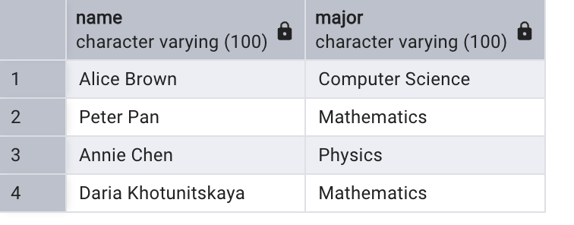

SELECT students.name, courses.title
FROM enrollments
JOIN students ON enrollments.student_id = students.id
JOIN courses ON enrollments.courses_id = courses.id;
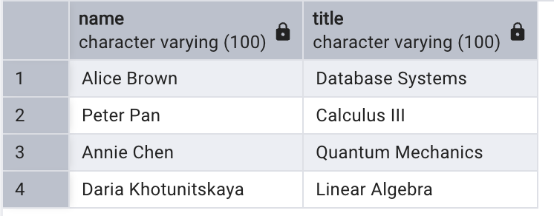

SELECT students.name, courses.title, enrollments.grade
FROM enrollments
JOIN students ON enrollments.student_id = students.id
JOIN courses ON enrollments.courses_id = courses.id;
