1
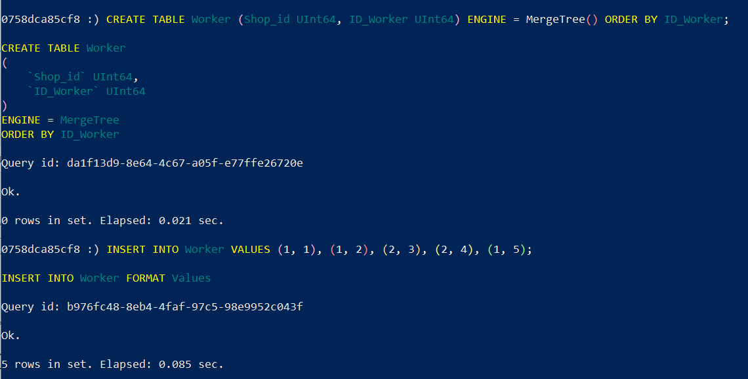
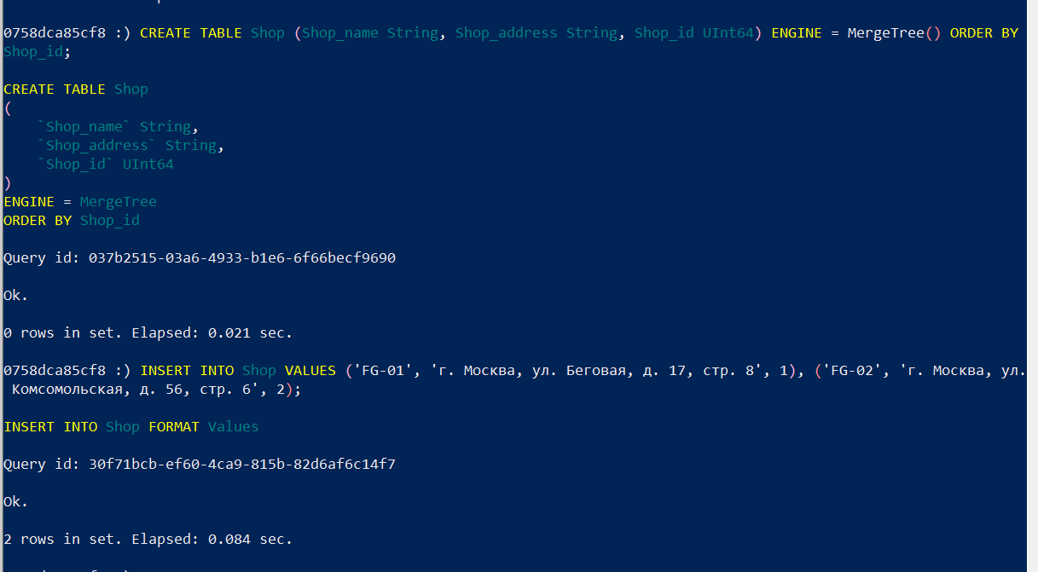
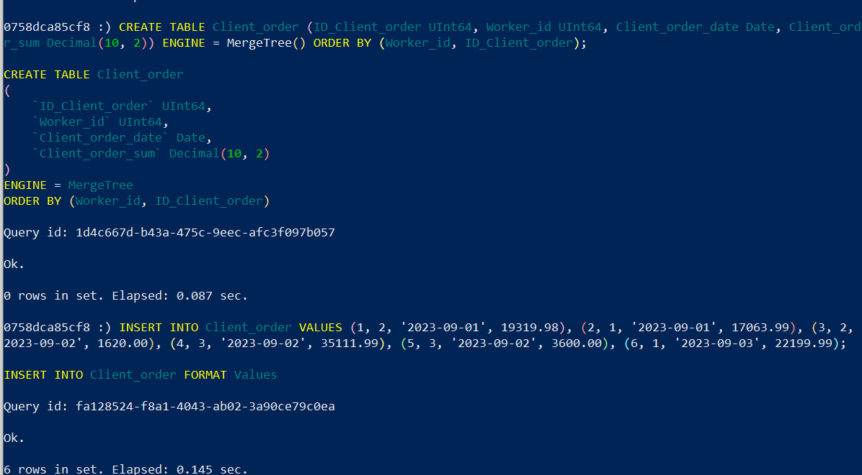
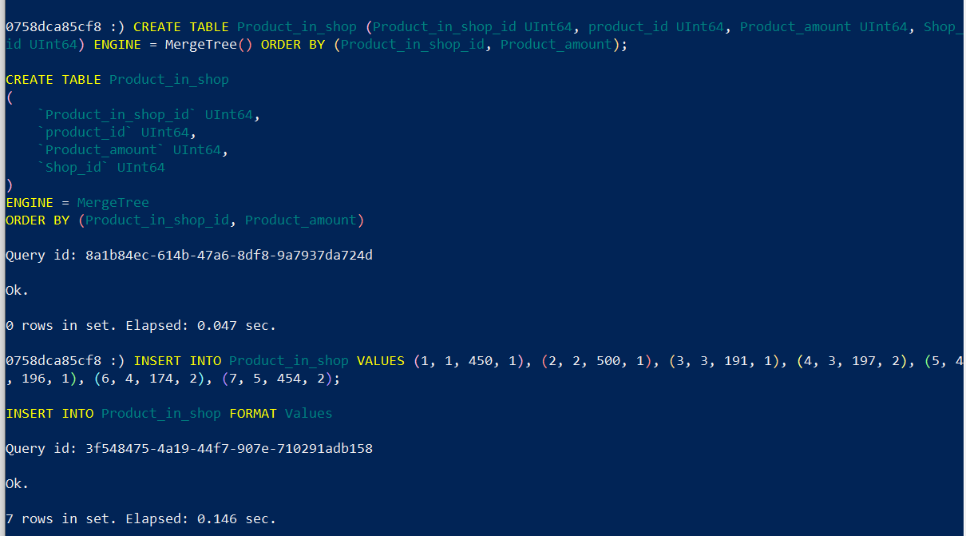
2. 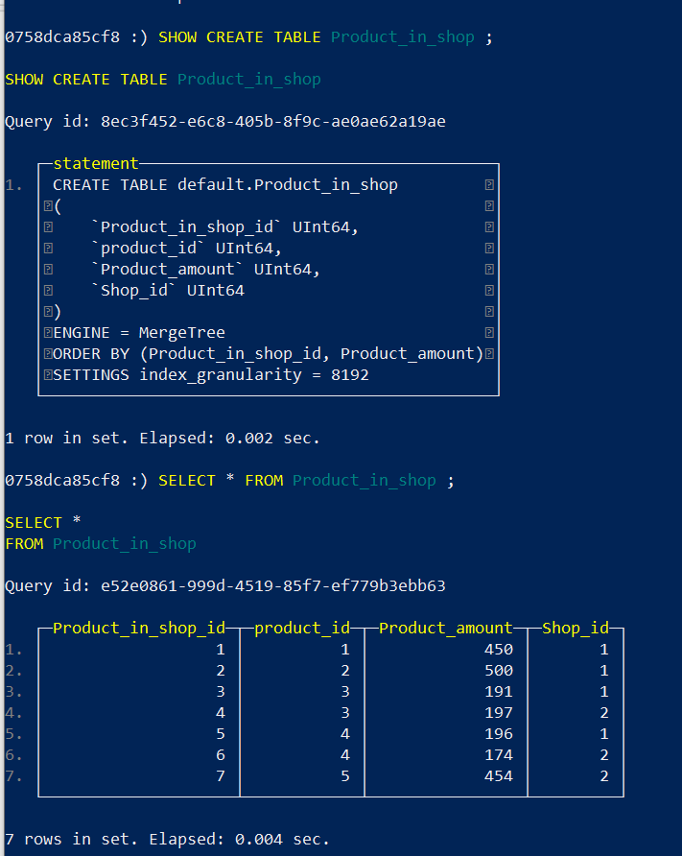
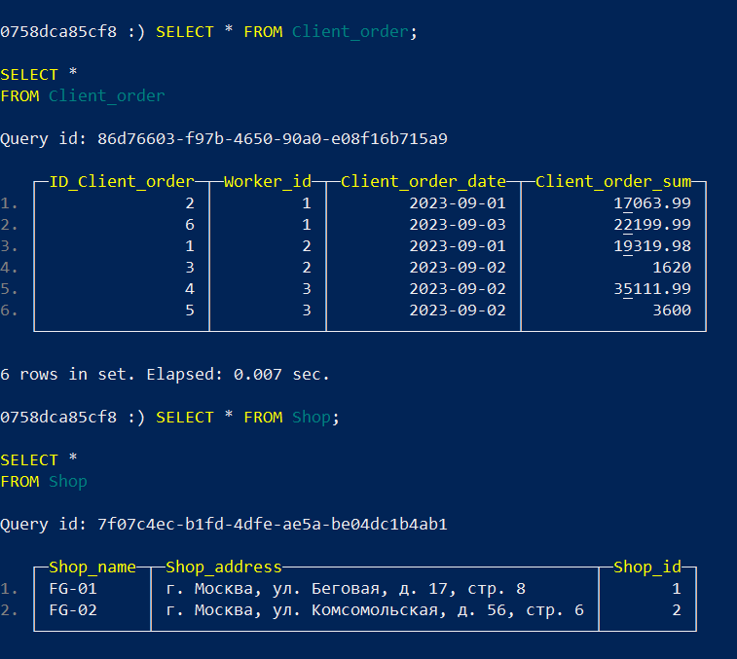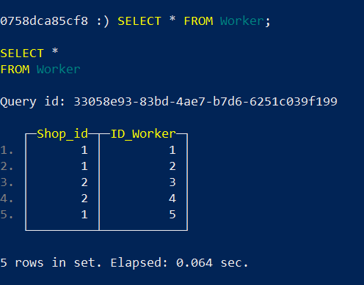

3.
SELECT Worker.Shop_id,
count(Product_in_shop.product_id) AS sold_products,
round(avg(Client_order.Client_order_sum)) AS average_order_sum
FROM Worker
JOIN Product_in_shop on Product_in_shop.Shop_id = Worker.Shop_id
JOIN Client_order on Client_order.Worker_id = Worker.ID_Worker
GROUP BY Worker.Shop_id
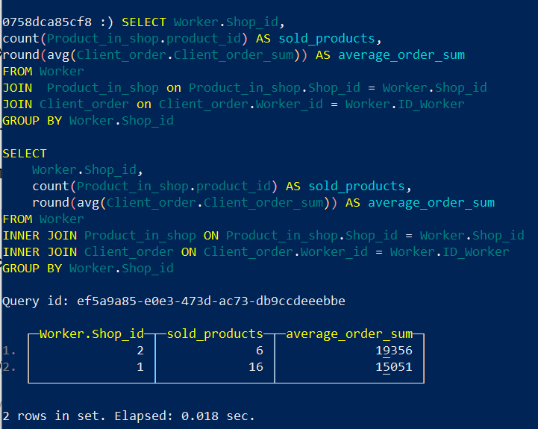
4. 

