Этапы выполнения работы:
- Сопровождение таблиц:
  - Создание файла;

  - Сопровождение объектов.
Таблица 1 – Сопровождение таблиц баз данных

Логическое название | Физическое название | Тип данных | Обязательность | Ограничения | Было | Стало | Результат
Сотрудник  (Worker) | Worker_id | Int | Not null | Суррогатный ключ | create table if not exists Worker (  ID_Worker int not null auto_increment primary key,  Worker_surname Varchar(36) not null ,  Worker_name Varchar(36) not null,  Worker_second_name Varchar(36) not null,  Worker_login Varchar(36) not null,  Worker_password Varchar(36) not null,  Shop_ID Int not null, constraint FK_Shop_Worker foreign key (Shop_ID) references Shop(ID_Shop),  Position_id Int not null, constraint FK_Position_Worker foreign key (Position_id) references Positions(ID_Position)  ); | ALTER TABLE Worker  -- ADD CONSTRAINT UQ_Worker_login UNIQUE (Worker_login),  ADD CONSTRAINT CH_Worker_login_len CHECK (LENGTH(Worker_login) >= 6),  ADD CONSTRAINT CH_Worker_login_LetterU CHECK (regexp_like(Worker_login, '[A-Z]')),  ADD CONSTRAINT CH_Worker_login_LetterL CHECK (regexp_like(Worker_login, '[a-z]')),  ADD CONSTRAINT CH_Worker_password_Len CHECK (length(Worker_password) >= 8),  ADD CONSTRAINT CH_Worker_password_LetterU CHECK (regexp_like(Worker_password, '[A-Z]')),  ADD CONSTRAINT CH_Worker_password_LetterL CHECK (regexp_like(Worker_password, '[a-z]')),  ADD CONSTRAINT CH_Worker_password_Numb CHECK (regexp_like(Worker_password, '[0-9]')),  ADD CONSTRAINT CH_Worker_password_Symb CHECK (regexp_like(Worker_password, '[!@#$%^&*()]')),  ALTER COLUMN Worker_second_name SET DEFAULT 'Нет данных'; | 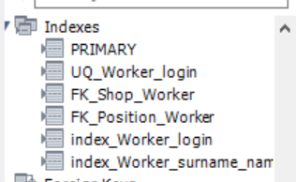
Сотрудник  (Worker) | Worker_surname | Varchar(36) | Not null
Сотрудник  (Worker) | Worker_name | Varchar(36) | Not null
Сотрудник  (Worker) | Worker_second_name | Varchar(36) | Null | Default(  «Нет данных»)
Сотрудник  (Worker) | Worker_login | Varchar(n) | Not null | Уникальное значение  Length >= 6, [a-Z][а-я]
Сотрудник  (Worker) | Worker_password | Varchar(36) | Not null | Length >= 8, [a-Z][0-9][!@#$%^&*()]
Сотрудник  (Worker) | Shop_id | Int | Not null | Внешний
Сотрудник  (Worker) | Position_id | Int | Not null | Внешний ключ
Должность  (Position) | Position_id | Int | Not null | Суррогатный ключ | create table if not exists Positions(  ID_Position int not null auto_increment primary key,  Position_name Varchar(36) not null  ); | Alter table Positions  add constraint UQ_Position_name unique (Position_name); | 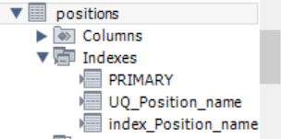
Должность  (Position) | Position_name | Varchar(36) | Not null | Уникальное значение
Заявка на поставку  (Request) | Request_id | Int | Not null | Суррогатный ключ | create table if not exists Request(  ID_Request Int not null auto_increment primary key,  Request_number Int not null,  Request_date Date not null,  Worker_id Int not null, constraint FK_Worker_Request foreign key (Worker_id) references Worker(ID_Worker)  ); | Alter table Request  add constraint UQ_Request_number unique (Request_number); | 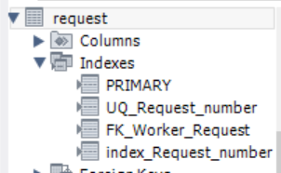
Заявка на поставку  (Request) | Request_number | Int | Not null | Уникальное значение
Заявка на поставку  (Request) | Request_date | Date | Not null | В настоящем времени
Заявка на поставку  (Request) | Worker_id | Int | Not null | Внешний ключ
Клиентский заказ  (Client_order) | Client_order_id | Int | Not null | Суррогатный ключ | create table if not exists Client_order(  ID_Client_order Int not null auto_increment primary key,  Client_order_number Int not null,  Customer_id Int not null, constraint FK_Customer_Client_order foreign key (Customer_id) references Customer(ID_Customer),  Client_order_date Date not null,  Client_order_time Time not null,  Client_order_sum Decimal(3,2) not null,  Worker_id Int not null, constraint FK_Worker_Client_order foreign key (Worker_id) references Worker(ID_Worker)  ); | Alter table Client_order  add constraint UQ_Client_order_number unique (Client_order_number),  add constraint CH_Client_order_number check (regexp_like(Client_order_number, 'ЗкП-[0-9]{9}-[0-9]{2}')),  add constraint CH_Client_order_sum check (Client_order_sum >= 0);  ALTER TABLE Client_order MODIFY Client_order_number varchar (19); | 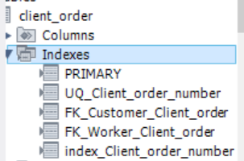
Клиентский заказ  (Client_order) | Client_order_number | Varchar(16) | Not null | ЗкП-000000000-00  Уникальное значение
Клиентский заказ  (Client_order) | Customer_id | Int | Not null | Внешний ключ
Клиентский заказ  (Client_order) | Client_order_date | Date | Not null | В настоящем времени
Клиентский заказ  (Client_order) | Client_order_time | Time | Not null | В настоящем времени
Клиентский заказ  (Client_order) | Client_order_sum | Decimal(3,2) | Not null | >0
Клиентский заказ  (Client_order) | Worker_id | Int | Not null | Внешний ключ
Чек  (Receipt) | Receipt_id | Int | Not null | Суррогатный ключ | create table if not exists Receipt(  ID_Receipt Int not null auto_increment primary key,  Receipt_number Varchar(36) not null,  Client_order_id Int not null, constraint FK_Client_order_Receipt foreign key (Client_order_id) references Client_order(ID_Client_order),  Receipt_date Date not null,  Receipt_time Time not null,  Receipt_sum Decimal(3,2) not null,  Receipt_change Decimal(3,2) not null  ); | Alter table Receipt  add constraint UQ_Receipt_number unique (Receipt_number),  add constraint CH_Receipt_number check (regexp_like(Receipt_number, 'КЧ-[0-9]{10}')),  add constraint CH_Receipt_sum check (Receipt_sum >= 0),  add constraint CH_Receipt_change check (Receipt_change >= 0);  Alter table Receipt MODIFY Receipt_number varchar(16); | 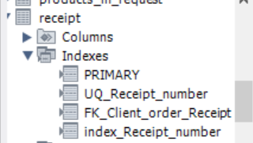
Чек  (Receipt) | Receipt_number | Varchar(36) | Not null | КЧ-0000000000  Уникальное значение
Чек  (Receipt) | Client_order_id | Int | Not null | Внешний ключ
Чек  (Receipt) | Receipt_date | Date | Not null | В настоящем времени
Чек  (Receipt) | Receipt_time | Time | Not null | В настоящем времени
Чек  (Receipt) | Receipt_sum | Decimal(10,2) | Not null | >=0
Чек  (Receipt) | Receipt_change | Decimal(10,2) | Not null | >=0
Торговый зал  (Sales_floor) | Sales_floor_id | Int | Not null | Суррогатный ключ | create table if not exists Sales_floor(  ID_Sales_floor Int not null auto_increment primary key,  Sales_floor_name Varchar(36) not null  ); | Alter table Sales_floor  add constraint UQ_Sales_floor_name unique (Sales_floor_name); | 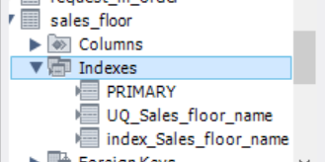
Торговый зал  (Sales_floor) | Sales_floor_name | Varchar(36) | Not null | Уникальное значение
Торговая точка  (Shop) | Shop_id | Int | Not null | Суррогатный ключ | create table if not exists Shop(  ID_Shop Int not null auto_increment primary key,  Shop_name Varchar(36) not null,  Shop_address Varchar(36) not null  ); | Alter table Shop  add constraint UQ_Shop_name unique (Shop_name),  add constraint CH_Shop_name check (regexp_like(Shop_name, 'FG-[0-9]{2}')),  add constraint UQ_Shop_address unique (Shop_address);  alter table Shop modify Shop_name varchar(7); | 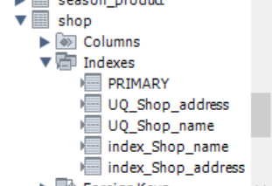
Торговая точка  (Shop) | Shop_name | Varchar(36) | Not null | FG-00  Уникальное значение
Торговая точка  (Shop) | Shop_address | Varchar(150) | Not null | Уникальное значение
Склад  (Warehouse) | Warehouse_id | Int | Not null | Суррогатный ключ | create table if not exists Warehouse(  ID_Warehouse Int not null auto_increment primary key,  Warehouse_number Int not null,  Warehouse_address Varchar(36) not null,  Shop_id Int not null, constraint FK_Shop_Warehouse foreign key (Shop_id) references Shop(ID_Shop)  ); | Alter table Warehouse  add constraint UQ_Warehouse_number unique (Warehouse_number),  add constraint CH_Warehouse_number check (regexp_like(Warehouse_number, 'СП[0-9]{2}'));  alter table Warehouse modify Warehouse_number varchar(7); | 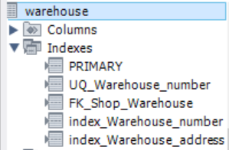
Склад  (Warehouse) | Warehouse_number | Varchar(36) | Not null | СП00  Уникальное значение
Склад  (Warehouse) | Warehouse_address | Varchar(150) | Not null | Уникальное значение
Склад  (Warehouse) | Shop_id | Int | Not null | Внешний ключ
Покупатель  (Customer) | Customer_id | Int | Not null | Суррогатный ключ | create table if not exists Customer(  ID_Customer Int not null auto_increment primary key,  Customer_surname Varchar(36) not null,  Customer_name Varchar(36) not null,  Customer_last_name Varchar(36) not null,  Passport_series Varchar(5) not null,  Passport_number Varchar(6) not null,  Issue_data Date not null,  Customer_phone_number Varchar(16) not null,  Credit_card_info Int not null,  Cusomer_email Varchar(36) not null,  Customer_login Varchar(36) not null,  Customer_password  Varchar(36) not null  ); | Alter table Customer  add constraint CH_Passport_series check (regexp_like(Passport_series, '[0-9]{2} [0-9]{2}')),  add constraint CH_Passport_number check (regexp_like(Passport_number, '[0-9]{6}')),  add constraint CH_Customer_phone_number check (regexp_like(Customer_phone_number, '^\\+7\\([0-9]{3}\\)[0-9]{3}-[0-9]{2}-[0-9]{2}$')),  add constraint CH_Credit_card_info check (regexp_like(Credit_card_info, '[0-9]{4} [0-9]{4} [0-9]{4} [0-9]{4}')),  add constraint UQ_Credit_card_info unique (Credit_card_info),  add constraint UQ_Customer_login unique (Customer_login),  add constraint CH_Customer_login_len check (length(Customer_login) >= 6),  add constraint CH_Customer_login_LetterU check (regexp_like(Customer_login, '[a-zA-Z]')),  add constraint CH_Customer_password_Len check (length(Customer_password) >= 8),  add constraint CH_Customer_password_LetterU check (regexp_like(Customer_password, '[A-Z]')),  add constraint CH_Customer_password_LetterL check (regexp_like(Customer_password, '[a-z]')),  add constraint CH_Customer_password_Numb check (regexp_like(Customer_password, '[0-9]')),  add constraint CH_Customer_passwor_Symb check (regexp_like(Customer_password, '[!@#$^&*()]'));  alter column Customer_last_name set default ('Нет данных');  alter table Customer modify Passport_series varchar(8);  alter table Customer modify Passport_number varchar(9);  alter table Customer modify Customer_phone_number varchar(19);  alter table Customer modify Credit_card_info varchar(22); | 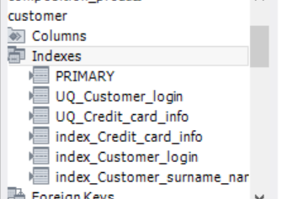
Покупатель  (Customer) | Customer_surname | Varchar(36) | Not null
Покупатель  (Customer) | Customer_name | Varchar(36) | Not null
Покупатель  (Customer) | Customer_last_name | Varchar(36) | Default(  «Нет данных») | Default(  «Нет данных»)
Покупатель  (Customer) | Passport_series | Varchar(5) | Not null | 00 00
Покупатель  (Customer) | Passport_number | Varchar(6) | Not null | 000000
Покупатель  (Customer) | Issue_data | Date | Not null | В прошлом (Дата выдачи паспорта, должна иметь разницу относительно текущей даты, не менее 14 лет)
Покупатель  (Customer) | Customer_phone_number | Varchar(16) | Not null | +7(000)000-00-00
Покупатель  (Customer) | Credit_card_info | Int | Not null | 0000 0000 0000 0000  Уникальное значение
Покупатель  (Customer) | Cusomer_email | Varchar(36) | Не  обяза  тельно
Покупатель  (Customer) | Customer_login | Varchar(n) | Not null | Уникальное значение  Length >= 6, [a-Z][а-я]
Покупатель  (Customer) | Customer_password | Varchar(36) | Not null | Length >= 8, [a-Z][0-9][!@#$%^&*()]
Товар  (Product) | Product_id | Int | Not null | Суррогатный ключ | create table if not exists Product(  ID_Product Int not null auto_increment primary key,  Article_number Varchar(10) not null,  Product_type Varchar(36) not null,  Product_photo Text not null,  Manufacturing_country_id Int not null, constraint FK_Manufacturing_country_Product foreign key (Manufacturing_country_id) references Manufacturing_country(ID_Manufacturing_country),  Manufacturer_id Int not null, constraint FK_Manufacturer_Product foreign key (Manufacturer_id) references Manufacturer(ID_Manufacturer),  Product_amount Int not null,  Product_price Decimal(3,2) not null  ); | Alter table Product  add constraint CH_Article_number check (regexp_like(Article_number, 'SP/[0-9]{7}')),  add constraint UQ_Article_number unique (Article_number),  add constraint UQ_Product_type unique (Product_type),  add constraint CH_Product_amount check (Product_amount > 0),  add constraint CH_Product_price check (Product_price > 0);  alter table Product modify Article_number varchar(13); | 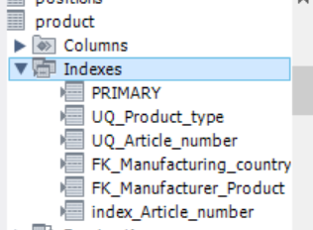
Товар  (Product) | Article_number | Varchar(10) | Not null | SP/0000000  Уникальное значение
Товар  (Product) | Product_type | Varchar(36) | Not null | Уникальное значение
Товар  (Product) | Product_photo |  | Not null
Товар  (Product) | Manufacturing_country_id | Varchar(36) | Not null | Внешний ключ
Товар  (Product) | Manufacturer_id | Varchar(36) | Not null | Внешний ключ
Товар  (Product) | Product_amount | Int | Not null | >0
Товар  (Product) | Product_price | Decimal(10,2) | Not null | >0
Наименование производителя  (Manufacturer) | Manufacturer _id | Int | Not null | Суррогатный ключ | create table if not exists Manufacturer(  ID_Manufacturer Int not null auto_increment primary key,  Manufacturer_name Varchar(36) not null  ); | Alter table Manufacturer  add constraint UQ_Manufacturer_name unique (Manufacturer_name); | 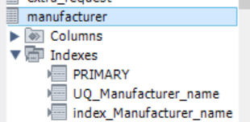
Наименование производителя  (Manufacturer) | Manufacturer _name | Varchar(36) | Not null | Уникальное значение
Страна производителя  (Manufacturing  _country) | Manufacturing_country_id | Int | Not null | Суррогатный ключ | create table if not exists Manufacturing_country(  ID_Manufacturing_country Int not null auto_increment primary key,  Manufacturing_country_name Varchar(36) not null  ); | Alter table Manufacturing_country  add constraint UQ_Manufacturing_country_name unique (Manufacturing_country_name); | 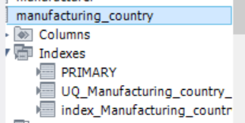
Страна производителя  (Manufacturing  _country) | Manufacturing_country_name | Varchar(36) | Not null | Уникальное значение
Сезон  (Season) | Season_id | Int | Not null | Суррогатный ключ | create table if not exists Season(  ID_Season Int not null auto_increment primary key,  Season_name Varchar(36) not null); | Alter table Season  add constraint UQ_Season_name unique (Season_name); | 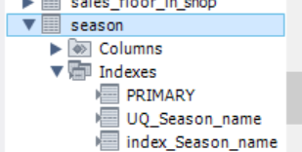
Сезон  (Season) | Season_name | Varchar(36) | Not null | Уникальное значение
Cостав  (Composition) | Compostion _id | Int | Not null | Суррогатный ключ | create table if not exists Composition(  ID_Composition Int not null auto_increment primary key,  Composition_name Varchar(36) not null  ); | Alter table Composition  add constraint UQ_Composition_name unique (Composition_name); | 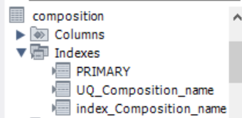
Cостав  (Composition) | Compostion _name | Varchar(36) | Not null | Уникальное значение
Размер  (Size) | Size_id | Int | Not null | Суррогатный ключ | create table if not exists Size(  ID_Size Int not null auto_increment primary key,  Size Int not null  ); | Alter table Size  add constraint UQ_Size unique (Size); | 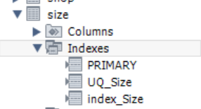
Размер  (Size) | Size | Int | Not null | Уникальное значение |  | Alter table Size  add constraint UQ_Size unique (Size);
Доп заявка  (Extra_request) | Extra_request_id | Int | Not null | Суррогатный ключ | create table if not exists Extra_request(  ID_Extra_request Int not null auto_increment primary key,  Extra_request_number Int not null,  Order_id Int not null, constraint FK_Order_Extra_request foreign key (Order_id) references Orders(ID_Order),  Worker_id Int not null, constraint FK_Worker_Extra_request foreign key (Worker_id) references Worker(ID_Worker)  ); | Alter table Extra_request  add constraint UQ_Extra_request_number unique (Extra_request_number),  add constraint CH_Extra_request_number check (regexp_like(Extra_request_number, 'ЗП-[0-9]{10}-[0-9]{2}/[0-9]'));  alter table Extra_request modify Extra_request_number varchar(21); | 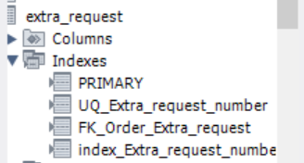
Доп заявка  (Extra_request) | Extra_request_number | Varchar(18) | Not null | ЗП-0000000000-00/0  Уникальное значение
Доп заявка  (Extra_request) | Order_id | Int | Not null | Внешний ключ
Заказ на поставку  (Orders) | Order_id | Int | Not null | Суррогатный ключ | create table if not exists Orders(  ID_Order Int not null auto_increment primary key,  Order_number Int not null,  Supplier_id Int not null, constraint FK_Supplier_Orders foreign key (Supplier_id) references Supplier(ID_Supplier),  Order_date Date not null,  Order_time Date not null,  Order_status_id Int not null, constraint FK_Order_status_Orders foreign key (Order_status_id) references Order_status(ID_Order_status),  Costs Decimal(3,2) not null  ); | Alter table Orders  add constraint UQ_Order_number unique (Order_number),  add constraint CH_Order_number check (regexp_like(Order_number, 'ЗП-[0-9]{10}-[0-9]{2}'));  alter table Orders modify Order_number varchar(19); | 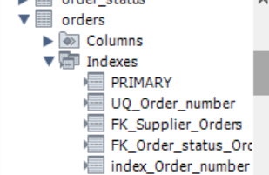
Заказ на поставку  (Orders) | Order_number | Varchsr(16) | Not null | ЗП-0000000000-00  Уникальное значение
Заказ на поставку  (Orders) | Supplier_id | Int | Not null | Внешний ключ
Заказ на поставку  (Orders) | Order_date | Date | Not null | В настоящее время
Заказ на поставку  (Orders) | Order_time | Date | Not null | В настоящее время
Заказ на поставку  (Orders) | Order_status_id | Int | Not null | Внешний ключ
Заказ на поставку  (Orders) | Cost | Decimal(3,2) | Not null | >0
Поставщик  (Supplier) | Supplier_id | Int | Not null | Суррогатный ключ | create table if not exists Supplier(  ID_Supplier Int not null auto_increment primary key,  Supplier_name Varchar(36) not null  ); | - | -
Поставщик  (Supplier) | Supplier_name | Varchar(36) | Not null |  |  | - | -
Статус заказа  (Order_status) | Order_status_id | Int | Not null | Суррогатный ключ | create table if not exists Order_status(  ID_Order_status Int not null auto_increment primary key,  Order_status Varchar(36) not null  ); | Alter table Order_status  add constraint CH_Order_status check (Order_status in ('В обработке', 'В пути', 'Доставлено')); | -
Статус заказа  (Order_status) | Order_status | Varchar(36) | Not null | Одно из нижеперечисленных значений:  В обработке, В пути, Доставлен |  |  | -
Заявки в заказе  (Request_in_  order) | Request_in_order_id | Int | Not null | Суррогатный ключ | create table if not exists Request_in_order(  ID_Request_in_order Int not null auto_increment primary key,  Request_id Int not null, constraint FK_Request_Request_in_order foreign key (Request_id) references Request(ID_Request),  Order_id Int not null, constraint FK_Order_Request_in_order foreign key (Order_id) references Orders(ID_Order)  ); |  | -
Заявки в заказе  (Request_in_  order) | Request_id | Int | Not null | Внешний ключ |  |  | -
Заявки в заказе  (Request_in_  order) | Order_id | Int | Not null | Внешний ключ |  |  | -
Товары в заявке  (Product_in_  request) | Product_in_request_id | Int | Not null | Суррогатный ключ | create table if not exists Products_in_request(  ID_Product_in_request Int not null auto_increment primary key,  Product_id Int not null, constraint FK_Product_Product_in_request foreign key (Product_id) references Product(ID_Product),  Request_id Int not null, constraint FK_Request_Product_in_request foreign key (Request_id) references Request(ID_Request)  ); |  | -
Товары в заявке  (Product_in_  request) | Product_id | Int | Not null | Внешний ключ |  |  | -
Товары в заявке  (Product_in_  request) | Request_id | Int | Not null | Внешний ключ |  |  | -
Содержимое клиентского заказа  (Product_in_  customer_  order) | Product_in_customer_order_id | Int | Not null | Суррогатный ключ | create table if not exists Products_in_customer_order (  ID_Product_in_customer_order Int not null auto_increment primary key,  Client_order_id Int not null, constraint FK_Client_order_Product_in_client_order foreign key (Client_order_id) references Client_order(ID_Client_order),  Product_id Int not null, constraint FK_Product_Product_in_customer_order foreign key (Product_id) references Product(ID_Product),  Product_amount Int not null  ); | Alter table Products_in_customer_order  add constraint CH_Products_amount check (Product_amount > 0); | -
 | Customer_order_id | Int | Not null | Внешний ключ |  |  | -
 | Product_id | Int | Not null | Внешний ключ |  |  | -
 | Product_amount | Int | Not null | >0 |  |  | -
Размер товара  (Product_size) | Product_size_id | Int | Not null | Суррогатный ключ | create table if not exists Product_size(  ID_Product_size Int not null auto_increment primary key,  Product_id Int not null, constraint FK_Product_Product_size foreign key (Product_id) references Product(ID_Product),  Size_id Int not null, constraint FK_Size_Product_size foreign key (Size_id) references Size(ID_Size)  ); |  | -
Размер товара  (Product_size) | Product_id | Int | Not null | Внешний ключ |  |  | -
Размер товара  (Product_size) | Size_id | Int | Not null | Внешний ключ |  |  | -
Состав товара  (Composition_  Product) | Composition_product_id | Int | Not null | Суррогатный ключ | create table if not exists Composition_product(  ID_Composition_product Int not null auto_increment primary key,  Composition_id Int not null, constraint FK_Composition_Composition_product foreign key (Composition_id) references Composition(ID_Composition),  Product_id Int not null, constraint FK_Product_Composition_product foreign key (Product_id) references Product(ID_Product),  Percents Int not null  ); | Alter table Composition_Product  add constraint CH_Percent check (Percents > 0); | -
Состав товара  (Composition_  Product) | Product_id | Int | Not null | Внешний ключ |  |  | -
Состав товара  (Composition_  Product) | Composition_id | Int | Not null | Внешний ключ |  |  | -
Состав товара  (Composition_  Product) | Percent | Int | Not null | >0 |  |  | -
Товар по точкам  (Product_in_  shop) | Product_in_shop_id | Int | Not null | Суррогатный ключ | create table if not exists Product_in_shop(  ID_Product_in_shop Int not null auto_increment primary key,  Shop_id Int not null, constraint FK_Shop_Product_in_shop foreign key (Shop_id) references Shop(ID_Shop),  Product_id Int not null, constraint FK_Product_Product_in_shop foreign key (Product_id) references Product(ID_Product),  Product_amount Int not null  ); | Alter table Product_in_  shop Alter table Product_in_shop  add constraint CH_Product_in_shop_Product_amount check (Product_amount > 0); add constraint CH_Product_amount check (Product_amount > 0); | -
Товар по точкам  (Product_in_  shop) | Product_id | Int | Not null | Внешний ключ |  |  | -
Товар по точкам  (Product_in_  shop) | Shop_id | Int | Not null | Внешний ключ |  |  | -
Товар по точкам  (Product_in_  shop) | Product_amount | Int | Not null | >0 |  |  | -
Сезон товара  (Season  _product) | Season_product_id | Int | Not null | Суррогатный ключ | create table if not exists Season_product(  ID_Season_product Int not null auto_increment primary key,  Product_id Int not null, constraint FK_Product_Season_product foreign key (Product_id) references Product(ID_Product),  Season_id Int not null, constraint FK_Season_Season_product foreign key (Season_id) references Season(ID_Season)  ); |  | -
Сезон товара  (Season  _product) | Season_id | Int | Not null | Внешний ключ |  |  | -
Сезон товара  (Season  _product) | Product_id | Int | Not null | Внешний ключ |  |  | -
Товары на стендах  (Product_  on_display) | Product_on  _display_id | Int | Not null | Суррогатный ключ | create table if not exists Product_on_display(  ID_Product_on_display Int not null auto_increment primary key,  Sales_floor_id Int not null, constraint FK_Sales_floor_Product_on_display foreign key (Sales_floor_id) references Sales_floor(ID_Sales_floor),  Product_id Int not null, constraint FK_Product_Product_on_display foreign key (Product_id) references Product(ID_Product),  Display_in_sales_floor Int not null  ); | Alter table Product_on_display  add constraint CH_Display_in_sales_floor check (Display_in_sales_floor > 0); | -
Товары на стендах  (Product_  on_display) | Product_id | Int | Not null | Внешний ключ |  |  | -
Товары на стендах  (Product_  on_display) | Sales_floor_id | Int | Not null | Внешний ключ |  |  | -
Товары на стендах  (Product_  on_display) | Display_in_sales_floor | Int | Not null | Уникальное значение  >0 |  |  | -
Залы торговой точки  (Sales_floor_  in_shop) | Sales_floor_  in_shop_id | Int | Not null | Суррогатный ключ | create table if not exists Sales_floor_in_shop(  ID_Sales_floor_in_shop Int not null auto_increment primary key,  Sales_floor_id Int not null, constraint FK_Sales_floor_Sales_floor_in_shop foreign key (Sales_floor_id) references Sales_floor(ID_Sales_floor),  Shop_id Int not null, constraint FK_Shop_Sales_floor_in_shop foreign key (Shop_id) references Shop(ID_Shop),  Sector_in_sales_floor Int not null  ); |  | -
Залы торговой точки  (Sales_floor_  in_shop) | Shop_id | Int | Not null | Внешний ключ |  |  | -
Залы торговой точки  (Sales_floor_  in_shop) | Sales_floor_id | Int | Not null | Внешний ключ |  |  | -
Залы торговой точки  (Sales_floor_  in_shop) | Sector_in_sales_floor | Int | Not null |  |  |  | -
Товары в доп заявке  (Product_in_ extra_request) | Product_in_ extra_request_id | Int | Not null | Суррогатный ключ | create table if not exists Product_in_extra_request(  ID_Product_in_extra_request Int not null auto_increment primary key,  Extra_request_id Int not null, constraint FK_Extra_request_Product_in_extra_request foreign key (Extra_request_id) references Extra_request(ID_Extra_request),  Product_id Int not null, constraint FK_Product_Product_in_extra_request foreign key (Product_id) references Product(ID_Product),  Sum Decimal(12, 2) not null  ); | Alter table Product_in_extra_request  add constraint CH_Sum check (Sum > 0);
Товары в доп заявке  (Product_in_ extra_request) | Extra_request_id | Int | Not null | Внешний ключ
Товары в доп заявке  (Product_in_ extra_request) | Product_id | Int | Not null | Внешний ключ
Товары в доп заявке  (Product_in_ extra_request) | Sum | Decimal(3,2) | Not null | >0
Заказы в маршрутном листе  (Client_order_in_itinerary) | Client_order_in_itinerary_id | Int | Not null | Суррогатный ключ |  | CREATE TABLE Client_order_in_itinerary (  ID_Client_order_in_itinerary INT AUTO_INCREMENT NOT NULL,  Itinerary_id INT NOT NULL,  Client_order_id INT NOT NULL,  Packaging_time TIME NOT NULL,  Cl_order_to_curier_time TIME NOT NULL,  Order_on_way TIME NOT NULL,  Cl_order_to_client TIME NOT NULL,  Deliv_order_status_id INT NOT NULL,  PRIMARY KEY (ID_Client_order_in_itinerary),  FOREIGN KEY (Itinerary_id) REFERENCES Itinerary (ID_Itinerary),  FOREIGN KEY (Client_order_id) REFERENCES Client_order (ID_Client_order),  FOREIGN KEY (Deliv_order_status_id) REFERENCES Deliv_order_status (ID_Deliv_order_status)  );  CREATE INDEX index_ID_Client_order_in_itinerary ON Client_order_in_itinerary (ID_Client_order_in_itinerary);  CREATE INDEX index_Cl_order_to_curier_time ON Client_order_in_itinerary (Cl_order_to_curier_time);  CREATE INDEX index_Packaging_time ON Client_order_in_itinerary (Packaging_time);  CREATE INDEX index_Order_on_way ON Client_order_in_itinerary (Order_on_way);  CREATE INDEX index_Cl_order_to_client ON Client_order_in_itinerary (Cl_order_to_client); | 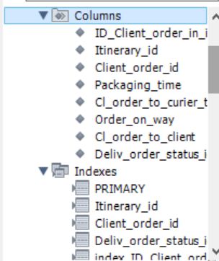
Заказы в маршрутном листе  (Client_order_in_itinerary) | Itinerary_id | Int | Not null | Внешний ключ
Заказы в маршрутном листе  (Client_order_in_itinerary) | Client_order_id | Int | Not null | Внешний ключ
Заказы в маршрутном листе  (Client_order_in_itinerary) | Packaging_time | Time | Not null | Время действия над позицией не может быть раньше даты формирования общего маршрутного листа
Заказы в маршрутном листе  (Client_order_in_itinerary) | Cl_order_to curier_time | Time | Not null | Время действия над позицией не может быть раньше даты формирования общего маршрутного листа
Заказы в маршрутном листе  (Client_order_in_itinerary) | Order_on_way | Time | Not null | Время действия над позицией не может быть раньше даты формирования общего маршрутного листа
Заказы в маршрутном листе  (Client_order_in_itinerary) | Cl_order_to_client | Time | Not null | Время действия над позицией не может быть раньше даты формирования общего маршрутного листа
Заказы в маршрутном листе  (Client_order_in_itinerary) | Deliv_order_status_id | Int |  | Внешний ключ
Статус доставки клиентского заказа  (Deliv_order_status) | Deliv_order_status_id | Int | Not null | Суррогатный ключ |  | CREATE TABLE Deliv_order_status (  ID_Deliv_order_status INT AUTO_INCREMENT NOT NULL,  Delivery_order_status VARCHAR(36) NOT NULL,  PRIMARY KEY (ID_Deliv_order_status),  UNIQUE KEY UQ_Delivery_order_status (Delivery_order_status),  CHECK (Delivery_order_status IN ('Ожидает выдачи', 'В пути', 'Закрыт'))  );  CREATE INDEX index_ID_Deliv_order_status ON Deliv_order_status (ID_Deliv_order_status);  CREATE INDEX index_Delivery_order_status ON Deliv_order_status (Delivery_order_status); | 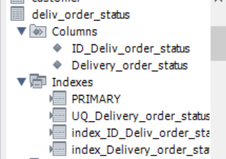
Статус доставки клиентского заказа  (Deliv_order_status) | Delivery_order_status | Varchar(36) | Not null | Уникален  хранит значения: ожидает выдачи,  в пути,  закрыт
Курьер  (Delivery_man) | Delivery_man_id | Int | Not null | Суррогатный ключ |  | CREATE TABLE Delivery_man (  ID_Delivery_man INT AUTO_INCREMENT NOT NULL,  Delivery_man_surname VARCHAR(36) NOT NULL,  Delivery_man_name VARCHAR(36) NOT NULL,  Delivery_man_second_name VARCHAR(36) DEFAULT 'Отсутствует',  Delivery_man_phone VARCHAR(16) NOT NULL,  PRIMARY KEY (ID_Delivery_man),  UNIQUE KEY UQ_Delivery_man_phone (Delivery_man_phone),  CHECK (Delivery_man_phone REGEXP '^\\+7\\([0-9]{3}\\)[0-9]{3}-[0-9]{2}-[0-9]{2}$')  );  CREATE INDEX index_ID_Delivery_man ON Delivery_man (ID_Delivery_man);  CREATE INDEX ndex_Delivery_man_phone ON Delivery_man (Delivery_man_phone); | 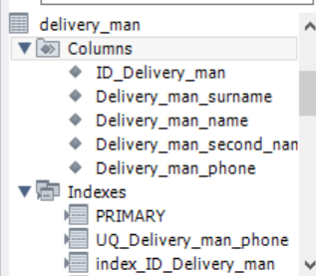
Курьер  (Delivery_man) | Delivery_man_surname | Varchar(36) | Not null
Курьер  (Delivery_man) | Delivery_man_name | Varchar(36) | Not null
Курьер  (Delivery_man) | Delivery_man_second_name | Varchar(36) | Default(«Отсутствует») | по умолчанию хранится значение «Отсутствует»
Курьер  (Delivery_man) | Delivery_man_phone | Varchar(16) | Not null | Уникален  хранится в формате +7(000)000-00-00
Автомобиль  (Car) | Car_id | Int | Not null | Суррогатный ключ |  | CREATE TABLE Car (  ID_Car INT NOT NULL AUTO_INCREMENT,  Car_model VARCHAR(36) NOT NULL,  Car_number VARCHAR(12) NOT NULL,  PRIMARY KEY (ID_Car),  UNIQUE KEY UQ_Car_model (Car_model),  UNIQUE KEY UQ_Car_number (Car_number),  CHECK (Car_number REGEXP '^[ABCEHKMOPTYX][0-9]{3}[ABCEHKMOPTYX]{2} [0-9]{2}')  );  CREATE INDEX index_ID_Car ON Car (ID_Car);  CREATE INDEX index_Car_number ON Car (Car_number); | 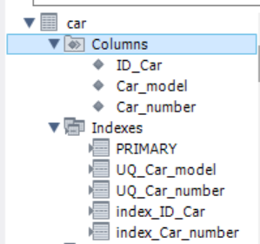
Автомобиль  (Car) | Car_model | Varchar(36) | Not null | Марка автомобиля уникальны
Автомобиль  (Car) | Car_number | Varchar(12) | Not null | уникален, хранится в формате Х000ХХ 00  буквы могут быть внесены только те, что одинаково пишутся, как на кириллице, так и на латинице
Маршрутный лист  (Itinerary) | Itinerary_id | Int | Not null | Суррогатный ключ |  | CREATE TABLE Itinerary (  ID_Itinerary INT NOT NULL AUTO_INCREMENT,  Itinerary_number VARCHAR(22) NOT NULL,  Itinerary_date DATE NOT NULL,  Itinerary_time TIME NOT NULL,  Delivery_man_id INT NOT NULL,  Car_id INT NOT NULL,  Overall_status_id INT NOT NULL,  PRIMARY KEY (ID_Itinerary),  UNIQUE KEY UQ_Itinerary_number (Itinerary_number),  CONSTRAINT CH_Itinerary_number CHECK (Itinerary_number REGEXP 'Д-МЛ-[0-9]{2}-[0-9]{10}'),  FOREIGN KEY (Delivery_man_id) REFERENCES Delivery_man (ID_Delivery_man),  FOREIGN KEY (Car_id) REFERENCES Car (ID_Car),  FOREIGN KEY (Overall_status_id) REFERENCES Overall_status (ID_Overall_status)  );  CREATE INDEX index_ID_Itinerary ON Itinerary (ID_Itinerary);  CREATE INDEX index_Itinerary_number ON Itinerary (Itinerary_number); | 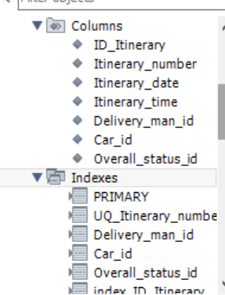
Маршрутный лист  (Itinerary) | Itinerary_number | Varchar(21) | Not null | Номер маршрутного листа уникален и хранится в формате Д-МЛ-00-0000000000
Маршрутный лист  (Itinerary) | Itinerary_date | Date | Not null | Дата формирования маршрутного листа, не может быть раньше, чем дата формирования заказа
Маршрутный лист  (Itinerary) | Itinerary_time | Time | Not null | время формирования маршрутного листа, не может быть раньше, чем время формирования заказа
Маршрутный лист  (Itinerary) | Delivery_man_id | Int | Not null | Внешний ключ
Маршрутный лист  (Itinerary) | Car_id | Int | Not null | Внешний ключ
Маршрутный лист  (Itinerary) | Overall_status_id | Int | Not null | Внешний ключ
Общий статус маршрутного листа  (Overall_status) | Overall_status_id | Int | Not null | Суррогатный ключ |  | CREATE TABLE Overall_status (  ID_Overall_status INT NOT NULL AUTO_INCREMENT,  Overall_status VARCHAR(36) NOT NULL,  PRIMARY KEY (ID_Overall_status),  UNIQUE KEY UQ_Overall_status (Overall_status),  CHECK (Overall_status IN ('Завершён', 'Выполняется'))  );  CREATE INDEX index_ID_Overall_status ON Overall_status (ID_Overall_status);  CREATE INDEX index_Overall_status ON Overall_status (Overall_status); | 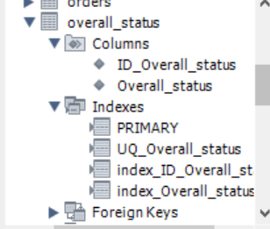
Общий статус маршрутного листа  (Overall_status) | Overall_status | Varchar(36) | Not null | уникален хранит значения: выполняется, завершён

- Сопровождение хранимых процедур:
  - Создание файла;

  - Набор тестовых сценариев для сопровождения хранимых процедур;
Таблица 2 – Сценарии тестирования
№ Сценария | Характеристики
 | Краткое описание теста
 | Ввод существующей страны производителя, с выводом сообщения об ошибке
 | Поля ввода
 | Название страны
 | Вводимые данные
 | Китай
 | Ожидаемый результат
 | Указанная страна уже есть в базе!
 | Краткое описание теста
 | Автоматическое формирование номера маршрутного листа
 | Поля ввода
 | Дата и время формирования, Код-ключ курьера, Код-ключ автомобиля, Код-ключ статуса
 | Вводимые данные
 | Дата и время: 01.03.2024 10:00:00, Курьер: Павлов Роман Дмитриевич, Автомобиль: KIA Rio О464ОР 77, Статус: Выполняется
 | Ожидаемый результат
 | Д-МЛ-24-0000000001
 | Краткое описание теста
 | Удаление существующего покупателя
 | Поля ввода
 | Код-ключ покупателя
 | Вводимые данные
 | Михаилов Валентин Олегович
 | Ожидаемый результат
 | Выбранного клиента невозможно удалить!
 | Краткое описание теста
 | Проверка сопоставления существующему товару вида сезона
 | Поля ввода
 | Код-ключ товара, Код-ключ сезона
 | Вводимые данные
 | Товар: SP/0000001, Сезон: Летний.
 | Ожидаемый результат
 | Указанный сезон уже есть у выбранного товара
 | Краткое описание теста
 | Автоматический перерасчёт стоимости заказа, при добавлении новой позиции товара.
 | Поля ввода
 | Код-ключ заказа, Код-ключ товара, количество товара
 | Вводимые данные
 | Заказ: ЗкП-000000002-23, Товар: SP/0000004, количество: 1
 | Ожидаемый результат
 | 18 863,98

  - Сопровождение и тестирование хранимых процедур;
Таблица 3 – Реализация хранимых процедур
№ Сценария | Скрипт | Результат | Статус тестирования
 | DROP PROCEDURE Manufacturing_country_Insert;  DELIMITER $$  CREATE PROCEDURE Manufacturing_country_Insert(IN p_Manufacturing_country_name VARCHAR(36))  BEGIN  DECLARE EXIT HANDLER FOR SQLEXCEPTION  BEGIN  -- Raise a notice about the duplicate entry  SELECT 'Указанная страна уже есть в базе!' AS notice;  END;  INSERT INTO Manufacturing_country (Manufacturing_country_name)  VALUES (p_Manufacturing_country_name);  END $$  DELIMITER ;  CALL Manufacturing_country_Insert('Китай'); | 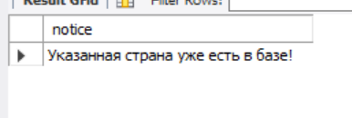 | Пройден
 | DELIMITER $$  CREATE PROCEDURE Itinerary_Insert (  p_Itinerary_date DATE,  p_Itinerary_time TIME,  p_Delivery_man_id INT,  p_Car_id INT,  p_Overall_status_id INT  )  BEGIN  DECLARE p_New_Number int;  DECLARE p_Year VARCHAR(2);  DECLARE p_Symb_Len INT;  DECLARE p_Loop_Max_Step INT;  DECLARE p_New_Text_Number VARCHAR(21) DEFAULT '';  DECLARE formatted_number VARCHAR(21);  SELECT COUNT(*) + 1 INTO p_New_Number FROM Itinerary;  SET p_Year = DATE_FORMAT(p_Itinerary_date, '%y');  SET p_Symb_Len = LENGTH(p_New_Number);  SET p_Loop_Max_Step = 10 - p_Symb_Len;  WHILE p_Loop_Max_Step > 0 DO  SET p_New_Text_Number = CONCAT(p_New_Text_Number, '0');  SET p_Loop_Max_Step = p_Loop_Max_Step - 1;  END WHILE;  SET formatted_number = CONCAT('Д-МЛ-', p_Year, '-', p_New_Text_Number, p_New_Number);  INSERT INTO Itinerary (Itinerary_number,  Itinerary_date,  Itinerary_time,  Delivery_man_id,  Car_id,  Overall_status_id)  VALUES (formatted_number, p_Itinerary_date, p_Itinerary_time, p_Delivery_man_id, p_Car_id, p_Overall_status_id);  END $$  DELIMITER ;  CALL Itinerary_Insert('2024-03-01', '10:00:00', 1, 1, 1); | 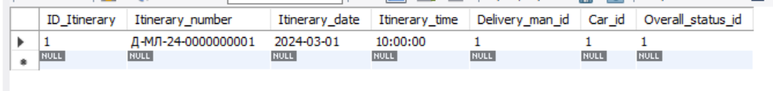
 | -- DROP PROCEDURE Customer_Delete;  DELIMITER $$  CREATE PROCEDURE Customer_Delete(IN p_ID_Customer INT)  BEGIN  DECLARE p_Exist_Client_order INT DEFAULT 0;  SELECT COUNT(*) INTO p_Exist_Client_order  FROM Client_order  WHERE Customer_id = p_ID_Customer;  IF p_Exist_Client_order > 0 THEN  SIGNAL SQLSTATE '45000'  SET MESSAGE_TEXT = 'Выбранного клиента невозможно удалить!';  ELSE  DELETE FROM Customer  WHERE ID_Customer = p_ID_Customer;  END IF;  END; $$  DELIMITER ;  CALL Customer_Delete(3); |  | Пройден
 | DROP PROCEDURE IF EXISTS Season_product_Insert;  DELIMITER $$  CREATE PROCEDURE Season_product_Insert(IN p_Product_id INT, IN p_Season_id INT)  BEGIN  DECLARE p_Exist_Season INT;  SELECT COUNT(*) INTO p_Exist_Season  FROM Season_product  WHERE Product_id = p_Product_id AND Season_id = p_Season_id;  IF (p_Exist_Season <> 0) THEN  SELECT 'Указанный сезон уже есть у выбранного товара!' AS message;  ELSE  INSERT INTO Season_product(Product_id, Season_id)  VALUES (p_Product_id, p_Season_id);  END IF;  END $$  DELIMITER ;  CALL Season_product_Insert(1, 1); | 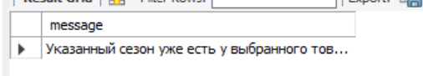 | Пройден
 | drop procedure products_in_customer_order_Insert;  DELIMITER $$  create procedure products_in_customer_order_Insert (IN p_Customer_order_id INT, IN p_Product_id INT, IN p_Product_amount INT)  begin  declare p_new_sum decimal(10,2);  INSERT INTO Products_in_customer_order (Customer_order_id, Product_id, Product_amount)  VALUES (p_Customer_order_id, p_Product_id, p_Product_amount);  select sum(Product_price*products_in_customer_order.Product_amount) into p_new_sum from product  inner join products_in_customer_order on id_product = product_id  where Customer_order_id = p_Customer_order_id;  update Client_order set  Client_order_sum = p_new_sum  where  ID_Client_order = p_Customer_order_id;  end $$  DELIMITER ;  select * from products_in_customer_order  where Customer_order_id = 5;  call products_in_customer_order_Insert(5, 4, 1);  select Client_order_sum from Client_order  where ID_Client_order = 5; | 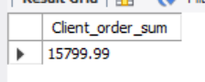 | Пройден

  - Создание не реализованных ранее хранимых процедур и дополнение процедур для верификации данных;
Таблица 4 – Реализация хранимых процедур

№ ПП | Скрипт | Результат
 | DROP PROCEDURE Request_Insert;  DELIMITER $$  CREATE PROCEDURE Request_Insert(  IN p_Request_number VARCHAR(12),  IN p_Request_date DATE,  IN p_Worker_id INT  )  BEGIN  IF p_Request_date < CURDATE() THEN  SIGNAL SQLSTATE '45000'  SET MESSAGE_TEXT = 'Дата создания учебной группы должна быть в настоящем времени!';  ELSE  INSERT INTO Request (Request_number, Request_date, Worker_id)  VALUES (p_Request_number, p_Request_date, p_Worker_id);  END IF;  END $$  DELIMITER ; | 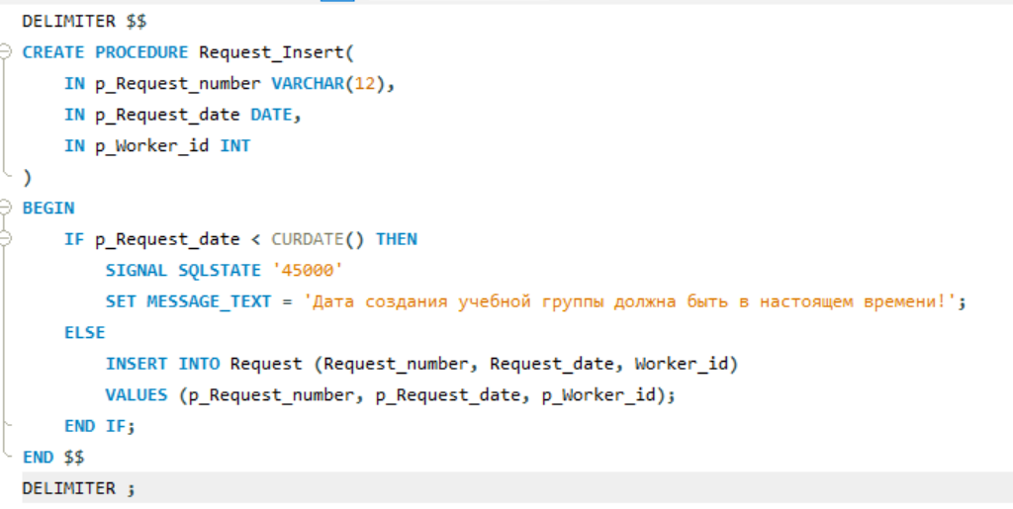
 | drop procedure Customer_Insert;  DELIMITER $$  CREATE PROCEDURE Customer_Insert(  IN p_Customer_surname VARCHAR(36),  IN p_Customer_name VARCHAR(36),  IN p_Customer_last_name VARCHAR(36),  IN p_Passport_series VARCHAR(5),  IN p_Passport_number VARCHAR(6),  IN p_Issue_data DATE,  IN p_Customer_phone_number VARCHAR(16),  IN p_Credit_card_info VARCHAR(19),  IN p_Cusomer_email VARCHAR(36),  IN p_Customer_login VARCHAR(36),  IN p_Customer_password VARCHAR(36)  )  BEGIN  DECLARE current_year INT;  SET current_year = YEAR(CURDATE());  IF TIMESTAMPDIFF(YEAR, p_Issue_data, CURDATE()) >= 14 THEN  INSERT INTO Customer(  Customer_surname,  Customer_name,  Customer_last_name,  Passport_series,  Passport_number,  Issue_data,  Customer_phone_number,  Credit_card_info,  Cusomer_email,  Customer_login,  Customer_password  ) VALUES (  p_Customer_surname,  p_Customer_name,  p_Customer_last_name,  p_Passport_series,  p_Passport_number,  p_Issue_data,  p_Customer_phone_number,  p_Credit_card_info,  p_Cusomer_email,  p_Customer_login,  p_Customer_password  );  ELSE  SIGNAL SQLSTATE '45000'  SET MESSAGE_TEXT = 'Дата выдачи паспорта, должна иметь разницу относительно текущей даты, не менее 14 лет!';  END IF;  END $$  DELIMITER ; | 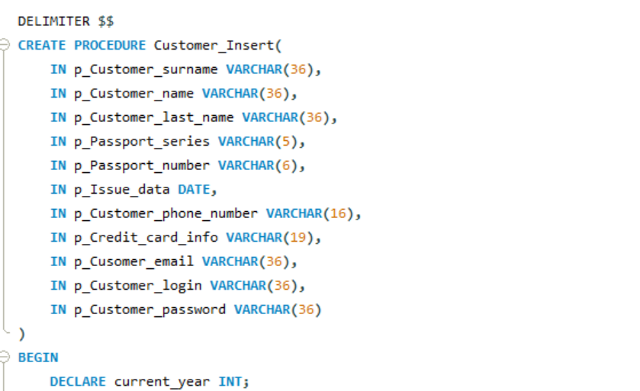  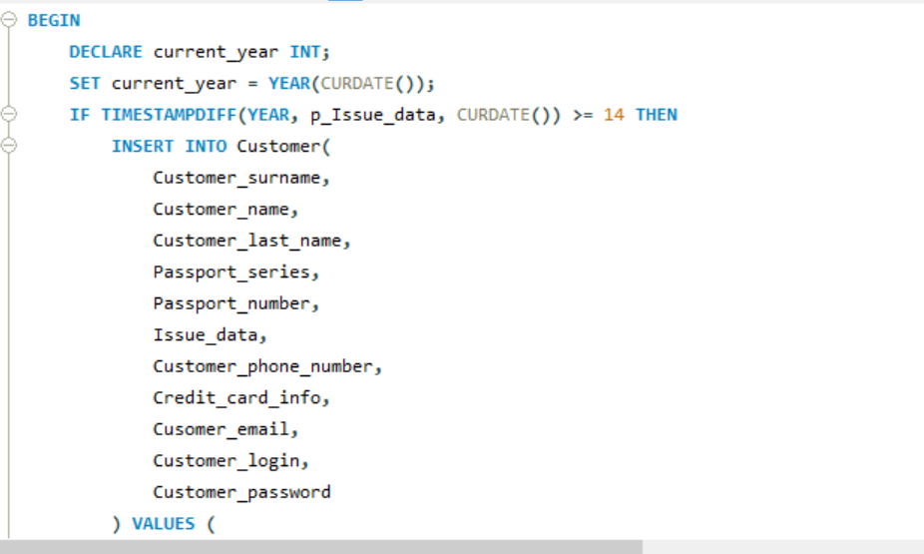  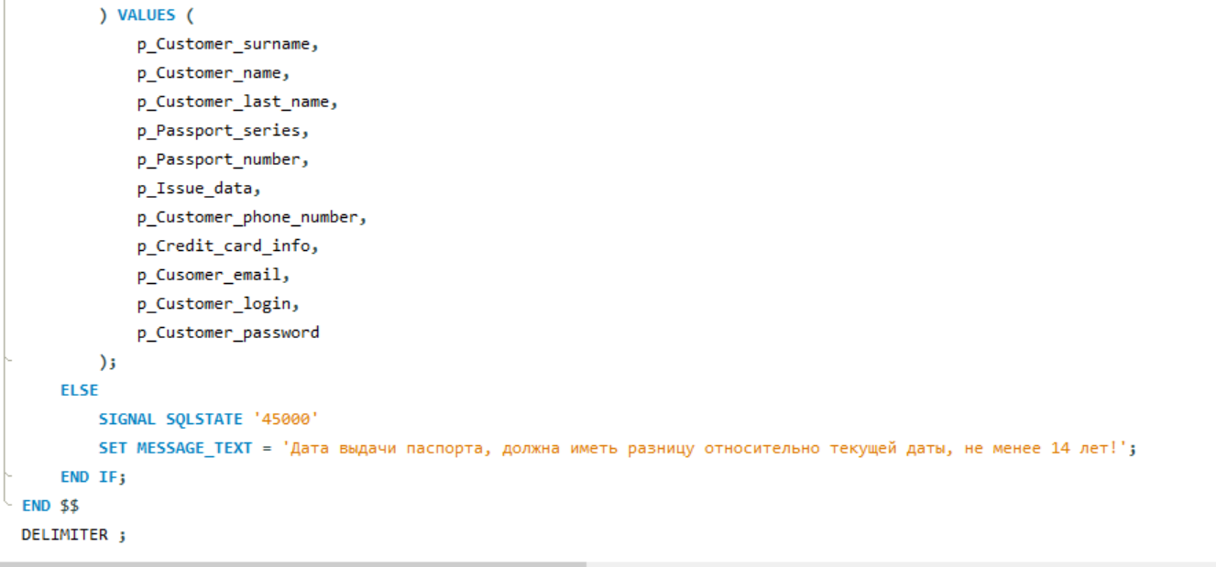
 | drop procedure Order_Insert;  DELIMITER $$  CREATE PROCEDURE Order_Insert (  IN p_Order_number VARCHAR(16),  IN p_Supplier_id INT,  IN p_Order_date DATE,  IN p_Order_time TIME,  IN p_Order_status_id INT,  IN p_Costs DECIMAL(10,2)  )  BEGIN  IF p_Order_date = CURDATE() AND p_Order_time = CURTIME() THEN  INSERT INTO Orders (Order_number, Supplier_id, Order_date, Order_time, Order_status_id, Costs)  VALUES (p_Order_number, p_Supplier_id, p_Order_date, p_Order_time, p_Order_status_id, p_Costs);  ELSE  SIGNAL SQLSTATE '45000' SET MESSAGE_TEXT = 'Дата заказа должна быть в настоящем времени!';  END IF;  END$$  DELIMITER ; | 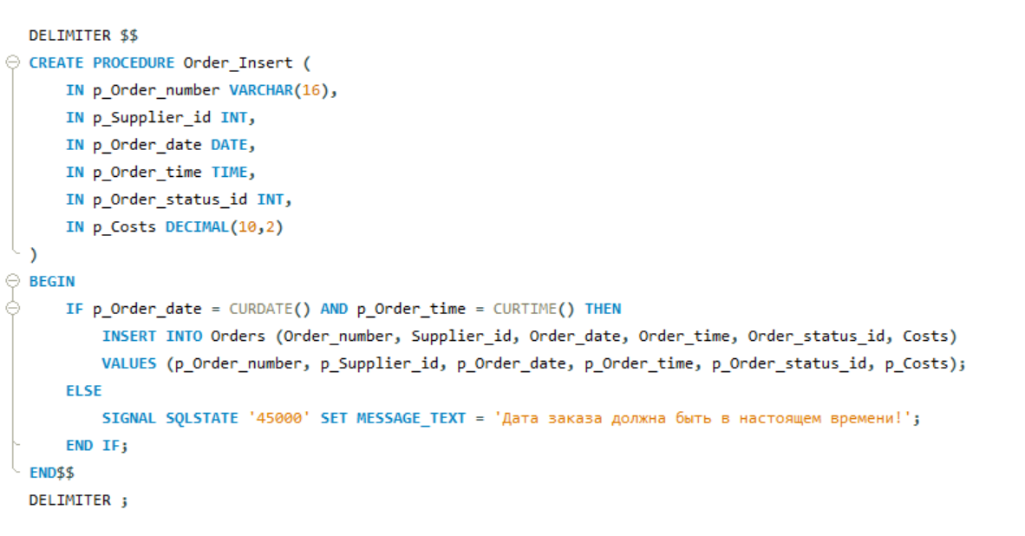
 | drop procedure Itinerary_Insert;  DELIMITER $$  CREATE PROCEDURE Itinerary_Insert(  IN p_Itinerary_date DATE,  IN p_Itinerary_time TIME,  IN p_Delivery_man_id INT,  IN p_Car_id INT,  IN p_Overall_status_id INT  )  BEGIN  DECLARE p_New_Number INT;  DECLARE p_Year INT;  DECLARE p_Symb_Len INT;  DECLARE p_Loop_Max_Step INT;  DECLARE p_New_Text_Number VARCHAR(21);  DECLARE p_cl_order_id INT;  DECLARE p_Form_data DATE;  SELECT COUNT(*) INTO p_New_Number FROM Itinerary;  SET p_New_Number = p_New_Number + 1;  SET p_Year = YEAR(p_Itinerary_date) % 100; -- Get the last two digits of the year  SET p_Symb_Len = LENGTH(p_New_Number);  SET p_Loop_Max_Step = 10 - p_Symb_Len;  SET p_New_Text_Number = '';  WHILE p_Loop_Max_Step > 0 DO  SET p_New_Text_Number = CONCAT(p_New_Text_Number, '0');  SET p_Loop_Max_Step = p_Loop_Max_Step - 1;  END WHILE;  SET p_New_Text_Number = CONCAT('Д-МЛ-', p_Year, '-', p_New_Text_Number, p_New_Number);  SELECT Client_order_id INTO p_cl_order_id FROM Client_order_in_itinerary ;  SELECT client_order_date INTO p_Form_data FROM Client_order WHERE id_client_order = p_cl_order_id;  IF p_Form_data > p_Itinerary_date THEN  SIGNAL SQLSTATE '45000' SET MESSAGE_TEXT = 'Дата заказа должна быть в настоящем времени!';  ELSE  INSERT INTO Itinerary (Itinerary_number, Itinerary_date, Itinerary_time, Delivery_man_id, Car_id, Overall_status_id)  VALUES (p_New_Text_Number, p_Itinerary_date, p_Itinerary_time, p_Delivery_man_id, p_Car_id, p_Overall_status_id);  END IF;  END $$  DELIMITER ; | 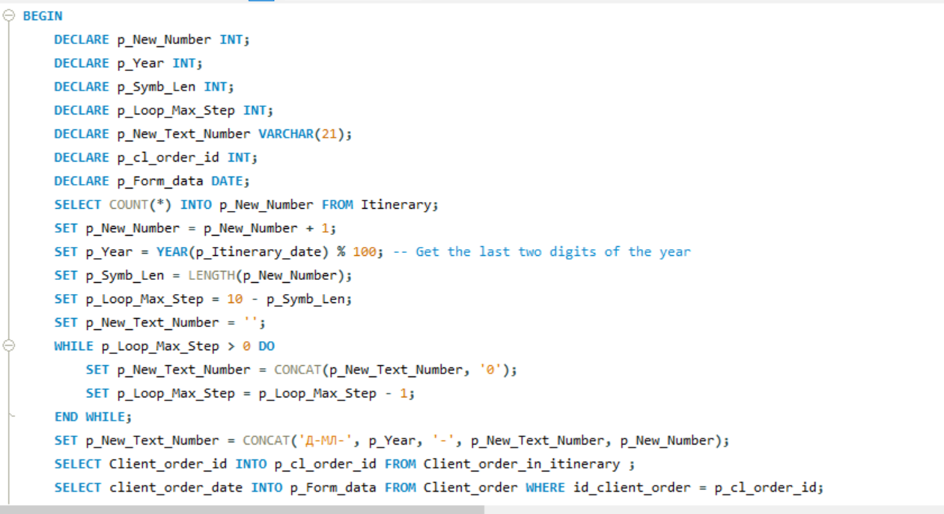  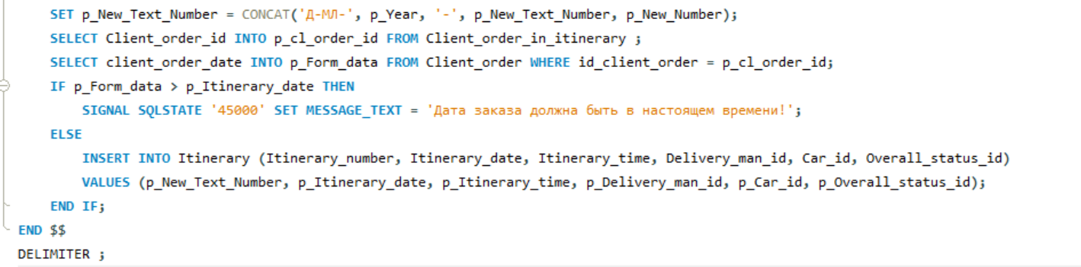
 | drop procedure Client_order_Insert;  DELIMITER $$  CREATE PROCEDURE Client_order_Insert(  IN p_Client_order_number VARCHAR(19),  IN p_Customer_id INT,  IN p_Client_order_date DATE,  IN p_Client_order_time TIME,  IN p_Client_order_sum DECIMAL(10,2),  IN p_Worker_id INT  )  BEGIN  IF (p_Client_order_date = CURDATE()) THEN  SIGNAL SQLSTATE '45000'  SET MESSAGE_TEXT = 'Дата создания заказа должна быть в будущем!';  ELSE  INSERT INTO Client_order(Client_order_number, Customer_id, Client_order_date, Client_order_time, Client_order_sum, Worker_id)  VALUES (p_Client_order_number, p_Customer_id, p_Client_order_date, p_Client_order_time, p_Client_order_sum, p_Worker_id);  END IF;  END $$  DELIMITER ; | 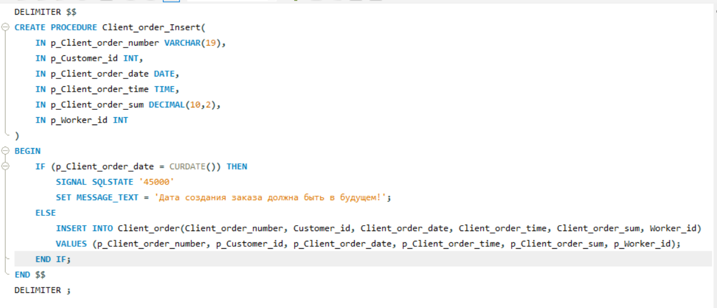
 | drop procedure Receipt_Insert;  DELIMITER $$  CREATE PROCEDURE Receipt_Insert (  IN p_Receipt_number VARCHAR(36),  IN p_Client_order_id INT,  IN p_Receipt_date DATE,  IN p_Receipt_time TIME,  IN p_Receipt_sum DECIMAL(10,2),  IN p_Receipt_change DECIMAL(10,2)  )  BEGIN  IF (p_Receipt_date = CURDATE() AND p_Receipt_time = CURTIME()) THEN  INSERT INTO Receipt  (Receipt_number, Client_order_id, Receipt_date, Receipt_time, Receipt_sum, Receipt_change)  VALUES  (p_Receipt_number, p_Client_order_id, p_Receipt_date, p_Receipt_time, p_Receipt_sum, p_Receipt_change);  ELSE  SIGNAL SQLSTATE '45000'  SET MESSAGE_TEXT = 'Дата создания чека должна быть в настоящем времени!';  END IF;  END$$  DELIMITER ; | 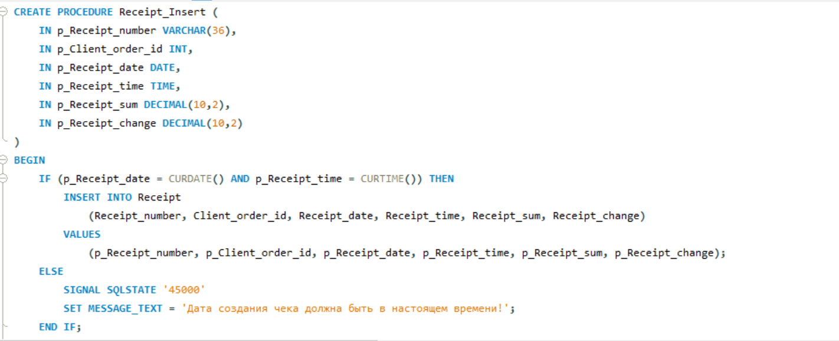
 | DELIMITER $$  CREATE PROCEDURE Deliv_order_status_Insert(IN p_Delivery_order_status VARCHAR(36))  BEGIN  DECLARE CONTINUE HANDLER FOR SQLEXCEPTION  BEGIN  SELECT 'Указанный статус уже есть!' AS message;  END;  INSERT INTO Deliv_order_status(Delivery_order_status)  VALUES (p_Delivery_order_status);  END $$  DELIMITER ; | 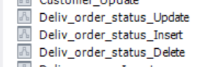
DELIMITER $$
CREATE PROCEDURE Deliv_order_status_Update(IN p_ID_Deliv_order_status INT, IN p_Delivery_order_status VARCHAR(36))
BEGIN
DECLARE CONTINUE HANDLER FOR SQLEXCEPTION
BEGIN
SELECT 'Указанный статус уже есть!' AS message;
END;
UPDATE Deliv_order_status
SET Delivery_order_status = p_Delivery_order_status
WHERE ID_Deliv_order_status = p_ID_Deliv_order_status;
END $$
DELIMITER ;
DELIMITER $$
CREATE PROCEDURE Deliv_order_status_Delete(IN p_ID_Deliv_order_status INT)
BEGIN
DECLARE p_Exist INT;
SELECT COUNT(*) INTO p_Exist
FROM Client_order_in_itinerary
WHERE Deliv_order_status_id = p_ID_Deliv_order_status;
IF p_Exist > 0 THEN
SELECT 'Выбранный тип удалить нельзя, есть созданная ID карта!' AS message;
ELSE
DELETE FROM Deliv_order_status
WHERE ID_Deliv_order_status = p_ID_Deliv_order_status;
END IF;
END $$
DELIMITER ;
 | DELIMITER $$  CREATE PROCEDURE Delivery_man_Insert(  IN p_Delivery_man_surname VARCHAR(36),  IN p_Delivery_man_name VARCHAR(36),  IN p_Delivery_man_second_name VARCHAR(36),  IN p_Delivery_man_phone VARCHAR(19)  )  BEGIN  INSERT INTO Delivery_man(Delivery_man_surname, Delivery_man_name, Delivery_man_second_name, Delivery_man_phone)  VALUES (p_Delivery_man_surname, p_Delivery_man_name, p_Delivery_man_second_name, p_Delivery_man_phone);  END $$  DELIMITER ; | 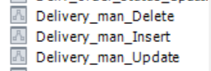
DELIMITER $$
CREATE PROCEDURE Delivery_man_Update(
IN p_ID_Delivery_man INT,
IN p_Delivery_man_surname VARCHAR(36),
IN p_Delivery_man_name VARCHAR(36),
IN p_Delivery_man_second_name VARCHAR(36),
IN p_Delivery_man_phone VARCHAR(19)
)
BEGIN
DECLARE EXIT HANDLER FOR SQLEXCEPTION
BEGIN
-- Handle exception and return a message or log it
SELECT 'Такой курьер уже есть!' AS message;
END;
UPDATE Delivery_man
SET
Delivery_man_surname = p_Delivery_man_surname,
Delivery_man_name = p_Delivery_man_name,
Delivery_man_second_name = p_Delivery_man_second_name,
Delivery_man_phone = p_Delivery_man_phone
WHERE
ID_Delivery_man = p_ID_Delivery_man;
END $$
DELIMITER ;
DELIMITER $$
CREATE PROCEDURE Delivery_man_Delete (
IN p_ID_Delivery_man INT
)
BEGIN
DECLARE p_Exist INT;
SELECT COUNT(*) INTO p_Exist
FROM Delivery_man
WHERE Delivery_man_id = p_ID_Delivery_man;
IF p_Exist > 0 THEN
SIGNAL SQLSTATE '45000' SET MESSAGE_TEXT = 'Selected Delivery man cannot be deleted!';
ELSE
DELETE FROM Delivery_man
WHERE ID_Delivery_man = p_ID_Delivery_man;
END IF;
END$$
DELIMITER ;
 | DELIMITER $$  CREATE PROCEDURE Car_Update(IN p_ID_Car INT, IN p_Car_model VARCHAR(36), IN p_Car_number VARCHAR(12))  BEGIN  DECLARE CONTINUE HANDLER FOR SQLEXCEPTION  BEGIN  SIGNAL SQLSTATE '45000'  SET MESSAGE_TEXT = 'Такой автомобиль уже есть!';  END;  UPDATE Car  SET Car_model = p_Car_model,  Car_number = p_Car_number  WHERE ID_Car = p_ID_Car;  END $$  DELIMITER ; | 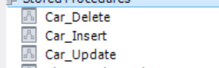
DELIMITER $$
CREATE PROCEDURE Car_Delete(IN p_ID_Car INT)
BEGIN
DECLARE p_Exist INT;
SELECT COUNT(*) INTO p_Exist FROM Itinerary WHERE Car_id = p_ID_Car;
IF p_Exist > 0 THEN
SIGNAL SQLSTATE '45000'
SET MESSAGE_TEXT = 'Выбранный автомобиль нельзя удалить, он есть в маршутном листе!';
ELSE
DELETE FROM Car WHERE ID_Car = p_ID_Car;
END IF;
END $$
DELIMITER ;
DELIMITER $$

CREATE PROCEDURE Car_Insert (
IN p_Car_model VARCHAR(36),
IN p_Car_number VARCHAR(12)
)
BEGIN
INSERT INTO Car (Car_model, Car_number)
VALUES (p_Car_model, p_Car_number);
END $$
DELIMITER ;
 | DELIMITER $$  CREATE PROCEDURE Itinerary_Update (  IN p_ID_Itinerary INT,  IN p_Itinerary_date DATE,  IN p_Itinerary_time TIME,  IN p_Delivery_man_id INT,  IN p_Car_id INT,  IN p_Overall_status_id INT  )  BEGIN  UPDATE Itinerary  SET  Itinerary_date = p_Itinerary_date,  Itinerary_time = p_Itinerary_time,  Delivery_man_id = p_Delivery_man_id,  Car_id = p_Car_id,  Overall_status_id = p_Overall_status_id  WHERE  ID_Itinerary = p_ID_Itinerary;  END$$  DELIMITER ; | 
DELIMITER $$
CREATE PROCEDURE Itinerary_Delete (
IN p_ID_Itinerary INT
)
BEGIN
DECLARE p_Exist INT;
SELECT COUNT(*) INTO p_Exist
FROM Client_order_in_itinerary
WHERE Itinerary_id = p_ID_Itinerary; -- Assuming you meant p_ID_Itinerary
IF p_Exist > 0 THEN
SIGNAL SQLSTATE '45000' SET MESSAGE_TEXT = 'Selected itinerary cannot be deleted!';
ELSE
DELETE FROM Itinerary
WHERE ID_Itinerary = p_ID_Itinerary; -- Assuming you meant ID_Itinerary
END IF;
END$$
DELIMITER ;
 | DELIMITER $$  CREATE PROCEDURE Overall_status_Insert(  IN p_Overall_status VARCHAR(36)  )  BEGIN  INSERT INTO Overall_status(Overall_status)  VALUES (p_Overall_status);  END $$  DELIMITER ; | 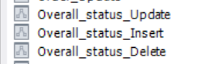
DELIMITER $$
CREATE PROCEDURE Overall_status_Update(IN p_ID_Overall_status INT, IN p_Overall_status VARCHAR(36))
BEGIN
DECLARE status_exists INT;
SELECT COUNT(*) INTO status_exists
FROM Overall_status
WHERE ID_Overall_status = p_ID_Overall_status;
IF status_exists > 0 THEN
UPDATE Overall_status
SET Overall_status = p_Overall_status
WHERE ID_Overall_status = p_ID_Overall_status;
ELSE
-- Notify that the status doesn't exist
SIGNAL SQLSTATE '45000' SET MESSAGE_TEXT = 'Такой статус уже есть!';
END IF;
END $$
DELIMITER ;
DELIMITER $$
CREATE PROCEDURE Overall_status_Delete(IN p_ID_Overall_status INT)
BEGIN
DECLARE p_Exist INT;
SELECT COUNT(*) INTO p_Exist
FROM Itinerary
WHERE Car_id = p_ID_Overall_status;
IF p_Exist > 0 THEN
SIGNAL SQLSTATE '45000' SET MESSAGE_TEXT = 'Выбранный статус нельзя удалить, он есть в маршутном листе!';
ELSE
DELETE FROM Overall_status
WHERE Overall_status_id = p_ID_Overall_status;
END IF;
END $$
DELIMITER ;
 | DELIMITER $$  CREATE PROCEDURE Client_order_in_itinerary_Insert (  IN p_Itinerary_id INT,  IN p_Client_order_id INT,  IN p_Packaging_time TIME,  IN p_Cl_order_to_curier_time TIME,  IN p_Order_on_way TIME,  IN p_Cl_order_to_client TIME,  IN p_Deliv_order_status_id INT  )  BEGIN  DECLARE p_Itinerary_time TIME;  SELECT Itinerary_time INTO p_Itinerary_time  FROM Itinerary  WHERE ID_itinerary = p_Itinerary_id;  IF p_Itinerary_time <= p_Packaging_time AND  p_Itinerary_time <= p_Cl_order_to_curier_time AND  p_Itinerary_time <= p_Order_on_way AND  p_Itinerary_time <= p_Cl_order_to_client THEN  INSERT INTO Client_order_in_itinerary (Itinerary_id, Client_order_id, Packaging_time, Cl_order_to_curier_time, Order_on_way, Cl_order_to_client, Deliv_order_status_id)  VALUES (p_Itinerary_id, p_Client_order_id, p_Packaging_time, p_Cl_order_to_curier_time, p_Order_on_way, p_Cl_order_to_client, p_Deliv_order_status_id);  ELSE  SIGNAL SQLSTATE '45000' SET MESSAGE_TEXT = 'Время действия над позицией не может быть раньше даты формирования общего маршрутного листа';  END IF;  END $$  DELIMITER ; | 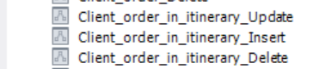
DELIMITER $$
CREATE PROCEDURE Client_order_in_itinerary_Update (
IN p_ID_Client_order_in_itinerary INT,
IN p_Itinerary_id INT,
IN p_Client_order_id INT,
IN p_Packaging_time TIME,
IN p_Cl_order_to_curier_time TIME,
IN p_Order_on_way TIME,
IN p_Cl_order_to_client TIME,
IN p_Deliv_order_status_id INT
)
BEGIN
UPDATE Client_order_in_itinerary
SET
Itinerary_id = p_Itinerary_id,
Client_order_id = p_Client_order_id,
Packaging_time = p_Packaging_time,
Cl_order_to_curier_time = p_Cl_order_to_curier_time,
Order_on_way = p_Order_on_way,
Cl_order_to_client = p_Cl_order_to_client,
Deliv_order_status_id = p_Deliv_order_status_id
WHERE ID_Client_order_in_itinerary = p_ID_Client_order_in_itinerary;
END $$
DELIMITER ;
DELIMITER $$
CREATE PROCEDURE Client_order_in_itinerary_Delete (
IN p_ID_Client_order_in_itinerary INT
)
BEGIN
DELETE FROM Client_order_in_itinerary
WHERE Client_order_in_itinerary_id = p_ID_Client_order_in_itinerary;
END $$
DELIMITER ;

- Распределение прав доступа к таблицам и хранимым процедурам БД;
Таблица 5 – Права доступа к таблицам и хранимым процедурам БД
Роли |  | Покупатель | Сотрудник | Поставщик | Администратор
Название объекта | Функции
Client_order_in_itinerary | Выборка | X | X |  | X
Client_order_in_itinerary | Добавление |  |  |  | X
Client_order_in_itinerary | Изменение |  |  |  | X
Client_order_in_itinerary | Удаление |  |  |  | X
Deliv_order_status | Выборка |  |  |  | X
Deliv_order_status | Добавление |  |  |  | X
Deliv_order_status | Изменение |  | X |  | X
Deliv_order_status | Удаление |  |  |  | X
Delivery_man | Выборка |  |  |  | X
Delivery_man | Добавление |  |  |  | X
Delivery_man | Изменение |  | X
Delivery_man | Удаление |  |  |  | X
Car | Выборка |  | X |  | X
Car | Добавление |  |  |  | X
Car | Изменение |  |  |  | X
Car | Удаление |  |  |  | X
Itinerary | Выборка |  | X |  | X
Itinerary | Добавление |  |  |  | X
Itinerary | Изменение |  | X
Itinerary | Удаление |  |  |  | X
Overall_status | Выборка | X | X |  | X
Overall_status | Добавление |  |  |  | X
Overall_status | Изменение |  | X |  | X
Overall_status | Удаление |  |  |  | X
Client_order_in_itinerary_Insert | Вызов |  |  |  | X
Client_order_in_itinerary_Update | Вызов |  |  |  | X
Client_order_in_itinerary_Delete | Вызов |  |  |  | X
Deliv_order_status_Insert | Вызов |  |  |  | X
Deliv_order_status_Update | Вызов |  |  |  | X
Deliv_order_status_Delete | Вызов |  |  |  | X
Delivery_man_Insert | Вызов |  |  |  | X
Delivery_man_Update | Вызов |  | X
Delivery_man_Delete | Вызов |  |  |  | X
Car_Insert | Вызов |  |  |  | X
Car_Update | Вызов |  |  |  | X
Car_Delete | Вызов |  |  |  | X
Itinerary_Insert | Вызов |  |  |  | X
Itinerary_Update | Вызов |  | X
Itinerary_Delete | Вызов |  |  |  | X
Overall_status_Insert | Вызов |  |  |  | X
Overall_status_Update | Вызов |  | X |  | X
Overall_status_Delete | Вызов |  |  |  | X

- Выдача прав доступа к таблицам и хранимым процедурам БД;
Таблица 6 – Реализация разграничения прав доступа
Название роли | Название объекта | Функция | Скрипт
‘rl_worker’@’127.0.0.1’ | Client_order_in_itinerary | Select | grant select on Client_order_in_itinerary to ‘rl_worker’@’127.0.0.1’;
‘rl_worker’@’127.0.0.1’ | Car | Select | grant select on Car to ‘rl_worker’@’127.0.0.1’;
‘rl_worker’@’127.0.0.1’ | Deliv_order_status | Update | grant update on Deliv_order_status to ‘rl_worker’@’127.0.0.1’;
‘rl_worker’@’127.0.0.1’ | Delivery_man | Update | grant update on Delivery_man to ‘rl_worker’@’127.0.0.1’;
‘rl_worker’@’127.0.0.1’ | Itinerary | Select, Update | grant select, update on Itinerary to ‘rl_worker’@’127.0.0.1’;
‘rl_worker’@’127.0.0.1’ | Overall_status | Select, Update | grant select, update on Overall_status to ‘rl_worker’@’127.0.0.1’;
‘rl_worker’@’127.0.0.1’ | Delivery_man_Update | Execute | grant execute on procedure Delivery_man_Update to ‘rl_worker’@’127.0.0.1’;
‘rl_worker’@’127.0.0.1’ | Itinerary_Update | Execute | grant execute on procedure Itinerary_Update to ‘rl_worker’@’127.0.0.1’;
‘rl_worker’@’127.0.0.1’ | Overall_status_Update | Execute | grant execute on procedure Overall_status_Update to ‘rl_worker’@’127.0.0.1’;
rl_customer | Discip_Skills | Select | grant select on Overall_status to 'rl_customer'@'127.0.0.1';
rl_administrator | Overall_status | Select, Insert, Update, Delete | GRANT SELECT, INSERT, UPDATE, DELETE ON Overall_status TO rl_administrator@'127.0.0.1';
rl_administrator | Car | Select, Insert, Update, Delete | GRANT SELECT, INSERT, UPDATE, DELETE ON Car TO 'rl_administrator'@'127.0.0.1';
rl_administrator | Client_order_in_itinerary | Select, Insert, Update, Delete | GRANT SELECT, INSERT, UPDATE, DELETE ON Client_order_in_itinerary TO 'rl_administrator'@'127.0.0.1';
rl_administrator | Deliv_order_status | Select, Insert, Update, Delete | GRANT SELECT, INSERT, UPDATE, DELETE ON Deliv_order_status TO 'rl_administrator'@'127.0.0.1';
rl_administrator | Itinerary | Select, Insert, Delete | GRANT SELECT, INSERT, DELETE ON Itinerary TO 'rl_administrator'@'127.0.0.1';
rl_administrator | Delivery_man | Select, Insert, Delete | GRANT SELECT, INSERT, DELETE ON Delivery_man TO 'rl_administrator'@'127.0.0.1';
rl_administrator | Client_order_in_itinerary_Insert | Execute | GRANT EXECUTE ON PROCEDURE Client_order_in_itinerary_Insert TO 'rl_administrator'@'127.0.0.1';
rl_administrator | Client_order_in_itinerary_Update | Execute | grant execute on procedure Client_order_in_itinerary_Update to ‘rl_administrator’@’127.0.0.1’;
rl_administrator | Client_order_in_itinerary_Delete | Execute | grant execute on procedure Client_order_in_itinerary_Delete to ‘rl_administrator’@’127.0.0.1’;
rl_administrator | Deliv_order_status_Insert | Execute | grant execute on procedure Deliv_order_status_Insert to ‘rl_administrator’@’127.0.0.1’;
rl_administrator | Deliv_order_status_Update | Execute | grant execute on procedure Deliv_order_status_Update to ‘rl_administrator’@’127.0.0.1’;
rl_administrator | Deliv_order_status_Delete | Execute | grant execute on procedure Deliv_order_status_Delete to ‘rl_administrator’@’127.0.0.1’;
rl_administrator | Delivery_man_Insert | Execute | grant execute on procedure Delivery_man_Insert to ‘rl_administrator’@’127.0.0.1’;
rl_administrator | Delivery_man_Delete | Execute | grant execute on procedure Delivery_man_Delete to ‘rl_administrator’@’127.0.0.1’;
rl_administrator | Car_Insert | Execute | grant execute on procedure Car_Insert to ‘rl_administrator’@’127.0.0.1’;
rl_administrator | Car_Update | Execute | grant execute on procedure Car_Update to ‘rl_administrator’@’127.0.0.1’;
rl_administrator | Car_Delete | Execute | grant execute on procedure Car_Delete to ‘rl_administrator’@’127.0.0.1’;
rl_administrator | Itinerary_Insert | Execute | grant execute on procedure Itinerary_Insert to ‘rl_administrator’@’127.0.0.1’;
rl_administrator | Itinerary_Delete | Execute | grant execute on procedure Itinerary_Delete to ‘rl_administrator’@’127.0.0.1’;
rl_administrator | Overall_status_Insert | Execute | grant execute on procedure Overall_status_Insert to ‘rl_administrator’@’127.0.0.1’;
rl_administrator | Overall_status_Update | Execute | grant execute on procedure Overall_status_Update to ‘rl_administrator’@’127.0.0.1’;
rl_administrator | Overall_status_Delete | Execute | grant execute on procedure Overall_status_Delete to ‘rl_administrator’@’127.0.0.1’;

- Создание резервной копии БД;
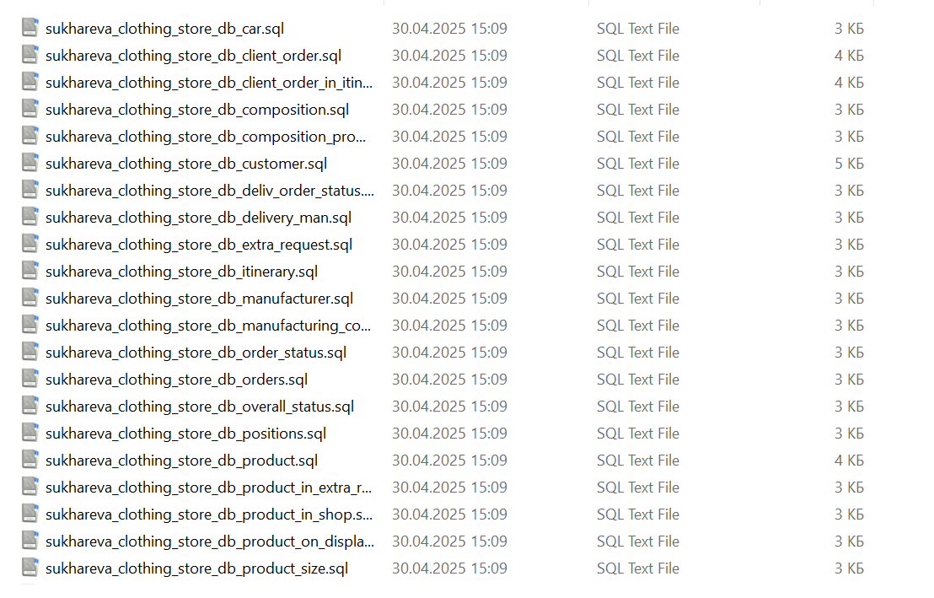
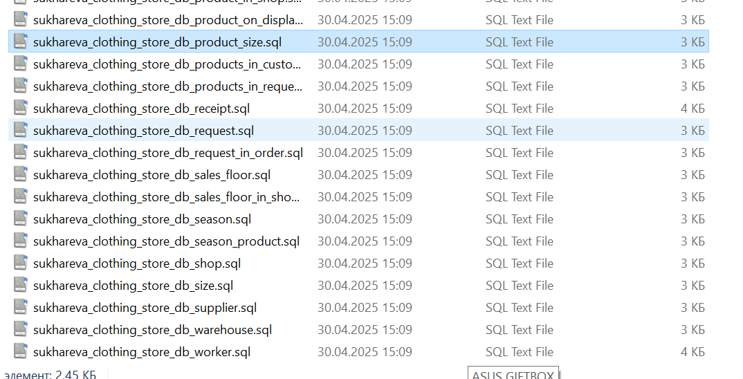

- Отчёт о созданных объектах.
Таблица 7 – Перечень созданных объектов
 | Информация по объектам
Запрос | select  information_schema.tables.table_name as "Название таблиц",  group_concat(distinct information_schema.columns.column_name) as "Столбцы",  group_concat(distinct information_schema.statistics.index_name) as "Индексы",  group_concat(distinct information_schema.routines.routine_name) as "Список процедур",  information_schema.tables.table_rows as "Кол-во записей в таблицах"  from information_schema.tables  inner join information_schema.columns  on information_schema.columns.table_name = information_schema.tables.table_name  inner join information_schema.statistics  on information_schema.tables.table_name = information_schema.statistics.table_name  inner join information_schema.routines  on information_schema.tables.table_name = substring(information_schema.routines.routine_name, 1, length(information_schema.tables.table_name))  where  information_schema.tables.table_schema = 'sukhareva_clothing_store_db' and  index_name <> 'PRIMARY'  group by  information_schema.tables.table_name,  table_rows  union all  select  (select  count(*)  from information_schema.tables  where  information_schema.tables.table_schema = 'sukhareva_clothing_store_db'),  (select  count(information_schema.columns.column_name)  from information_schema.tables  inner join information_schema.columns  on information_schema.columns.table_name = information_schema.tables.table_name  where  information_schema.tables.table_schema = 'sukhareva_clothing_store_db'),  (select  count(information_schema.statistics.index_name)  from information_schema.statistics  where  information_schema.statistics.table_schema = 'sukhareva_clothing_store_db' and  index_name <> 'PRIMARY'),  (select  count(information_schema.routines.routine_name) from information_schema.routines  where  routine_type = 'PROCEDURE' and  routine_name not in ('structure_create','structure_re_create')),  (select  sum(information_schema.tables.table_rows)  from information_schema.tables  where  information_schema.tables.table_schema = 'sukhareva_clothing_store_db');
Результат локальной БД
Результат удалённой БД

