ПРИЛОЖЕНИЕ 1

Этапы выполнения работы:
- Реализация хранимых процедур;
Таблица 1 – Хранимые процедуры
Таблица | Скрипт реализации | Результат
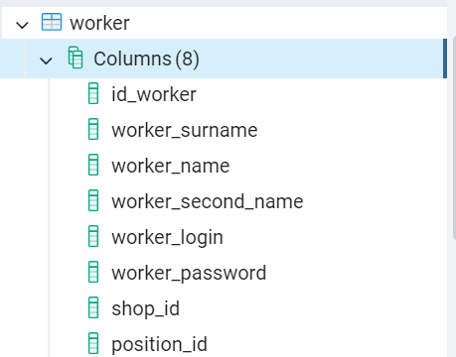 | Добавление | 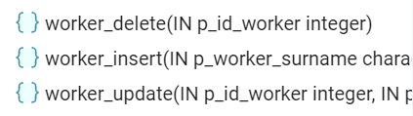
create or replace procedure Worker_Insert (p_worker_surname Varchar(36),
p_worker_name Varchar (36),
p_worker_second_name Varchar(36),
p_worker_login Varchar(36),
p_worker_password Varchar(36),
p_shop_id int,
p_position_id int
)
language plpgsql
as $$
begin
insert into Worker (worker_surname, worker_name, worker_second_name, worker_login, worker_password, shop_id, position_id )
Values (p_worker_surname, p_worker_name, p_worker_second_name, p_worker_login, p_worker_password, p_shop_id, p_position_id );
end;
$$;
 | Изменение
create or replace procedure Worker_Update (
p_id_worker int,
p_worker_surname Varchar(36),
p_worker_name Varchar (36),
p_worker_second_name Varchar(36),
p_worker_login Varchar(36),
p_worker_password Varchar(36),
p_shop_id int,
p_position_id int)

language plpgsql
as $$
begin
update Worker set
worker_surname = p_worker_surname,
worker_name = p_worker_name,
worker_second_name = p_worker_second_name,
worker_login = p_worker_login,
worker_password = p_worker_password,
shop_id = p_shop_id,
position_id = p_position_id

where
id_worker = p_id_worker;
end;
$$;
 | Удаление
create or replace procedure Worker_Delete (p_id_worker int)
language plpgsql
as $$
begin
delete from Worker
where
id_worker = p_id_worker;
end;
$$;
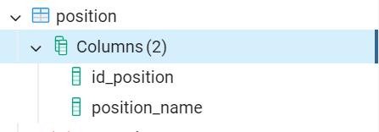 | Добавление | 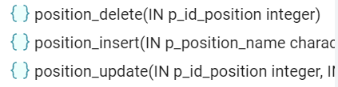
create or replace procedure Position_Insert (p_Position_name Varchar(36))
language plpgsql
as $$
begin
insert into Position (Position_name)
values (p_Position_name);
end;
$$;
 | Изменение
create or replace procedure Position_Update (p_ID_Position int, p_Position_name Varchar(36))
language plpgsql
as $$
begin
update Position set
Position_name = p_Position_name
where
ID_Position = p_ID_Position;
end;
$$;
 | Удаление
create or replace procedure Position_Delete (p_ID_Position int)
language plpgsql
as $$
begin
delete from Position
where
ID_Position = p_ID_Position;
end;
$$;
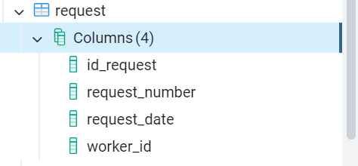 | Добавление | 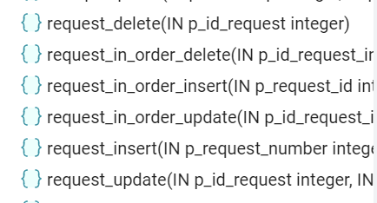
create or replace procedure Request_Insert (p__Request_number Int, p_Request_date Date, p_Worker_id Int)
language plpgsql
as $$
begin
insert into Discipline (Request_number, Request_date, Worker_id)
values (p__Request_number, p_Request_date, p_Worker_id);
end;
$$;
 | Изменение
create or replace procedure Request_Update (p_ID_Request Int, p_Request_number Int, p_Request_date Date, p_Worker_id Int)
language plpgsql
as $$
begin
update Request set
Request_number = p_Request_number,
Request_date = p_Request_date,
Worker_id = p_Worker_id

where
ID_Request = p_ID_Request;
end;
$$;
 | Удаление
create or replace procedure Request_Delete (p_ID_Request int)
language plpgsql
as $$
begin
delete from Request
where
ID_Request = p_ID_Request;
end;
$$;
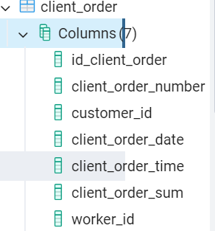 | Добавление | 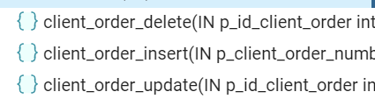
create or replace procedure Client_order_Insert(
p_Client_order_number Int,
p_Customer_id Int,
p_Client_order_date Date,
p_Client_order_time Time,
p_Client_order_sum Decimal(3,2),
p_Worker_id Int)
language plpgsql
as $$
begin
insert into Client_order(Client_order_number, Customer_id, Client_order_date, Client_order_time, Client_order_sum, Worker_id)
values (p_Client_order_number, p_Customer_id, p_Client_order_date, p_Client_order_time, p_Client_order_sum, p_Worker_id);
end;
$$;
 | Изменение
create or replace procedure Client_order_Update (
p_ID_Client_order Int,
p_Client_order_number Int,
p_Customer_id Int,
p_Client_order_date Date,
p_Client_order_time Time,
p_Client_order_sum Decimal(3,2),
p_Worker_id Int)
language plpgsql
as $$
begin
update Client_order set

Client_order_number = p_Client_order_number,
Customer_id = p_Customer_id,
Client_order_date = p_Client_order_date,
Client_order_time = p_Client_order_time,
Client_order_sum = p_Client_order_sum,
Worker_id = p_Worker_id
where
ID_Client_order = p_ID_Client_order;
end;
$$;
 | Удаление
create or replace procedure Client_order_Delete (p_ID_Client_order Int)
language plpgsql
as $$
begin
delete from Client_order
where
Client_order_id = p_Client_order;
end;
$$;
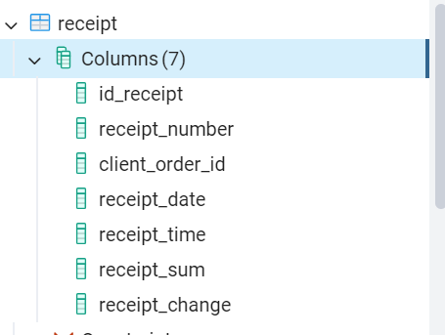 | Добавление | 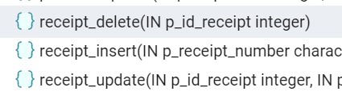
create or replace procedure Receipt_Insert (p_Receipt_number Varchar(36),
p_Client_order_id Int,
p_Receipt_date Date,
p_Receipt_time Time,
p_Receipt_sum Decimal(3,2),
p_Receipt_change Decimal(3,2)
)
language plpgsql
as $$
begin
insert into Receipt (Receipt_number, Client_order_id, Receipt_date, Receipt_time, Receipt_sum, Receipt_change)
values (p_Receipt_number, p_Client_order_id, p_Receipt_date, p_Receipt_time, p_Receipt_sum, p_Receipt_change
);
end;
$$;
 | Изменение
create or replace procedure Receipt_Update (
p_ID_Receipt Int,
p_Receipt_number Varchar(36),
p_Client_order_id Int,
p_Receipt_date Date,
p_Receipt_time Time,
p_Receipt_sum Decimal(3,2),
p_Receipt_change Decimal(3,2)
)

language plpgsql
as $$
begin
update Territory set
Receipt_number = p_Receipt_number,
Client_order_id = p_Client_order_id,
Receipt_date = p_Receipt_date,
Receipt_time = p_Receipt_time,
Receipt_sum = p_Receipt_sum,
Receipt_change = p_Receipt_change

where
ID_Receipt = p_ID_Receipt;
end;
$$;
 | Удаление
create or replace procedure Receipt_Delete (p_ID_Receipt Int)
language plpgsql
as $$
begin
delete from Receipt
where
ID_Receipt = p_ID_Receipt;
end;
$$;
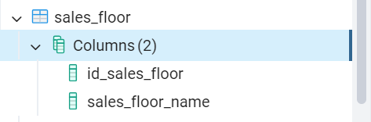 | Добавление | 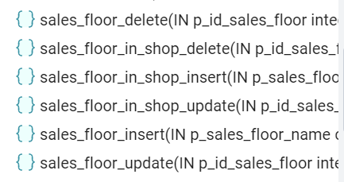
create or replace procedure Sales_floor_Insert (p_Sales_floor_name Varchar(36))
language plpgsql
as $$
begin
insert into Sales_floor (Sales_floor_name)
values (p_Sales_floor_name);
end;
$$;
 | Изменение
create or replace procedure Sales_floor_Update (p_ID_Sales_floor Int, p_Sales_floor_name Varchar(36))
language plpgsql
as $$
begin
update Sales_floor set
Sales_floor_name = p_Sales_floor_name
where
ID_Sales_floor = p_ID_Sales_floor;
end;
$$;
 | Удаление
create or replace procedure Sales_floor_Delete (p_ID_Sales_floor Int)
language plpgsql
as $$
begin
delete from Sales_floor
where
ID_Sales_floor = p_ID_Sales_floor;
end;
$$;
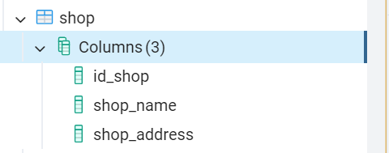 | Добавление | 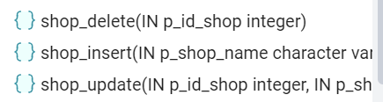
create or replace procedure Shop_Insert (p_Shop_name Varchar(36), p_Shop_address Varchar(36))
language plpgsql
as $$
begin
insert into Shop (Shop_name, Shop_address)
values (p_Shop_name, p_Shop_address);
end;
$$;

 | Изменение
create or replace procedure Shop_Update (p_ID_Shop Int, p_Shop_name Varchar(36), p_Shop_address Varchar(36))
language plpgsql
as $$
begin
update Shop set
Shop_name = p_Shop_name,
Shop_address = p_Shop_address
where
ID_Shop = p_ID_Shop;
end;
$$;
 | Удаление
create or replace procedure Shop_Delete (p_ID_Shop Int)
language plpgsql
as $$
begin
delete from Shop where
ID_Shop = p_ID_Shop;
end;
$$;
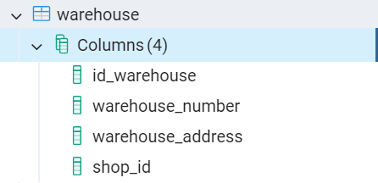 | Добавление | 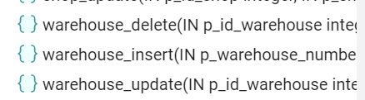
create or replace procedure Warehouse_Insert (p_Warehouse_number Varchar(4), p_Warehouse_address Varchar(36), p_Shop_id Int)
language plpgsql
as $$
begin
insert into Warehouse (Warehouse_number, Warehouse_address, Shop_id)
values (p_Warehouse_number, p_Warehouse_address, p_Shop_id);
end;
$$;
 | Изменение
create or replace procedure Warehouse_Update (p_ID_Warehouse Int, p_Warehouse_number Varchar(4), p_Warehouse_address Varchar(36), p_Shop_id Int)
language plpgsql
as $$
begin
update Warehouse set
Warehouse_number = p_Warehouse_number,
Warehouse_address = p_Warehouse_address,
Shop_id = p_Shop_id

where
ID_Warehouse = p_ID_Warehouse;
end;
$$;
 | Удаление
create or replace procedure Warehouse_Delete (p_ID_Warehouse int)
language plpgsql
as $$
begin
delete from Warehouse
where
ID_Warehouse = p_ID_Warehouse;
end;
$$;
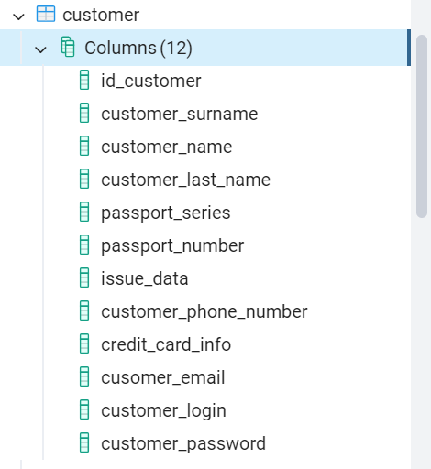 | Добавление | 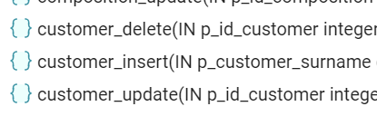
create or replace procedure Customer_Insert (p_Customer_surname Varchar(36),
p_Customer_name Varchar(36),
p_Customer_last_name Varchar(36),
p_Passport_series Varchar(5),
p_Passport_number Varchar(6),
p_Issue_data Date,
p_Customer_phone_number Varchar(16),
p_Credit_card_info Varchar(19),
p_Cusomer_email Varchar(36),
p_Customer_login Varchar(36),
p_Customer_password Varchar(36)
)
language plpgsql
as $$
begin
insert into Customer(Customer_surname, Customer_name, Customer_last_name, Passport_series, Passport_number, Issue_data, Customer_phone_number, Credit_card_info, Cusomer_email, Customer_login, Customer_password)
values (p_Customer_surname, p_Customer_name, p_Customer_last_name, p_Passport_series, p_Passport_number, p_Issue_data, p_Customer_phone_number, p_Credit_card, p_Cusomer_email, p_Customer_login, p_Customer_password);
end;
$$;
 | Изменение
create or replace procedure Customer_Update (
p_ID_Customer Int,
p_Customer_surname Varchar(36),
p_Customer_name Varchar(36),
p_Customer_last_name Varchar(36),
p_Passport_series Varchar(5),
p_Passport_number Varchar(6),
p_Issue_data Date,
p_Customer_phone_number Varchar(16),
p_Credit_card_info Int,
p_Cusomer_email Varchar(36),
p_Customer_login Varchar(36),
p_Customer_password Varchar(36)
)

language plpgsql
as $$
begin
update Customer set
Customer_surname = p_Customer_surname,
Customer_name = p_Customer_name,
Customer_last_name = p_Customer_last_name,
Passport_series = p_Passport_series,
Passport_number = p_Passport_number,
Issue_data = p_Issue_data,
Customer_phone_number = p_Customer_phone_number,
Credit_card_info = p_Credit_card_info,
Cusomer_email = p_Cusomer_email,
Customer_login = p_Customer_login,
Customer_password = p_Customer_password
where
ID_Customer = p_ID_Customer;
end;
$$;
 | Удаление
create or replace procedure Customer_Delete (p_ID_Customer Int)
language plpgsql
as $$
begin
delete from Customer
where
ID_Customer = p_ID_Customer;
end;
$$;
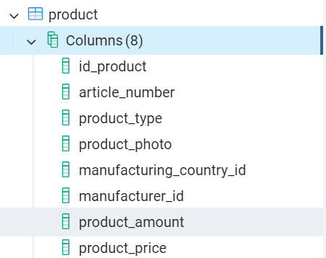 | Добавление | 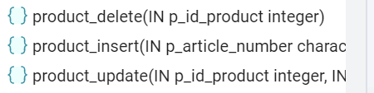
create or replace procedure Product_Insert (p_Article_number Varchar(10),
p_Product_type Varchar(36),
p_Product_photo Text,
p_Manufacturing_country_id Int,
p_Manufacturer_id Int,
p_Product_amount Int,
p_Product_price Decimal(3,2)
)
language plpgsql
as $$
begin
insert into Student (Article_number, Product_type, Product_photo, Manufacturing_country_id, Manufacturer_id, Product_amount, Product_price)
values (p_Article_number, p_Product_type, p_Product_photo, p_Manufacturing_country_id, p_Manufacturer_id, p_Product_amount, p_Product_price);
end;
$$;
 | Изменение
create or replace procedure Product_Update (
p_ID_Product Int,
p_Article_number Varchar(10),
p_Product_type Varchar(36),
p_Product_photo Text,
p_Manufacturing_country_id Int,
p_Manufacturer_id Int,
p_Product_amount Int,
p_Product_price Decimal(3,2)
)

language plpgsql
as $$
begin
update Student set
Article_number = p_Article_number,
Product_type = p_Product_type,
Product_photo = p_Product_photo,
Manufacturing_country_id = p_Manufacturing_country,
Manufacturer_id = p_Manufacturer_id,
Product_amount = p_Product_amount,
Product_price = p_Product_price where
ID_Product = p_ID_Product;
end;
$$;
 | Удаление
create or replace procedure Product_Delete (p_ID_Product Int)
language plpgsql
as $$
begin
delete from Product
where
ID_Product = p_ID_Product;
end;
$$;
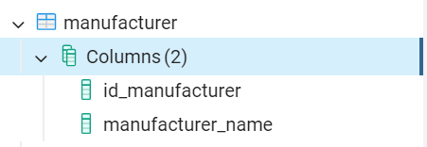 | Добавление | 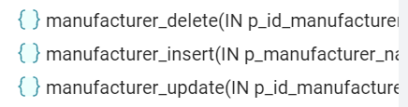
create or replace procedure Manufacturer_Insert (p_Manufacturer_name Varchar(36))
language plpgsql
as $$
begin
insert into Manufacturer (Manufacturer_name)
values (p p_Manufacturer_name);
end;
$$;
 | Изменение
create or replace procedure Manufacturer_Update (p_ID_Manufacturer Int, p_Manufacturer_name Varchar(36))
language plpgsql
as $$
begin
update Manufacturer set

Manufacturer_name = p_Manufacturer_name
where
ID_Manufacturer = p_ID_Manufacturer;
end;
$$;
 | Удаление
create or replace procedure Manufacturer_Delete (p_ID_Manufacturer Int)
language plpgsql
as $$
begin
delete from Manufacturer
where
ID_Manufacturer = p_ID_Manufacturer;
end;
$$;
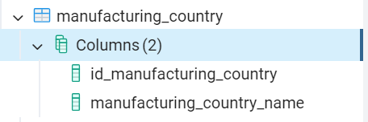 | Добавление | 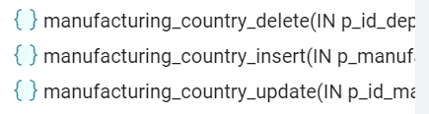
create or replace procedure Manufacturing_country_Insert (p_Manufacturing_country_name Varchar(36))
language plpgsql
as $$
begin
insert into Manufacturing_country
(Manufacturing_country_name )
values (p_Manufacturing_country_name );
end;
$$;
 | Изменение
create or replace procedure Manufacturing_country_Update (p_ID_Manufacturing_country Int, p_Manufacturing_country_name Varchar(36))
language plpgsql
as $$
begin
update Manufacturing_country set
Manufacturing_country_name = p_Manufacturing_country_name where
ID_Manufacturing_country = p_ID_Manufacturing_country;
end;
$$;
 | Удаление
create or replace procedure Manufacturing_country_Delete (p_ID_Dep_Discipl int)
language plpgsql
as $$
begin
delete from Manufacturing_country
where
ID_Manufacturing_country = p_ID_Manufacturing_country;
end;
$$;
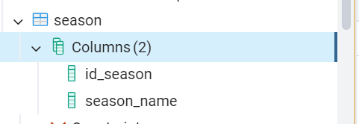 | Добавление | 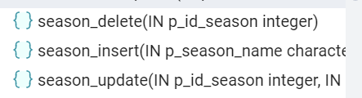
create or replace procedure Season_Insert (p_Season_name Varchar(36))
language plpgsql
as $$
begin
insert into Season (Season_name)
values (p_Season_name);
end;
$$;
 | Изменение
create or replace procedure Season_Update (p_ID_Season Int, p_Season_name Varchar(36))
language plpgsql
as $$
begin
update Season set
Season_name = p_Season_name
where
ID_Season = p_ID_Season;
end;
$$;
 | Удаление
create or replace procedure Season_Delete (p_ID_Season Int)
language plpgsql
as $$
begin
delete from Season
where
ID_Season = p_ID_Season ;
end;
$$;
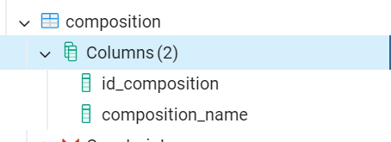 | Добавление | 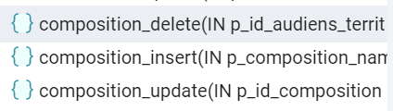
create or replace procedure Composition_Insert (p_Composition_name Varchar(36))
language plpgsql
as $$
begin
insert into Composition (Composition_name )
values (p_Composition_name );
end;
$$;
 | Изменение
create or replace procedure Composition_Update (p_ID_Composition Int, p_Composition_name Varchar(36))
language plpgsql
as $$
begin
update Composition set
Composition_name = p_Composition_name
where
ID_Composition = p_ID_Composition;
end;
$$;
 | Удаление
create or replace procedure Composition_Delete (p_ID_Audiens_Territ int)
language plpgsql
as $$
begin
delete from Composition
where
ID_Composition = p_ID_Composition;
end;
$$;
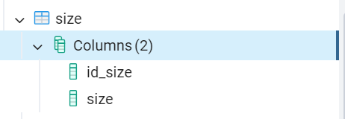 | Добавление | 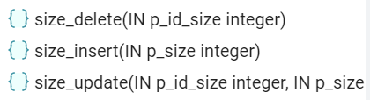
create or replace procedure Size_Insert (p_Size int)
language plpgsql
as $$
begin
insert into Size (Size)
values (p_Size);
end;
$$;
 | Изменение
create or replace procedure Size_Update (p_ID_Size int, p_Size int)
language plpgsql
as $$
begin
update Size set
Size = p_Size
where
ID_Size = p_ID_Size;
end;
$$;
 | Удаление
create or replace procedure Size_Delete (p_ID_Size int)
language plpgsql
as $$
begin
delete from Size
where
ID_Size = p_ID_Size;
end;
$$;
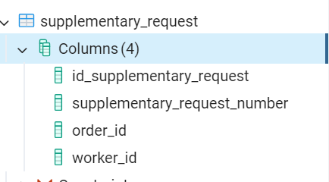 | Добавление | 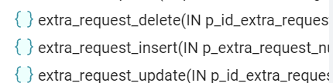
create or replace procedure Extra_request_Insert (p_Extra_request_number Int, p_Order_id Int, p_Worker_id Int)
language plpgsql
as $$
begin
insert into Extra_request (Extra_request_number, Order_id, Worker_id)
values (p_Extra_request_number, p_Order_id, p_Worker_id);
end;
$$;
 | Изменение
create or replace procedure Extra_request_Update (p_ID_Extra_request int, p_Extra_request_number Int, p_Order_id Int, p_Worker_id Int)
language plpgsql
as $$
begin
update Extra_request set
Extra_request_number = p_Extra_request_number,
Order_id = p_Order_id,
Worker_id = p_ Worker_id
where
ID_Extra_request = p_ID_Extra_request;
end;
$$;
 | Удаление
create or replace procedure Extra_request_Delete (p_ID_Extra_request int)
language plpgsql
as $$
begin
delete from Extra_request
where
ID_Extra_request = p_ID_Extra_request;
end;
$$;
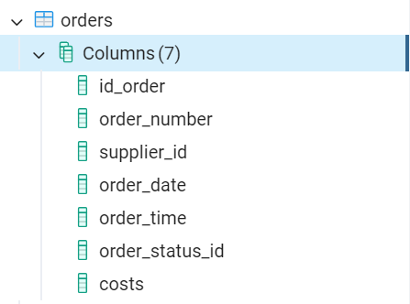 | Добавление | 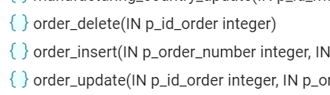
create or replace procedure Order_Insert (p_Order_number Int, p_Supplier_id Int, p_Order_date Date, p_Order_time Date, p_Order_status_id Int, p_Costs Decimal(3,2))
language plpgsql
as $$
begin
insert into Orders
(Order_number, Supplier_id, Order_date, Order_time, Order_status_id, Costs)
values (p_Order_number, p_Supplier_id, p_Order_date, p_Order_time, p_Order_status_id, p_Costs);
end;
$$;
 | Изменение
create or replace procedure Order_Update (p_ID_Order int, p_Order_number Int, p_Supplier_id Int, p_Order_date Date, p_Order_time Date, p_Order_status_id Int, p_Costs Decimal(3,2))
language plpgsql
as $$
begin
update Orders set
Order_number = p_Order_number,
Supplier_id = p_Supplier_id,
Order_date = p_Order_date,
Order_time = p_Order_time,
Order_status_id = p_Order_status_id,
Costs =p_Costs
where
ID_Order = p_ID_Order;
end;
$$;
 | Удаление
create or replace procedure Order_Delete (p_ID_Order int)
language plpgsql
as $$
begin
delete from Orders
where
ID_Order = p_ID_Order;
end;
$$;
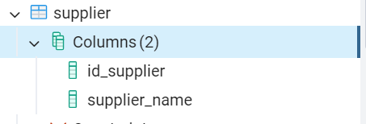 | Добавление | 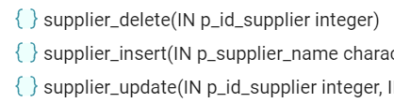
create or replace procedure Supplier_Insert (p_Supplier_name Varchar(36))
language plpgsql
as $$
begin
insert into Supplier
(Supplier_name)
values (p_Supplier_name);
end;
$$;
 | Изменение
create or replace procedure Supplier_Update (p_ID_Supplier int, p_Supplier_name Varchar(36) )
]language plpgsql
as $$
begin
update Supplier set
Supplier_name = p_Supplier_name where
ID_Supplier= p_ID_Supplier;
end;
$$;
 | Удаление
create or replace procedure Supplier_Delete (p_ID_Supplier int)
language plpgsql
as $$
begin
delete from Supplier
where
ID_Supplier = p_ID_Supplier;
end;
$$;
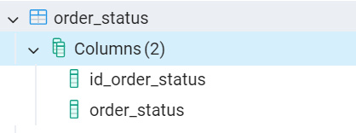 | Добавление | 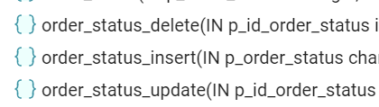
create or replace procedure Order_status_Insert (p_Order_status Varchar(36))
language plpgsql
as $$
begin
insert into Order_status
(Order_status )
values (p_Order_status);
end;
$$;
 | Изменение
create or replace procedure Order_status_Update (p_ID_Order_status int, p_Order_status Varchar(36))
language plpgsql
as $$
begin
update Order_status set
Order_status = p_Order_status
where
ID_Order_status = p_ID_Order_status;
end;
$$;
 | Удаление
create or replace procedure Order_status_Delete (p_ID_Order_status int)
language plpgsql
as $$
begin
delete from Order_status
where
ID_Order_status = p_ID_Order_status;
end;
$$;
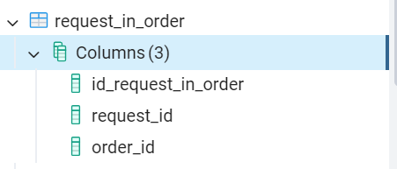 | Добавление | 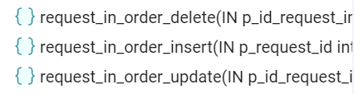
create or replace procedure Request_in_order_Insert (p_Request_id Int, p_Order_id Int)
language plpgsql
as $$
begin
insert into Request_in_order
((Request_id, Order_id))
values (p_Request_id, p_Order_id);
end;
$$;
 | Изменение
create or replace procedure Request_in_order_Update (p_ID_Request_in_order int, p_Request_id Int, p_Order_id Int)
language plpgsql
as $$
begin
update Request_in_order set
Request_id = p_Request_id,
Order_id = p_Order_id
where ID_Request_in_order = p_ID_Request_in_order;
end;
$$;
 | Удаление
create or replace procedure Request_in_order_Delete (p_ID_Request_in_order int)
language plpgsql
as $$
begin
delete from Request_in_order
where
ID_Request_in_order = p_ID_Request_in_order;
end;
$$;
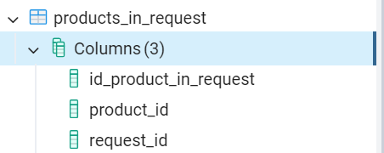 | Добавление | 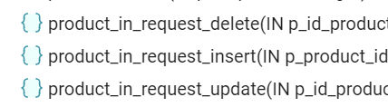
create or replace procedure Product_in_request_Insert (p_Product_id Int, p_Request_id Int)
language plpgsql
as $$
begin
insert into Product_in_request
(Product_id, Request_id)
values (p_Product_id, p_Request_id);
end;
$$;
 | Изменение
create or replace procedure Product_in_request_Update (p_ID_Product_in_request int, p_Product_id Int, p_Request_id Int)
language plpgsql
as $$
begin
update Product_in_request set
Product_id = p_Product_id,
Request_id = p_Request_id where
ID_Product_in_request = p_ID_Product_in_request;
end;
$$;
 | Удаление
create or replace procedure Product_in_request_Delete (p_ID_Product_in_request int)
language plpgsql
as $$
begin
delete from Product_in_request
where
ID_Product_in_request = p_ID_Product_in_request;
end;
$$;
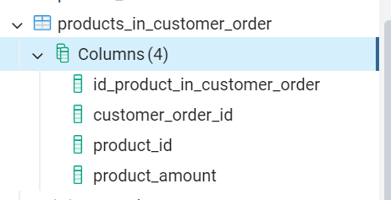 | Добавление | 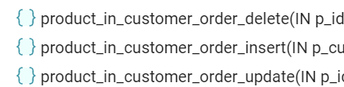
create or replace procedure Product_in_customer_order_Insert
(p_Customer_order_id Int, p_Product_id Int, p_Product_amount Int)
language plpgsql
as $$
begin
insert into Product_in_customer_order
(Customer_order_id, Product_id, Product_amount)
values (p_Customer_order_id, p_Product_id, p_Product_amount);
end;
$$;
 | Изменение
create or replace procedure Product_in_customer_order_Update (p_ID_Product_in_customer_order int, p_Customer_order_id Int, p_Product_id Int, p_Product_amount Int)
language plpgsql
as $$
begin
update Product_in_customer_order set
Customer_order_id = p_Customer_order_id,
Product_id = p_Product_id,
Product_amount = p_Product_amount where
ID_Product_in_customer_order = p_ID_Product_in_customer_order;
end;
$$;
 | Удаление
create or replace procedure Product_in_customer_order_Delete (p_ID_Product_in_customer_order int)
language plpgsql
as $$
begin
delete from Product_in_customer_order
where
ID_Product_in_customer_order = p_ID_Product_in_customer_order;
end;
$$;
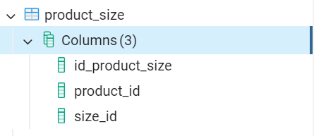 | Добавление | 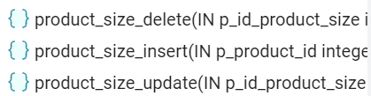
create or replace procedure Product_size_Insert (p_Product_id Int, p_Size_id Int)
language plpgsql
as $$
begin
insert into Product_size
((Product_id, Size_id))
values (p_Product_id, p_Size_id);
end;
$$;
 | Изменение
create or replace procedure Product_size_Update (p_ID_Product_size Int, p_Product_id Int, p_Size_id Int)
language plpgsql
as $$
begin
update Product_size set
Product_id = p_Product_id,
Size_id = p_Size_id where
ID_Product_size = p_ID_Product_size;
end;
$$;
 | Удаление
create or replace procedure Product_size_Delete (p_ID_Product_size int)
language plpgsql
as $$
begin
delete from Product_size
where
ID_Product_size = p_ID_Product_size;
end;
$$;
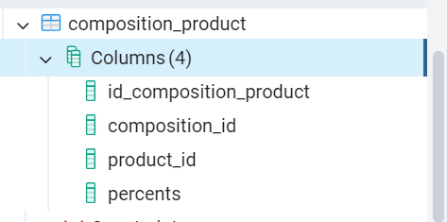 | Добавление | 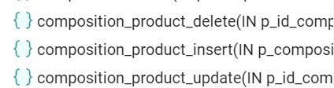
create or replace procedure Composition_product_Insert (p_Product_id Int, p_Composition_id Int, p_Percents Int)
language plpgsql
as $$
begin
insert into Composition_product
(Product_id, Composition_id, Percents )
values (p_Product_id, p_Composition_id, p_Percents);
end;
$$;
 | Изменение
create or replace procedure Composition_product_Update (p_ID_Composition_product Int, p_Product_id Int, p_Composition_id Int, p_Percents Int)
language plpgsql
as $$
begin
update Composition_product set

Product_id = p_Product_id
Composition_id = p_Composition_id,
Percents = p_Percents where
ID_Composition_product = p_ID_Composition_product;
end;
$$;
 | Удаление
create or replace procedure Composition_product_Delete (p_ID_Composition_product int)
language plpgsql
as $$
begin
delete from Composition_product
where
ID_Composition_product = p_ID_Composition_product;
end;
$$;
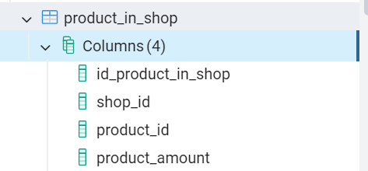 | Добавление | 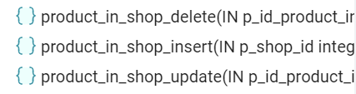
create or replace procedure Product_in_shop_Insert (p_Shop_id Int, p_Product_id Int, p_Product_amount Int)
language plpgsql
as $$
begin
insert into Product_in_shop
(Shop_id, Product_id, Product_amount)
values (p_Shop_id, p_Product_id, p_Product_amount);
end;
$$;
 | Изменение
create or replace procedure Product_in_shop_Update (p_ID_Product_in_shop int, p_Shop_id Int, p_Product_id Int, p_Product_amount Int)
language plpgsql
as $$
begin
update Product_in_shop set

Shop_id = p_Shop_id,
Product_id = p_Product_id,
Product_amount = p_Product_amount where
ID_Product_in_shop = p_ID_Product_in_shop;
end;
$$;
 | Удаление
create or replace procedure Product_in_shop_Delete (p_ID_Product_in_shop int)
language plpgsql
as $$
begin
delete from Product_in_shop
where
ID_Product_in_shop = p_ID_Product_in_shop;
end;
$$;
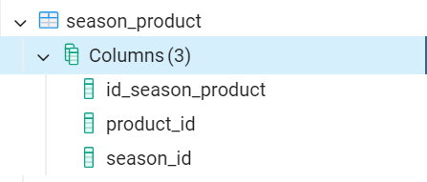 | Добавление | 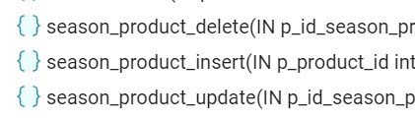
create or replace procedure Season_product_Insert (p_Product_id Int, p_Season_id Int)
language plpgsql
as $$
begin
insert into Season_product
(Product_id, Season_id)
values (p_Product_id, p_Season_id);
end;
$$;
 | Изменение
create or replace procedure Season_product_Update (p_ID_Season_product int, p_Product_id Int, p_Season_id Int)
language plpgsql
as $$
begin
update Season_product set

Product_id = p_Product_id,
Season_id = p_Season_id where
ID_Season_product = p_ID_Season_product;
end;
$$;
 | Удаление
create or replace procedure Season_product_Delete (p_ID_Season_product int)
language plpgsql
as $$
begin
delete from Season_product
where
ID_Season_product = p_ID_Season_product;
end;
$$;
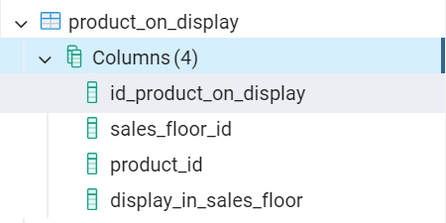 | Добавление | 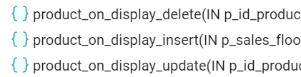
create or replace procedure Product_on_display_Insert (p_Sales_floor_id Int, p_Product_id Int, p_Display_in_sales_floor Int)
language plpgsql
as $$
begin
insert into Product_on_display
(Sales_floor_id, Product_id, Display_in_sales_floor)
values (p_Sales_floor_id, p_Product_id, p_Display_in_sales_floor);
end;
$$;
 | Изменение
create or replace procedure Product_on_display_Update (p_ID_Product_on_display int, p_Sales_floor_id Int, p_Product_id Int, p_Display_in_sales_floor Int)
language plpgsql
as $$
begin
update Product_on_display set
Sales_floor_id = p_Sales_floor_id,
Product_id = p_Product_id,
Display_in_sales_floor = p_Display_in_sales_floor where
ID_Product_on_display = p_ID_Product_on_display;
end;
$$;
 | Удаление
create or replace procedure Product_on_display_Delete (p_ID_Product_on_display int)
language plpgsql
as $$
begin
delete from Product_on_display
where
ID_Product_on_display = p_ID_Product_on_display;
end;
$$;
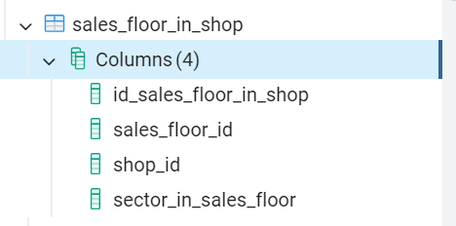 | Добавление | 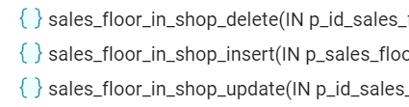
create or replace procedure Sales_floor_in_shop_Insert (p_Sales_floor_id Int, p_Shop_id Int, p_Sector_in_sales_floor Int)
language plpgsql
as $$
begin
insert into Sales_floor_in_shop
(Sales_floor_id, Shop_id, Sector_in_sales_floor)
values (p_Sales_floor_id, p_Shop_id, p_Sector_in_sales_floor);
end;
$$;
 | Изменение
create or replace procedure Sales_floor_in_shop_Update (p_ID_Sales_floor_in_shop int, p_Sales_floor_id Int, p_Shop_id Int, p_Sector_in_sales_floor Int)
language plpgsql
as $$
begin
update Sales_floor_in_shop set

Sales_floor_id = p_Sales_floor_id,
Shop_id = p_Shop_id,
Sector_in_sales_floor = p_Sector_in_sales_floor
where
ID_Sales_floor_in_shop = p_ID_Sales_floor_in_shop;
end;
$$;
 | Удаление
create or replace procedure Sales_floor_in_shop_Delete (p_ID_Sales_floor_in_shop int)
language plpgsql
as $$
begin
delete from Sales_floor_in_shop
where
ID_Sales_floor_in_shop = p_ID_Sales_floor_in_shop;
end;
$$;
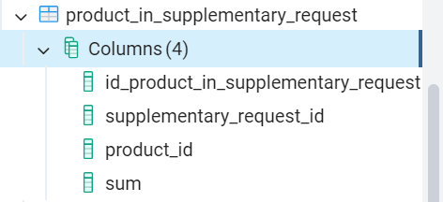 | Добавление | 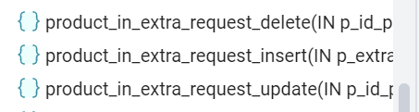
create or replace procedure Product_in_extra_request_Insert (p_Extra_request_id Int, p_Product_id Int, p_Sum Decimal(12, 2))
language plpgsql
as $$
begin
insert into Product_in_extra_request
(Extra_request_id, Product_id, Sum)
values (p_Extra_request_id, p_Product_id, p_Sum);
end;
$$;
 | Изменение
create or replace procedure Product_in_extra_request_Update (p_ID_Product_in_extra_request int, p_Extra_request_id Int, p_Product_id Int, p_Sum Decimal(12, 2)
language plpgsql
as $$
begin
update Product_in_extra_request set

Extra_request_id = p_Extra_request_id,
Product_id = p_Product_id,
Sumoor = p_Sum where
ID_Product_in_extra_request = p_ID_Product_in_extra_request;
end;
$$;
 | Удаление
create or replace procedure Product_in_extra_request_Delete (p_ID_Product_in_extra_request int)
language plpgsql
as $$
begin
delete from Product_in_extra_request where
ID_Product_in_extra_request = p_ID_Product_in_extra_request;
end;
$$;

- Распределение прав доступа к хранимым процедурам БД;
Таблица 2 – Права доступа к хранимым процедурам БД
Роли |  | Покупатель | Сотрудник | Поставщик | Администратор
Название объекта | Функции
worker_insert | Вызов |  |  |  | X
worker_update | Вызов |  | X
worker_delete | Вызов |  |  |  | X
position_update | Вызов |  |  |  | X
position_insert | Вызов |  |  |  | X
position_delete | Вызов |  |  |  | X
request_update | Вызов |  | X |  | X
request_insert | Вызов |  | X
request_delete | Вызов |  | X |  | X
client_order_update | Вызов | X
client_order_insert | Вызов | X
client_order_delete | Вызов | X |  |  | X
receipt_update | Вызов |  |  |  | X
receipt_insert | Вызов |  |  |  | X
receipt_delete | Вызов |  |  |  | X
sales_floor_update | Вызов |  |  |  | X
sales_floor_insert | Вызов |  |  |  | X
sales_floor_delete | Вызов |  |  |  | X
shop_update | Вызов |  |  |  | X
shop_insert | Вызов |  |  |  | X
shop_delete | Вызов |  |  |  | X
warehouse_update | Вызов |  |  |  | X
warehouse_insert | Вызов |  |  |  | X
warehouse_delete | Вызов |  |  |  | X
customer_update | Вызов | X
customer_insert | Вызов | X | X
customer_delete | Вызов | X |  |  | X
product_update | Вызов |  | X | X | X
product_insert | Вызов |  | X |  | X
product_delete | Вызов |  | X |  | X
manufacturer_update | Вызов |  |  | X
manufacturer_insert | Вызов |  |  | X
manufacturer_delete | Вызов |  |  | X
manufacturing_country_update | Вызов |  |  | X
manufacturing_country_insert | Вызов |  |  | X
manufacturing_country_delete | Вызов |  |  | X
season_update | Вызов |  |  | X
season_insert | Вызов |  |  | X
season_delete | Вызов |  |  | X
composition_update | Вызов |  |  | X
composition_insert | Вызов |  |  | X
composition_delete | Вызов |  |  | X
size_update | Вызов |  |  | X
size_insert | Вызов |  |  | X
size_delete | Вызов |  |  | X
extra_request_update | Вызов |  | X |  | X
extra_request_insert | Вызов |  | X |  | X
extra_request_delete | Вызов |  | X |  | X
order_update | Вызов |  | X |  | X
order_insert | Вызов |  | X |  | X
order_delete | Вызов |  | X |  | X
supplier_update | Вызов |  |  | X | X
supplier_insert | Вызов |  |  |  | X
supplier_delete | Вызов |  |  |  | X
order_status_update | Вызов |  | X | X | X
order_status_insert | Вызов |  |  | X
order_status_delete | Вызов |  |  | X
request_in_order_update | Вызов |  | X |  | X
request_in_order_insert | Вызов |  | X |  | X
request_in_order_delete | Вызов |  | X |  | X
product_in_customer_  order_update | Вызов | X
product_in_customer_order _insert | Вызов | X
product_in_customer_order _delete | Вызов | X
product_size_update | Вызов |  |  | X
product_size_insert | Вызов |  |  | X
product_size_delete | Вызов |  |  | X
composition_product_update | Вызов |  |  | X
composition_product_insert | Вызов |  |  | X
composition_product_delete | Вызов |  |  | X
product_in_shop_update | Вызов |  | X |  | X
product_in_shop_insert | Вызов |  | X |  | X
product_in_shop_delete | Вызов |  | X |  | X
season_product_update | Вызов |  |  | X
season_product_insert | Вызов |  |  | X
season_product_delete | Вызов |  |  | X
product_on_display_update | Вызов |  | X |  | X
product_on_display_insert | Вызов |  | X |  | X
product_on_display_delete | Вызов |  | X |  | X
sales_floor_in_shop_update | Вызов |  |  |  | X
sales_floor_in_shop_insert | Вызов |  |  |  | X
sales_floor_in_shop_delete | Вызов |  |  |  | X
product_in_extra_request_update | Вызов |  | X |  | X
product_in_extra_request_insert | Вызов |  | X |  | X
product_in_extra_request_delete | Вызов |  | X |  | X
Точь-в-толь ли оно должно быть с распределением ролей в кт 3?

- Выдача прав доступа к хранимым процедурам БД.
Таблица 3 – Реализация разграничения прав доступа
Название роли | Название объекта | Функция | Скрипт
rl_customer | client_order_update | Execute | grant execute on procedure client_order_update to rl_customer;
rl_customer | client_order_insert | Execute | grant execute on procedure client_order_insert to rl_customer;
rl_customer | client_order_delete | Execute | grant execute on procedure client_order_delete to rl_customer;
rl_customer | customer_update | Execute | grant execute on procedure customer_update to rl_customer;
rl_customer | customer_insert | Execute | grant execute on procedure customer_insert to rl_customer;
rl_customer | customer_delete | Execute | grant execute on procedure customer_delete to rl_customer;
rl_customer | product_in_customer_order_update | Execute | grant execute on procedure product_in_customer_order_update to rl_customer;
rl_customer | product_in_customer_order_insert | Execute | grant execute on procedure product_in_customer_order_insert to rl_customer;
rl_customer | product_in_customer_order_delete | Execute | grant execute on procedure product_in_customer_order_delete to rl_customer;
rl_worker | worker_update | Execute | grant execute on procedure worker_update to rl_worker;
rl_worker | request_update | Execute | grant execute on procedure request_update to rl_worker;
rl_worker | request_insert | Execute | grant execute on procedure request_insert to rl_worker;
rl_worker | request_delete | Execute | grant execute on procedure request_delete to rl_worker;
rl_worker | customer_insert | Execute | grant execute on procedure customer_insert to rl_worker;
rl_worker | product_update | Execute | grant execute on procedure product_update to rl_worker;
rl_worker | product_insert | Execute | grant execute on procedure product_insert to rl_worker;
rl_worker | product_delete | Execute | grant execute on procedure product_delete to rl_worker;
rl_worker | extra_request_update | Execute | grant execute on procedure extra_request_update to rl_worker;
rl_worker | extra_request_insert | Execute | grant execute on procedure extra_request_insert to rl_worker;
rl_worker | extra_request_delete | Execute | grant execute on procedure extra_request_delete to rl_worker;
rl_worker | order_update | Execute | grant execute on procedure order_update to rl_worker;
rl_worker | order_insert | Execute | grant execute on procedure order_insert to rl_worker;
rl_worker | order_delete | Execute | grant execute on procedure order_delete to rl_worker;
rl_worker | order_status_update | Execute | grant execute on procedure order_status_update to rl_worker;
rl_worker | request_in_order_update | Execute | grant execute on procedure request_in_order_update to rl_worker;
rl_worker | request_in_order_insert | Execute | grant execute on procedure request_in_order_insert to rl_worker;
rl_worker | request_in_order_delete | Execute | grant execute on procedure request_in_order_delete to rl_worker;
rl_worker | product_in_shop_update | Execute | grant execute on procedure product_in_shop_update to rl_worker;
rl_worker | product_in_shop_insert | Execute | grant execute on procedure product_in_shop_insert to rl_worker;
rl_worker | product_in_shop_delete | Execute | grant execute on procedure product_in_shop_delete to rl_worker;
rl_worker | product_on_display_update | Execute | grant execute on procedure product_on_display_update to rl_worker;
rl_worker | product_on_display_insert | Execute | grant execute on procedure product_on_display_insert to rl_worker;
rl_worker | product_on_display_delete | Execute | grant execute on procedure product_on_display_delete to rl_worker;
rl_worker | product_in_extra_request_update | Execute | grant execute on procedure product_in_extra_request_update to rl_worker;
rl_worker | product_in_extra_request_insert | Execute | grant execute on procedure product_in_extra_request_insert to rl_worker;
rl_worker | product_in_extra_request_delete | Execute | grant execute on procedure product_in_extra_request_delete to rl_worker;
rl_supplier | product_update | Execute | grant execute on procedure product_update to rl_supplier;
rl_supplier | manufacturer_update | Execute | grant execute on procedure manufacturer_update to rl_supplier;
rl_supplier | manufacturer_insert | Execute | grant execute on procedure manufacturer_insert te to rl_supplier;
rl_supplier | manufacturer_delete | Execute | grant execute on procedure product_update to rl_supplier;
rl_supplier | manufacturing_country_update | Execute | grant execute on procedure manufacturing_country_update to rl_supplier;
rl_supplier | manufacturing_country_insert | Execute | grant execute on procedure manufacturing_country_insert to rl_supplier;
rl_supplier | manufacturing_country_delete | Execute | grant execute on procedure manufacturing_country_delete to rl_supplier;
rl_supplier | season_update | Execute | grant execute on procedure season_update to rl_supplier;
rl_supplier | season_insert | Execute | grant execute on procedure season_insert to rl_supplier;
rl_supplier | season_delete | Execute | grant execute on procedure season_delete to rl_supplier;
rl_supplier | composition_update | Execute | grant execute on procedure composition_update to rl_supplier;
rl_supplier | composition_insert | Execute | grant execute on procedure composition_insert to rl_supplier;
rl_supplier | composition_delete | Execute | grant execute on procedure composition_delete to rl_supplier;
rl_supplier | size_update | Execute | grant execute on procedure size_update to rl_supplier;
rl_supplier | size_insert | Execute | grant execute on procedure size_insert to rl_supplier;
rl_supplier | size_delete | Execute | grant execute on procedure size_delete to rl_supplier;
rl_supplier | supplier_update | Execute | grant execute on procedure supplier_update to rl_supplier;
rl_supplier | order_status_update | Execute | grant execute on procedure order_status_update to rl_supplier;
rl_supplier | order_status_insert | Execute | grant execute on procedure order_status_insert to rl_supplier;
rl_supplier | order_status_delete | Execute | grant execute on procedure order_status_delete to rl_supplier;
rl_supplier | product_size_update | Execute | grant execute on procedure product_size_update to rl_supplier;
rl_supplier | product_size_insert | Execute | grant execute on procedure product_size_insert to rl_supplier;
rl_supplier | product_size_delete | Execute | grant execute on procedure product_size_delete to rl_supplier;
rl_supplier | composition_product_update | Execute | grant execute on procedure composition_product_update to rl_supplier;
rl_supplier | composition_product_insert | Execute | grant execute on procedure composition_product_insert to rl_supplier;
rl_supplier | composition_product_delete | Execute | grant execute on procedure composition_product_delete to rl_supplier;
rl_supplier | season_product_update | Execute | grant execute on procedure season_product_update to rl_supplier;
rl_supplier | season_product_insert | Execute | grant execute on procedure season_product_insert to rl_supplier;
rl_supplier | season_product_delete | Execute | grant execute on procedure season_product_delete to rl_supplier;
rl_administrator | worker_insert | Execute | grant execute on procedure worker_insert to rl_administrator;
rl_administrator | worker_delete | Execute | grant execute on procedure worker_delete to rl_administrator;
rl_administrator | position_update | Execute | grant execute on procedure position_update to rl_administrator;
rl_administrator | position_insert | Execute | grant execute on procedure position_insert to rl_administrator;
rl_administrator | position_delete | Execute | grant execute on procedure position_delete to rl_administrator;
rl_administrator | request_update | Execute | grant execute on procedure request_update to rl_administrator;
rl_administrator | request_delete | Execute | grant execute on procedure request_delete to rl_administrator;
rl_administrator | client_order_delete | Execute | grant execute on procedure client_order_delete to rl_administrator;
rl_administrator | receipt_update | Execute | grant execute on procedure receipt_update to rl_administrator;
rl_administrator | receipt_insert | Execute | grant execute on procedure receipt_insert to rl_administrator;
rl_administrator | receipt_delete | Execute | grant execute on procedure receipt_delete to rl_administrator;
rl_administrator | sales_floor_update | Execute | grant execute on procedure sales_floor_update to rl_administrator;
rl_administrator | sales_floor_insert | Execute | grant execute on procedure sales_floor_insert to rl_administrator;
rl_administrator | sales_floor_delete | Execute | grant execute on procedure sales_floor_delete to rl_administrator;
rl_administrator | shop_update | Execute | grant execute on procedure shop_update to rl_administrator;
rl_administrator | shop_insert | Execute | grant execute on procedure shop_insert to rl_administrator;
rl_administrator | shop_delete | Execute | grant execute on procedure shop_delete to rl_administrator;
rl_administrator | warehouse_update | Execute | grant execute on procedure warehouse_update to rl_administrator;
rl_administrator | warehouse_insert | Execute | grant execute on procedure warehouse_insert to rl_administrator;
rl_administrator | warehouse_delete | Execute | grant execute on procedure warehouse_delete to rl_administrator;
rl_administrator | customer_delete | Execute | grant execute on procedure customer_delete to rl_administrator;
rl_administrator | product_update | Execute | grant execute on procedure product_update to rl_administrator;
rl_administrator | product_insert | Execute | grant execute on procedure product_insert to rl_administrator;
rl_administrator | product_delete | Execute | grant execute on procedure product_delete to rl_administrator;
rl_administrator | extra_request_update | Execute | grant execute on procedure extra_request_update to rl_administrator;
rl_administrator | extra_request_insert | Execute | grant execute on procedure extra_request_insert to rl_administrator;
rl_administrator | extra_request_delete | Execute | grant execute on procedure extra_request_delete to rl_administrator;
rl_administrator | order_update | Execute | grant execute on procedure order_update to rl_administrator;
rl_administrator | order_insert | Execute | grant execute on procedure order_insert to rl_administrator;
rl_administrator | order_delete | Execute | grant execute on procedure order_delete to rl_administrator;
rl_administrator | supplier_update | Execute | grant execute on procedure supplier_update to rl_administrator;
rl_administrator | supplier_insert | Execute | grant execute on procedure supplier_insert to rl_administrator;
rl_administrator | supplier_delete | Execute | grant execute on procedure supplier_delete to rl_administrator;
rl_administrator | order_status_update | Execute | grant execute on procedure order_status_update to rl_administrator;
rl_administrator | request_in_order_update | Execute | grant execute on procedure request_in_order_update to rl_administrator;
rl_administrator | request_in_order_insert | Execute | grant execute on procedure request_in_order_insert to rl_administrator;
rl_administrator | request_in_order_delete | Execute | grant execute on procedure request_in_order_delete to rl_administrator;
rl_administrator | product_in_shop_update | Execute | grant execute on procedure product_in_shop_update to rl_administrator;
rl_administrator | product_in_shop_insert | Execute | grant execute on procedure product_in_shop_insert to rl_administrator;
rl_administrator | product_in_shop_delete | Execute | grant execute on procedure product_in_shop_delete to rl_administrator;
rl_administrator | product_on_display_update | Execute | grant execute on procedure product_on_display_update to rl_administrator;
rl_administrator | product_on_display_insert | Execute | grant execute on procedure product_on_display_insert to rl_administrator;
rl_administrator | product_on_display_delete | Execute | grant execute on procedure product_on_display_delete to rl_administrator;
rl_administrator | sales_floor_in_shop_update | Execute | grant execute on procedure sales_floor_in_shop_update to rl_administrator;
rl_administrator | sales_floor_in_shop_insert | Execute | grant execute on procedure sales_floor_in_shop_insert to rl_administrator;
rl_administrator | sales_floor_in_shop_delete | Execute | grant execute on procedure sales_floor_in_shop_delete to rl_administrator;
rl_administrator | product_in_extra_request_update | Execute | grant execute on procedure product_in_extra_request_update to rl_administrator;
rl_administrator | product_in_extra_request_insert | Execute | grant execute on procedure product_in_extra_request_insert to rl_administrator;
rl_administrator | product_in_extra_request_delete | Execute | grant execute on procedure product_in_extra_request_delete to rl_administrator;

