Этапы выполнения работы:
- Сопровождение таблиц:
  - Создание файла;

  - Сопровождение объектов.
Таблица 1 – Сопровождение таблиц баз данных

Логическое название | Физическое название | Тип данных | Обязательность | Ограничения | Было | Стало | Результат
Сотрудник  (Worker) | Worker_id | Int | Not null | Суррогатный ключ | create table if not exists Worker (  ID_Worker Serial not null constraint PK_Worker primary key,  Worker_surname Varchar(36) not null ,  Worker_name Varchar(36) not null,  Worker_second_name Varchar(36) not null,  Worker_login Varchar(36) not null, Worker_password Varchar(36) not null,  Shop_id Int not null references Shop(ID_Shop),  Position_id Int not null references Position(ID_Position)  ); | Alter table Worker  add constraint UQ_Worker_login unique (Worker_login),  add constraint CH_Worker_login_len check (length(Worker_login) >= 6),  add constraint CH_Worker_login_LetterU check (Worker_login similar to '%[A-Z]%'),  add constraint CH_Worker_login_LetterL check (Worker_login similar to '%[a-z]%'),  add constraint CH_Worker_login_LetterRL check (Worker_login similar to '%[а-я]%'),  add constraint CH_Worker_password_Len check (length(Worker_password) >= 8),  add constraint CH_Worker_password_LetterU check (Worker_password similar to '%[A-Z]%'),  add constraint CH_Worker_password_LetterL check (Worker_password similar to '%[a-z]%'),  add constraint CH_Worker_password_Numb check (Worker_password similar to '%[0-9]%'),  add constraint CH_Worker_passwor_Symb check (Worker_passwordsimilar to '%[!@#$%^&*()]%'),  alter column Worker_second_name set default (' Нет данных '); | 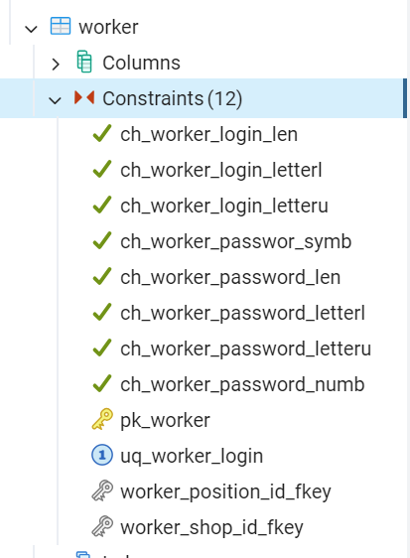
Сотрудник  (Worker) | Worker_surname | Varchar(36) | Not null
Сотрудник  (Worker) | Worker_name | Varchar(36) | Not null
Сотрудник  (Worker) | Worker_second_name | Varchar(36) | Null | Default(  «Нет данных»)
Сотрудник  (Worker) | Worker_login | Varchar(n) | Not null | Уникальное значение  Length >= 6, [a-Z][а-я]
Сотрудник  (Worker) | Worker_password | Varchar(36) | Not null | Length >= 8, [a-Z][0-9][!@#$%^&*()]
Сотрудник  (Worker) | Shop_id | Int | Not null | Внешний
Сотрудник  (Worker) | Position_id | Int | Not null | Внешний ключ
Должность  (Position) | Position_id | Int | Not null | Суррогатный ключ | create table if not exists Position(  ID_Position Serial not null constraint PK_Position primary key,  Position_name Varchar(36) not null  ); | Alter table Position  add constraint UQ_Position_name unique (Position_name); | 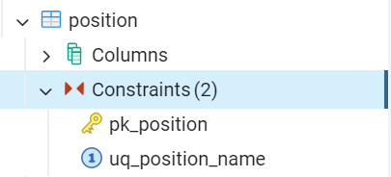
Должность  (Position) | Position_name | Varchar(36) | Not null | Уникальное значение
Заявка на поставку  (Request) | Request_id | Int | Not null | Суррогатный ключ | create table if not exists Request(  ID_Request Serial not null constraint PK_Request primary key,  Request_number Varchar(15) not null,  Request_date Date not null,  Worker_id Int not null references Worker(ID_Worker)  ); | Alter table Request  add constraint UQ_Request_number unique (Request_number); | 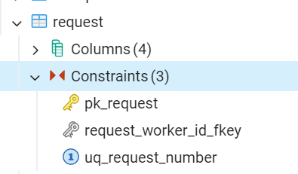
Заявка на поставку  (Request) | Request_number | Int | Not null | Уникальное значение
Заявка на поставку  (Request) | Request_date | Date | Not null | В настоящем времени
Заявка на поставку  (Request) | Worker_id | Int | Not null | Внешний ключ
Клиентский заказ  (Client_order) | Client_order_id | Int | Not null | Суррогатный ключ | create table if not exists Client_order(  ID_Client_order Serial not null constraint PK_Client_order primary key,  Client_order_number Int not null,  Customer_id Int not null references Customer(ID_Customer),  Client_order_date Date not null,  Client_order_time Time not null,  Client_order_sum Decimal(3,2) not null,  Worker_id Int not null references Worker(ID_Worker)  ); | Alter table Client_order  add constraint UQ_Client_order_number unique (Client_order_number),  add constraint CH_Client_order_number check (Client_order_number similar to 'ЗкП-[0-9]{9}-[0-9]{2}'),  add constraint CH_ Client_order_sum check (Client_order_sum >= 0);  Alter table Client_order  alter column Client_order_number type varchar (19); | 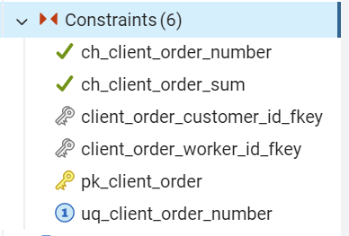
Клиентский заказ  (Client_order) | Client_order_number | Varchar(16) | Not null | ЗкП-000000000-00  Уникальное значение
Клиентский заказ  (Client_order) | Customer_id | Int | Not null | Внешний ключ
Клиентский заказ  (Client_order) | Client_order_date | Date | Not null | В настоящем времени
Клиентский заказ  (Client_order) | Client_order_time | Time | Not null | В настоящем времени
Клиентский заказ  (Client_order) | Client_order_sum | Decimal(3,2) | Not null | >0
Клиентский заказ  (Client_order) | Worker_id | Int | Not null | Внешний ключ
Чек  (Receipt) | Receipt_id | Int | Not null | Суррогатный ключ | create table if not exists Receipt(  ID_Receipt Serial not null constraint PK_Receipt primary key,  Receipt_number Varchar(36) not null,  Client_order_id Int not null references Client_order(ID_Client_order),  Receipt_date Date not null,  Receipt_time Time not null,  Receipt_sum Decimal(3,2) not null,  Receipt_change Decimal(3,2) not null,  ); | Alter table Receipt  add constraint UQ_Receipt_number unique (Receipt_number),  add constraint CH_Receipt_number check (Receipt_number similar to 'КЧ-[0-9]{10}'),  add constraint CH_Receipt_sum check (Receipt_sum >= 0),  add constraint CH_Receipt_change check (Receipt_change >= 0);  Alter table Receipt  alter column Receipt_number type varchar(16); | 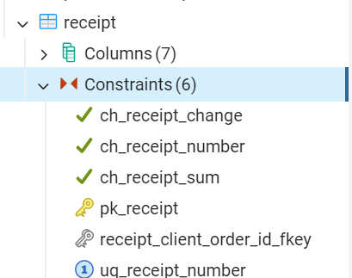
Чек  (Receipt) | Receipt_number | Varchar(36) | Not null | КЧ-0000000000  Уникальное значение
Чек  (Receipt) | Client_order_id | Int | Not null | Внешний ключ
Чек  (Receipt) | Receipt_date | Date | Not null | В настоящем времени
Чек  (Receipt) | Receipt_time | Time | Not null | В настоящем времени
Чек  (Receipt) | Receipt_sum | Decimal(10,2) | Not null | >=0
Чек  (Receipt) | Receipt_change | Decimal(10,2) | Not null | >=0
Торговый зал  (Sales_floor) | Sales_floor_id | Int | Not null | Суррогатный ключ | create table if not exists Sales_floor(  ID_Sales_floor Serial not null constraint PK_Sales_floor primary key,  Sales_floor_name Varchar(36) not null  ); | Alter table Sales_floor  add constraint UQ_Sales_floor_name unique (Sales_floor_name); | 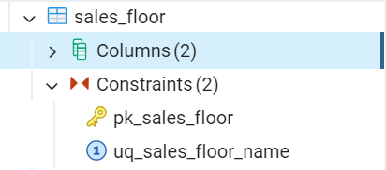
Торговый зал  (Sales_floor) | Sales_floor_name | Varchar(36) | Not null | Уникальное значение
Торговая точка  (Shop) | Shop_id | Int | Not null | Суррогатный ключ | create table if not exists Shop(  ID_Shop Serial not null constraint PK_Shop primary key,  Shop_name Varchar(36) not null,  Shop_address Varchar(36) not null  ); | Alter table Shop  add constraint UQ_Shop_name unique (Shop_name),  add constraint CH_Shop_name check (Shop_name similar to 'FG-[0-9]{2}'),  add constraint UQ_Shop_address unique (Shop_address);  alter table Shop  alter column Shop_name type varchar(7); | 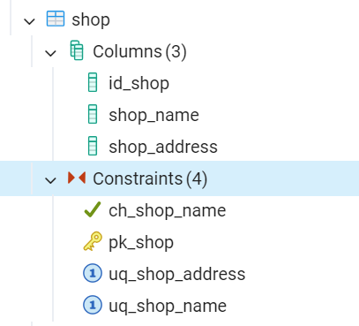
Торговая точка  (Shop) | Shop_name | Varchar(36) | Not null | FG-00  Уникальное значение
Торговая точка  (Shop) | Shop_address | Varchar(150) | Not null | Уникальное значение
Склад  (Warehouse) | Warehouse_id | Int | Not null | Суррогатный ключ | create table if not exists Warehouse(  ID_Warehouse Serial not null constraint PK_Warehouse primary key,  Warehouse_number Int not null,  Warehouse_address Varchar(36) not null,  Shop_id Int not null references Shop(ID_Shop)  ); | Alter table Warehouse  add constraint UQ_Warehouse_number unique (Warehouse_number),  add constraint CH_Warehouse_number check (Warehouse_number similar to 'СП [0-9]{2}'),  add constraint UQ_Warehouse_address unique (Warehouse_address);  alter table Warehouse  alter column Warehouse_name type varchar(7); | 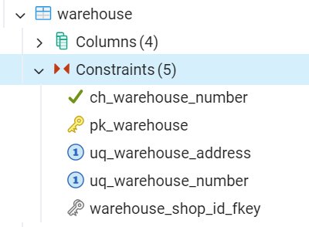
Склад  (Warehouse) | Warehouse_number | Varchar(36) | Not null | СП00  Уникальное значение
Склад  (Warehouse) | Warehouse_address | Varchar(150) | Not null | Уникальное значение
Склад  (Warehouse) | Shop_id | Int | Not null | Внешний ключ
Покупатель  (Customer) | Customer_id | Int | Not null | Суррогатный ключ | create table if not exists Customer(  ID_Customer Serial not null constraint PK_Customer primary key,  Customer_surname Varchar(36) not null,  Customer_name Varchar(36) not null,  Customer_last_name Varchar(36) not null,  Passport_series Varchar(5) not null,  Passport_number Varchar(6) not null,  Issue_data Date not null,  Customer_phone_number Varchar(16) not null,  Credit_card_info Varchar(36) not null,  Cusomer_email Varchar(36) not null,  Customer_login Varchar(36) not null,  Customer_password  Varchar(36) not null  ); | Alter table Customer  add constraint CH_Passport_series check (Passport_series similar to '[0-9]{2} [0-9]{2}'),  add constraint CH_Passport_number check (Passport_number similar to '[0-9]{6}'),  add constraint CH_Customer_phone_number check (Customer_phone_number similar to '\+7\([0-9]{3}\)[0-9]{3}-[0-9]{2}-[0-9]{2}');  add constraint CH_Credit_card_info check (Credit_card_info similar to '[0-9]{4} [0-9]{4} [0-9]{4} [0-9]{4}'),  add constraint UQ_Credit_card_info unique (Credit_card_info),  add constraint UQ_Customer_login unique (Customer_login),  add constraint CH_Customer_login_len check (length(Customer_login) >= 6),  add constraint CH_Customer_login_LetterU check (Customer_login similar to '%[a-zA-Z]%')  add constraint CH_Customer_password_Len check (length(Customer_password) >= 8),  add constraint CH_Customer_password_LetterU check (Customer_password similar to '%[A-Z]%'),  add constraint CH_Customer_password_LetterL check (Customer_password similar to '%[a-z]%'),  add constraint CH_Customer_password_Numb check (Customer_password similar to '%[0-9]%'),  add constraint CH_Customer_passwor_Symb check (Customer_password similar to '%[!@#$%^&*()]%');  alter table Customer  alter column Customer_last_name set default ('Нет данных');  alter table Customer  alter column Passport_series type varchar(8);  alter table Customer  alter column Passport_number type varchar(9);  alter table Customer  alter column Customer_phone_number type varchar(19);  alter table Customer  alter column Credit_card_info type varchar(22); | 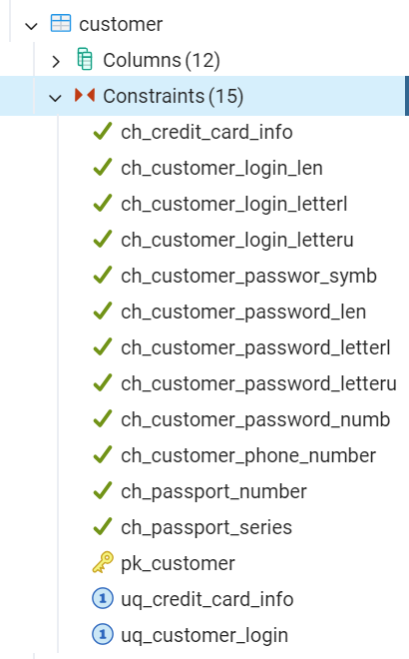
Покупатель  (Customer) | Customer_surname | Varchar(36) | Not null
Покупатель  (Customer) | Customer_name | Varchar(36) | Not null
Покупатель  (Customer) | Customer_last_name | Varchar(36) | Default(  «Нет данных») | Default(  «Нет данных»)
Покупатель  (Customer) | Passport_series | Varchar(5) | Not null | 00 00
Покупатель  (Customer) | Passport_number | Varchar(6) | Not null | 000000
Покупатель  (Customer) | Issue_data | Date | Not null | В прошлом (Дата выдачи паспорта, должна иметь разницу относительно текущей даты, не менее 14 лет)
Покупатель  (Customer) | Customer_phone_number | Varchar(16) | Not null | +7(000)000-00-00
Покупатель  (Customer) | Credit_card_info | Int | Not null | 0000 0000 0000 0000  Уникальное значение
Покупатель  (Customer) | Cusomer_email | Varchar(36) | Не  обяза  тельно
Покупатель  (Customer) | Customer_login | Varchar(n) | Not null | Уникальное значение  Length >= 6, [a-Z][а-я]
Покупатель  (Customer) | Customer_password | Varchar(36) | Not null | Length >= 8, [a-Z][0-9][!@#$%^&*()]
Товар  (Product) | Product_id | Int | Not null | Суррогатный ключ | create table if not exists Product(  ID_Product Serial not null constraint PK_Product primary key,  Article_number Varchar(10) not null,  Product_type Varchar(36) not null,  Product_photo Text not null,  Manufacturing_country_id Int not null references  Manufacturing_country(ID_Manufacturing_country),  Manufacturer_id Int not null references Manufacturer(ID_Manufacturer),  Product_amount Int not null,  Product_price Decimal(3,2) not null  ); | Alter table Product  add constraint CH_Article_number check (Article_number similar to 'SP/[0-9]{7}'),  add constraint UQ_Article_number unique (Article_number),  add constraint UQ_Product_type unique (Product_type),  add constraint CH_Product_amount check (Product_amount > 0),  add constraint CH_Product_price check (Product_price > 0);  alter table Product  alter column Article_number type varchar(13); | 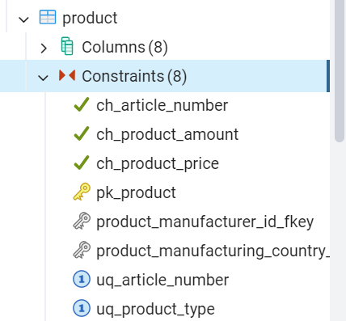
Товар  (Product) | Article_number | Varchar(10) | Not null | SP/0000000  Уникальное значение
Товар  (Product) | Product_type | Varchar(36) | Not null | Уникальное значение
Товар  (Product) | Product_photo |  | Not null
Товар  (Product) | Manufacturing_country_id | Varchar(36) | Not null | Внешний ключ
Товар  (Product) | Manufacturer_id | Varchar(36) | Not null | Внешний ключ
Товар  (Product) | Product_amount | Int | Not null | >0
Товар  (Product) | Product_price | Decimal(10,2) | Not null | >0
Наименование производителя  (Manufacturer) | Manufacturer _id | Int | Not null | Суррогатный ключ | create table if not exists Manufacturer(  ID_Manufacturer Serial not null constraint PK_Manufacturer primary key,  Manufacturer_name Varchar(36) not null  ); | Alter table Manufacturer  add constraint UQ_Manufacturer_name unique (Manufacturer_name); | 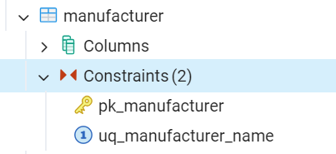
Наименование производителя  (Manufacturer) | Manufacturer _name | Varchar(36) | Not null | Уникальное значение
Страна производителя  (Manufacturing  _country) | Manufacturing_country_id | Int | Not null | Суррогатный ключ | create table if not exists Manufacturing_country(  ID_Manufacturing_country Serial not null constraint PK_Manufacturing_country primary key,  Manufacturing_country_name Varchar(36) not null  ); | Alter table Manufacturing_country  add constraint UQ_Manufacturing_country_name unique (Manufacturing_country_name); | 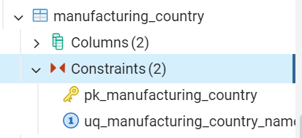
Страна производителя  (Manufacturing  _country) | Manufacturing_country_name | Varchar(36) | Not null | Уникальное значение
Сезон  (Season) | Season_id | Int | Not null | Суррогатный ключ | create table if not exists Season(  ID_Season Serial not null constraint PK_Season primary key,  Season_name Varchar(36) not null); | Alter table Season  add constraint UQ_Season_name unique (Season_name); | 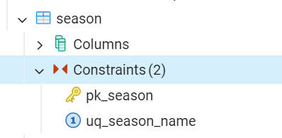
Сезон  (Season) | Season_name | Varchar(36) | Not null | Уникальное значение
Cостав  (Composition) | Compostion _id | Int | Not null | Суррогатный ключ | create table if not exists Composition(  ID_Composition Serial not null constraint PK_Composition primary key,  Composition_name Varchar(36) not null  ); | Alter table Composition  add constraint UQ_Composition_name unique (Composition_name); | 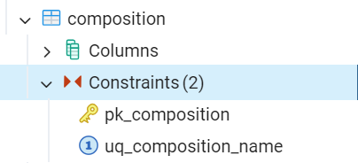
Cостав  (Composition) | Compostion _name | Varchar(36) | Not null | Уникальное значение
Размер  (Size) | Size_id | Int | Not null | Суррогатный ключ | create table if not exists Size(  ID_Size Serial not null constraint PK_Size primary key,  Size Int not null  ); | Alter table Size  add constraint UQ_Size unique (Size); | 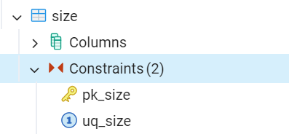
Размер  (Size) | Size | Int | Not null | Уникальное значение |  | Alter table Size  add constraint UQ_Size unique (Size);
Доп заявка  (Extra_request) | Extra_request_id | Int | Not null | Суррогатный ключ | create table if not exists Extra_request(  ID_Extra_request Serial not null constraint PK_Extra_request primary key,  Extra_request_number Int not null,  Order_id Int not null references Orders(ID_Order),  Worker_id Int not null references Worker(ID_Worker)  ); | Alter table Extra_request  add constraint UQ_Extra_request_number unique (Extra_request_number)  add constraint CH_Extra_request_number check (Extra_request_number similar to ' ЗП-[0-9]{10}-[0-9]{2}/[0-9]');  alter table Extra_request  alter column Extra_request_number type varchar(21); | 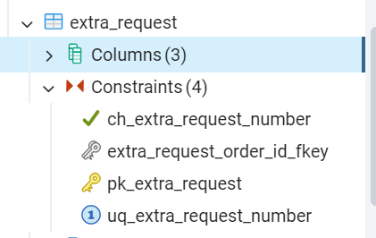
Доп заявка  (Extra_request) | Extra_request_number | Varchar(18) | Not null | ЗП-0000000000-00/0  Уникальное значение
Доп заявка  (Extra_request) | Order_id | Int | Not null | Внешний ключ
Заказ на поставку  (Orders) | Order_id | Int | Not null | Суррогатный ключ | create table if not exists Orders(  ID_Order Serial not null constraint PK_Order primary key,  Order_number Int not null,  Supplier_id Int not null references Supplier(ID_Supplier),  Order_date Date not null,  Order_time Date not null,  Order_status_id Int not null references Order_status(ID_Order_status),  Costs Decimal(3,2) not nul,l  ); | Alter table Order  add constraint UQ_Order_number unique (Order_number),  add constraint CH_Order_number check (Order_number similar to 'ЗП-[0-9]{10}-[0-9]{2}');  alter table Order  alter column Order_number type varchar(19); | 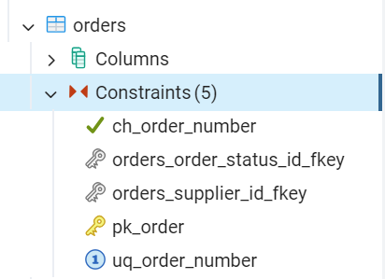
Заказ на поставку  (Orders) | Order_number | Varchsr(16) | Not null | ЗП-0000000000-00  Уникальное значение
Заказ на поставку  (Orders) | Supplier_id | Int | Not null | Внешний ключ
Заказ на поставку  (Orders) | Order_date | Date | Not null | В настоящее время
Заказ на поставку  (Orders) | Order_time | Date | Not null | В настоящее время
Заказ на поставку  (Orders) | Order_status_id | Int | Not null | Внешний ключ
Заказ на поставку  (Orders) | Cost | Decimal(3,2) | Not null | >0
Поставщик  (Supplier) | Supplier_id | Int | Not null | Суррогатный ключ | create table if not exists Supplier(  ID_Supplier Serial not null constraint PK_Supplier primary key,  Supplier_name Varchar(36) not null  ); |  | 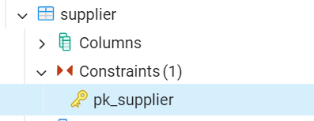
Поставщик  (Supplier) | Supplier_name | Varchar(36) | Not null
Статус заказа  (Order_status) | Order_status_id | Int | Not null | Суррогатный ключ | create table if not exists Order_status(  ID_Order_status Serial not null constraint PK_Order_status primary key,  Order_status Varchar(36) not null  ); | Alter table Order_status  add constraint CH_Order_status check (Order_status in ('В обработке', 'В пути', 'Доставлено')); | 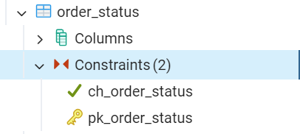
Статус заказа  (Order_status) | Order_status | Varchar(36) | Not null | Одно из нижеперечисленных значений:  В обработке, В пути, Доставлен
Заявки в заказе  (Request_in_  order) | Request_in_order_id | Int | Not null | Суррогатный ключ | create table if not exists Request_in_order(  ID_Request_in_order Serial not null constraint PK_Request_in_order primary key,  Request_id Int not null references Request(ID_Request),  Order_id Int not null references Orders(ID_Order)  ); |  | 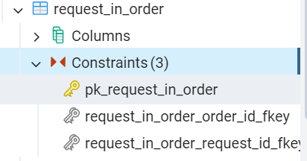
Заявки в заказе  (Request_in_  order) | Request_id | Int | Not null | Внешний ключ
Заявки в заказе  (Request_in_  order) | Order_id | Int | Not null | Внешний ключ
Товары в заявке  (Product_in_  request) | Product_in_request_id | Int | Not null | Суррогатный ключ | create table if not exists Products_in_request(  ID_Product_in_request Serial not null constraint PK_Product_in_request primary key,  Product_id Int not null references Product(ID_Product),  Request_id Int not null references Request(ID_Request)  ); |  | 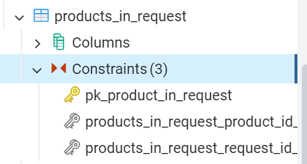
Товары в заявке  (Product_in_  request) | Product_id | Int | Not null | Внешний ключ
Товары в заявке  (Product_in_  request) | Request_id | Int | Not null | Внешний ключ
Содержимое клиентского заказа  (Product_in_  customer_  order) | Product_in_customer_order_id | Int | Not null | Суррогатный ключ | create table if not exists Products_in_customer_order (  ID_Product_in_customer_order Serial not null constraint PK_Product_in_customer_order primary key,  Customer_order_id Int not null references Customer(ID_Customer),  Product_id Int not null references Product(ID_Product),  Product_amount Int not null  ); | Alter table Product_in_customer_order  add constraint CH_Product_amount check (Product_amount > 0); | 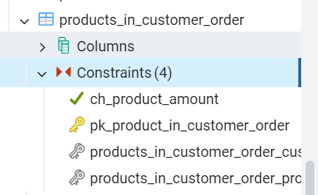
 | Customer_order_id | Int | Not null | Внешний ключ
 | Product_id | Int | Not null | Внешний ключ
 | Product_amount | Int | Not null | >0
Размер товара  (Product_size) | Product_size_id | Int | Not null | Суррогатный ключ | create table if not exists Product_size(  ID_Product_size Serial not null constraint PK_Product_size primary key,  Product_id Int not null references Product(ID_Product),  Size_id Int not null references Size(ID_Size)  ); |  | 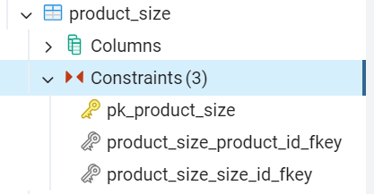
Размер товара  (Product_size) | Product_id | Int | Not null | Внешний ключ
Размер товара  (Product_size) | Size_id | Int | Not null | Внешний ключ
Состав товара  (Composition_  Product) | Composition_product_id | Int | Not null | Суррогатный ключ | create table if not exists Composition_product(  ID_Composition_product Serial not null constraint PK_Composition_product primary key,  Composition_id Int not null references Composition(ID_Composition),  Product_id Int not null references Product(ID_Product),  Percents Int not null  ); | Alter table Composition_  Product  add constraint CH_Percent check (Percent > 0); | 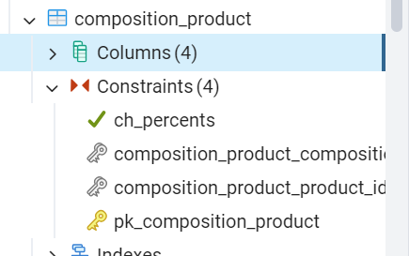
Состав товара  (Composition_  Product) | Product_id | Int | Not null | Внешний ключ
Состав товара  (Composition_  Product) | Composition_id | Int | Not null | Внешний ключ
Состав товара  (Composition_  Product) | Percent | Int | Not null | >0
Товар по точкам  (Product_in_  shop) | Product_in_shop_id | Int | Not null | Суррогатный ключ | create table if not exists Product_in_shop(  ID_Product_in_shop Serial not null constraint PK_Product_in_shop primary key,  Shop_id Int not null references Shop(ID_Shop),  Product_id Int not null references Product(ID_Product),  Product_amount Int not null  ); | Alter table Product_in_  shop add constraint CH_Product_amount check (Product_amount > 0); | 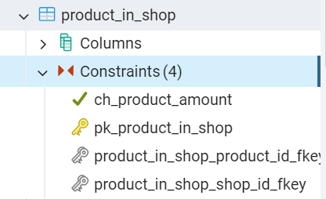
Товар по точкам  (Product_in_  shop) | Product_id | Int | Not null | Внешний ключ
Товар по точкам  (Product_in_  shop) | Shop_id | Int | Not null | Внешний ключ
Товар по точкам  (Product_in_  shop) | Product_amount | Int | Not null | >0
Сезон товара  (Season  _product) | Season_product_id | Int | Not null | Суррогатный ключ | create table if not exists Season_product(  ID_Season_product Serial not null constraint PK_Season_product primary key,  Product_id Int not null references Product(ID_Product),  Season_id Int not null references Season(ID_Season)  ); |  | 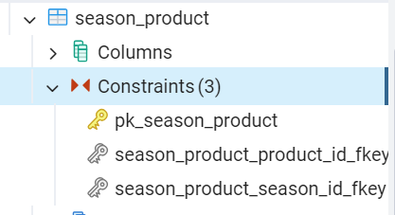
Сезон товара  (Season  _product) | Season_id | Int | Not null | Внешний ключ
Сезон товара  (Season  _product) | Product_id | Int | Not null | Внешний ключ
Товары на стендах  (Product_  on_display) | Product_on  _display_id | Int | Not null | Суррогатный ключ | create table if not exists Product_on_display(  ID_Product_on_display Serial not null constraint PK_Product_on_display primary key,  Sales_floor_id Int not null references Sales_floor(ID_Sales_floor),  Product_id Int not null references Product(ID_Product),  Display_in_sales_floor Int not null  ); | Alter table Product_on_display  add constraint CH_Display_in_sales_floor check (Display_in_sales_floor > 0); | 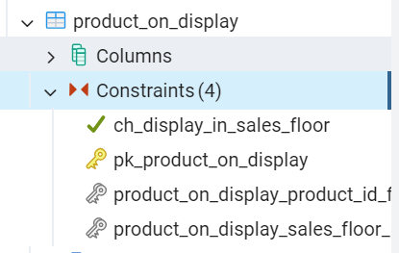
Товары на стендах  (Product_  on_display) | Product_id | Int | Not null | Внешний ключ
Товары на стендах  (Product_  on_display) | Sales_floor_id | Int | Not null | Внешний ключ
Товары на стендах  (Product_  on_display) | Display_in_sales_floor | Int | Not null | Уникальное значение  >0
Залы торговой точки  (Sales_floor_  in_shop) | Sales_floor_  in_shop_id | Int | Not null | Суррогатный ключ | create table if not exists Sales_floor_in_shop(  ID_Sales_floor_in_shop Serial not null constraint PK_Sales_floor_in_shop primary key,  Sales_floor_id Int not null references Sales_floor(ID_Sales_floor),  Shop_id Int not null references Shop(ID_Shop),  Sector_in_sales_floor Int not null  ); |  | 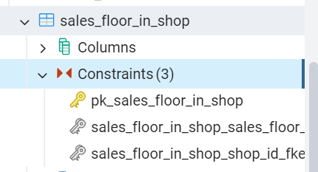
Залы торговой точки  (Sales_floor_  in_shop) | Shop_id | Int | Not null | Внешний ключ
Залы торговой точки  (Sales_floor_  in_shop) | Sales_floor_id | Int | Not null | Внешний ключ
Залы торговой точки  (Sales_floor_  in_shop) | Sector_in_sales_floor | Int | Not null
Товары в доп заявке  (Product_in_ extra_request) | Product_in_ extra_request_id | Int | Not null | Суррогатный ключ | create table if not exists Product_in_extra_request(  ID_Product_in_extra_request Serial not null constraint PK_Product_in_extra_request primary key,  Extra_request_id Int not null references Extra_request(ID_Extra_request),  Product_id Int not null references Product(ID_Product),  Sum Decimal(12, 2) not null  ); | Alter table Product_in_extra_request  add constraint CH_Sum check (Sum > 0); | 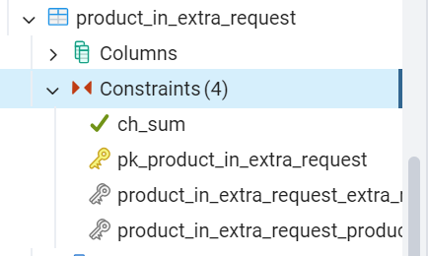
Товары в доп заявке  (Product_in_ extra_request) | Extra_request_id | Int | Not null | Внешний ключ
Товары в доп заявке  (Product_in_ extra_request) | Product_id | Int | Not null | Внешний ключ
Товары в доп заявке  (Product_in_ extra_request) | Sum | Decimal(3,2) | Not null | >0
Заказы в маршрутном листе  (Client_order_in_itinerary) | Client_order_in_itinerary_id | Int | Not null | Суррогатный ключ |  | create table Client_order_in_itinerary  (  ID_Client_order_in_itinerary serial not null constraint PK_Client_order_in_itinerary primary key,  Itinerary_id Int not null references Itinerary (ID_Itinerary),  Client_order_id Int not null references Client_order (ID_Client_order),  Packaging_time Time not null,  Cl_order_to_curier_time Time not null,  Order_on_way Time not null,  Cl_order_to_client Time not null  Deliv_order_status_id Int not null references Deliv_order_status_(ID_Deliv_order_status);  create index if not exists index_ID_Client_order_in_itinerary on Client_order_in_itinerary (ID_Client_order_in_itinerary);  create index if not exists index_ Cl_order_to_curier_time on Client_order_in_itinerary (Cl_order_to_curier_time);  create index if not exists Packaging_time  on Client_order_in_itinerary (Packaging_time  );  create index if not exists index_Order_on_way on Client_order_in_itinerary (Order_on_way);  create index if not exists index_Cl_order_to_client on Client_order_in_itinerary (Cl_order_to_client); | 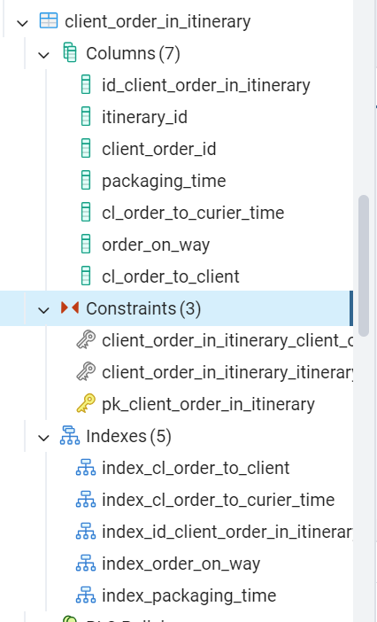
Заказы в маршрутном листе  (Client_order_in_itinerary) | Itinerary_id | Int | Not null | Внешний ключ
Заказы в маршрутном листе  (Client_order_in_itinerary) | Client_order_id | Int | Not null | Внешний ключ
Заказы в маршрутном листе  (Client_order_in_itinerary) | Packaging_time | Time | Not null | Время действия над позицией не может быть раньше даты формирования общего маршрутного листа
Заказы в маршрутном листе  (Client_order_in_itinerary) | Cl_order_to curier_time | Time | Not null | Время действия над позицией не может быть раньше даты формирования общего маршрутного листа
Заказы в маршрутном листе  (Client_order_in_itinerary) | Order_on_way | Time | Not null | Время действия над позицией не может быть раньше даты формирования общего маршрутного листа
Заказы в маршрутном листе  (Client_order_in_itinerary) | Cl_order_to_client | Time | Not null | Время действия над позицией не может быть раньше даты формирования общего маршрутного листа
Заказы в маршрутном листе  (Client_order_in_itinerary) | Deliv_order_status_id | Int |  | Внешний ключ
Статус доставки клиентского заказа  (Deliv_order_status) | Deliv_order_status_id | Int | Not null | Суррогатный ключ |  | create table Deliv_order_status  (  ID_Deliv_order_status serial not null constraint PK_Deliv_order_status primary key,  Delivery_order_status varchar(36) not null constraint UQ_Delivery_order_status unique  constraint CH_Delivery_order_status check (Delivery_order_status in ('Ожидает выдачи', 'В пути', 'Закрыт'))  );  create index if not exists index_ID_Deliv_order_status on Deliv_order_status (ID_Deliv_order_status);  create index if not exists index_Delivery_order_status on Delivery_order_status (Delivery_order_status); | 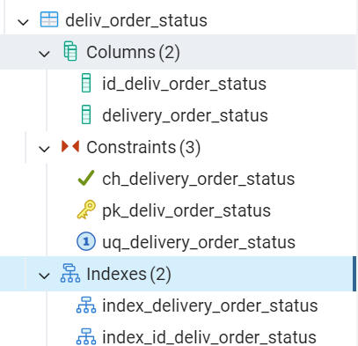
Статус доставки клиентского заказа  (Deliv_order_status) | Delivery_order_status | Varchar(36) | Not null | Уникален  хранит значения: ожидает выдачи,  в пути,  закрыт
Курьер  (Delivery_man) | Delivery_man_id | Int | Not null | Суррогатный ключ |  | create table Delivery_man  (  ID_Delivery_man serial not null constraint PK_Delivery_man primary key,  Delivery_man_surname Varchar(36) not null,  Delivery_man_name Varchar(36) not null,  Delivery_man_second_name Varchar(36) null,  Delivery_man_phone Varchar(16) not null constraint UQ_Delivery_man_phone unique  constraint CH_Delivery_man_phone check (Delivery_man_phone similar to '\+7\([0-9]{3}\)[0-9]{3}-[0-9]{2}-[0-9]{2}')  );  create index if not exists index_ID_Delivery_man on Delivery_man (ID_Delivery_man ); create index if not exists index_Delivery_man_phone on Delivery_man(Delivery_man_phone);  Alter table Delivery_man  alter column Delivery_man_second_name set default ('Отсутствует'); | 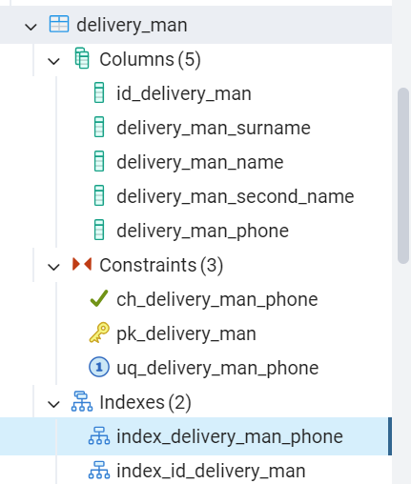
Курьер  (Delivery_man) | Delivery_man_surname | Varchar(36) | Not null
Курьер  (Delivery_man) | Delivery_man_name | Varchar(36) | Not null
Курьер  (Delivery_man) | Delivery_man_second_name | Varchar(36) | Default(«Отсутствует») | по умолчанию хранится значение «Отсутствует»
Курьер  (Delivery_man) | Delivery_man_phone | Varchar(16) | Not null | Уникален  хранится в формате +7(000)000-00-00
Автомобиль  (Car) | Car_id | Int | Not null | Суррогатный ключ |  | create table Car  (  ID_Car serial not null constraint PK_Car primary key,  Car_model Varchar(36) not null constraint UQ_Car_model unique,  Car_number Varchar(12) not null constraint UQ_Car_number unique  constraint CH_Car_number check (Car_number similar to '[ABCEHKMOPTYX][0-9]{3}[ABCEHKMOPTYX]{2} [0-9]{2}')  );  create index if not exists index_ID_Car on Car (ID_Car);  create index if not exists index_Car_number on Car(Car_number); | 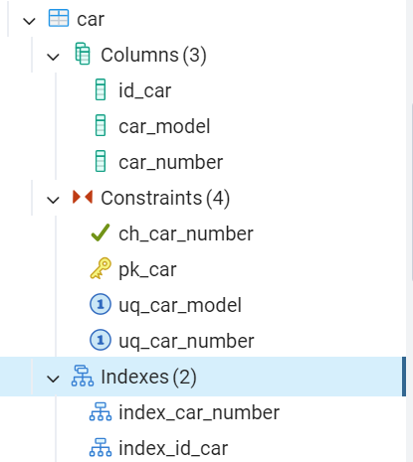
Автомобиль  (Car) | Car_model | Varchar(36) | Not null | Марка автомобиля уникальны
Автомобиль  (Car) | Car_number | Varchar(12) | Not null | уникален, хранится в формате Х000ХХ 00  буквы могут быть внесены только те, что одинаково пишутся, как на кириллице, так и на латинице
Маршрутный лист  (Itinerary) | Itinerary_id | Int | Not null | Суррогатный ключ |  | create table Itinerary  (  ID_Itinerary serial not null constraint PK_Itinerary primary key,  Itinerary_number Varchar(22) not null constraint UQ_Itinerary_number unique  constraint CH_Itinerary_number check (Itinerary_number similar to 'Д-МЛ-[0-9]{2}-[0-9]{10}'),  Itinerary_date Date not null,  Itinerary_time Time not null,  Delivery_man_id Int not null references Delivery_man (ID_Delivery_man),  Car_id Int not null references Car (ID_Car),  Overall_status_id Int not null references Overall_status (ID_Overall_status)  );  create index if not exists index_ID_Itinerary on Itinerary (ID_Itinerary);  create index if not exists index_Itinerary_number  on Itinerary (Itinerary_number); | 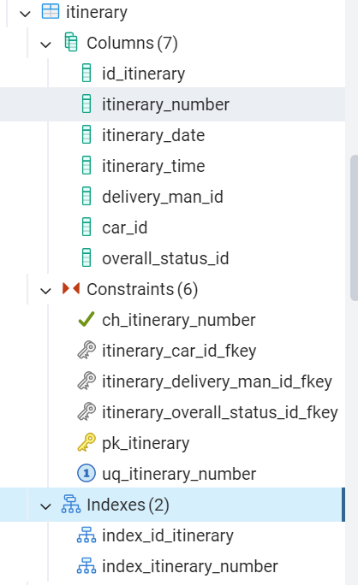
Маршрутный лист  (Itinerary) | Itinerary_number | Varchar(21) | Not null | Номер маршрутного листа уникален и хранится в формате Д-МЛ-00-0000000000
Маршрутный лист  (Itinerary) | Itinerary_date | Date | Not null | Дата формирования маршрутного листа, не может быть раньше, чем дата формирования заказа
Маршрутный лист  (Itinerary) | Itinerary_time | Time | Not null | время формирования маршрутного листа, не может быть раньше, чем время формирования заказа
Маршрутный лист  (Itinerary) | Delivery_man_id | Int | Not null | Внешний ключ
Маршрутный лист  (Itinerary) | Car_id | Int | Not null | Внешний ключ
Маршрутный лист  (Itinerary) | Overall_status_id | Int | Not null | Внешний ключ
Общий статус маршрутного листа  (Overall_status) | Overall_status_id | Int | Not null | Суррогатный ключ |  | create table Overall_status  (  ID_Overall_status serial not null constraint PK_Overall_status primary key,  Overall_status varchar(36) not null constraint UQ_Overall_status unique  constraint CH_Overall_status check (Overall_status in ('Завершён', 'Выполняется'))  );  create index if not exists index_ID_Overall_status on Overall_status (ID_Overall_status);  create index if not exists index_Overall_status on Overall_status (Overall_status); | 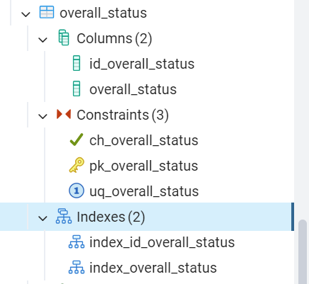
Общий статус маршрутного листа  (Overall_status) | Overall_status | Varchar(36) | Not null | уникален хранит значения: выполняется, завершён

- Сопровождение хранимых процедур:
  - Создание файла;

  - Набор тестовых сценариев для сопровождения хранимых процедур;
Таблица 2 – Сценарии тестирования
№ Сценария | Характеристики
 | Краткое описание теста
 | Ввод существующей страны производителя, с выводом сообщения об ошибке
 | Поля ввода
 | Название страны
 | Вводимые данные
 | Китай
 | Ожидаемый результат
 | Указанная страна уже есть в базе!
 | Краткое описание теста
 | Автоматическое формирование номера маршрутного листа
 | Поля ввода
 | Дата и время формирования, Код-ключ курьера, Код-ключ автомобиля, Код-ключ статуса
 | Вводимые данные
 | Дата и время: 01.03.2024 10:00:00, Курьер: Павлов Роман Дмитриевич, Автомобиль: KIA Rio О464ОР 77, Статус: Выполняется
 | Ожидаемый результат
 | Д-МЛ-24-0000000001
 | Краткое описание теста
 | Удаление существующего покупателя
 | Поля ввода
 | Код-ключ покупателя
 | Вводимые данные
 | Михаилов Валентин Олегович
 | Ожидаемый результат
 | Выбранного клиента невозможно удалить!
 | Краткое описание теста
 | Проверка сопоставления существующему товару вида сезона
 | Поля ввода
 | Код-ключ товара, Код-ключ сезона
 | Вводимые данные
 | Товар: SP/0000001, Сезон: Летний.
 | Ожидаемый результат
 | Указанный сезон уже есть у выбранного товара
 | Краткое описание теста
 | Автоматический перерасчёт стоимости заказа, при добавлении новой позиции товара.
 | Поля ввода
 | Код-ключ заказа, Код-ключ товара, количество товара
 | Вводимые данные
 | Заказ: ЗкП-000000002-23, Товар: SP/0000004, количество: 1
 | Ожидаемый результат
 | 18 863,98

  - Сопровождение и тестирование хранимых процедур;
Таблица 3 – Реализация хранимых процедур
№ Сценария | Скрипт | Результат | Статус тестирования
 | create or replace procedure Manufacturing_country_Insert (p_Manufacturing_country_name Varchar(36))  language plpgsql  as $$  begin  insert into Manufacturing_country  (Manufacturing_country_name )  values (p_Manufacturing_country_name );  exception when others then  raise notice 'Указанная страна уже есть в базе!';  end;  $$;  call Manufacturing_country_Insert('Китай'); | 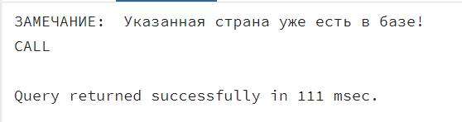 | Пройден
 | create or replace procedure Itinerary_Insert (  p_Itinerary_date Date,  p_Itinerary_time Time,  p_Delivery_man_id Int,  p_Car_id Int,  p_Overall_status_id Int  )  language plpgsql  as $$  declare p_New_Number int := count(*)+1 from Itinerary;  declare p_Year int := SUBSTRING(p_Itinerary_date::text, 3, 2);  declare p_Symb_Len smallint := length(p_New_Number::text);  declare p_Loop_Max_Step smallint := 10 - p_Symb_Len;  declare p_New_Text_Number varchar (21) := '';  begin  for i in 1..p_Loop_Max_Step loop  p_New_Text_Number := p_New_Text_Number||'0';  end loop;  p_New_Text_Number:= 'Д-МЛ-'||p_Year||'-'||p_New_Text_Number||p_New_Number;  insert into Itinerary ( Itinerary_number,  Itinerary_date,  Itinerary_time,  Delivery_man_id,  Car_id,  Overall_status_id)  values (p_New_Text_Number, p_Itinerary_date, p_Itinerary_time, p_Delivery_man_id, p_Car_id,  p_Overall_status_id);  end;  $$;  call Itinerary_Insert('2024-03-01', '10:00:00', 1, 4, 1); | 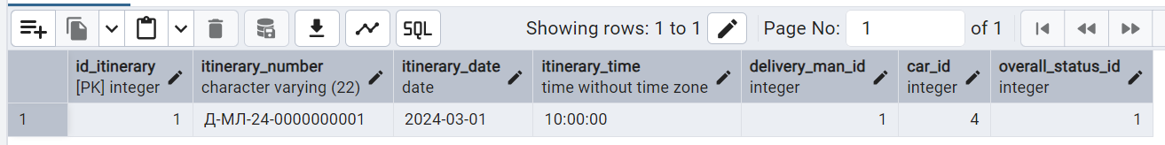
 | drop procedure Customer_Delete;  create or replace procedure Customer_Delete (p_ID_Customer int)  language plpgsql  as $$  declare p_Exist_Client_order smallint := count(*) from Client_order  where Customer_id = p_ID_Customer;  begin  if (p p_Exist_Client_order > 0) then  raise notice Выбранного клиента невозможно удалить!';  else  delete from Customer  where  ID_Customer = p_ID_Customer;  end if;  end;  $$;  call Bussines_Role_Delete(1); | 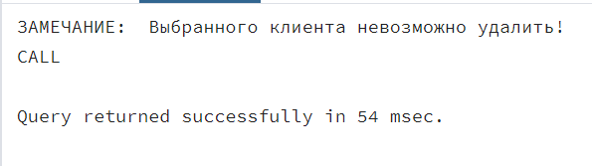 | Пройден
 | drop procedure Season_product_Insert ;  create or replace procedure Season_product_Insert (p_Product_id Int, p_Season_id Int)  language plpgsql  as $$  declare p_Exist_Season smallint := count(*) from Season_product  where  Product_id = p_Product_id and  Season_id = p_Season_id;  begin  if (p_Exist_Season <> 0) then  raise notice 'Указанный сезон уже есть у выбранного товара!';  else  insert into Season_product(Product_id, Season_id)  values (p_Product_id, p_Season_id);  end if;  end;  $$;  call Season_product_Insert(15, 1); | 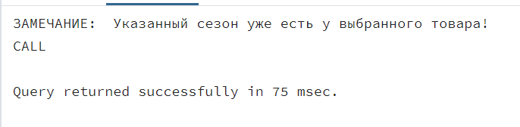 | Пройден
 | drop procedure product_in_customer_order_Insert;  create or replace procedure product_in_customer_order_Insert (p_Customer_order_id Int, p_Product_id Int, p_Product_amount Int)  language plpgsql  as $$  declare p_new_sum decimal(10,2):= 0;  begin  INSERT INTO Products_in_customer_order (Customer_order_id, Product_id, Product_amount)  VALUES (p_Customer_order_id, p_Product_id, p_Product_amount);  select sum(Product_price*products_in_customer_order.Product_amount) into p_new_sum from product  inner join products_in_customer_order on id_product = product_id  where Customer_order_id = p_Customer_order_id;  update Client_order set  Client_order_sum = p_new_sum  where  ID_Client_order = p_Customer_order_id;  end;  $$;  call product_in_customer_order_Insert(17, 18, 1);  select Client_order_sum from Client_order  where ID_Client_order = 17; | 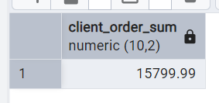 | Пройден

  - Создание не реализованных ранее хранимых процедур и дополнение процедур для верификации данных;
Таблица 4 – Реализация хранимых процедур

№ ПП | Скрипт | Результат
 | create or replace procedure Request_Insert (p_Request_number Varchar(12), p_Request_date Date, p_Worker_id Int)  language plpgsql  as $$  begin  if (p_Request_date < current_Date) then  raise notice 'Дата создания учебной группы должна быть в настоящем времени!';  else  insert into Request (Request_number, Request_date, Worker_id)  values (p_Request_number, p_Request_date, p_Worker_id);  end if;  end;  $$; | 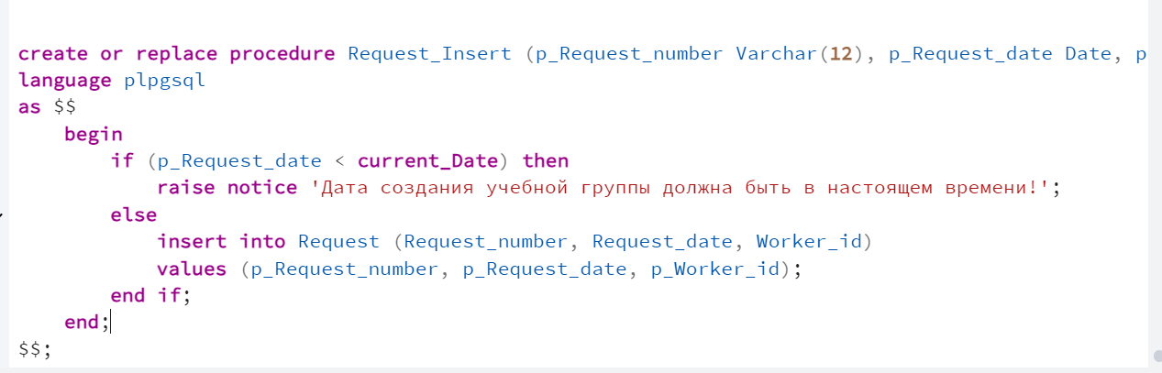
 | create or replace procedure Customer_Insert (p_Customer_surname Varchar(36),  p_Customer_name Varchar(36),  p_Customer_last_name Varchar(36),  p_Passport_series Varchar(5),  p_Passport_number Varchar(6),  p_Issue_data Date,  p_Customer_phone_number Varchar(16),  p_Credit_card_info Varchar(19),  p_Cusomer_email Varchar(36),  p_Customer_login Varchar(36),  p_Customer_password Varchar(36)  )  language plpgsql  as $$  begin  SELECT EXTRACT(YEAR FROM NOW()) as current_year;  if EXTRACT(YEAR FROM AGE(current_year, issue_data)) then  insert into Customer(Customer_surname, Customer_name, Customer_last_name, Passport_series, Passport_number, Issue_data, Customer_phone_number, Credit_card_info, Cusomer_email, Customer_login, Customer_password)  values (p_Customer_surname, p_Customer_name, p_Customer_last_name, p_Passport_series, p_Passport_number, p_Issue_data, p_Customer_phone_number, p_Credit_card_info, p_Cusomer_email, p_Customer_login, p_Customer_password);  else  raise notice 'Дата выдачи паспорта, должна иметь разницу относительно текущей даты, не менее 14 лет!';  end if;  end;  $$; | 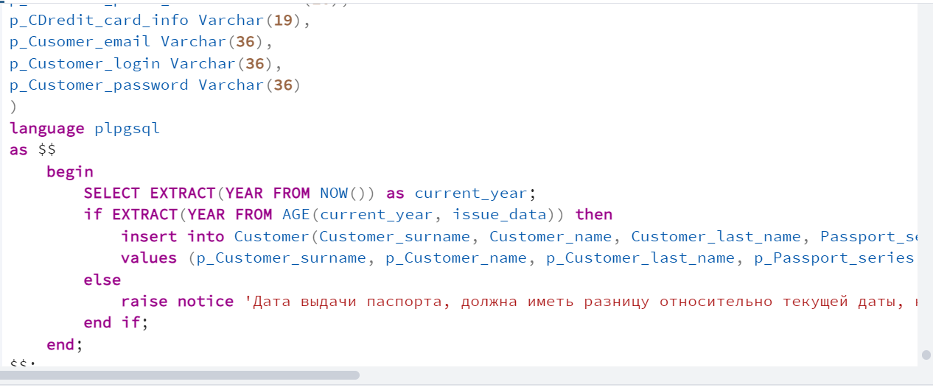
 | create or replace procedure Order_Insert (p_Order_number Varchar(16), p_Supplier_id Int, p_Order_date Date, p_Order_time Time, p_Order_status_id Int, p_Costs Decimal(10,2))  language plpgsql  as $$  begin  if p_Order_date = current_Date AND p_Order_time = current_Time then  insert into Orders  (Order_number, Supplier_id, Order_date, Order_time, Order_status_id, Costs)  values (p_Order_number, p_Supplier_id, p_Order_date, p_Order_time, p_Order_status_id, p_Costs);  else  raise notice 'Дата заказа должна быть в настоящем времени!';  end if;  end;  $$; | 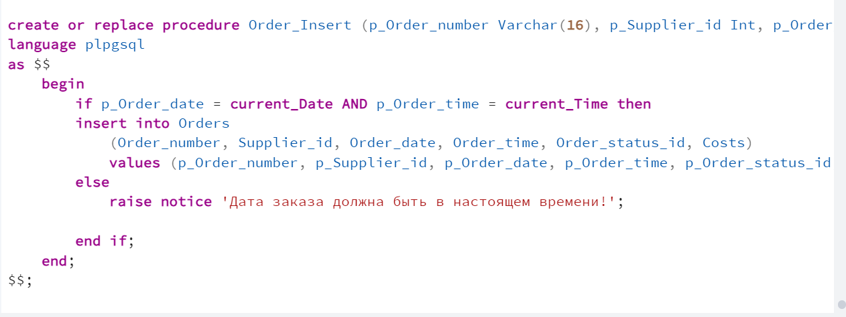
 | create or replace procedure Itinerary_Insert (  p_Itinerary_date Date,  p_Itinerary_time Time,  p_Delivery_man_id Int,  p_Car_id Int,  p_Overall_status_id Int  )  language plpgsql  as $$  declare p_New_Number int := count(*)+1 from Itinerary;  declare p_Year int := SUBSTRING(p_Itinerary_date::text, 3, 2);  declare p_Symb_Len smallint := length(p_New_Number::text);  declare p_Loop_Max_Step smallint := 10 - p_Symb_Len;  declare p_New_Text_Number varchar (21) := '';  declare p_cl_order_id Int := Client_order_id from Client_order_in_itinerary;  declare p_Form_data date := client_order_date from Client_order  where id_client_order = p_cl_order_id;  begin  for i in 1..p_Loop_Max_Step loop  p_New_Text_Number := p_New_Text_Number||'0';  end loop;  p_New_Text_Number:= 'Д-МЛ-'||p_Year||'-'||p_New_Text_Number||p_New_Number;  if p_Form_data - Itinerary_date >0 then  raise notice 'Дата заказа должна быть в настоящем времени!';  else  insert into Itinerary ( Itinerary_number,  Itinerary_date,  Itinerary_time,  Delivery_man_id,  Car_id,  Overall_status_id)  values (p_New_Text_Number, p_Itinerary_date, p_Itinerary_time, p_Delivery_man_id, p_Car_id,  p_Overall_status_id);  end if;  end;  $$; | 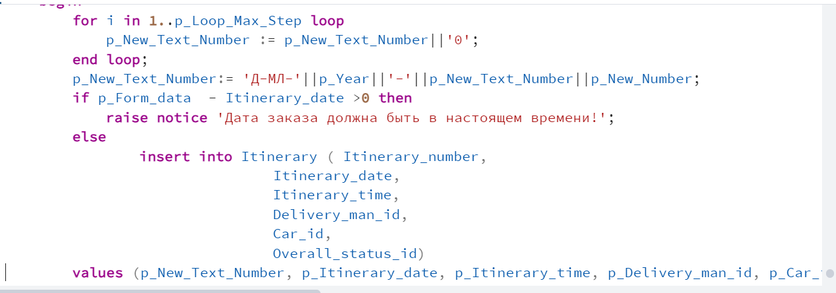
 | create or replace procedure Client_order_Insert(  p_Client_order_number Varchar(19),  p_Customer_id Int,  p_Client_order_date Date,  p_Client_order_time Time,  p_Client_order_sum Decimal(10,2),  p_Worker_id Int)  language plpgsql  as $$  begin  if (p_Client_order_date = current_Date) then  raise notice 'Дата создания учебной группы должна быть в настоящем времени!';  else  insert into Client_order(Client_order_number, Customer_id, Client_order_date, Client_order_time, Client_order_sum, Worker_id)  values (p_Client_order_number, p_Customer_id, p_Client_order_date, p_Client_order_time, p_Client_order_sum, p_Worker_id);  end if;  end;  $$; | 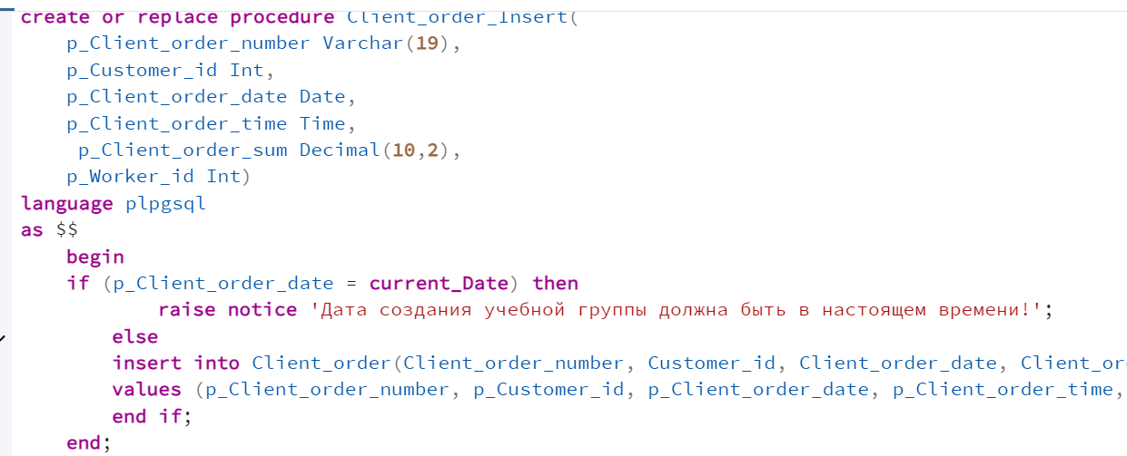
 | create or replace procedure Client_order_Insert(  p_Client_order_number Varchar(19),  p_Customer_id Int,  p_Client_order_date Date,  p_Client_order_time Time,  p_Client_order_sum Decimal(10,2),  p_Worker_id Int)  language plpgsql  as $$  begin  if (p_Client_order_date = current_Date AND p_Client_order_time = current_Time) then  raise notice 'Дата создания учебной группы должна быть в настоящем времени!';  else  insert into Client_order(Client_order_number, Customer_id, Client_order_date, Client_order_time, Client_order_sum, Worker_id)  values (p_Client_order_number, p_Customer_id, p_Client_order_date, p_Client_order_time, p_Client_order_sum, p_Worker_id);  end if;  end;  $$; | 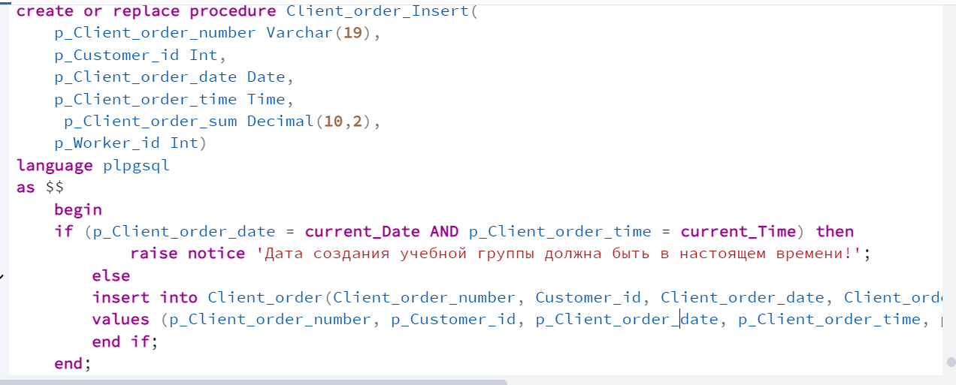
 | create or replace procedure Receipt_Insert (  p_Receipt_number Varchar(36),  p_Client_order_id Int,  p_Receipt_date Date,  p_Receipt_time Time,  p_Receipt_sum Decimal(10,2),  p_Receipt_change Decimal(10,2)  )  language plpgsql  as $$  begin  if (p_Receipt_date = current_Date AND p_Receipt_time = current_Time) then  insert into Receipt  (Receipt_number, Client_order_id, Receipt_date, Receipt_time, Receipt_sum, Receipt_change )  values (p_Receipt_number, p_Client_order_id, p_Receipt_date, p_Receipt_time, p_Receipt_sum, p_Receipt_change);  else  raise notice 'Дата создания чека должна быть в настоящем времени!';  end if;  end;  $$; | 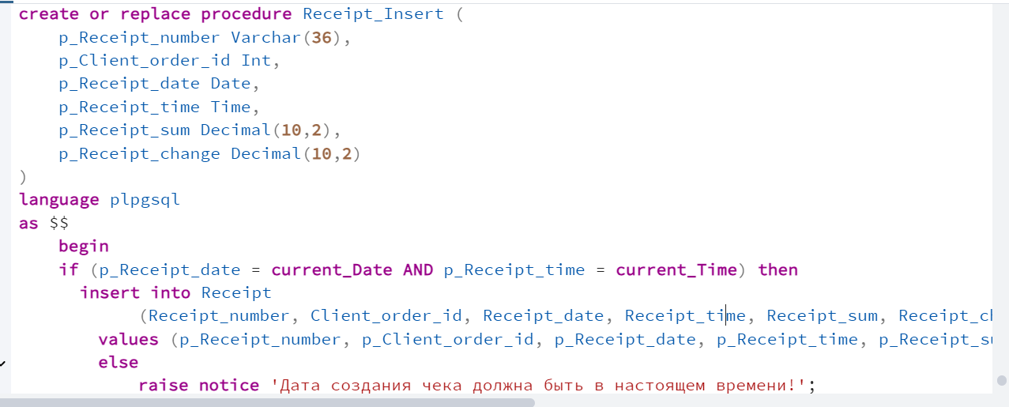
 | create or replace procedure Deliv_order_status_Insert (p_Delivery_order_status varchar(36))  language plpgsql  as $$  begin  insert into Deliv_order_status(Delivery_order_status)  values (p_Delivery_order_status);  exception when others then  raise notice 'Указанный статус уже есть!';  end;  $$; | 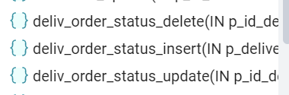
create or replace procedure Deliv_order_status_Update(p_ID_Deliv_order_status int, p_Delivery_order_status varchar(36))
language plpgsql
as $$
begin
update Deliv_order_status set
Delivery_order_status = p_Delivery_order_status
where
ID_Deliv_order_status = p_ID_Deliv_order_status ;
exception when others then
raise notice 'Указанный статус уже есть!';
end;
$$;
create or replace procedure Deliv_order_status_Delete(p_ID_Deliv_order_status int)
language plpgsql
as $$
declare p_Exist smallint := count(*) from Client_order_in_itinerary
where Deliv_order_status_id = p_ID_Deliv_order_status;
begin
if (p_Exist > 0) then
raise notice 'Выбранный тип удилть нельзя, есть созданная ID карта!';
else
delete from Deliv_order_status
where
Deliv_order_status_id = p_ID_Deliv_order_status;
end if;
end;
$$;
 | create or replace procedure Delivery_man_Insert ( p_Delivery_man_surname Varchar(36),  p_Delivery_man_name Varchar(36),  p_Delivery_man_second_name Varchar(36),  p_Delivery_man_phone Varchar(19) )  language plpgsql  as $$  begin  insert into Delivery_man (Delivery_man_surname, Delivery_man_name, Delivery_man_second_name, Delivery_man_phone)  values (p_Delivery_man_surname, p_Delivery_man_name, p_Delivery_man_second_name, p_Delivery_man_phone);  exception when others then  raise notice 'Такой курьер уже есть!';  end;  $$; | 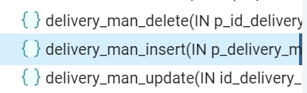
create or replace procedure Delivery_man_Update(p_ID_Delivery_man Int,
p_Delivery_man_surname Varchar(36),
p_Delivery_man_name Varchar(36),
p_Delivery_man_second_name Varchar(36),
p_Delivery_man_phone Varchar(19))

language plpgsql
as $$

begin
update Delivery_man set
Delivery_man_surname = p_Delivery_man_surname,
Delivery_man_name = p_Delivery_man_name,
Delivery_man_second_name = p_Delivery_man_second_name,
Delivery_man_phone = p_Delivery_man_phone
where
ID_Delivery_man = p_ID_Delivery_man;

end;
$$;
 | create or replace procedure Car_Delete(p_ID_Car Int)  language plpgsql  as $$  declare p_Exist smallint := count(*) from Itinerary  where Car_id = p_ID_Car;  begin  if (p_Exist > 0) then  raise notice 'Выбранный автомобиль нельзя удалить, он есть в маршутном листе!';  else  delete from Car  where  Car_id = p_ID_Car;  end if;  end;  $$; | 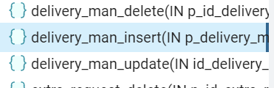
create or replace procedure Car_Update(p_ID_Car Int, p_Car_model Varchar(36), p_Car_number Varchar(12))
language plpgsql
as $$
begin
update Car set
Car_model = p_Car_model,
Car_number = p_Car_number
where
ID_Car = p_ID_Car;
exception when others then
raise notice 'Такой автомобиль уже есть!';
end;
$$;
create or replace procedure Car_Insert (
p_Car_model Varchar(36),
p_Car_number Varchar(12)
)
language plpgsql
as $$
begin
insert into Car (Car_model, Car_number)
values (p_Car_model, p_Car_number);
end;
$$;
call Car_Insert('KIA Rio', 'O464OP 77');
select * from Car;
 | create or replace procedure Itinerary_Update (  p_ID_Itinerary Int,  p_itinerary_number Varchar(22),  p_Itinerary_date Date,  p_Itinerary_time Time,  p_Delivery_man_id Int,  p_Car_id Int,  p_Overall_status_id Int  )  language plpgsql  as $$  begin  update Itinerary set  itinerary_number = p_itinerary_number,  Itinerary_date = p_Itinerary_date,  Itinerary_time = p_Itinerary_time,  Delivery_man_id = p_Delivery_man_id,  Car_id = p_Car_id,  Overall_status_id = p_Overall_status_id  where  ID_Itinerary = p_ID_Itinerary;  end;  $$; | 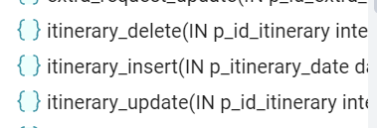
create or replace procedure Itinerary_Delete (p_ID_Itinerary Int)
language plpgsql
as $$
declare p_Exist smallint := count(*) from Client_order_in_itinerary
where Itinerary_id = p_Itinerary_Car;
begin
if (p_Exist > 0) then
raise notice 'Выбранный маршутный лист нельзя удалить!';
else
delete from Itinerary
where
Itinerary_id = p_ID_Itinerary;
end if;
end;
$$;
 | create or replace procedure Overall_status_Insert (p_Overall_status varchar(36))  language plpgsql  as $$  begin  insert into Overall_status (Overall_status)  values (p_Overall_status);  end;  $$; | 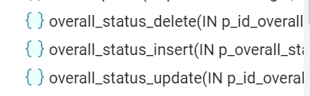
create or replace procedure Overall_status_Update(p_ID_Overall_status Int, p_Overall_status varchar(36))
language plpgsql
as $$
begin
update Overall_status set
Overall_status = p_Overall_status
where
ID_Overall_status = p_ID_Overall_status;
exception when others then
raise notice 'Такой статус уже есть!';
end;
$$;
create or replace procedure Overall_status_Delete(p_ID_Overall_status Int)
language plpgsql
as $$
declare p_Exist smallint := count(*) from Itinerary
where Car_id = p_ID_Car;
begin
if (p_Exist > 0) then
raise notice 'Выбранный статус нельзя удалить, он есть в маршутном листе!';
else
delete from Overall_status
where
Overall_status_id = p_ID_Overall_status;
end if;
end;
$$;
 | create or replace procedure Client_order_in_itinerary_Insert ( p_Itinerary_id Int,  p_Client_order_id Int,  p_Packaging_time Time,  p_Cl_order_to_curier_time Time,  p_Order_on_way Time,  p_Cl_order_to_client Time,  p_Deliv_order_status_id Int )  language plpgsql  as $$  declare p_Itinerary_time time := Itinerary_time from Itinerary  where ID_itinerary = p_Itinerary_id;  begin  if p_Itinerary_time <= Packaging_time AND p_Itinerary_time <= Cl_order_to_curier_time AND p_Itinerary_time <= Order_on_way AND p_Itinerary_time <= Cl_order_to_client then  insert into Client_order_in_itinerary (Itinerary_id, Client_order_id, Packaging_time, Cl_order_to_curier_time, Order_on_way, Cl_order_to_client, Deliv_order_status_id)  values (p_Itinerary_id, p_Client_order_id, p_Packaging_time, p_Cl_order_to_curier_time, p_Order_on_way, p_Cl_order_to_client, p_Deliv_order_status_id);  else  raise notice 'Время действия над позицией не может быть раньше даты формирования общего маршрутного листа';  end if;  end;  $$; | 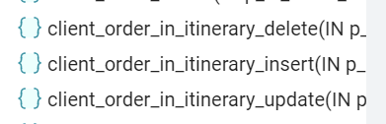
create or replace procedure Client_order_in_itinerary_Update( p_ID_Client_order_in_itinerary Int,
p_Itinerary_id Int,
p_Client_order_id Int,
p_Packaging_time Time,
p_Cl_order_to_curier_time Time,
p_Order_on_way Time,
Cl_order_to_client Time,
p_Deliv_order_status_id Int )
language plpgsql
as $$
begin
update Client_order_in_itinerary set
Itinerary_id =p_Itinerary_id,
Client_order_id = p_Client_order_id,
Packaging_time = p_Packaging_time,
Cl_order_to_curier_time = p_Cl_order_to_curier_time,
Order_on_way = p_Order_on_way,
Cl_order_to_client = p_Cl_order_to_client,
Deliv_order_status_id = p_Deliv_order_status_id
where
ID_Client_order_in_itinerary = p_ID_Client_order_in_itinerary;

end;
$$;
create or replace procedure Client_order_in_itinerary_Delete(p_ID_Client_order_in_itinerary Int)
language plpgsql
as $$
begin
delete from Client_order_in_itinerary
where
Client_order_in_itinerary_id = p_ID_Client_order_in_itinerary ;

end;
$$;

- Распределение прав доступа к таблицам и хранимым процедурам БД;
Таблица 5 – Права доступа к таблицам и хранимым процедурам БД
Роли |  | Покупатель | Сотрудник | Поставщик | Администратор
Название объекта | Функции
Client_order_in_itinerary | Выборка | X | X |  | X
Client_order_in_itinerary | Добавление |  |  |  | X
Client_order_in_itinerary | Изменение |  |  |  | X
Client_order_in_itinerary | Удаление |  |  |  | X
Deliv_order_status | Выборка |  |  |  | X
Deliv_order_status | Добавление |  |  |  | X
Deliv_order_status | Изменение |  | X |  | X
Deliv_order_status | Удаление |  |  |  | X
Delivery_man | Выборка |  |  |  | X
Delivery_man | Добавление |  |  |  | X
Delivery_man | Изменение |  | X
Delivery_man | Удаление |  |  |  | X
Car | Выборка |  | X |  | X
Car | Добавление |  |  |  | X
Car | Изменение |  |  |  | X
Car | Удаление |  |  |  | X
Itinerary | Выборка |  | X |  | X
Itinerary | Добавление |  |  |  | X
Itinerary | Изменение |  | X
Itinerary | Удаление |  |  |  | X
Overall_status | Выборка | X | X |  | X
Overall_status | Добавление |  |  |  | X
Overall_status | Изменение |  | X |  | X
Overall_status | Удаление |  |  |  | X
Client_order_in_itinerary_Insert | Вызов |  |  |  | X
Client_order_in_itinerary_Update | Вызов |  |  |  | X
Client_order_in_itinerary_Delete | Вызов |  |  |  | X
Deliv_order_status_Insert | Вызов |  |  |  | X
Deliv_order_status_Update | Вызов |  |  |  | X
Deliv_order_status_Delete | Вызов |  |  |  | X
Delivery_man_Insert | Вызов |  |  |  | X
Delivery_man_Update | Вызов |  | X
Delivery_man_Delete | Вызов |  |  |  | X
Car_Insert | Вызов |  |  |  | X
Car_Update | Вызов |  |  |  | X
Car_Delete | Вызов |  |  |  | X
Itinerary_Insert | Вызов |  |  |  | X
Itinerary_Update | Вызов |  | X
Itinerary_Delete | Вызов |  |  |  | X
Overall_status_Insert | Вызов |  |  |  | X
Overall_status_Update | Вызов |  | X |  | X
Overall_status_Delete | Вызов |  |  |  | X

- Выдача прав доступа к таблицам и хранимым процедурам БД;
Таблица 6 – Реализация разграничения прав доступа
Название роли | Название объекта | Функция | Скрипт
rl_worker | Client_order_in_itinerary | Select | grant select on Client_order_in_itinerary to rl_worker;
rl_worker | Car | Select | grant select on Car to rl_worker;
rl_worker | Deliv_order_status | Update | grant update on Deliv_order_status to rl_worker;
rl_worker | Delivery_man | Update | grant update on Delivery_man to rl_worker;
rl_worker | Itinerary | Select, Update | grant select, update on Itinerary to rl_worker;
rl_worker | Overall_status | Select, Update | grant select, update on Overall_status to rl_worker;
rl_worker | Delivery_man_Update | Execute | grant execute on procedure Delivery_man_Update to rl_worker;
rl_worker | Itinerary_Update | Execute | grant execute on procedure Itinerary_Update to rl_worker;
rl_worker | Overall_status_Update | Execute | grant execute on procedure Overall_status_Update to rl_worker;
rl_customer | Discip_Skills | Select | grant select on Overall_status to rl_customer;
rl_administrator | Overall_status | Select, Insert, Update, Delete | grant select, insert, update, delete on Overall_status to rl_administrator;  grant usage, select on sequence Overall_status_id_Overall_status_seq to rl_administrator;
rl_administrator | Car | Select, Insert, Update, Delete | grant select, insert, update, delete on Car to rl_administrator;  grant usage, select on sequence Car_id_Car_seq to rl_administrator;
rl_administrator | Client_order_in_itinerary | Select, Insert, Update, Delete | grant select, insert, update, delete on Client_order_in_itinerary to rl_administrator;  grant usage, select on sequence Client_order_in_itinerary_id_Client_order_in_itinerary_seq to rl_administrator;
rl_administrator | Deliv_order_status | Select, Insert, Update, Delete | grant select, insert, update, delete on Deliv_order_status to rl_administrator;  grant usage, select on sequence Deliv_order_status_id_Deliv_order_status_seq to rl_administrator;
rl_administrator | Itinerary | Select, Insert, Delete | grant select, insert, delete on Itinerary to rl_administrator;  grant usage, select on sequence Itinerary_id_Itinerary_seq to rl_administrator;
rl_administrator | Delivery_man | Select, Insert, Delete | grant select, insert, delete on Delivery_man to rl_administrator;  grant usage, select on sequence Delivery_man_id_Delivery_man_seq to rl_administrator;
rl_administrator | Client_order_in_itinerary_Insert | Execute | grant execute on procedure Client_order_in_itinerary_Insert to rl_administrator;
rl_administrator | Client_order_in_itinerary_Update | Execute | grant execute on procedure Client_order_in_itinerary_Update to rl_administrator;
rl_administrator | Client_order_in_itinerary_Delete | Execute | grant execute on procedure Client_order_in_itinerary_Delete to rl_administrator;
rl_administrator | Deliv_order_status_Insert | Execute | grant execute on procedure Deliv_order_status_Insert to rl_administrator;
rl_administrator | Deliv_order_status_Update | Execute | grant execute on procedure Deliv_order_status_Update to rl_administrator;
rl_administrator | Deliv_order_status_Delete | Execute | grant execute on procedure Deliv_order_status_Delete to rl_administrator;
rl_administrator | Delivery_man_Insert | Execute | grant execute on procedure Delivery_man_Insert to rl_administrator;
rl_administrator | Delivery_man_Delete | Execute | grant execute on procedure Delivery_man_Delete to rl_administrator;
rl_administrator | Car_Insert | Execute | grant execute on procedure Car_Insert to rl_administrator;
rl_administrator | Car_Update | Execute | grant execute on procedure Car_Update to rl_administrator;
rl_administrator | Car_Delete | Execute | grant execute on procedure Car_Delete to rl_administrator;
rl_administrator | Itinerary_Insert | Execute | grant execute on procedure Itinerary_Insert to rl_administrator;
rl_administrator | Itinerary_Delete | Execute | grant execute on procedure Itinerary_Delete to rl_administrator;
rl_administrator | Overall_status_Insert | Execute | grant execute on procedure Overall_status_Insert to rl_administrator;
rl_administrator | Overall_status_Update | Execute | grant execute on procedure Overall_status_Update to rl_administrator;
rl_administrator | Overall_status_Delete | Execute | grant execute on procedure Overall_status_Delete to rl_administrator;

- Создание резервной копии БД;


- Отчёт о созданных объектах.
Таблица 7 – Перечень созданных объектов
 | Информация по объектам
Запрос | select  information_schema.tables.table_name as "Название таблиц",  string_agg(distinct information_schema.columns.column_name, ', ') as "Столбцы",  string_agg(distinct pg_indexes.indexname, ', ') as "Индексы",  string_agg(distinct information_schema.routines.routine_name, ', ') as "Список процедур",  n_live_tup as "Кол-во записей в таблицах"  from information_schema.tables  inner join information_schema.columns  on information_schema.columns.table_name = information_schema.tables.table_name  inner join pg_indexes  on information_schema.tables.table_name = pg_indexes.tablename  inner join information_schema.routines  on information_schema.tables.table_name = substring(information_schema.routines.routine_name, 1, length(information_schema.tables.table_name))  inner join pg_stat_user_tables  on information_schema.tables.table_name = pg_stat_user_tables.relname  where  information_schema.tables.table_schema = 'public'and  routine_type = 'PROCEDURE' and  information_schema.tables.table_schema = 'public' and  indexname not like 'pk_%'  group by  information_schema.tables.table_name,  n_live_tup  union all  select  (select  count(*)::text  from information_schema.tables  where  table_schema = 'public'),  (select  count(information_schema.columns.column_name)::text  from information_schema.tables  inner join information_schema.columns  on information_schema.columns.table_name = information_schema.tables.table_name  where  information_schema.tables.table_schema = 'public'),  (select  count(pg_indexes.indexname)::text  from information_schema.tables  inner join pg_indexes  on information_schema.tables.table_name = pg_indexes.tablename  where  information_schema.tables.table_schema = 'public' and  indexname not like 'pk_%'),  (select  count(information_schema.routines.routine_name)::text from information_schema.routines  where  routine_type = 'PROCEDURE' and  routine_name not in ('structure_create','structure_re_create')),  (select  sum(n_live_tup)  from pg_stat_user_tables);
Результат локальной БД | 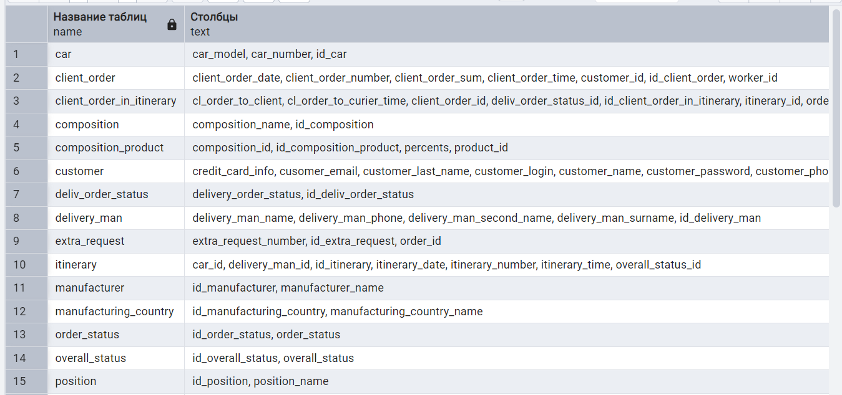  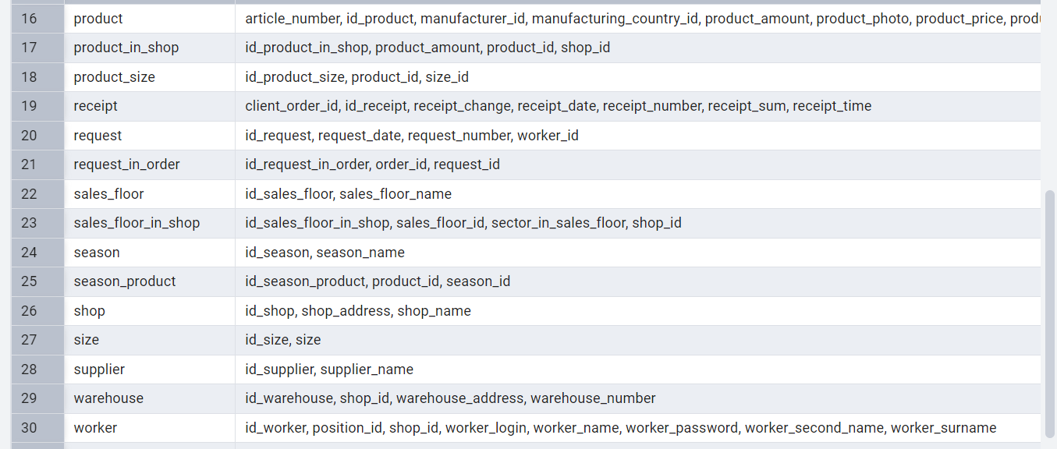
Результат удалённой БД | 

