CereBI – Daria Rosen – Assignment Answers

1. In-Depth Problem Understanding & Logical Solution Proposal
LogiDog operates across a global, multi-modal logistics network that handles thousands of daily shipments.
Delays can result from external factors (outside operational control) or internal operational inefficiencies.
Identifying at-risk shipments early enables intervention before a delay becomes customer-facing.
External Delay Factors (Implemented):
• Customs inspections (CustomsHold)
• Extreme weather disruptions (WeatherAlert)
• Port congestion slowing vessel movement (PortCongestion)
• Carrier capacity shortages (CapacityShortage)
• Missing or incorrect documentation (DocsMissing)
• Missed or incomplete pickup attempts (NoPickup)
• Long dwell times at logistics hubs (LongDwell)
• Lost or misdirected shipments (Lost)
Operational Delay Factors(Implemented):
• Hub congestion (HubCongestion)
• Documentation issues (DocsMissing)
• Delayed system scans → detected only after 72 hours (StaleStatus)
• Carrier underperformance → inferred via capacity shortage patterns
Early Delay Identification Logic (Simplified Flow):
Pre-checks
- Future shipments → Return immediately
- Completion check → Not at risk if delivered
- Cancellation check → Canceled if stuck >30 days AND 14+ days past ETA
Risk detection conditions
- Past ETA — always at risk
- StaleStatus — no update > 3 days
- MissedDeparture — within 3 days of ETA but still in early stage
- LongDwell — stuck in same stage > 2 days
- CustomsHold — stuck in customs > 1 day
- PortCongestion — stuck at port > 2 days
- NoPickup — awaiting pickup > 1 day
- HubCongestion — stuck at hub > 1 day
- WeatherAlert — weather keywords in any event
- CapacityShortage — capacity keywords in any event
- DocsMissing — documentation keywords in any event
- Delayed — fallback for past ETA with no other reasons
- Lost — for canceled shipments
Strong Predictive Data Signals:
• Timestamps (order date, event times) → timeline deviations
• Lane/geography (origin/destination) → congestion & risk profiles
• Mode & carrier → performance variability
• Dwell time at each milestone → operational bottlenecks
• Event descriptions → exceptions & disruptions
• Weather/external conditions → delays independent of operations
• Service level/priority → stricter deadlines
Data Needed for ML (Future):
• Historical carrier performance metrics
• Structured exception codes
• Quantified weather & congestion indices
• GPS / IoT movement data
• Consignee delivery attempt patterns
Alert Triggering Approach:
The prototype uses a rule-based approach due to its simplicity and high interpretability.
ML is planned later but requires significantly more historical data and labeled outcomes.
Rule-based advantages:
+ Transparent and easy to debug
+ Requires no large dataset
+ Predictable behavior
ML advantages (future):
+ Can identify complex patterns
+ Learns lane-mode-carrier seasonal trends

2. UX/UI Design for Alerts Dashboard
The Alerts Dashboard focuses on clarity, operational usability, and fast scanning of at-risk shipments.
Visual Design:
• Soft teal gradient background: from-teal-50 → #E6FFFA → teal-100
• Card-based layout with rounded corners for clean separation
• Typography: teal-900 for headings, teal-700 for body content
• Icons for mode, severity, and risk factors
Dashboard Components:
1. Summary Metrics (Top Row)
• Total at-risk shipments
• Severity distribution (donut chart)
• Top contributing risk factors (bar chart)
2. Filters & Search
• Global search (ID, destination, carrier)
• Filters: mode, severity, carrier, service level
• Advanced filters: origin, destination, owner, risk score range, daysToEta
3. At-Risk Table
• RiskScore badge (color-coded)
• Lane: origin → destination
• Mode/carrier
• CurrentStage
• plannedEta + daysToEta countdown
• RiskReasons icons
• Owner and acknowledgment state
Real-Time Data Updates:
Current approach: React Query polling every 2 minutes
→ Stable, simple to maintain, avoids reconnection logic.
SSE (futured), not implemented because:
• Requires backend stream endpoint + EventSource client handling
• Needs reconnection & heartbeat logic
• Adds complexity without a clear benefit at the prototype stage
• Polling is fully adequate for non-real-time-sensitive alerts
Data Structure for Display:
Current: Hybrid
• shipments table stores calculated fields: riskScore, severity, riskReasons[], daysToEta
• shipment_events stores a granular event timeline
• Client merges the two
Planned: Fully denormalized AlertShipment view for fast filtering.

Dashboard Screenshot
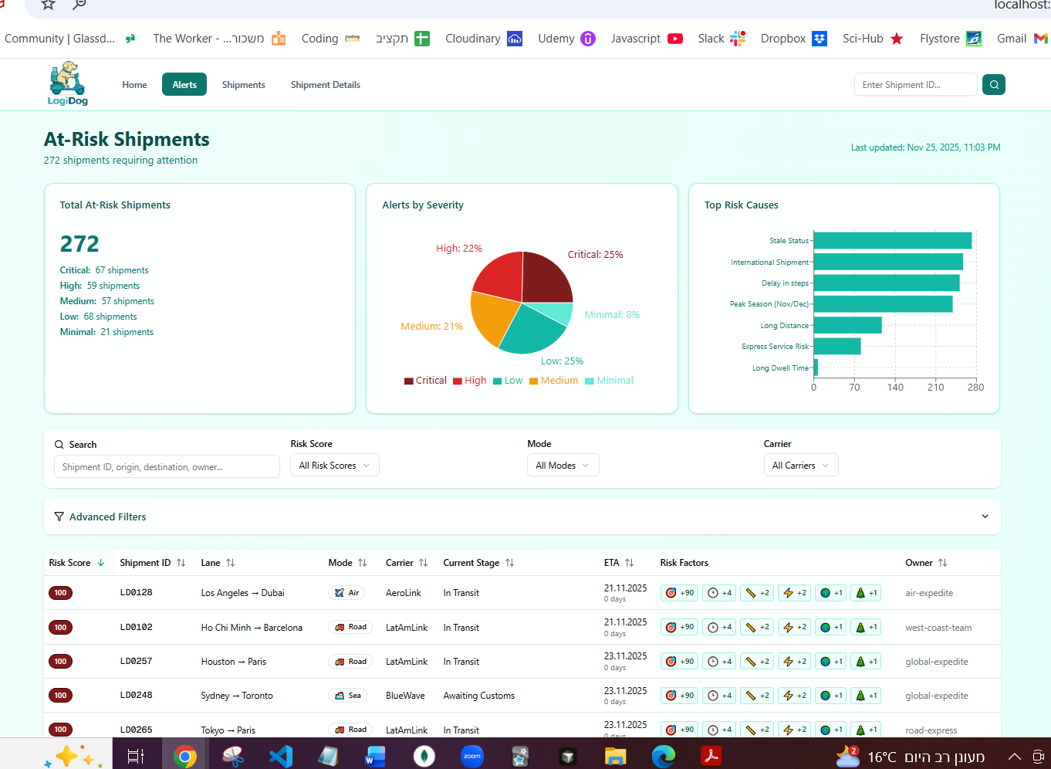

3. Sample Data & API Design
Sample Data:
The Supabase database contains over 300 shipments with diverse carriers, lanes, modes, and risk scenarios.
Every shipment includes planned ETA, calculated risk score, severity, reasons, and timeline events.
API Design:
Protocol: REST over HTTPS
SSE is planned but not yet implemented.
Endpoints:
• GET /api/alerts
Filters: severity, mode, carrier, origin, destination, owner, serviceLevel, search,
minRiskScore, maxRiskScore, minDaysToEta, maxDaysToEta, riskFactor
• GET /api/alerts/{shipmentId}
→ Returns detailed shipment with timeline (steps)
• POST /api/alerts/acknowledge
→ Acknowledges shipment alert
• GET /api/alerts/stream
→ NOT IMPLEMENTED (future SSE support)
AlertShipment Response Includes:
• shipmentId
• origin, destination
• mode
• carrierName
• serviceLevel
• currentStage
• plannedEta (ISO)
• daysToEta
• orderDate
• lastMilestoneUpdate
• riskScore (0–100)
• severity
• riskReasons[]
• riskFactorPoints {}
• owner
• acknowledged, acknowledgedBy, acknowledgedAt
• status (completed, in_progress, canceled, future)
• steps[] timeline

4. Delay Logic Implementation (TypeScript)
Sample Dataset Files:
- sample-shipments-dataset.json — JSON array matching the AlertShipment API response structure.
- SAMPLE_SHIPMENTS_DATASET_README.md — documentation explaining dataset structure, coverage, scenarios, and usage.
These files include 15 representative shipments covering all severity levels, transportation modes, major risk factors, and realistic timelines.
/**
* Simple rule-based delay detection.
*/
interface ShipmentData {
shipment_id: string;
order_date: string;
expected_delivery: string;
current_status: string;
events: { event_time: string; event_stage: string; description?: string }[];
}
export function isShipmentAtRisk(shipment: ShipmentData): boolean {
const now = new Date();
const expected = new Date(shipment.expected_delivery);
const daysSince = (d: Date) =>
(now.getTime() - d.getTime()) / (1000 * 60 * 60 * 24);
const daysUntil = (d: Date) =>
(d.getTime() - now.getTime()) / (1000 * 60 * 60 * 24);
// Safe handling of empty events
const latestEvent = shipment.events.length > 0
? shipment.events.sort(
(a, b) => new Date(b.event_time).getTime() - new Date(a.event_time).getTime()
)[0]
: null;
const lastUpdate = latestEvent
? new Date(latestEvent.event_time)
: new Date(shipment.order_date);
const daysPastEta = daysSince(expected);
const daysToEta = daysUntil(expected);
const currentStage = (latestEvent?.event_stage || shipment.current_status).toLowerCase();
// Completed shipments are always healthy
if (currentStage.includes("delivered") || currentStage.includes("package received"))
return false;
// Past ETA means delayed
if (daysPastEta > 0) return true;
// No updates for > 3 days
if (daysSince(lastUpdate) > 3) return true;
// Near ETA but still in an early stage
const earlyStage =
currentStage.includes("warehouse") ||
currentStage.includes("prepared") ||
currentStage.includes("packed") ||
currentStage.includes("collected") ||
currentStage.includes("ready for dispatch");
if (daysToEta <= 3 && earlyStage) return true;
return false;
}

