Отчет

Выполнила Сазонова Дарья ПКС-304

Вариант 1

Диаграмма базы данных:

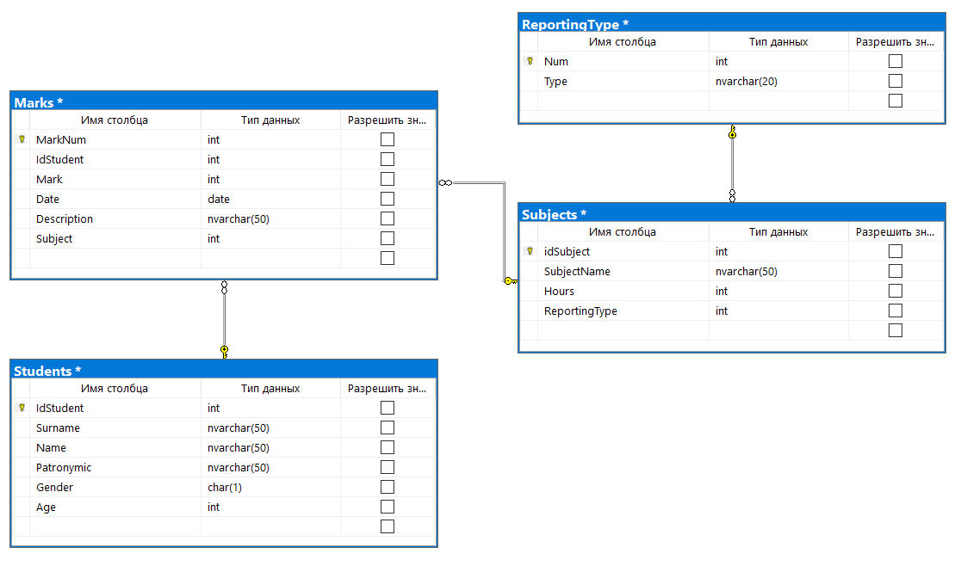

Скриншоты таблиц:

Marks:

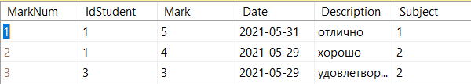

Reporting type:

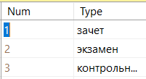

Students:

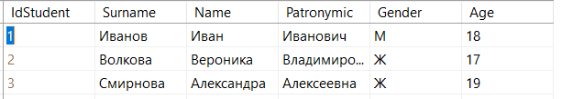

Subjects:

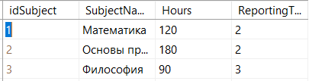

Просмотр таблиц:

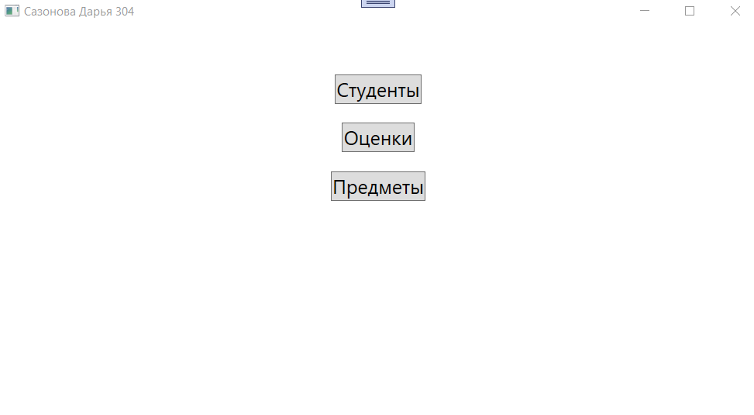

Просмотр таблицы Студентов:

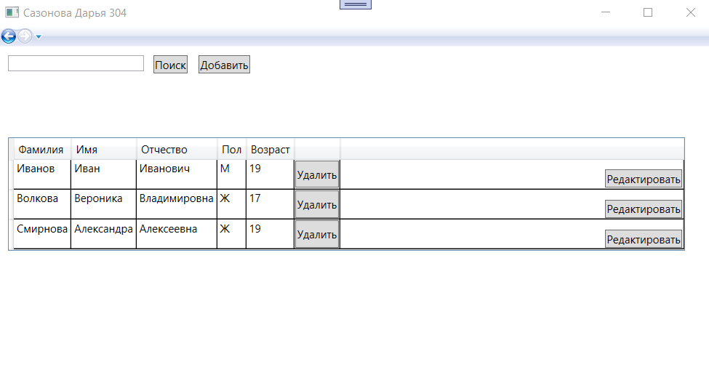

Просмотр таблицы оценки:

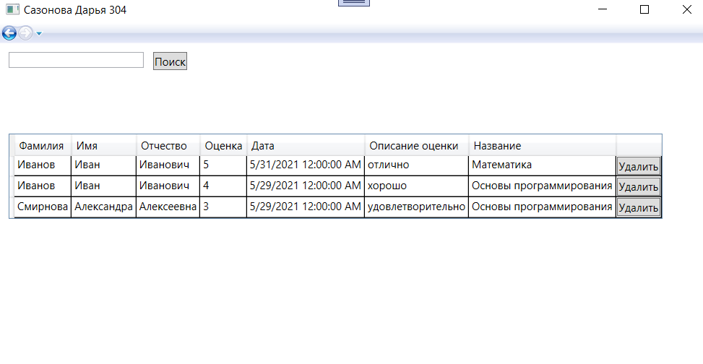

Просмотр таблицы предметы:

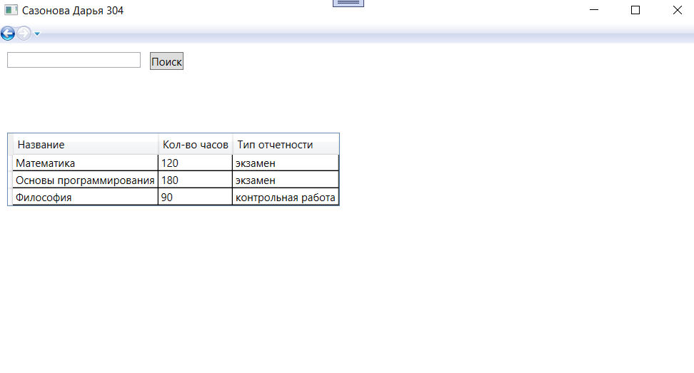

Поиск по всем полям(таблицы Студенты, Оценки, Предметы):

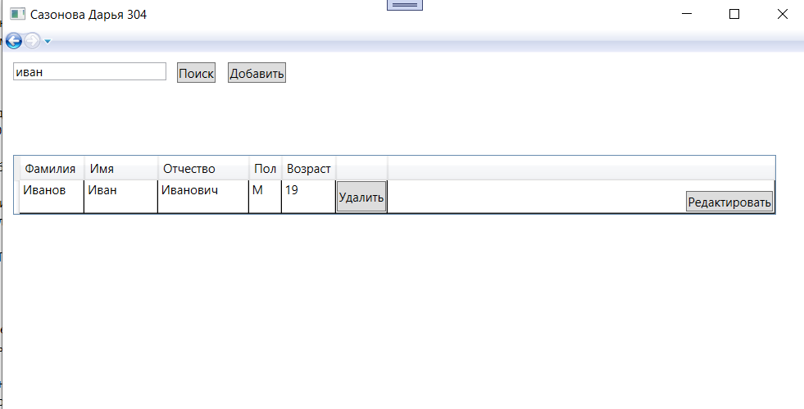

Добавление новых записей(в таблице Студенты):

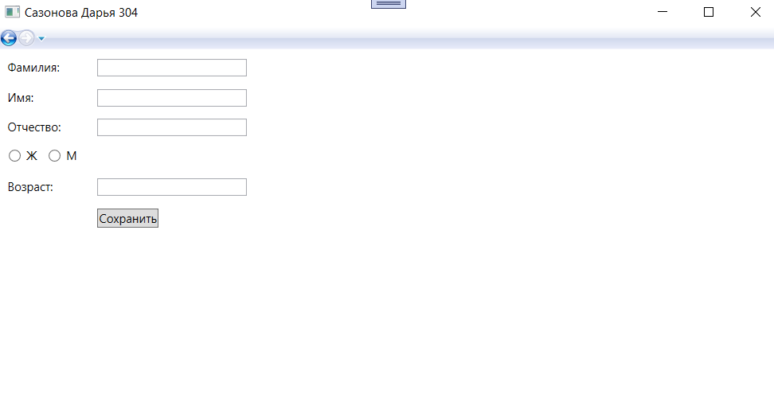

Редактирование(В таблице студенты):

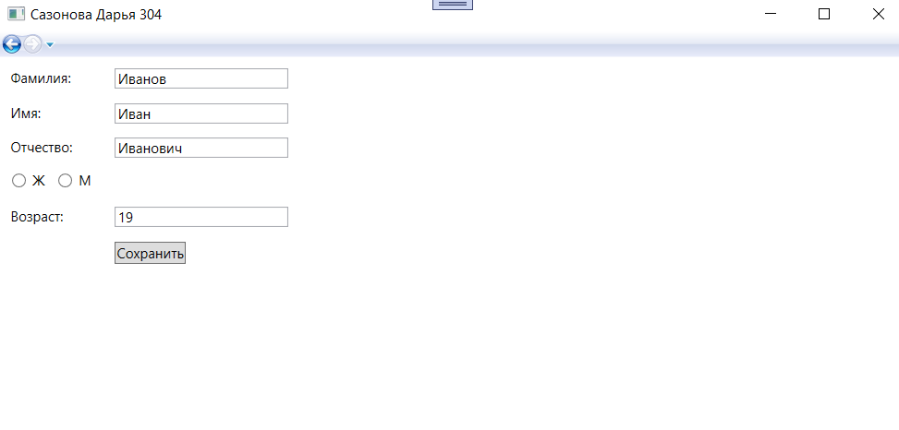

Удаление в таблице Студенты и оценки:

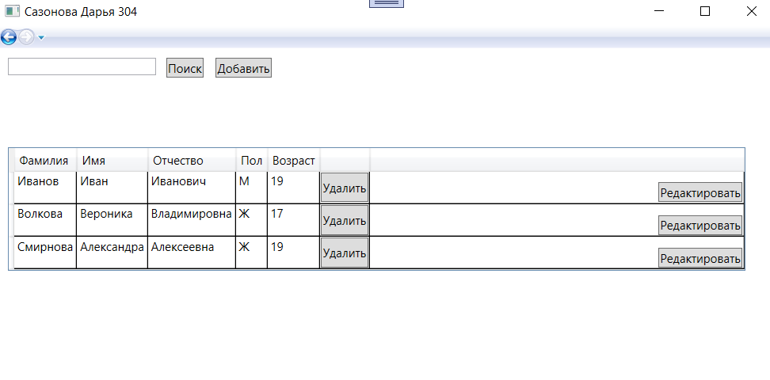

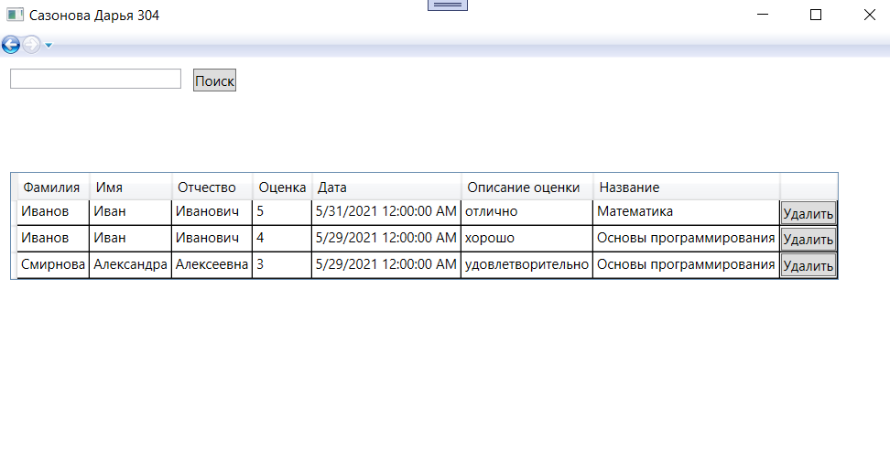

Скрипт:

USE [master]

GO

/****** Object: Database [kvalEkzSazonova304] Script Date: 29.06.2021 12:07:51 ******/

CREATE DATABASE [kvalEkzSazonova304]

CONTAINMENT = NONE

ON PRIMARY

( NAME = N'kvalEkzSazonova304', FILENAME = N'C:\Program Files\Microsoft SQL Server\MSSQL14.SQLEXPRESS\MSSQL\DATA\kvalEkzSazonova304.mdf' , SIZE = 8192KB , MAXSIZE = UNLIMITED, FILEGROWTH = 65536KB )

LOG ON

( NAME = N'kvalEkzSazonova304_log', FILENAME = N'C:\Program Files\Microsoft SQL Server\MSSQL14.SQLEXPRESS\MSSQL\DATA\kvalEkzSazonova304_log.ldf' , SIZE = 8192KB , MAXSIZE = 2048GB , FILEGROWTH = 65536KB )

GO

ALTER DATABASE [kvalEkzSazonova304] SET COMPATIBILITY_LEVEL = 140

GO

IF (1 = FULLTEXTSERVICEPROPERTY('IsFullTextInstalled'))

begin

EXEC [kvalEkzSazonova304].[dbo].[sp_fulltext_database] @action = 'enable'

end

GO

ALTER DATABASE [kvalEkzSazonova304] SET ANSI_NULL_DEFAULT OFF

GO

ALTER DATABASE [kvalEkzSazonova304] SET ANSI_NULLS OFF

GO

ALTER DATABASE [kvalEkzSazonova304] SET ANSI_PADDING OFF

GO

ALTER DATABASE [kvalEkzSazonova304] SET ANSI_WARNINGS OFF

GO

ALTER DATABASE [kvalEkzSazonova304] SET ARITHABORT OFF

GO

ALTER DATABASE [kvalEkzSazonova304] SET AUTO_CLOSE OFF

GO

ALTER DATABASE [kvalEkzSazonova304] SET AUTO_SHRINK OFF

GO

ALTER DATABASE [kvalEkzSazonova304] SET AUTO_UPDATE_STATISTICS ON

GO

ALTER DATABASE [kvalEkzSazonova304] SET CURSOR_CLOSE_ON_COMMIT OFF

GO

ALTER DATABASE [kvalEkzSazonova304] SET CURSOR_DEFAULT GLOBAL

GO

ALTER DATABASE [kvalEkzSazonova304] SET CONCAT_NULL_YIELDS_NULL OFF

GO

ALTER DATABASE [kvalEkzSazonova304] SET NUMERIC_ROUNDABORT OFF

GO

ALTER DATABASE [kvalEkzSazonova304] SET QUOTED_IDENTIFIER OFF

GO

ALTER DATABASE [kvalEkzSazonova304] SET RECURSIVE_TRIGGERS OFF

GO

ALTER DATABASE [kvalEkzSazonova304] SET DISABLE_BROKER

GO

ALTER DATABASE [kvalEkzSazonova304] SET AUTO_UPDATE_STATISTICS_ASYNC OFF

GO

ALTER DATABASE [kvalEkzSazonova304] SET DATE_CORRELATION_OPTIMIZATION OFF

GO

ALTER DATABASE [kvalEkzSazonova304] SET TRUSTWORTHY OFF

GO

ALTER DATABASE [kvalEkzSazonova304] SET ALLOW_SNAPSHOT_ISOLATION OFF

GO

ALTER DATABASE [kvalEkzSazonova304] SET PARAMETERIZATION SIMPLE

GO

ALTER DATABASE [kvalEkzSazonova304] SET READ_COMMITTED_SNAPSHOT OFF

GO

ALTER DATABASE [kvalEkzSazonova304] SET HONOR_BROKER_PRIORITY OFF

GO

ALTER DATABASE [kvalEkzSazonova304] SET RECOVERY SIMPLE

GO

ALTER DATABASE [kvalEkzSazonova304] SET MULTI_USER

GO

ALTER DATABASE [kvalEkzSazonova304] SET PAGE_VERIFY CHECKSUM

GO

ALTER DATABASE [kvalEkzSazonova304] SET DB_CHAINING OFF

GO

ALTER DATABASE [kvalEkzSazonova304] SET FILESTREAM( NON_TRANSACTED_ACCESS = OFF )

GO

ALTER DATABASE [kvalEkzSazonova304] SET TARGET_RECOVERY_TIME = 60 SECONDS

GO

ALTER DATABASE [kvalEkzSazonova304] SET DELAYED_DURABILITY = DISABLED

GO

ALTER DATABASE [kvalEkzSazonova304] SET QUERY_STORE = OFF

GO

USE [kvalEkzSazonova304]

GO

/****** Object: Table [dbo].[Marks] Script Date: 29.06.2021 12:07:51 ******/

SET ANSI_NULLS ON

GO

SET QUOTED_IDENTIFIER ON

GO

CREATE TABLE [dbo].[Marks](

[MarkNum] [int] IDENTITY(1,1) NOT NULL,

[IdStudent] [int] NOT NULL,

[Mark] [int] NOT NULL,

[Date] [date] NOT NULL,

[Description] [nvarchar](50) NOT NULL,

[Subject] [int] NOT NULL,

CONSTRAINT [PK_Marks] PRIMARY KEY CLUSTERED

(

[MarkNum] ASC

)WITH (PAD_INDEX = OFF, STATISTICS_NORECOMPUTE = OFF, IGNORE_DUP_KEY = OFF, ALLOW_ROW_LOCKS = ON, ALLOW_PAGE_LOCKS = ON) ON [PRIMARY]

) ON [PRIMARY]

GO

/****** Object: Table [dbo].[ReportingType] Script Date: 29.06.2021 12:07:51 ******/

SET ANSI_NULLS ON

GO

SET QUOTED_IDENTIFIER ON

GO

CREATE TABLE [dbo].[ReportingType](

[Num] [int] IDENTITY(1,1) NOT NULL,

[Type] [nvarchar](20) NOT NULL,

CONSTRAINT [PK_ReportingType] PRIMARY KEY CLUSTERED

(

[Num] ASC

)WITH (PAD_INDEX = OFF, STATISTICS_NORECOMPUTE = OFF, IGNORE_DUP_KEY = OFF, ALLOW_ROW_LOCKS = ON, ALLOW_PAGE_LOCKS = ON) ON [PRIMARY]

) ON [PRIMARY]

GO

/****** Object: Table [dbo].[Students] Script Date: 29.06.2021 12:07:51 ******/

SET ANSI_NULLS ON

GO

SET QUOTED_IDENTIFIER ON

GO

CREATE TABLE [dbo].[Students](

[IdStudent] [int] IDENTITY(1,1) NOT NULL,

[Surname] [nvarchar](50) NOT NULL,

[Name] [nvarchar](50) NOT NULL,

[Patronymic] [nvarchar](50) NOT NULL,

[Gender] [char](1) NOT NULL,

[Age] [int] NOT NULL,

CONSTRAINT [PK_Students] PRIMARY KEY CLUSTERED

(

[IdStudent] ASC

)WITH (PAD_INDEX = OFF, STATISTICS_NORECOMPUTE = OFF, IGNORE_DUP_KEY = OFF, ALLOW_ROW_LOCKS = ON, ALLOW_PAGE_LOCKS = ON) ON [PRIMARY]

) ON [PRIMARY]

GO

/****** Object: Table [dbo].[Subjects] Script Date: 29.06.2021 12:07:51 ******/

SET ANSI_NULLS ON

GO

SET QUOTED_IDENTIFIER ON

GO

CREATE TABLE [dbo].[Subjects](

[idSubject] [int] IDENTITY(1,1) NOT NULL,

[SubjectName] [nvarchar](50) NOT NULL,

[Hours] [int] NOT NULL,

[ReportingType] [int] NOT NULL,

CONSTRAINT [PK_Subjects] PRIMARY KEY CLUSTERED

(

[idSubject] ASC

)WITH (PAD_INDEX = OFF, STATISTICS_NORECOMPUTE = OFF, IGNORE_DUP_KEY = OFF, ALLOW_ROW_LOCKS = ON, ALLOW_PAGE_LOCKS = ON) ON [PRIMARY]

) ON [PRIMARY]

GO

SET IDENTITY_INSERT [dbo].[Marks] ON

INSERT [dbo].[Marks] ([MarkNum], [IdStudent], [Mark], [Date], [Description], [Subject]) VALUES (1, 1, 5, CAST(N'2021-05-31' AS Date), N'отлично', 1)

INSERT [dbo].[Marks] ([MarkNum], [IdStudent], [Mark], [Date], [Description], [Subject]) VALUES (2, 1, 4, CAST(N'2021-05-29' AS Date), N'хорошо', 2)

INSERT [dbo].[Marks] ([MarkNum], [IdStudent], [Mark], [Date], [Description], [Subject]) VALUES (3, 3, 3, CAST(N'2021-05-29' AS Date), N'удовлетворительно', 2)

SET IDENTITY_INSERT [dbo].[Marks] OFF

GO

SET IDENTITY_INSERT [dbo].[ReportingType] ON

INSERT [dbo].[ReportingType] ([Num], [Type]) VALUES (1, N'зачет')

INSERT [dbo].[ReportingType] ([Num], [Type]) VALUES (2, N'экзамен')

INSERT [dbo].[ReportingType] ([Num], [Type]) VALUES (3, N'контрольная работа')

SET IDENTITY_INSERT [dbo].[ReportingType] OFF

GO

SET IDENTITY_INSERT [dbo].[Students] ON

INSERT [dbo].[Students] ([IdStudent], [Surname], [Name], [Patronymic], [Gender], [Age]) VALUES (1, N'Иванов', N'Иван', N'Иванович', N'М', 19)

INSERT [dbo].[Students] ([IdStudent], [Surname], [Name], [Patronymic], [Gender], [Age]) VALUES (2, N'Волкова', N'Вероника', N'Владимировна', N'Ж', 17)

INSERT [dbo].[Students] ([IdStudent], [Surname], [Name], [Patronymic], [Gender], [Age]) VALUES (3, N'Смирнова', N'Александра', N'Алексеевна', N'Ж', 19)

SET IDENTITY_INSERT [dbo].[Students] OFF

GO

SET IDENTITY_INSERT [dbo].[Subjects] ON

INSERT [dbo].[Subjects] ([idSubject], [SubjectName], [Hours], [ReportingType]) VALUES (1, N'Математика', 120, 2)

INSERT [dbo].[Subjects] ([idSubject], [SubjectName], [Hours], [ReportingType]) VALUES (2, N'Основы программирования', 180, 2)

INSERT [dbo].[Subjects] ([idSubject], [SubjectName], [Hours], [ReportingType]) VALUES (3, N'Философия', 90, 3)

SET IDENTITY_INSERT [dbo].[Subjects] OFF

GO

ALTER TABLE [dbo].[Marks] WITH CHECK ADD CONSTRAINT [FK_Marks_Students] FOREIGN KEY([IdStudent])

REFERENCES [dbo].[Students] ([IdStudent])

GO

ALTER TABLE [dbo].[Marks] CHECK CONSTRAINT [FK_Marks_Students]

GO

ALTER TABLE [dbo].[Marks] WITH CHECK ADD CONSTRAINT [FK_Marks_Subjects] FOREIGN KEY([Subject])

REFERENCES [dbo].[Subjects] ([idSubject])

GO

ALTER TABLE [dbo].[Marks] CHECK CONSTRAINT [FK_Marks_Subjects]

GO

ALTER TABLE [dbo].[Subjects] WITH CHECK ADD CONSTRAINT [FK_Subjects_ReportingType] FOREIGN KEY([ReportingType])

REFERENCES [dbo].[ReportingType] ([Num])

GO

ALTER TABLE [dbo].[Subjects] CHECK CONSTRAINT [FK_Subjects_ReportingType]

GO

ALTER TABLE [dbo].[Marks] WITH CHECK ADD CONSTRAINT [CK_Marks] CHECK (([Mark]>=(1) AND [Mark]<=(5)))

GO

ALTER TABLE [dbo].[Marks] CHECK CONSTRAINT [CK_Marks]

GO

/****** Object: StoredProcedure [dbo].[viewMarks] Script Date: 29.06.2021 12:07:51 ******/

SET ANSI_NULLS ON

GO

SET QUOTED_IDENTIFIER ON

GO

CREATE PROC [dbo].[viewMarks]

AS

BEGIN

select MarkNum, Subjects.SubjectName, Surname, Name, Patronymic, Mark, Date, Description

From marks

join students on students.idStudent = marks.idStudent

join Subjects on Subjects.idSubject=marks.Subject

END

GO

/****** Object: StoredProcedure [dbo].[viewSearchMarks] Script Date: 29.06.2021 12:07:51 ******/

SET ANSI_NULLS ON

GO

SET QUOTED_IDENTIFIER ON

GO

Create PROC [dbo].[viewSearchMarks]

@seachString nvarchar(50)

AS

BEGIN

select Subjects.SubjectName, Surname, Name, Patronymic, Mark, Date, Description

From marks

join students on students.idStudent = marks.idStudent

join Subjects on Subjects.idSubject=marks.Subject

where SubjectName like '%'+@seachString+'%' or Surname like '%'+@seachString+'%' or name like '%'+@seachString+'%' or patronymic like '%'+@seachString+'%' or Mark like '%'+@seachString+'%' or Description like '%'+@seachString+'%' or Date like '%'+@seachString+'%'

END

GO

/****** Object: StoredProcedure [dbo].[viewSearchStudents] Script Date: 29.06.2021 12:07:51 ******/

SET ANSI_NULLS ON

GO

SET QUOTED_IDENTIFIER ON

GO

CREATE PROC [dbo].[viewSearchStudents]

@seachString nvarchar(50)

AS

BEGIN

select *

From Students

where surname like '%'+@seachString+'%' or name like '%'+@seachString+'%' or patronymic like '%'+@seachString+'%'

END

GO

/****** Object: StoredProcedure [dbo].[viewSearcSubjects] Script Date: 29.06.2021 12:07:51 ******/

SET ANSI_NULLS ON

GO

SET QUOTED_IDENTIFIER ON

GO

Create PROC [dbo].[viewSearcSubjects]

@seachString nvarchar(50)

AS

BEGIN

select SubjectName, Hours, type

From subjects

join ReportingType on subjects.ReportingType=ReportingType.Num

where SubjectName like '%'+@seachString+'%' or Hours like '%'+@seachString+'%' or type like '%'+@seachString+'%'

END

GO

/****** Object: StoredProcedure [dbo].[viewSubjects] Script Date: 29.06.2021 12:07:51 ******/

SET ANSI_NULLS ON

GO

SET QUOTED_IDENTIFIER ON

GO

CREATE PROC [dbo].[viewSubjects]

AS

BEGIN

select SubjectName, Hours, type

From subjects

join ReportingType on subjects.ReportingType=ReportingType.Num

END

GO

USE [master]

GO

ALTER DATABASE [kvalEkzSazonova304] SET READ_WRITE

GO