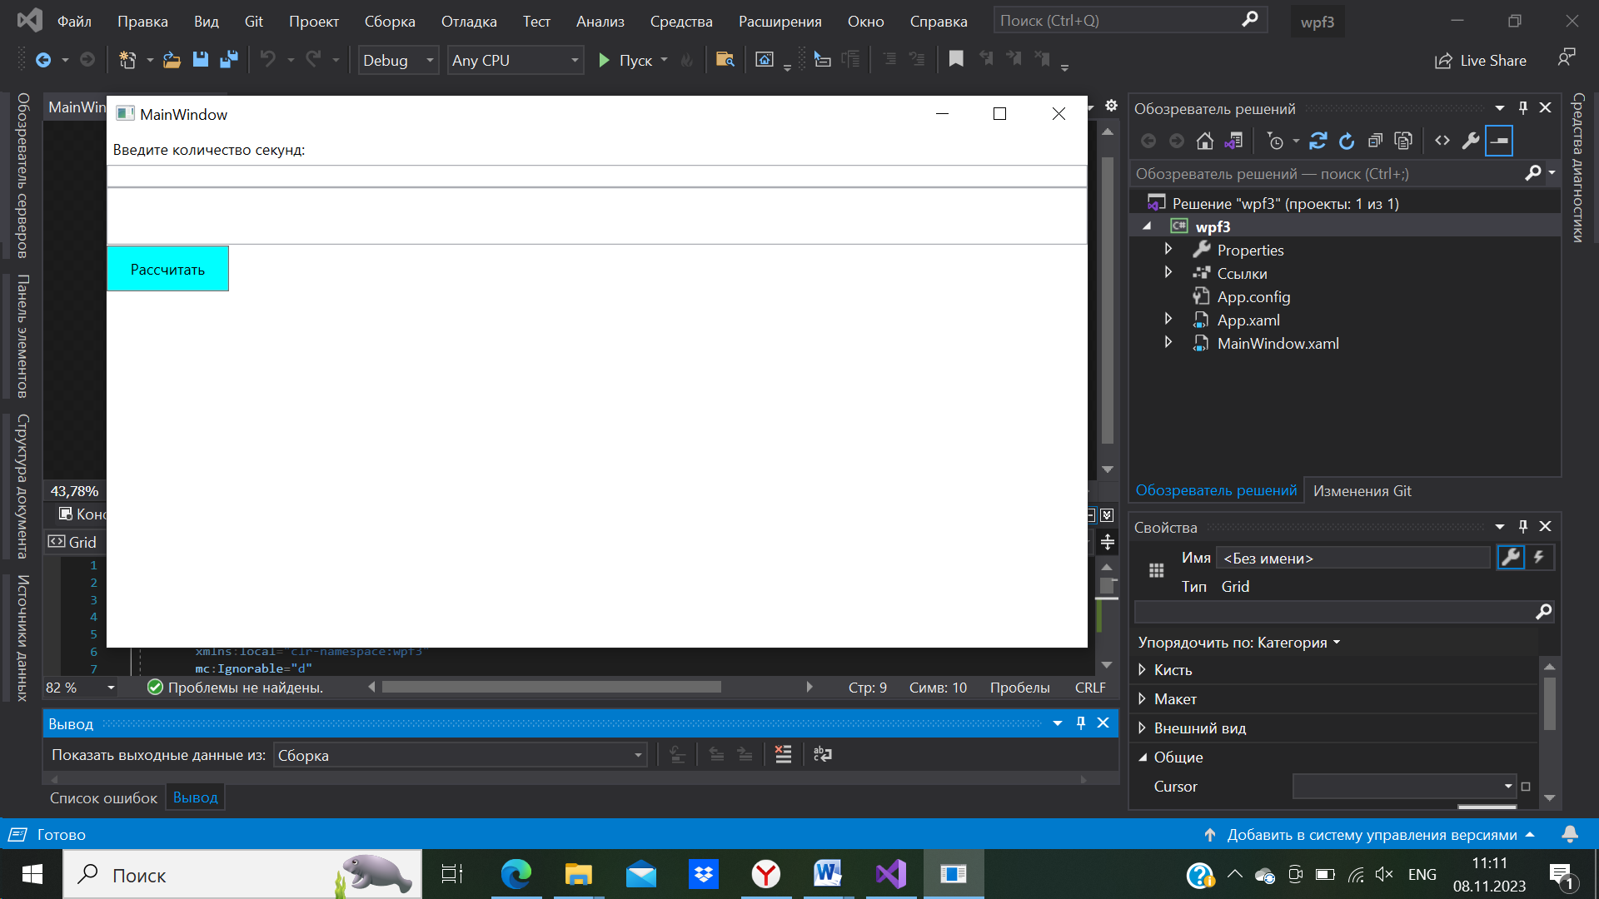

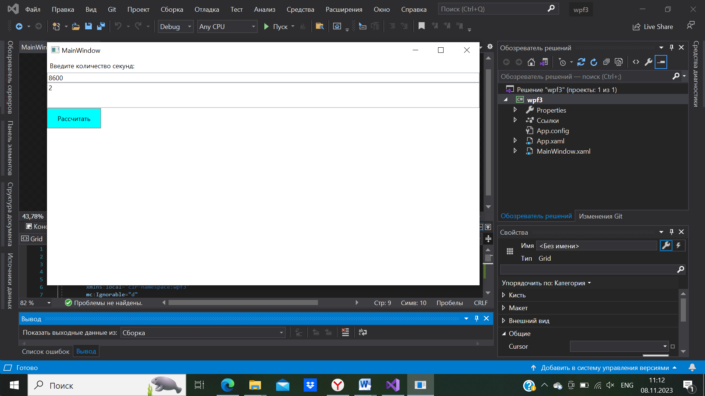

<Window x:Class="wpf3.MainWindow"

xmlns="http://schemas.microsoft.com/winfx/2006/xaml/presentation"

xmlns:x="http://schemas.microsoft.com/winfx/2006/xaml"

xmlns:d="http://schemas.microsoft.com/expression/blend/2008"

xmlns:mc="http://schemas.openxmlformats.org/markup-compatibility/2006"

xmlns:local="clr-namespace:wpf3"

mc:Ignorable="d"

Title="MainWindow" Height="450" Width="800">

<Grid>

<Grid.RowDefinitions>

<RowDefinition Height="Auto"/>

<RowDefinition Height="Auto"/>

<RowDefinition Height="Auto"/>

</Grid.RowDefinitions>

<Label Content="Введите количество секунд:"/>

<TextBox x:Name="secondsTextBox" Grid.Row="1"/>

<Button Content="Рассчитать" Click="CalculateButton_Click" Grid.Row="2" Margin="0,47,687.333,-37.333" Background="Cyan" />

<Label Content="Полные часы:" Grid.Row="3" Margin="0 10"/>

<TextBox x:Name="hoursTextBox" Grid.Row="4" IsReadOnly="True"/>

</Grid>

</Window>

namespace wpf3

{

/// <summary>

/// Логика взаимодействия для MainWindow.xaml

/// </summary>

public partial class MainWindow : Window

{

public MainWindow()

{

InitializeComponent();

}

private void CalculateButton_Click(object sender, RoutedEventArgs e)

{

int seconds = int.Parse(secondsTextBox.Text);

int hours = seconds / 3600; // 1 час

hoursTextBox.Text = hours.ToString();

}

}

}