CIS 4000 Progress Report
Student Name
Week 6 or Week 10

Project Overview

The project name is FinanceHuddle as the name fits the long-term goal of expanding to American sports other than the NFL. The website’s domain name will be firstdownhub so that the current Football-specific focus is clear to users. The website’s purpose is to display information on all 32 NFL teams regarding financials, including top 5 highest contracts, remaining salary cap, and other data to give users a better understanding of where each franchise is positioned. The intended users will include those who want to be more knowledgeable about financial factors that would influence specific team capabilities.

Current Project Status

Currently, the web page has no visually presentable progress. I was able to recreate a banner from the inspiration page using copilot for the CSS. I understand that I have poorly performed in this phase.

What Has Gone Well

I was able to find a reference point and better understand the complications of established code being used for personal creations. I am more familiar with VS Code and it is my preferred environment currently to use.

Challenges and Problem Solving

Explain challenges you encountered, how you approached them, and what you learned from solving (or attempting to solve) them.

I attempted to take the html from a reference website, and then strip the unnecessary code to use the established UI and color palette so that I can have a template for duplicating and then changing variables per file. Each team should have a file. Troubleshooting took longer than anticipated and I was unable to cleanly repurpose the code for the intended use in the time I dedicated. I learned it most likely better to only take pieces if I outsource any code so that I do not clutter up the file.

Next Steps

My goals are to fix my shortcomings and catch back up so that I am on pace for an optimal amount of progress by the end of the project timeline. I will dedicate even more time to account for issues ahead of the deadline. For the next phase, my home page will include a functioning selection banner to navigate between each team, as well as a quick ranking of teams containing the most salary cap. I will also have a standardized template to use for all 32 NFL teams for easy user navigation , aside from thematics. The standardized templates will all include information include the top 3 highest player contracts currently, salary cap, and team net worth.

Resources and Tools Used

I used Github Pages, nfl.com, https://www.nfl.com/teams/new-orleans-saints/, and VSCode during my work. I hosted with Github Pages while using VS Code as my coding environment to commit and push updates to my code.

Generative AI Use (If Applicable)

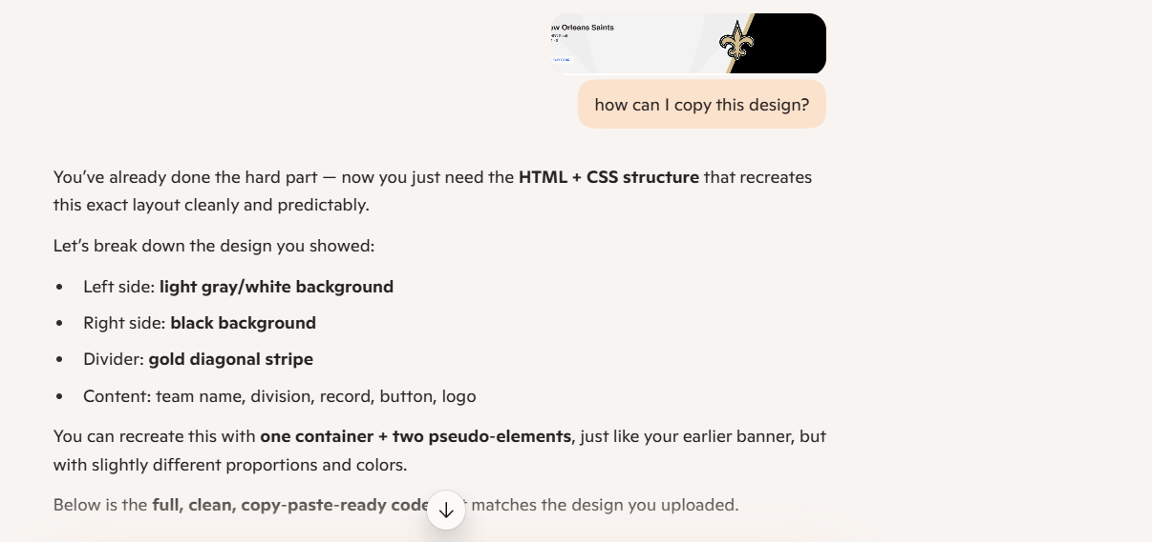
I had to retype the prompt because the image was not showing up anymore to accurately show my prompt. This was used to help generate CSS for the banner aspect.
Links to Project Artifacts

https://github.com/Darian-Blanch/cis3020project/tree/main

