# Feature Observations

## Age

|  |  |
| --- | --- |
| Figure : Histogram of the age feature | * Uniform distribution with people making >50K   + Goes up at 20s and peaks at people in their 30s and 40s * <=50K income is heavily skewed right, goes down as age increases   + However people in there 60s and above could just be because of population |

## Workclass

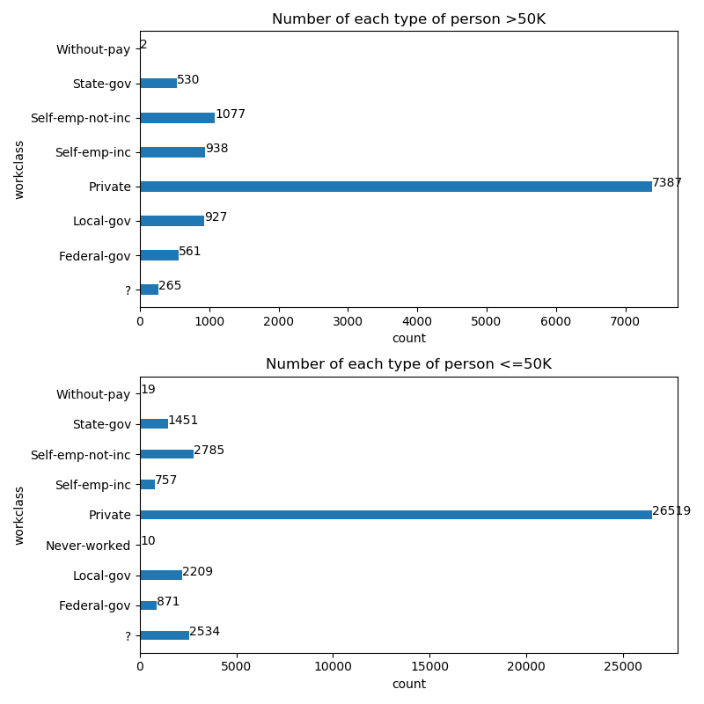

* Self-emp-inc is higher in the population of >50K than <=50K (approximately 24% difference)
* Never-worked doesn’t appear in the >50K population but only has 10 entries

## Education

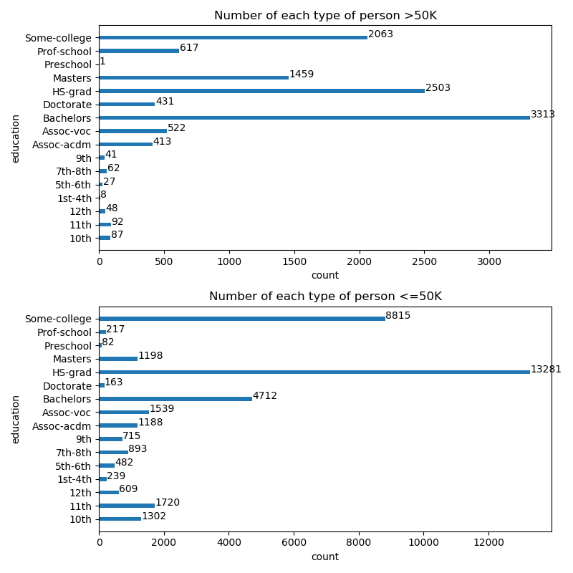

* 3/4’s of people with prof-school education make >50K
* Only 1 person with their highest as preschool has an income of >50K
* Most people with highest education as high-school makes less than 50K (16% makes more)
  + Even less with a highest education below high-school make >50k
* Most people with doctorate make more than 50K

## Marital-status

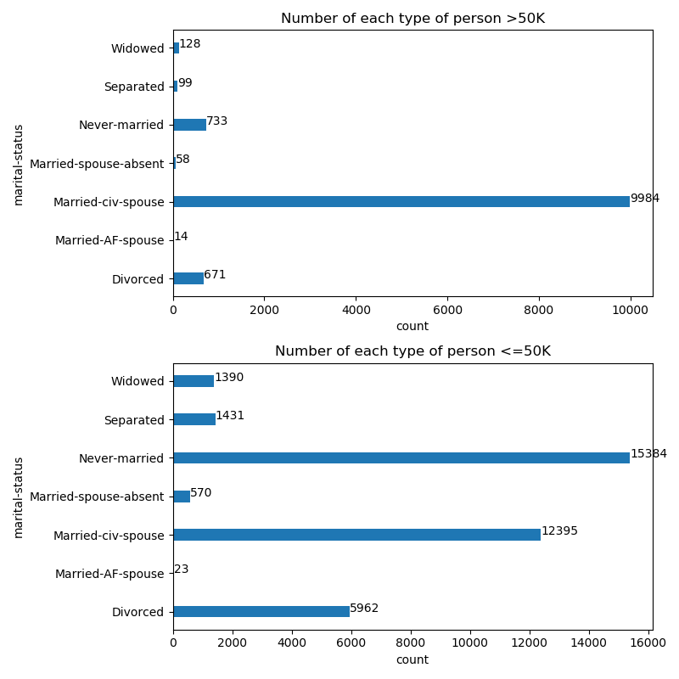

* Majority of people who make >50K annually are married-civ-spouse
* Only 4.5% of people who never-married make more than 50K annually
* Very few outside of married makes more than 50K annually

## Occupation

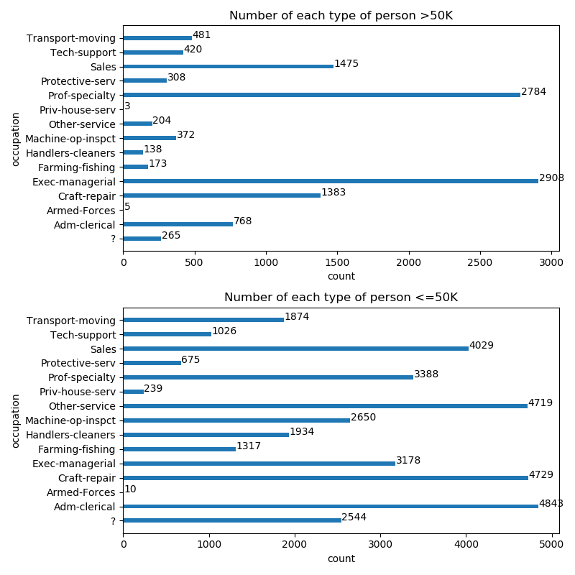

* >50K and <=50K annually almost have the same amount of people who occupation is Exec-managerial
* Only 3 priv-house-serv make more than 50K annually out of 242 with the occupation
* ? does appear to have people >50K but it is very few (approximately 10%)

## Relationship

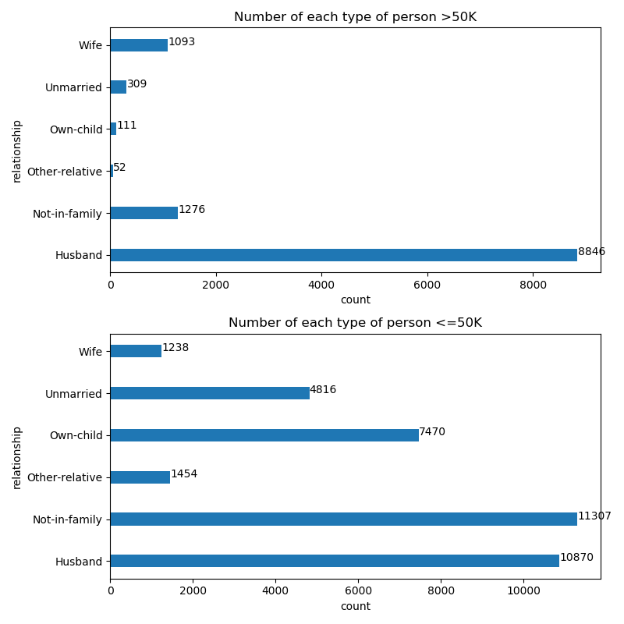

* Majority of people making >50K are a wife or husband
* Very few unmarried, own-child, other-relative make >50K

## Sex

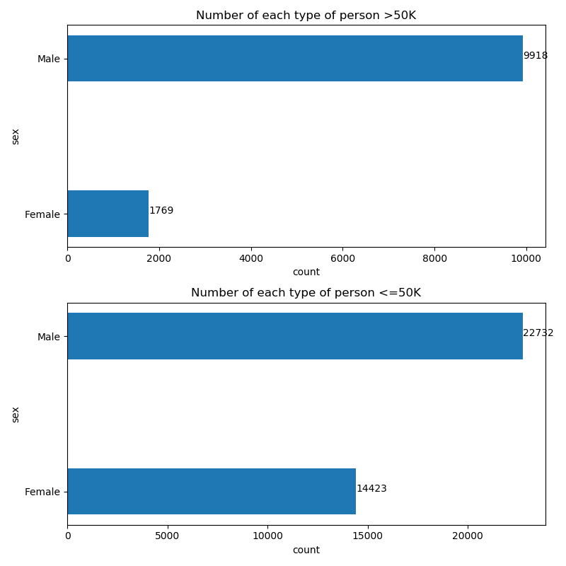

* Males are more likely to make >50K a year (30% of males and 11% females make >50K annually)

## Hours-per-week

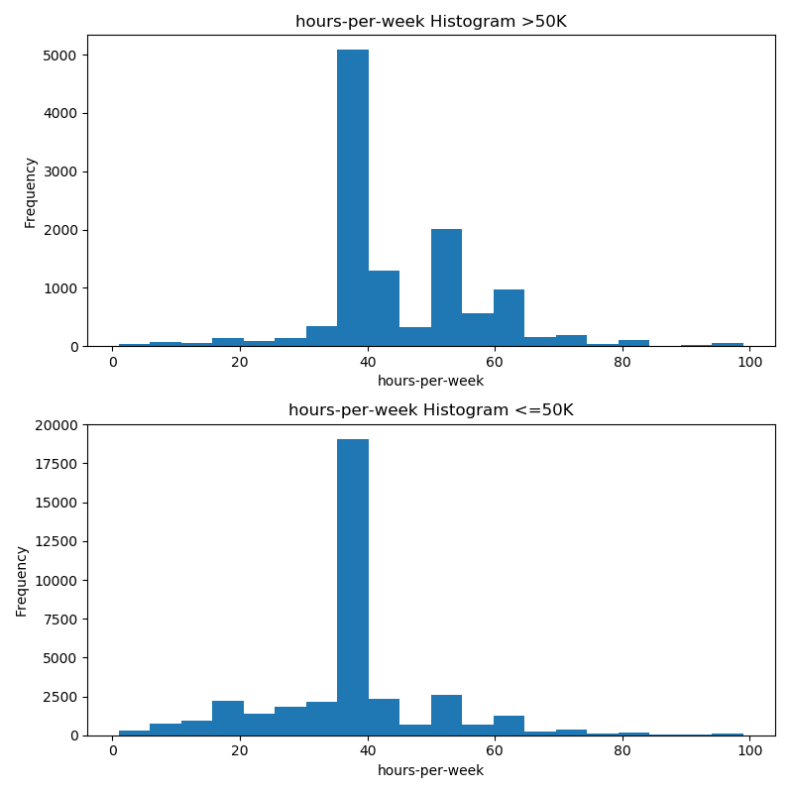

* A majority of people worked 40 hours but not much working less than 40 hours make >50K a year

## Features that didn’t really show much

* Fnlwgt, Race, Native-country, Capital-Gain, Capital-loss, Education-num (same as education but less information)