**Universidad De Las Fuerzas Armadas - ESPE**

**Members:** Josué Merino, Darian Martinez

**Theme:** Summary of Chapter 6 *“Objects and Data Structures”*

We have a reason to keep our variables secret. We do not want to depend on anyone. We want to be independent and we want to be creative in some way or implementation.

**Data Structures:** The two examples illustrate the differences between representations of objects and data. This includes the data on the back of the tablet and reveals the active data functions. The data structure provides data and does not have a useful function.

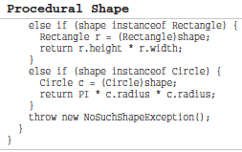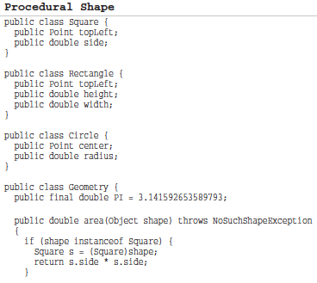

**The Law of Demeter:** It says that the unit does not have to know the inside of the objects it uses. The object hides the data and assumes its function. This means that the object must not reveal its internal structure through the accessors because to do so is to expose, rather than to hide, its internal structure.

**Data Transfer Objects:** The quintessential form of a data structure is a class with public variables and no func-tions. This is sometimes called a data transfer object, or DTO. DTOs are very useful struc-tures, especially when communicating with databases or parsing messages from sockets, and so on. They often become the ﬁrst in a series of translation stages that convert raw data in a database into objects in the application code.

**Conclusion:** Objects expose behavior and hide data. This makes it easy to add new kinds of objects without changing existing behaviors. It also makes it hard to add new behaviors to existing objects. Data structures expose data and have no signiﬁcant behavior. This makes it easy to add new behaviors to existing data structures but makes it hard to add new data structures to existing functions.