Name: DANKWA RICHARD

Index Number: 4610718

Project Supervisor: DR. ERIC OSEI

**PROJECT TOPIC** : HOSTEL INFORMATION WEBSITE



**Table of Contents**

CHAPTER 1 : INTRODUCTION

1.0 Problem Statement……………………………………………………….2

1.1 Aim of Project…………………………………………………………....2

1.2 Project Scope…………………………..…………………………………2

CHAPTER 2 : DEVELOPMENT TOOLS AND PLATFORMS CONSIDERATION

2.0 Development tools and platforms consideration…………………………2

2.1 Database Design…………………………………………………………2

2.2 User Interfaces……………………………………………………………3

CHAPTER 3: TESTING AND IMPLEMENTATION

3.0 Testing……………………………………………………………………5

3.1 Deployment model and platforms………………………………………..5

CHAPTER 4: CONCLUSIONS AND RECOMMENDATIONS

4.0 Conclusions……………………………………………………………...5

4.2 References……………………………………………………………….5

**CHAPTER 1: INTRODUCTION**

**1.0 PROBLEM STATEMENT**

Very often, most students find it frustrating going to hostels to make in inquiry and find one of their choice, even sometimes they go do not find that they want and even if they do find they may not be able to afford the place which often leads to waste of precious time , energy and resources. How about a website to display hostels, their environment , their contacts, reviews and other information about the hostels so that students can check online before making a choice.

* 1. **AIM OF PROJECT**

This website application makes students see various hostels and choose one of their choice before even going forward to gain accommodation there.

**1.2 PROJECT SCOPE**

The scope of the project is exclusive to KNUST students who wish to find accommodation in private hostels in the environ of the university.

**CHAPTER 2 : METHOLOGY**

**2.0 DEVELOPMENT TOOLS AND PLATFORMS CONSIDERATION**

This web application was designed using JavaScript, HTML, CSS, and MYSQL together with PHP.

CSS was used to design the interface by adding different styles to the individual pages and making the application user friendly.

JavaScript was used to make the web application dynamic by performing specified functions.

MYSQL was used to create the database and used for storage.

PHP was used to query the database.

This web application can be used on any web browser and is web based.

**2.1 DATABASE DESIGN**

This section contains information about the database .The accounts table contains the id, username, password, email, gender with the id as the primary key. The diagram below shows the table in the database .

|  |
| --- |
| **Customer** |
| id |
| username |
| password |
| email |
| gender |
| phone |

**2.2 USER INTERFACES**

Whenever the website is opened, the homepage opened consists of the login link and the sign up link and a drop menu of the various areas around the university campus. Every user needs to sign in first before getting access to the information about the hostels.

After selecting the area of your choice , a list of hostels peculiar to your selection is displayed for you choose from.

Hostel information is displayed specifying hostel facilities, reviews, contact information amongst others. 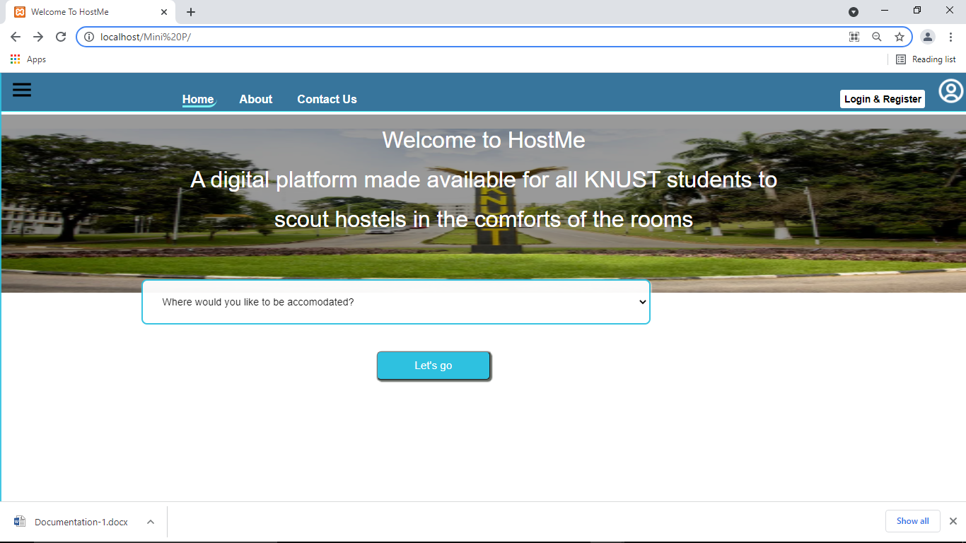

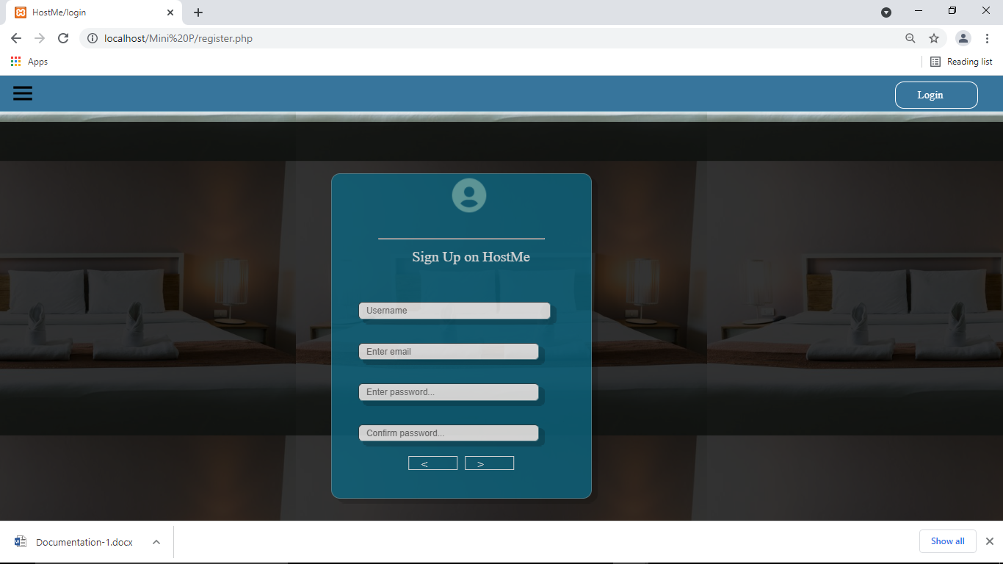 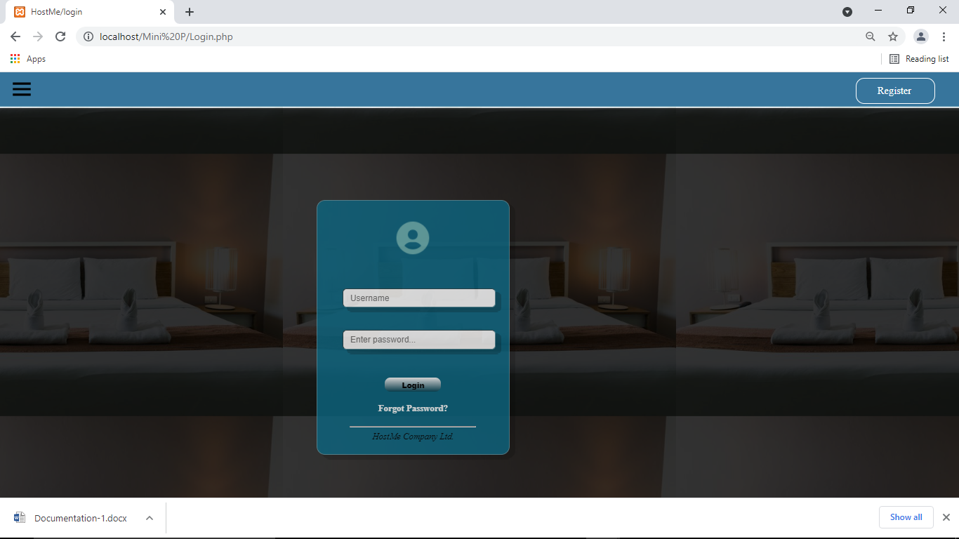

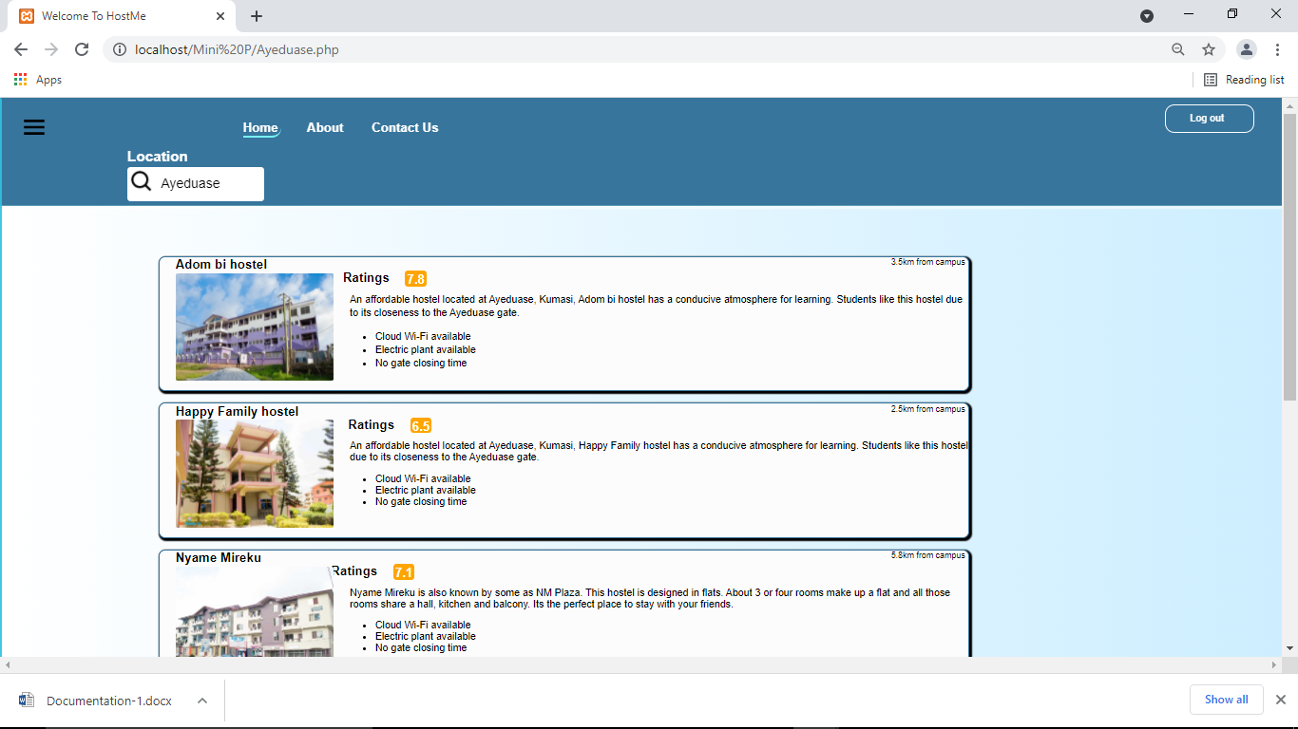

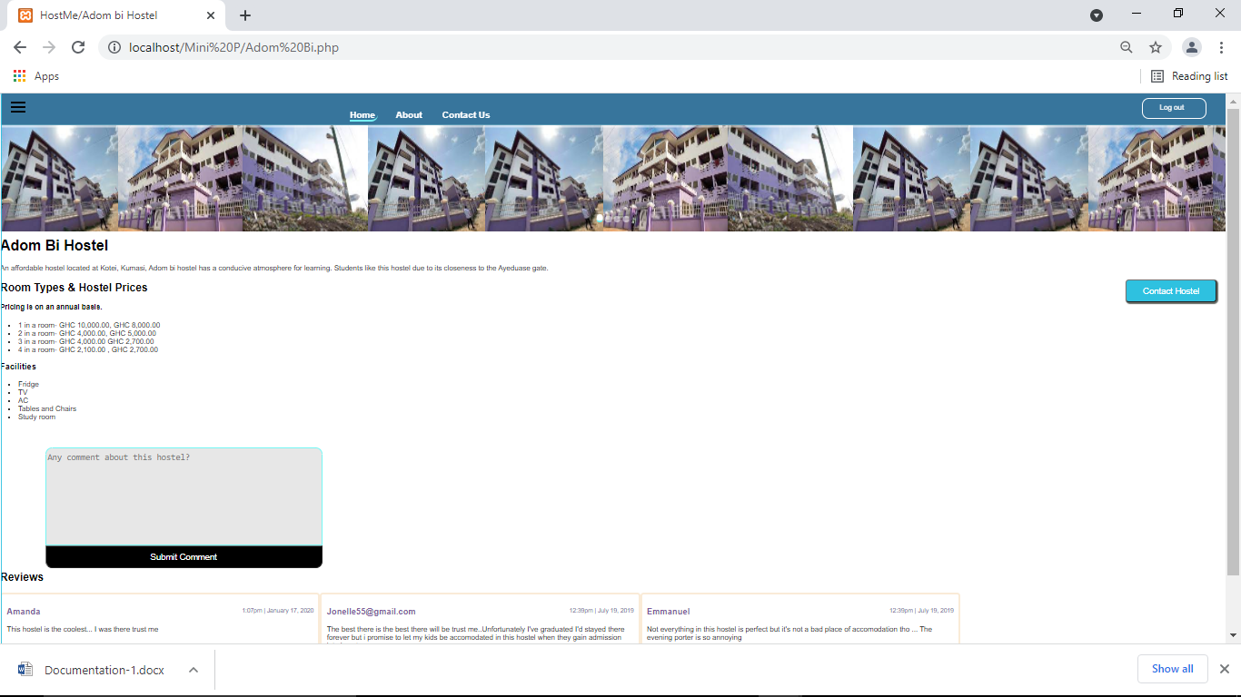

**CHAPTER 3: TESTING AND IMPLEMENTATION**

**3.0 TESTING**

After the implementation of the codes for this proposed system, various testing techniques were used to test the functionality of the system. This proposed system was tested on a Lenovo laptop on the Google chrome browser.

**3.1 DEPLOYMENT MODEL AND PLATFORMS**

The deployment model used in this proposed system is Multi User Deployment. This means that the proposed system can only work when the local server is installed on the devices of multiple users before a booking can be done. Also, this proposed system can function on laptop, pcs. This proposed system can’t work on mobile devices since the local server can function only on laptops and personal computers.

**CHAPTER 4: CONCLUSIONS AND RECOMMENDATIONS**

**4.0 CONCLUSIONS**

Building this project initially was presumed to be relatively difficult and after encountering all of the problems I faced, I realized that there was more to it than just thinking or imaging because implementing an idea is very challenging since I had about just handful knowledge in android programming.

Finally, I must conclude by saying, this project has been a very challenging academic exercise that has given me a lot experience from understanding error messages in order to debug them to applying all that I have been taught from my first lecture to my last lecture.

.

**4.1 REFRENCES**

[**https://www.**](https://www.smartdraw.com/uml-diagram/)**hostelworld.com**

[**https://library.sacredheart.edu/c.php?g=29803&p=185933**](https://library.sacredheart.edu/c.php?g=29803&p=185933)

[**https://www.**](https://www.)**w3schools.com**

[https://www.stackoverflow.com](https://www.stackoverflow.com/)

[https://en.m.wikipedia.org](https://en.m.wikipedia.org/)