Amazon - 4

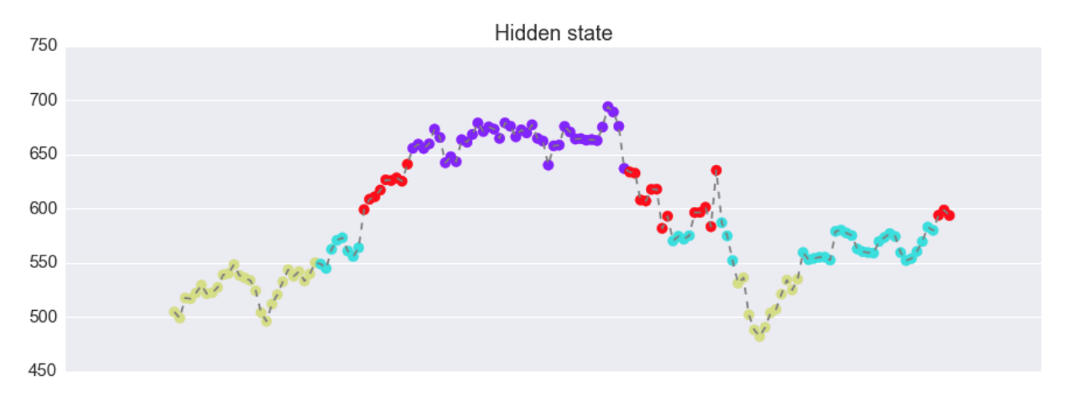

5

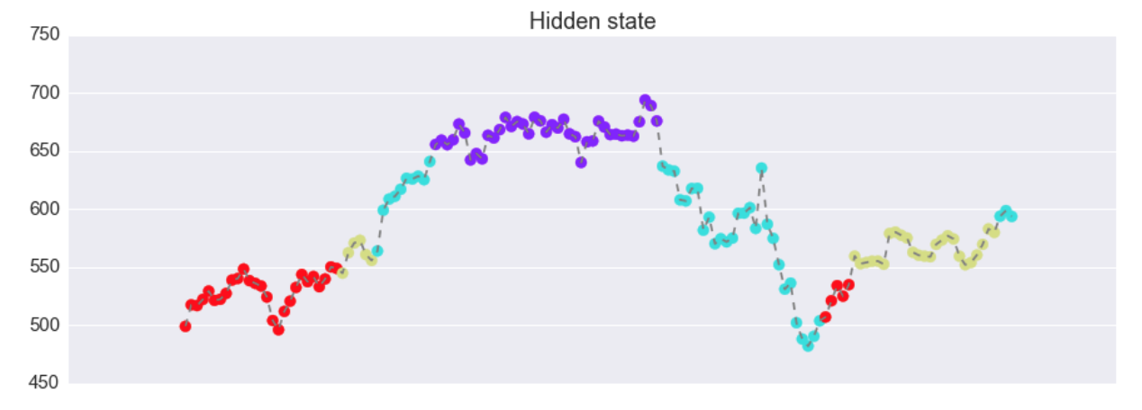

predict

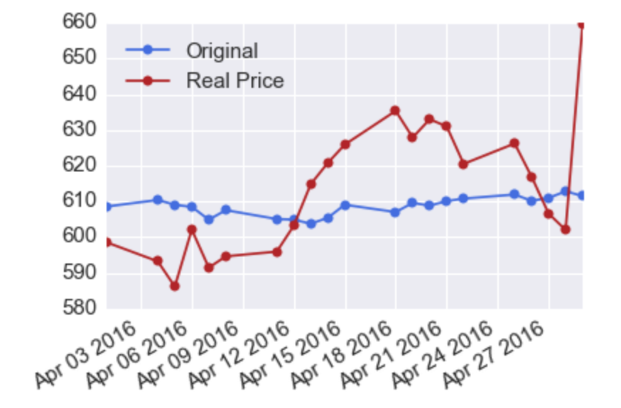

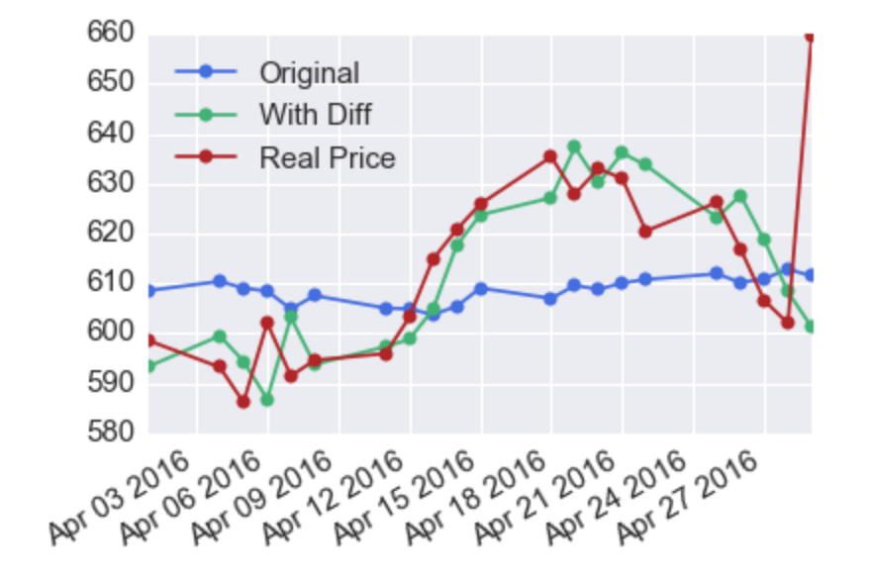

Linkedin

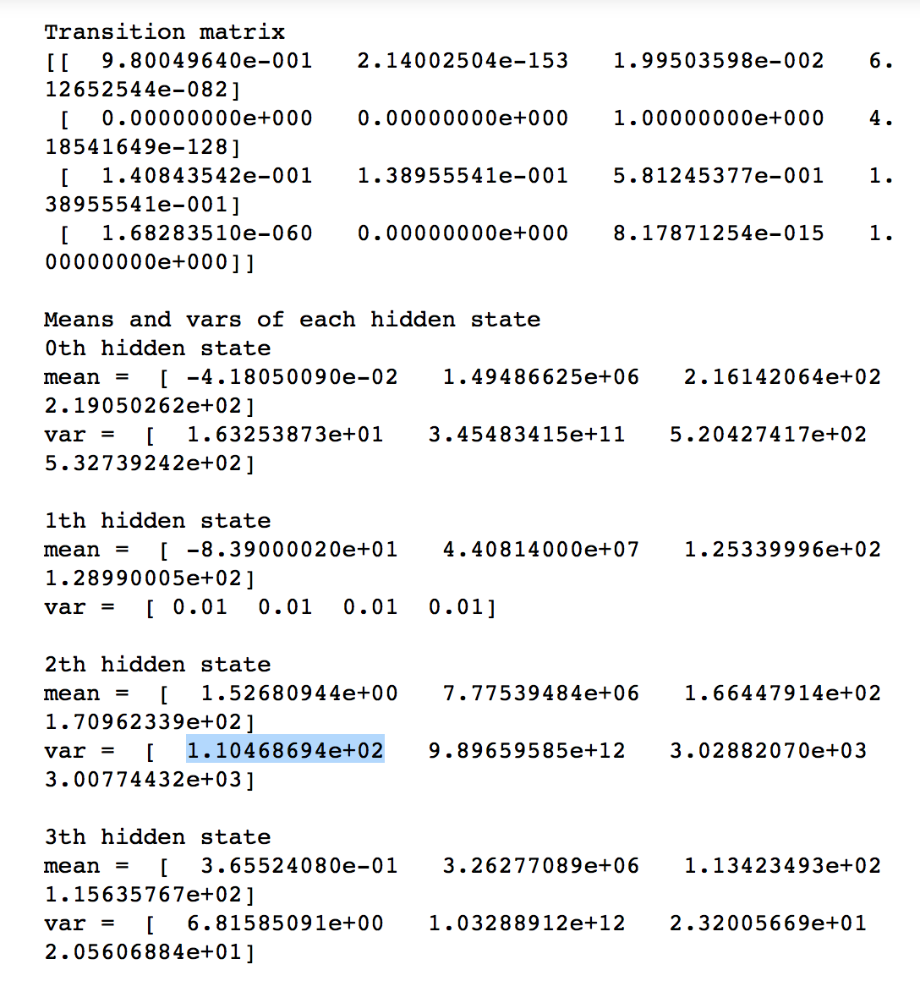

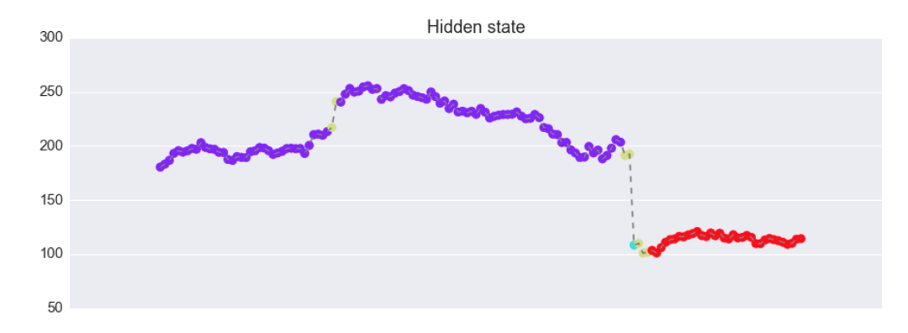

Plot 1: hidden state using the original model

since we use [close, open, high, low] as the observation, which are all stock price, the four hidden states are concentrate on the four level of price. It can not catch the increasing/decreasing trend.

And from the predict price in the plot below, we find that the predict price is always state, which is far from the real price. We think it is reasonable, if the hidden state does not change.

Plot 2: So, we add the difference of close price into our model, which will be negative when price decrease and positive when price increase. After adding difference, we could see that the blue state almost catch the whole process of decreasing. And the predict stock price looks pretty good.