516-DaríoNL-ISO303-fdisk-GParted
TAJAMAR | MADRID | 20/02/2026
Utilization off fdisk, parted and Gparted from a Live-CD off Ubuntu
ISO – Unit 3 - DISKS

Contenido
Objectives 2
Understanding the Environment: CD vs. Live CD 2
The Evolution of Partitioning Tools 3
Our Lab Roadmap 4
Inventory 5
Execution 6
Boot Live CD 6
fdisk Phase 8
Partitioning system 8
Identify disks 9
HD1 10
HD2 12
Verify the changes 15
parted Phase 16
Resetting the Disks 16
Recreating HD1 (2GB) 17
Recreating HD2 (4GB) 18
Verification 19
GParted Phase 20
Delete the structure 21
Recreating HD1 (2GB) 22
Recreating HD2 (4GB) 25
Continue the instalation 27
Conclusion 28

Objectives

In this laboratory, we are exploring the critical skill of partitioning and disk management.
Whether you are setting up a new server or recovering a failing system, understanding how to manipulate storage without compromising data is a fundamental competency for any systems administrator.
The core of this lab focuses on moving from low-level command-line tools to modern graphical interfaces, all while operating within a Live CD environment.

Understanding the Environment: CD vs. Live CD

Before touching the hardware, we must distinguish between the media we use to interact with the system:
- Standard CD/Installer:
  - Traditionally used to boot a machine for the sole purpose of installing an Operating System (OS) onto the hard drive.
- Live CD/USB:
  - A complete, bootable operating system that runs entirely in the computer's RAM (Random Access Memory).
  - It allows you to use a computer without modifying its internal storage or existing OS.
  - This is the “Swiss Army Knife” for technicians, used for data recovery, virus removal, and (as we will see today) disk repartitioning.

The Evolution of Partitioning Tools

During this lab, we will progress through three distinct utilities.
Each serves a specific purpose depending on the complexity of the task and the environment available.
- fdisk (The Classic):
  - fdisk is a text-based utility used for creating and manipulating partition tables.
  - It is lightweight and available on almost every Unix-like system.
  - While powerful, it is primarily designed for MBR (Master Boot Record) partitions and operates via a menu-driven command-line interface.
- parted (The Modern CLI):
  - As disk sizes grew beyond 2TB, fdisk reached its limits.
  - parted (Partition Editor) was developed to handle GPT (GUID Partition Table) and larger volumes.
  - In a Live CD environment, parted is often the tool because it supports a wider range of partition formats and allows for resizing partitions directly.
- GParted (The Visual Standard):
  - GParted is the Gnome Partition Editor, a graphical “front-end” for libparted.
  - It provides a visual representation of your disk's layout, making it much harder to make accidental mistakes.

Our Lab Roadmap

- Boot Live CD:
  - We select “Try Ubuntu” to run the OS in RAM, keeping our hard drive untouched while we work.
- fdisk Phase:
  - We use this classic CLI tool to inspect the raw disk structure and manage basic MBR partitions.
- parted Phase:
  - We move to this advanced CLI to handle GPT labels and perform precise resizing that fdisk can't manage.
- GParted Phase:
  - We use the graphical interface to visually verify our work and apply complex changes with a safety “undo” buffer.
- Ubuntu Installation:
  - With our partitions ready, we run the installer and choose “Something Else” to map Ubuntu to the specific layout we created.

Inventory

For the realization of the laboratory we have used:
- Hardware:
  - Host PC of the classroom T01 of Tajamar.
- Software:
  - Ubuntu utilities:
    - Fdisk.
    - Parted.
    - Gparted.
  - Live CD off Ubuntu Desktop (Virtual Machine).

Execution

Boot Live CD

First we will create our VM, we will give her 2 virtual disk. One with 2GB and the other with 4GB.
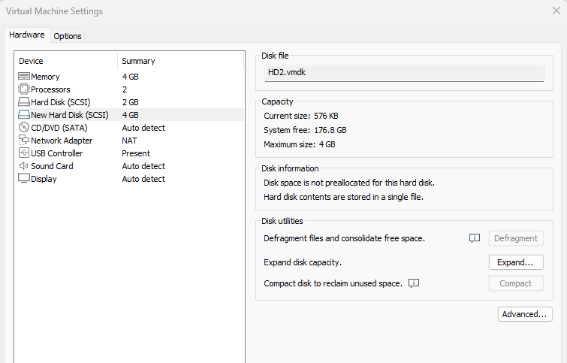
We add the live CD.
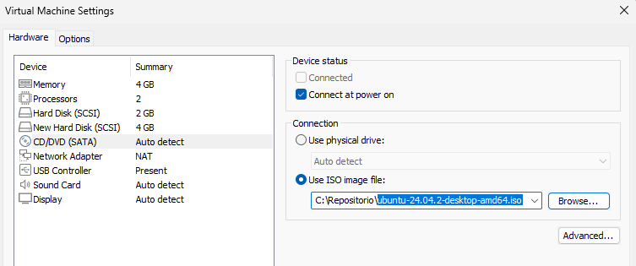
We have to boot the VM, and select “Try Ubuntu” for work with the
Live-CD.
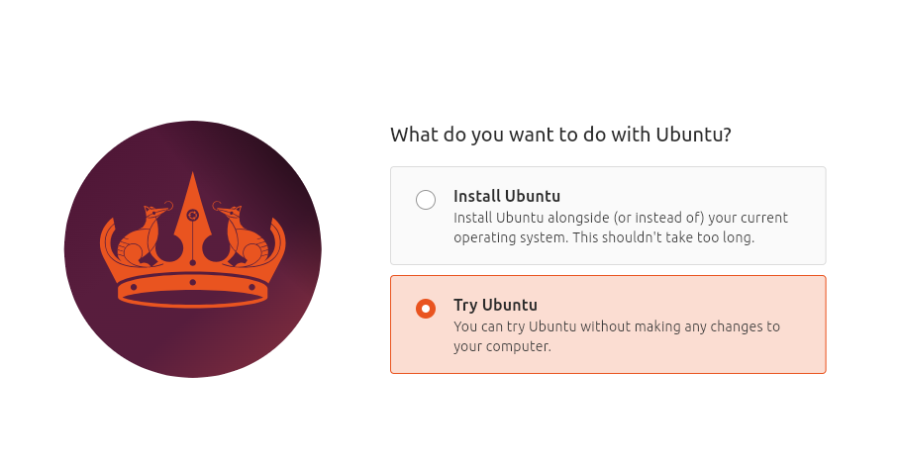

fdisk Phase

Now we can open the Terminal to work with CLI options.
Because is a laboratory we will work always as sudo.
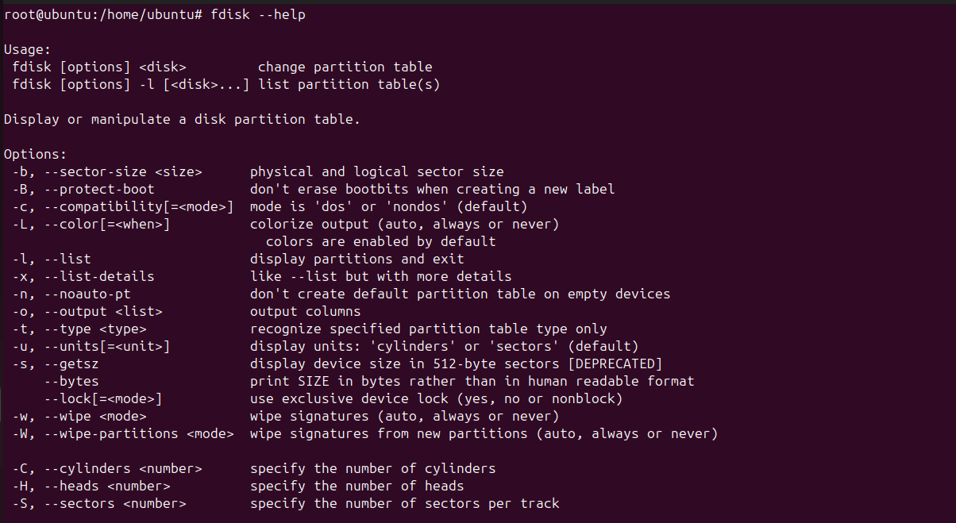

Partitioning system

HD1 (2GB):
- 3 primary partitions of (100MB - 200MB - 300MB)
- Active the 300MB partition.
HD2 (4GB):
- 1 primary partition of 200MB (active partition).
- 1 extended partition with the rest of space. Inside it, 2 logic partitions.
- 100 MB and 50 MB.

Identify disks

Before we start, we must identify which disk is which.
- lsblk -d
Disk Identification Summary:
- Loops:
  - These are virtual devices used by the Live CD to mount compressed system files (like Snaps and the core OS) into RAM.
  - We ignore these for partitioning.
- sda (2GB):
  - This is our HD1.
  - We will use this disk to create our three primary partitions.
- sdb (4GB):
  - This is our HD2.
  - We will use this disk for our primary and extended/logical partition scheme.
- sr0 (5.9GB):
  - This is the Live CD media itself (labeled as /cdrom), which provides our working environment.

HD1

Now that we know our targets are /dev/sda and /dev/sdb, we can start the operations with fdisk.
Steps:
- Enter the disk: Fdisk /dev/sda
- Create Partition 1 (100MB):
  - Type n (new partition).
  - Type p (primary).
  - Type 1 (partition number).
  - Press Enter for the first sector (default).
  - Type +100M (size).
- Create Partition 2 (200MB):
  - Type n, then p, then 2.
  - Press Enter for the first sector.
  - Type +200M.
- Create Partition 3 (300MB):
  - Type n, then p, then 3.
  - Press Enter for the first sector.
  - Type +300M.
- Set the 300MB Partition as Active:
  - Type a (toggle bootable flag).
  - Type 3 (selects our 300MB partition).
- Save our work:
  - Type w (this writes the changes and exits).
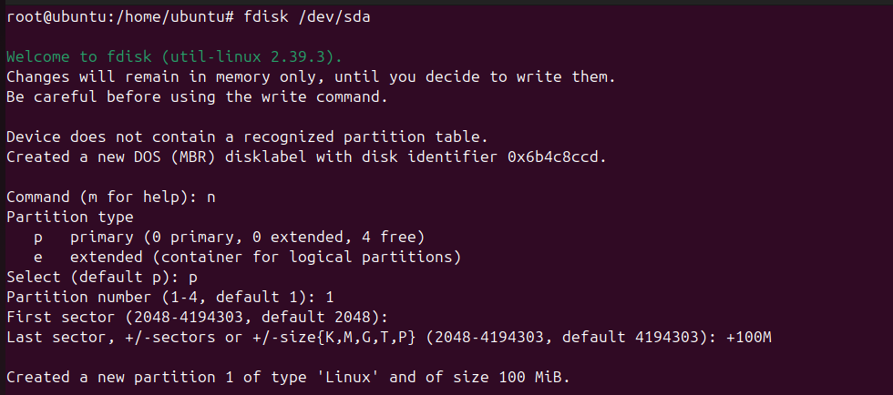
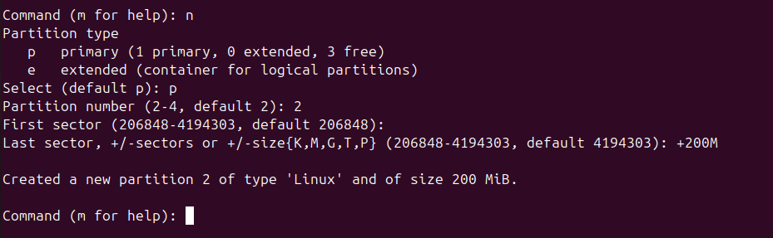
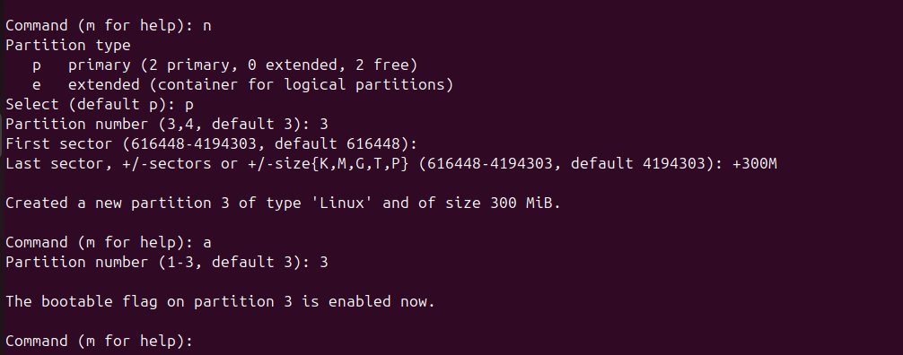
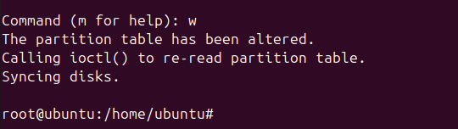

HD2

Moving on to HD2 (/dev/sdb), this is where we get to practice a more complex layout.
We are going to handle a mix of primary and logical partitions.
Steps:
- Enter the disk: Fdisk /dev/sdb
- The 200MB Primary (Active) Partition:
  - Type n, then, p then, 1.
  - First sector: Press Enter (default).
  - Last sector: Type +200M.
  - Make it Active: Type a, then type 1.
- The Extended Partition (Rest of the space):
  - Type n, then e (Extended), then 2.
  - First sector: Press Enter.
  - Last sector: Press Enter again.

- The 100MB Logical Partition:
  - Type n.
  - Notice:
    - Since we have an extended partition, fdisk will automatically suggest creating a logical partition (usually starting at number 5).
  - First sector: Press Enter.
  - Last sector: Type +100M.
- The 50MB Logical Partition:
  - Type n.
  - First sector: Press Enter.
  - Last sector: Type +50M.
- Save our work:
  - Type w (this writes the changes and exits).

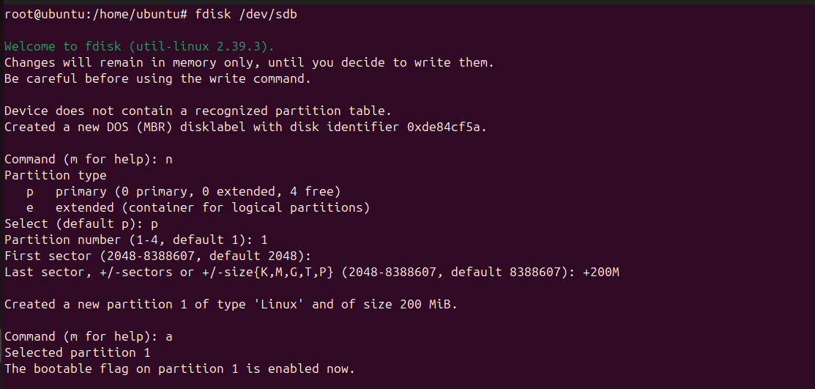
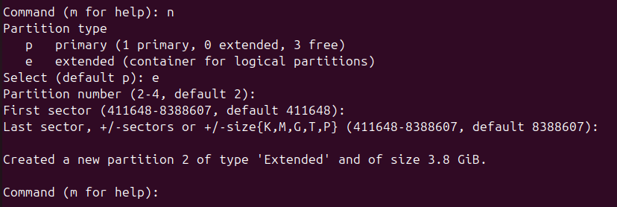
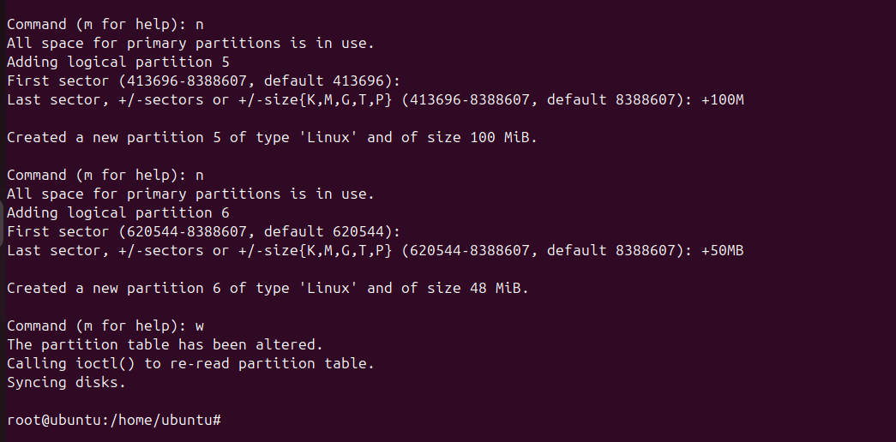

Verify the changes

Run this command to see a structure of our disks:
- lsblk -o NAME,SIZE,TYPE,MOUNTPOINTS /dev/sda /dev/sdb
- fdisk -l /dev/sda
- fdisk -l /dev/sdb
The partition with the “*” symbol ys the active.
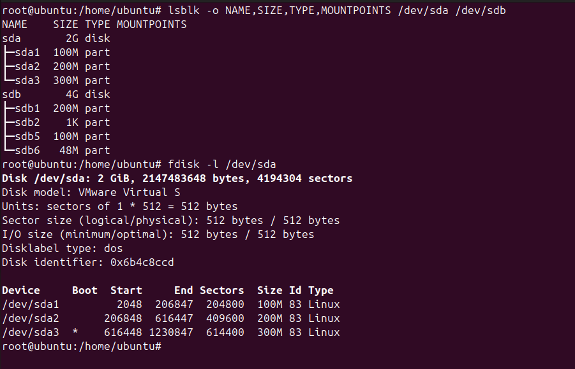
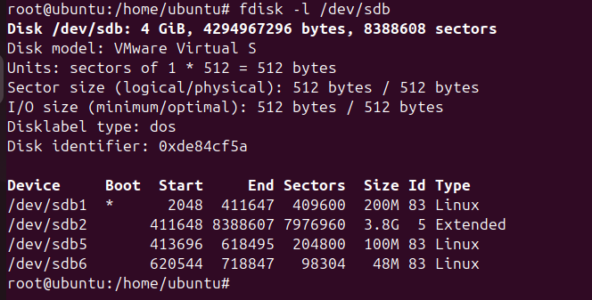

parted Phase

Now we will use parted to reset and recreate our layout.
Unlike fdisk, parted applies changes instantly.

Resetting the Disks

We must delete the existing partitions to start fresh:
- For HD1:
  - sudo parted /dev/sda rm 1 rm 2 rm 3
- For HD2:
  - sudo parted /dev/sdb rm 1 rm 2
  - (Deleting the extended partition automatically removes the logical ones).
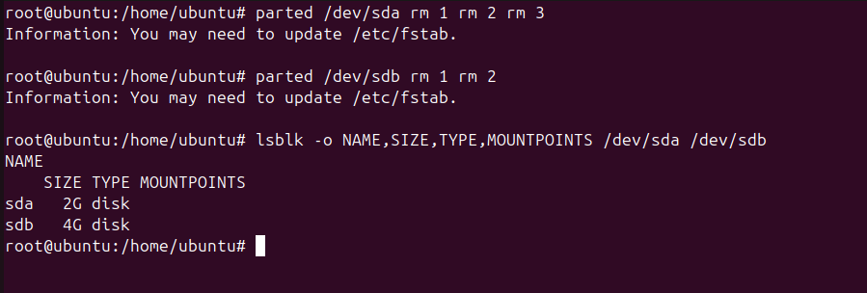

Recreating HD1 (2GB)

We use the mkpart command.
In parted, we must specify the start and end points in MB.
Steps: Other option is using mkpart with the assitent.
- Open Disk:
  - sudo parted /dev/sda
- 100MB Partition:
  - mkpart primary 1MB 101MB
- 200MB Partition:
  - mkpart primary 101MB 301MB
- 300MB Partition:
  - mkpart primary 301MB 601MB
- Set Active:
  - set 3 boot on
- Exit:
  - quit
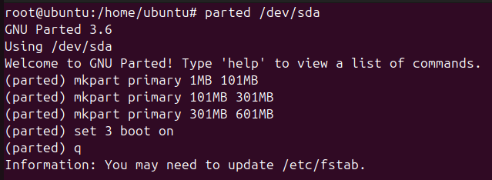

Recreating HD2 (4GB)

We follow the same logic but include the extended/logical structure.
Steps:
- Open Disk:
  - sudo parted /dev/sdb
- 200MB Primary & Active:
  - * mkpart primary 1MB 201MB
  - set 1 boot on
- Extended Partition:
  - mkpart extended 201MB 100%
- 100MB Logical:
  - mkpart logical 202MB 302MB
- 50MB Logical:
  - mkpart logical 302MB 352MB
- Exit:
  - quit
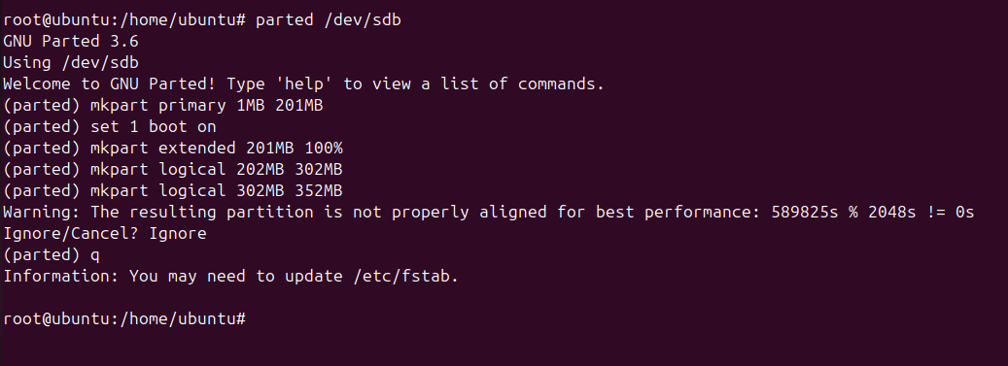

Verification

We check our work immediately with:
- sudo parted -l
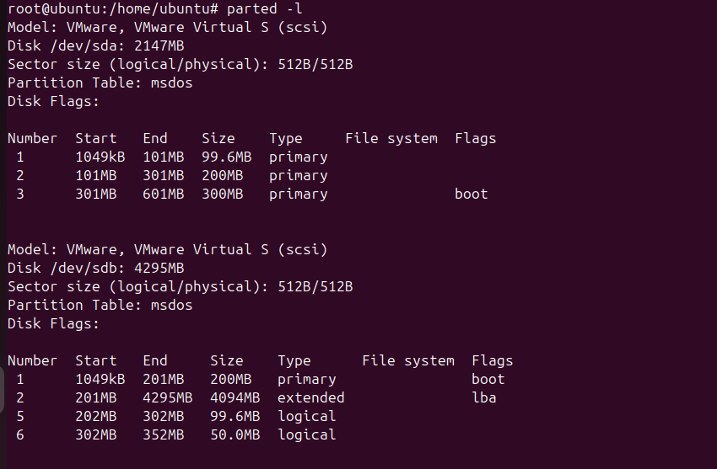

GParted Phase

We have to go to the Live Desktop, and search for GParted.
When we open GParted, we can see the partitions that we have made.
Visual Interface
Select disks

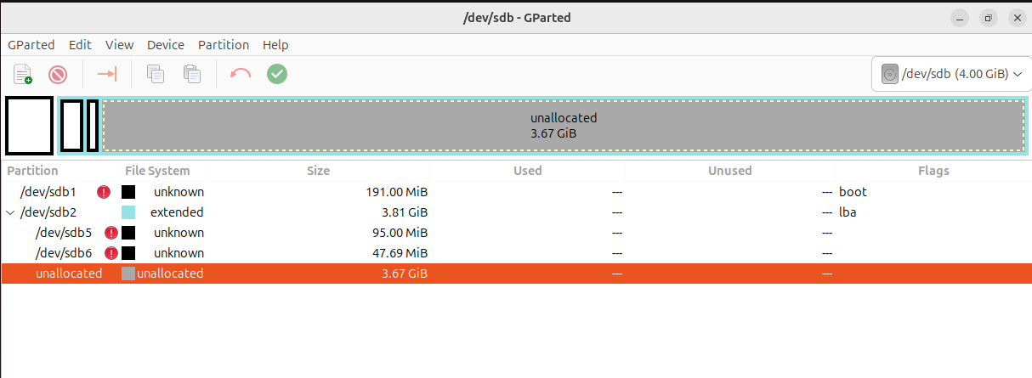
Text Interface

Delete the structure

We will delte all the preovius structure.
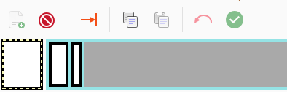
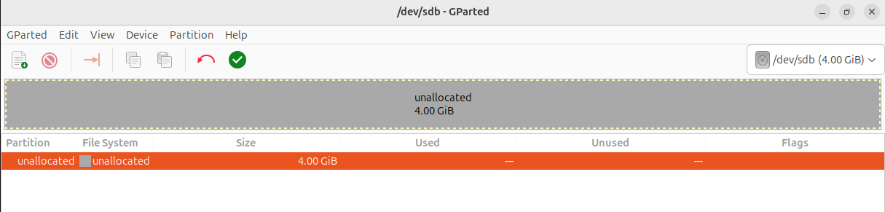
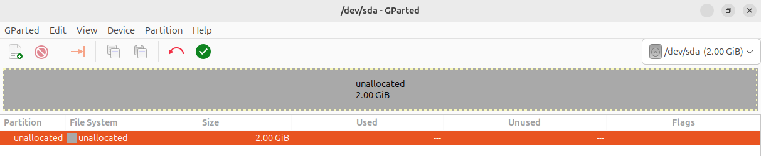

Recreating HD1 (2GB)

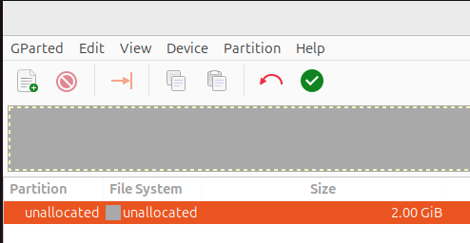
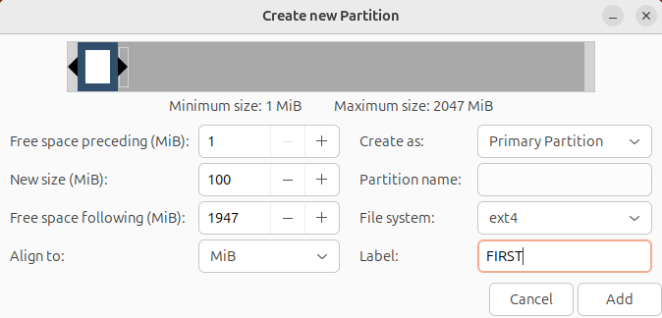
Apply changes.
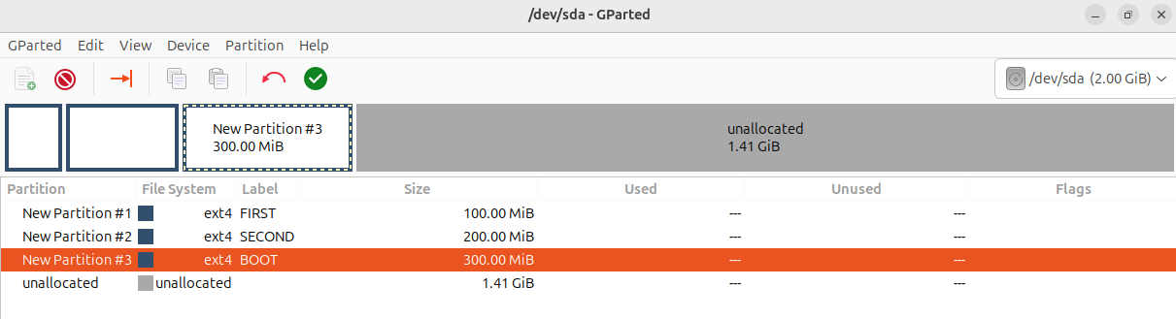

Set up the active partition.
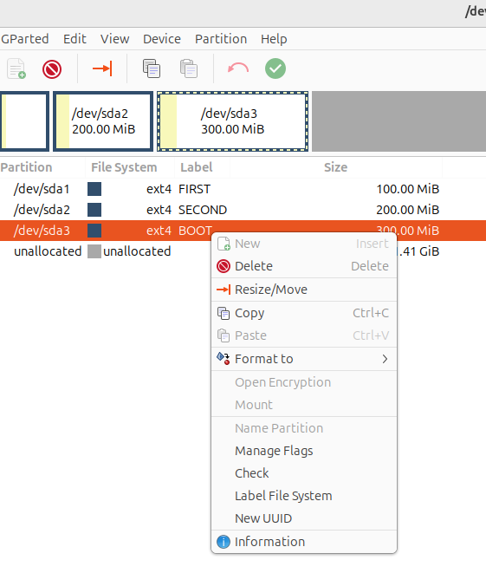
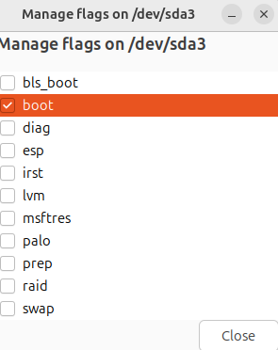

Finnal result in HD1

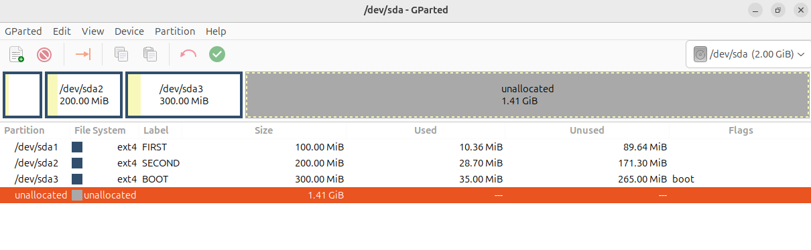

Recreating HD2 (4GB)

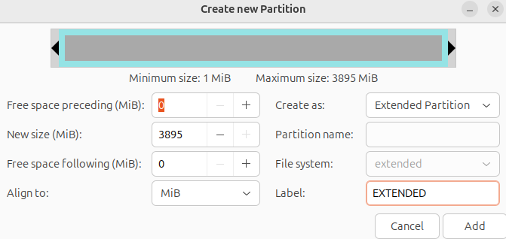

Finnal result in HD2

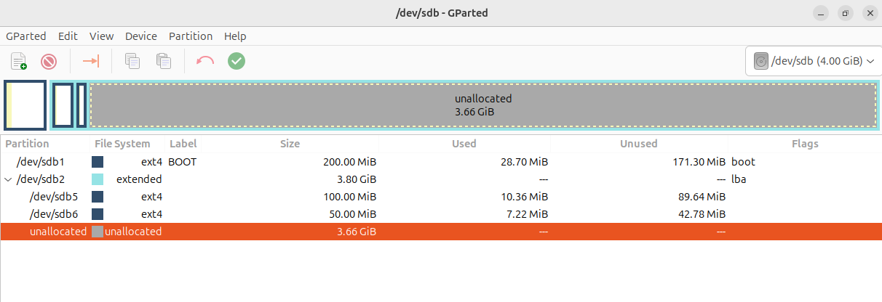

Continue the instalation

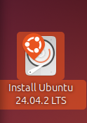
To maintain the structure, we can not select to format the all disk.
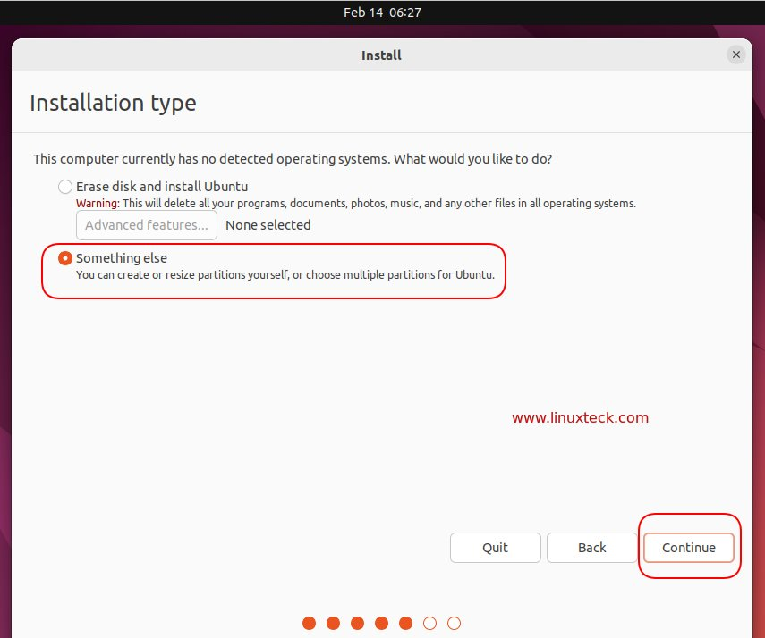

Conclusion

We have now mastered the full range of partitioning tools.
This laboratory highlights a vital lesson for any technician:
- GParted is highly intuitive:
  - Its graphical nature makes complex tasks simple and reduces the risk of human error through visual confirmation.
- CLI is essential:
  - Despite the ease of a GUI, we won't always have one.
  - Whether we are in a recovery shell, a remote SSH session, or a headless server, the ability to use fdisk and parted ensures we can work in any environment.
Final Takeaway:
- We use the GUI for convenience, but we master the CLI for survival.

