516-DaríoNL-ISO304-Multiboot
TAJAMAR | MADRID | 24/02/2026
Multiboot Win-Linux
ISO – Unit 3 - Multiboot

Contenido
Introduction 3
Investigation: Installation Hierarchy 4
Inventory 5
Execution 6
Instalation Windows 11 6
Instalation of Ubuntu 7
Multiboot 13
Conclusion 16

Introduction

The primary objective of this practice is to successfully install two distinct operating systems on a single disk.
This process requires careful management of disk partitions to ensure adequate space for both environments.
This setup allows us to select the desired operating system at startup, maximizing the utility of the available hardware.
To implement a dual-boot system, we must understand the fundamental requirements and the specific order of operations:
- Software Requirements:
  - We require the ISO images for both Windows 11 and Ubuntu Desktop.
- Installation Sequence:
  - The standard procedure dictates installing Windows first, followed by Ubuntu.
- Disk Management:
  - We must account for partition sizes during the initial setup to ensure both systems fit on the shared storage medium.
- Bootloading:
  - The installation of Ubuntu introduces a boot manager (such as GRUB) that facilitates the selection between the two systems.

Investigation: Installation Hierarchy

As part of the lab report, we have investigated the technical justifications for the specific installation order required for a stable dual-boot system.
Why must Windows be installed before Ubuntu?
- Windows possesses a restrictive bootloader (Windows Boot Manager).
- When Windows is installed, it assumes it is the only operating system on the disk and overwrites the Master Boot Record (MBR) or the EFI partition with its own code.
- Because the Windows bootloader does not automatically recognize Linux partitions, installing Windows first allows the subsequent Linux installation to detect the existing Windows environment and configure a multiboot menu (GRUB) that can host both systems.
What occurs if the systems are installed in reverse order?
- If we install Ubuntu first and then Windows, the Windows installation process will overwrite the Linux bootloader (GRUB) without adding an entry for Ubuntu.
- System Inaccessibility:
  - The computer will boot directly into Windows, making the Ubuntu installation inaccessible to the user despite the files remaining on the disk.
- Recovery Requirements:
  - Restoring access to Ubuntu would require manual intervention using a “Live” Linux environment to reinstall and reconfigure GRUB to recognize the Windows partition.

Inventory

For the realization of the laboratory we have used:
- Hardware:
  - Host PC.
- Software:
  - VM of VMware:
    - Windows 11.
    - Ubuntu 20.04.2.

Execution

Instalation Windows 11

The first part of this lab is doing the typical instalation of Windows 11.
As I documented it already in other practice, I will not document all the instalation of Windows 11.
The only thing I need to clarify that we gave to create a disk that allows the two systems (more than 90GB).
In this laboratory I will provide of 100GB (36GB for Ubuntu).
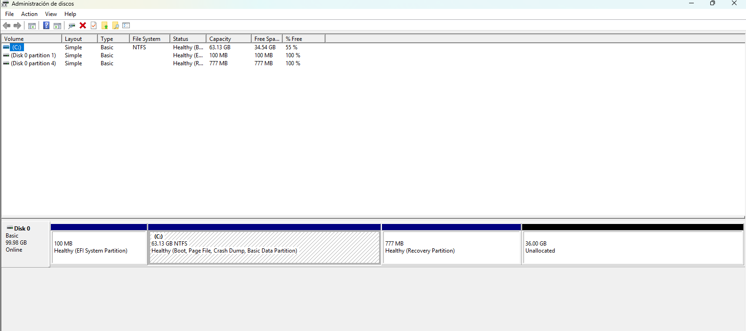

Instalation of Ubuntu

Settings VM:
With the Windows 11 off, we are going to add a live CD of Ubuntu in the VM.
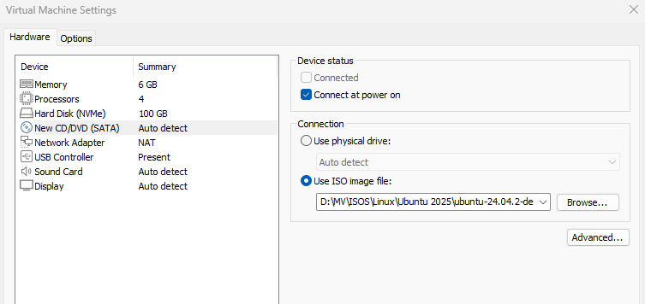

Start the instalation of Ubuntu:
We need to start the system by the CD instead the disk (Windows 11).
For this we are going to change the hierarchy of startup (in the BIOS).
To acces to the BIOS, we repeatedly press “F2” during startup.
Finnaly we start the system by the CDROM.
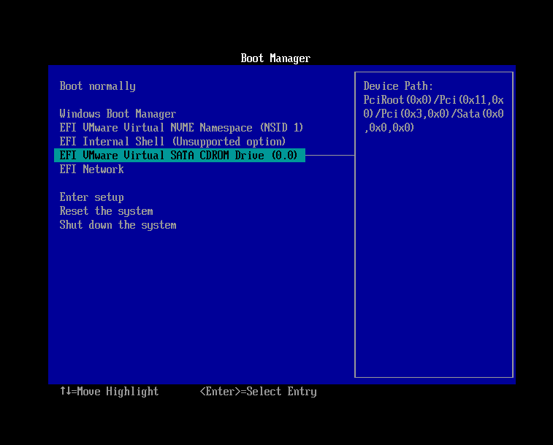
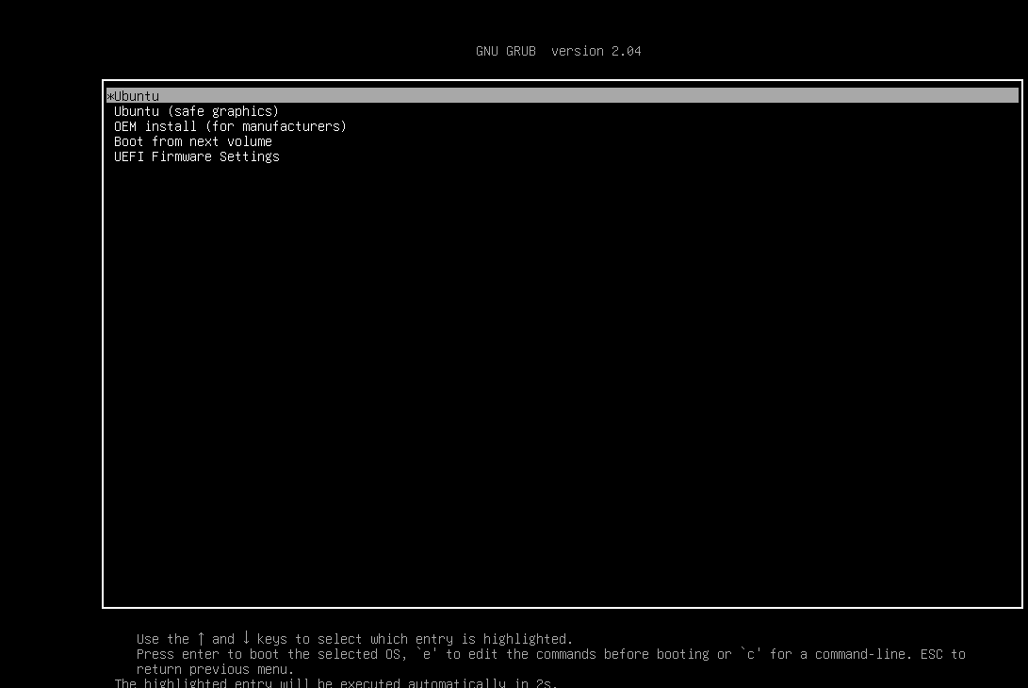

Ubuntu Instalation:
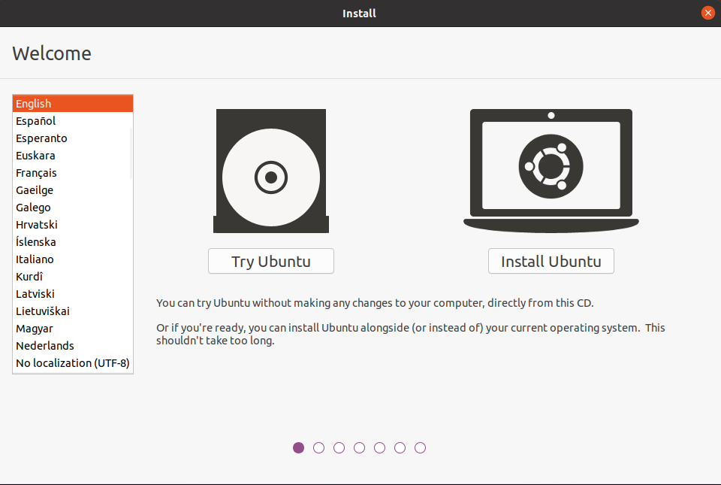
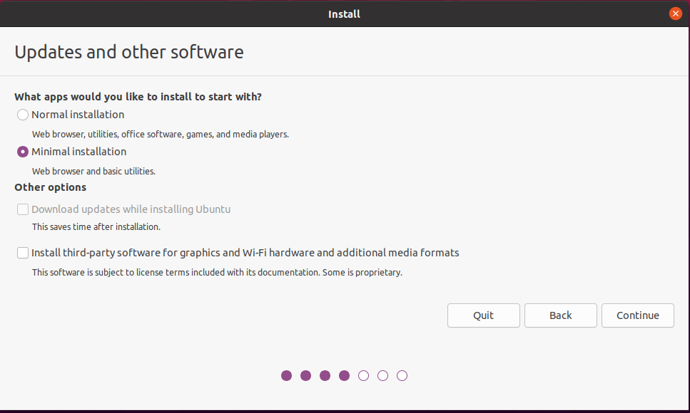

We will use the third option because we can control were is going to be the instalation of Ubuntu.
In the first option it will carve out its own niche that we cannot control.
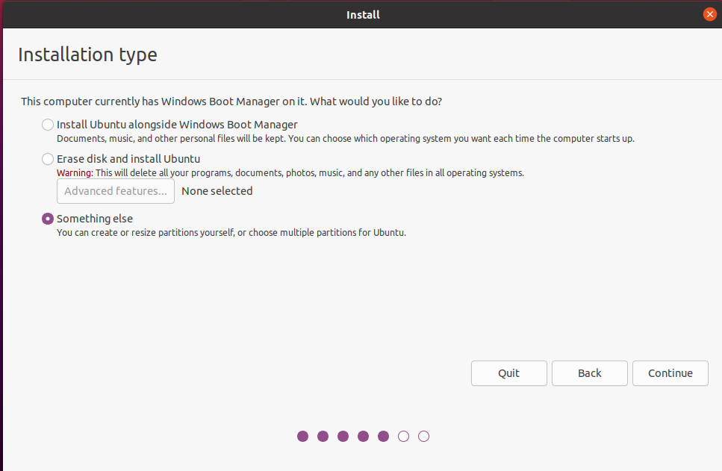
The instalation will be alocated in the free space.
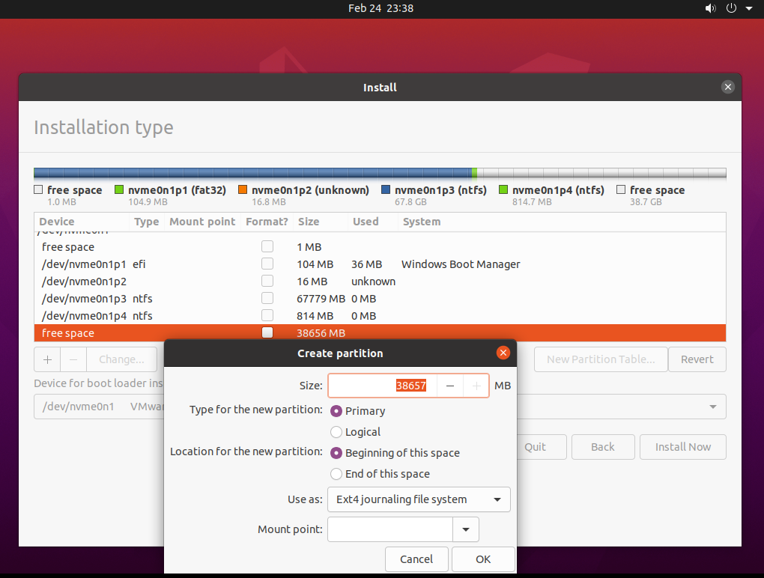

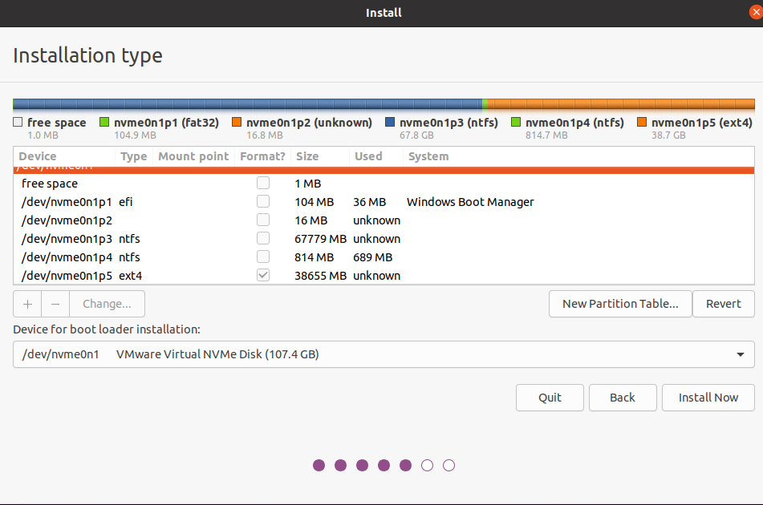
We have to select the mount point, and start the instalation.
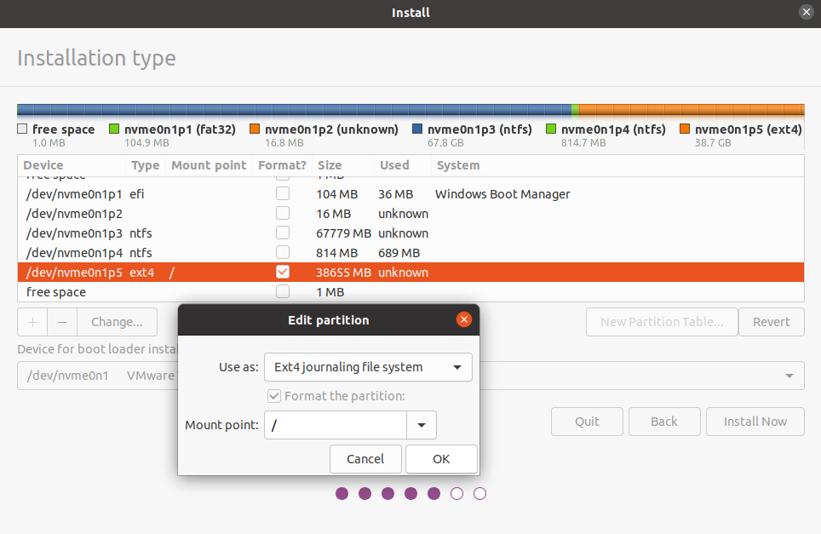

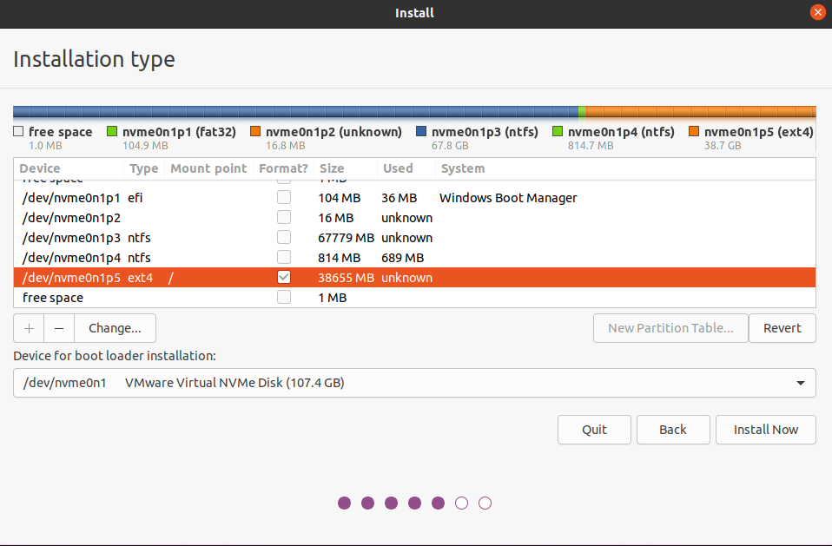
Now we can proceed with the typical instalation.
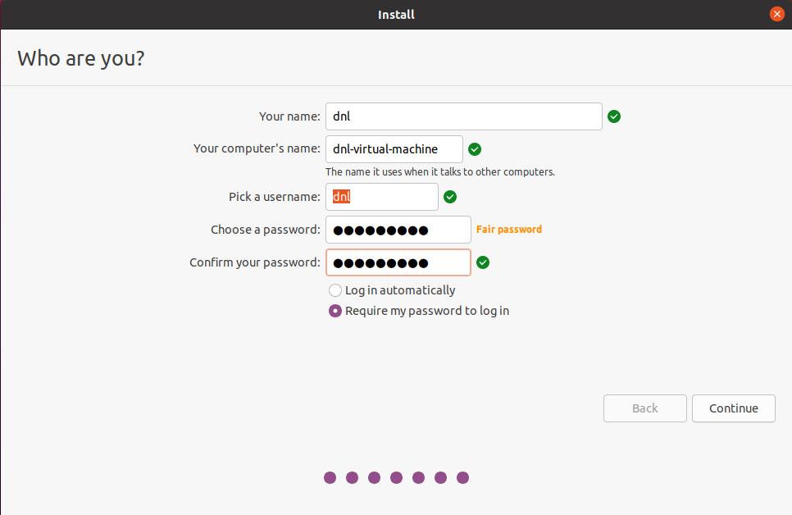

Multiboot

Now in the GRUB menu we can select the OS that we want to start.
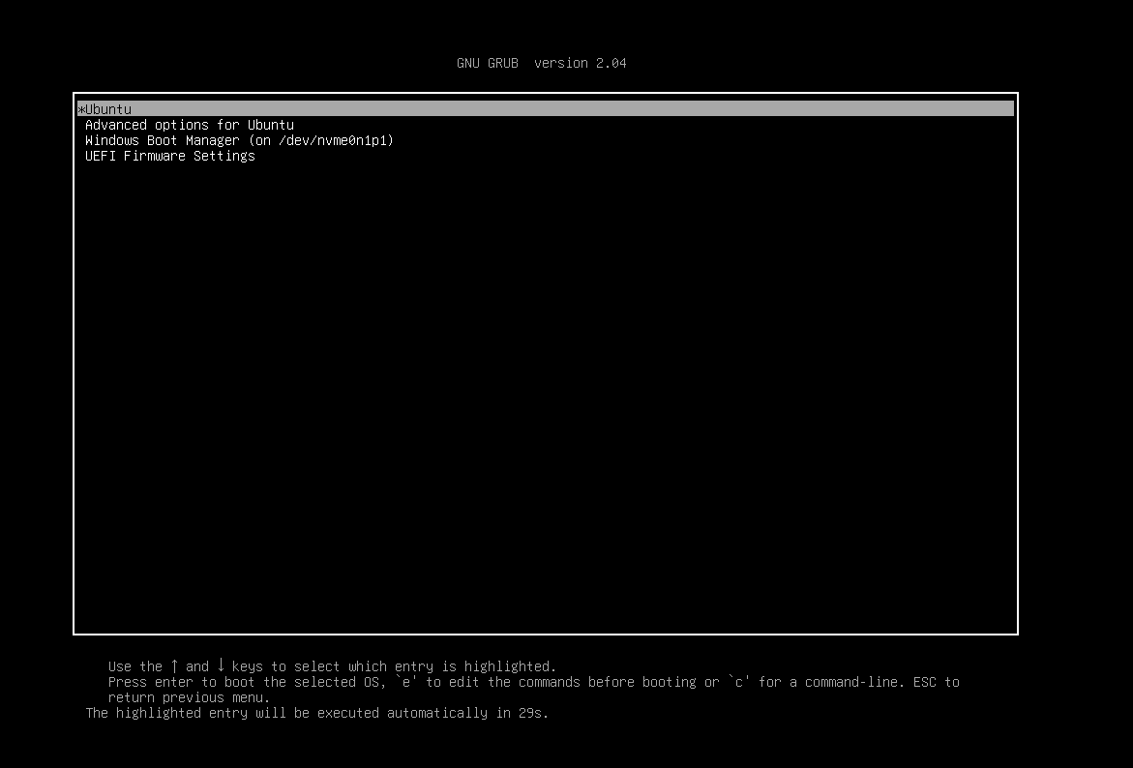
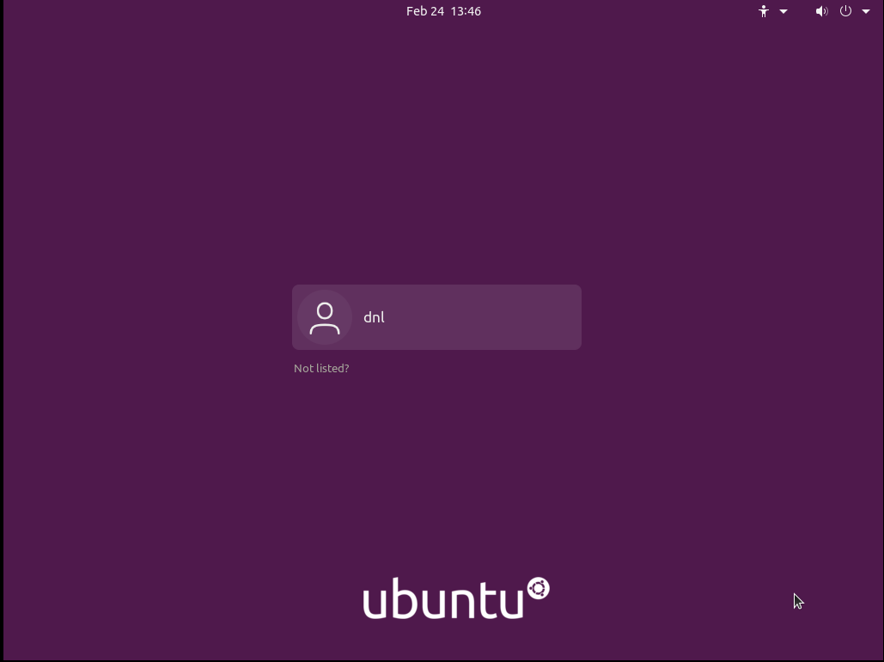

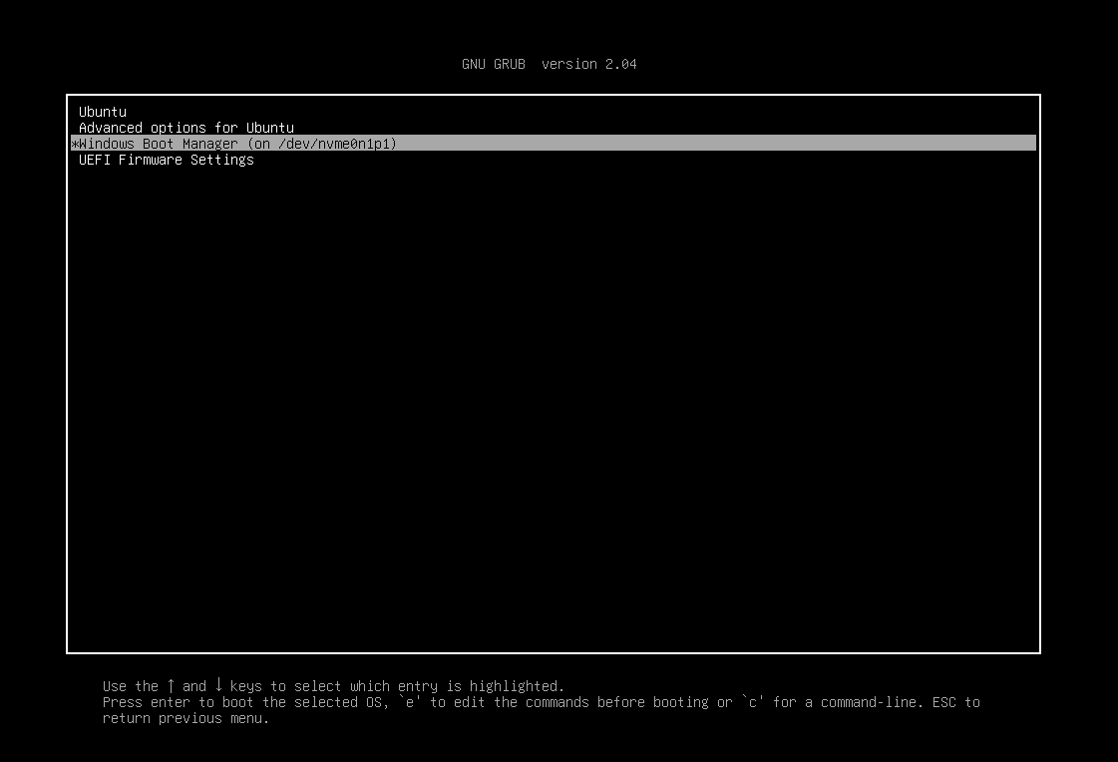
Since we accessed the disk directly, and not from within Windows, the system will perform a check that could take some time. However, because we didn't modify any Windows partitions (since we did everything within the free disk space), there won't be any problems and the system will boot.
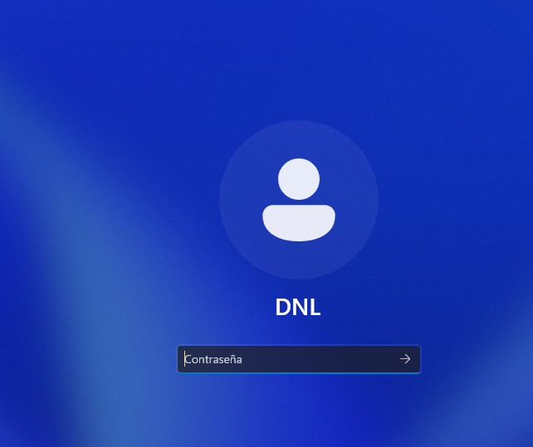

From Disk Management in Windows, we see how it recognizes that the space is being used, but then it cannot access the data.
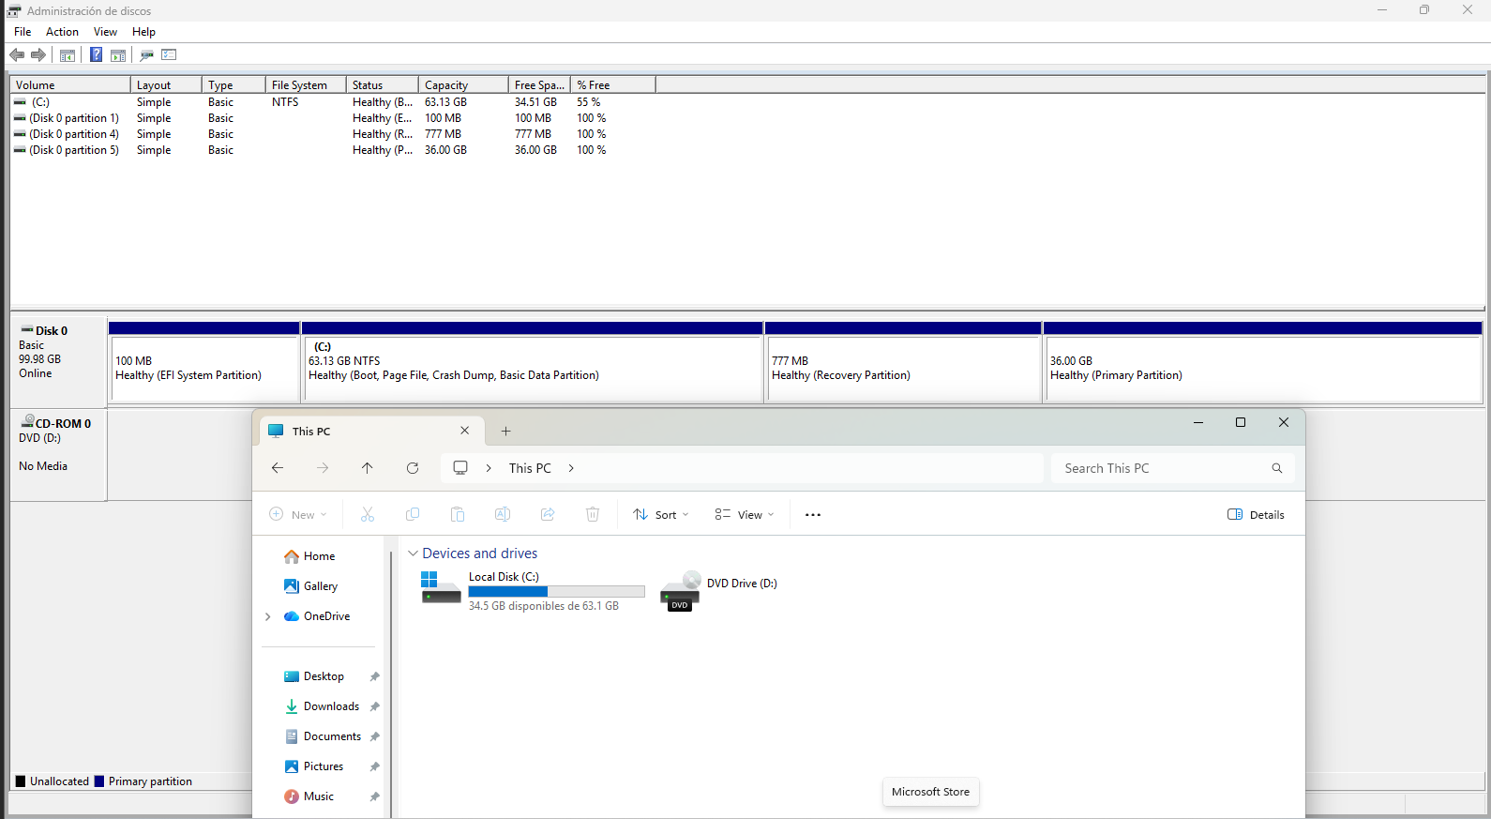

Conclusion

The laboratory successfully demonstrated the implementation of a stable dual-boot system by adhering to a specific installation hierarchy.
By installing Windows 11 first, we accounted for its restrictive bootloader, which otherwise would have overwritten the Linux boot record.
Key takeaways from the process include:
- Strategic Partitioning:
  - Utilizing a 100GB disk allowed for a shared storage medium where Windows and Ubuntu (36GB) could coexist.
- Bootloader Integration:
  - The subsequent installation of Ubuntu introduced the GRUB menu, which effectively facilitates the selection between both operating systems at startup.
- Manual Control:
  - Using the “Something else” installation type ensured that Ubuntu was allocated to the intended free space without damaging the Windows environment.
This setup maximizes hardware utility by allowing the selection of the desired environment upon booting the system.

