516-DaríoNL-ISO304-Repair
TAJAMAR | MADRID | 01/03/2026
Repair Startup
ISO – Unit 3 – REpair startup

Contenido
Introduction 3
Roadmap 3
Theoretical Introduction 4
Inventory 5
Execution 6
Part I 6
Terminal Operations 9
Part II 11
Part III 13
Partition Mounting 14
Windows Operations 15
Part IV 16
Conclusion 17

Introduction

In this laboratory we are going to modify the UEFI boot priority to prioritize the Windows Boot Manager over GRUB, simulating a common failure where Ubuntu becomes inaccessible.
Perform a recovery procedure using a Live Ubuntu environment and the chroot method to reinstall and update the bootloader.
Verify and document the configuration states of both the Windows BCD (Boot Configuration Data) and the GRUB configuration files.

Roadmap

- Part I:
  - Direct modification of the boot path from within Windows 11.
- Part II:
  - Verification of the “Ubuntu-invisible” state.
- Part III:
  - Environment preparation (Live ISO) and Partition mounting.
  - Reinstallation of GRUB and configuration update via chroot.
- Part IV:
  - Final verification of the Dual-Boot menu.

Theoretical Introduction

GRUB (GRand Unified Bootloader) is a multi-boot loader used primarily by Linux systems.
In modern UEFI systems, it resides in the EFI System Partition (ESP) as an .efi executable.
GRUB functions by loading its configuration (grub.cfg), which contains directives to either load the Linux kernel or “chainload” another bootloader, such as the Windows Boot Manager (bootmgfw.efi).
When Windows is set as the primary boot entry in the NVRAM, it ignores the existence of GRUB and boots directly into the Windows kernel.
Recovery involves pointing the UEFI firmware back to the GRUB executable and ensuring the GRUB configuration correctly identifies the Windows Partition.

Inventory

For the realization of the laboratory we have used:
- Hardware:
  - Host PC.
- Software:
  - VM of VMware:
    - Windows 11.
    - Ubuntu 20.04.2.

Execution

Part I

The purpose of this phase is to manually override the UEFI boot order from within the Windows environment to prioritize the Windows Boot Manager over GRUB, effectively hiding the Ubuntu installation.
Using Startup Repair of Windows 11:
- Boot Windows 11.
- Configuration System Recuperation Advanced Startup.
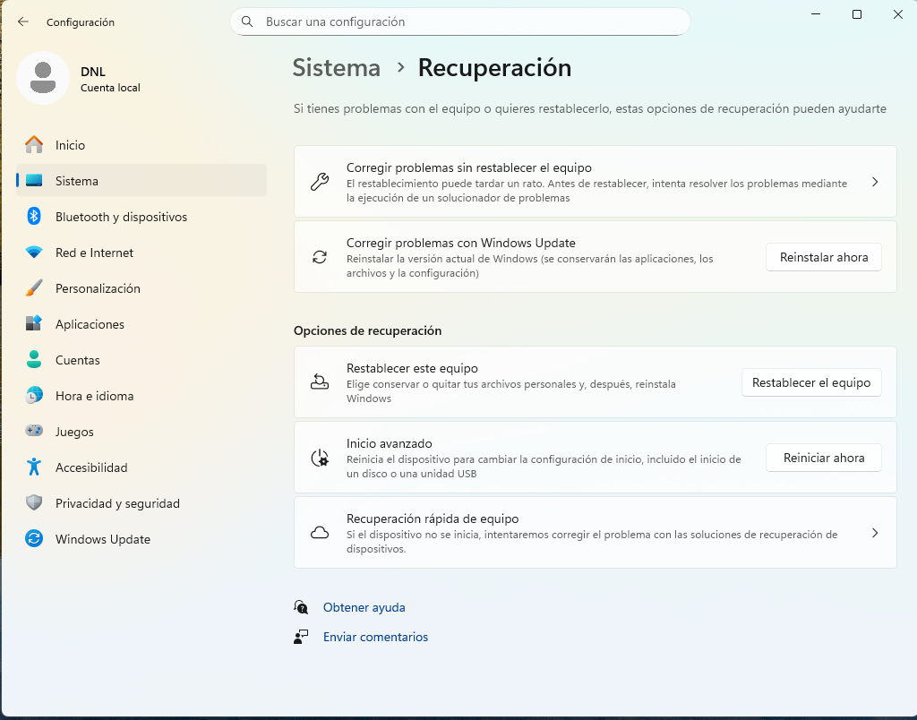
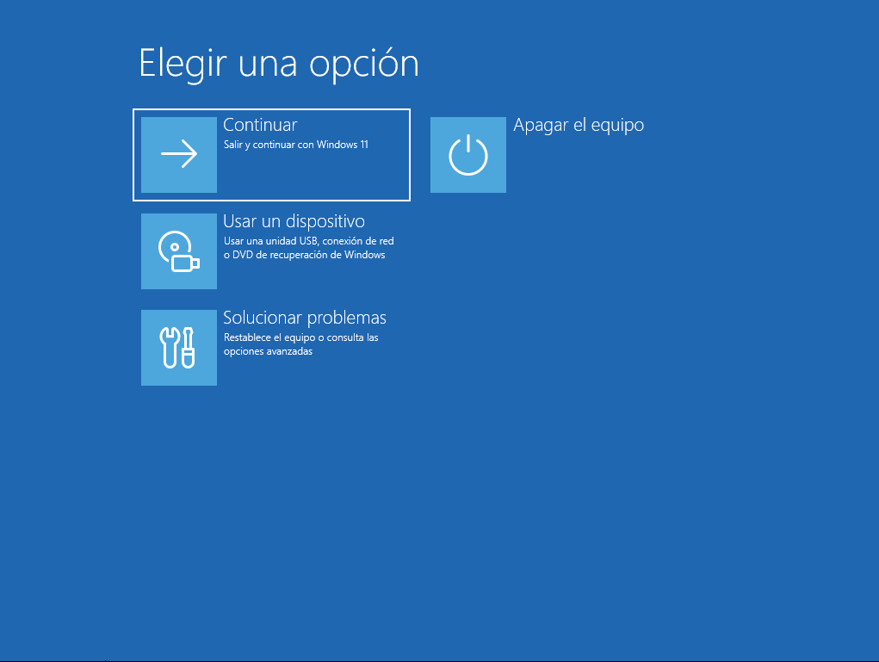
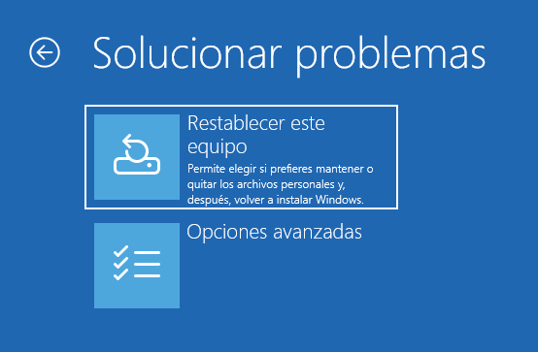
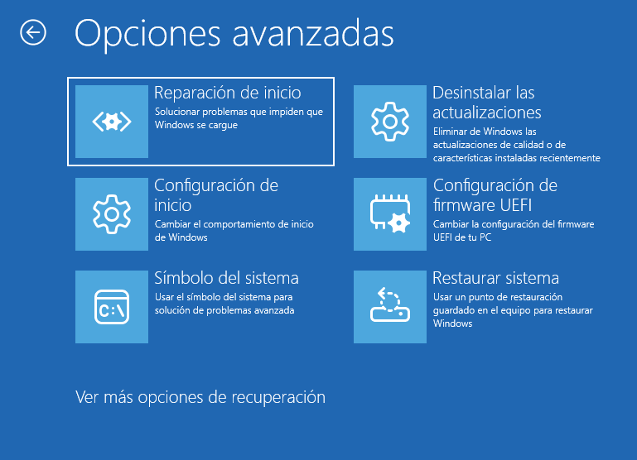

Now we are in the terminal of Windows, but we have acces by the recuperation system (because this tools is specific when we have problems with Windows and we need to use some recuperations tools).
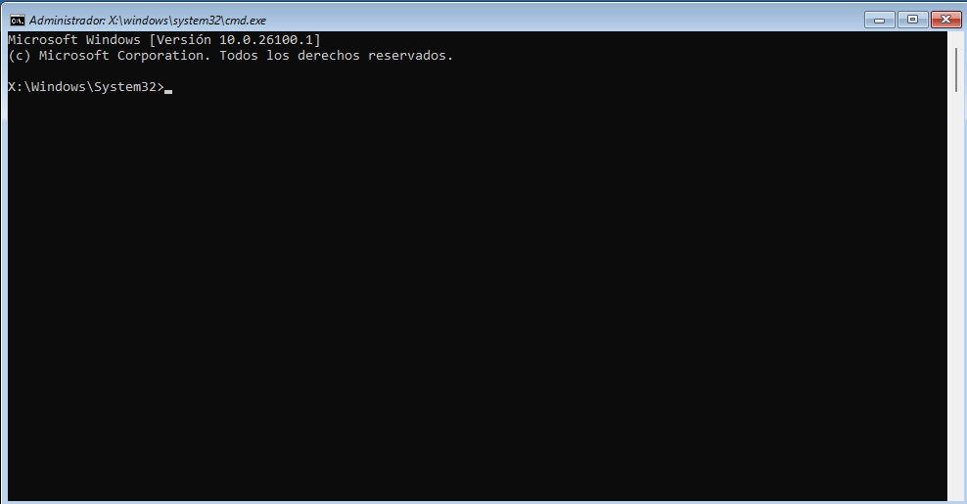

Terminal Operations

Identify and prepare the EFI Partition:
The volume with the “FAT32” File System and “System” label
(usually 100MB).
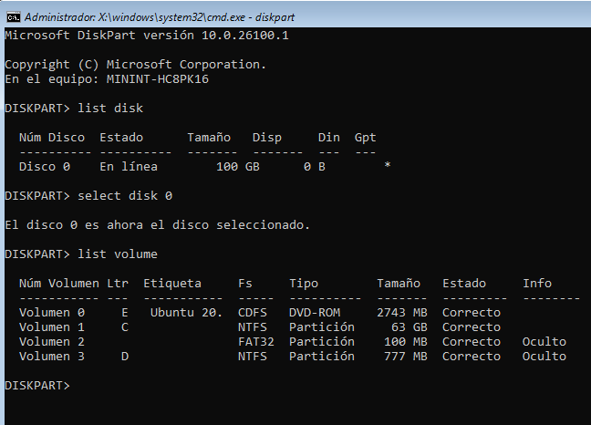
Assign a drive letter:
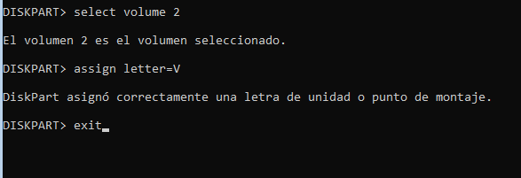

Corrective repair command:
We need the message “Boot files created successfully”
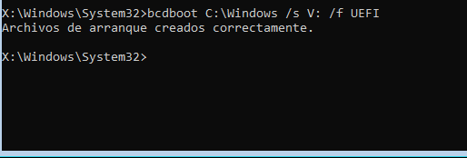
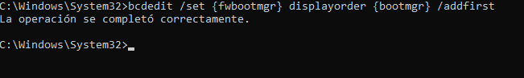
Final Check (BCD check):
The path is now set to \EFI\Microsoft\Boot\bootmgfw.efi.
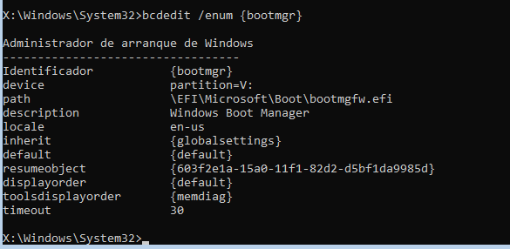
The verification of the Windows Boot Configuration Data (BCD) is performed by executing the finnal command.
This command interrogates the BCD store to display the current parameters of the Windows Boot Manager.
The resulting output confirms that the device is correctly mapped to the EFI System Partition and, most critically, that the path variable is set to \EFI\Microsoft\Boot\bootmgfw.efi.
By explicitly defining this path, the UEFI firmware is instructed to execute the Microsoft bootloader directly upon startup.

Part II

Once the Windows Boot Manager has been prioritized, it is necessary to verify the system's behavior to ensure the laboratory objective of hiding the Linux environment has been met.
Functional Boot Test:
- The system is restarted to observe the initial software execution.
- Expected Behavior:
  - The computer bypasses the GRUB menu entirely.
  - The Windows logo appears immediately, followed by the Windows 11 login screen.
- Procedural Observation:
  - At no point during the boot sequence is the user presented with an option to select “Ubuntu” or access a command-line interface like the GRUB rescue shell.

Logical Verification via Disk Management:
- To confirm that the Ubuntu installation still exists despite being “invisible,” we verify the partition table from within Windows.
  - Right-click the Start button and select Disk Management.
  - Observe the disk layout.
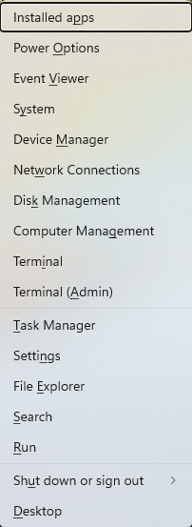
The Ubuntu partition will appear in Disk Management as “Healthy (Primary Partition)” but will not have a drive letter assigned.
Because Windows cannot natively read EXT4 filesystems, it recognizes the space as occupied but “unknown”.
This state confirms that the files are intact, yet the boot chain is broken because the Windows Boot Manager does not possess a pointer to the Linux partition's mount point.

Part III

This phase covers the restoration of the dual-boot system by accessing the installed Linux partition from an external medium and reconfiguring the bootloader.
To begin the repair, the system is booted from an Ubuntu Live ISO (like it has documentated in the previous lab).
Once the desktop environment loads, a terminal is used to map the physical disk structure and mount the required partitions.
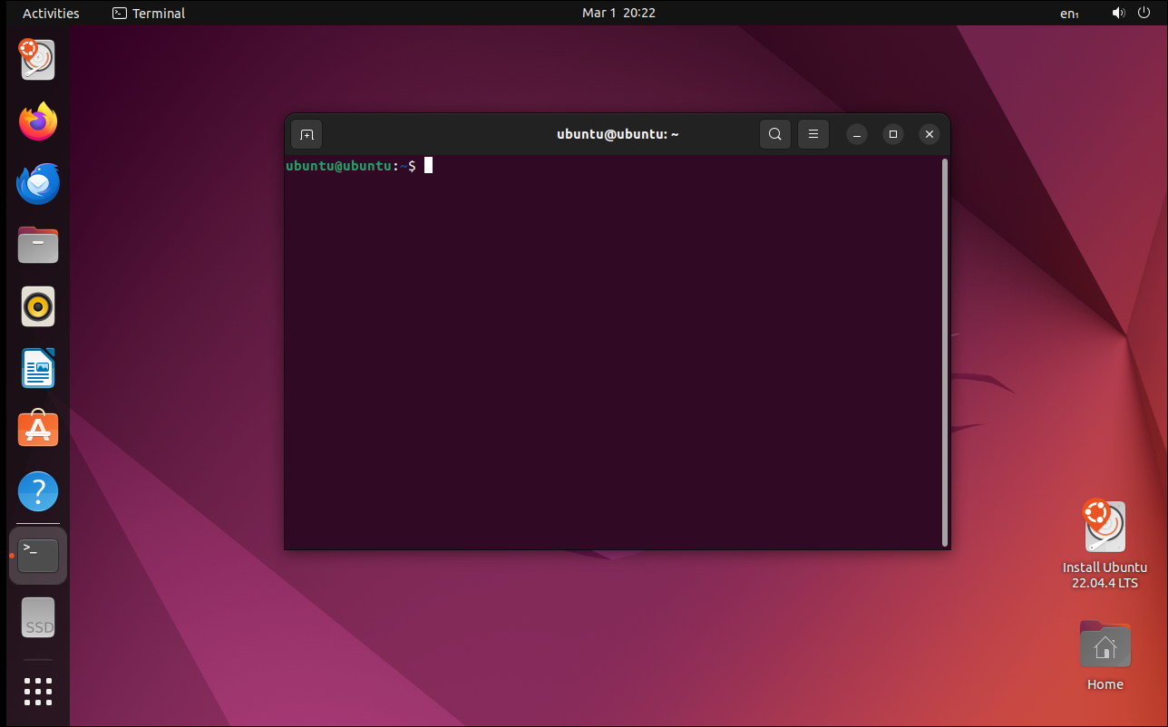

Partition Mounting

Mount necessary systems:
- sudo mount --bind /dev /mnt/dev
- sudo mount --bind /proc /mnt/proc
- sudo mount --bind /sys /mnt/sys
- sudo mount --bind /run /mnt/run
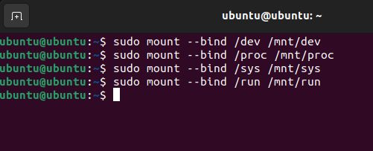
Enter in the system:
- sudo chroot /mnt
Reinstall GRUB on UEFI (NVMe):
- grub-install
--target=x86_64-efi
--efi-directory=/boot/efi
--bootloader-id=GRUB
- update-grub
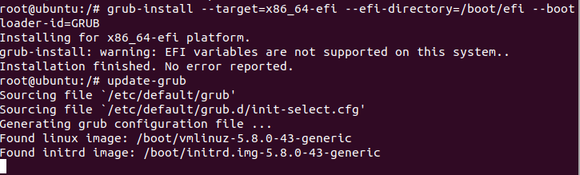
Exit and reboot the system.

Windows Operations

Finally we have to change the order in Windows.
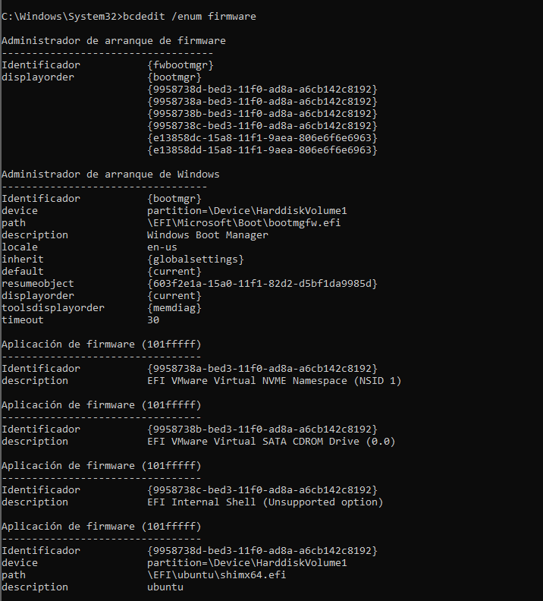
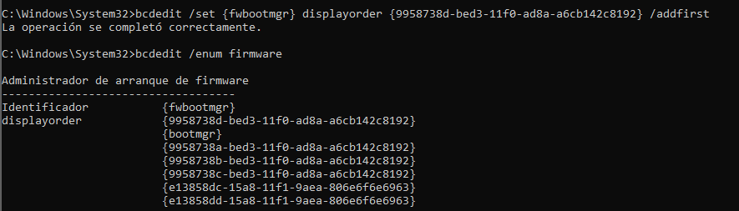

Part IV

Upon completing the recovery procedure and rebooting the system, the successful restoration of the boot chain is confirmed by the appearance of the GRUB menu.
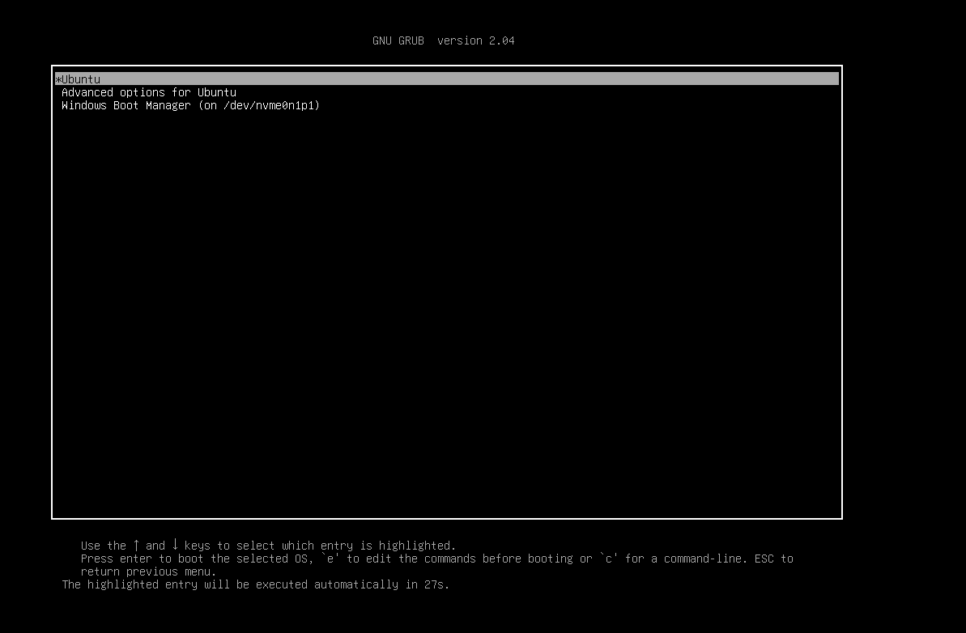

Conclusion

The laboratory successfully demonstrated the manipulation and recovery of a dual-boot environment on a UEFI-based system with NVMe storage.
By intentionally prioritizing the Windows Boot Manager, we simulated a common failure where the GRUB interface becomes inaccessible.
The technical execution transitioned from the Windows Recovery Environment to an Ubuntu Live environment for a full system rescue.
Final State:
- The system has been restored to its optimal configuration.
- The GRUB menu acts as the primary gatekeeper, providing stable access to both Ubuntu 24.04 and Windows 11.
- The objectives were achieved with a complete understanding of how bootloader paths and partition types (EFI vs. Linux filesystem) interact in modern virtualization environments.

