516-DaríoNL-ISO401-GestCuentasWinLinux
TAJAMAR | MADRID | 23/03/2026
Administration of users accounts Windows - Linux
ISO – Unit 4 – Users accounts

Contenido
Introduction 3
User Scheme 4
Theoretical Introduction: User Profile vs. User Account 5
Inventory 6
Execution 7
Windows 11 7
Accessing Local Users and Groups 7
Creating the Local Groups 8
Creating the User Accounts 10
Assigning Users to Groups 12
Configuring the Guest Account 14
Finnal Verification 15
Ubuntu Desktop 17
Preparation: Accessing the Advanced GUI Tool 17
Creating the User Accounts 18
Creating the Local Groups 22
Configuring the Guest Account 24
Finnal Verification 25
Ubuntu Server 27
Configuring the Reception Department 27
Configuring the Sales Department 28
Configuring the Management Department 29
Configuring the Guest Account 30
Setting Passwords (Required for Login) 31
Conclusion 32

Introduction

In this laborator, the primary objective is to deploy, configure, and manage a multi-OS environment.
To achieve this, we will be working with a virtualized infrastructure consisting of three distinct virtual machines:
- Windows 11 (GUI).
- Ubuntu Desktop (GUI).
- Ubuntu Server (CLI).
Through this setup, a comprehensive understanding of local system administration can be achieved, allowing us to practice cross-platform management techniques using both visual environments and command-line tools.

User Scheme

Based on the specific operational requirements of the company, a structured hierarchy of local accounts and groups must be established.
We have designed the following user scheme to ensure proper access control and role separation:
- Receptionists Group (reception):
  - Purpose: Daily front-desk operations across different shifts.
  - Users: Miguel Aguado, José Luis López.
- Sales Group (sales):
  - Purpose: Occasional system access, primarily for checking email.
  - Users: Raúl Mitrado, José Miguel Soriano, Enrique del Moral.
- Management Group (management):
  - Purpose: A reserved, secure account for handling administrative tasks and receiving electronic invoices.
  - User: Marcos de la Iglesia.
- Guest Account (guest):
  - Purpose: A highly restricted account with zero administrative privileges, intended to be used for any other miscellaneous function or temporary access.

Theoretical Introduction:
User Profile vs. User Account

Before proceeding with the practical configuration on the virtual machines, it is essential to clearly distinguish between two fundamental concepts in system administration…
User Account:
- Represents the digital identity within an operating system.
- We use it to handle authentication (verifying who is trying to access the system via credentials like a username and password) and authorization (defining the permissions and security rights that identity possesses).
- Essentially, the account dictates whether access is granted and what system resources can be interacted with.
User Profile:
- Is the collection of data, specific settings, and personal files associated with a given user account.
- Once we successfully log in using an account, the operating system loads the corresponding profile.
- This includes the specific desktop background, customized application preferences, browser history, and personal directory folders (such as Documents, Pictures, and Downloads).
In summary, the account acts as the security key that unlocks the system, whereas the profile is the personalized workspace provided after the door is opened.

Inventory

For the realization of the laboratory we have used:
- Hardware:
  - Host PC.
- Software:
  - Windows 11.
  - Ubuntu Server 24.04.3.
  - Ubuntu Desktop 24.04.2.

Execution

Windows 11

To implement the defined user scheme in the Windows 11 virtual machine, the graphical user interface (GUI) is utilized.
Specifically, the Computer Management console is the most appropriate tool for advanced local account administration.

Accessing Local Users and Groups

First, we must access the management console where local identities are configured.
- Press Win + X and select Computer Management.
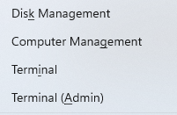
- In the left pane, we navigate to System Tools Local Users and Groups.
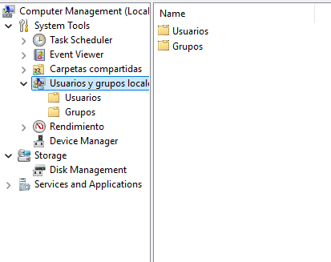

Creating the Local Groups

Before creating the users, it is considered best practice to create the structural groups first.
This allows us to desing the groups (usually importans because they are a container of permisions). And later assign each user (orignal or new) to the appropiate group.
- We click on the Groups folder in the left pane.
- Right-click in the empty space of the center pane and select New Group.
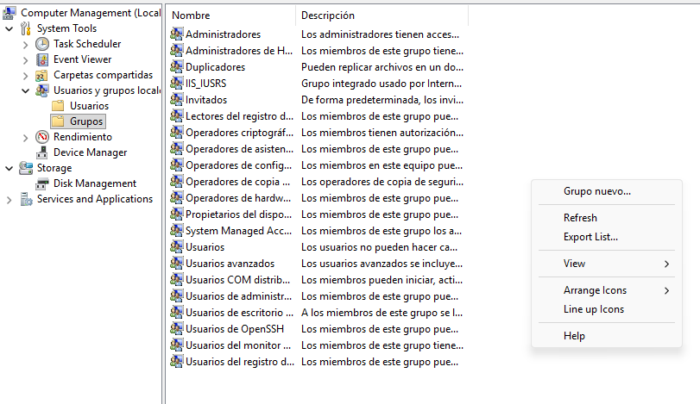

- We repeat this process to create the following groups, filling in the "Group name" and a brief "Description" for each:
  - Group Name:
    - Reception (Description: Front-desk staff)
  - Group Name:
    - Sales (Description: Commercial team)
  - Group Name:
    - Management (Description: General management)
- Click Create and then Close.
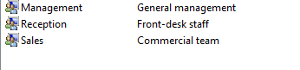

Creating the User Accounts

Next, we proceed to create the individual user accounts.
To maintain a professional standard, a username convention (first initial + last name) is applied, while the full name is registered in the properties.
- In the left pane, we click on the Users folder.
- Right-click in the center pane and select New User.
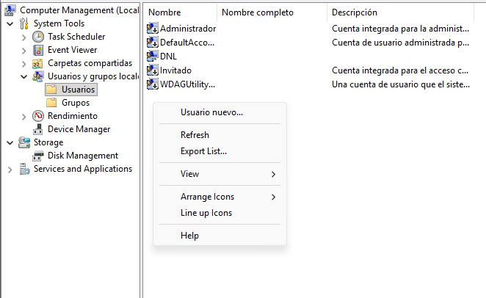

- We fill out the required fields for each employee.
  - For security purposes during this lab, a generic password is set for all users, and the option User must change password at next logon is checked.
  - Receptionists:
    - User name: maguado | Full name: Miguel Aguado
    - User name: jlopez | Full name: José Luis López
  - Sales Team:
    - User name: rmitrado | Full name: Raúl Mitrado
    - User name: jsoriano | Full name: José Miguel Soriano
    - User name: emoral | Full name: Enrique del Moral
  - Manager:
    - User name: miglesia | Full name: Marcos de la Iglesia
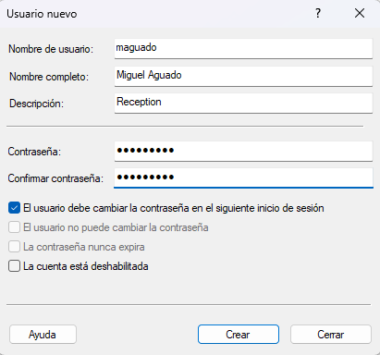
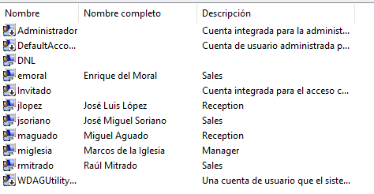

Assigning Users to Groups

Once the accounts are created, they must be assigned to their designated roles, and standard user permissions must be enforced.
- We double-click on each newly created user to open their Properties.
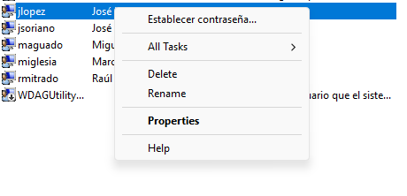
- Navigate to the Member Of tab.
- By default, users are members of the Users group. We keep this to ensure standard baseline permissions.
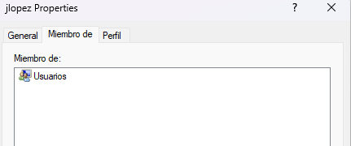

- Click Add, type the name of the specific group (Example, Reception), click Check Names to verify, and then click OK.
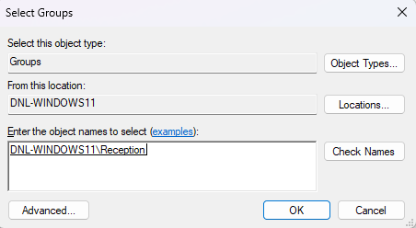
- This process is repeated so that Miguel and José Luis are added to Reception; Raúl, José Miguel, and Enrique to Sales; and Marcos to Management.
  - We algo can add users at one group in the group area.
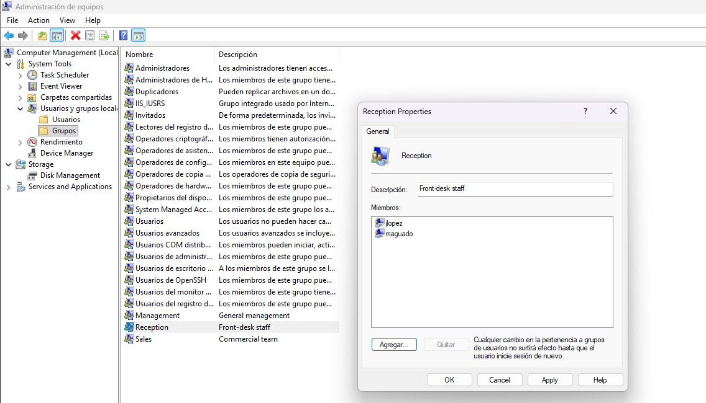

Configuring the Guest Account

Finally, the requirement for a restricted account for miscellaneous functions must be addressed.
Instead of creating a new account, the built-in Windows Guest account can be utilized.
- In the Users folder, we locate the default Guest account.
- Double-click the Guest account to open its properties.
- We uncheck the box that says Account is disabled to activate it.
- This account inherently belongs to the Guests group, which automatically restricts system modifications, software installations, and access to other users' files, fulfilling the security requirement for temporary access.
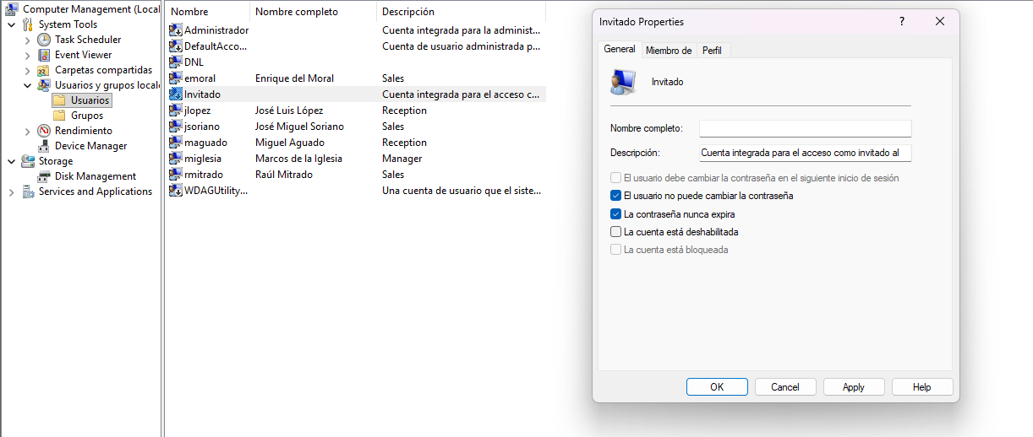

Finnal Verification

To ensure that the previous configuration was applied correctly and to verify the user-to-group assignments, we can use the Windows Command Prompt (CMD).
This allows us to quickly audit the system without navigating back through the graphical interface.
To check which users are assigned to a specific group, the net localgroup command is utilized followed by the group name:
- For example, to verify the Reception group, we execute:
  - net localgroup Reception
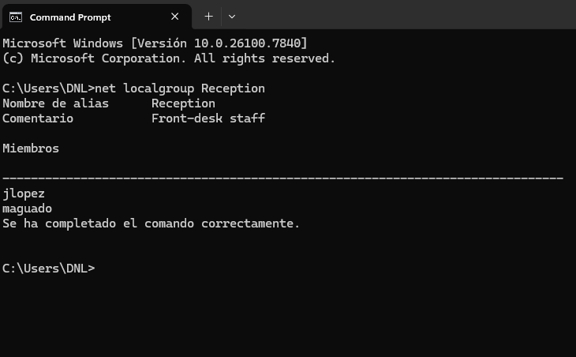

Alternatively, to check the group memberships from the perspective of a specific user, we use the net user command:
- For example, to check the manager's account, we execute:
  - net user miglesia
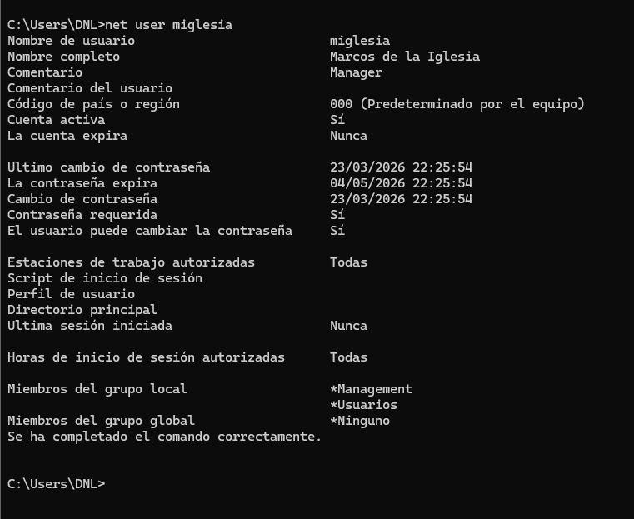

Ubuntu Desktop

To implement the user scheme in the Ubuntu Desktop virtual machine using a graphical interface, the default system settings are often too limited for custom group management.
Therefore, we utilize the advanced Users and Groups application (gnome-system-tools) to achieve the required granular control.

Preparation: Accessing the Advanced GUI Tool

First, we must ensure the proper graphical management tool is available on the system.
- We need the Users and Groups tool:
  - This can be quickly installed via terminal using:
    - sudo apt install gnome-system-tools
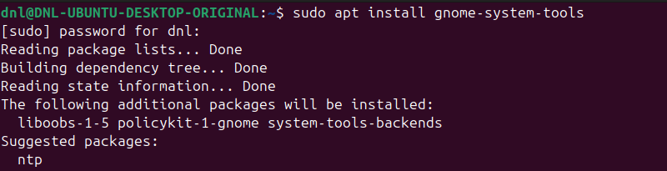
- Once installed, we open the application menu, search for Users and Groups, and launch the application.
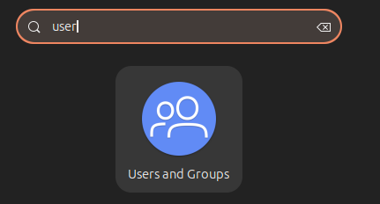

Creating the User Accounts

In the second pashe, the other way around Windows.
We will generate the individual accounts for the employees. Utilizing other name standar to diferenciate of the part in Windows, now the username will be (Name + First Letter of the Surname).
- In the main Users Settings window, we click on Add.
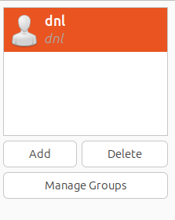

- We fill in the "Full Name" and "Username" for each employee and click OK:
  - Receptionists:
    - Full Name: Miguel Aguado | Username: miguela
    - Full Name: José Luis López | Username: josell
  - Sales Team:
    - Full Name: Raúl Mitrado | Username: raulm
    - Full Name: José Miguel Soriano | Username: josems
    - Full Name: Enrique del Moral | Username: emoral
  - Manager:
    - Full Name: Marcos de la Iglesia | Username: marcosdli
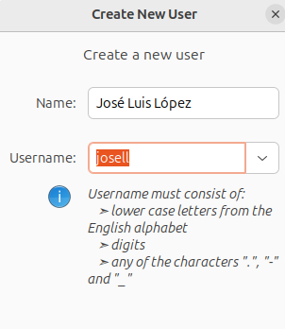
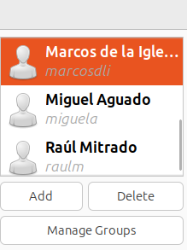
- Immediately after creating each user, the system prompts us to configure a password.
  - We assign a secure, generic password for the lab and confirm (also we can generate a random password).
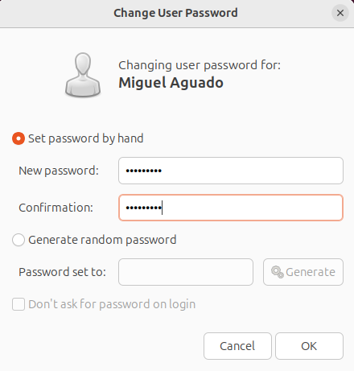

- Finnaly, we will change the account type to a standar user account (because in this lab we will not work with permisions, and we will set deafault user privilegies to all the new users).
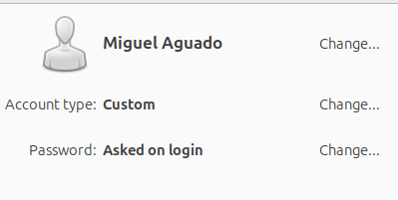
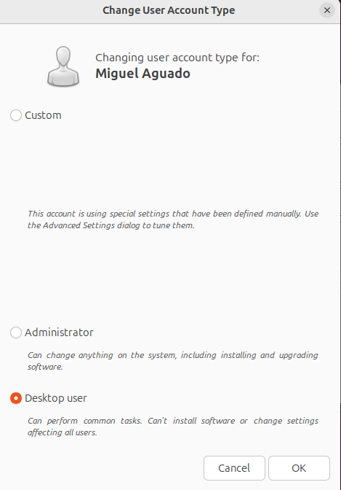

Creating the Local Groups

Now we are goint to configurate the group settings:
This order is actually less practical since in reality you would first establish the work groups and their permissions and then add each new user to the corresponding group, but in a practical case I think it is faster to do it in this order since you add the users directly to the group.
- In the main window of the application, we click on the Manage Groups button.
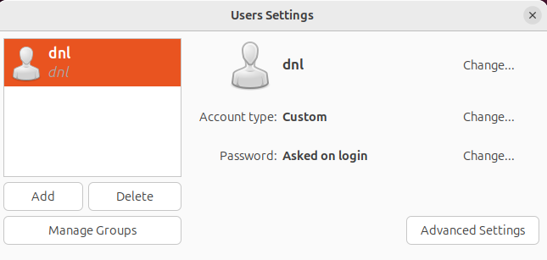
- We click on Add (authentication as an administrator will be required).
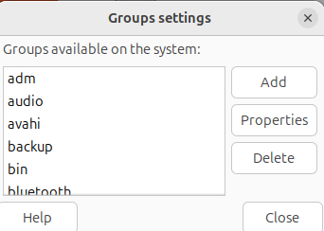

- We create the following groups by entering the exact group names, assign the users to the group and clicking OK:
  - Group name:
    - reception
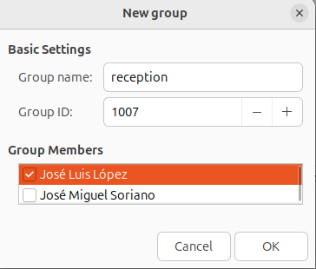
  - Group name:
    - sales
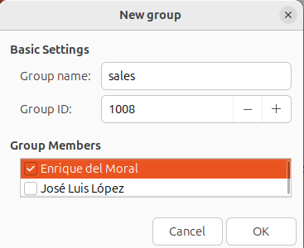
  - Group name:
    - management
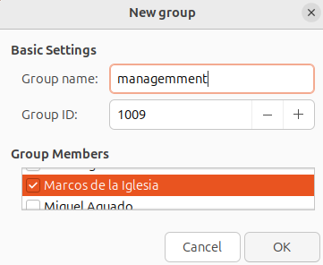
- Once all three groups are created, we close the Group settings window to return to the main menu.

Configuring the Guest Account

Modern Ubuntu environments no longer include a built-in guest session by default due to security architecture changes.
To satisfy the requirement for a restricted account, we manually create a standard user profile for temporary access.
- Back in the main Users Settings window, we click Add.
- We create a user with the Full Name Guest and the username guest.
- We ensure the account type is strictly set to Custom.
- We set a simple, known password for this account to allow temporary access for miscellaneous functions.
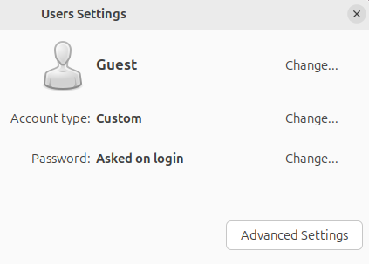
- Now in Advanced Settings we can retrict the privilegies to the Guest account.
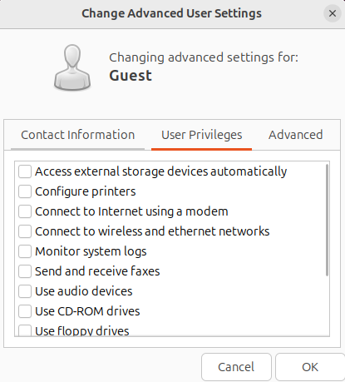

Finnal Verification

To quickly confirm that the graphical configurations were applied correctly in Ubuntu Desktop, we can open the terminal and utilize a few simple verification commands.
First we have to login with the account to activate it.
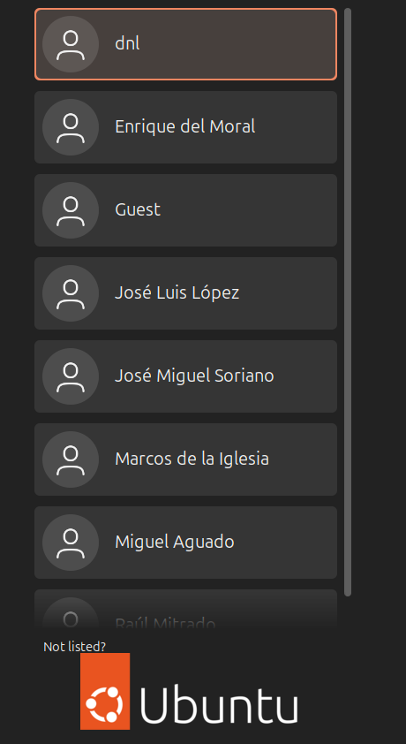
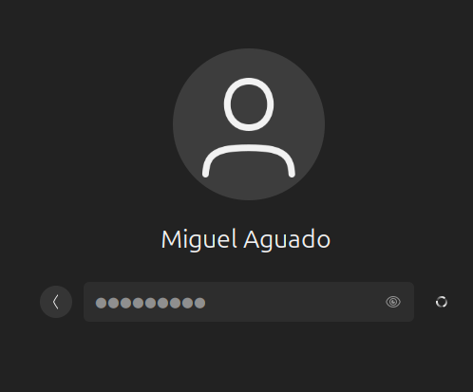

To check which groups a specific user belongs to, we use the groups command followed by the username:
- For example, to verify Miguel Aguado's account, we execute:
  - groups miguela
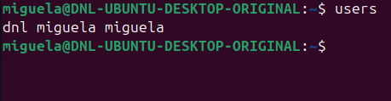
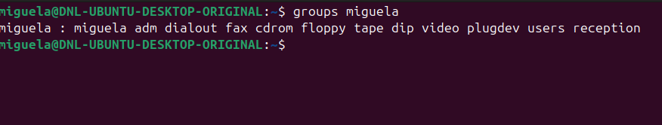
Alternatively, to view all the members assigned to a specific group, we use the getent group command:
- For example, to verify the sales team, we execute:
  - getent group sales
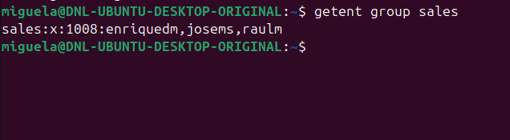

Ubuntu Server

For the Ubuntu Server virtual machine, we will utilize the Command Line Interface (CLI).
In this environment, the useradd, groupadd, and usermod commands provide precise control over account creation and permissions.

Configuring the Reception Department

First, we set up the accounts for the front-desk staff, create their specific group, and assign them to it:
- Create the users:
  - sudo useradd -m -c "Miguel Aguado" maguado
  - sudo useradd -m -c "Jose Luis Lopez" jlopez
- Create the group:
  - sudo groupadd reception
- Add users to the group:
  - sudo usermod -aG reception maguado
  - sudo usermod -aG reception jlopez
  - The -aG flags append the user to the supplementary group without removing them from their default primary group.
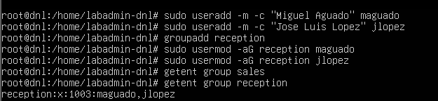

Configuring the Sales Department

Next, we repeat the workflow for the commercial team, who require occasional system access:
- Create the users:
  - sudo useradd -m -c "Raul Mitrado" rmitrado
  - sudo useradd -m -c "Jose Miguel Soriano" jsoriano
  - sudo useradd -m -c "Enrique del Moral" emoral
- Create the group:
  - sudo groupadd sales
- Add users to the group:
  - sudo usermod -aG sales rmitrado
  - sudo usermod -aG sales jsoriano
  - sudo usermod -aG sales emoral
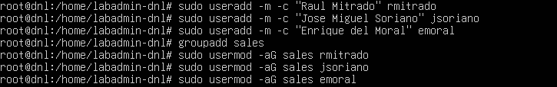


Configuring the Management Department

We now establish the reserved account for the manager:
- Create the user:
  - sudo useradd -m -c "Marcos de la Iglesia" miglesia
- Create the group:
  - sudo groupadd management
- Add user to the group:
  - sudo usermod -aG management miglesia
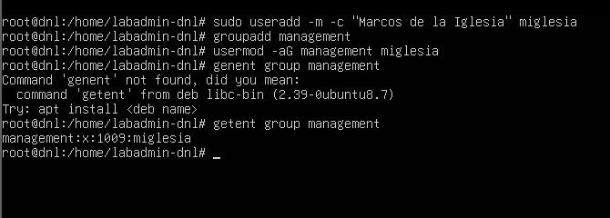

Configuring the Guest Account

Finally, we create the restricted account for miscellaneous functions.
Since this user should have no privileges, we simply create the standard account without assigning it to any elevated or specific organizational group.
Create the guest user:
- sudo useradd -m -c "Guest Account" guest
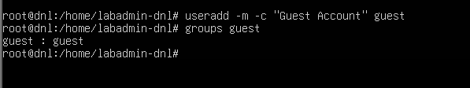

Setting Passwords (Required for Login)

To finalize the CLI setup, it is important to remember that accounts created with useradd are locked by default until a password is set.
In a real-world scenario, we must assign a password to each user so they can access their profiles.
To set a password, the following command is executed for each username (the system will prompt you to type and confirm the password):
- sudo passwd maguado
- sudo passwd jlopez
- # (Repeat for the rest of the created users)
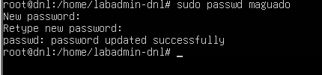
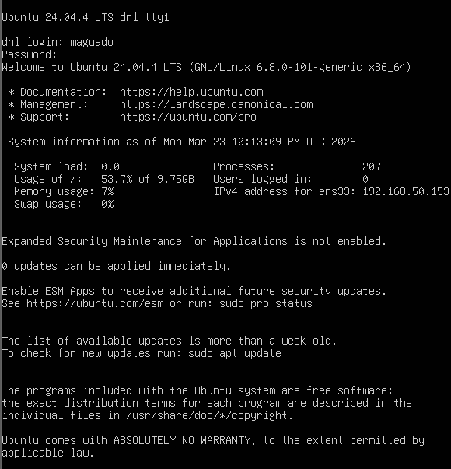

Conclusion

In this laboratory, we have successfully deployed a standardized user architecture across three distinct operating system environments (Windows 11, Ubuntu Desktop, and Ubuntu Server).
This exercise demonstrates that while the tools, interfaces, and commands may vary between platforms, the fundamental principles of local identity management remain consistent.
The most critical takeaway from this deployment is understanding the true administrative function of a user group.
Rather than viewing groups merely as organizational labels, they must be understood strictly as containers of permissions.
- Managing access rights on an individual, user-by-user basis is highly inefficient and prone to security oversights.
- Instead, system privileges and access to resources are assigned directly to the group.
- Consequently, when we assign a user account (like maguado) to a group (like reception), that user instantly inherits all the permissions contained within that group.
- If an employee changes departments, we simply move their account to a different group container, automatically revoking old privileges and granting new ones.
- This methodology is the cornerstone of secure, scalable, and efficient system administration

