516-DaríoNL-ISOP401-ConfigRedWinLinux
TAJAMAR | MADRID | 10/04/2026
Basic Network Configuration
ISO – Unit 4 – NETWORK in linux / windows

Contenido
Introduction 3
Inventory 4
Network Administration in Windows 10 5
Roadmap 5
Phase I: Identity and Addressing 6
Phase II: Management of Windows Defender Firewall 15
Phase III: Availability and Data Persistence 25
Ubuntu Desktop Network Administration 28
Hostname, Addressing, and DNS 28
Basic Firewall Configuration (UFW) 30
Verification via Terminal 33
Ubuntu Server Network Administration (CLI) 34
Hostname Configuration 34
Addressing and Name Resolution (Netplan) 35
Basic Firewall Configuration (UFW) 38
Conclusion 40

Introduction

This laboratory focuses on the standardization of network parameters across a heterogeneous environment comprising Windows 10, Ubuntu Desktop, and Ubuntu Server.
The primary objective is to achieve consistent logical identification, IP addressing, and DNS name resolution across all nodes to ensure seamless inter-operability.
Furthermore, the practice emphasizes security baselines through firewall management and explores Windows-specific administrative features, such as Offline Files and advanced Interface Bridging, to optimize resource availability and network segment integration.
- Identity and Resolution:
  - Proper management of hostnames and DNS settings is critical for reliable resource discovery and communication between Windows and Linux systems.
- Edge Security:
  - Implementing basic Firewall rules (utilizing Windows Defender and UFW on Ubuntu Desktop) establishes essential protection against unauthorized inbound traffic.
- Data Persistence:
  - The configuration of Offline Files ensures that critical network resources remain accessible on the local machine during periods of restricted connectivity.

Inventory

For the realization of the laboratory we have used:
- Hardware:
  - Host PC.
- Software:
  - Windows 10.
  - Ubuntu Server 24.04.3.
  - Ubuntu Desktop 24.04.2.

Network Administration in Windows 10

Roadmap

Phase I: Identity and Addressing.
- Modification of the NetBIOS computer name and workgroup membership.
- Configuration of static and dynamic (DHCP) IPv4/IPv6 addressing.
- Assignment of primary and secondary DNS servers for name resolution.
Phase II: Management of Windows Defender Firewall.
- Management of Windows Defender Firewall operational states.
- Review of basic inbound and outbound filtering rules for Private and Public network profiles.
Phase III: Availability and Data Persistence.
- Activation of Offline Files through the Windows Sync Center.
- Management of cache limits and synchronization schedules for network resources.

Phase I: Identity and Addressing

In this pashe we will work with the principals configurations of a client (Name, and network parameters).
There will be critical for the proper functioning and integration of the work station in his own network.
Modification of the NetBIOS computer name and workgroup membership:
There are so many diferents forms to configurate this parametters but we will acced by this steps.
Settings System About Change name.
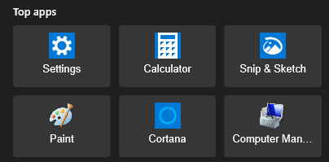
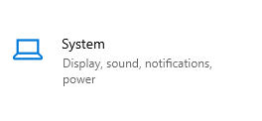


Go down and look for Related Rename this PC Change.
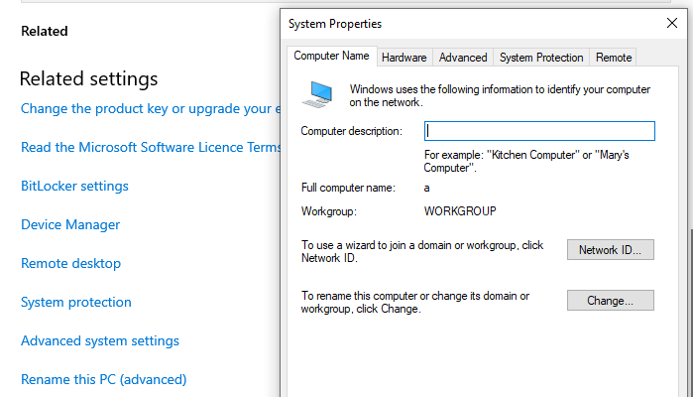
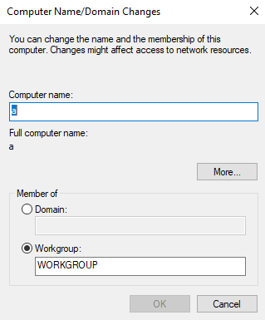

Here we could change the name and the group (or domain) we belong to.
It is not possible to test a domain change because we do not have a local domain to join, so we will only change the Workgroup name.
We will have to restart when we want to apply it.
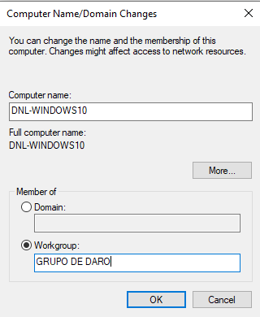
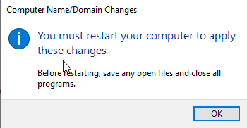
Comprobation after the restart.

- Workgroup vs. Domain:
  - Workgroup
    - Architecture: Peer-to-peer (no central server).
    - Management: Decentralized. Each computer is autonomous.
    - Authentication: Local security database stores user accounts and passwords on each machine.
    - Resource Sharing: Manual configuration required on every individual device.
    - Scalability: Limited to small environments (typically under 20 devices).
  - Domain
    - Architecture: Client-server (managed by a Domain Controller).
    - Management: Centralized via Active Directory.
    - Authentication: Global database for all user identities and credentials.
    - Single Sign-On: Users log into any workstation with a single network account.
    - Governance: Administrators use Group Policies to manage all computers simultaneously.
  - Primary Difference
    - Workgroup: Manual and independent node management.
    - Domain: Automated and centralized infrastructure control.

Configuration of static and dynamic (DHCP) IPv4/IPv6 addressing and assignment of primary and secondary DNS servers for name resolution:
Control Panel Network and Internet Network and Sharing Center.
We have to select our NIC.
Ethernet0 Propierties.
In the propierties, we can change a lot of parameters, we will focus on the IPV4 or IPV6 settings.
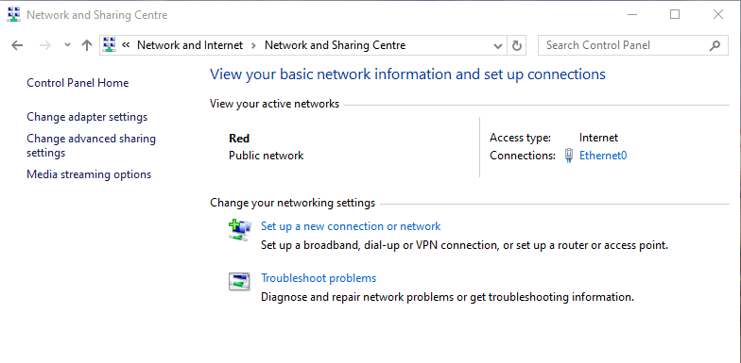

- IPv4:
  - Selectting the IPv4 option, shows the IPv4 configuration settings in Windows where a static IP is being assigned.
  - The configuration uses a Class C network, as indicated by the IP address range 192.168.65.200, which belongs to the private Class C.
  - The subnet mask 255.255.255.0 is automatically applied based on the Class C default, defining a /24 network and separating network and host portions.
  - The default gateway is set to 192.168.65.2, which acts as the exit point to other networks.
  - DNS servers are manually configured using public DNS (8.8.8.8 and 8.8.4.4), overriding automatic DNS assignment.
  - The focus of this configuration is the manual assignment of IP addressing parameters rather than dynamic IP behavior, illustrating basic IPv4 network setup.
  - We can obtaint these parameters by DHCP if we select the automatic configuration.

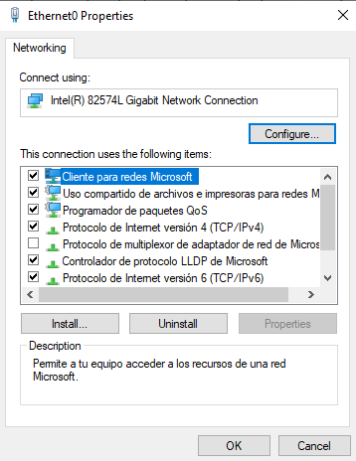
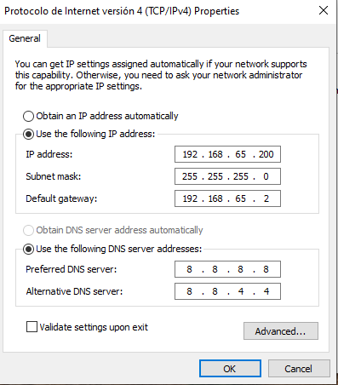
We can confirm the changes in the CMD with ipconfig.
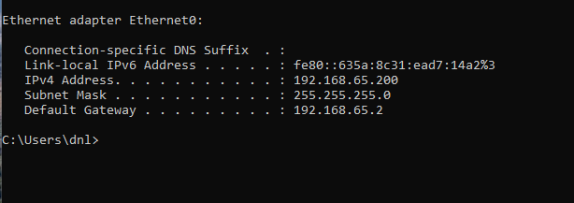
- IPv6.
  - First seleccting the chekbox, we can disable IPv4.
  - Then we will select IPv6.
  - Selecting the IPv6 option displays the Windows configuration window where a static address is manually assigned.
  - The configuration uses a Unique Local Address (ULA), identified by the fd15 prefix, ensuring local communication within the private network.
  - A subnet prefix length of 64 is defined, representing the standard size for IPv6 segments and separating the network prefix from the interface identifier.
  - The default gateway is set to fd15:4ba5:5a2b:1008::1, which acts as the exit node for traffic destined outside the local segment.
  - DNS resolution is manually pointed to public IPv6 DNS servers (2001:4860:4860::8888 and 2001:4860:4860::8844) instead of automatic assignment.
  - This setup emphasizes manual addressing parameters over dynamic behavior, establishing a persistent and predictable network identity for the system.
  - We can obtaint these parameters by DHCP if we select the automatic configuration.

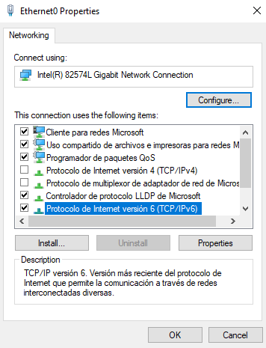
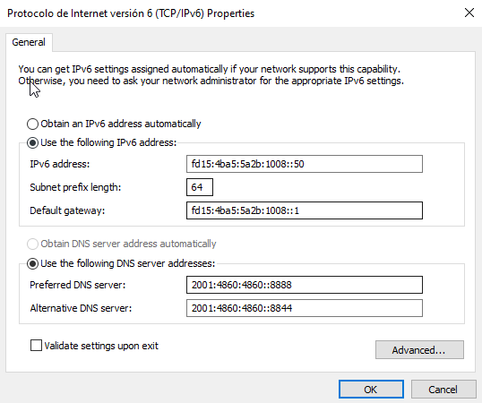
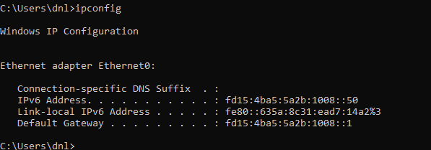

Phase II: Management of Windows Defender Firewall

The Windows Defender Firewall acts as a protective barrier that monitors and filters data packets traveling between the computer and the network.
It uses a set of security rules to determine whether to allow or block specific traffic based on the connection's origin and the assigned Network Profile.

Operational States and Network Profiles

Active/Inactive State:
- The firewall can be toggled On or Off for each profile.
- Keeping it active is the baseline for preventing unauthorized external access.
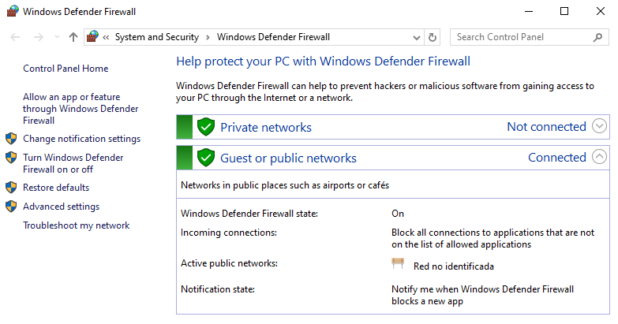
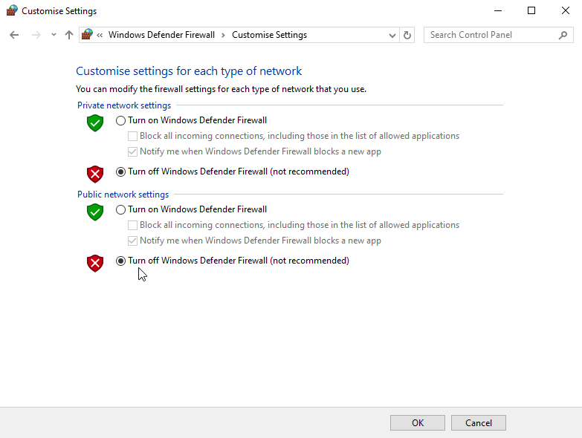
Profile Types:
- Domain Profile:
  - Automatically applied when the computer is joined to an Active Directory domain (typical in corporate environments).
- Private Profile:
  - Used for trusted networks like home or office, where the device is discoverable to others for resource sharing (printers, files).
- Public Profile:
  - Designed for untrusted networks (airports, cafes).
  - It hides the computer from other devices to maximize security.
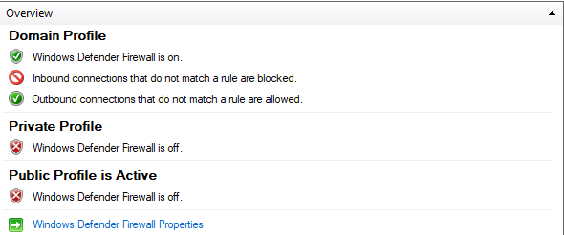

Filtering Rules

Inbound Rules:
- Filter traffic coming from the network to the computer.
- By default, most unsolicited inbound traffic is blocked unless a specific rule (like for a web server or game) allows it.
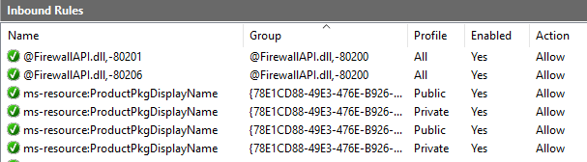
Outbound Rules:
- Filter traffic sent from the computer to the network.
- Usually, all outbound traffic is permitted by default to ensure apps can reach the internet, but it can be restricted to block specific malware or telemetry.
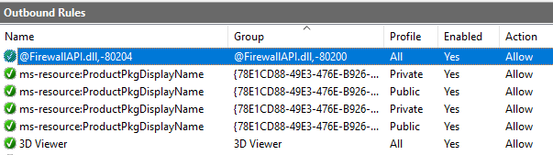
Scope and Port:
- Rules are defined by specific Port numbers (e.g., Port 80 for HTTP) and Protocols (TCP/UDP), allowing for granular control over which applications can communicate.

Operating with new rules

We are going to enable ICMP (ping) trafic from a specific IP, to allow control checks of that host.
First we are going to prove that we can not do a “ping” to the Window 10 host.
We have to activate the firewall.
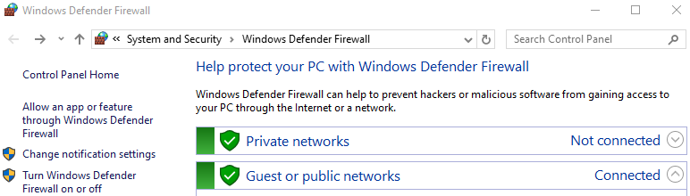
Now we check our IP.
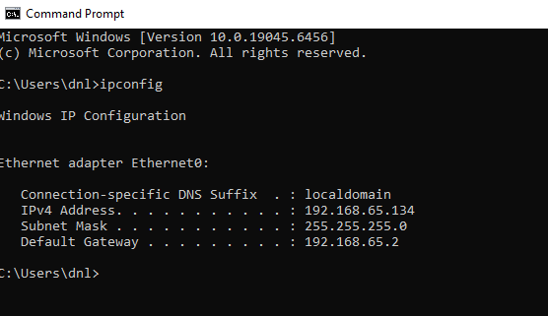

Form other node we prove that we can not do a ping to the Windows 10 host.
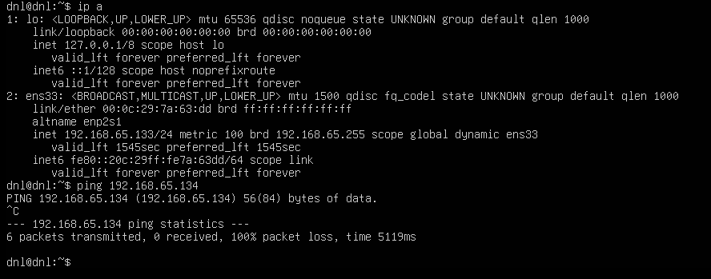

To operate with these rules, we have to go to “Advanced Settings”.
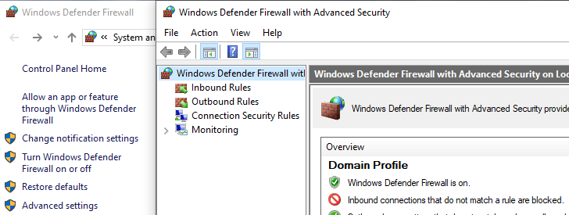
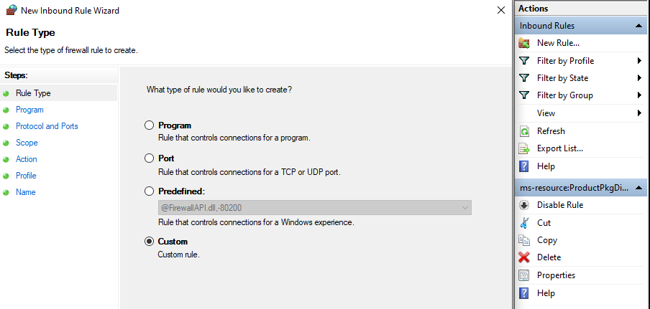
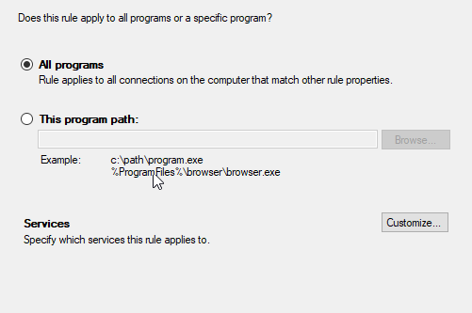
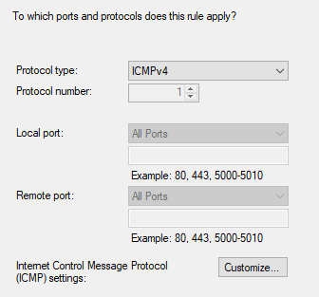
To allow a device on our network:
- “Which remote IP addresses does this rule apply to?” WE USE THIS
  - We enter the IP address of the device we want to allow.
  - Example: 192.168.65.133.
- “Which local IP addresses…”
  - Refers to our own computer (where the rule is applied).
  - We do not use this to control other devices.
Correct setup:
- Local IP: Any IP address.
- Remote IP: IP of the device we want to block.
Meaning:
- Remote = Target device (we allow this).
- Local = Our machine.

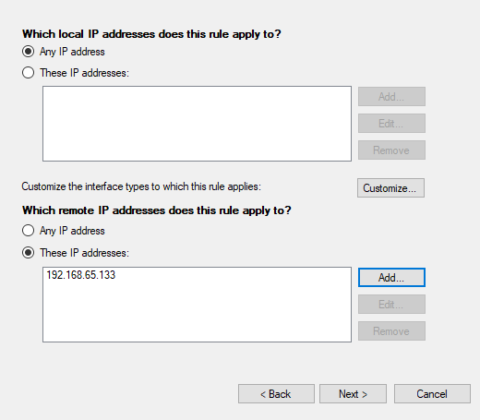
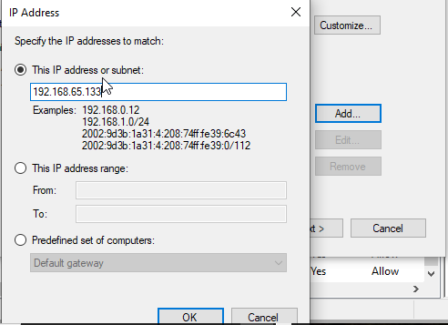
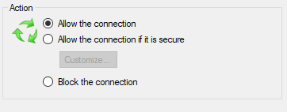
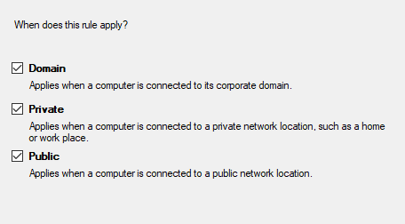
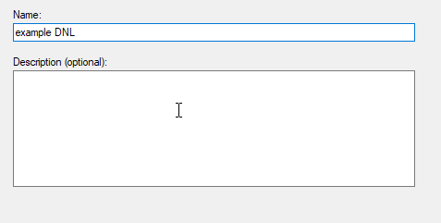
Now we finished de creation of the rule, form this panel, we can edit it.
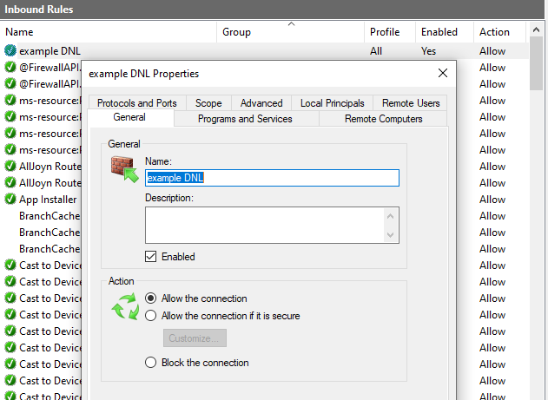
Finnally from the other host we are goint to check if we can realize the ping.
And of course, we demostrated the correct working of this new rule, because we do not have failures in the “ping” resolution.
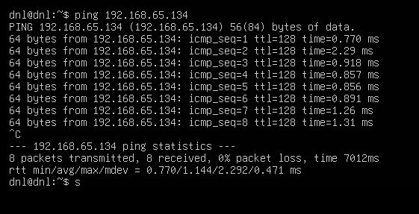

Phase III: Availability and Data Persistence

Offline Files and Sync Center:
- Offline Files is a Windows feature that allows users to access network resources even when the computer is not connected to the local network by storing a local copy in the system cache.
Activation Step-by-Step:
- Open the Control Panel.
- Select Sync Center.
- Click on Manage offline files in the left-hand sidebar.
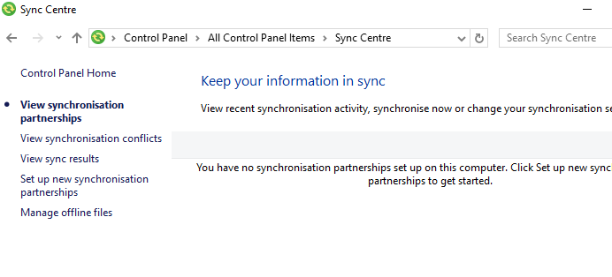
- Click the Enable offline files button in the General tab.
- Confirm the administrative prompt if required.
- Restart the operating system to initialize the local cache service.
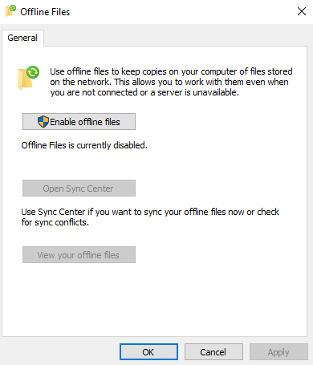

Managing Cache Limits:
- Open the Offline Files configuration window from the Sync Center.
- Navigate to the Disk Usage tab.
- Click on Change limits.
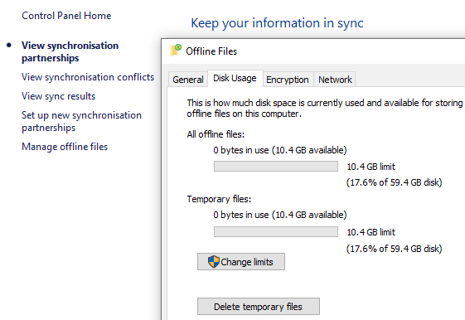
- Adjust the slider for Maximum amount of disk space for all offline files to define the total cache size.
- Adjust the slider for Maximum amount of disk space for temporary files to control auto-cached data.
- Click OK to apply the storage restrictions.
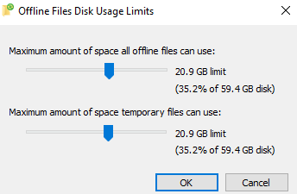
Synchronization Scheduling:
If we were on a network, we could operate with a network folder, set up it and then habilitate it to work with it offline.
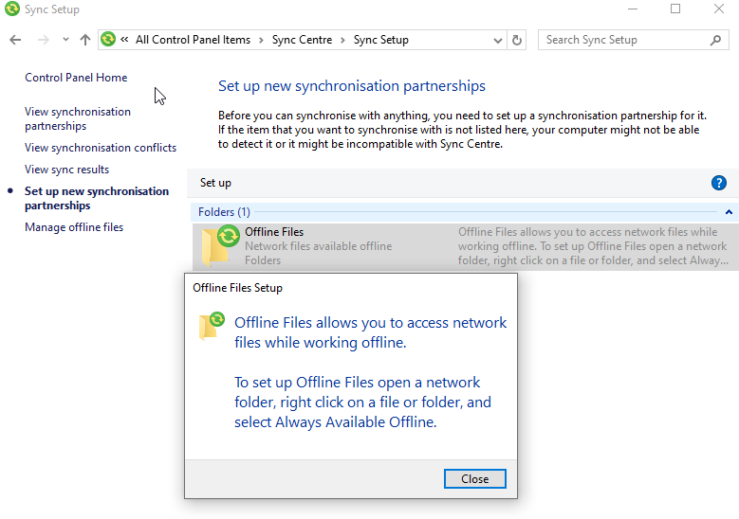

Ubuntu Desktop Network Administration

Hostname, Addressing, and DNS

Hostname Management (CLI):
- View current hostname:
  - hostname
- Change hostname permanently:
  - sudo hostnamectl set-hostname [new-name]
- Local resolution update:
  - Edit /etc/hosts to ensure the local loopback matches the new name.
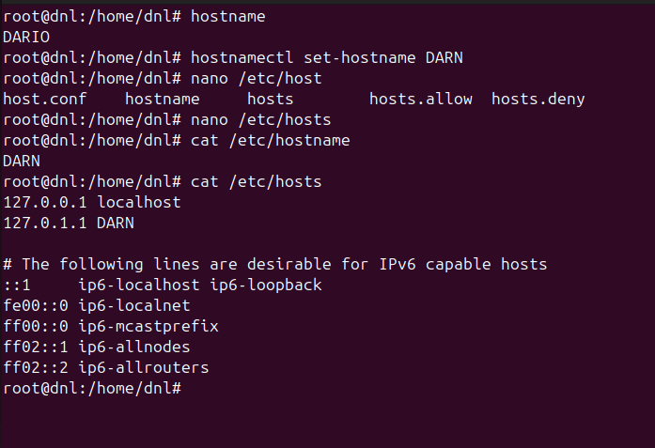

IP Addressing (GUI):
- Access Settings Network.
- Click the Gear Icon next to the active Wired or Wi-Fi connection.
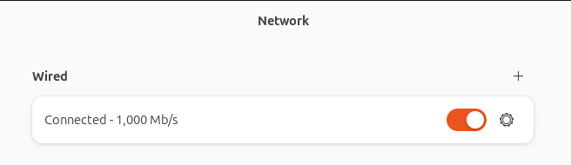
- Select the IPv4 or IPv6 tab.
- Switch IPv4 Method from Automatic (DHCP) to Manual.
- Enter the specific Address, Netmask, and Gateway.
- Enter preferred DNS servers separated by commas (1.1.1.1, 8.8.8.8).
- Click Apply and toggle the interface OFF and ON to reload settings.
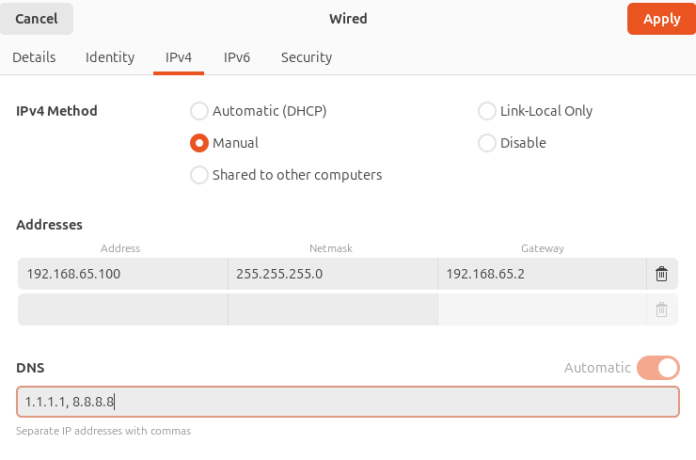

Basic Firewall Configuration (UFW)

To manage the Uncomplicated Firewall (UFW) via a graphical interface on Ubuntu Desktop, you need to use GUFW (Graphical Uncomplicated Firewall).
If it is not installed, use sudo apt install gufw.
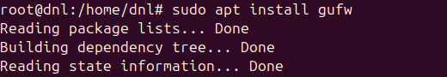
Firewall Management:
- Status, Activation, and Deactivation:
  - Toggle Switch:
    - Use the Status slider at the top of the main window to enable (on) or disable (off) the firewall.
- Default Policies:
  - Incoming/Outgoing Dropdowns:
    - Select the Incoming and Outgoing dropdown menus to set global policies, such as setting Incoming to Deny and Outgoing to Allow.
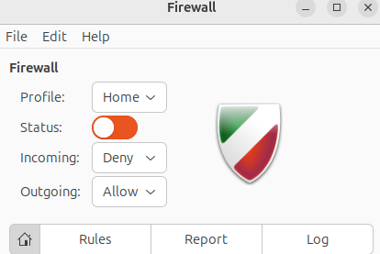
- Rule Management (Allow/Deny/Reject):
  - Rules Tab:
    - Click the Rules tab at the top of the interface.
  - Add Button (+):
    - Press the plus icon at the bottom to open the rule addition window.
  - Simple Tab:
    - Use the Policy (Allow/Deny), Direction (In/Out), and Port fields to create specific filters.
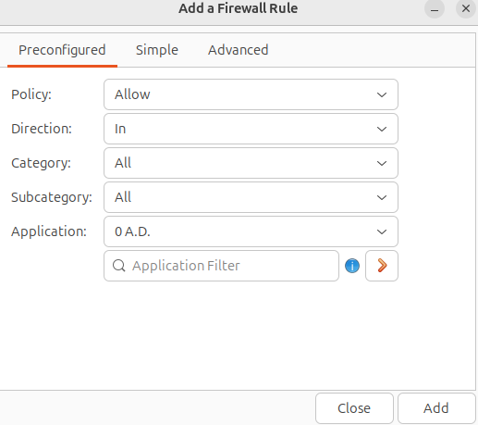

  - Delete Button (-):
    - Highlight an existing rule in the list and press the minus icon to remove it.
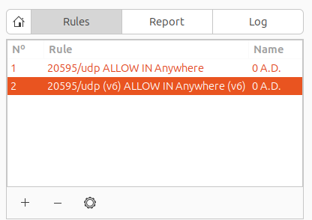
- Applying Changes:
  - Automatic Sync:
    - Unlike the CLI, the GUI applies and reloads the kernel rules immediately whenever a change is made through the interface.

Verification via Terminal

Confirm IP and Mask:
- ip addr show
Confirm DNS Resolvers:
- resolvectl status
Confirm active firewall rules:
- sudo ufw status verbose
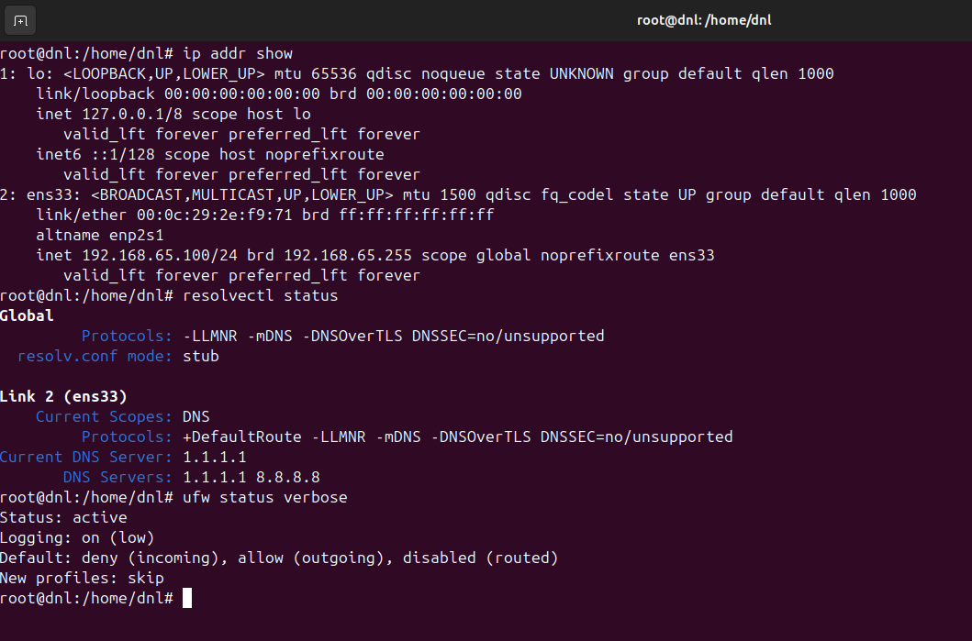

Ubuntu Server Network Administration (CLI)

Hostname Configuration

- Check current hostname:
  - hostnamectl status
- Change hostname permanently:
  - sudo hostnamectl set-hostname [new-hostname]
- Update local resolution file:
  - sudo nano /etc/hosts
- Apply changes without reboot:
  - exec bash
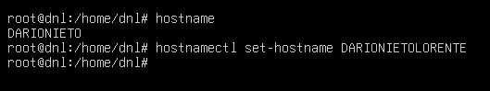
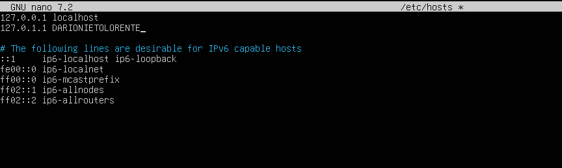
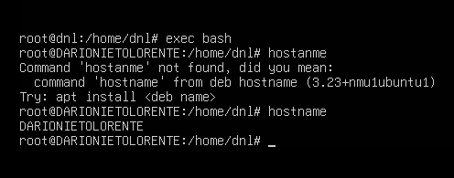

Addressing and Name Resolution (Netplan)

- Check NIC name:
  - ip a
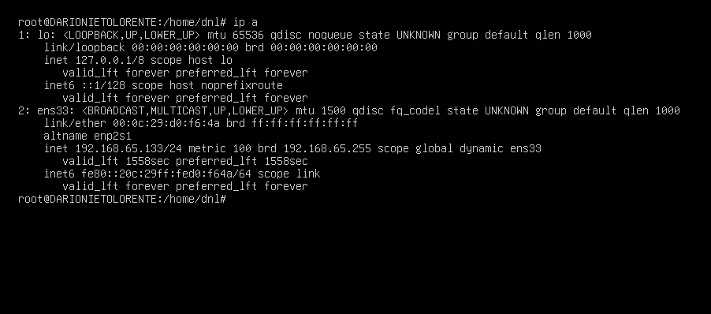
- Locate configuration file:
  - ls /etc/netplan/
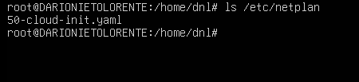

- Edit YAML configuration:
  - sudo nano /etc/netplan/50-cloud-init.yaml
- Configuration structure for ens33:
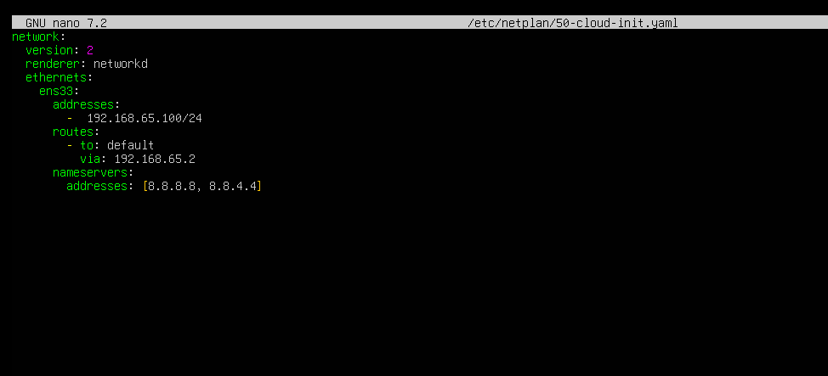
- Apply changes:
  - sudo netplan apply
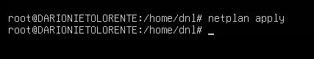

- Verify IP assignment:
  - ip addr show ens33
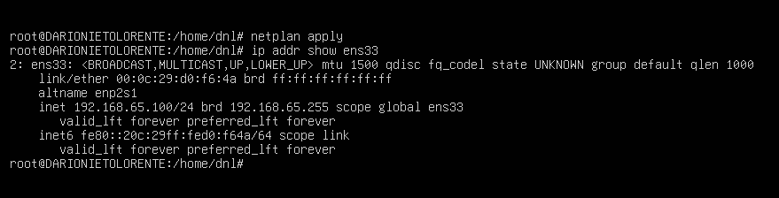
- Verify DNS resolution:
  - resolvectl status
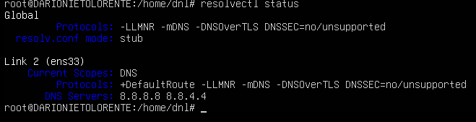

Basic Firewall Configuration (UFW)

Enable firewall service:
- sudo ufw enable
Check active rules and status:
- sudo ufw status verbose
Set default inbound policy:
- sudo ufw default deny incoming
Set default outbound policy:
- sudo ufw default allow outgoing
Allow essential management port (SSH):
- sudo ufw allow 22/tcp
Allow specific web traffic:
- sudo ufw allow 80,443/tcp
Reload configuration:
- sudo ufw reload

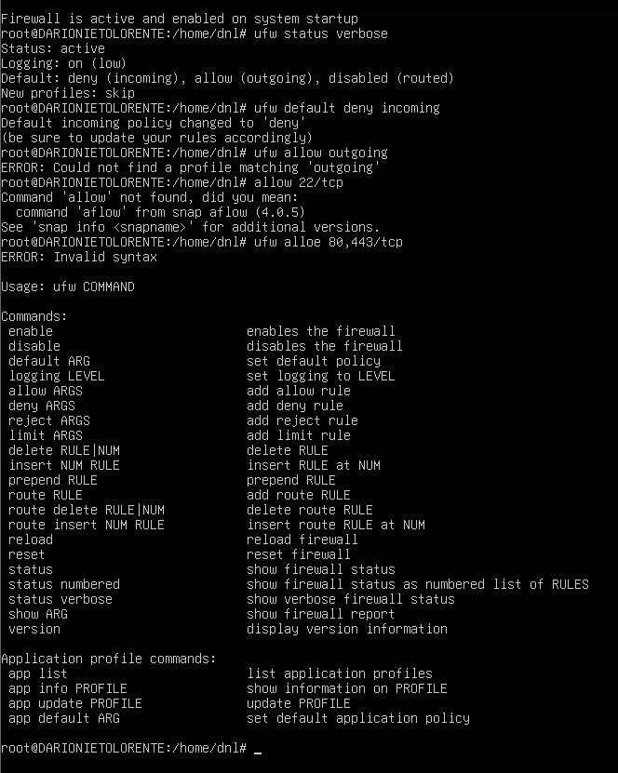


Conclusion

This laboratory provided a comprehensive implementation of Standardized Network Parameters across Windows 10, Ubuntu Desktop, and Ubuntu Server.
The primary focus was the transition from default dynamic settings to persistent, static configurations that ensure logical identity and secure communication.
By integrating security baselines and availability services, the practice demonstrated the critical balance between network accessibility and endpoint protection in a multi-platform environment.

