516-DaríoNL-ISOP406-ResetPasswWIN
TAJAMAR | MADRID | 20/04/2026
Reset password Windows
ISO – Unit 4 – Reset passw win

Contenido
Introduction 3
Theoretical Framework 4
Roadmap 5
Inventory 6
Execution 7
Phase I: Virtual Environment Configuration 7
Phase II: Filesystem Mounting 10
Phase III: Software Deployment 13
Phase IV: Password Reset Execution 15
Phase V: System Restoration and Verification 18
Conclusion 20

Introduction

This laboratory demonstrates a fundamental principle of cybersecurity:
Physical access to a machine often equates to total administrative control.
The objective is to perform an offline password reset on a Windows 7 system by utilizing an Ubuntu Live CD environment.
By bypassing the native operating system's security layers, we gain direct access to the filesystem and the security databases that store user credentials.
This exercise highlights the vulnerability of unencrypted storage media and provides a practical methodology for system recovery in scenarios where administrative access has been lost.
Offline Manipulation:
- We perform actions outside the Windows environment, ensuring that the target OS's security protocols (like login screens or account lockouts) are not active.
Administrative Recovery:
- We focus on resetting the password for a local administrator account without needing to know the previous credential.
Filesystem Interoperability:
- We utilize Linux tools to interact with the Windows NTFS filesystem and modify system registry hives.

Theoretical Framework

The Security Accounts Manager (SAM):
- In Windows systems, local user account information and password hashes are stored in a database file called the SAM (Security Accounts Manager).
- This file is part of the Windows Registry and is located within the C:\Windows\System32\config directory.
- When the operating system is running, this file is locked and protected by the kernel.
- However, by booting from an external medium (Live CD), the file becomes accessible as a standard data object.
chntpw Utility:
- The chntpw (Change NT Password) utility is an open-source software tool designed to overwrite or reset passwords in the Windows SAM database.
- It works by directly editing the binary data of the registry hive.
- Instead of attempting to "crack" the password (which could take a significant amount of time depending on complexity), chntpw allows us to clear the password field entirely or promote a standard user to an administrator.
Live CD Environment:
- An Ubuntu Live CD runs entirely within the computer's RAM, leaving the host's hard drive untouched unless we manually mount the partitions.
- This provides a clean, safe environment to perform administrative tasks, install temporary forensic tools, and manipulate host files without triggering Windows security software.

Roadmap

Phase I: Virtual Environment Configuration:
- We configure the virtual machine to boot from the Ubuntu ISO while maintaining a persistent connection to the target Windows 7 virtual disk.
Phase II: Filesystem Mounting:
- We identify the Windows partition within the Linux environment and mount it to gain access to the system folders.
Phase III: Software Deployment:
- We update the Linux package repositories and install the chntpw utility from the community developer archives.
Phase IV: Password Reset Execution:
- We navigate to the specific path of the SAM hive and execute the reset command to clear the administrator's password.
Phase V: System Restoration and Verification:
- We unmount the disk, shutdown the Live environment, and boot into Windows 7 to verify that administrative access is granted without a password prompt.

Inventory

For the realization of the laboratory we have used:
- Hardware:
  - Host PC.
- Software:
  - Windows 7.
  - Live CD Ubuntu Desktop 20.04.6.

Execution

Phase I: Virtual Environment Configuration

The first phase of the recovery process involves reconfiguring the virtual hardware to allow an external operating system to interact with the target disk.
We must ensure that the Ubuntu Live environment has full access to the Windows 7 storage while remaining the primary boot device.
We start from having a Windows 7 system, where we know the user name but not the pasword.
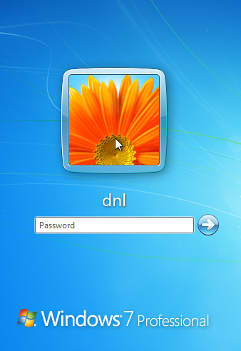
ISO Mounting and Virtual Drive Setup:
- Within the virtual machine settings, we navigate to the CD/DVD (SATA/IDE) configuration section.
- We set the connection to use an ISO image file and browse for the Ubuntu distribution.
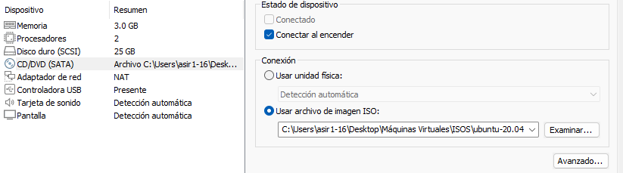
Storage Persistence and Integrity:
- We verify that the Windows 7 Virtual Hard Disk (.vmdk) remains attached to the virtual controller.
- We specifically avoid creating a new virtual disk for the Ubuntu session.
- Since our objective is to modify the existing Security Accounts Manager (SAM) database, the Ubuntu environment must be able to "see" the Windows disk as a secondary data source.
- Maintaining the existing disk ensures that we are working directly on the filesystem we intend to hack.

Boot Order Optimization:
- We access the virtual BIOS/UEFI firmware settings during the initial power-on sequence.
- Within the Boot tab, we move the CD-ROM Drive to the highest priority, placing it above the Hard Drive.
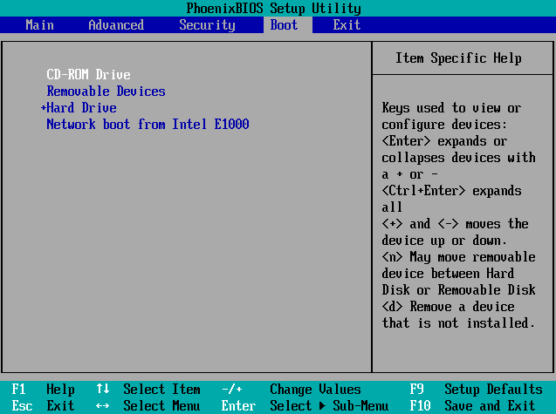
Initializing the Live Session:
- Once the VM starts from the ISO, we select the "Try Ubuntu" option from the menu.
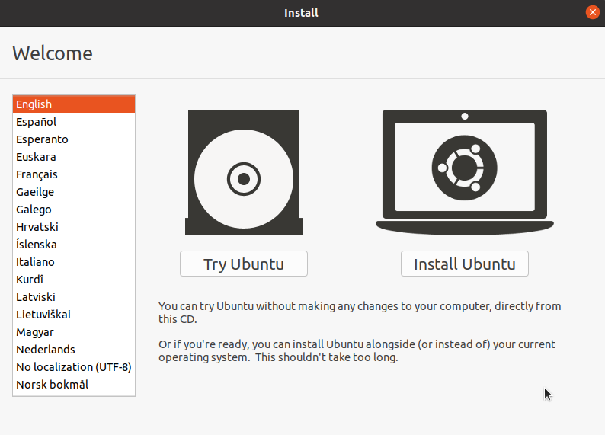

Phase II: Filesystem Mounting

In this phase, we bridge the gap between the virtual block devices and the operating system's directory structure.
Since the Ubuntu Live environment runs in RAM, it does not automatically integrate the host's hard drive into its primary file tree.
We must manually identify and link the Windows partition to a local directory to manipulate the internal files.
Identification of Block Devices:
- We execute the command lsblk in the terminal to list all detected storage devices.
- We look for a partition that has the Windows system (same Gb of storage), typically identified as /dev/sda2, depending on the virtual controller type.
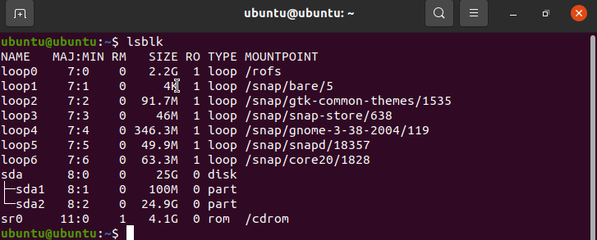

Mount Point Creation:
- We create a new directory within the temporary filesystem to act as an anchor point for the disk:
  - sudo mkdir /mnt/win7
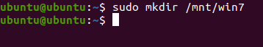
Executing the Mount Command:
- We link the identified partition to the newly created directory:
  - sudo mount /dev/sda2 /mnt/win7
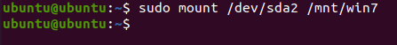
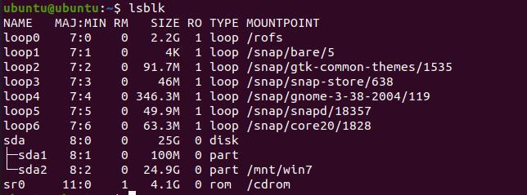

Verification of Access:
- We navigate to the mount point and list the contents:
  - ls /mnt/win7
- We specifically confirm the presence of the Windows and Users folders.
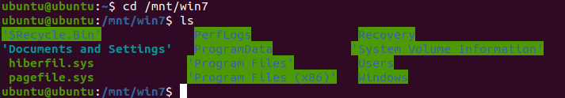

Phase III: Software Deployment

In this phase, we prepare the Ubuntu Live environment by acquiring the specific forensic tools required to modify the Windows registry.
Since the Live session begins with a volatile and minimal software set, we must synchronize with external repositories to download the necessary utility.
Enabling Community Repositories:
- We open the terminal and execute the command:
  - sudo add-apt-repository universe
- Ubuntu separates its software into different "components" based on licensing and support.
- The chntpw utility is maintained by the community rather than the core Ubuntu developers.
- Therefore, we must explicitly enable the Universe repository to make this software available for installation.
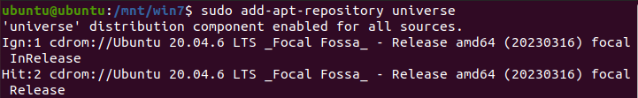

Synchronizing Package Indexes:
- We run the following command to refresh the local cache of available software:
  - sudo apt update
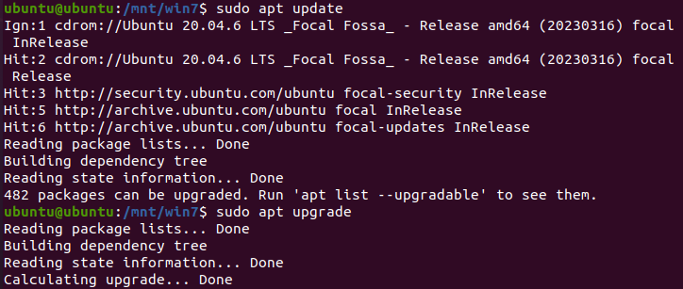
Installing the chntpw Utility:
- We perform the final installation by executing:
  - sudo apt install chntpw
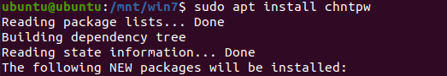
Binary Verification:
- We verify the installation by typing chntpw -h to display the help menu.
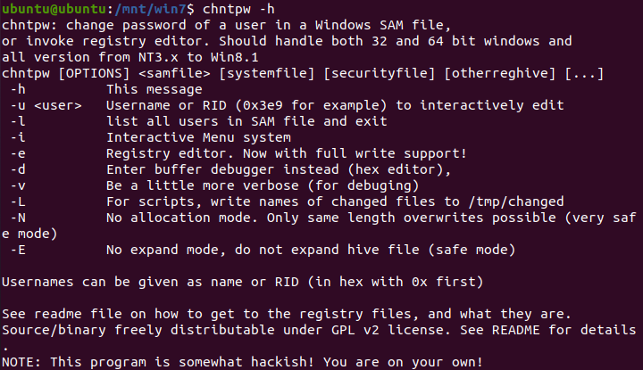

Phase IV: Password Reset Execution

In this critical phase, we perform the actual modification of the Windows security database.
Having established a secure link to the filesystem and installed the necessary tools, we target the specific registry hive that controls local user authentication.
Navigation to the Registry Hive:
- We navigate to the directory containing the Windows configuration files:
  - cd /mnt/win7/Windows/System32/config
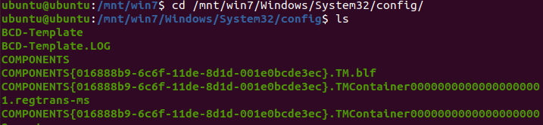
Executing the chntpw Tool:
- We run the utility targeting the specific administrator account:
  - sudo chntpw -u [Administrator_Name] SAM
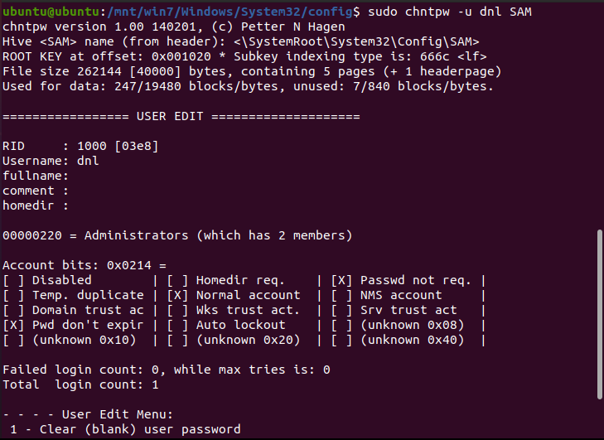
Modifying User Attributes (The Interactive Menu):
- Once the tool opens the interactive menu, we select…
  - Option 1: "Clear (blank) user password."
- Explanation:
  - Instead of attempting to decrypt or brute-force the existing password hash, we simply overwrite the password field with a null value.
  - This effectively tells the Windows kernel that the account no longer requires a credential for authentication.
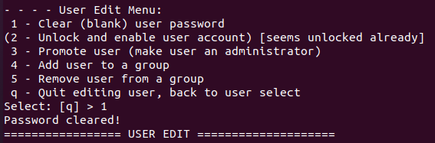
Committing Changes to Disk:
- We exit the tool by typing q.
- And, most importantly, we press y when prompted to "Write hive files?".
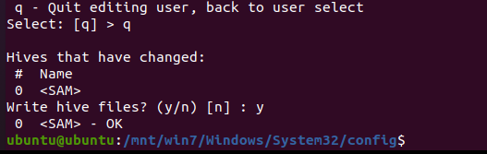

Unmounting for Data Integrity:
- We exit the directory and unmount the partition:
  - cd ~ && sudo umount /mnt/win7
- Explanation:
  - Unmounting the disk ensures that all cached write operations are completed and the filesystem is marked as "clean."
  - This prevents data corruption and ensures that Windows 7 does not encounter filesystem errors during its next boot sequence.
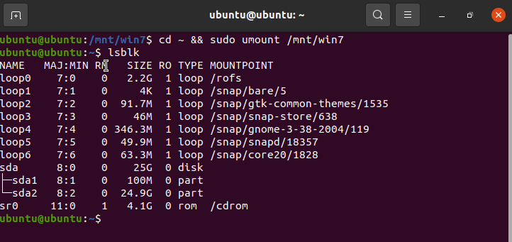

Phase V: System Restoration and Verification

Once the database modification is complete, we must properly exit the Live environment and return control to the host hardware.
This final phase ensures that the changes are recognized by the Windows kernel and that administrative access is restored.
Reverting Virtual Hardware:
- We shut down the Ubuntu Live session.
- Before powering the virtual machine back on, we navigate to the settings and either disconnect the ISO or adjust the boot order to prioritize the Hard Disk.
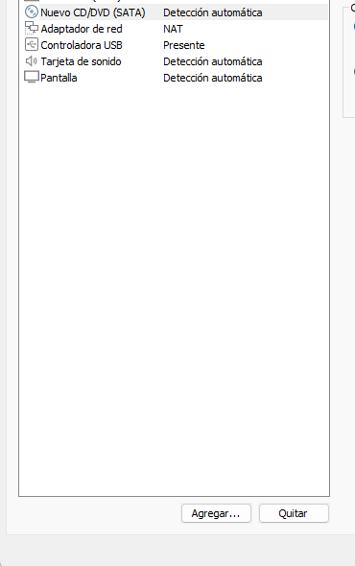

Initial Windows 7 Boot (The Checkdisk Prompt):
- Upon booting into Windows 7, the system may detect that the disk was accessed by an external utility and prompt for a Disk Check (chkdsk).
- We choose to skip this check to speed up the process.
Verification of Administrative Access:
- The system proceeds to the login screen.
- If the targeted account was the primary administrator, Windows 7 may log in automatically or present the user icon without a password field.
This command displays the configuration details of a local user account in Windows 7.
It is used to verify account properties such as whether a password is required.
The field “Password required” indicates the current password status.
- If it shows “No”, the account does not have a password set.
- If it shows “Yes”, the account is protected by a password.
This command is useful after modifying user credentials to confirm the resulting security state of the account.
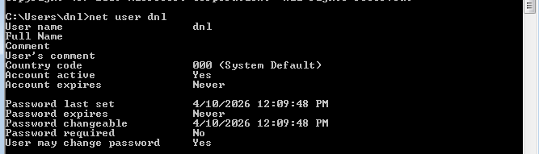

Conclusion

The successful completion of this laboratory demonstrates that physical access to a device frequently results in complete administrative control if the storage media is not protected by full-disk encryption.
This methodology serves as a critical resource for legitimate system recovery, allowing administrators to reclaim hardware when credentials have been lost or forgotten.
However, the ease with which these security layers were bypassed highlights the necessity of implementing additional protections, such as BitLocker or BIOS passwords, in professional environments.
It is vital to emphasize that these techniques must be applied with the highest ethical standards.
The purpose of this procedure is the restoration of services and data recovery in authorized scenarios, never for unauthorized access or data theft.
As system administrators, we carry the responsibility to use these capabilities to maintain infrastructure integrity and support user continuity.

