516-DaríoNL-ISOP411-Git-GitHub
TAJAMAR | MADRID | 07/05/2026
Git
ISO – Unit 4 –Git github

Contenido
Introduction 3
Theorical Framework 4
Distributed Version Control Systems (DVCS) 4
Key Operational Concepts 5
Roadmap 6
Inventory 8
Execution 9
Phase I: Environment & Global Identity 9
Phase II: Workspace Initialization 11
Phase III: Initial Versioning 13
Phase IV: Remote Connection & Deployment 14
Phase V: Basic Workflow & Sync 19
Conclusion 21

Introduction

This laboratory establishes the operational foundations for version control management within the professional software development lifecycle.
The primary objective is to implement a distributed workflow utilizing Git for local change tracking and GitHub for remote synchronization and collaboration.
By completing this project, the student will master the mechanisms required to maintain data integrity, document project evolution through incremental snapshots, and navigate the technical complexities of non-linear development and merge conflicts.

Theorical Framework

Distributed Version Control Systems (DVCS)

Git Architecture:
- It is a decentralized engine that records the history of a filesystem as a series of snapshots.
- It operates through three main local states:
  - The Working Directory (current changes).
  - The Staging Area (files marked for the next commit).
  - The Local Repository (stored history).
- Every contributor possesses a full copy of the repository’s history, ensuring total autonomy and redundancy.
GitHub Integration:
- It serves as a cloud-based hosting platform that extends Git’s local functionality with centralized collaboration tools.
- It acts as the “Source of Truth” for development teams, facilitating code reviews, issue tracking, and repository backup.
- It utilizes the SSH or HTTPS protocols to secure data transmission between the local client and the remote server.

Key Operational Concepts

Commits:
- Permanent records of a specific state of the project, including metadata about the author, timestamp, and a descriptive message.
Branching:
- A mechanism to isolate development lines, allowing for the creation of new features or experiments without compromising the stable code.
Merging and Conflicts:
- The process of integrating independent timelines.
- Conflicts arise when the system cannot automatically reconcile divergent changes in the same file segment, requiring manual arbitration.

Roadmap

Phase I: Environment & Global Identity (Points 1-2):
- Infrastructure Preparation:
  - Software installation and GitHub account registration.
- Identity Configuration:
  - Establishing the global user.name and user.email in the Git engine.
- Metatada Accuracy:
  - Ensuring local commits are correctly attributed to the developer's cloud profile.
Phase II: Workspace Initialization (Point 3):
- Directory Provisioning:
  - Creating the physical folder for the project and navigating into the workspace.
- Local Database Creation:
  - Executing git init to generate the hidden tracking folder.
- Repository Activation:
  - Transforming a standard directory into a managed version-controlled project.

Phase III: Initial Versioning (Point 4):
- Document Generation:
  - Creating the primary documentation file for the project.
- Staging Logic:
  - Moving new files from the working directory to the index area.
- First Snapshot:
  - Recording the initial state of the project with a descriptive commit message.
Phase IV: Remote Connection & Deployment (Points 5-6):
- Remote Provisioning:
  - Setting up an empty, public repository on the GitHub cloud.
- Logical Bridging:
  - Linking the local workstation to the remote URL using the “origin” alias.
- Initial Push:
  - Uploading the local history and setting the upstream relationship for the main branch.
Phase V: Basic Workflow & Sync (Points 7-8):
- Standard Development Cycle:
  - the modify-add-commit-push sequence for daily updates.
- Cloud Persistence:
  - Ensuring every local milestone is mirrored in the GitHub repository.
- Remote Fetching:
  - Using the pull command to download and integrate changes from the cloud to the local machine.

Inventory

For the realization of the laboratory we have used:
- Hardware:
  - Host PC.
- Software:
  - Ubuntu Desktop 20.04.6.
  - Git (Distributed Version Control System).
  - GitHub (Cloud-based Hosting Platform).
  - Linux Terminal (CLI).
  - Basic Text Editor (Nano).

Execution

Phase I: Environment & Global Identity

Infrastructure Preparation:
- Install the Git engine on the local workstation to enable version control commands.
  - sudo apt install git
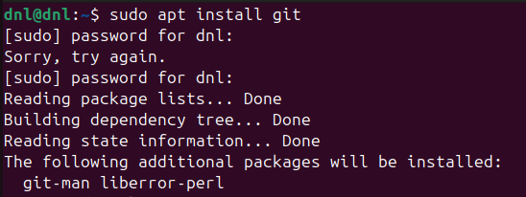
- Register a unique account on the GitHub platform to establish a remote hosting destination.
  - https://github.com/
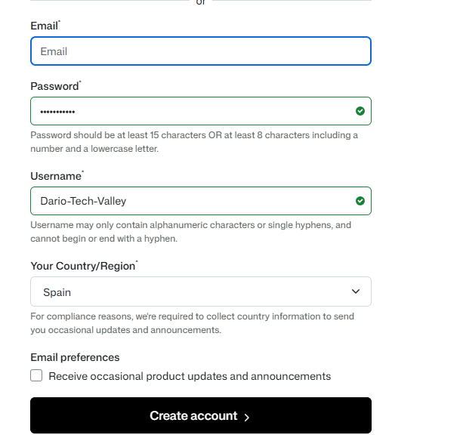

Identity Configuration:
- Execute the following command to to set the author identity:
  - git config --global user.name “Your Name”
- Execute the following command to link the local client with the cloud profile:
  - git config --global user.email your@email.com
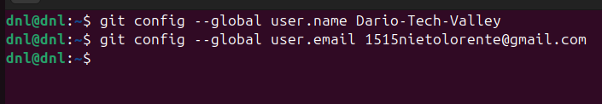

Phase II: Workspace Initialization

Create a dedicated project directory:
- Using the command mkdir git-repo to establish a physical container on the storage drive.
Access the new workspace:
- By executing cd git-repo, ensuring all subsequent commands are applied to the correct path.
Initialize the version control system:
- By running git init within the directory.
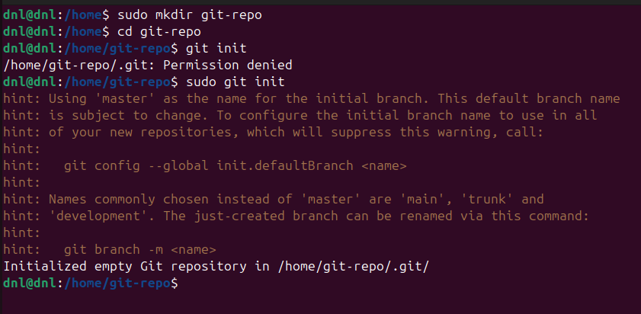
Explanation:
- Logical Containment:
  - Creating and entering a specific folder prevents the Git tracking engine from monitoring unrelated system files, maintaining a clean and focused development environment.
- The .git Directory:
  - The git init command generates a hidden subdirectory that serves as the repository's internal database.
- Tracking Activation:
  - Once initialized, the directory is no longer a standard folder; it becomes a managed project where Git can track file states, store the commit history, and manage branches.
- Local Autonomy:
  - This initialization process occurs entirely on the local machine, allowing the developer to manage versions without needing an active internet connection or a remote server
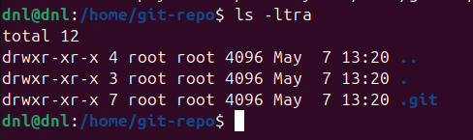

Phase III: Initial Versioning

Create the primary documentation file by running te following command in the root directory:
- touch README.md
  - Add essential content such as the project title and a basic functional description using a text editor.
Stage the file for tracking by executing the command:
- git add README.md (if it sends an error, execute the solution that appears in the shell).
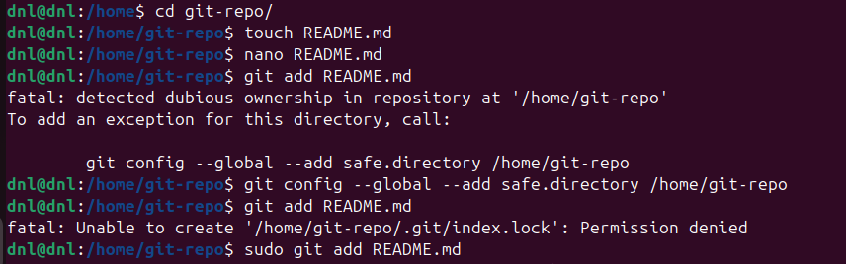
Record the initial project state in the local database using:
- git commit -m “Initial commit: base structure”.
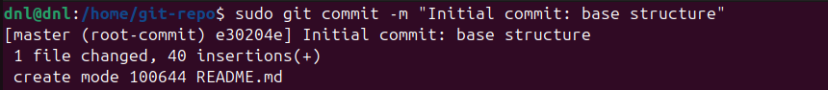

Phase IV: Remote Connection & Deployment

Following the successful local initialization, we must transition the project into a collaborative cloud environment.
This phase focuses on provisioning the remote infrastructure and establishing a secure data link between the local workstation and the GitHub servers.
Remote Repository Provisioning IN GITHUB:
- Access GitHub and create a new Public repository.
- Namespace Alignment:
  - Name the repository exactly like the local project folder.
- Integrity Control:
  - Do not initialize the repository with a README, .gitignore, or License through the web interface.
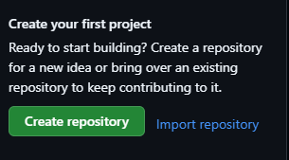
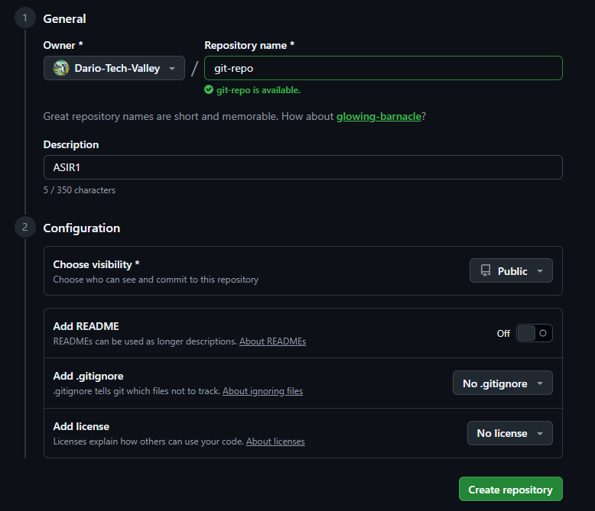

Logical Linkage and Initial Synchronization IN THE VM:
- Link the environments:
  - Execute git remote add origin <repository_URL> to create the logical bridge.
- Branch Standardization:
  - Rename the local primary branch using:
    - git branch -M main
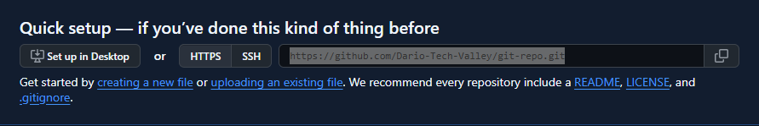
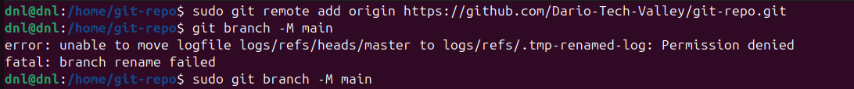

- The Upstream Push:
  - You will need to create a key for SSH authentication.
  - Bash:
    - ssh-keygen -t ed25519 -C “email”
    - cat ~/.ssh/id_ed25519.pub Copy all.
  - Github:
    - Settings SSH keys New SSH Key
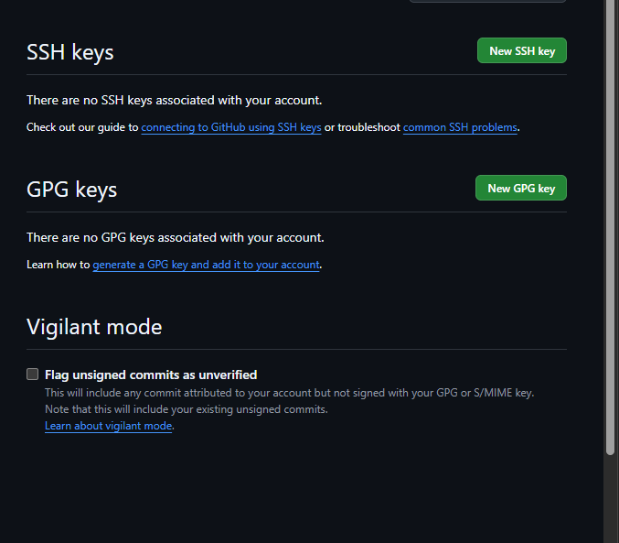
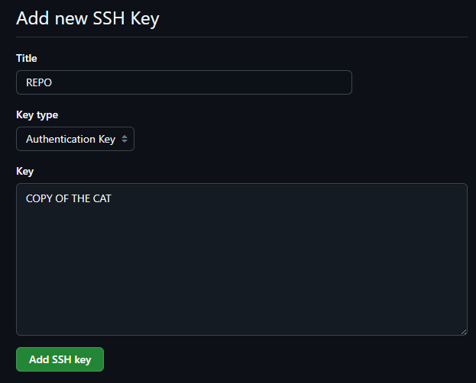
  - Bash:
    - ssh -T git@github.com
    - git remote set-url origin git@github.com:USER/git-repo.git
    - Execute git push -u origin main to upload files and establish a tracking relationship.

Now we are able to see our README.md in GitHub.
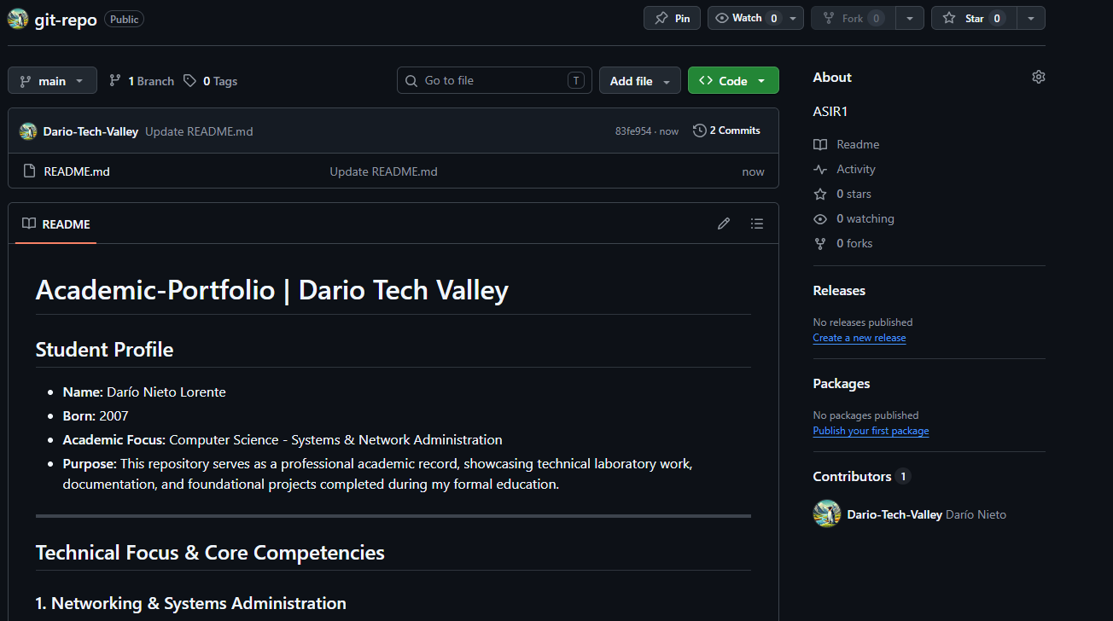

Phase V: Basic Workflow & Sync

Daily Development Cycle:
- Modify the README.md file by adding technical content or project sections.
- Stage the updated file for versioning using the command:
  - git add README.md
- Record the changes locally by executing:
  - git commit -m “Update README with additional content”
- Synchronize with the cloud by running the command:
  - git push
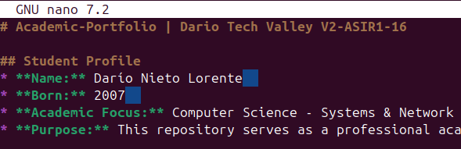
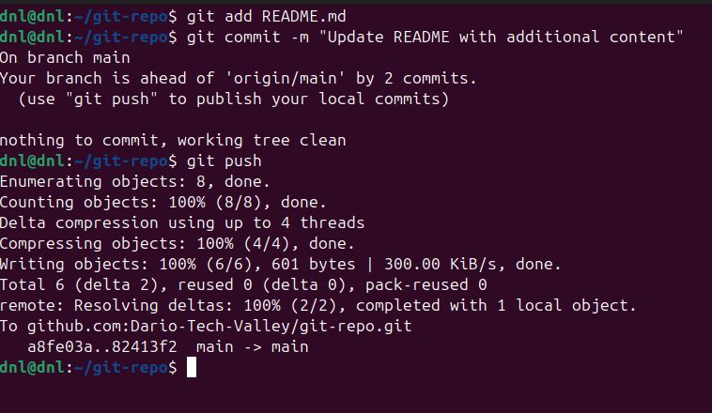
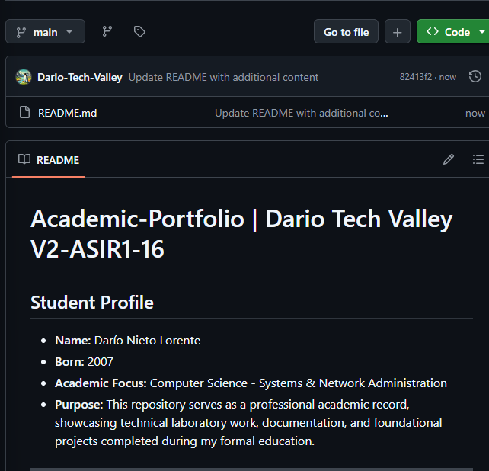

Conclusion

This laboratory has established an operational version control infrastructure through the integration of Git and GitHub.
The workflow has been completed from the initial environment configuration to the bidirectional synchronization of files between the local system and the cloud repository.
Importance of Git and GitHub:
- Project Traceability:
  - Recording the chronological evolution of the project through permanent and reversible snapshots.
- Cloud Persistence:
  - Ensuring the backup of source code in remote repositories to guarantee data availability.
- Workflow Synchronization:
  - Maintaining parity between local and remote states through standardized transfer protocols.
- Identity Management:
  - Linking every technical modification to a specific author to ensure accountability within the development lifecycle.
- Metadata Integrity:
  - Ensuring that all project history remains intact during the transition from local storage to the remote host.

