516-DaríoNL-PAR405-LinuxNetwork
TAJAMAR | MADRID | 01/03/2026
Linux Network
PAR – Unit 4 – Linux Network

Index
Introduction 3
Roadmap 3
Theoretical Framework 4
Inventory 6
Execution 7
Network Manager 7
Initiation 7
Static IP 9
Dynamic IP (DHCP) 14
Netplan 16
Initiation 16
Static + Dynamic configuration 20
Bridge 25
/etc/network/interefaces 29
Initiation 29
Static + Dynamic configuration 32
Bridge 34
Conclusion 36

Introduction

In this laboratory, we will explore the various methodologies for managing network interfaces within the Ubuntu ecosystem, covering both Desktop and Server environments.

Roadmap

In this lab, we will navigate through three distinct management systems to configure network connectivity.
Our progression will follow this structure:
- Ubuntu Desktop (Network Manager):
  - We will use the graphical interface and command-line tools to configure DHCP and Static IP addresses.
- Ubuntu Server (Netplan):
  - We will manage a dual-interface system.
  - One card will be configured via DHCP and the other with a Static IP.
  - Additionally, we will implement a Bridge configuration using YAML syntax.
- Legacy Configuration (/etc/network/interfaces):
  - We will replicate the dual-interface and bridge setups using the traditional Debian networking method to understand legacy systems.
- Verification:
  - Throughout the process, we will utilize net-tools (specifically ifconfig) to validate state changes before and after our modifications.

Theoretical Framework

Before proceeding with the practical application, we must define the tools and concepts that govern Linux networking.
Management Tools:
- Network Manager:
  - The standard network selection tool for Ubuntu Desktop.
  - It is designed to be plug-and-play, automatically handling transitions between Wi-Fi and Ethernet.
  - It primarily uses a GUI.
- Netplan:
  - The modern default network configuration utility for Ubuntu Server (since 17.10).
  - It acts as an abstraction layer:
    - You write configuration in YAML files, and Netplan “renders” those settings for either Network Manager or systemd-networkd.
- /etc/network/interfaces:
  - The legacy configuration file used by the ifupdown package.
  - While largely replaced by Netplan in newer Ubuntu versions, it remains a fundamental skill for managing older Debian-based systems.

Configuration Methods:
Method | Description
DHCP | Dynamic Host Configuration Protocol.  The system automatically requests an IP address, subnet mask, and gateway from a server on the local network.
Static IP | A manually assigned, permanent IP address.  We define the specific IP, Gateway, and DNS servers to ensure the machine’s address never changes.
Bridge | A software-defined link that connects two or more network interfaces.  It allows them to act as a single aggregate network, commonly used in virtualization to allow Virtual Machines to share a physical network card.

Inventory

For the realization of the laboratory, we have used:
- Hardware:
  - Host PC.
- Software:
  - Utilities of Ubuntu:
    - Network Manager.
    - Netplan.
    - Net-tools.
    - /etc/network/interfaces.
  - VMware:
    - Ubuntu Desktop 24.04.2.
    - Ubuntu Server 24.04.3.

Execution

Network Manager

Initiation

As it has been defined in the introduction, we will configurate the network parameters with Network Manger (GUI) in Ubuntu Desktop.
First, we must open this tool.

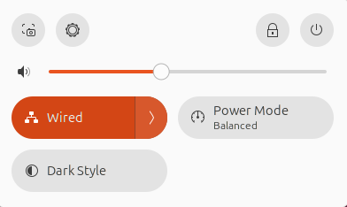

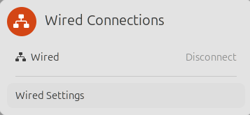
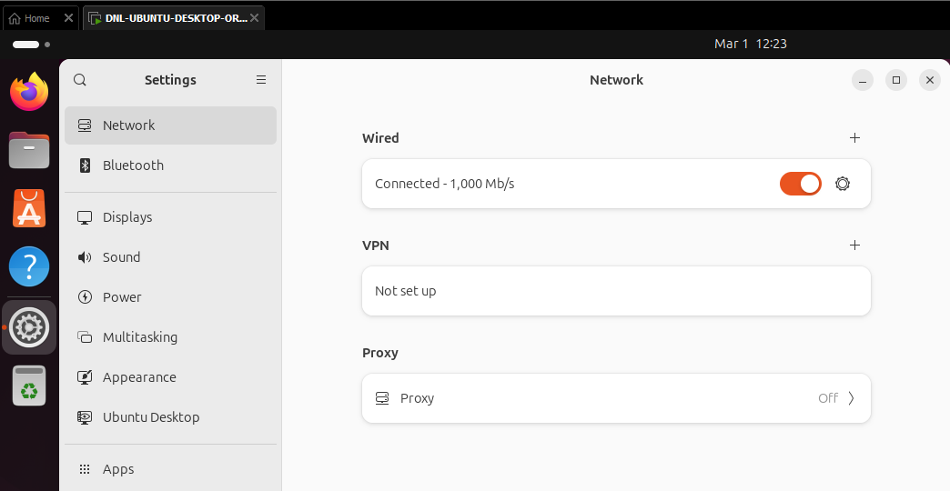

Static IP

Once we have opened the tool, we must open the IPv4 options for start the configuration.
As we now, for use a static IP we must establish the parameters.
These ones will be “static”, this means that the parameters will remain as we have set them.
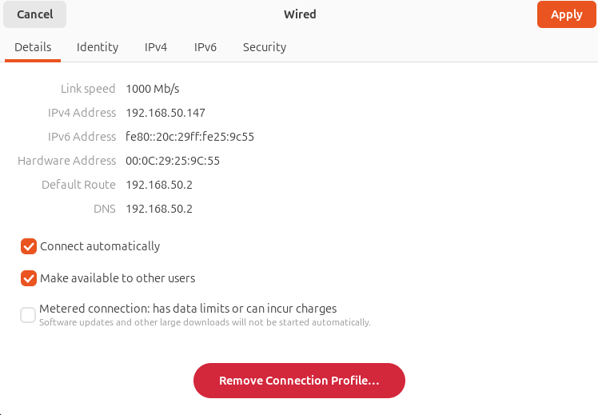

For configurate the static IP the option “Manual” must be selected.
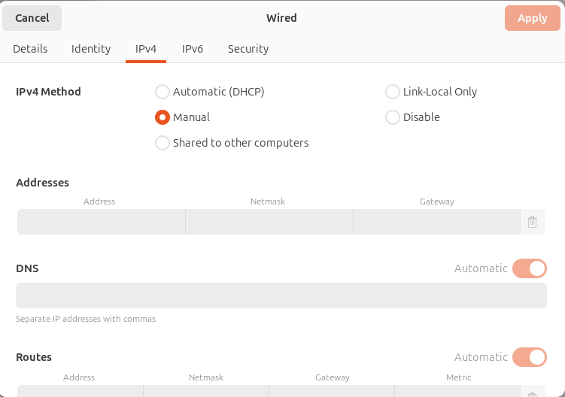

Now we must fill all the camps of “Addresses” and “DNS”:
- Address: 192.168.50.10
  - The unique numerical identifier assigned to a device so it can be located on a network.
- Netmask: 255.255.255.0
  - A screen that defines which portion of the IP address belongs to the network and which belongs to the host.
- Gateway: 192.168.50.2
  - The “exit door” or router address used to send data packets outside of the local network.
- DNS: 8.8.8.8
  - A service that translates human-readable domain names
    - (like https://www.marca.com/)
  - Into numerical IP addresses.
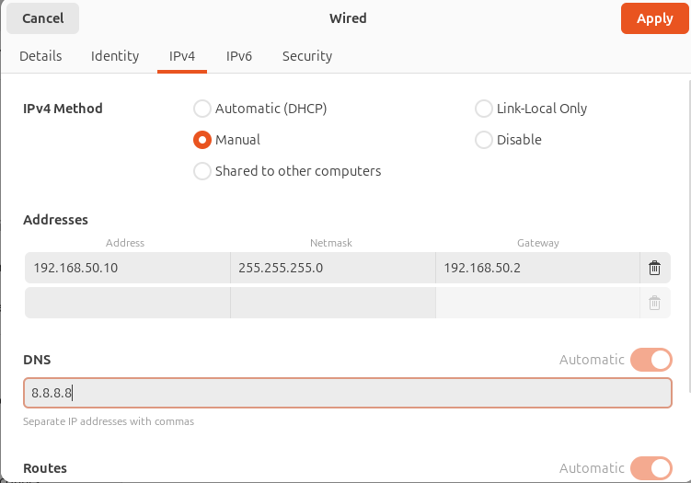
For check that the changes have been applied, we can se the new parameters in the section of “Details”. Or using the command “ip a”.
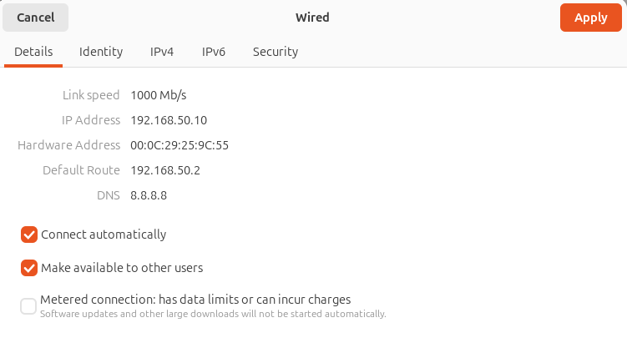
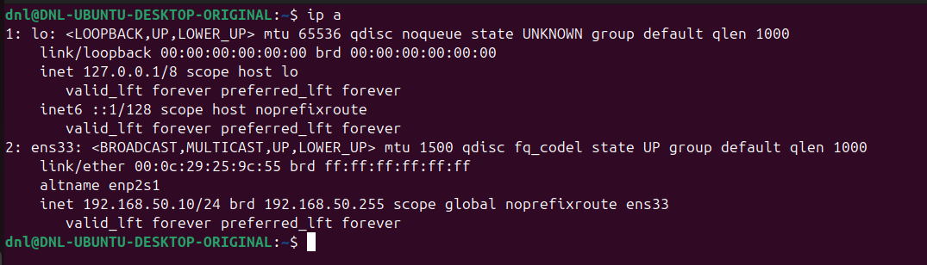
Also, we can test our connectivity with others using “ping” and “nslookup” (in this case we can navigate because the VM is configurated to do it).
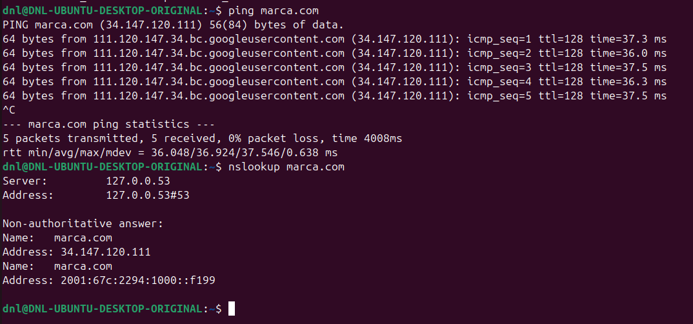
With this process in the terminal, we have check:
- ip a
  - To check the assigned address.
- ping
  - To test connectivity to the gateway or external hosts.
- nslookup
  - To confirm that the DNS resolution is functioning correctly.

Dynamic IP (DHCP)

To configure a Dynamic IP using Network Manager, the process is streamlined as we only must select the “Automatic (DHCP)” option within the IPv4 settings.
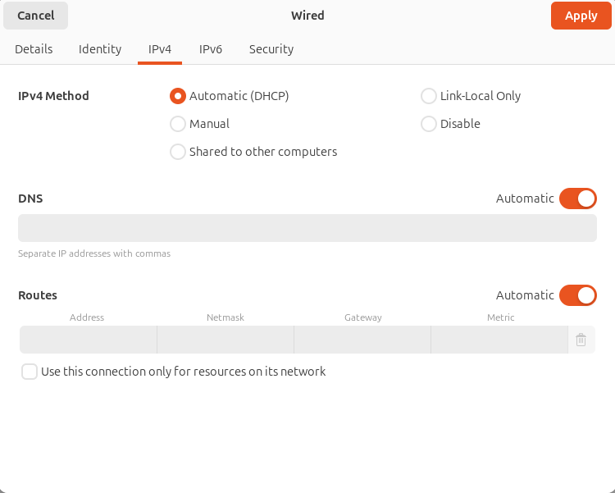
Once applied, the system handles the handshake with the DHCP server to lease an address, netmask, and gateway automatically.

To ensure the configuration is active, we can verify the status through the “Details” or by utilizing the same commands that we have used before.
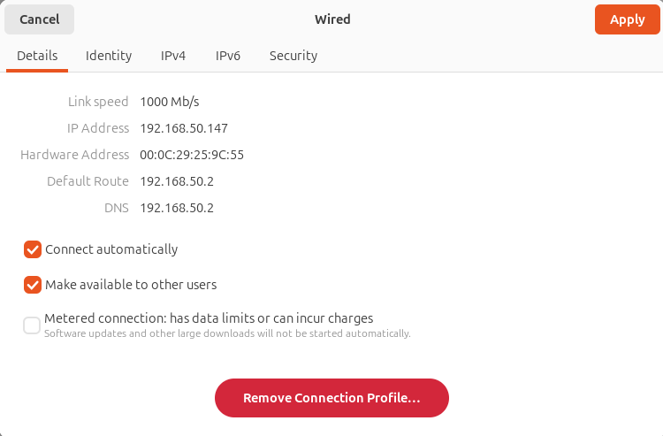
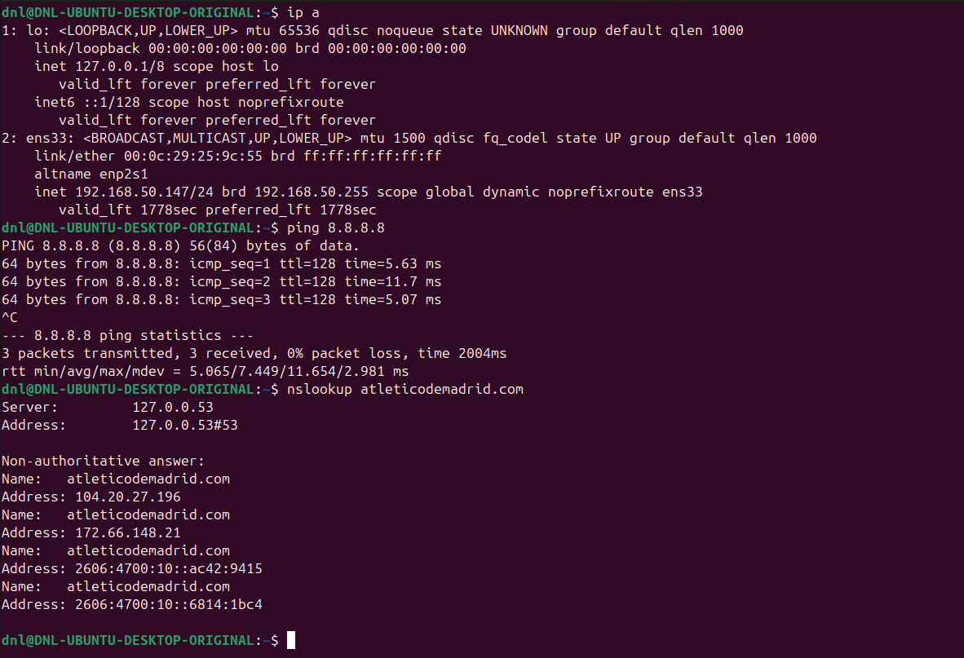

Netplan

Initiation

To begin the configuration on Ubuntu Server, we transition from the graphical interface of the Desktop version to the command-line driven architecture of Netplan.
As the default network renderer for modern Ubuntu distributions, Netplan utilizes YAML files located in /etc/netplan/ to define the desired state of our interfaces.

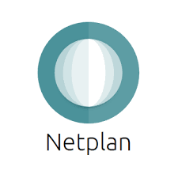

Network cards

In this section, we will manage two network cards simultaneously, applying a hybrid configuration where one interface serves as a dynamic node (DHCP) and the other acts as a fixed point (Static IP), ensuring we correctly designate the default gateway to maintain external connectivity.
We will configure the first network card as:
- NAT (Network Address Translation):
  - To provide the server with external connectivity.
  - This mode allows the VM to share the host's IP address to "navigate" the internet, which is essential for downloading updates or installing packages like net-tools.
The second card will be set to:
- Host-Only mode:
  - Assigning the server an IP address strictly for the internal network.
  - This creates a private communication channel between the host and the virtual machine, isolated from external traffic for security and local testing.
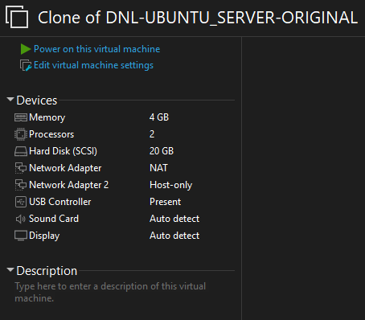

Net-tools

Before applying any changes, we must identify our interface names and their current states.
We will use the following command to establish a baseline: ifconfig -a
If ifconfig is not found, we will install it using: sudo apt install net-tools
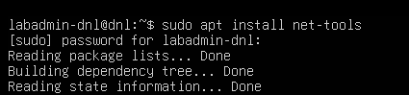
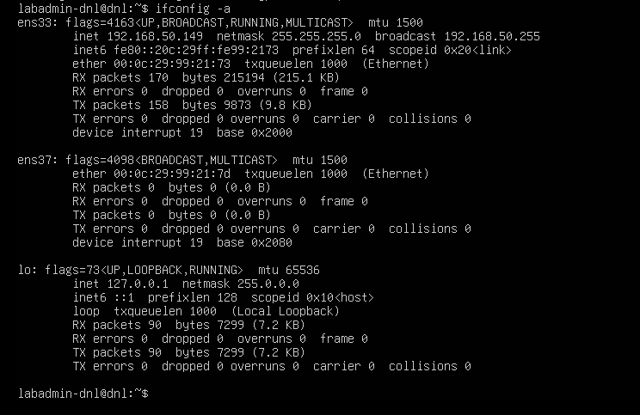
Based on the ifconfig -a output, we can quickly identify the role of each interface:
- ens33 (NAT):
  - We identify this as the NAT interface because it has already been assigned a dynamic IP (192.168.50.149), granting it external connectivity for internet navigation.
- ens37 (Host-Only):
  - We identify this as the Host-Only interface because it currently lacks an assigned IP address, showing only its MAC address and signaling it is ready for our internal static configuration.

Netplan Hierarchy Structure

To configure Netplan, we must adhere to a strict YAML hierarchy.
This format relies on precise indentation (tabulations) to define relationships between elements:
- "Fathers" (parent keys) must contain their "Sons" (child properties) at a consistent indentation level, typically using two spaces.
Netplan Hierarchy Structure:
- Network (The Root):
  - The top-level "Father" that initiates the configuration.
- Renderers:
  - Defines which backend tool will execute the plan (usually networkd for servers).
- Ethernets:
  - The section where we list our specific physical interfaces (ens33, ens37).
- Interface Configuration: Each interface acts as a "Father" to its specific settings…
  - Addresses:
    - A list of IP addresses in CIDR notation (/24).
  - DHCP4:
    - A boolean (true/false) to enable or disable automatic addressing.
  - Routes:
    - Used to define the Gateway (the exit point for traffic).
  - Nameservers:
    - Where we define our DNS addresses.

Static + Dynamic configuration

To access and touch the configuration we will use:
- sudo nano /etc/netplan/50-cloud-init.yaml
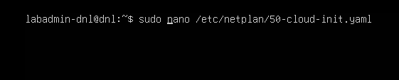
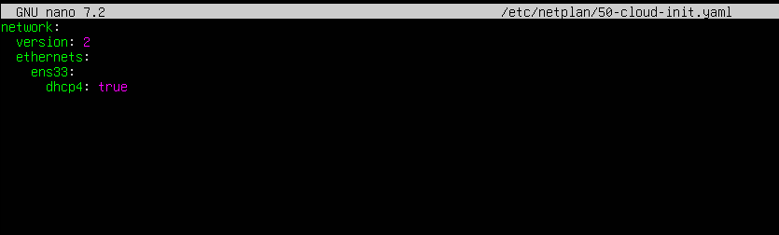

We will configure ens33 for NAT (DHCP) and ens37 for Host-Only (Static):
- Note how each "son" is indented under its "father".
- Including a default route on the Host-Only card causes a conflict that prevents internet access by misdirecting traffic to an internal-only interface.
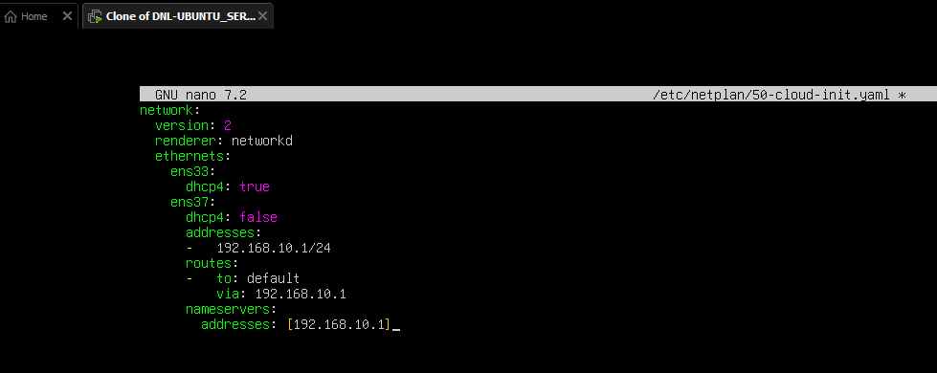
- By deleting the route from the Host-Only configuration, the system correctly defaults to the NAT interface's gateway, restoring our ability to navigate the internet.
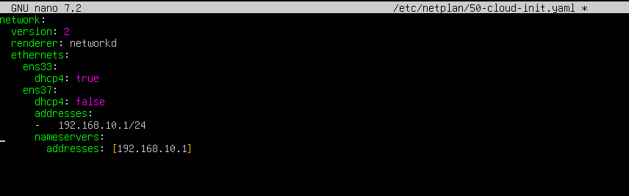
Finally, we apply the changes:
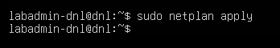

Verification

To conclude the Netplan configuration, we must perform a functional verification to ensure our dual-interface strategy is working as intended.
Visualization of the changes with ifconfig:
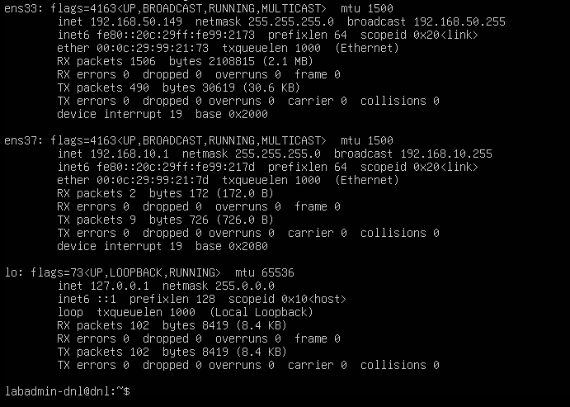

External Connectivity (NAT - ens33):
- Since ens33 is our NAT interface, it is our only gateway to the outside world.
- We verify this using two primary tests:
  - Connectivity:
    - We run ping 8.8.8.8 to confirm that packets can leave our local network and reach the internet.
  - Resolution:
    - We use nslookup google.com to ensure the system can translate domain names into IP addresses using external DNS servers.
With “routes” in the ens37…
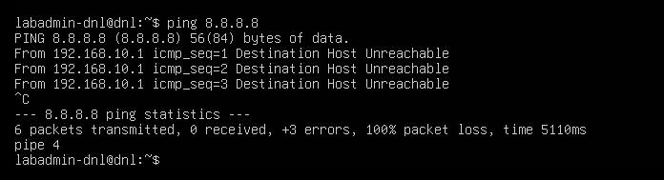
Without “routes” in the ens37…
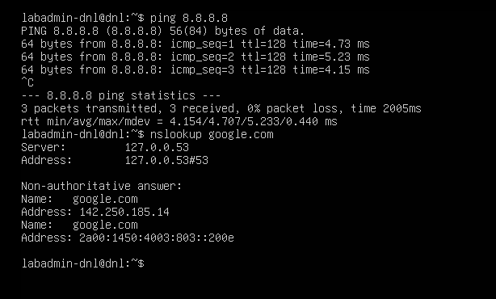
Internal Network Limitations (Host-Only - ens37):
- For the ens37 interface, verification is restricted to the local node.
- Because this is a hypothetical server setup, we must note two key constraints:
  - Isolated Environment:
    - We cannot ping other devices in the internal network yet, as no other hosts have been configured in this private segment.
  - DNS Infrastructure:
    - Although we defined 192.168.10.1 as the DNS, name resolution will not work for internal queries because we have not yet installed or configured an actual DNS service (like Bind9) on this server.

Bridge

In this final phase of Netplan, we will configure a Network Bridge.
A bridge acts as a virtual switch, logically connecting two or more physical network interfaces (or virtual ones) to operate as a single aggregate network segment.
This is particularly useful in server environments where multiple interfaces need to share the same IP configuration or allow Virtual Machines to communicate directly with the external physical network.

Implementation

To create a bridge, we must define a new entity in our Netplan YAML file.
We will transition from individual interface settings to a unified bridge structure.
- Define the "Members":
  - We list our physical interfaces (ens33, ens37) but remove their individual IP configurations.
- Define the "Bridge":
  - We create a new interface, typically named br0.
- Assign Parameters:
  - We move the IP, Gateway, and DNS settings to the br0 interface itself.

We are going to install a bridge tool for later.
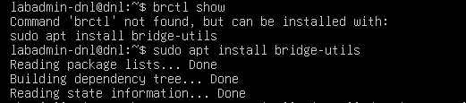
Hypervisor Settings Change the state of the Network Adapter to Bridged.
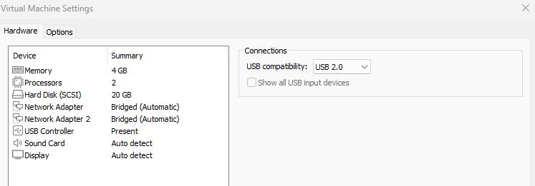
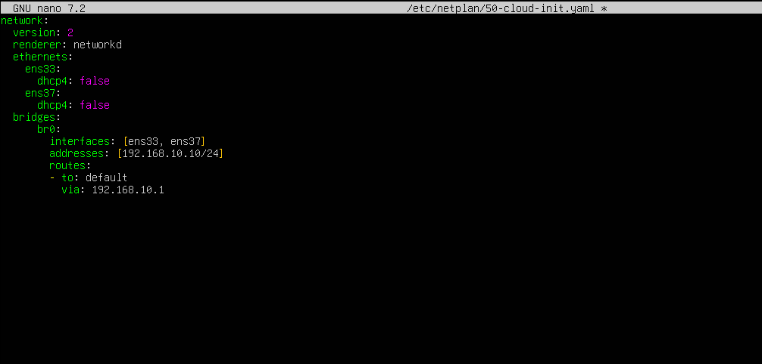
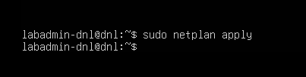

Verification

To apply these changes, we must restart:
- reboot
We then verify the state as follows:
- Check Interfaces:
  - We use ifconfig to confirm that br0 now holds the IP address 192.168.10.10 while ens33 and ens37 show no IP.
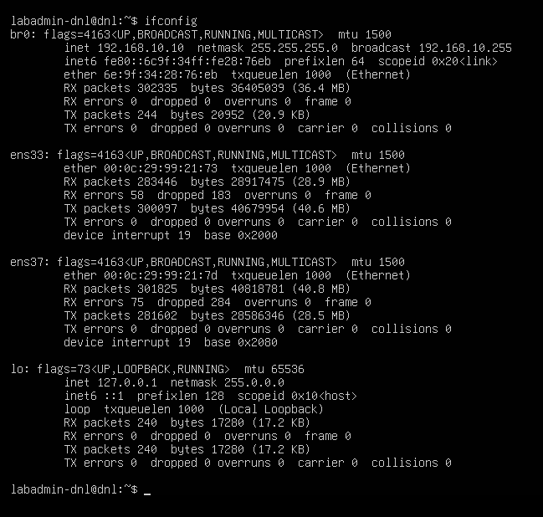

- Bridge Table:
  - We use the command brctl show.
  - This will display a table showing br0 as the bridge and both ens33 and ens37 listed under the "interfaces" column.
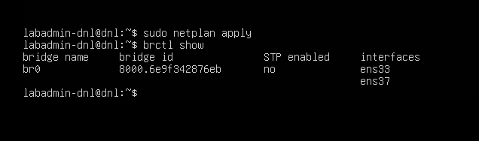
Finally, we will restart the configurations because for the next part we will need to install some software.
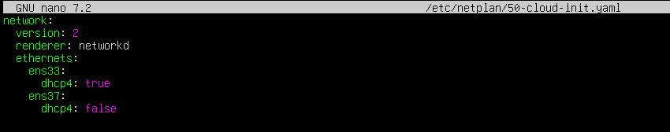
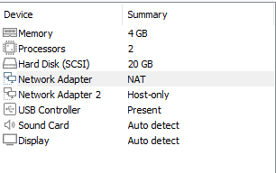

/etc/network/interefaces

Initiation

Having completed the Netplan configuration, we now move to the legacy method: The /etc/network/interfaces file.
To configure our network through this method, we must follow these steps:
- Install ifupdown:
  - It provides the ifup, ifdown, and networking service that reads and applies /etc/network/interfaces. Without it, that file is ignored.
    - sudo apt install ifupdown

- Stop Netplan:
  - To avoid conflicts between the modern and legacy systems, it is often necessary to stop or disable the Netplan services before relying entirely on the interfaces file.
    - sudo mkdir /etc/netplan.old
    - sudo mv /etc/netplan/*.yaml /etc/netplan.old/
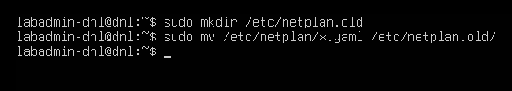

- Stop systemd-networkd:
  - Disabling this service ensures it does not compete with ifupdown for control over network interfaces, preventing IP address flapping or connectivity drops.
    - sudo systemctl mask systemd-networkd
    - sudo systemctl stop systemd-networkd.socket
    - sudo systemctl stop systemd-networkd
    - sudo systemctl disable systemd-networkd.socket
    - sudo systemctl disable systemd-networkd
    - sudo systemctl status systemd-networkd
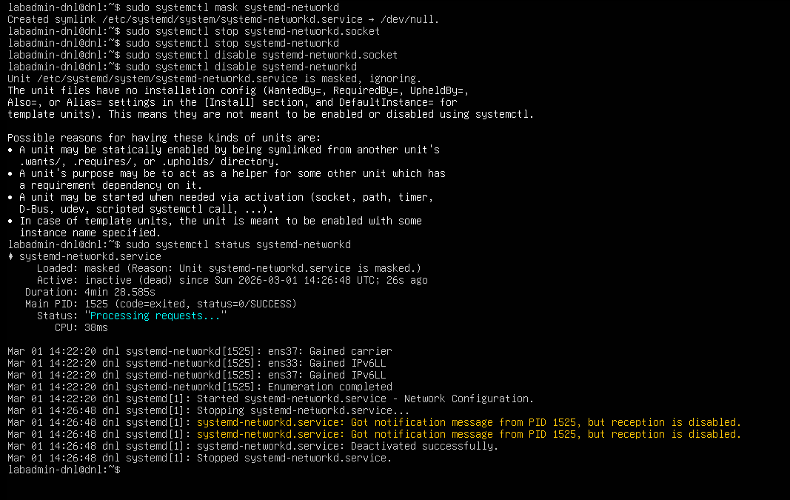

- Access:
  - Since this is a system-level configuration, we must use a text editor with root privileges.
  - We will access it by running:
    - sudo nano /etc/network/interfaces
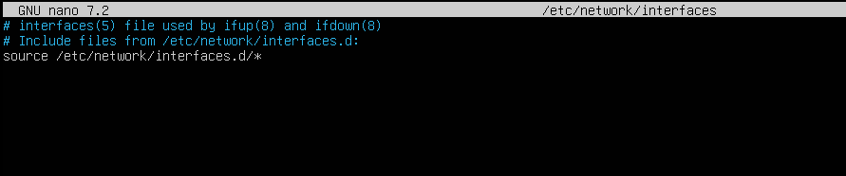
- Applying Changes:
  - Once the file is saved, the configuration is not applied automatically.
  - We must restart the networking service:
    - sudo systemctl restart networking

Static + Dynamic configuration

Now we can proceed and configurate the file.
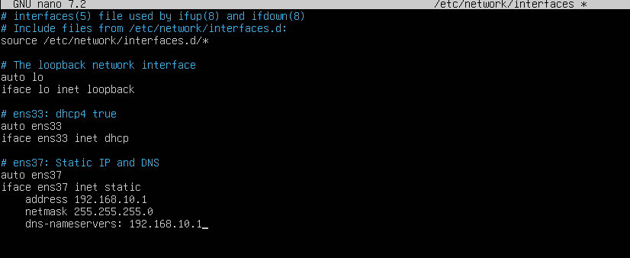
We must restart the service to apply the changes.
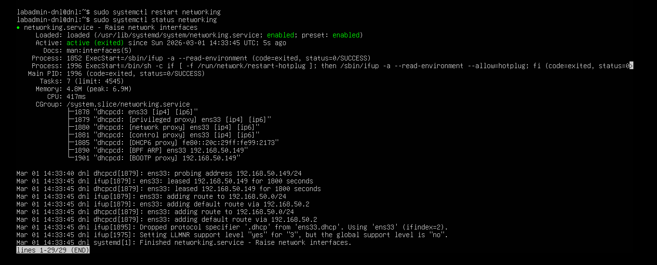

We can verify as the same form that we did it in the Netplan configuration.
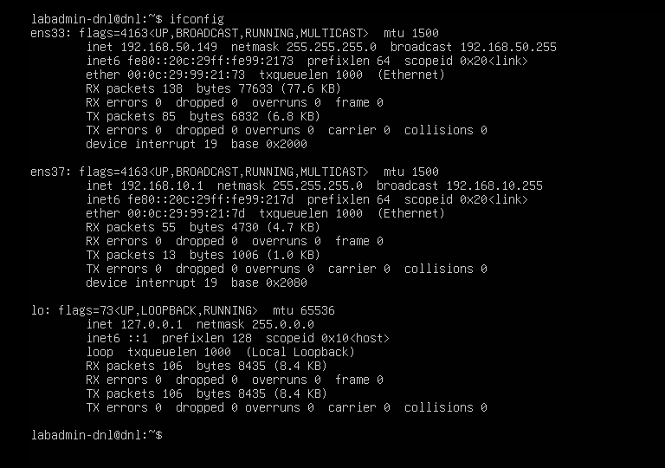
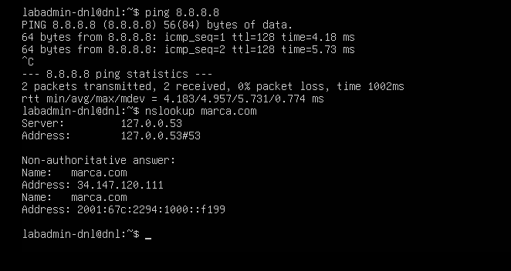

Bridge


Now we proceed with the bridge.
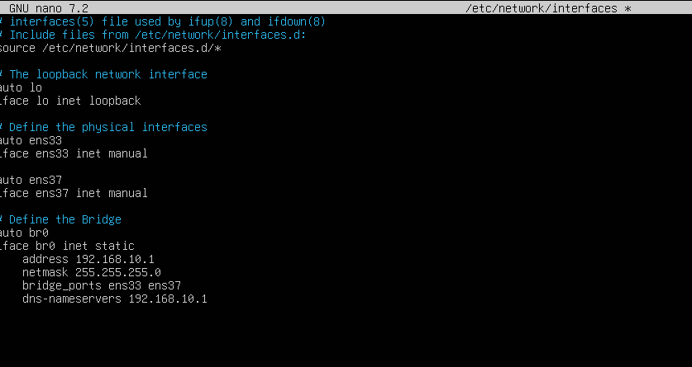
Restart the service.
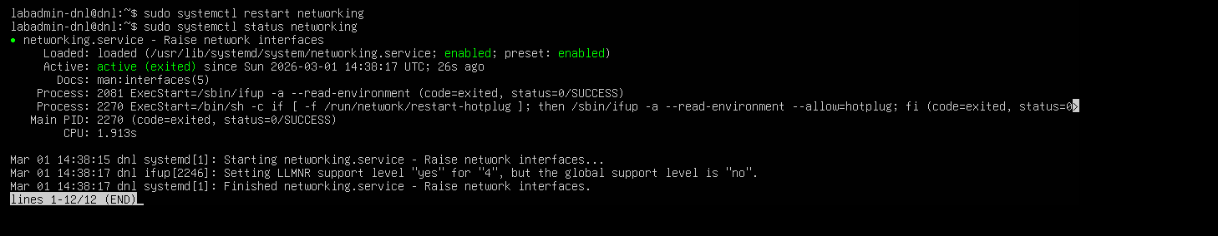

We can verify like we did it in the previous part.
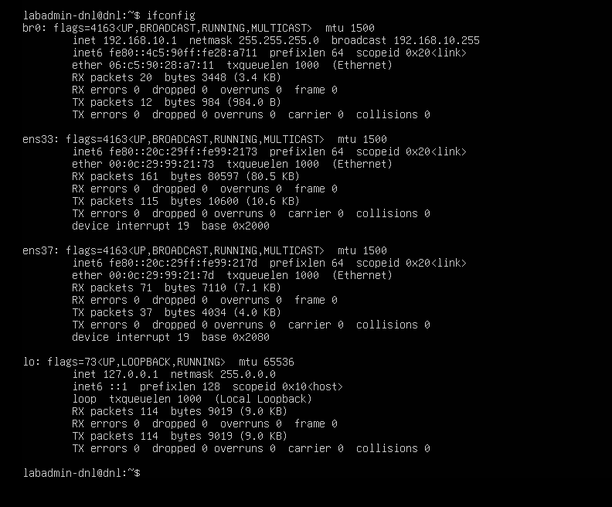
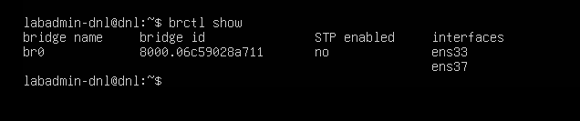

Conclusion

This laboratory successfully demonstrated the evolution and versatility of network management within the Ubuntu ecosystem.
By navigating through Network Manager, Netplan, and the legacy ifupdown system, we gained a comprehensive understanding of how Linux handles connectivity across different environments.
Key concepts:
- Method Diversity:
  - We transitioned from the graphical ease of Network Manager in Desktop to the modern YAML structure of Netplan and the traditional ifupdown legacy system.
- Service Conflict Resolution:
  - We identified that systemd-networkd can remain active via triggering sockets even after being stopped, requiring masking to ensure the legacy /etc/network/interfaces file takes full control.
- Advanced Networking:
  - By implementing Bridges, we successfully aggregated multiple physical interfaces into a single logical switch (br0), a critical skill for server virtualization.
- Validation:
  - All configurations were verified using ifconfig, ping, and nslookup to ensure stable connectivity and correct DNS resolution.

