516-DaríoNL-PAR411-ParentalOpenDNS
TAJAMAR | MADRID | 02/03/2026
Parental OpenDNS
PAR – Unit 4 – Parental open-dns

Index
Introduction 3
Theoretical Foundation 3
Inventory 4
Execution 5
Create Account 5
Adding the network 7
Configurate Filtering 10
Verification 12
Conclusion 15
Lab Summary 15
Utility and Use Cases 15
Economic and Strategic Context 16
DNS Lists vs. Manual Filtering 16

Introduction

In this laboratory we will implement a network-level navigation protection system using OpenDNS services.
We must configure and differentiate between OpenDNS Family Shield and OpenDNS Home Internet Security.
Finally, we will validate the filtering of prohibited categories and malicious domains via DNS redirection.

Theoretical Foundation

DNS Filtering:
- Is a technique used to control web traffic by intercepting domain name resolution requests.
- When a user enters a URL, the system queries a DNS server to translate the name into an IP address.
- By using a filtering provider like OpenDNS, if the requested domain belongs to a prohibited category (e.g., malware, adult content), the server returns the IP of a “blocked” landing page instead of the actual site.
OpenDNS Services Overview:
Service | Characteristics | Best Use Case
OpenDNS Family Shield | Pre-configured to block adult content automatically. No account required for basic use. | Immediate, “set-and-forget” household protection.
OpenDNS Home Internet Security | Customizable via a personal account. Allows choosing specific categories to block and viewing traffic stats. | Advanced users requiring granular control and logging.

Inventory

For the realization of the laboratory, we have used:
- Hardware:
  - Host PC.
- Software:
  - Utilities:
    - OpenDNS
  - VMware:
    - Ubuntu Desktop 24.04.2.

Execution

Create Account

We must create an account in OpenDNS:
- https://signup.opendns.com/homefree/
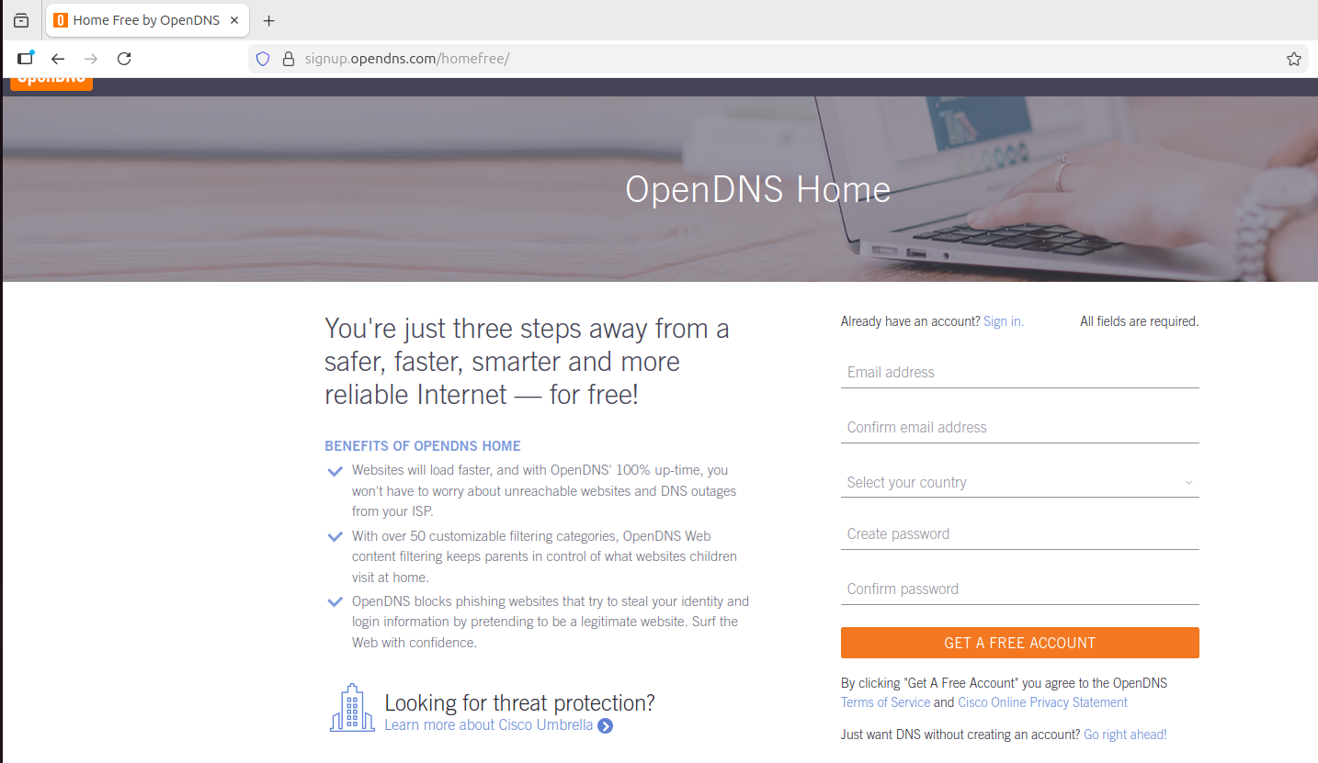
To create an account, fill all the gaps. You must validate your email (check your inbox).
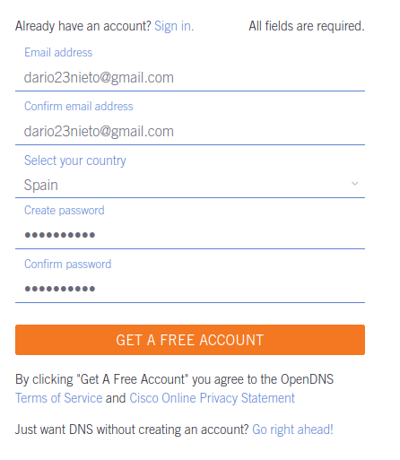
Once we have created the account, first we are going to remember the nameservers that OpenDNS provides us:
- 208.67.222.222
- 208.67.220.220
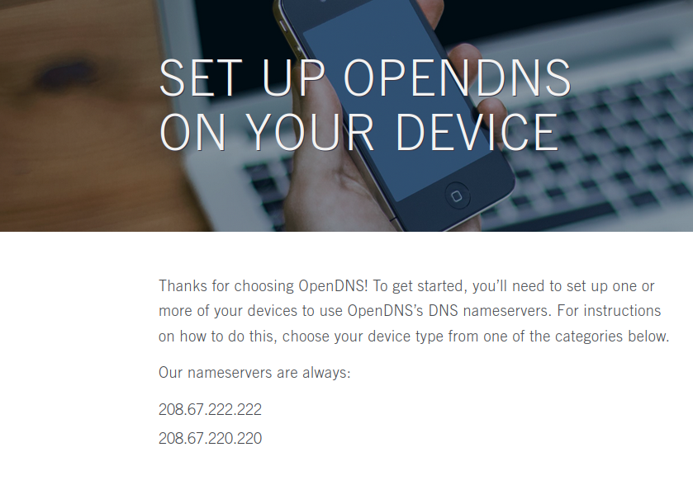
If we go down in the same website, we see the different devices that we can implant the Parental Control.
In this case is a Workstation for one device, but this tool can be implanted in a hole network if we configurate it for a router.
Pick a device here is not the route for implant the tool, this is only a community-help website.
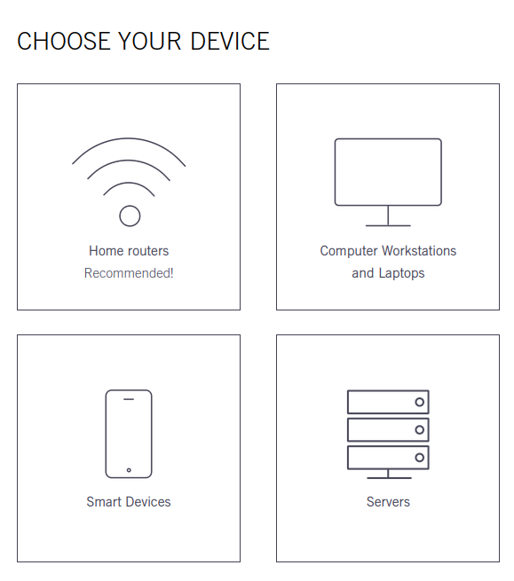

Adding the network

For continue the lab we must validate our email, and we will continue working in the same site (The Dashboard).
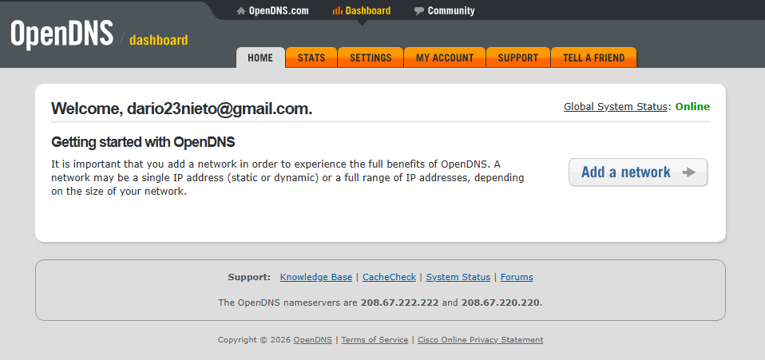
To add our network, we must select our public IP.
To see our IP in the terminal:
- curl ifconfig.me
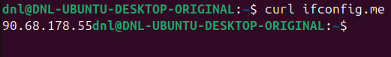
Usually, the correct IP will be introduced automatically in the gaps.
We must add the network.
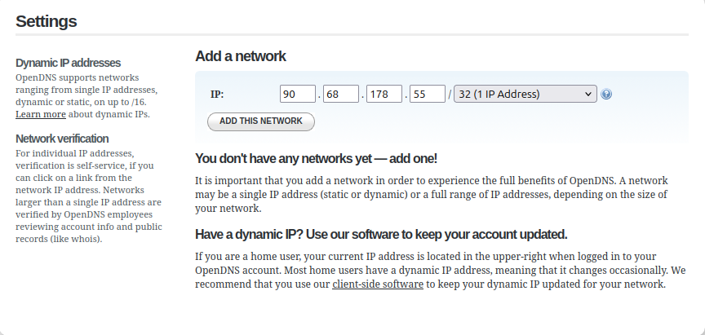

Now we are going to select some parameters of our network:
- Give a name to the control.
- Select if your IP is dynamic.
  - If it is, you will have to download a software to maintain the tool working although your IP changes.
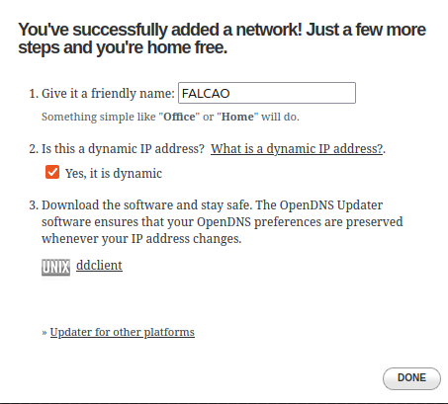
The network has been successfully added.
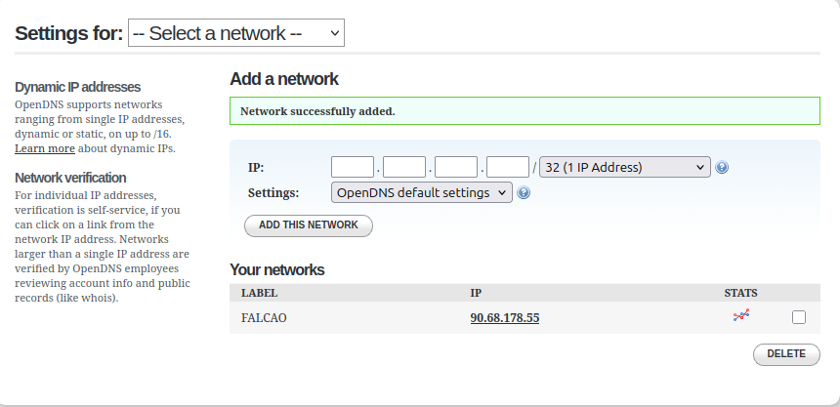
The final step of this part is adding the nameservers of OpenDNS to our network parameters.
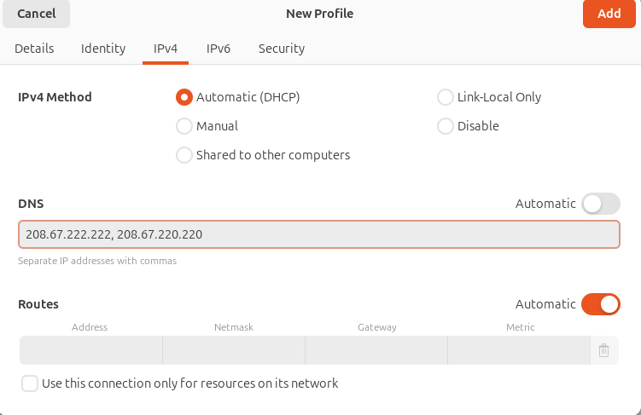
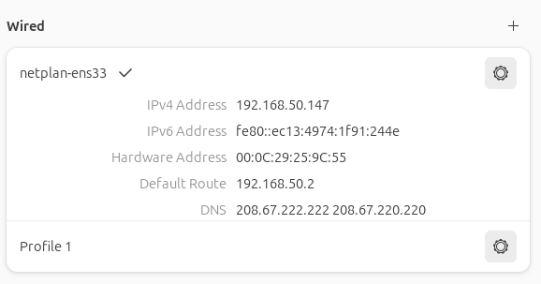

Configurate Filtering

Still working in the dashboard, we must activate the filtering in the “Settings” of our network.
There are different filtering complexity levels:
- High:
  - Provides maximum protection by blocking adult-related content, illegal activities, social networking, video sharing, and general time-wasting sites (27 categories total).
- Moderate:
  - Offers a balanced filter that protects against all adult-related sites and illegal activities (14 categories total).
- Low:
  - Focuses specifically on basic protection by blocking only pornography (5 categories total).
- None:
  - Disables all web content filtering. No categories or sites are blocked.
- Custom:
  - Allows the administrator to manually select specific individual categories to block based on granular network requirements.

All the categories can be selected by choosing “Custom”.

In this lab the protection will be High.
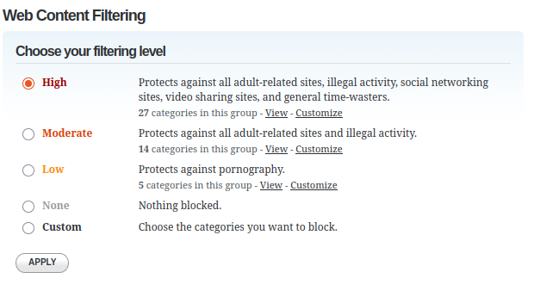
We also can block a specific domain.
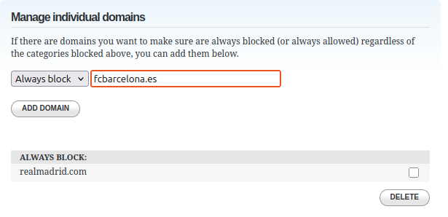

Verification

Finally, we are going to validate that his configuration has been implanted.
We are going to clean the DNS cache:
- Cleaning the DNS cache is a critical step because it forces the operating system to discard locally stored IP addresses and request fresh, updated records from the newly configured OpenDNS servers.
- This ensures that any previously allowed sites are immediately subjected to the new filtering rules rather than loading from the outdated local memory.
- sudo resolvectl flush-caches
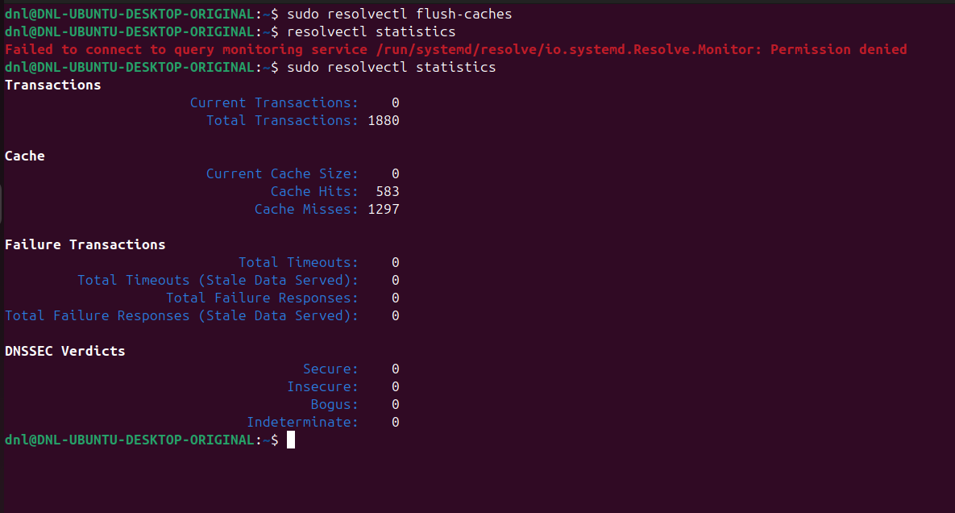

Verification that the VM is using the tool:
- http://welcome.opendns.com
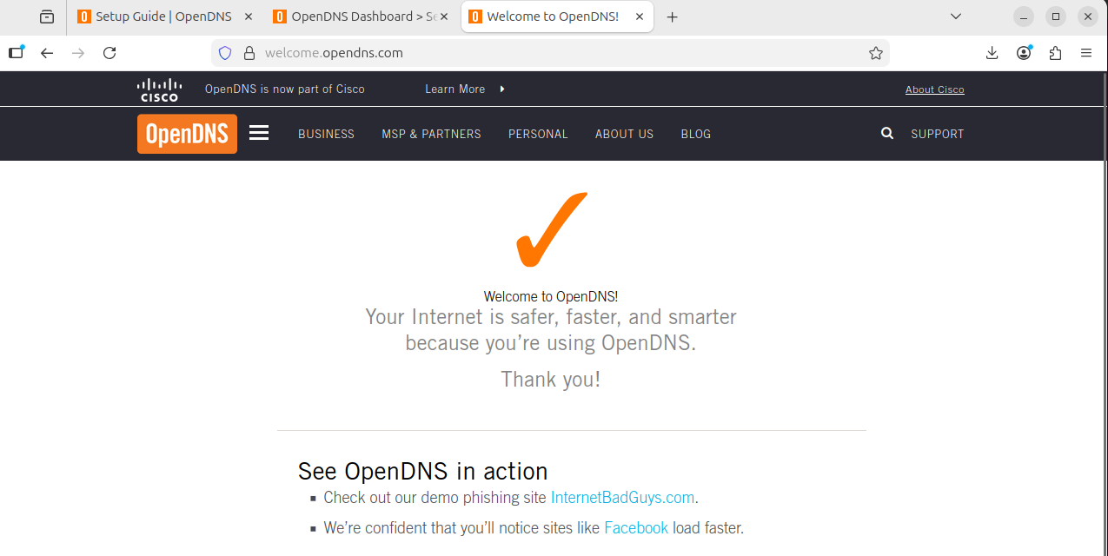

Verification of prohibited domains:
- Personalised domain:
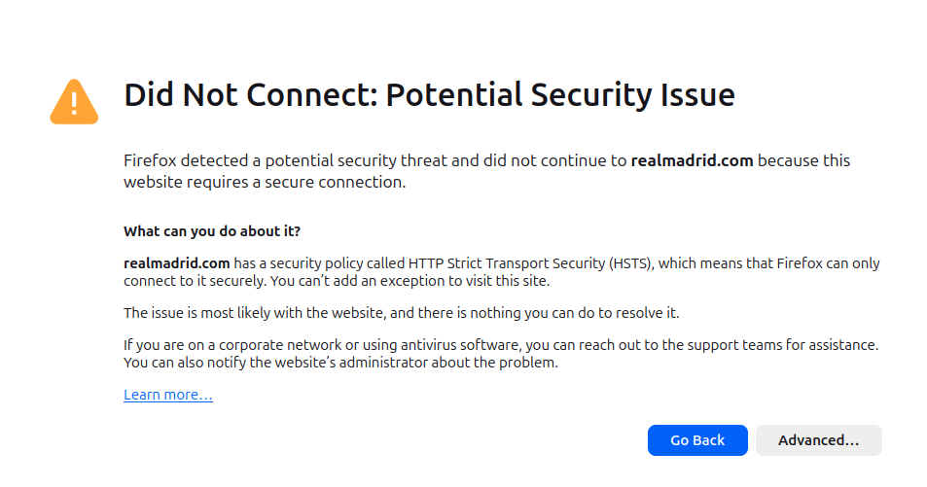
- Casino domain:
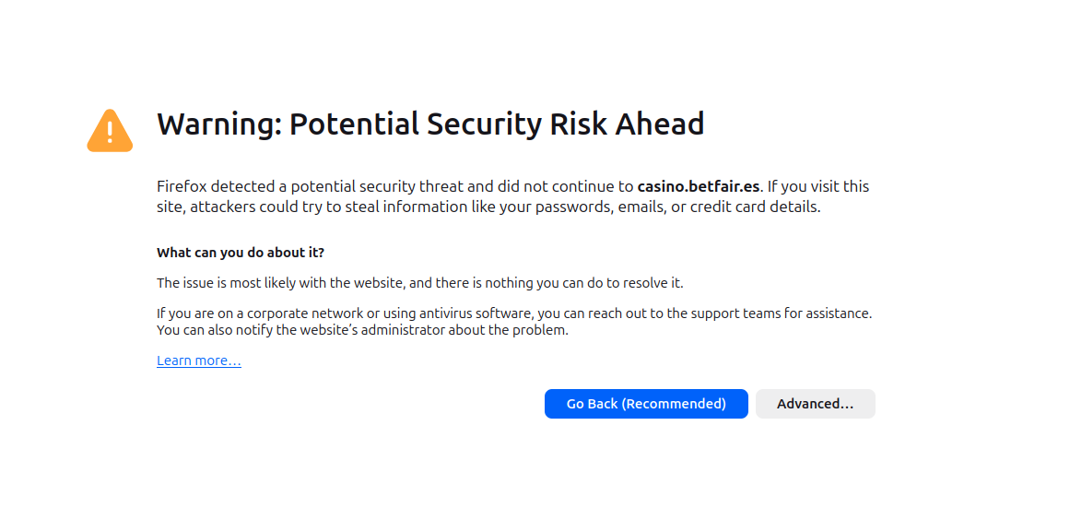
- Porn domain:
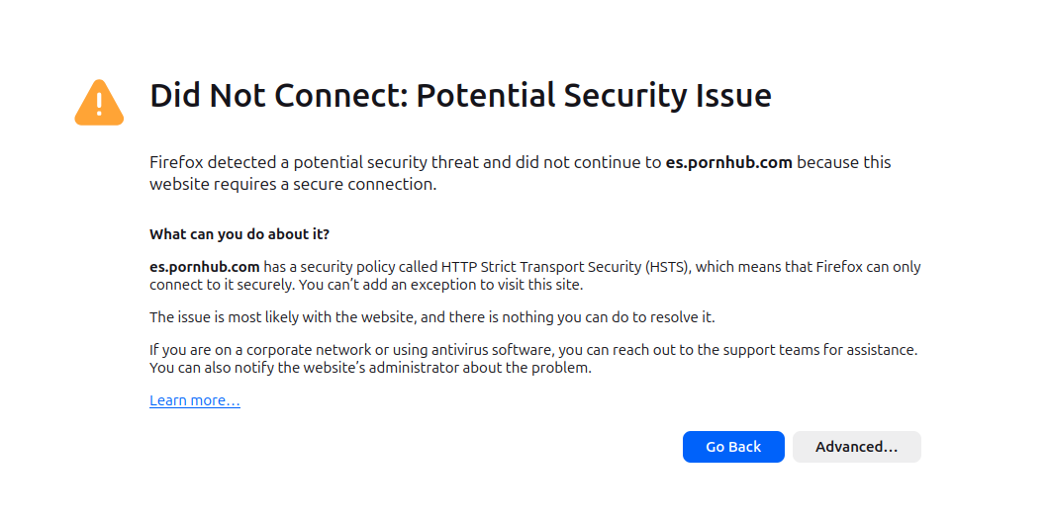

Conclusion

The implementation of the OpenDNS filtering system on Ubuntu Desktop demonstrates a robust method for managing network security and content access at the DNS level.

Lab Summary

In this laboratory, we successfully redirected the Ubuntu network resolution to the OpenDNS Anycast servers.
We analyzed the different filtering tiers and configured the OpenDNS Dashboard to enforce specific “High,” “Moderate,” or “Low” security profiles.
Finally, we had certificated the correct implantation of the tool.

Utility and Use Cases

This tool is exceptionally useful for environments requiring controlled internet access without the need for complex, resource-heavy local firewalls:
- Schools:
  - To ensure students comply with educational policies by blocking social media and distractive content.
- Homes:
  - To protect minors from adult content and malicious domains automatically.
- Small Businesses:
  - To prevent employees from accessing high-risk or non-work-related sites, reducing the likelihood of phishing and malware infections.

Economic and Strategic Context

While the services used in this lab are free, it is important to recognize the underlying business model.
Professional-grade features (such as advanced reporting, larger network support, or faster resolution) are reserved for paid tiers like Cisco Umbrella.
Additionally, free services often involve a strategic trade-off where the provider gains access to DNS query data, which is used for strategic marketing and global threat intelligence.

DNS Lists vs. Manual Filtering

Technically, blocking specific IP addresses is a trivial task that can be performed manually using tools like iptables or nftables.
However, the true value of OpenDNS is not the redirection itself, but the dynamic lists.
Manually maintaining a list of millions of malicious or inappropriate websites is impossible for a single administrator; with OpenDNS, we are essentially “paying” (via data or subscription) for a real-time, curated database that updates automatically to block new threats as they emerge.

