516-DaríoNL-PAR503-PingARP
TAJAMAR | MADRID | 22/03/2026
Ping ARP
PAR – Unit 4 – PING ARP

Index
Introduction 3
Theoretical Background 3
Inventory 4
Execution 5
System preparation 5
Windows 11 5
Ubuntu Desktop 8
ARP operations 10
Cache search 10
Cache deletes 13
Operating with other IP 15
Poisoning de ARP 19
Conclusion 21
Final Analysis questions 21
Conclusion 23

Introduction

In this laboratory session, an investigation into the fundamental mechanisms of local area network communication is conducted.
We will perform a series of connectivity tests using the ping utility and the Address Resolution Protocol (arp).
By capturing real-time traffic with Wireshark, the objective is to analyze the relationship between Logical Addressing (IP) and Physical Addressing (MAC), observing how hosts discover each other and maintain their internal tables.

Theoretical Background

To understand the practical results, it is essential to define the core protocols and identifiers used:
- IP (Internet Protocol):
  - A logical addressing system used to identify devices on a network and route packets between them.
- MAC (Media Access Control):
  - A unique physical identifier assigned to a network interface controller (NIC) for communications within a local network segment.
- ARP (Address Resolution Protocol):
  - The protocol responsible for mapping a known IP address to a physical MAC address.
- Ping (ICMP):
  - A diagnostic tool used to test the reachability of a host. It utilizes ICMP (Internet Control Message Protocol) Echo Request and Echo Reply packets.

Inventory

For the realization of the laboratory, we have used:
- Hardware:
  - Host PC.
- Software:
  - Utilities:
    - Ping
    - ARP
    - Wireshark
  - VMware:
    - Ubuntu Desktop 24.04.2.
    - Windows 11

Execution

System preparation

In this section we will conduct a study of the initial parameters of each system.

Windows 11

MAC:
We will change it for give a final with 01 for identify the VM.
- Open Device Manager.
- Locate Network Adapter.
- Access Properties.
- Advanced Settings Locally Administered Address.
- Enter New Value.
- Apply and verify.
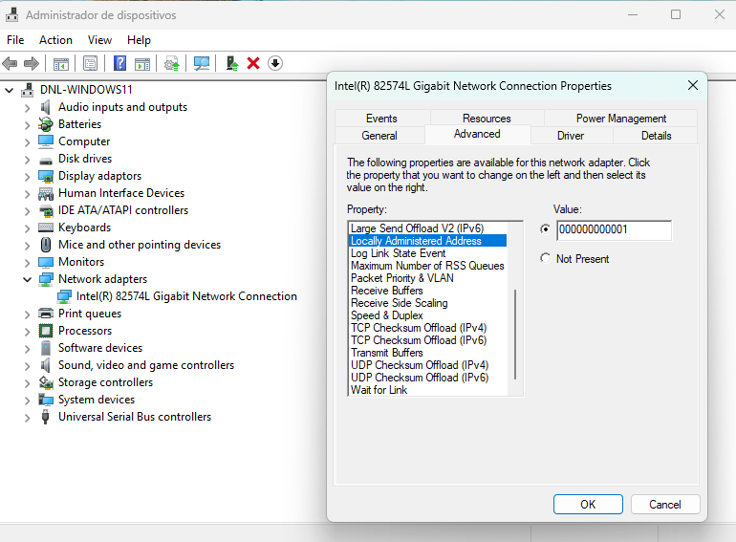
IP:
We will use an IP of a local range, that will be the same in Ubuntu.
In this case we must configure the default gateway because we will need to download software of internet (and the NIC must be in NAT in the VM settings).
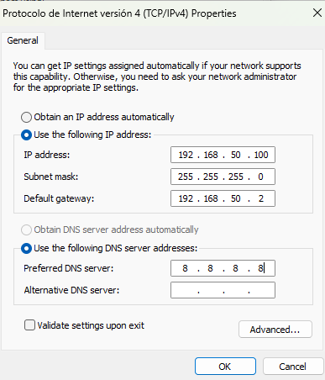

Final verification of MAC, IP and Hostname:
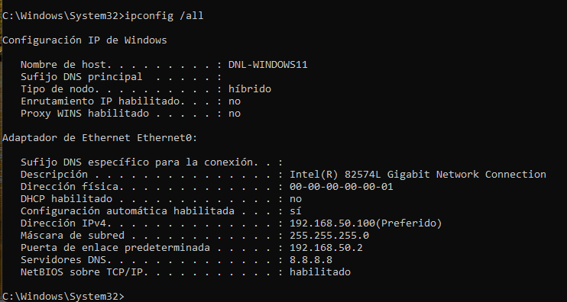
Wireshark installation and initiate capture:
https://www.wireshark.org/
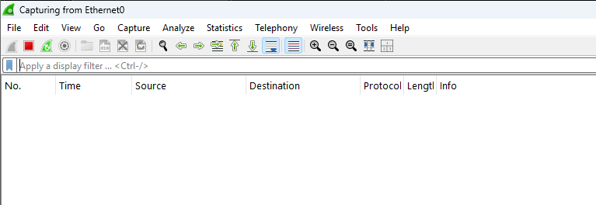

Ubuntu Desktop

MAC:
- Identify the interface name.
- Disable the interface.
- Apply the new MAC address.
- Enable the interface.
- Verify the change.
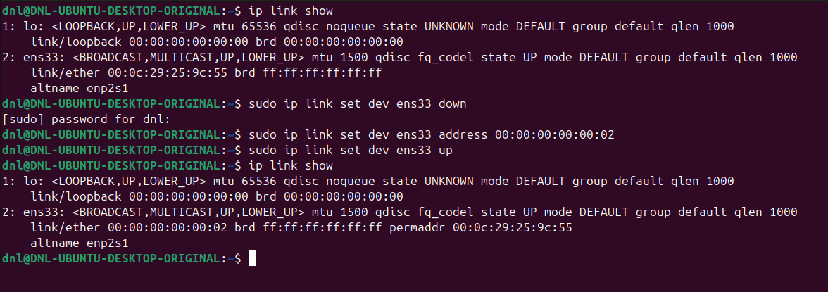
IP:
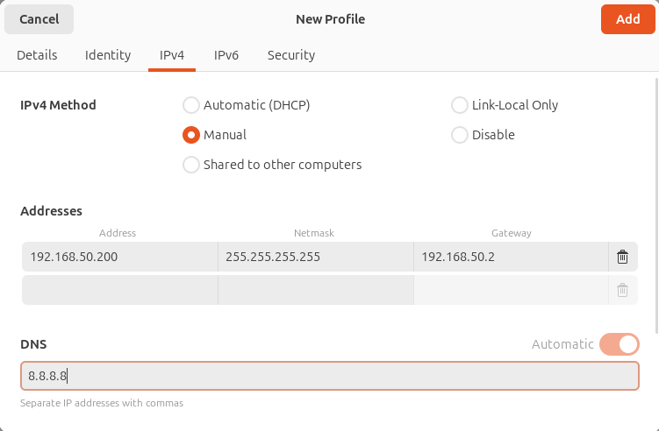

Final verification:
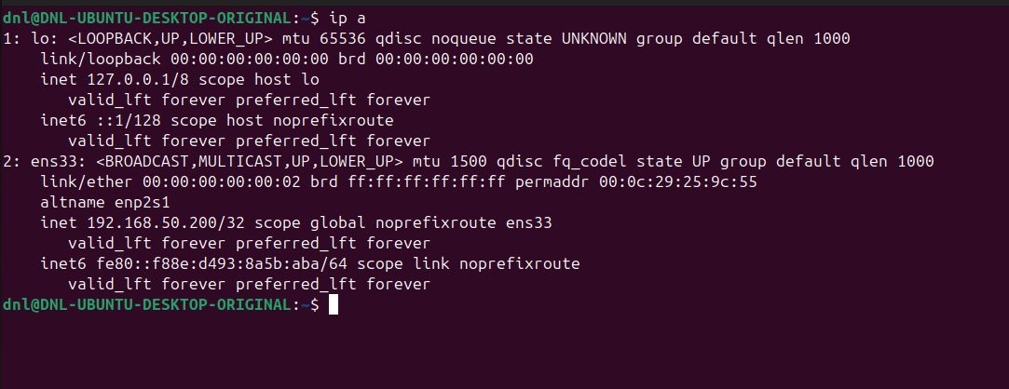

ARP operations

Cache search

We ran arp -a on both nodes to ensure a clean baseline.
We will observe that the cache is populated automatically as soon as a network neighbour is discovered.
The initial ARP table in Windows:
- Shows several reserved multicast and broadcast addresses.
- And the Ubuntu host is not yet present in the dynamic list, which is the expected state before any ping is initiated.
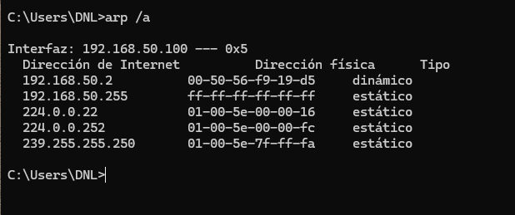
We observed that the Ubuntu node:
- Much like the Windows node, maintains an internal list of active neighbors.
- At this stage, the Windows host is not yet listed, as no direct communication has been established between them.
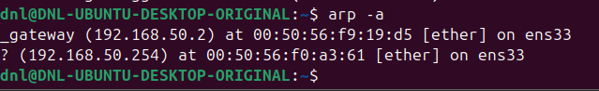

We will do a ping in the two systems.
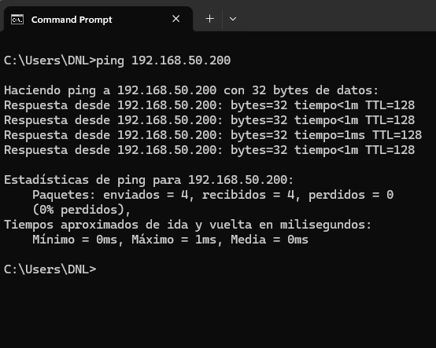
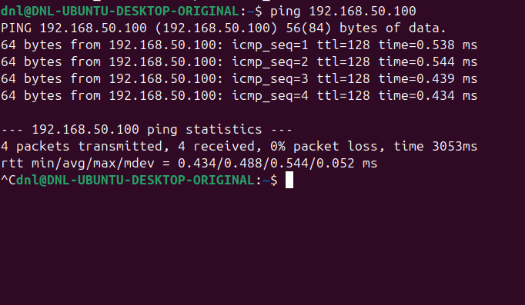

We will search in the arp cache again.
After adjusting the timing and ensuring the packets were correctly processed, we executed the arp -a command once more on both nodes.
This time, the ARP tables successfully registered the corresponding MAC addresses for each host.
On the Windows machine (PC1), the IP 192.168.50.200 is now mapped to the MAC address ending in ...02 (Ubuntu), while on the Ubuntu machine (PC2), the IP 192.168.50.100 is correctly associated with the MAC 00:00:00:00:00:01.
The registration of the MAC address in the ARP cache is a mandatory step for Ethernet communication.
Since IP addresses operate at the Network Layer (Layer 3) and MAC addresses at the Data Link Layer (Layer 2), a mapping must exist to encapsulate the data into a physical frame.
When the ping command was initiated, the source host (PC1) broadcasted an ARP Request asking, “Who has IP 192.168.50.200?”.
Once the destination (PC2) responded with its physical address via an ARP Reply, both systems automatically stored this information in their local tables to avoid redundant broadcasts in future transmissions.
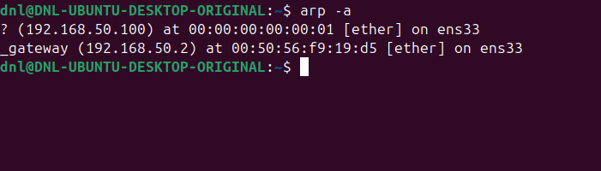
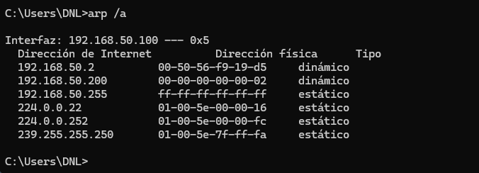

Cache deletes

We proceeded to clear the ARP cache on both nodes using arp -d on Windows and sudo ip neigh flush all on Ubuntu.
After the deletion, we inspected the tables again:
- The Windows host (PC1) only retained entries for the default gateway, and the multicast address 224.0.0.22 (which is the IGMPv3 membership report address used by the OS to manage network group subscriptions).
- In contrast, the Ubuntu node (PC2) showed a completely empty neighbor table, as it does not maintain static multicast mappings by default.
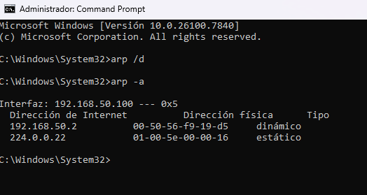
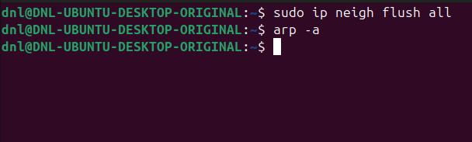

Analysis Questions

- Has the cache changed on PC1? And on PC2? Why?
  - Yes, both caches have changed significantly.
  - On PC1, the dynamic entry for PC2 was removed, leaving only the gateway and essential system multicast addresses.
  - On PC2, the table was entirely wiped.
  - Reason:
    - The manual deletion command forces the Operating System to purge its temporary mapping table.
    - This is done to simulate a “cold” network state where no prior knowledge of neighbor hardware addresses exists.
- What do you have to do to recover the PC2 record in the PC1 ARP cache?
  - To recover the record, we must initiate any network communication from PC1 directed toward the IP address of PC2 (such as a ping).
  - Technical justification:
    - Since the mapping no longer exists in the local cache, the network stack will automatically trigger a new ARP Request broadcast.
    - Once PC2 sends an ARP Reply, the entry will be re-registered as a dynamic mapping in PC1's table.

Operating with other IP

Ping to a Non-Existent Address (Windows 11):
- We attempted to establish communication with the IP address (or your equivalent non-existent address like 10.10.1.1).
- As expected, the ping utility provided the following output:
  - “Request timed out”.
- This message indicates that the source host (PC1) sent out a request but received no response within the default timeout period.
ARP Cache Verification:
- Upon running arp -a immediately after the failed ping, we observed that there is no entry for the IP 10.10.1.1 in the local table.
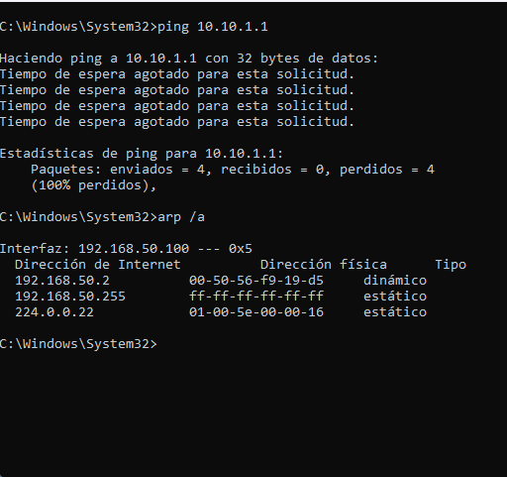

Static ARP Injection and Connectivity Test
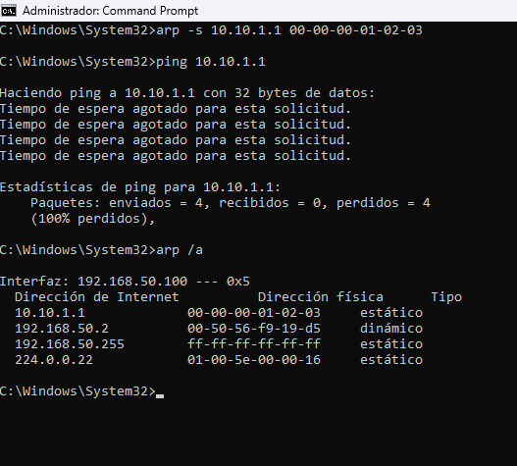
- We manually injected a static entry into the Windows ARP cache using the command arp -s 10.10.1.1 00-00-00-01-02-03.
- Upon verification with arp -a, the entry appeared as Static, confirming that the OS now “believes” that the IP 10.10.1.1 belongs to that specific MAC address.

Observation of the Ping Command:
- When performing a new ping 10.10.1.1, the message remains:
  - “Request timed out”.
- However, the behavior behind the scenes has changed:
  - We can identify in Wireshark that PC1 no longer sends an “ARP Request” (Who has...?).
  - Instead, it immediately encapsulates the ICMP packet and sends it directly to the network interface, targeting the MAC 00:00:00:01:02:03.
Wireshark before we injected the MAC:
Wireshark after we injected the MAC:

Analysis: Why does Ping still fail?
- Address resolution (ARP) is only the first step of the communication process.
- While we have successfully “resolved” the Layer 2 address (MAC), there is no physical network interface card (NIC) on the local segment configured with that MAC address or that IP address.
- The breakdown:
- PC1 sends the Ethernet frame to the local switch.
- The switch attempts to forward the frame to the port where 00:00:00:01:02:03 is located.
- Since no device exists with that MAC, the frame is effectively lost or dropped by the network hardware.
- Even if a device received it, its IP stack would reject it because it is not configured with the IP 10.10.1.1.
Conclusion:
- Having a MAC address in the cache is a necessary condition for sending a packet, but it is not sufficient for a successful response if the destination host does not exist.

Poisoning de ARP

Delete entries.
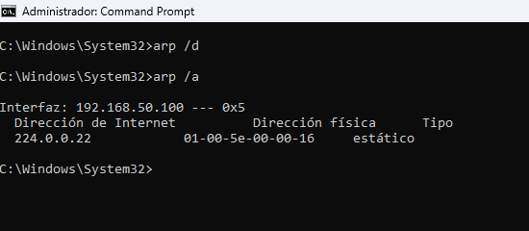
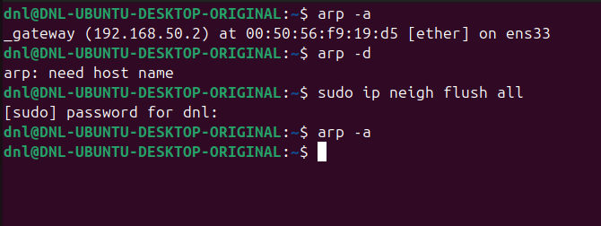
Adding the MAC address of Ubuntu at the fake IP.
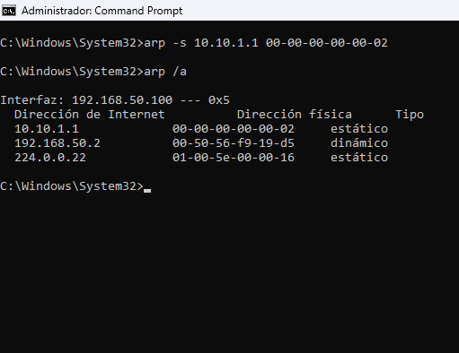

We performed a ping from PC1 to 10.10.1.1
- After mapping this IP to the physical MAC of PC2.
  - The result was a “Request timed out”.
- What occurs?
  - PC1 sends the Ethernet frames directly to PC2's network interface, but no response is received.
- Why? (Justification):
  - Although the frames physically reach PC2 (Layer 2), the Ubuntu OS identifies that the destination IP 10.10.1.1 does not match its own configured IP 192.168.50.200.
  - Consequently, the IP stack of PC2 discards the packet at Layer 3 and does not generate an ICMP Echo Reply.
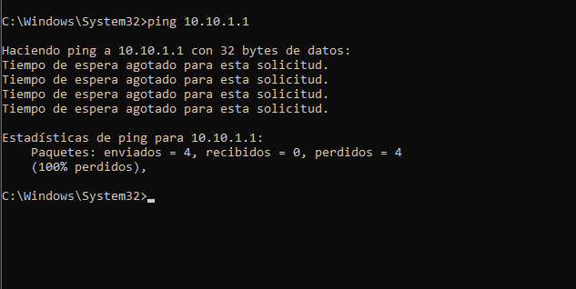

Conclusion

Final Analysis questions

How many datagrams intervene in the ARP resolution?
- Two datagrams:
  - One ARP Request (Broadcast) and one ARP Reply (Unicast).
What type of packets identify the ping and ARP sends?
- Ping uses ICMP (Echo Request/Reply) encapsulated in IP.
- ARP uses its own protocol directly over Ethernet (EtherType 0x0806).
Why is the ARP resolution not executed again immediately?
- Because the mapping is already stored in the OS ARP Cache.
- We verified that the system only performs a new resolution when the entry expires (TTL) or is manually deleted.

Comparison Windows vs Linux

Feature | Windows (PC1) | Linux (PC2)
Ping behavior | Stops after 4 packets by default. | Runs infinitely until stopped (Ctrl+C).
ARP Cache TTL | Very aggressive  (entries expire in seconds). | More persistent  (entries stay longer).
ARP Commands | arp -a, arp -d, arp -s. | arp (deprecated) or the modern ip neigh.
Ping output | Provides a summary (Loss/Min/Max). | Provides detailed per-packet timing and statistics.

Conclusion

The completion of this laboratory session has provided a comprehensive understanding of the interplay between Layer 2 (Data Link) and Layer 3 (Network) protocols.
We have demonstrated that while IP addresses are used for logical identification, the Address Resolution Protocol (ARP) is the essential “bridge” that allows physical delivery via MAC addresses.
Through the various experiments (including connectivity tests, manual cache manipulation, and simulated ARP poisoning) several key principles were verified…
Dependency:
- A valid IP configuration is useless without a successful ARP mapping, yet a manual ARP entry cannot force a response from a non-existent or misconfigured host.
Efficiency:
- The use of a local ARP cache significantly reduces network overhead by preventing redundant broadcast traffic for subsequent communications.
Operating System Variations:
- Differences in how Windows and Linux manage their neighbor tables (TTL and persistence) and utility outputs (Ping defaults) were successfully identified.
In summary, the use of Wireshark allowed for the visual confirmation of these “invisible” processes, proving that network communication is a multi-step encapsulation journey.
We conclude that a deep knowledge of these protocol behaviors is fundamental for network troubleshooting and security auditing.

