516-DaríoNL-PARP504-SSMTP_CLI
TAJAMAR | MADRID | 24/03/2026
Send mail with the shell in Linux
PAR – Unit 4 – SSMTP CLI

Index
Introduction 3
Roadmap 3
Theoretical Framework 4
What is a Mail Server? 4
SMTP (Simple Mail Transfer Protocol) 4
SSMTP 4
Inventory 5
Execution 6
Phase 1: Environment Preparation 6
Linux Server Readiness 6
Gmail Account Security Configuration 8
Phase 2: Installation and Backup 11
Installing the SSMTP Package 11
Preserving Original Configuration Files 12
Phase 3: Service Configuration 13
Creating the Configuration File 13
Defining SMTP and Authentication Parameters 14
Phase 4: Permission Hardening 16
Ownership Refinement 16
Access Bit Modification 17
Phase 5: Validation 18
Executing Delivery Tests 19
Conclusion 22
Why Automated Alerts Matter 23

Introduction

In this laboratory, the configuration of a Mail Transfer Agent (MTA) on a Linux environment will be explored.
The main objective is to establish a functional bridge between a local server and Google’s infrastructure to enable automated email notifications directly from the command line.
By following this guide, we will transition from basic network concepts to the practical implementation of secure mail routing.

Roadmap

To ensure a successful configuration, we have structured our workflow into the following strategic milestones:
- Phase 1: Environment Preparation:
  - Provisioning the Linux server and adjusting Gmail security settings.
- Phase 2: Installation and Backup:
  - Deploying the SSMTP package and preserving original configuration files.
- Phase 3: Service Configuration:
  - Defining SMTP parameters, authentication credentials, and port management.
- Phase 4: Permission Hardening:
  - Securing sensitive data through ownership and permission refinement (chmod/chown).
- Phase 5: Validation:
  - Executing delivery tests from the shell to verify end-to-end connectivity.

Theoretical Framework

Before proceeding with the technical implementation, it is essential to understand the underlying technologies that govern electronic mail.

What is a Mail Server?

A mail server is a computerized system that sends and receives email.
It acts as a digital post office, using specific protocols to move messages across networks.
We can distinguish between MTAs (Mail Transfer Agents) like SSMTP, which handle the routing, and MDAs (Mail Delivery Agents), which store the mail for the final user.

SMTP (Simple Mail Transfer Protocol)

SMTP is the standard communication protocol for sending email messages between servers.
It operates on a push mechanis:
- When we send an email, our client uses SMTP to “push” the message to the recipient's server.
It typically utilizes port 25 (standard), 465 (SSL), or 587 (TLS).

SSMTP

Unlike full-scale mail servers like Postfix or Exim, SSMTP is an extremely lightweight MTA.
It does not receive mail or manage a local queue, instead, it simply forwards (relays) outgoing mail from a local computer to a defined mail hub (such as Gmail’s SMTP servers).
It is the ideal solution for automated scripts and system alerts due to its simplicity and low resource consumption.

Inventory

For the realization of the laboratory, we have used:
- Hardware:
  - Host PC.
- Software:
  - Utilities:
    - GMAIL account.
  - VMware:
    - Ubuntu Desktop 24.04.3.
- Guide Videos for help:
  - https://www.youtube.com/watch?v=Y_u5KIeXiVI

Execution

Phase 1: Environment Preparation

To establish a successful and secure link between our Linux server and the Gmail SMTP relay, several preliminary adjustments must be performed.
Due to modern security standards implemented by Google, simple authentication with a primary account password is no longer permitted.
Therefore, we will focus on updating the local server and configuring advanced security credentials for the Google account.

Linux Server Readiness

Before installing any packages, we must ensure our system is updated and that we possess the necessary administrative privileges.
System Update:
- It is highly recommended to synchronize the package index files from their sources.
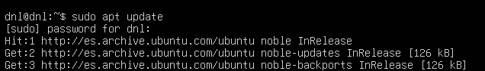
Root Access:
- Throughout this practice, we will be modifying system configuration files located in /etc/.
- Therefore, we will operate using the root user or via the sudo command to prevent permission-related errors.

Network Check:
- We must verify that the server has an active internet connection and that outgoing traffic on ports 587 (STARTTLS) or 465 (SSL) is not restricted by an external firewall.
- Connectivity to internet and verifications of ports:
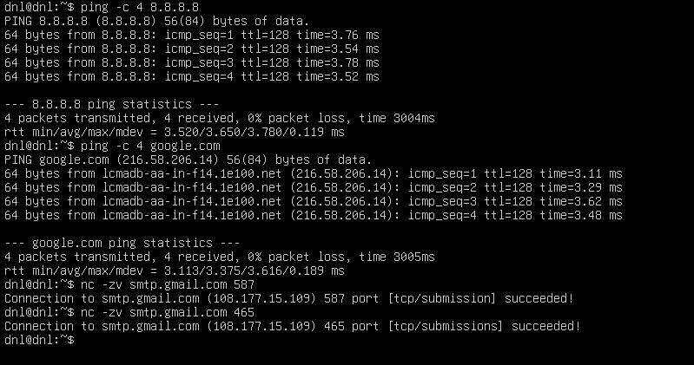
- Local firewall (deactivated) and ensure the output:
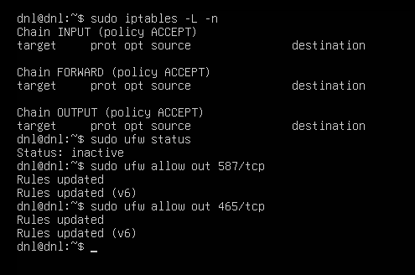

Gmail Account Security Configuration

As of May 30, 2022, Google has deprecated the support for third-party apps or devices which ask you to sign in to your Google Account using only your username and password (“Less Secure Apps”).
To bypass this restriction securely for automated services like SSMTP, we must utilize App Passwords.
An App Password is a 16-digit passcode that gives a less secure app or device permission to access your Google Account.
App Passwords can only be used with accounts that have 2-Step Verification turned on.
Authentication Note:
- You will not use your primary Gmail login password in the SSMTP configuration file.
- Attempting to do so will result in an authentication failure.
- We must generate a unique token for this specific server.

Steps to prepare the account:
- Access Security Settings:
  - Log into the Gmail account and navigate to the “Security” section of the Google Account management console.
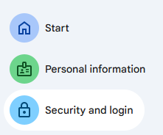
- Enable 2-Step Verification:
  - It is mandatory to enable 2-Step Verification for this process.
  - If it is not already active, we must set it up before proceeding.
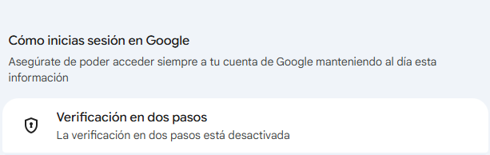


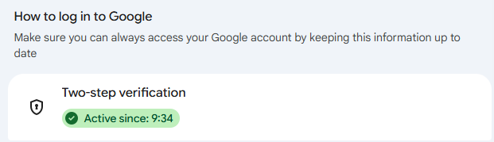
- Generate an App Password:
  - Search App passwords.
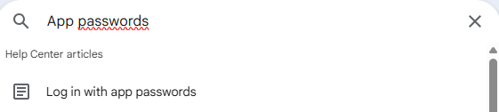
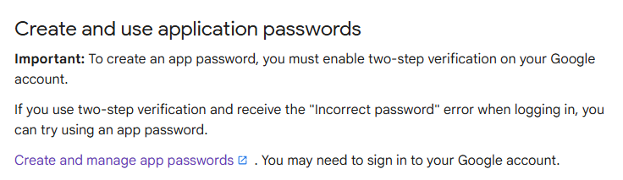
  - Select an app “Mail”.
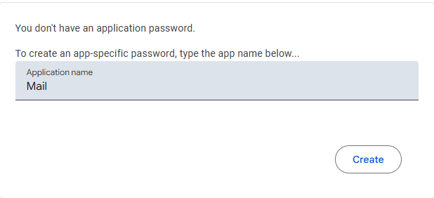
- Preserve the Token:
  - A window will appear showing a 16-character password inside a yellow bar.
  - We must copy this password immediately and safely.
  - Once the window is closed, it cannot be displayed again.
  - This token will be used in place of our regular password during Phase 2.

Phase 2: Installation and Backup

Once the network parameters have been verified and the secure Gmail credentials generated, we must proceed with the deployment of the SSMTP software on our Linux server.
The primary objective of this phase is to obtain the necessary binaries and preserve the default vendor configuration.

Installing the SSMTP Package

SSMTP is generally available through standard distribution repositories.
For Debian-based systems (like Ubuntu), the apt-get utility is utilized.
To deploy the package, the following command must be executed with root privileges:
- apt-get install ssmtp
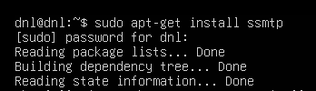

Preserving Original Configuration Files

A critical best practice in system administration is the preservation of original configuration files before customization.
Modifying the vendor's default file directly is discouraged, as it complicates troubleshooting or restoring the service to its initial state.
Upon a successful installation, SSMTP populates the directory /etc/ssmtp/ with two key files:
- ssmtp.conf: The main configuration file.
- revaliases: Re-writing of email addresses (optional).
We will focus on protecting ssmtp.conf.
Instead of deleting it, we will rename it to serve as a baseline backup:
- mv /etc/ssmtp/ssmtp.conf /etc/ssmtp/ssmtp.conf.old
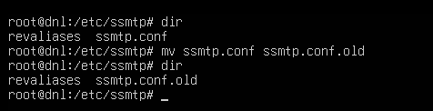
After renaming the original file, a clean baseline has been established for the subsequent custom configuration.
We are now ready to populate the directory with our operational parameters in the next phase.

Phase 3: Service Configuration

With the original configuration safely backed up, we must now define the operational parameters for our SSMTP agent.
This involves establishing a secure link to Gmail's infrastructure and providing the authentication token generated in Phase 1.

Creating the Configuration File

Since we moved the original ssmtp.conf, the first step is to create a new file that will house our custom settings (but we will copy the original file to have the template).
To initialize the new configuration file, we execute the following command:
- cp /etc/ssmtp/ssmtp.conf.old /etc/ssmtp/ssmtp.conf
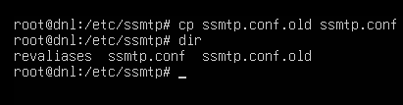

Defining SMTP and Authentication Parameters

We will now populate the /etc/ssmtp/ssmtp.conf file using a text editor.
It is imperative that the data entered matches our specific account details and Google's technical requirements.
The file must contain the following structural blocks:
Parameter | Value | Description
root | your-email@gmail.com | The email address that receives mail for “root”.
mailhub | smtp.gmail.com:587 | The remote SMTP server address and the communication port.
rewriteDomain | gmail.com | The domain used in the “From” header of outgoing mail.
hostname | localhost | The internal name of our Linux server.
UseSTARTTLS | YES | Enables secure encryption (mandatory for Google).
AuthUser | your-email@gmail.com | Our full Gmail username for authentication.
AuthPass | … | CRITICAL:  The 16-character App Password (Token).
FromLineOverride | YES | Allows the user to specify their own “From” address in the email.

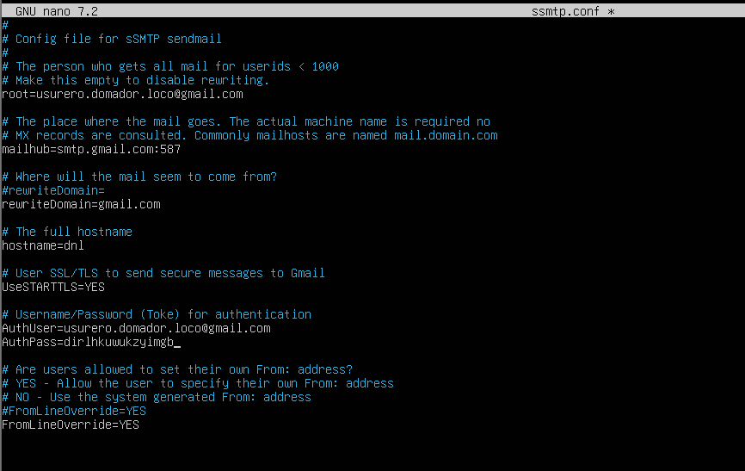

Phase 4: Permission Hardening

The objective of this phase is to ensure that only the system and authorized users can access the sensitive credentials stored in /etc/ssmtp/ssmtp.conf.
We will achieve this by modifying both the ownership and the access permissions of the file.

Ownership Refinement

By default, the file may belong to the root user and the root group.
To allow the mail system to function while maintaining security, we will assign the file to the mail group.
We execute the chown (change owner) command to set the user to root and the group to mail:
- chown root:mail /etc/ssmtp/ssmtp.conf
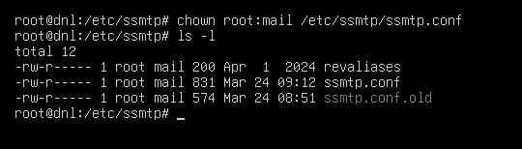

Access Bit Modification

We must prevent “others” (any user not in the root or mail groups) from reading the file.
We will use the 640 octal mask:
- 6 (read/write) for the owner (root).
- 4 (read-only) for the group (mail).
- 0 (no access) for everyone else.
- We apply these restrictions using the chmod command:
  - chmod 640 /etc/ssmtp/ssmtp.conf
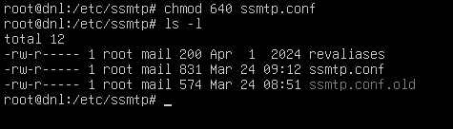
This configuration ensures that even if a malicious user gains access to a standard shell on the server, they will be unable to “cat” or read your Gmail token.

Phase 5: Validation

The objective of this final stage is to verify end-to-end connectivity between our Linux shell and the recipient's inbox.
First, we have to install mailutils.
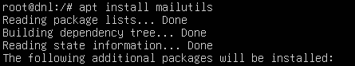
I had to change the configuration because I made a mistake when entering my email address; I misspelled it by one letter.
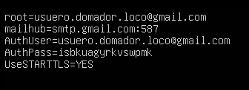

Executing Delivery Tests

We have two primary methods to verify that mail is leaving the server correctly.
Method A: Using the mail command (Piped):
- This is the most common way to send automated alerts.
- We pipe the message body directly into the mail utility:
  - echo “MESSAGE” |
  - mail -s “SSMTP Test” destination-email
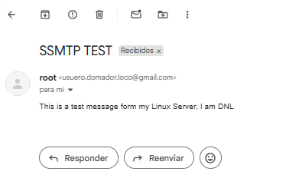

Method B: Direct SSMTP Interaction (Interactive Mode):
- While piping commands is efficient for automation, SSMTP can also be used in an interactive mode.
- This is particularly useful for manually constructing the email headers or for quick debugging without relying on external packages like mailutils.
- We invoke the ssmtp binary followed by the destination email address:
  - ssmtp DESTINATION
(The terminal will appear to hang; it is waiting for your input).
- Constructing the Message:
  - To ensure the email is formatted correctly in the recipient's inbox, we should manually define the headers.
  - Is recommended following this structure:
    - To: (Optional, as it was defined in the command).
    - Subject: The title of your email.
    - (Empty line): Critical. An empty line must separate the headers from the body.
    - Body: The actual content of your message.
  - Sending the Mail:
    - Once the text is complete, we press ENTER to go to a new line and then use the keyboard shortcut CTRL+D.
    - This sends the EOF (End Of File) signal, triggering the delivery process.

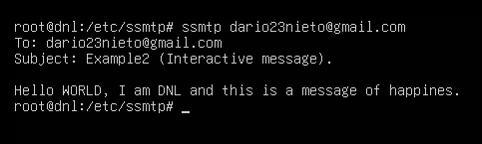
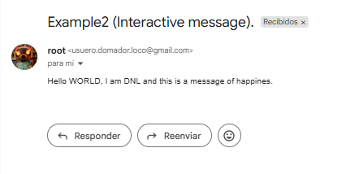
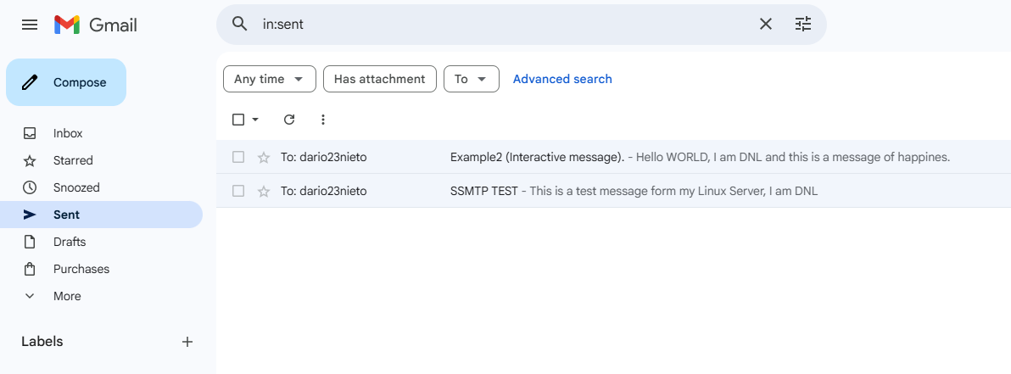

Conclusion

The successful implementation of SSMTP on our Linux server demonstrates how a lightweight, efficient agent can bridge the gap between local system environments and enterprise-grade mail infrastructure.
By transitioning from legacy security methods to Google’s App Passwords, we have ensured a secure and reliable delivery path for our server's communications.
We have established a robust foundation where the command line is no longer an isolated environment, but a node capable of notifying administrators of its status in real-time, regardless of physical location.

Why Automated Alerts Matter

The true power of a configured MTA (Mail Transfer Agent) lies in its ability to turn a passive server into an active monitor.
Implementing this bridge to Gmail is critical for several high-impact operational reasons:
- Real-Time Error Reporting:
  - Servers often run critical processes in the background (Crontabs, Databases, Web Services).
  - If a service crashes or a script fails at 3:00 AM, the server can now send an immediate email alert.
  - This allows us to react to downtime before users even notice a problem.
- Log Monitoring and Security:
  - By piping system logs directly to our inbox, we can monitor for suspicious activity without manually logging into the shell every hour.
- Failed Logins:
  - We can configure the server to email us after a specific number of failed SSH attempts.
- System Health:
  - SSMTP allows us to receive daily “health reports,” summarizing the CPU load or memory usage over the last 24 hours.
- Resource Exhaustion Alerts:
  - One of the most common causes of server failure is a full disk.
  - With this setup, we can automate a check that sends a high-priority Gmail notification when disk usage exceeds 90%, preventing database corruption or total system lockouts.

