516-DaríoNL-PARP603-RoutersWIN
TAJAMAR | MADRID | 11/05/2026
Routers in Windows
PAR – Unit 6 – Routers win

Index
Introduction 3
Design 4
Inventory 5
Execution 6
Environment preparation 6
Virtual machine basic configuration 7
Windows Server (DNL-RT1) 7
Windows 10 (DNL-r1-cl1) 14
Windows 10 (DNL-r2-cl1) 16
Final Information DNL-r1-cl1 & DNL-r2-cl1 18
Router deployment DNL-RT1 19
Features Installation 19
Start router 21
Router configuration 22
Connectivity Verification 24
Connectivity tests analysis 28
Conclusion 30

Introduction

This project focuses on the deployment of a virtualized network environment where a Windows Server 2022 instance is configured to operate as a functional software router using the Routing and Remote Access Service (RRAS).
By bridging two distinct subnets, the server acts as the central gateway for two Windows 10 workstations, enabling seamless communication and packet forwarding between isolated segments.
The primary goal is to simulate an enterprise-level routing infrastructure entirely within the Windows ecosystem, ensuring that client machines on different networks can communicate through a centralized routing table and properly configured network interfaces without the need for external physical hardware.

Design
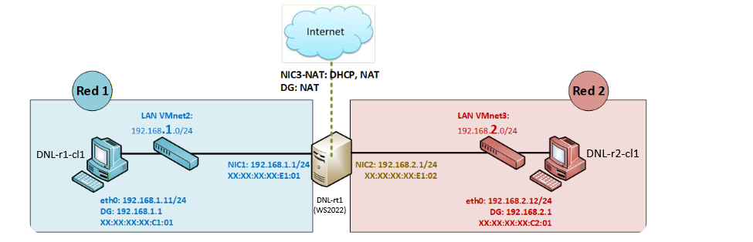

Inventory

For the realization of the laboratory, we have used:
- Hardware:
  - Host PC.
- Software:
  - Utilities:
    - Routing and Remote Access Service (RRAS).
    - Windows Network Diagnostic Tools (Ping, Tracert).
    - Command Line Interface (CLI).
    - Virtual Network Editor.
  - VMware:
    - Windows 10.
    - Windows Server 2022.

Execution

Environment preparation

We will use 2 clients (Windows 10) and a router (Windows Server 2022) with their respective naming conventions.
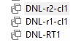
Network Adapters:
- DNL-RT1:
  - NAT
  - Internal network VMnet2 (with r1-cl1).
  - Internal network VMnet3 (with r2-cl1).
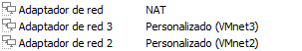
- DNL-r1-cl1:
  - Internal network VMnet2 (with RT1).
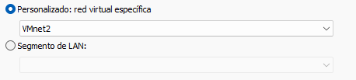
- DNL-r1-cl1:
  - Internal network VMnet3 (with RT1).
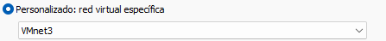

Virtual machine basic configuration

Windows Server (DNL-RT1)

Name of Server

We will change de name of the Server to dictate a nomenclature in accordance with what has been established.
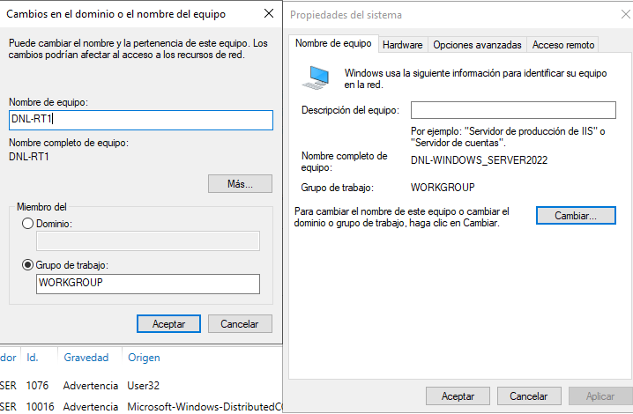

Network Adapters (MAC)

We will identify each network card using:
- In Power Shell:
  - getmac /v
    - With this we will see the MAC of each interface.
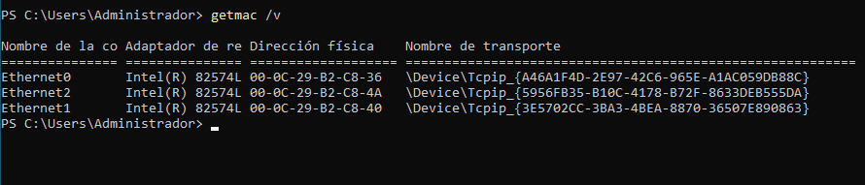
- In the settings of the VM:
  - Network Adapter Advanced MAC.
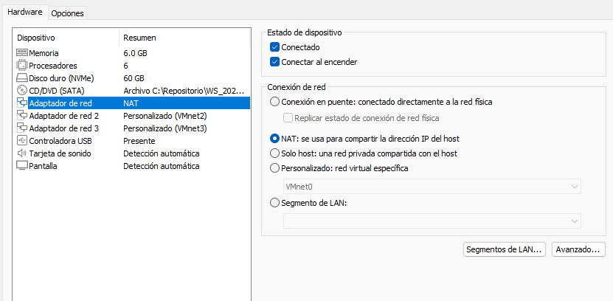
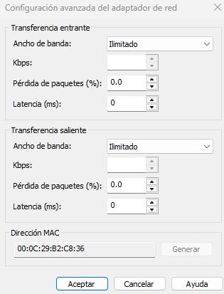
Now we can compare and know which Network adapter is each interface:
- Network Adapter NAT Ethernet 0.
- Network Adapter 2 VMnet2 Ethernet 1.
- Network Adapter 3 VMnet3 Ethernet 2.
Finally, we have to change de MAC to establish the same of the design:
- Network Adapter 2 VMnet2 Ethernet 1.
  - XX:XX:XX:XX:E1:01
- Network Adapter 3 VMnet3 Ethernet 2.
  - XX:XX:XX:XX:E1:02
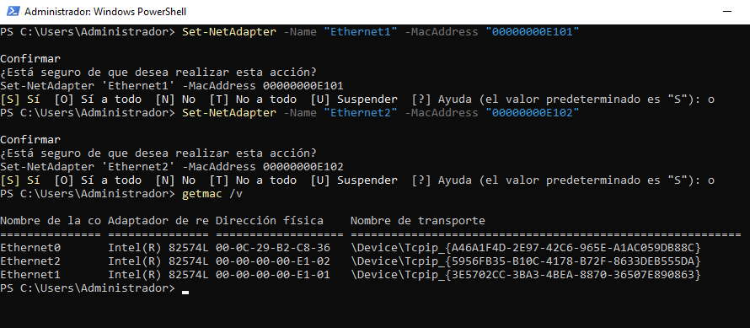

Network Interfaces (IP)

Finally, for this basic configuration on the server, we will configurate the IP parameters (Level 3):
- Ethernet0, NAT:
  - IP: DHCP / Dynamic.
  - Mask: 255.255.255.0
  - Gateway: Auto of NAT.
  - DNS: Auto.
  - Desactivate IPv6.
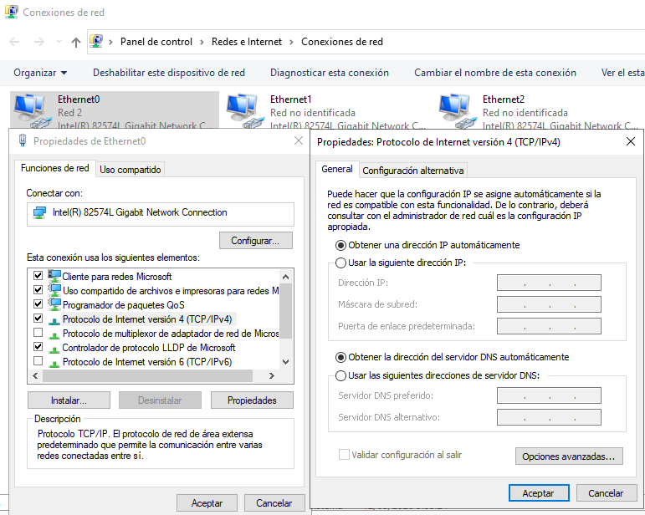

- Ethernet1, VMnet2:
  - IP: 192.168.1.1
  - Mask: 255.255.255.0
  - Gateway: Empty.
  - DNS: Empty.
  - Desactivate IPv6.
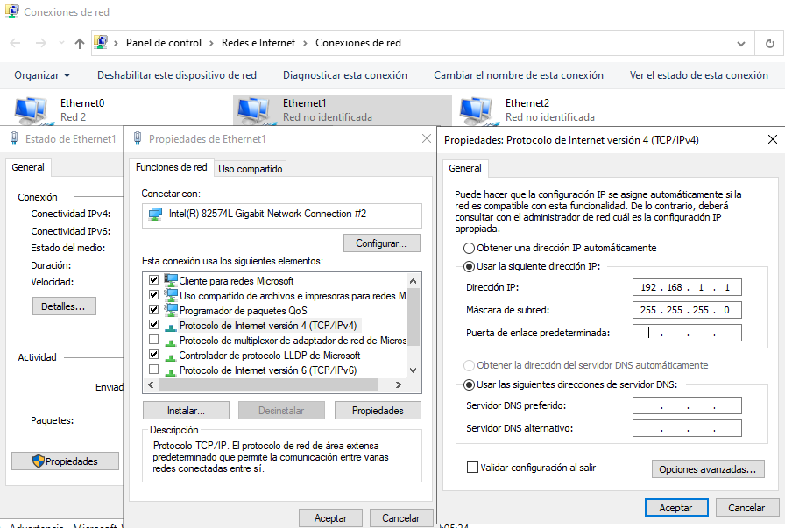

- Ethernet2, VMnet3:
  - IP: 192.168.2.1
  - Mask: 255.255.255.0
  - Gateway: Empty.
  - DNS: Empty.
  - Desactivate IPv6.
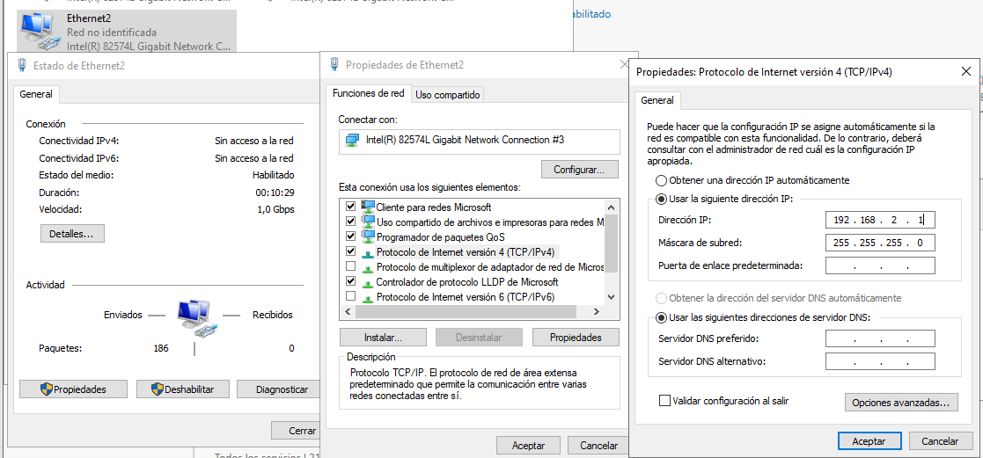
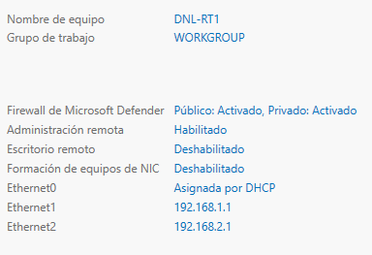

Final Information

ROUTER: | DNL-RT1
Interfaces | Nombre | Switch | Tipo (D/E) | IP | Máscara
NIC1: | Ethernet0 | NAT | D | Dynamic | 24
NIC2: | Ethernet1 | VMnet2 | E | 192.168.1.1 | 24
NIC3: | Ethernet2 | VMnet3 | E | 192.168.2.1 | 24

Rutas: | Literal | Destino | Interfaz | IP interfaz salida | Puerta
DG: | Default | No específico | Ethernet0 | Dynamic | NAT
1 | VMnet2 | 192.168.1.0/24 | Ethernet1 | 192.168.1.1
2 | VMnet3 | 192.168.2.0/24 | Ethernet2 | 192.168.2.1

Windows 10 (DNL-r1-cl1)

Rename:
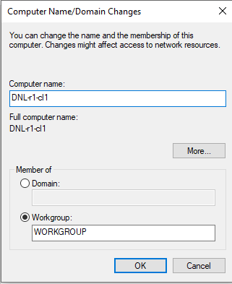
MAC:
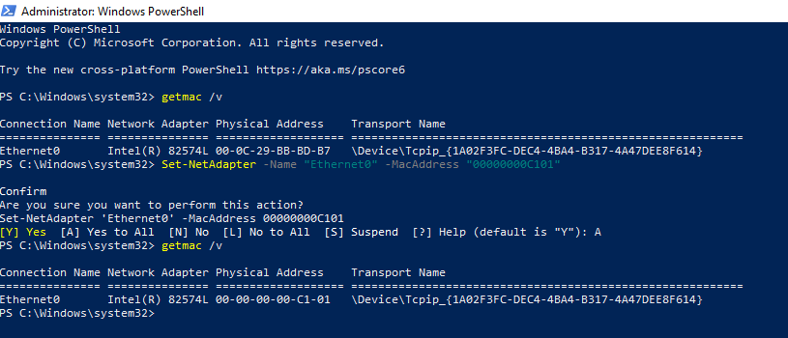

IP:
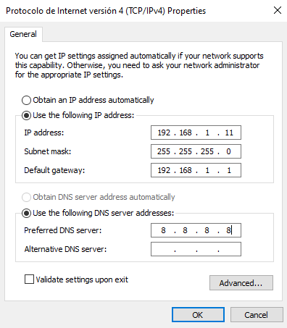
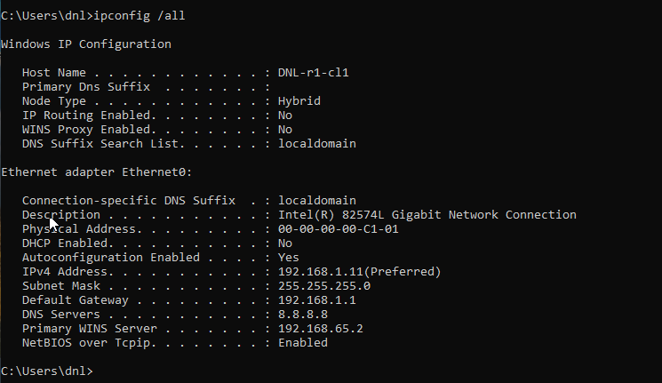

Windows 10 (DNL-r2-cl1)

Rename:
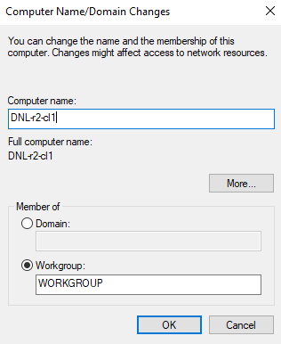
MAC:
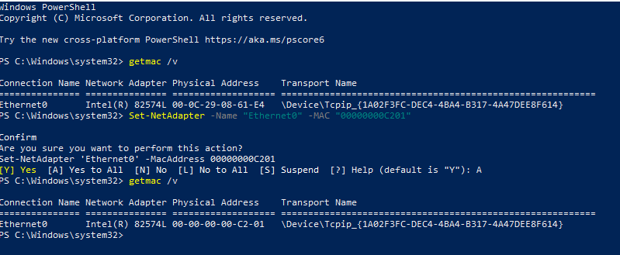

IP:
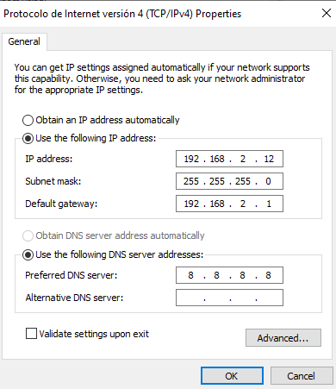
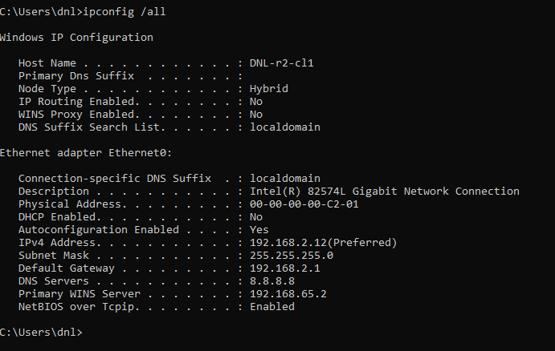

Final Information DNL-r1-cl1 & DNL-r2-cl1

CLIENTE: | DNL-r1-cl1
Interfaces | Nombre | Switch | Tipo (D/E) | IP | Máscara
NIC1: | Ethernet0 | VMnet2 | E | 192.168.1.11 | 24
NIC2:

Rutas: | Literal | Destino | Interfaz | IP interfaz salida | Puerta
DG: | Default | No específico | Ethernet0 | 192.168.1.11 | 192.168.1.1
1 | VMnet2 | 192.168.1.0/24 | Ethernet0 | 192.168.1.11

CLIENTE: | DNL-r2-cl1
Interfaces | Nombre | Switch | Tipo (D/E) | IP | Máscara
NIC1: | Ethernet0 | VMnet3 | E | 192.168.2.12 | 24
NIC2:

Rutas: | Literal | Destino | Interfaz | IP interfaz salida | Puerta
DG: | Default | No específico | Ethernet0 | 192.168.2.12 | 192.168.2.1
1 | VMnet3 | 192.168.2.0/24 | Ethernet0 | 192.168.2.12

Router deployment DNL-RT1

Features Installation

We will go to the server, to the administrator section, and click on “Add roles and features”.
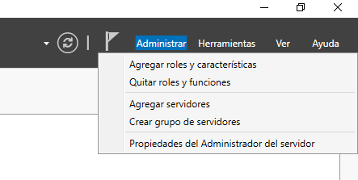
We'll select all default settings until we reach “Server Roles”.
Here we will add “Remote Access”.
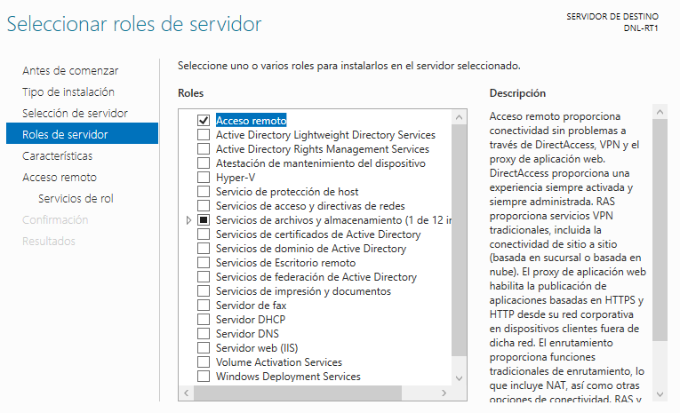

Now we have to go directly to role services and check “Routing”.
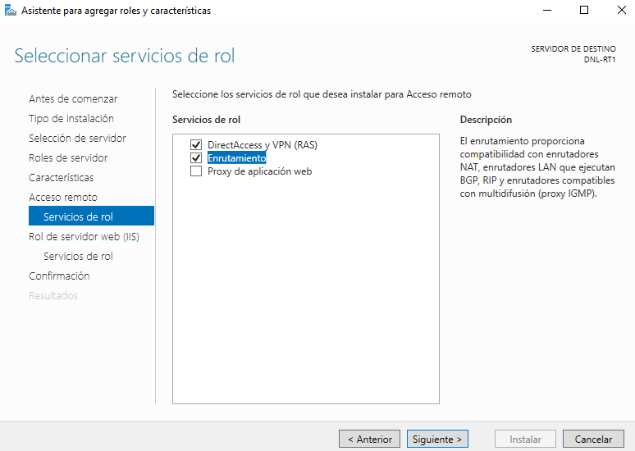
Once we have assigned the role to the server and the routing service, we can proceed directly to the installation.
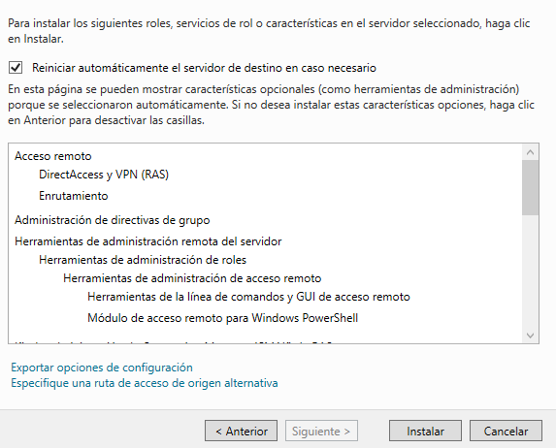

Start router

Once installed, we proceed to initialize the router.
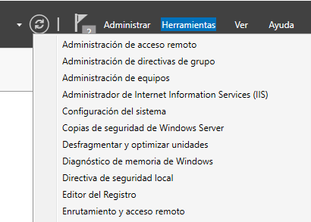
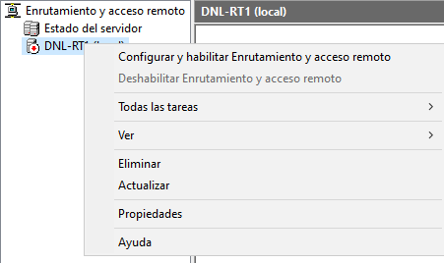

Router configuration

We will configure the router in a customized way.
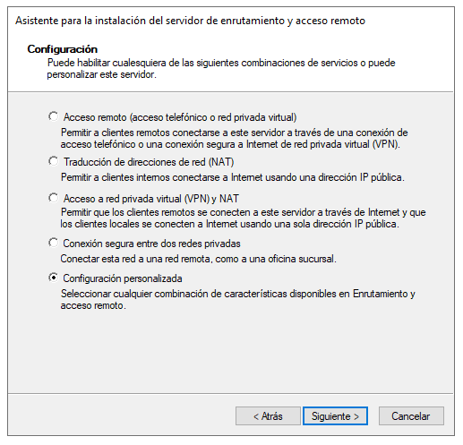
We only checked the “LAN Routing” box, and we finish the assistant.
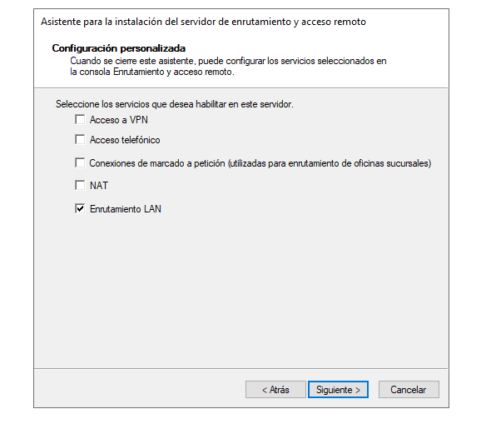
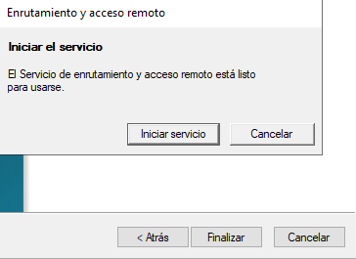
Now we have the assistant working.
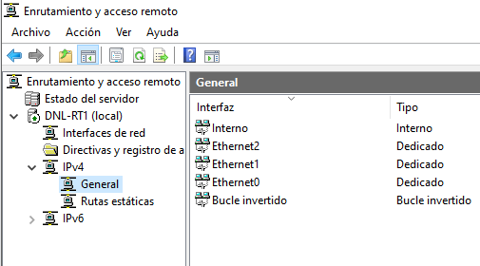

Connectivity Verification

Before performing the connectivity tests, disable the firewall on all machines to avoid ICMP/ping blocking.
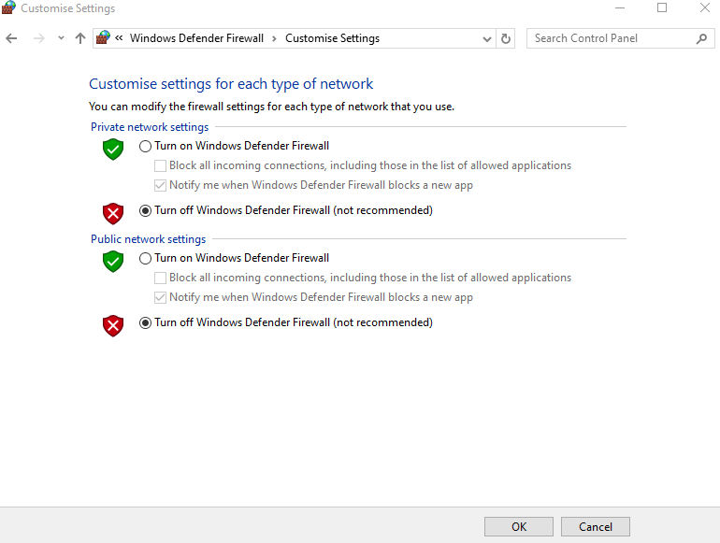

Ping between R1-CL1 and the Router:
- Test connectivity from DNL-r1-cl1 to the router interface 192.168.1.1.
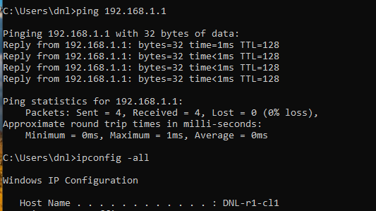
- Test connectivity from DNL-RT1 to DNL-r1-cl1 (192.168.1.11).
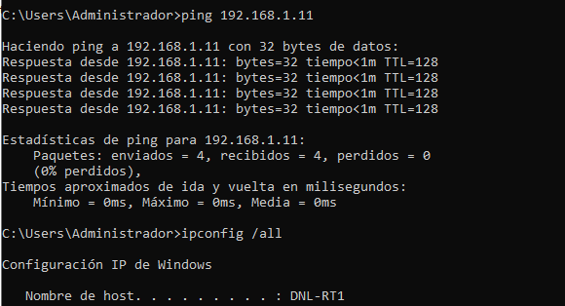

Ping between R2-CL1 and the Router:
- Test connectivity from DNL-r2-cl1 to the router interface 192.168.2.1.
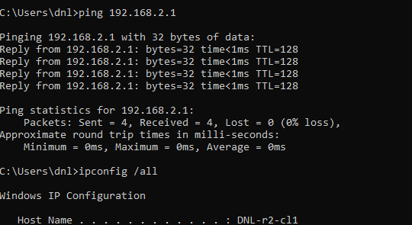
- Test connectivity from DNL-RT1 to DNL-r2-cl1 (192.168.2.12).
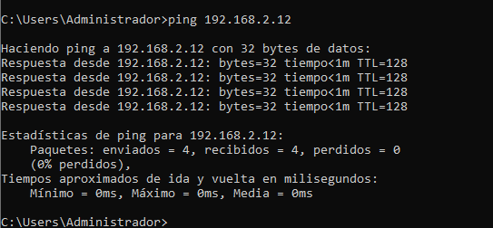

Ping between R1-CL1 and R2-CL1:
- Test connectivity from DNL-r1-cl1 to DNL-r2-cl1.
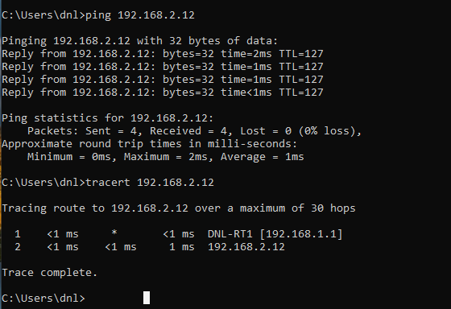
- Test connectivity from DNL-r2-cl1 to DNL-r1-cl1.
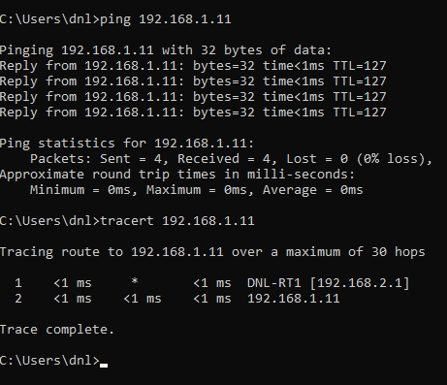

Connectivity tests analysis

Router to Client Connectivity

The ping tests between the router and both clients confirmed that each device could successfully communicate within its own local subnet.
- DNL-r1-cl1 successfully reached 192.168.1.1
- DNL-r2-cl1 successfully reached 192.168.2.1
  - The router successfully replied to both clients
These results verified that:
- IP addresses were correctly configured.
- Subnet masks matched the network design.
- Network interfaces were connected to the correct VMnet segments.
- Local Layer 3 communication was operational.

Inter-Network Communication

The ping tests between DNL-r1-cl1 and DNL-r2-cl1 confirmed successful communication between different networks.
- 192.168.1.11 reached 192.168.2.12
- 192.168.2.12 reached 192.168.1.11
This demonstrated that:
- The router was correctly forwarding packets between subnets
- Default gateways on both clients were properly configured
- Routing between 192.168.1.0/24 and 192.168.2.0/24 was functioning correctly
The successful replies proved that traffic could move between isolated VMnet networks through DNL-RT1.

Traceroute Analysis

A traceroute test was performed between the two clients to analyse the packet path.
The result showed:
- The first hop was the router interface
- The second hop was the destination client
This verified that:
- Traffic was routed through DNL-RT1
- Clients were located on separate subnets
- Inter-network communication depended on the router
- The network topology behaved as expected
The traceroute confirmed the routing process and validated the logical network design.

Conclusion

This project successfully established a functional software-based routing infrastructure using the Windows environment, validating the ability of Windows Server 2022 to manage inter-network traffic.
Infrastructure and Connectivity:
- Network Segmentation:
  - The use of VMnet2 and VMnet3 virtual switches provided the necessary physical isolation to simulate distinct subnets .
- IP Addressing:
  - Correct Layer 3 configuration on both clients ensured they were properly situated within their respective logical networks.
- Gateway Configuration:
  - Defining the router's internal interfaces as the Default Gateway on the Windows 10 workstations enabled packet egress from local segments.
System Functionality and Roles:
- RRAS Deployment:
  - The installation of the Remote Access role and the Routing service transformed the server into a multi-homed routing engine.
- Forwarding Logic:
  - The LAN Routing feature successfully processed and moved traffic between the 192.168.1.0/24 and 192.168.2.0/24 subnets.
- Administrative Control:
  - The centralized routing table managed all traffic paths without requiring external hardware or static route manual entry.

Traffic Analysis and Verification:
- ICMP Validation:
  - Successful ping tests between isolated clients confirmed that the end-to-one and end-to-end communication was operational .
- Tracert Hop Analysis:
  - The traceroute utility provided visual evidence of the routing process by identifying the server as the mandatory first hop.
- Path Transparency:
  - Hops confirmed that traffic did not bypass the router, validating the security and logical flow of the established design.
- Environment Integrity:
  - Disabling firewalls during testing proved that internal routing logic was sound, independent of security filtering.

