516-DaríoNL-PARP604-RoutersLinux-3RoutersAnillo
TAJAMAR | MADRID | 18/05/2026
Routers in Linux
PAR – Unit 6 – Routers LINUX

Index
Introduction 3
Design 4
Inventory 5
Execution 6
Environment preparation 6
Virtual machine basic configuration 8
Ubuntu Desktop (DNL-CL1, DNL-CL2, DNL-CL3) 8
Ubuntu Server (DNL-RT1) 10
Ubuntu Server (DNL-RT2) 12
Ubuntu Server (DNL-RT3) 14
Core Routing and Security Configuration 16
Connectivity Verification and Path Analysis 17
Conclusion 22
Infrastructure and Connectivity 22
System Functionality and Kernel Services 23
Traffic Analysis and Path Verification 24
Routing table 24

Introduction

This laboratory focuses on the technical deployment, configuration, and verification of a virtualized network infrastructure organized in a redundant ring topology using native GNU/Linux systems.
By interconnecting three multi-homed Linux instances acting as software routers (DNL-RT1, DNL-RT2, and DNL-RT3) in a closed-loop framework, the network architecture provides reliable transit pathways to bridge three physically isolated client subnets (DNL-CL1, DNL-CL2, and DNL-CL3).
The operational core of this infrastructure involves the implementation of precise static routing policies via declarative Netplan configurations, combined with the activation of kernel-level IP forwarding and explicit firewall deactivation across all routing nodes.
Through this structural design, path trajectory, route asymmetry, and multi-hop packet-forwarding logic are systematically analyzed using diagnostic utilities such as ICMP ping and traceroute, validating a resilient and scalable enterprise-grade network design without relying on dedicated hardware routing components.

Design
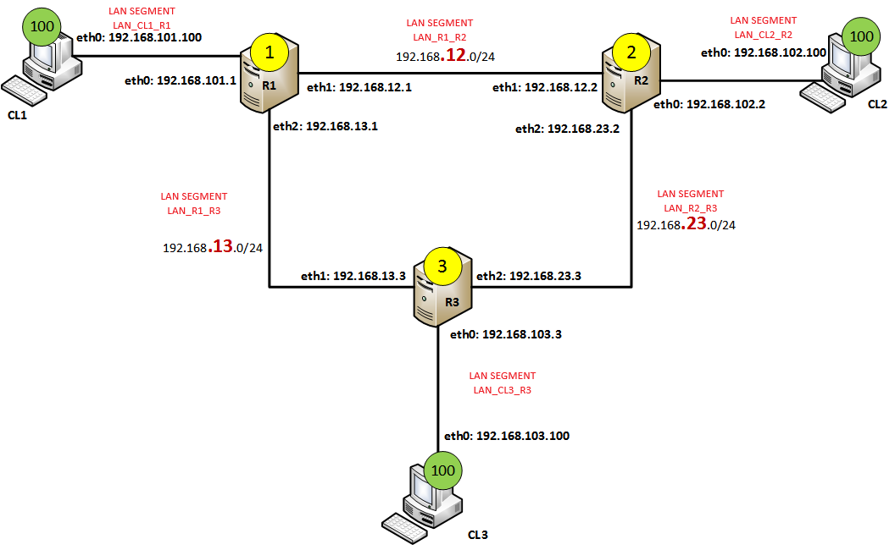

Inventory

For the realization of the laboratory, we have used:
- Hardware:
  - Host PC.
- Software:
  - Utilities:
    - Linux Network Configuration Tools (iproute2
    - Linux Network Diagnostic Tools (ping, traceroute).
    - Command Line Interface (Bash).
    - Virtual Network Editor.
  - VMware:
    - ubuntu-24.04.3-live-server-amd64.
    - ubuntu-24.04.2-desktop-amd64.

Execution

Environment preparation

We will use 3 clients (Ubuntu Desktop) and 3 routers (Ubuntu Server) with their respective naming conventions.
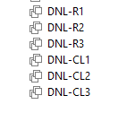
Creation of LAN Segments:
- Go to “Settings” of any VM.
- Network Adapter LAN Segment Add.
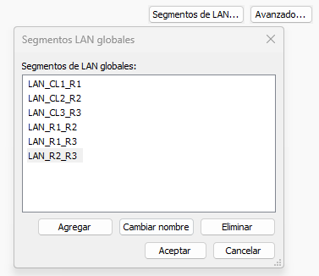
Network adapters:
- DNL-RT1:
  - LAN_CL1_R1
  - LAN_R1_R2
  - LAN_R1_R3
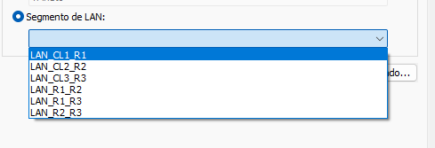
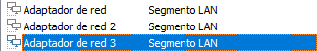
- DNL-RT2:
  - LAN_CL2_R2
  - LAN_R1_R2
  - LAN_R2_R3
- DNL-RT3:
  - LAN_CL3_R3
  - LAN_R1_R3
  - LAN_R2_R3
- DNL-CL1: LAN_CL1_R1
- DNL-CL2: LAN_CL2_R2
- DNL-CL3: LAN_CL3_R3

Virtual machine basic configuration

Ubuntu Desktop (DNL-CL1, DNL-CL2, DNL-CL3)

Name and Network Interfaces

We will change de name of the clients to dictate a nomenclature in accordance with what has been established.
Additionally, we will configure de Network Parameters.
Change name:
- sudo hostnamectl set-hostname NEW_NAME
- Edit: /etc/hosts
DNL-CL1:
- IP: 192.168.101.100
- MASK: 255.255.255.0
- DG: 192.168.101.1
- DNS: Empty
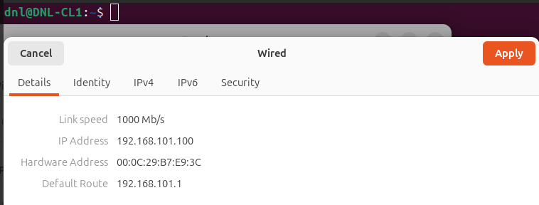

DNL-CL2:
- IP: 192.168.102.100
- MASK: 255.255.255.0
- DG: 192.168.102.2
- DNS: Empty
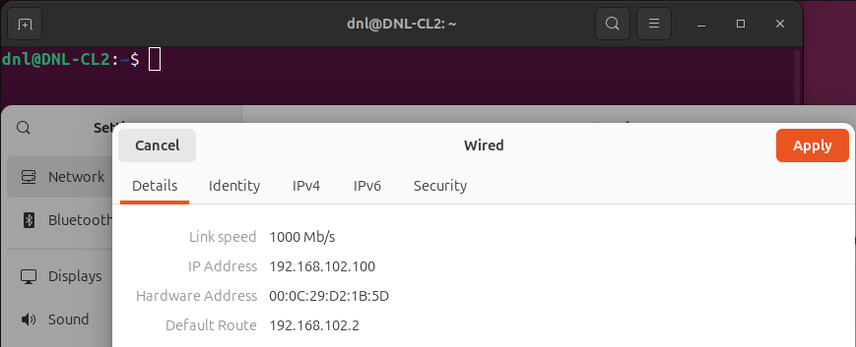
DNL-CL3:
- IP: 192.168.103.100
- MASK: 255.255.255.0
- DG: 192.168.103.3
- DNS: Empty
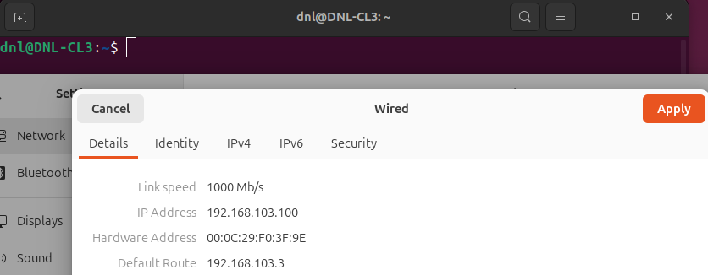

Ubuntu Server (DNL-RT1)

Verify each Network Adapter:
- Ip -br link | grep ens
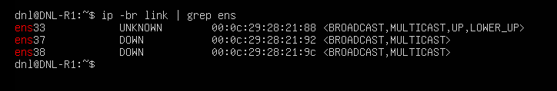
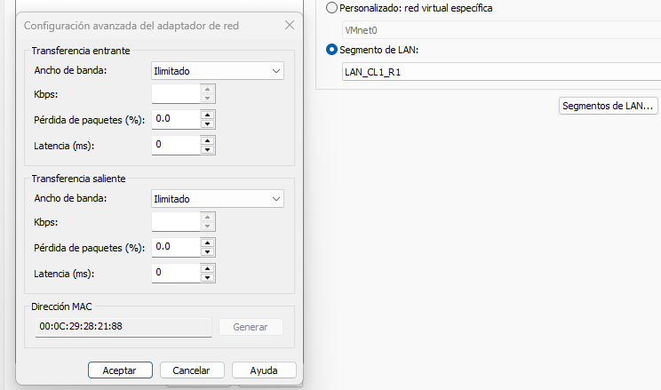
- Ens33: LAN_CL1_R1
- Ens37: LAN_R1_R2
- Ens38: LAN_R1_R3

Network configuration (based on the design):
- Configurate Netplan.
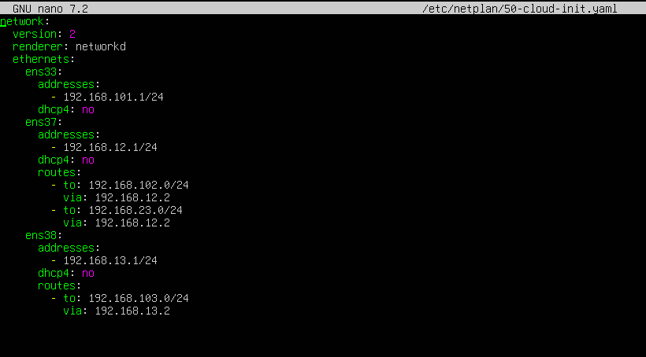
- Apply the configuration Netplan apply.
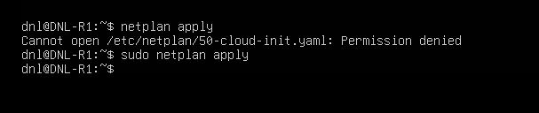
- Check the configuration
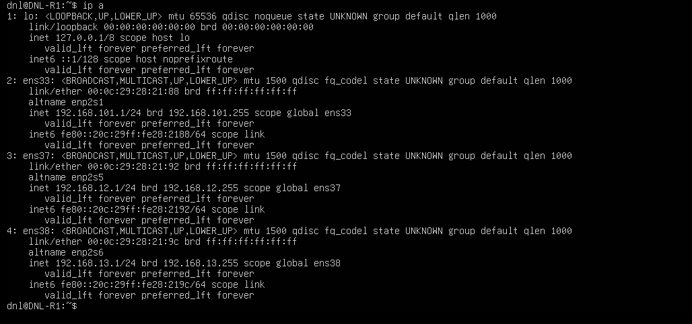

Ubuntu Server (DNL-RT2)

Verify each Network Adapter:
- Ip -br link | grep ens
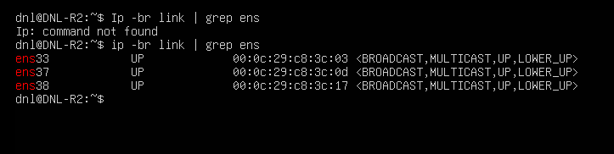
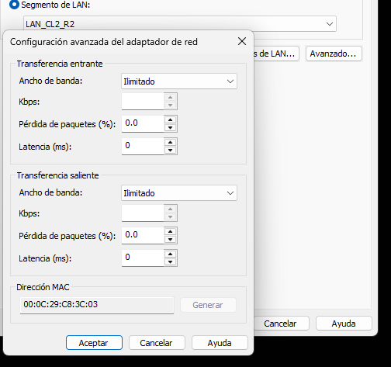
- Ens33: LAN_CL2_R2
- Ens37: LAN_R1_R2
- Ens38: LAN_R2_R3

Network configuration (based on the design):
- Configurate Netplan.
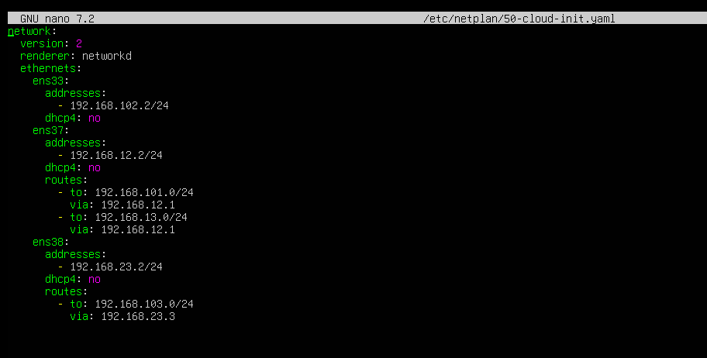
- Apply the configuration Netplan apply.
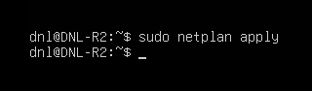
- Check the configuration ip a.
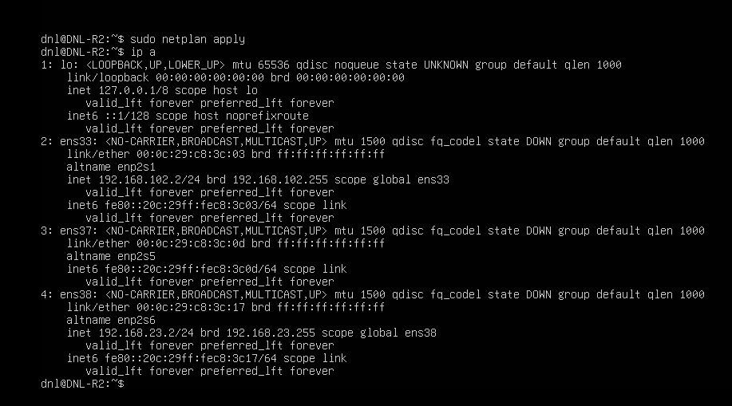

Ubuntu Server (DNL-RT3)

Verify each Network Adapter:
- Ip -br link | grep ens
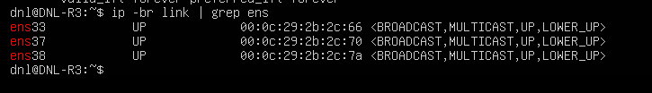
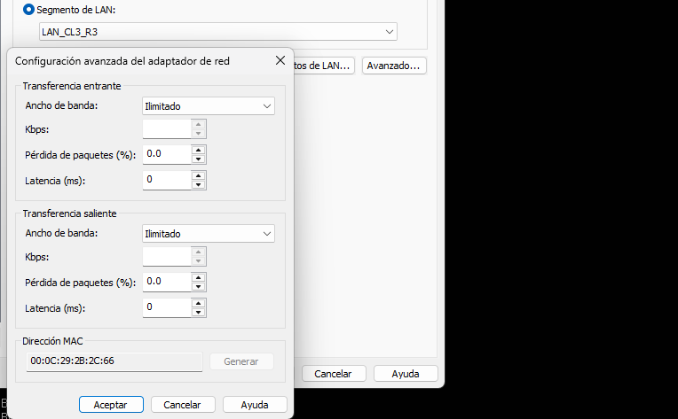
- Ens33: LAN_CL3_R3
- Ens37: LAN_R1_R3
- Ens38: LAN_R2_R3

Network configuration (based on the design):
- Configurate Netplan.
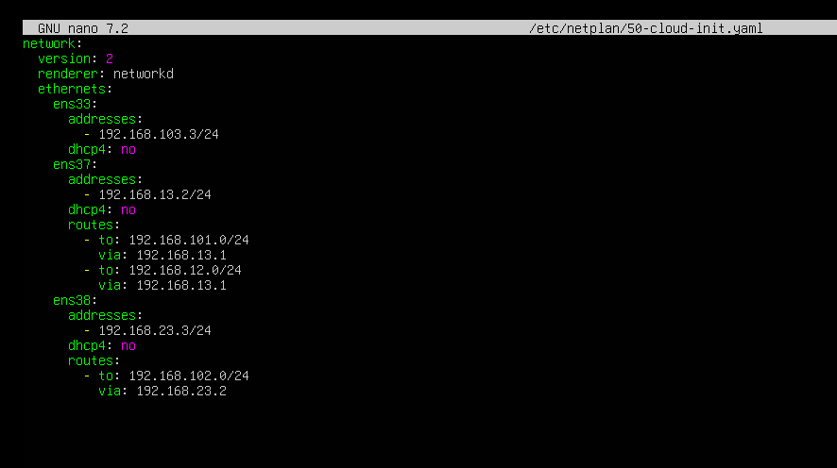
- Apply the configuration Netplan apply.
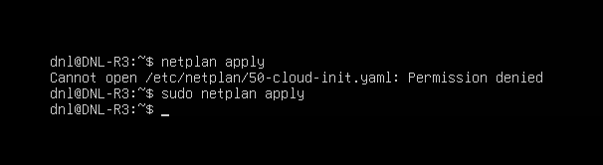
- Check the configuration ip a.
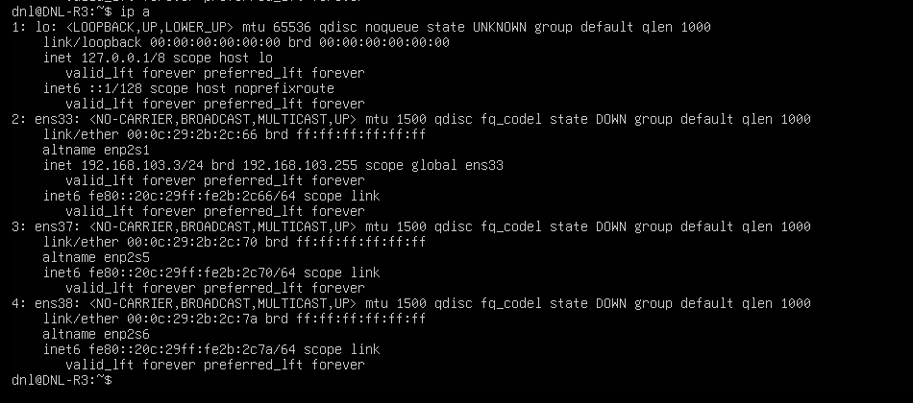

Core Routing and Security Configuration

We will configurate these parameters in the 3 routers.
Permanent IP Forwarding Activation:
- echo “net.ipv4.ip_forward=1” | sudo tee -a /etc/sysctl.conf
- This appends the configuration key to the system-wide runtime configuration file, ensuring that the Linux kernel retains its packet-forwarding capabilities permanently across reboots.
Kernel Parameter Application:
- sudo sysctl -p
- This forces the operating system to immediately load and apply the modifications made to the configuration file without requiring a system restart.
IP Forwarding Status Verification:
- sysctl net.ipv4.ip_forward
- This inspects the active memory state of the kernel, where a return value of 1 confirms that the node is ready to forward transit packets between network interfaces.
Firewall Deactivation:
- sudo ufw disable
- This shuts down the Uncomplicated Firewall, preventing default security chains from dropping incoming and outgoing diagnostic traffic across the ring subnets.
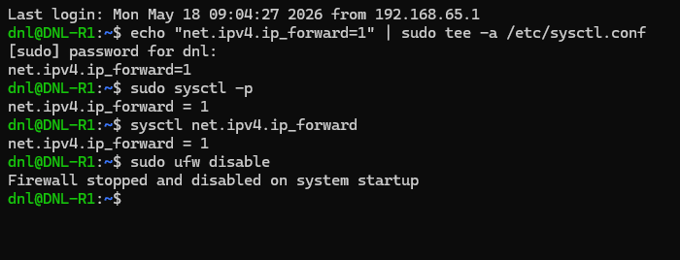

Connectivity Verification and Path Analysis

Gateway and Local Subnet Validation:
- ping -c 4 192.168.101.1
  - From DNL-CL1.
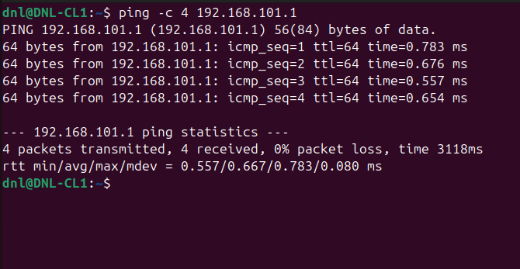
- ping -c 4 192.168.102.2
  - From DNL-CL2.
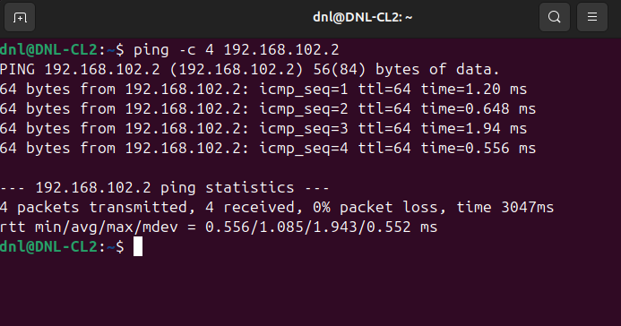

- ping -c 4 192.168.103.3
  - From DNL-CL3.
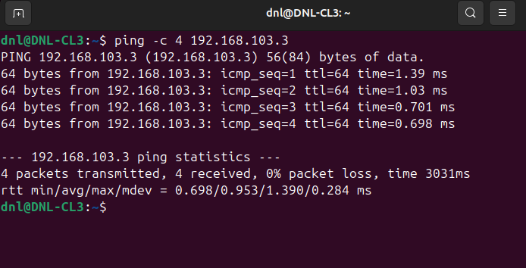
- This test verifies immediate Layer 2 and Layer 3 connectivity between each endpoint and its designated default gateway to ensure local interfaces are functional.

Remote Infrastructure Reachability:
- ping -c 4 192.168.12.2
- ping -c 4 192.168.23.3
  - From DNL-CL1.
- This checks if the local router successfully handles packets destined for transit links located further along the loop architecture.
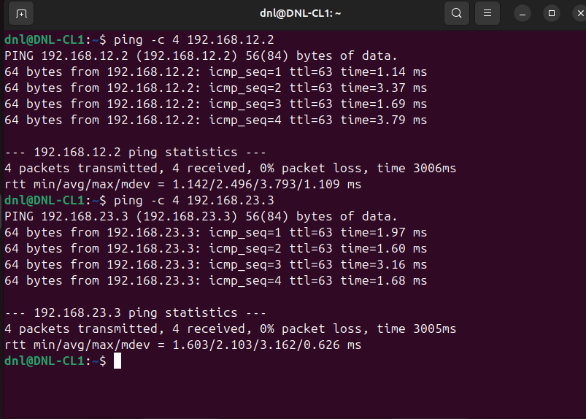

Inter-Subnet End-to-End Connectivity:
- ping -c 4 192.168.102.100
- ping -c 4 192.168.103.100
  - From DNL-CL1, repeating this cross-network matrix from DNL-CL2 and DNL-CL3.
- This confirms bidirectional data transit across the entire ring topology, proving that all intermediate routing tables possess correct entries for remote customer subnets.
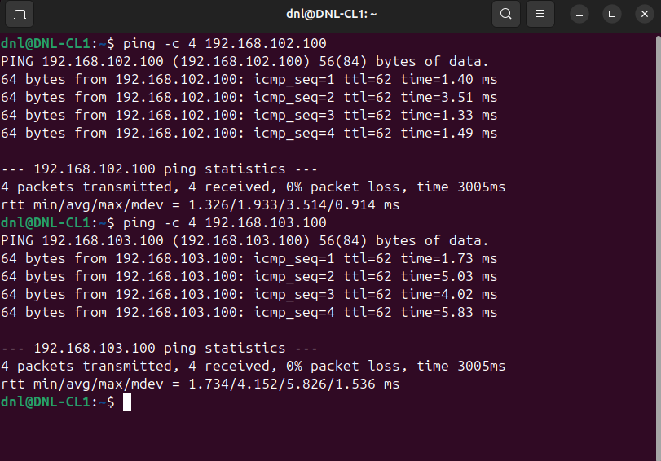

Multi-Hop Path Trajectory Analysis:
- traceroute 192.168.103.100
  - From DNL-CL1 and analyze the output layout.
- This tool tracks the precise path taken by packets through the ring network, exposing the intermediate routing hops and confirming the directional traffic flow.
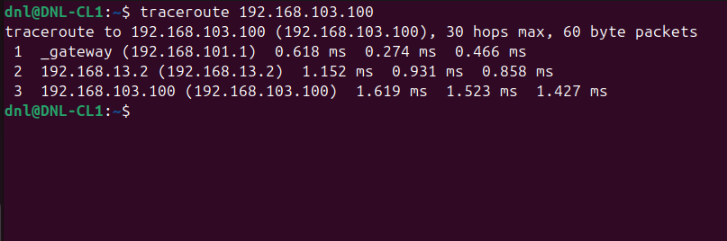
Route Asymmetry and Return Verification:
- traceroute 192.168.101.100
- From DNL-CL3 to map the symmetrical or asymmetrical return path back to the origin.
- This reveals if the traffic loops back through the same interfaces or travels clockwise/counter-clockwise through the ring, validating routing consistency.
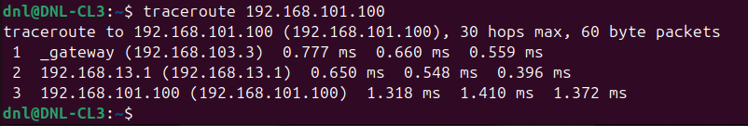
Router-Initiated Diagnostic Exclusion:
- We will omit comprehensive ping matrices directly from the console of DNL-RT1, DNL-RT2, or DNL-RT3.
- Testing directly from the endpoints is sufficient because successful client-to-client traffic inherently verifies that all routing nodes are processing, forwarding, and returning data accurately.

Conclusion

Infrastructure and Connectivity

Virtual Segmentation:
- The isolation of traffic using distinct virtual network switches successfully simulated independent broadcast domains for each client subnet and point-to-point transit link.
Declarative Management:
- Netplan YAML manifests allowed for precise, permanent assignment of IP addresses and static route blocks across multi-homed interfaces (ens33, ens37, ens38).
Gateway Reliance:
- Configuring the local router's address as the default gateway on endpoint nodes successfully enabled workstations to exit their local segments and target remote subnets.

System Functionality and Kernel Services

IP Forwarding:
- Activating net.ipv4.ip_forward permanently via sysctl.conf successfully modified the Linux kernel behavior from a standard host to a Layer 3 packet-forwarding engine.
Deterministic Pathing:
- The manually defined static routing entries allowed each router to establish next-hop logic for remote client networks not physically attached to its interfaces.
Security Mitigation:
- Disabling the Uncomplicated Firewall (UFW) eliminated default dropping rules, ensuring that diagnostic traffic could pass across intermediate nodes without restriction.

Traffic Analysis and Path Verification

End-to-End Validation:
- Multi-directional ICMP ping matrices confirmed total reachability, proving that the return paths from destination subnets were as structurally sound as the outbound paths.
Traceroute Hop Mapping:
- Utilizing traceroute provided definitive visual proof of packet transit, explicitly listing each intermediate software router interface crossed along the ring topology.
Topology Soundness:
- The experiment successfully proved that a loop architecture can remain highly stable and free of routing loops when next-hop metrics and paths are explicitly detailed in the configuration tables.

Routing table

