516-DaríoNL-PARP605-RoutersWINLinux
TAJAMAR | MADRID | 21/05/2026
Routers in Linux/Windows
PAR – Unit 6 – Routers Windows/LINUX

Index
Introduction 3
Design 5
Inventory 6
Execution 7
Environment preparation 7
Virtual machine basic configuration 9
Ubuntu Desktop (DNL-CL1, DNL-CL2) 9
Windows 10 (DNL-CL3) 11
Ubuntu Server (DNL-RT1) 12
Ubuntu Server (DNL-RT2) 14
Windows Server (DNL-RT3) 17
Router deployment DNL-RT3 21
Features Installation 21
Start router 23
Router configuration 24
Adding static routes 26
Core Routing and Security Configuration 29
Connectivity Verification and Path Analysis 30
Conclusion 36
Routing table 36

Introduction

This laboratory focuses on the technical deployment, configuration, and verification of a virtualized network infrastructure organized in a redundant ring topology using a hybrid environment of GNU/Linux and Windows systems.
By interconnecting two multi-homed Linux instances and one Windows Server instance acting as software routers (DNL-RT1, DNL-RT2, and DNL-RT3) in a closed-loop framework, the network architecture provides reliable transit pathways to bridge three physically isolated client subnets (DNL-CL1, DNL-CL2, and DNL-CL3).
The operational core of this infrastructure involves the implementation of precise static routing policies via declarative Netplan configurations and kernel-level IP forwarding for the Linux nodes, combined with the Routing and Remote Access Service (RRAS) for the Windows routing node.
Through this structural design, path trajectory, route asymmetry, and multi-hop packet-forwarding logic are systematically analyzed using diagnostic cross-platform utilities such as ICMP ping, traceroute, and tracert, validating a resilient and scalable enterprise-grade network design without relying on dedicated hardware routing components.

Static Routes:
- Static routing manually establishes network paths to direct packets toward specific destination subnets.
- The structural implementation differs based on the underlying operating system. In GNU/Linux systems, routes are defined declaratively via Netplan, integrating next-hop instructions directly within the YAML configuration files of each network interface.
- In Windows Server systems, routes are applied imperatively using PowerShell commands, such as New-NetRoute, or through the Routing and Remote Access Service (RRAS) console, managing the system's routing table as an operational component independent of the initial IP address assignment of the adapters.

Design
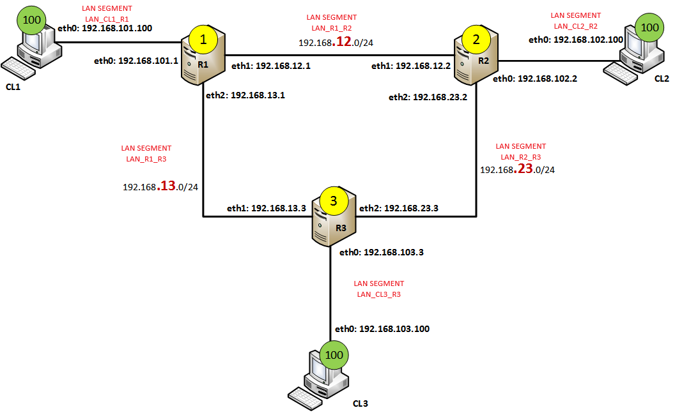

Inventory

For the realization of the laboratory, we have used:
- Hardware:
  - Host PC.
- Software:
  - Utilities:
    - Linux Network Configuration Tools (iproute2
    - Linux Network Diagnostic Tools (ping, traceroute).
    - Virtual Network Editor.
    - Routing and Remote Access Service (RRAS).
    - Windows Network Diagnostic Tools (ping, tracert).
    - Command Line Interfaces (Bash, PowerShell, CMD).
  - VMware:
    - ubuntu-24.04.3-live-server-amd64.
    - ubuntu-24.04.2-desktop-amd64.
    - Windows 10.
    - Windows Server 2022.

Execution

Environment preparation

We will use 2 clients (Ubuntu Desktop), 1 client (Windows 10), 2 routers (Ubuntu Server) and 1 router (Windows Server 2022) with their respective naming conventions.
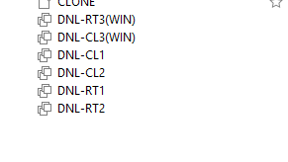
Creation of LAN Segments:
- Go to “Settings” of any VM.
- Network Adapter LAN Segment Add.
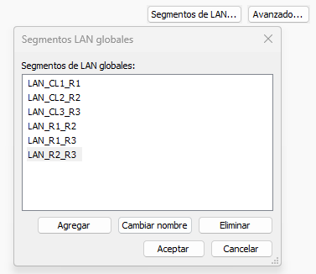
Network adapters:
- DNL-RT1:
  - LAN_CL1_R1
  - LAN_R1_R2
  - LAN_R1_R3
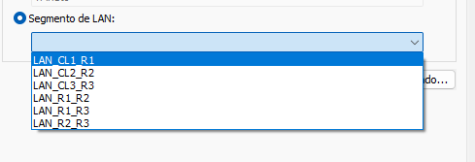
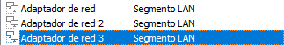
- DNL-RT2:
  - NAT
  - LAN_CL2_R2
  - LAN_R1_R2
  - LAN_R2_R3
- DNL-RT3:
  - NAT
  - LAN_CL3_R3
  - LAN_R1_R3
  - LAN_R2_R3
- DNL-CL1: LAN_CL1_R1
- DNL-CL2: LAN_CL2_R2
- DNL-CL3: LAN_CL3_R3

Virtual machine basic configuration

Ubuntu Desktop (DNL-CL1, DNL-CL2)

Name and Network Interfaces

We will change de name of the clients to dictate a nomenclature in accordance with what has been established.
Additionally, we will configure de Network Parameters.
Change name:
- sudo hostnamectl set-hostname NEW_NAME
- Edit: /etc/hosts
DNL-CL1:
- IP: 192.168.101.100
- MASK: 255.255.255.0
- DG: 192.168.101.1
- DNS: Empty
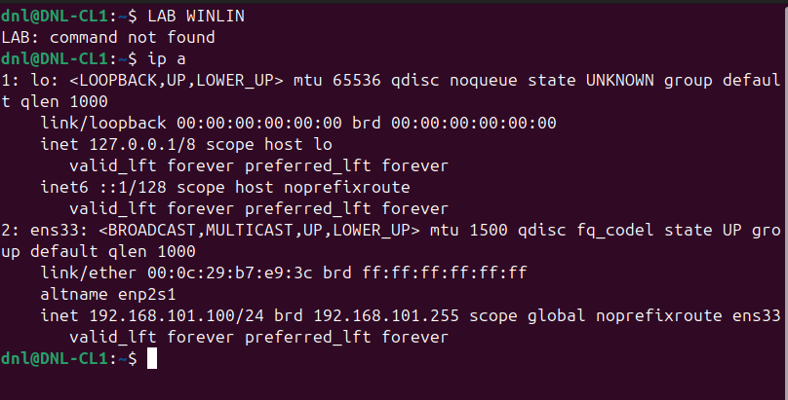

DNL-CL2:
- IP: 192.168.102.100
- MASK: 255.255.255.0
- DG: 192.168.102.2
- DNS: Empty
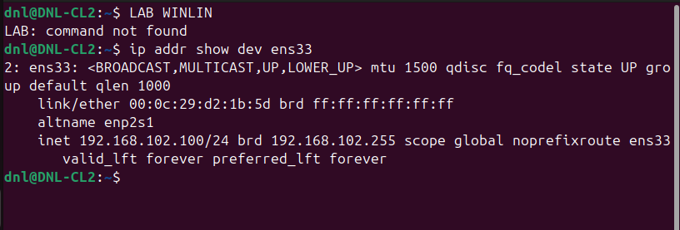

Windows 10 (DNL-CL3)

Name and Network Interfaces

DNL-CL3:
- IP: 192.168.103.100
- MASK: 255.255.255.0
- DG: 192.168.103.3
- DNS: Empty
- Firewall: Off
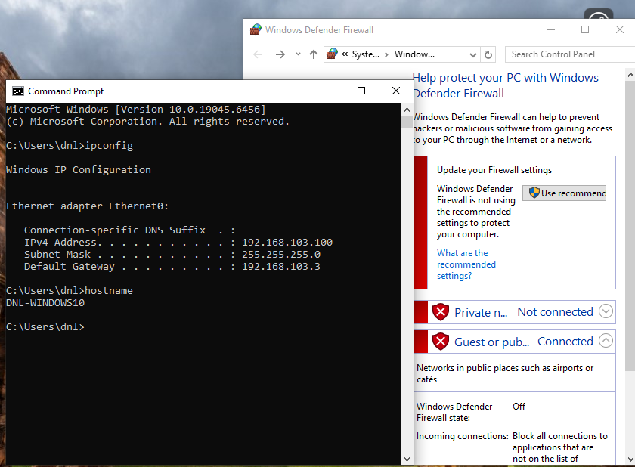

Ubuntu Server (DNL-RT1)

Verify each Network Adapter:
- Ip -br link | grep ens
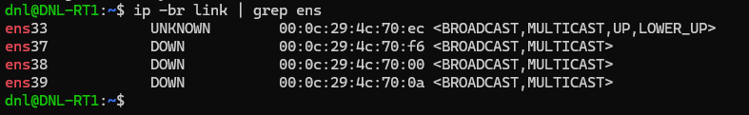
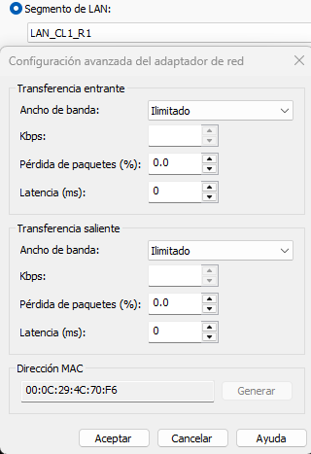

- Ens33: NAT (test and installations)
- Ens37: LAN_CL1_R1
- Ens38: LAN_R1_R2
- Ens39: LAN_R1_R3

Network configuration (based on the design):
- Configurate Netplan.
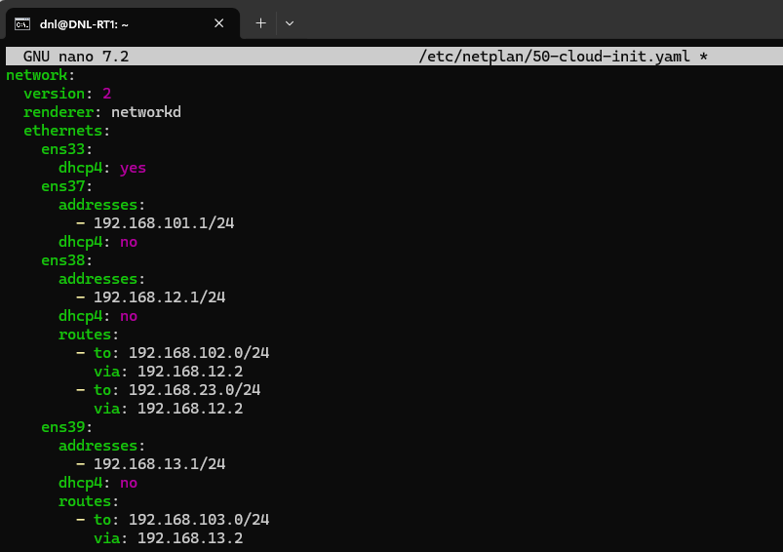
- Apply the configuration Netplan apply.
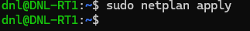
- Check the configuration ifconfig.
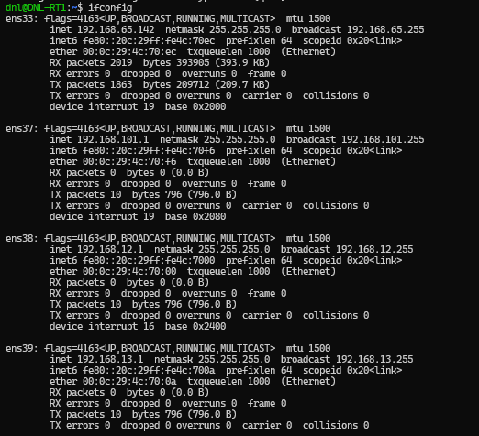

Ubuntu Server (DNL-RT2)

Verify each Network Adapter:
- Ip -br link | grep ens
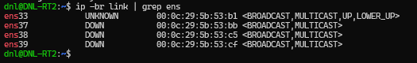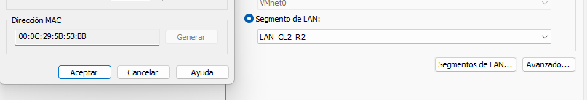
- Ens33: NAT (test and installations)
- Ens37: LAN_CL2_R2
- Ens38: LAN_R1_R2
- Ens39: LAN_R2_R3

Network configuration (based on the design):
- Configurate Netplan.
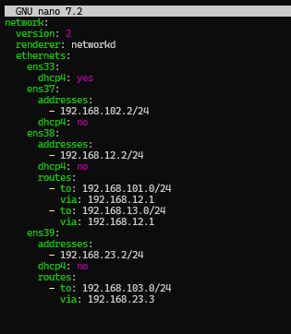
- Apply the configuration Netplan apply.
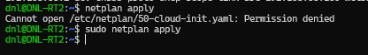

- Check the configuration ip a / ip route show.
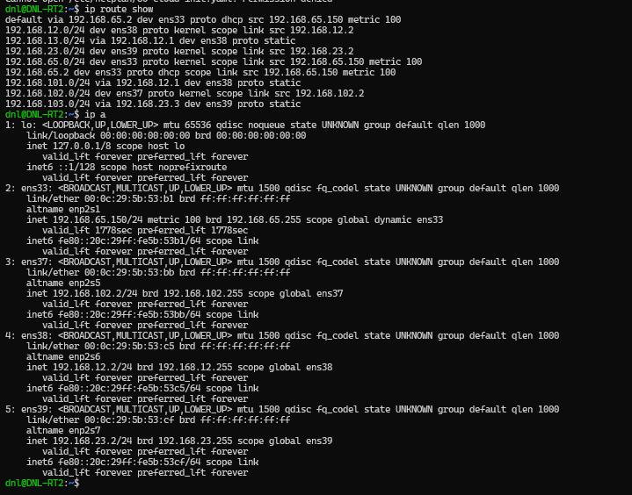

Windows Server (DNL-RT3)

Network Adapters (MAC)

We will identify each network card using:
- In Power Shell:
  - getmac /v
    - With this we will see the MAC of each interface.
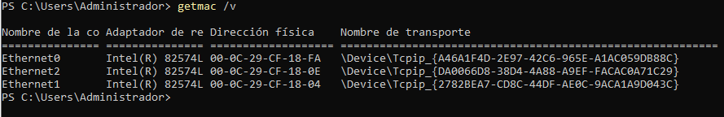
- In the settings of the VM:
  - Network Adapter Advanced MAC.
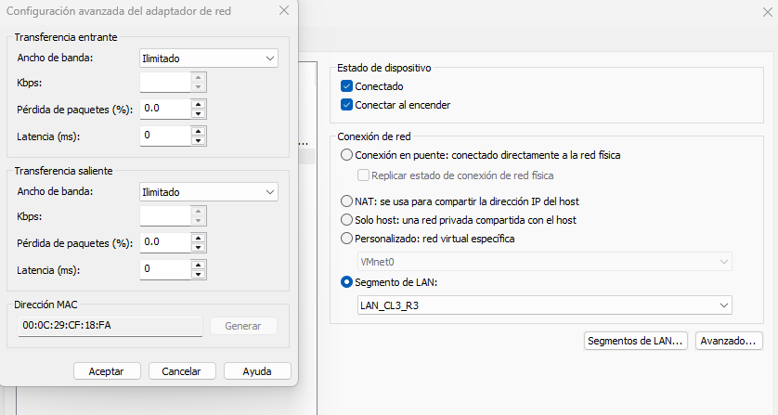

Now we can compare and know which Network adapter is each interface:
- Network Adapter (LAN_CL3_R3) Ethernet 0.
- Network Adapter 2 (LAN_R1_R3) Ethernet 1.
- Network Adapter 3 (LAN_R2_R3) Ethernet 2.

Network Interfaces (IP)

Finally, for this basic configuration on the server, we will configurate the IP parameters (Level 3):
Desactivate Firewalls.
- Ethernet 0, LAN_CL3_R3:
  - IP: 192.168.103.3
  - Mask: 255.255.255.0
  - Gateway: Empty
  - DNS: Empty
  - Desactivate IPv6
- Ethernet 1, LAN_R1_R3:
  - IP: 192.168.13.2
  - Mask: 255.255.255.0
  - Gateway: Empty
  - DNS: Empty
  - Desactivate IPv6.

- Ethernet 2, LAN_R2_R3:
  - IP: 192.168.23.3
  - Mask: 255.255.255.0
  - Gateway: Empty
  - DNS: Empty
  - Desactivate IPv6.
PowerShell:
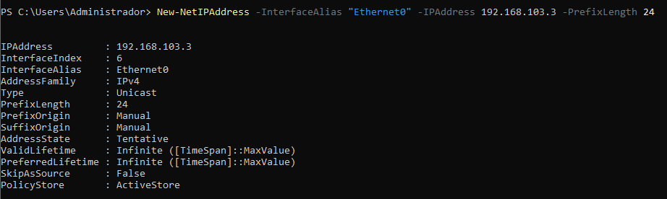
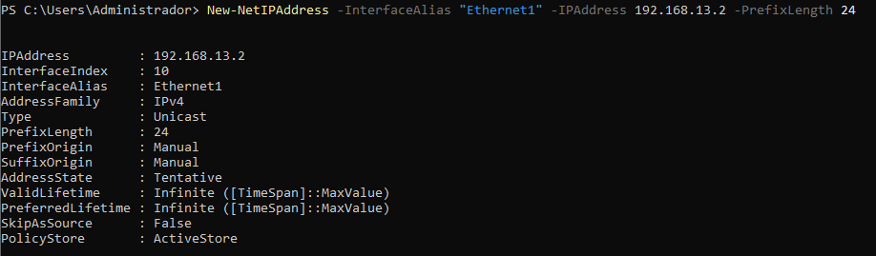
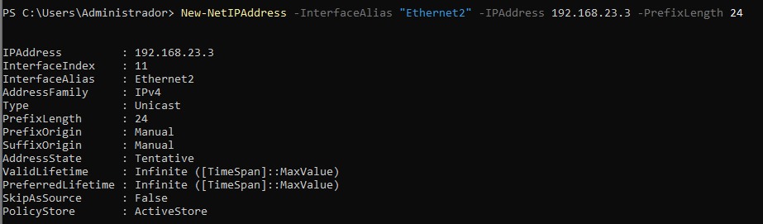

Check:
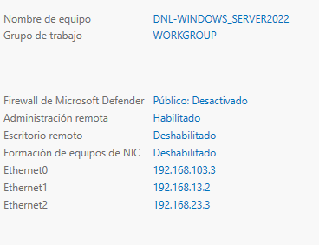

Router deployment DNL-RT3

Features Installation

We will go to the server, to the administrator section, and click on “Add roles and features”.
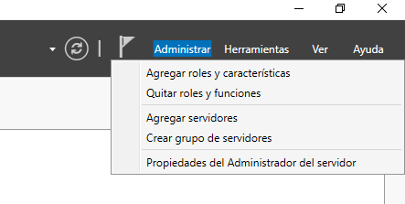
We'll select all default settings until we reach “Server Roles”.
Here we will add “Remote Access”.
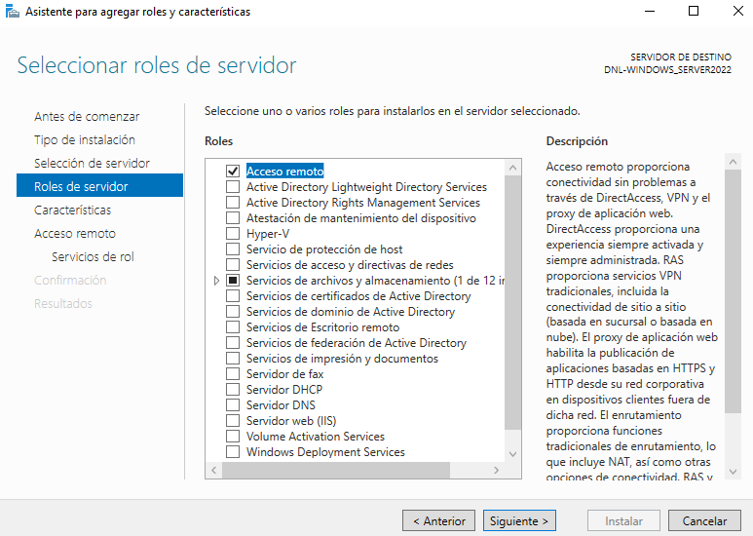

Now we have to go directly to role services and check “Routing”.
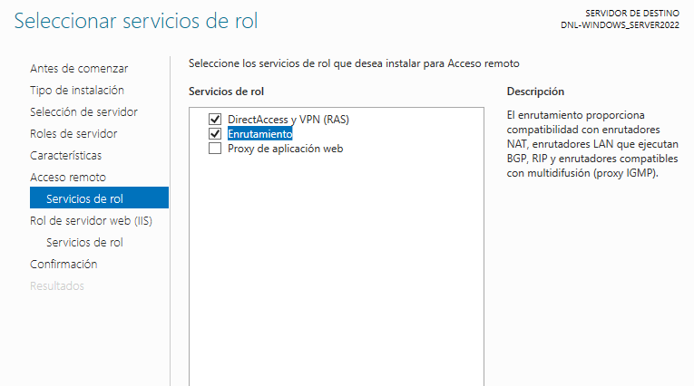
Once we have assigned the role to the server and the routing service, we can proceed directly to the installation.
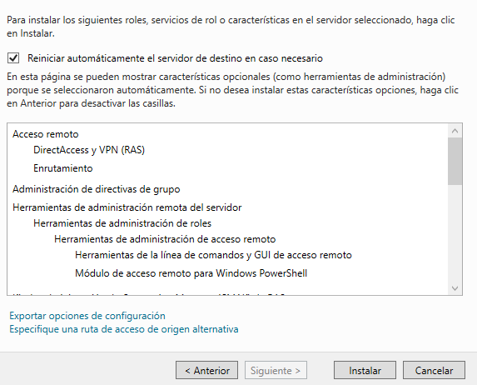

Start router

Once installed, we proceed to initialize the router.
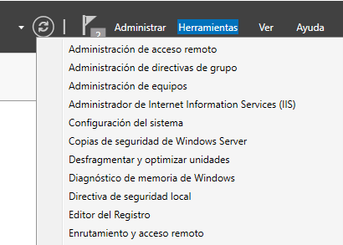
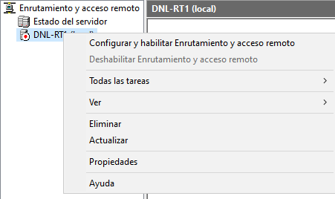

Router configuration

We will configure the router in a customized way.
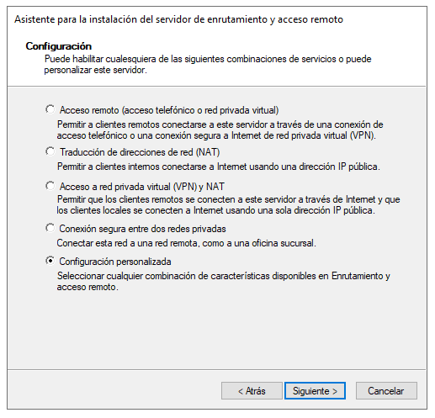
We only checked the “LAN Routing” box, and we finish the assistant.
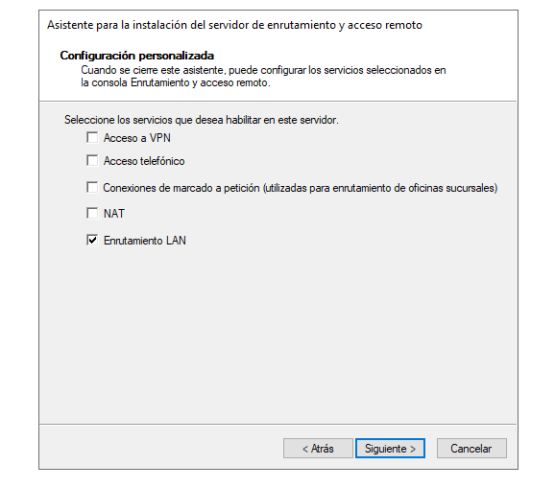
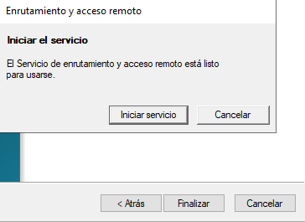
Now we have the router working.
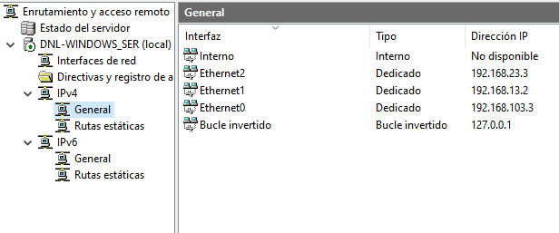

Adding static routes

We will add these routes in PowerShell.
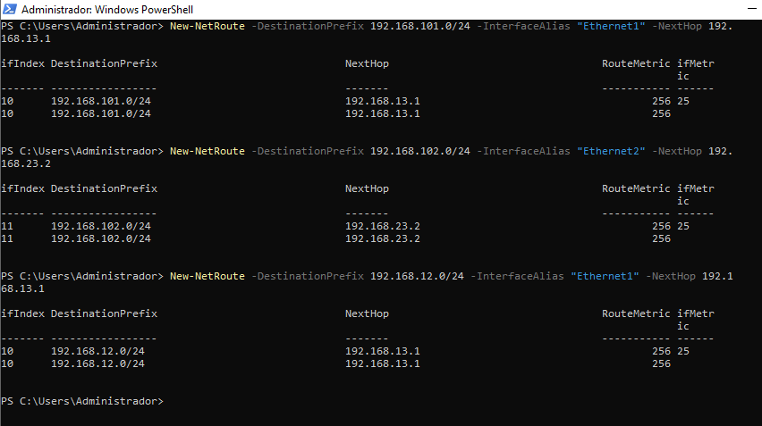

Route print analysis:
- Directly Connected Networks (On-link):
  - The destination 192.168.13.0/24 operates directly over the local interface 192.168.13.2.
  - The destination 192.168.23.0/24 operates directly over the local interface 192.168.23.3.
  - The destination 192.168.103.0/24 operates directly over the local interface 192.168.103.3.
- Active Static Routes:
  - Packets destined for the remote 192.168.12.0/24 network are routed through the next-hop gateway 192.168.13.1.
  - Packets destined for the remote 192.168.101.0/24 network are routed through the next-hop gateway 192.168.13.1.
  - Packets destined for the remote 192.168.102.0/24 network are routed through the next-hop gateway 192.168.23.2.
- Persistent Routes:
  - The manually defined paths to 192.168.12.0, 192.168.101.0, and 192.168.102.0 are explicitly saved in the system.
  - These specific routing rules survive system reboots and apply automatically on startup.
  - The structure of these routes corresponds to the DNL-RT3 configuration parameters within the ring topology architecture.

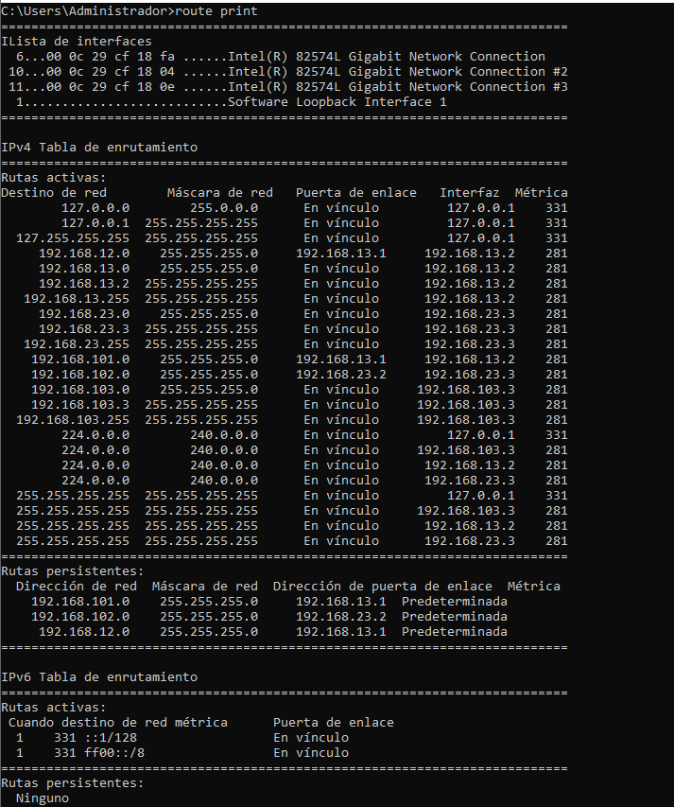

Core Routing and Security Configuration

We will configurate these parameters in the 2 routers ubuntu server.
Permanent IP Forwarding Activation:
- echo “net.ipv4.ip_forward=1” | sudo tee -a /etc/sysctl.conf
- This appends the configuration key to the system-wide runtime configuration file, ensuring that the Linux kernel retains its packet-forwarding capabilities permanently across reboots.
Kernel Parameter Application:
- sudo sysctl -p
- This forces the operating system to immediately load and apply the modifications made to the configuration file without requiring a system restart.
IP Forwarding Status Verification:
- sysctl net.ipv4.ip_forward
- This inspects the active memory state of the kernel, where a return value of 1 confirms that the node is ready to forward transit packets between network interfaces.
Firewall Deactivation:
- sudo ufw disable
- This shuts down the Uncomplicated Firewall, preventing default security chains from dropping incoming and outgoing diagnostic traffic across the ring subnets.
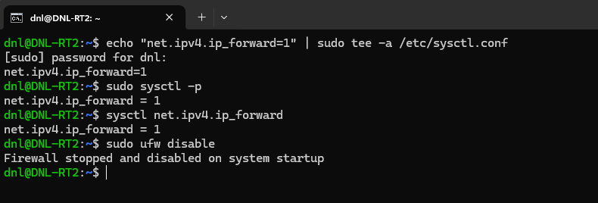

Connectivity Verification and Path Analysis

Gateway and Local Subnet Validation:
- ping -c 4 192.168.101.1
  - From DNL-CL1.
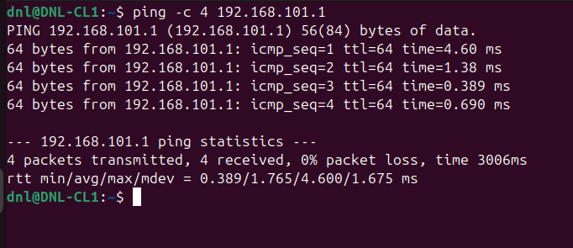
- ping -c 4 192.168.102.2
  - From DNL-CL2.
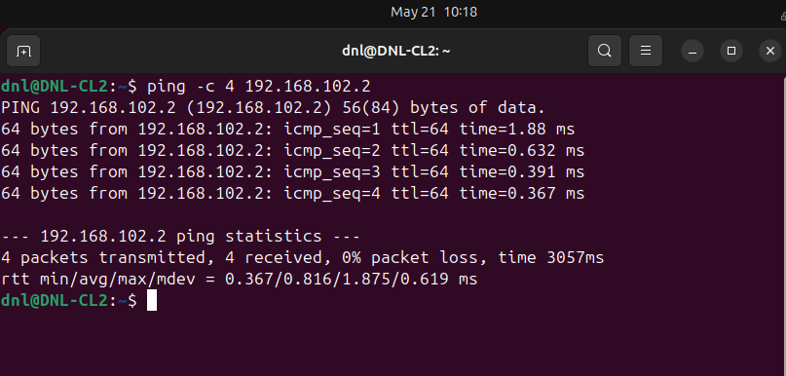

- ping 192.168.103.3
  - From DNL-CL3.
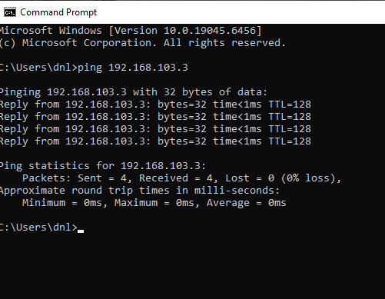
- This test verifies immediate Layer 2 and Layer 3 connectivity between each endpoint and its designated default gateway to ensure local interfaces are functional.

Remote Infrastructure Reachability:
- Ping 192.168.12.2
- ping 192.168.12.3
  - From DNL-CL3.
- This checks if the local router successfully handles packets destined for transit links located further along the loop architecture (specifically the remote LAN_R1_R2 segment).
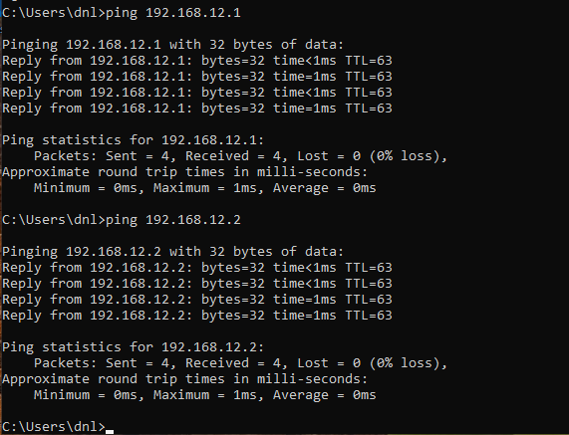

Inter-Subnet End-to-End Connectivity:
- ping -c 4 192.168.102.100
- ping -c 4 192.168.103.100
  - From DNL-CL1, repeating this cross-network matrix from DNL-CL2 and DNL-CL3.
- This confirms bidirectional data transit across the entire ring topology, proving that all intermediate routing tables possess correct entries for remote customer subnets.
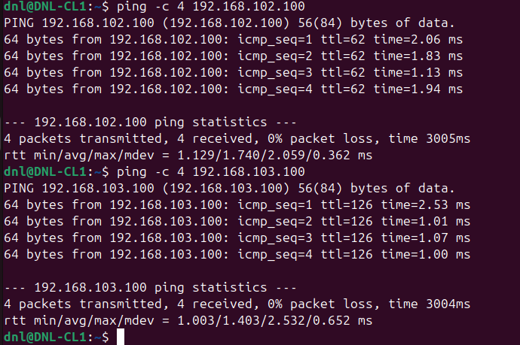
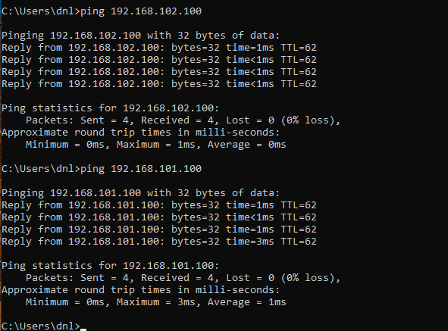

Multi-Hop Path Trajectory Analysis:
- traceroute 192.168.103.100
  - From DNL-CL1 and analyze the output layout.
- This tool tracks the precise path taken by packets through the ring network, exposing the intermediate routing hops and confirming the directional traffic flow.
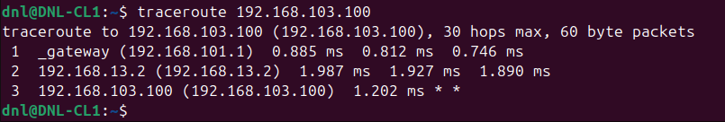
Route Asymmetry and Return Verification:
- tracert -d 192.168.101.100
- From DNL-CL3 to map the symmetrical or asymmetrical return path back to the origin.
- This reveals if the traffic loops back through the same interfaces or travels clockwise/counter-clockwise through the ring, validating routing consistency.
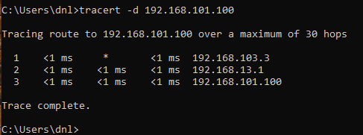
Router-Initiated Diagnostic Exclusion:
- We will omit comprehensive ping matrices directly from the console of DNL-RT1, DNL-RT2, or DNL-RT3.
- Testing directly from the endpoints is sufficient because successful client-to-client traffic inherently verifies that all routing nodes are processing, forwarding, and returning data accurately.

Conclusion

System Interoperability:
- The integration of GNU/Linux and Windows Server routing nodes within a redundant ring topology is fully functional at Layer 3.
Static Route Management:
- The implementation of network policies demonstrates the operational equivalence between declarative Netplan methods in Ubuntu and imperative PowerShell commands in Windows.
Firewall Impact:
- The modification or deactivation of UFW and Windows Defender Firewall is a mandatory technical requirement to allow the transit and return of ICMP packets through intermediate routers.
Diagnostic Trace Divergence:
- Connectivity validation highlighted the structural differences between traceroute in Linux environments and tracert in Windows environments, requiring security adaptations to manage ICMP "Time Exceeded" messages.
Infrastructure Viability:
- The design validates the capability to build scalable, asymmetrical, and multi-hop enterprise network environments using general-purpose software without dedicated network hardware.

Routing table

