516-DaríoNL-ISOP403-ICS_Win_Linux
TAJAMAR | MADRID | 14/04/2026
ICS
ISO – Unit 4 – ICS Win-linux

Contenido
Introduction 3
Roadmap 3
Theoretical Framework 4
Inventory 5
Execution 6
Phase I: Windows Host Preparation 6
Identification of Network Adapters 6
ICS Activation in Windows 7
Phase II: Node Interconnection 9
Phase IV: Verification and Diagnostics 10
Conclusion 14

Introduction

This laboratory implements a network architecture where a Windows host functions as a gateway to provide internet connectivity to a Linux client.
The primary objective is to manage two distinct network interfaces while ensuring seamless traffic flow between different operating systems.
This exercise validates the practical application of manual TCP/IP administration and the ability to establish cross-platform interoperability in a virtualized environment.

Roadmap

Phase I: Windows Host Preparation:
- Identification of network adapters and activation of the ICS service on the interface with Internet access.
Phase II: Node Interconnection:
- Linking both systems to the same virtual network segment to establish Layer 2 communication.
Phase III: Linux Client Configuration:
- The IP address, subnet mask, DNS and default gateway will be assigned dynamically via DHCP provided by ICS on the Windows host.
Phase IV: Verification and Diagnostics:
- Execution of sequential ICMP tests to confirm local connectivity, external routing, and domain resolution.

Theoretical Framework

Internet Connection Sharing (ICS) is a native Windows feature designed to provide Network Address Translation (NAT) services to clients on a local network.
When ICS is activated on an interface with internet access, the host machine assumes the roles of a router and a transparent DNS proxy, translating internal private requests into valid external traffic.
This service facilitates the sharing of a single wide-area connection across multiple devices without the need for specialized routing hardware.
NAT Operation:
- Mapped private local addresses are translated to the host's public-facing IP for external communication.
Service Integration:
- The host provides simplified DHCP services and DNS forwarding to all clients within the shared segment.
Interface Requirements:
- The architecture necessitates at least two active network adapters to segregate external input from local distribution.
Protocol Support:
- ICS manages the redirection of standard TCP/IP traffic, enabling full browsing capabilities for subordinate nodes.

Inventory

For the realization of the laboratory we have used:
- Hardware:
  - Host PC.
- Software:
  - Windows 11.
  - Ubuntu Desktop 24.04.2.

Execution

Phase I: Windows Host Preparation

The initial phase focuses on identifying the virtual hardware and configuring the host operating system to function as a network gateway using Internet Connection Sharing (ICS).

Identification of Network Adapters

For initialize the laboratory we have to work with the VM Network Adapters.
For this we go to Settings Network Adpter.
- Adapter 1 (NAT):
  - Identified as the primary interface providing external internet access to the host machine.
- Adapter 2 (VMnet3):
  - Identified as the internal interface designated for the private local network segment.

- Verification:
  - Use the ipconfig command in the terminal to confirm the current status and naming of both adapters.
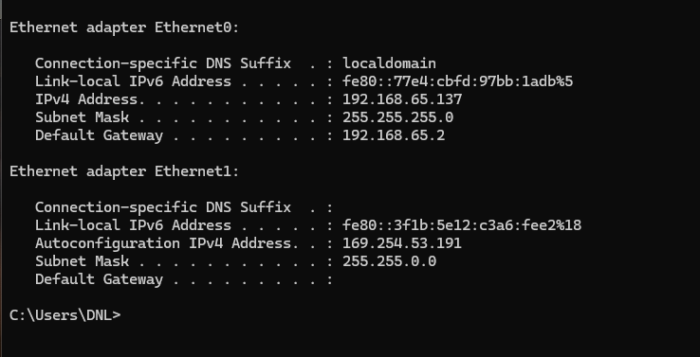

ICS Activation in Windows

Now we procced to activate the ICS in the first adapter (NAT):
- Access Properties:
  - Open the Network Connections (Control Panel)
  - Left-click the NAT adapter (Ethernet0), and select Properties.
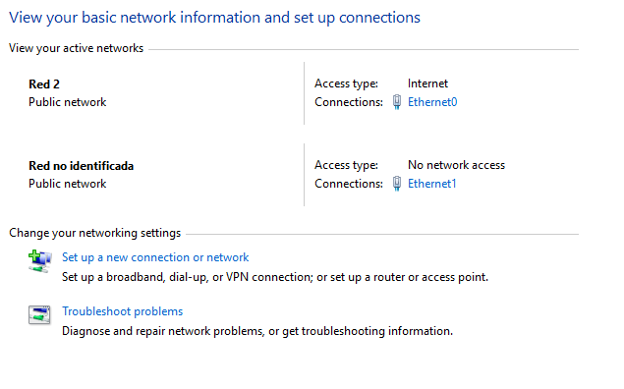
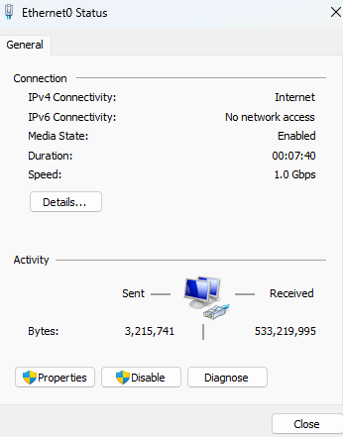
- Sharing Configuration:
  - Navigate to the Sharing tab within the adapter properties window.
- Enable Service:
  - Check the box labeled "Allow other network users to connect through this computer's Internet connection".
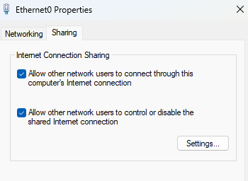
- Target Selection:
  - This is automatic when we only have two adapters.
Static IP Assignment (VMnet3):
- Upon activating Internet Connection Sharing (ICS) on the primary interface, the system automatically assigns the static IP 192.168.137.1
- We ensure that the Default Gateway and DNS fields remain empty, as this machine now serves as the entry point for the local network.
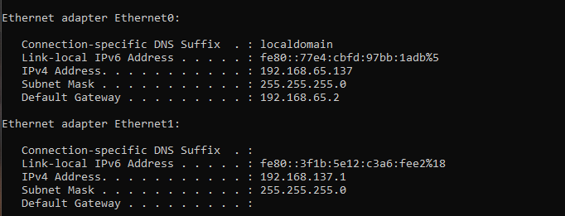

Phase II: Node Interconnection

We access the virtual machine settings for the Linux client within the hypervisor.
The network adapter is configured to use the Custom (VMnet3) virtual switch.
This selection ensures both the Windows host and the Linux client reside on the same isolated Layer 2 segment.
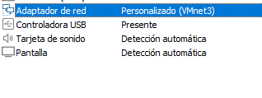
The Linux client receives its network configuration automatically through ICS (Internet Connection Sharing) enabled on the Windows host.
As shown in the following capture, the system is assigned the IP address 192.168.137.121 with the corresponding subnet mask, and the default gateway is set to 192.168.137.1, which is the IP address of the Windows machine previously verified. Also de DNS is assigned by Windows.
This confirms that the Windows host is correctly providing DHCP and routing services to the Linux client.
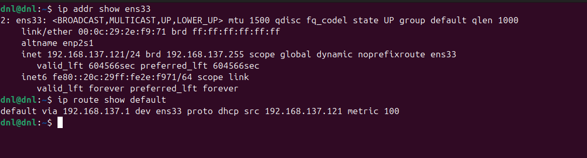
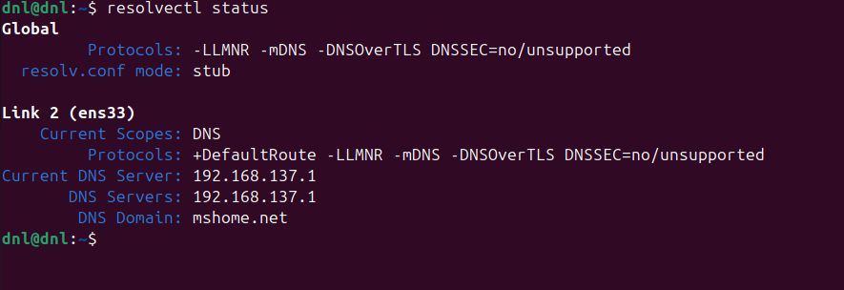

Phase IV: Verification and Diagnostics

In this section we are going to do the execution of sequential ICMP tests to confirm local connectivity, external routing, and domain resolution.
Restart Network Service:
- Command:
  - sudo systemctl restart NetworkManager
- Explanatiom:
  - Restarts the network service to ensure the client requests a fresh IP configuration from the ICS DHCP service on the Windows host.
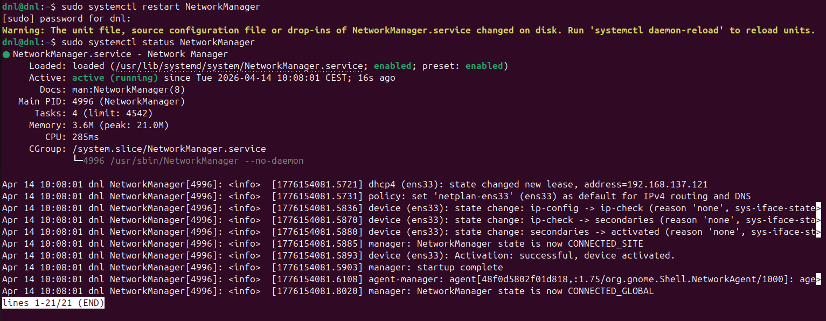

Test Local Connectivity (ICMP):
- Command:
  - ping 192.168.137.1
- Explanation:
  - Sends ICMP echo requests to the Windows host.
  - Successful replies confirm local network connectivity between the Linux client and the ICS server.
  - We had to desactivate the Windows Firewall or create a speciffic rule to allow the ICMP protocol (like we had learned in the previous laboratory).
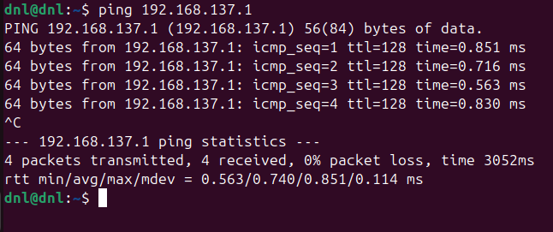

Test External Connectivity (ICMP):
- Command:
  - ping 8.8.8.8
- Explanation:
  - Tests connectivity to an external IP address.
  - Confirms that routing and NAT through ICS are functioning correctly.
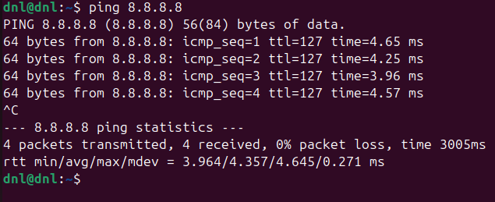
Test DNS Resolution:
- Command:
  - ping google.com
- Explanation:
  - Verifies domain name resolution. If successful, it confirms that DNS is correctly configured via ICS.
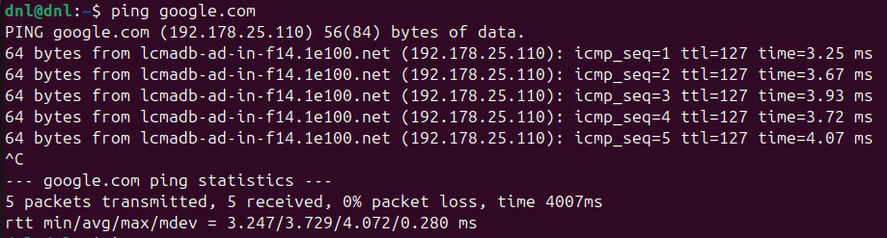

Traceroute Verification of ICS and NAT Routing Path:
- Command:
  - traceroute 8.8.8.8
- Explanation:
  - Displays the route taken by packets to reach the external DNS server 8.8.8.8.
  - The first hop shows the Windows ICS interface, confirming that traffic is being forwarded through Internet Connection Sharing.
  - The next hop passes through the VMware NAT gateway (192.168.65.2), after which the route continues through the normal external ISP routing path toward Google’s network.
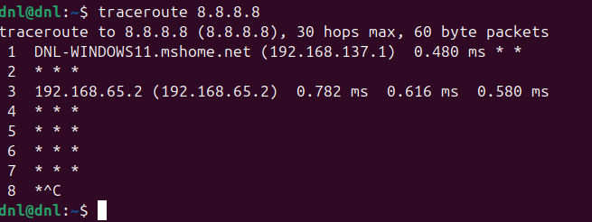

Conclusion

As a conclusion to this project, we successfully established a cross-platform network infrastructure that integrates Windows and Linux systems through standardized administration practices.
We validated the critical importance of manual TCP/IP configuration, edge security, and data availability to maintain a stable and professional environment.
By implementing Internet Connection Sharing (ICS), we demonstrated how a single host can effectively act as a secure gateway for isolated local segments, ensuring that connectivity and name resolution remain consistent across heterogeneous operating systems.

