516-DaríoNL-ISOP509_LVM
TAJAMAR | MADRID | 08/05/2026
LVM
ISO – Unit 5 –LVM

Contenido
Introduction 3
Introduction 3
Theoretical Framework 4
LVM Architecture and Components 4
Roadmap 5
Inventory 6
Execution 7
Phase I: Environment Preparation and Disk Virtualization 7
Phase II: LVM Structure Configuration (PV and VG) 10
Phase III: Logical Volume Management (LV) 15
Phase IV: Filesystem Implementation and Mounting 18
Phase V: Advanced Operations and Maintenance 21
Phase VI: Functional Testing and Delivery 26
Conclusion 28

Introduction

Introduction

This laboratory focuses on the implementation and management of a Logical Volume Manager (LVM) system within a GNU/Linux environment.
The primary objective is to establish an abstraction layer between physical hardware and filesystems, providing superior flexibility compared to traditional static partitioning.
Through this practice, the complete lifecycle of data management will be explored:
- From the virtualization of physical devices and resource aggregation into common pools.
- To the creation of dynamic logical volumes, snapshot management, and live data migration.
Storage Flexibility:
- Ability to resize volumes and add new disks to existing groups without service interruption.
Hardware Abstraction:
- Management of multiple physical units as a single logical storage entity.
Security and Availability:
- Implementation of state preservation techniques through snapshots and mirroring configurations.
Performance Optimization:
- Utilization of data distribution techniques (striping) to improve transfer rates.

Theoretical Framework

LVM Architecture and Components

Physical Volume (PV):
- A physical storage device (entire disk or partition) initialized for use by LVM. It acts as the foundational layer.
Volume Group (VG):
- An administrative unit that groups one or more Physical Volumes, creating a centralized pool of storage space.
Logical Volume (LV):
- A virtual partition created from the space available in a Volume Group. It is the entity that contains the filesystem and is mounted into the directory tree.
Physical Extent (PE):
- The smallest unit of allocation within a Physical Volume, typically 4MB in size.
Snapshot:
- A point-in-time copy of a logical volume used for backups or testing without risking the integrity of the original data.
Striping:
- A technique that spreads data across multiple physical volumes to increase performance through parallel access.

Roadmap

Phase I: Environment Preparation and Disk Virtualization:
- Installation of management tools, verification of kernel support, and creation of loop devices to simulate physical disks using image files.
Phase II: LVM Structure Configuration (PV and VG):
- Initialization of virtual devices as Physical Volumes and the creation/management of Volume Groups, including capacity expansion and reduction.
Phase III: Logical Volume Management (LV):
- Deployment of logical volumes with specific sizes based on direct units or extents, including the implementation of striped volumes.
Phase IV: Filesystem Implementation and Mounting:
- Formatting logical volumes with various filesystems (ext3, ReiserFS, JFS) and integrating them into the system's hierarchical directory structure.
Phase V: Advanced Operations and Maintenance:
- Resizing existing volumes, managing snapshot modules for state preservation, and executing data migrations between physical devices.
Phase VI: Functional Testing and Delivery:
- Validation of multiple filesystem types, execution of data modification tests compared against snapshots, and consolidation of technical documentation for final delivery.

Inventory

For the realization of the laboratory we have used:
- Hardware:
  - Host PC.
- Software:
  - Ubuntu Desktop 24.04.4 LTS

Execution

Phase I: Environment Preparation and Disk Virtualization

Software Deployment:
- Install the lvm2 package using the system package manager.
  - sudo apt install lvm2
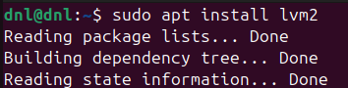
Kernel Verification:
- Check the current kernel version with:
  - uname -r
- And verify LVM module support via:
  - sudo dmsetup version
  - If it responds with the driver and library version, Device Mapper is working correctly.
- LVM relies on the dm_mod (Device Mapper) module.
- Without it, the operating system cannot map logical blocks to physical sectors.
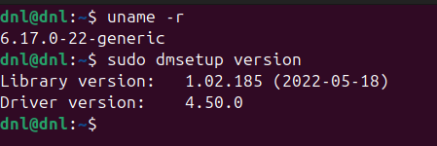
Image File Creation:
- Generate four 100MB virtual disk images using:
  - truncate -s 100M disk1.img
- Check the results:
  - ls -lh *.img
- Using image files and loop devices allows for the simulation of multiple physical hard drives within a single virtualized environment.
- Truncation creates files that report a specific size to the OS but only consume actual disk space as data is written, optimizing laboratory resources.
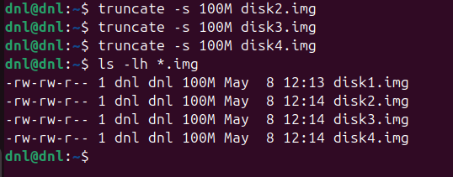

Loop Device Association:
- Map the created image files to the system's loopback interface using:
  - sudo losetup -fP disk1.img
- This process tricks the kernel into treating a standard file as a block device (/dev/loopX), making it eligible to be initialized as an LVM Physical Volume.
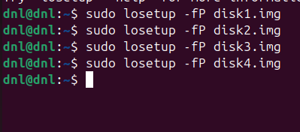
Device Confirmation:
- List all active loop devices with losetup -a to ensure the virtual hardware is correctly recognized by the OS.
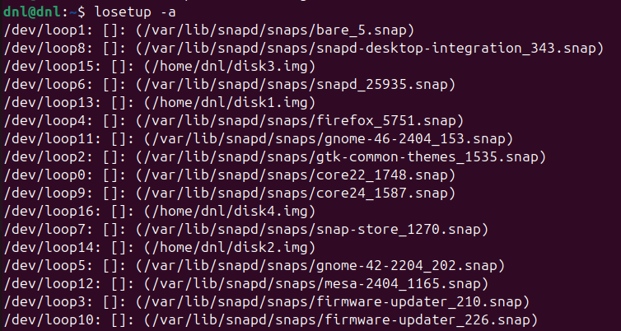
At this point, we have associated the image file with a loop device, allowing the file to behave as a physical storage drive.
Associations (for my case):
- DISK1: loop13 // DISK2: loop14.
- DISK3: loop15 // DISK4: loop16.

Phase II: LVM Structure Configuration (PV and VG)

Physical Volume (PV) Initialization:
- Run sudo pvcreate /dev/loopX /dev/loopX /dev/loopX /dev/loopX
  - De X depends of the /dev/loop assigned with the previous command.
- This command writes LVM metadata to the virtual devices, identifying them as “Physical Volumes.”
- It prepares the raw block devices to be integrated into the LVM management layer.
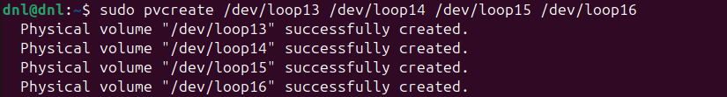
Volume Group (VG) Creation:
- Run sudo vgcreate vg_practice /dev/loop13 /dev/loop14
- This aggregates the first two physical volumes into a centralized pool of storage called a “Volume Group.”
- The system now treats these separate disks as a single administrative unit of storage.
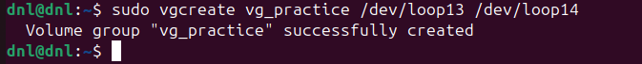

Volume Group Access Management (Activation/Deactivation):
- Use sudo vgchange -a n vg_practice to deactivate.
- And sudo vgchange -a y vg_practice to reactivate.
- Deactivating a group makes its logical volumes inaccessible to the kernel, which is a necessary safety step for certain maintenance tasks or when moving disks between systems.
- At this stage, no visible change will occur because the volume group does not yet contain any logical volumes.
- Therefore, there are no active filesystems or devices that the kernel can mount or unmount.
- The purpose of this step is purely to understand how activation and deactivation works at the Volume Group level.
- In the next phase, logical volumes will be created and mounted, where these commands will have a visible and functional effect.
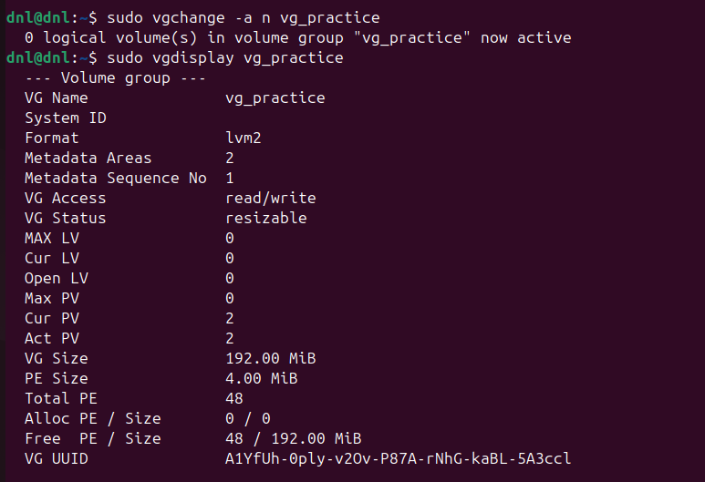

Capacity Expansion:
- Run sudo vgextend vg_practice /dev/loop15
- Later we will run sudo pvs to check the new integrates of the VG.
- This command seamlessly adds a third physical volume to the existing group, instantly increasing the total pool of available space without affecting any data already stored in the group.
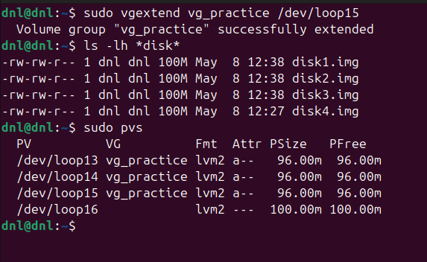

Status and Property Verification:
- Run pvs, vgs, pvdisplay, and vgdisplay
- These tools provide detailed reports on the health and allocation of the storage.
- pvs and vgs give quick summaries, while the display versions show technical details like the size of Physical Extents (PE) and exact UUIDs.
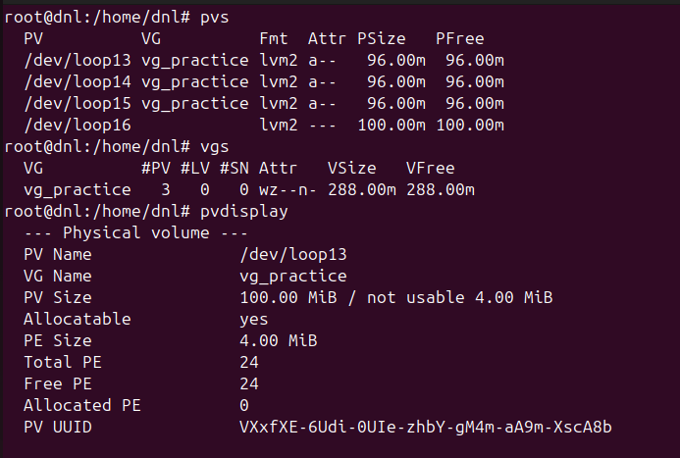
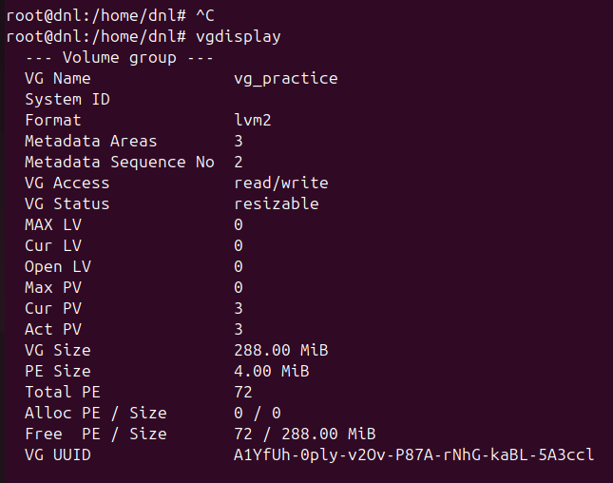

Group Reduction and PV Decommissioning:
- Run sudo vgreduce vg_practice /dev/loop13
- Followed by sudo pvremove /dev/loop16
- vgreduce removes a specific physical volume from the group's pool (only if it's not being used by any data).
- pvremove then wipes the LVM labels from the device, returning it to a “raw” unmanaged state.
- After check the results with pvs.
- We will return and create another time the LVM.
  - sudo pvcreate /dev/loop16
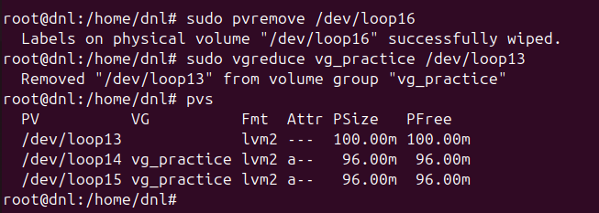
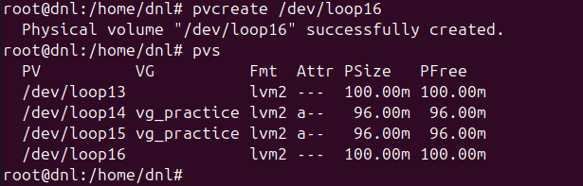

Phase III: Logical Volume Management (LV)

Kernel Module Loading:
- Run sudo modprobe dm-mod to load the Device Mapper driver into the active kernel.
- This module is the core engine that allows the Linux kernel to map logical blocks to physical storage locations.
Direct Unit Volume Creation:
- Run lvcreate -L 50M -n lv_standard vg_practice to create a volume using specific size units.
- The -L flag allocates a human-readable size (e.g., Megabytes, Gigabytes) by calculating the necessary number of Physical Extents (PE) automatically.
Extent-based Volume Creation:
- Run lvcreate -l 25 -n lv_extents vg_practice to define size by the number of logical units.
- The -l flag provides granular control by allocating a specific count of Physical Extents, which is useful when attempting to use exactly 100% of the remaining free space in a group.
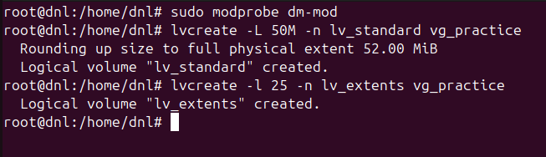

Striped Volume Implementation (Striping):
- Run lvcreate -i 2 -I 64 -L 100M -n lv_striped vg_practice to spread data across multiple disks.
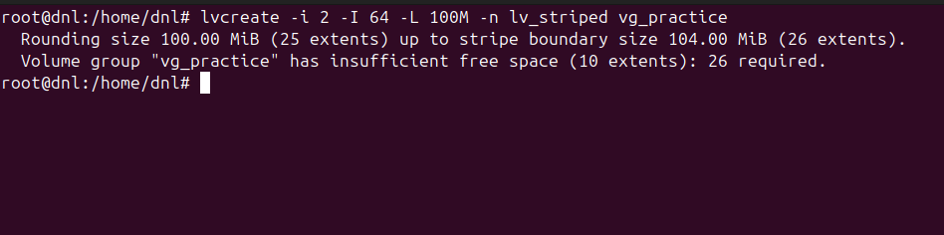
- This configuration uses the -i (stripes) and -I (stripe size) flags to write data chunks in parallel across different Physical Volumes, significantly increasing I/O performance.

Specific Physical Device Assignment:
- Run lvcreate -L 20M -n lv_fixed vg_practice /dev/loop1 to force the volume onto a specific disk.
- Specifying a Physical Volume at the end of the command ensures that the Logical Volume only consumes space from that particular hardware unit, facilitating physical isolation for sensitive data.
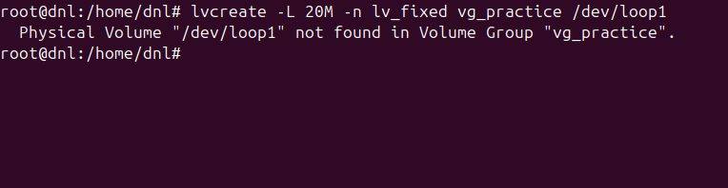
Logical Volume Removal:
- Run lvremove /dev/vg_practice/lv_standard and confirm the action with y.
- Deleting a volume destroys the virtual partition and returns its allocated Physical Extents back to the Volume Group's free pool for future use.
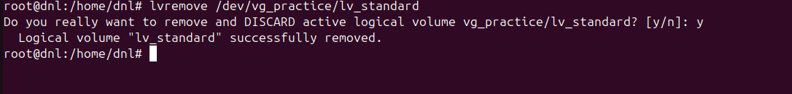

Phase IV: Filesystem Implementation and Mounting

Mount Point Creation:
- Run sudo mkdir -p /mnt/lvm_ext3 /mnt/lvm_reiser /mnt/lvm_jfs
- Mount points are empty directories within the Linux hierarchical tree that serve as the physical entry points for accessing the data stored on the logical volumes.
Diversified Filesystem Formatting:
- Create a new LV:
  - sudo lvcreate -L 50M -n lv_standard vg_practice
  - sudo lvcreate -L 50M -n lv_striped vg_practice
- Install ReiserFS:
  - sudo apt install reiserfsprogs
  - sudo apt install reiserfsprogs jfsutils.
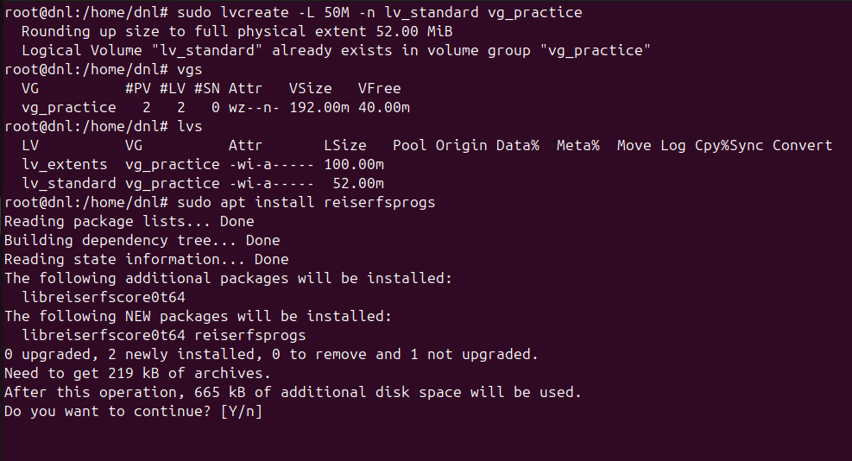
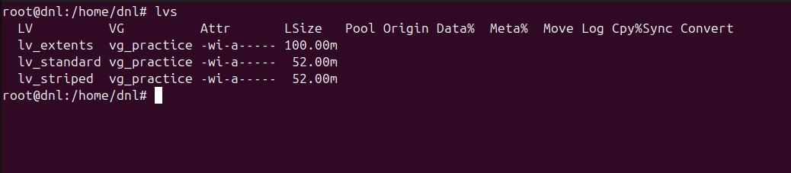
- Run sudo mkfs.ext3 /dev/vg_practice/lv_standard and sudo mkfs.reiserfs /dev/vg_practice/lv_striped
- Formatting initializes the logical volume by creating the necessary data structures, such as inodes and journals, which the operating system uses to organize and store files.
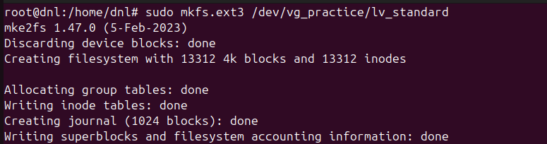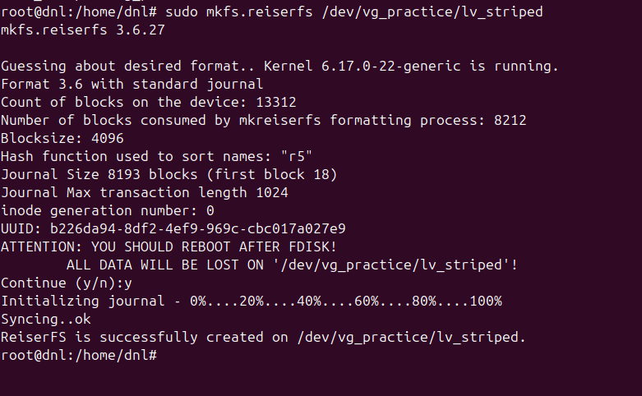

Mounting Operations:
- Run sudo mount /dev/vg_practice/lv_standard /mnt/lvm_ext3
- The mount command establishes a logical link between the formatted block device and the directory tree, enabling the kernel to direct read/write operations to the LVM volume.
Structural Verification and Visualization:
- Run lsblk, df -Th, and mount | grep lv_
- These commands provide a comprehensive view of the storage architecture, confirming the relationship between physical disks, logical volumes, and their current usage and mount status.
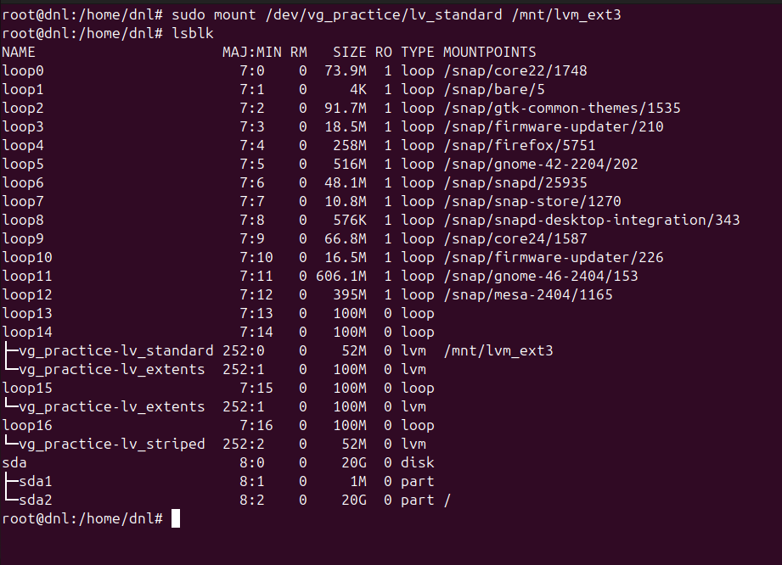
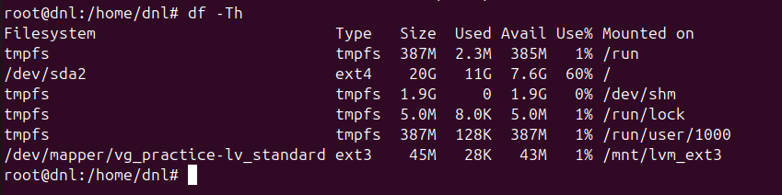
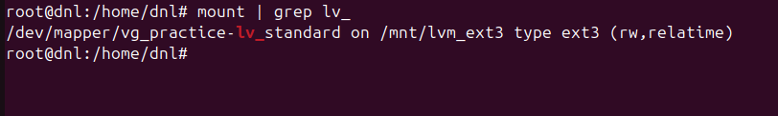

Phase V: Advanced Operations and Maintenance

Logical Volume Expansion:
- Run sudo lvextend -L +20M /dev/vg_practice/lv_standard followed by sudo resize2fs /dev/vg_practice/lv_standard
- The first command increases the size of the logical block device, while the second command expands the actual filesystem to occupy the newly available space without losing data.
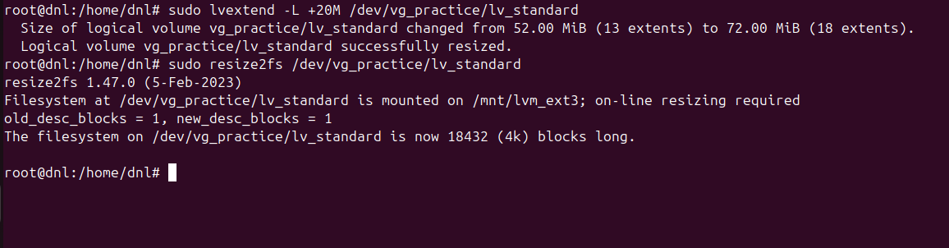
Snapshot Module Management:
- Run sudo modprobe dm-snapshot and verify with lsmod | grep dm_snapshot
- This loads the kernel driver required for “Copy-on-Write” (CoW) operations, allowing the system to track differences between a volume and its point-in-time image.
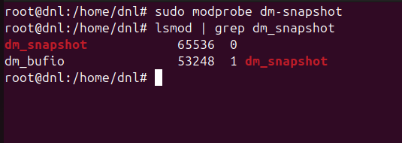

Snapshot Creation for State Preservation:
- Run sudo lvcreate -s -n lv_snap_base -L 20M /dev/vg_practice/lv_standard
- This creates a frozen image of the source volume.
- It only stores blocks that change after the snapshot is taken, serving as a highly efficient backup or testing point.
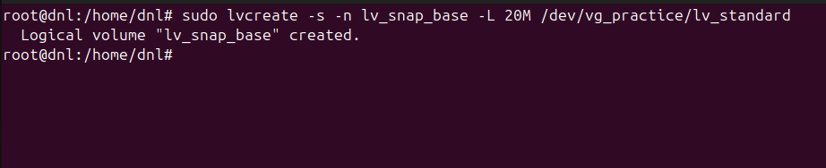
Snapshot Access and Mounting:
- Create:
- sudo mkdir -p /mnt/lvm_snapshot
- Run sudo mount /dev/vg_practice/lv_snap_base /mnt/lvm_snapshot
- Mounting the snapshot allows the developer to browse files exactly as they existed when the snapshot was created, even if the original volume is currently being modified.
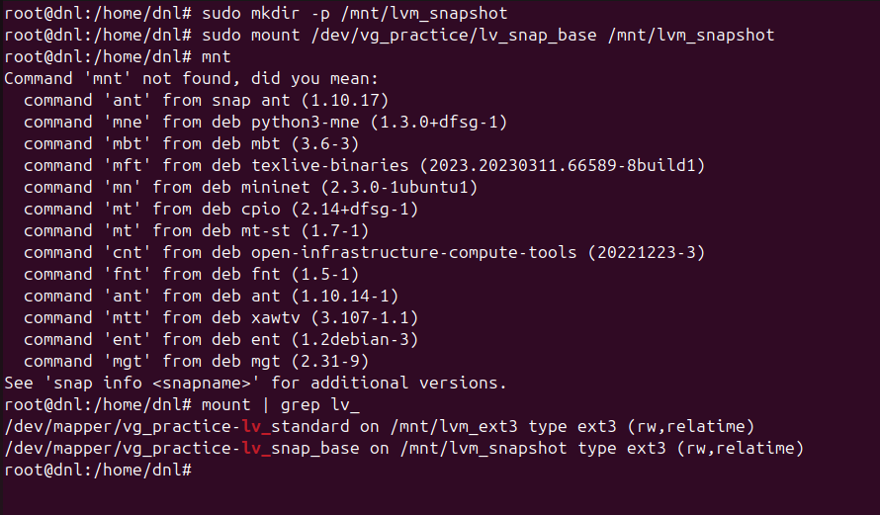
Adding space to the Volume Group:
- Create or prepare another disk:
  - truncate -s 500M disk5.img
- If you do not already have another loop device:
  - sudo losetup -fP disk5.img
- Check which loop device was assigned:
  - losetup -a
- Convert it into a Physical Volume:
  - sudo pvcreate /dev/loopX
  - (replace loopX with the actual assigned loop device)
- Add it to the Volume Group:
  - sudo vgextend vg_practice /dev/loopX
- Verify free space:
  - sudo vgs

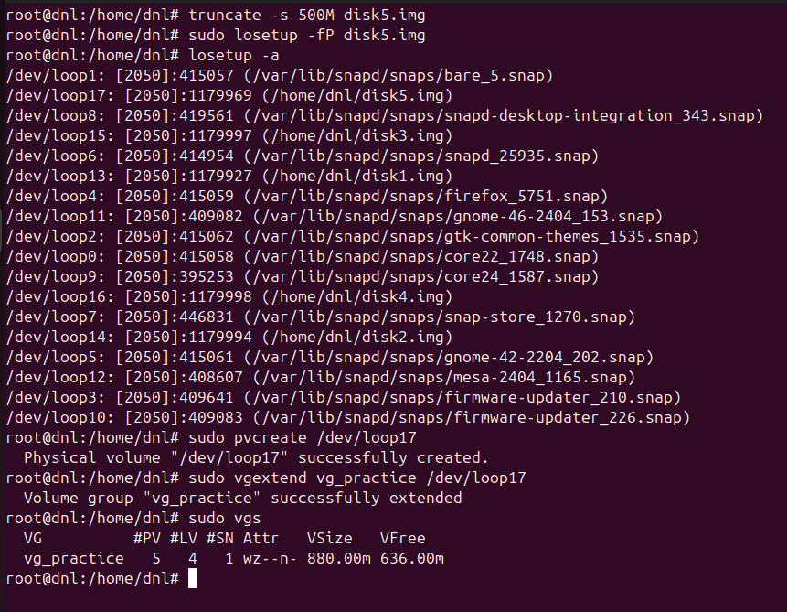

Mirroring and Redundancy Configuration:
- RAID1 Logical Volume Creation:
  - Run sudo lvcreate --type raid1 -m1 -L 50M -n lv_raid1 vg_practice
  - This command creates a mirrored Logical Volume using RAID1.
  - LVM duplicates the data across two physical volumes, providing redundancy and improving fault tolerance in case one disk fails.
- Execution Verification:
  - Run sudo lvs -a -o +devices
  - This command displays the Logical Volume attributes and the physical devices being used. If the RAID1 creation was successful, the LV will appear with RAID-related attributes and mirrored storage mappings.
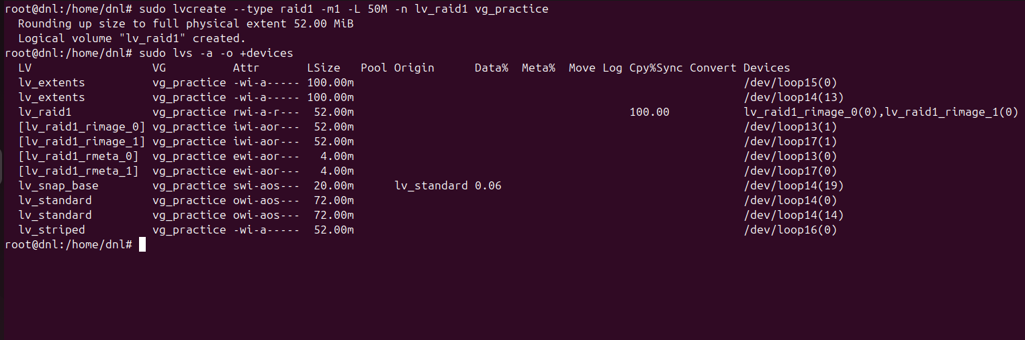

Phase VI: Functional Testing and Delivery

Filesystem Validation:
- Verify the integrity of the various storage formats by running:
  - df -Th
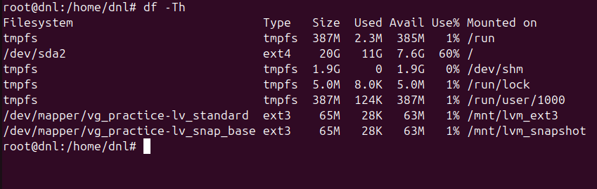

Documentation and Verification:
- Compile all terminal outputs from commands like lvs, vgs, and lsblk into the final report.
- Systematic documentation provides the technical audit trail required to prove that all storage layers (from loop devices to the final filesystems) were configured according to the operational roadmap.
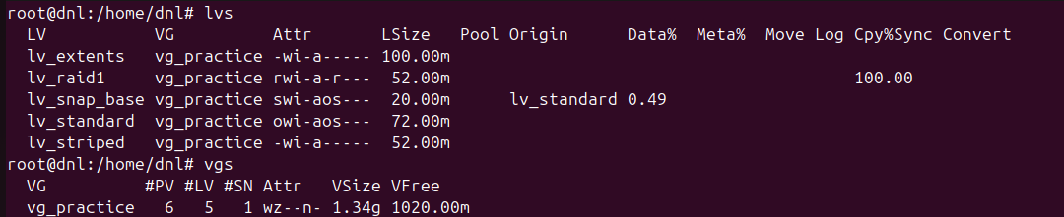
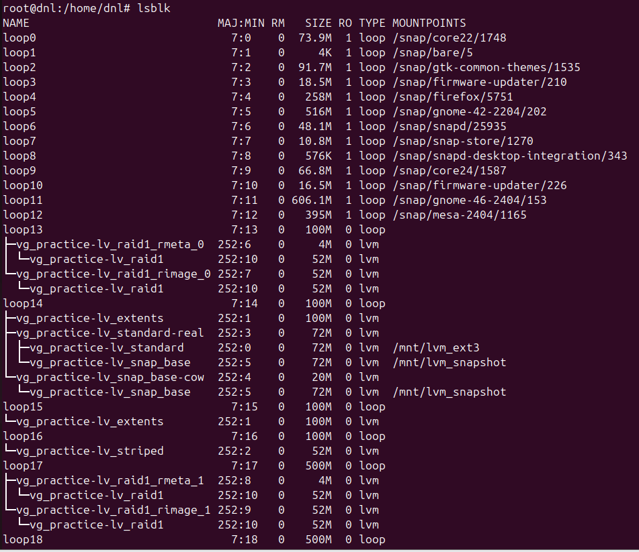

Conclusion

This laboratory on Logical Volume Manager (LVM) successfully demonstrated the transition from traditional static partitioning to a dynamic, flexible abstraction layer for storage management.
By mastering the complete lifecycle of LVM (from physical initialization to logical deployment) the following key objectives were achieved…
Key Takeaways from the Practice
- Operational Flexibility:
  - We proved that storage can be resized and hardware units can be added or removed without service interruption, providing a massive advantage over static disks.
- Logical Architecture:
  - The practice solidified the understanding of the LVM hierarchy, moving from Physical Volumes (PV) to Volume Groups (VG) and finally to usable Logical Volumes (LV) .
- Advanced Data Safety:
  - Through the implementation of Snapshots, we established a reliable method for point-in-time backups and safe testing.
- Redundancy and Performance:
  - The setup of RAID1 mirroring provided essential fault tolerance, while striping techniques demonstrated how to optimize data transfer rates across multiple disks.
In short, this exercise confirms that LVM is an indispensable tool for modern Linux environments, allowing for a scalable and resilient storage infrastructure

