516-DaríoNL-ISOP503-ParticionesPermisos
TAJAMAR | MADRID | 27/04/2026
Partitions - Permissions
ISO – Unit 4 – Partitions and Permissions

Contenido
Introduction 3
Theoretical Framework 4
Storage Mounting and /etc/fstab 4
Permissions and Access Control 5
Roadmap 6
Inventory 7
Execution 8
Pashes I and II : Persistent Mounting 8
Phase III: Linux Identity and Directory Security 14
Phase IV: Windows NTFS Implementation 18
Conclusion 23

Introduction

This laboratory focuses on the management of storage resources and the implementation of access control models within Ubuntu and Windows environments.
The exercise is designed to simulate real-world system administration tasks, including the provisioning of virtual hardware, the configuration of persistent mounting points through the filesystem table, and the enforcement of data confidentiality.
By managing local partitions and granular file permissions, we establish a secure multi-user infrastructure where resource access is strictly regulated based on identity.
Storage Integration:
- We will explore the lifecycle of a secondary disk, from initialization to logical mounting.
Persistence Control:
- We will analyze the behavior of the system boot process by modifying the /etc/fstab configuration.
Access Control:
- We are goint to implement security policies across different filesystems (ext4 and NTFS) to ensure that users can only interact with their designated data segments.
Cross-Platform Validation:
- We will compare the permission management mechanisms between GNU/Linux and Windows to understand the functional differences in security implementations.

Theoretical Framework

Storage Mounting and /etc/fstab

Mounting is the process by which the operating system makes a storage device's filesystem accessible through the directory tree.
In Linux, the /etc/fstab (File Systems Table) file is the primary configuration tool for defining how partitions are handled during boot.
- ext4:
  - The standard journaling filesystem for Linux, providing high performance and reliability.
- Mount Options:
  - Parameters such as auto (mount at boot) and noauto (require manual mounting) allow administrators to control resource availability.
- Mount Points:
  - Logical directories used as the entry point for the external storage data.

Permissions and Access Control

File permissions are the primary defense mechanism in multi-user operating systems, ensuring that users can only read, write, or execute files they are authorized to access.
Linux Permissions:
- Based on Ownership (User, Group, Others) and Permission Bits (Read, Write, Execute).
- Commands like chmod and chown are essential for hardening directory structures.
NTFS (New Technology File System):
- A proprietary Windows filesystem that supports advanced Access Control Lists (ACLs).
- Unlike FAT32, NTFS allows for granular security settings per user.

Roadmap

Phase I: Disk Provisioning and Partitioning:
- We add secondary virtual hardware and initialize a new ext4 partition for testing purposes.
Phase II: Mount Management and Automation:
- We configure the /etc/fstab file to manage automatic and manual mounting states, verifying the system behavior during reboot.
Phase III: Linux Identity and Directory Security:
- We create multiple user accounts and establish a restricted directory structure in the root of the system.
- We perform cross-user login tests to validate that the permission masks correctly block unauthorized access attempts.
Phase IV: Windows NTFS Implementation:
- We replicate the security structure on a Windows system, utilizing NTFS partitions to apply specific user permissions.
- We perform cross-user login tests to validate that the permission masks correctly block unauthorized access attempts.

Inventory

For the realization of the laboratory we have used:
- Hardware:
  - Host PC.
- Software:
  - Windows 11.
  - Ubuntu Desktop 24.04.2.

Execution

Pashes I and II : Persistent Mounting

Physical Disk Identification:
- We added a secondary 1GB Virtual Hard Disk to the virtual machine settings.
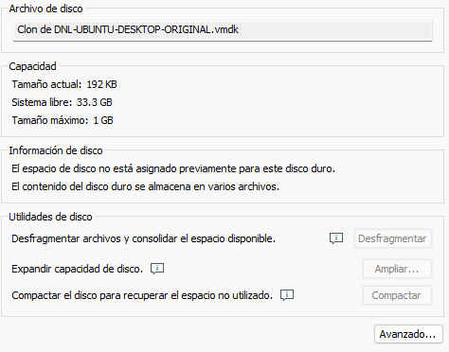
- After starting the system, we executed the lsblk command in the terminal to confirm that the Linux kernel successfully recognized the new hardware as a block device, identified as /dev/sdb.
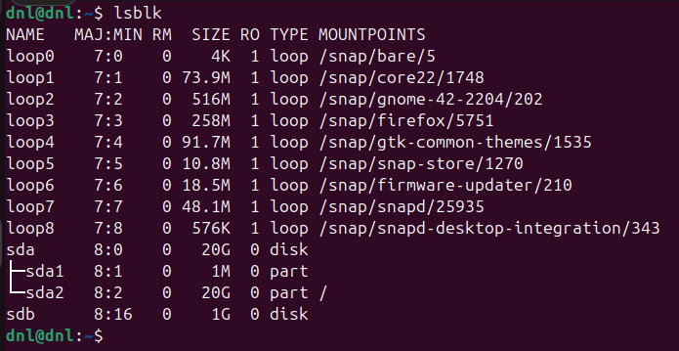
Logical Partitioning:
- We initialized the disk using the utility sudo fdisk /dev/sdb.
- Inside the interactive menu, we created a new primary partition using the default start and end sectors to utilize the entire disk capacity, then wrote the changes to the partition table.
- Secuence:
  - If the disk does not have a partition table, fdisk will indicate it.
  - Create a new table: Press g creates a GPT partition table
  - Verify: Press p The empty table should be displayed.
  - Create a partition: Press n and Accept the default values (uses the entire disk).
  - Save changes: Press w
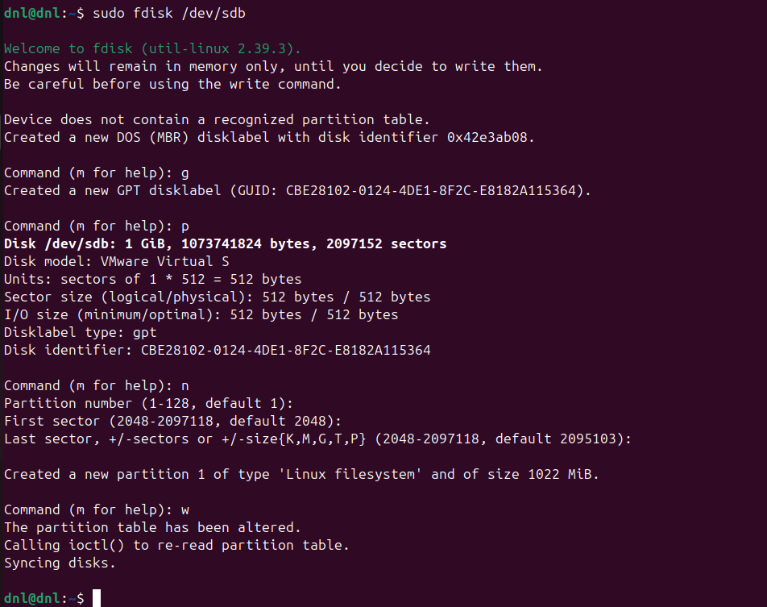
Filesystem Formatting (ext4):
- We applied a filesystem to the new partition by running the command sudo mkfs.ext4 /dev/sdb1.
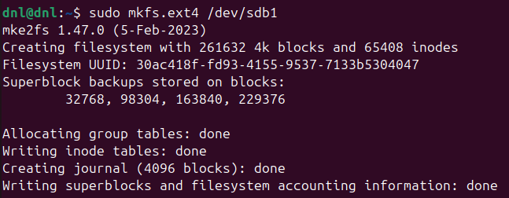
- This process built the necessary metadata structures and initialized the journaling system.

Manual Mounting and Data Verification:
- We created a mount point directory at /mnt/storage_test and linked the partition using sudo mount /dev/sdb1 /mnt/storage_test.
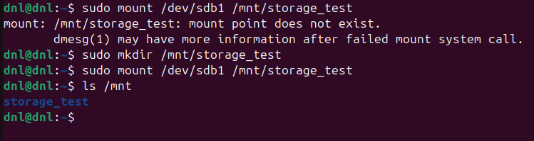
- Then has been generated a test file by executing:
  - echo “Data Integrity Check” |
  - sudo tee /mnt/storage_test/test.txt.
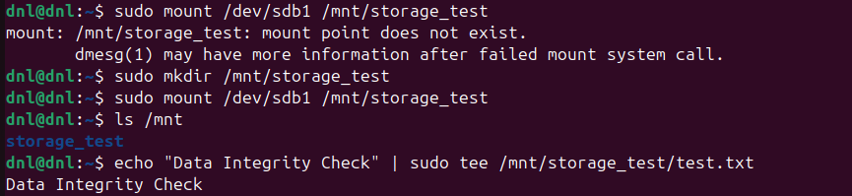
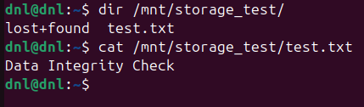
- Explanation:
  - Mounting is the process of attaching a filesystem to a specific point in the directory tree.
  - By creating a test file manually before automating the process, we verify that the partition is writable and that the hardware-to-software link is functioning correctly.

Persistent Automatic Mounting:
- We retrieved the partition’s Universally Unique Identifier using:
  - sudo blkid
- Then we will edit the /etc/fstab file to include the following entry:
  - UUID=Unique-ID /mnt/storage_test ext4 defaults 0 2
  - Update system: systemctl daemon-reload
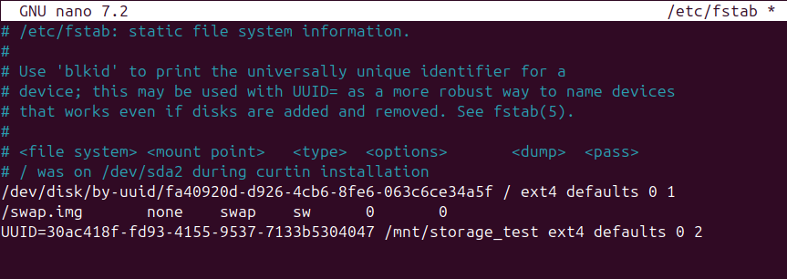
- We verified the entry by unmounting the disk and running:
  - umount /mnt/storage_test
  - sudo mount -a
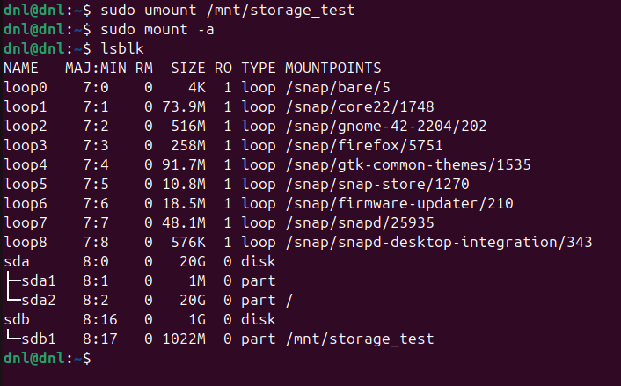
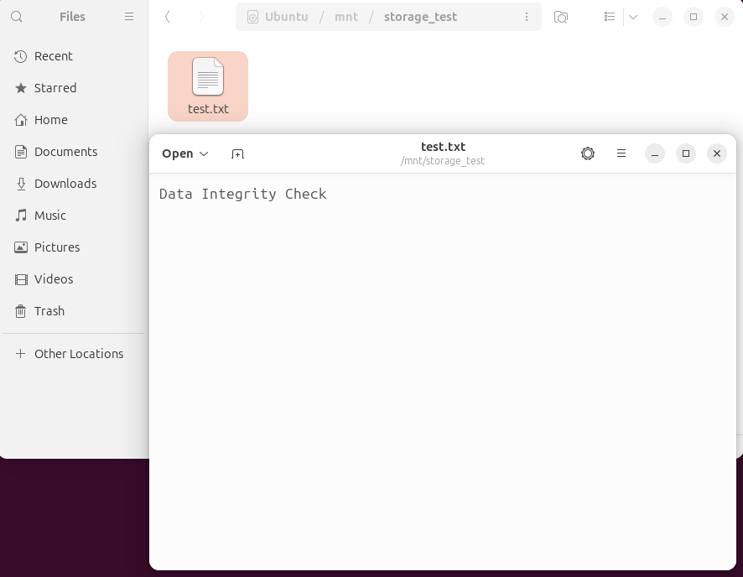
Configurable Manual Mounting (noauto):
- We modified the /etc/fstab entry, changing the defaults parameter to noauto,user 0 0
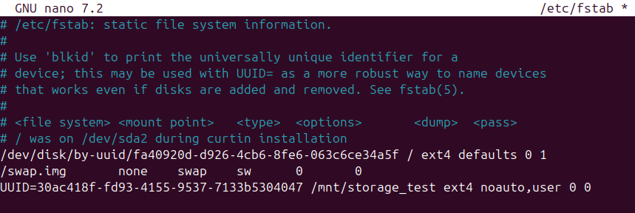
- We then rebooted the system and confirmed that the /mnt/storage_test folder was empty until we manually executed the command
mount /mnt/storage_test without using sudo.
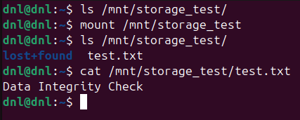
- Explanation:
  - The noauto flag prevents the operating system from mounting the disk during the boot sequence, which is useful for secondary or removable storage.
  - The user flag grants standard users the permission to mount the device, providing flexibility without requiring administrative privileges for routine storage access.

Phase III: Linux Identity and Directory Security

Creation of Multiple User Identities:
- We initialized three distinct local user accounts using the command sudo adduser.
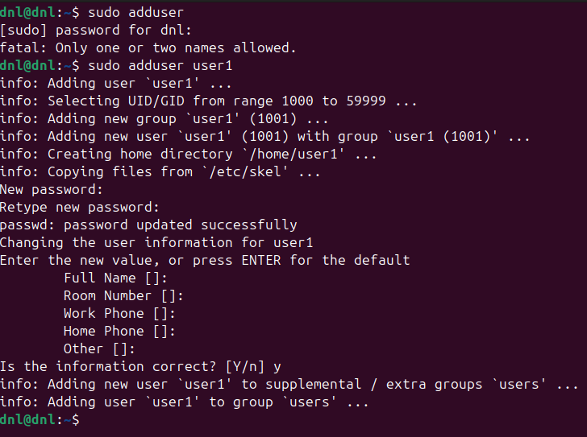
- For this laboratory, we created user1, user2, and user3, assigning each a unique password and completing the profile configuration for each identity.
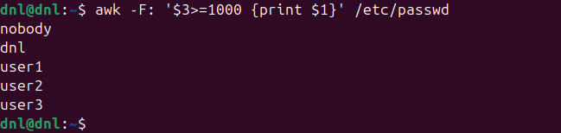
- Explanation:
  - The creation of individual accounts is the basis of multi-user system security.
  - By establishing separate identities, the operating system can track and restrict actions at the kernel level, ensuring that each person operating the system has a unique UID (User ID) associated with their processes and file ownership.

Directory Infrastructure in Root:
- We created three dedicated directories at the root of the filesystem (/) using the command:
  - sudo mkdir /data_user1 /data_user2 /data_user3
- We used the root path to ensure these directories were outside of the standard /home environment, testing global access control.
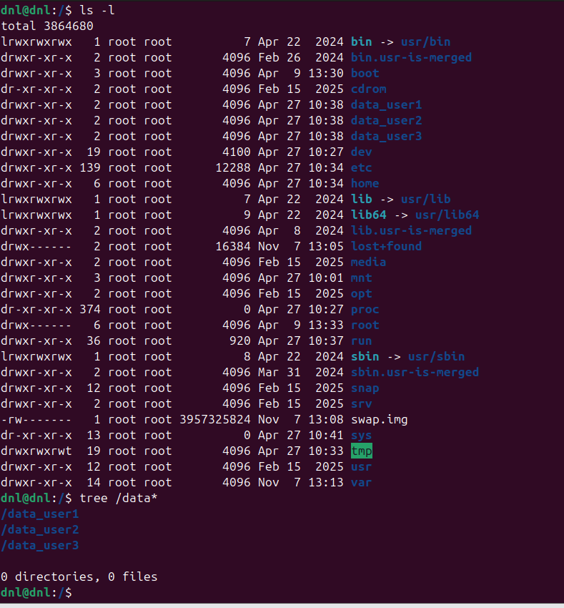

Ownership and Permission Lockdown:
- We utilized the chown and chmod commands to isolate each directory.
- First, we assigned ownership to the respective users:
  - sudo chown user1:user1 /data_user1
- Then, we applied a strict permission mask of 700:
  - sudo chmod 700 /data_user1
- This process was repeated for the remaining two users and their folders.
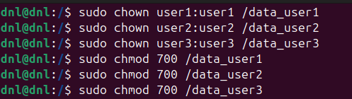
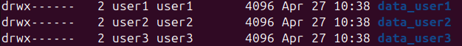
- Explanation:
  - chown:
    - This command changes the owner and group of a file.
    - By making user1 the owner of /data_user1, we define who “controls” the space.
  - chmod 700:
    - This numerical mask grants read, write, and execute (7) permissions to the owner, while granting zero permissions (00) to the group and others.
    - In Linux, without “execute” permission on a directory, a user cannot even enter it to see its contents.

Cross-Account Access Validation:
- We tested the security implementation by switching between accounts using su - [username].
- While logged in as user1, we attempted to access all three directories.
- We confirmed that ls /data_user1 worked successfully, while attempting to access /data_user2 or /data_user3 resulted in a “Permission denied” error.
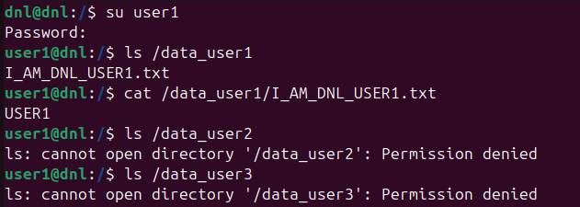
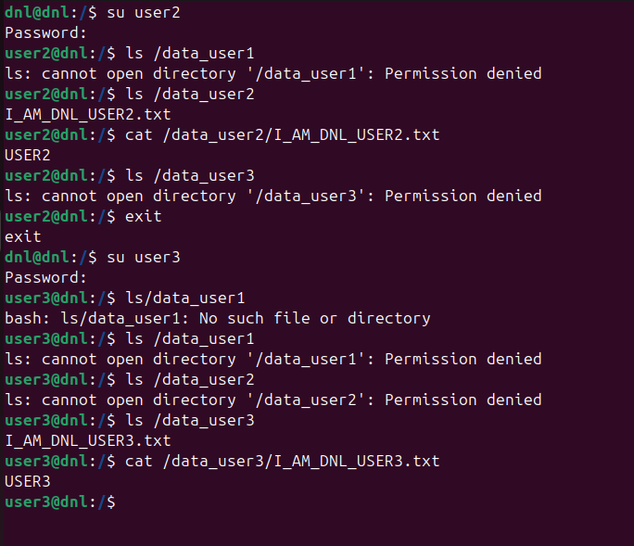

Phase IV: Windows NTFS Implementation

User Provisioning:
- We utilized the Command Prompt with Administrative privileges to create three local user accounts.
- We executed the following commands:
  - net user win_DNLuser1 *** /add
  - net user win_DNLuser2 *** /add
  - net user win_DNLuser3 *** /add
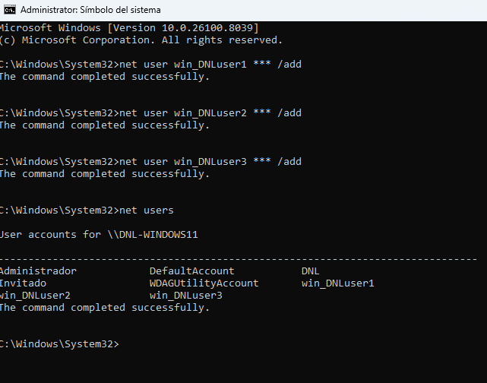

Directory Structure Deployment:
- We established the directory hierarchy directly in the root of the system drive using the following commands:
  - mkdir C:\data_DNLwin1
  - mkdir C:\data_DNLwin2
  - mkdir C:\data_DNLwin3
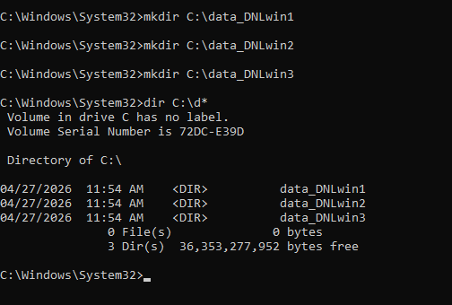

Advanced ACL Configuration (icacls)
- We applied strict isolation policies by modifying the Access Control Lists (ACLs) of each folder.
- We used the icacls utility to remove inheritance and grant exclusive access:
icacls C:\data_DNLwin1 /inheritance:r /grant:r win_DNLuser1:(OI)(CI)F
icacls C:\data_DNLwin2 /inheritance:r /grant:r win_DNLuser2:(OI)(CI)F
icacls C:\data_DNLwin3 /inheritance:r /grant:r win_DNLuser3:(OI)(CI)F
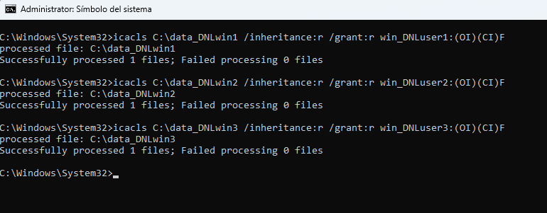
- Explanation:
  - /inheritance:r:
    - This flag is critical. It “removes” all inherited permissions from the parent folder (C:), ensuring that groups like “Authenticated Users” or “Users” lose their default read access.
  - (OI)(CI):
    - These indicate “Object Inherit” and “Container Inherit,” ensuring that any files or subfolders created inside the directory automatically receive these same permissions.
  - F:
    - This grants “Full Control” to the specific owner, allowing them to manage their own data while everyone else is excluded.
GUI Verification and Access Testing:
- We transitioned to the Windows Graphical User Interface (GUI) to validate the security mask.
- We logged into the system as win_user1 and attempted to browse the directories via File Explorer.
- We confirmed that C:\data_win1 opened successfully, while double-clicking C:\data_win2 or C:\data_win3 triggered a “You don't currently have permission to access this folder” system alert.
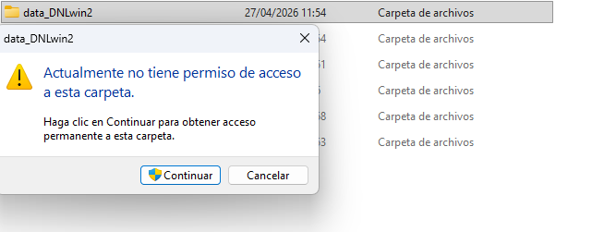
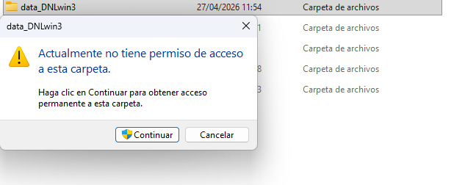
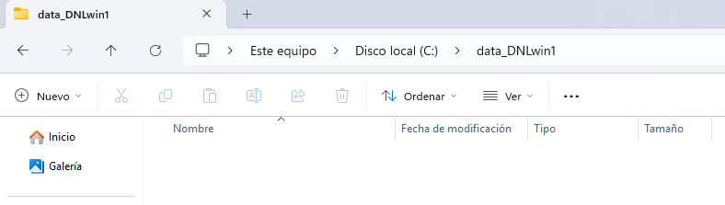
- Explanation:
  - Verification via GUI is essential because it reflects the end-user experience and confirms that the Windows Shell respects the underlying NTFS security descriptors.
  - The successful rejection of the unauthorized user validates that our CLI commands correctly hardened the filesystem against horizontal data access.

Conclusion

In conclusion, we have established a robust storage and security infrastructure across both Ubuntu and Windows environments.
This laboratory allowed us to master the critical lifecycle of secondary storage, transitioning from the initial provisioning of virtual hardware to the configuration of persistent and manual mounting policies within the filesystem table.
By implementing strict access control models (utilizing numerical permission masks in Linux and advanced ACLs in Windows) we successfully created an isolated multi-user environment where data confidentiality is enforced at the kernel and filesystem levels.
- Strategic Storage Integration:
  - We configured ext4 partitions and managed their availability through /etc/fstab, ensuring storage behaves predictably during the system boot sequence.
- Enforced Data Confidentiality:
  - We applied the principle of least privilege by stripping inherited permissions and assigning exclusive ownership, verified through cross-user login testing on both platforms.
- Cross-Platform Interoperability:
  - We validated the functional differences and similarities between Linux permission bits and Windows NTFS descriptors, providing a comprehensive understanding of multi-user security management.
Understanding these concepts is essential for maintaining system integrity.
Improper mounting can lead to resource unavailability or boot failures, while poorly managed permissions expose sensitive data to unauthorized internal threats.

