516-DaríoNL-ISOP503-ParticionesPermisos
TAJAMAR | MADRID | 05/05/2026
RAID
ISO – Unit 5 – RAID IN WINDOWS

Contenido
Introduction 3
Theoretical Framework 4
Storage Volume Types 4
Roadmap 5
Inventory 6
Execution 7
Phase I. Environment Initialization 7
Phase II. RAID 1 Implementation (Mirroring) 10
Phase III. RAID 5 Configuration (Parity) 14
Phase IV. Spanned Volume Setup 18
Phase V. RAID 0 Deployment (Striping) 21
Pashe VI. RAID 1 (Mirroring) in Windows 10 25
Conclusion 28

Introduction

This laboratory focuses on the implementation and management of advanced storage configurations within the Windows Server environment.
The objective is to move beyond basic partitioning and explore software-defined storage solutions that provide either enhanced performance, increased capacity, or data redundancy.
By utilizing the Logical Disk Manager, we simulate professional storage administration tasks, evaluating how different volume types respond to hardware availability and performance requirements.
- Resource Optimization:
  - We utilize multiple virtual disks to create complex logical structures.
- Fault Tolerance:
  - We implement configurations designed to protect data against physical drive failures.
- Performance Scaling:
  - We analyze how data striping can improve input/output speeds.
- Logical Volume Management:
  - We manage the transition from Basic to Dynamic disks to enable advanced software RAID features.

Theoretical Framework

Storage Volume Types

RAID 0 (Striped Volume):
- It distributes data across two or more disks to increase performance.
- It provides no redundancy; if one disk fails, all data on the volume is lost.
- It is primarily used for non-critical data requiring high read/write speeds.
RAID 1 (Mirrored Volume):
- It duplicates data across two physical disks, creating an exact copy.
- It provides high fault tolerance; if one disk fails, the system continues to operate using the remaining disk.
- It effectively cuts the total available storage capacity in half.
RAID 5 (Parity Volume):
- It stripes data and parity information across three or more disks.
- It offers a balance between performance and redundancy, allowing the system to reconstruct data if a single drive fails.
- It is a standard for professional server environments due to its efficient use of disk space.
Spanned Volume:
- It combines unallocated space from multiple physical disks into a single logical drive.
- It fills the space on the first disk before moving to the next one.
- It increases total storage capacity but offers no performance or redundancy benefits.

Roadmap

Phase I. Environment Initialization:
- We prepare the Windows Server system by attaching multiple virtual disks and initializing them within the Disk Management console.
Phase II. RAID 1 Implementation (Mirroring):
- We configure a mirrored volume to ensure data persistence and test the system's reaction to a simulated disk failure.
Phase III. RAID 5 Configuration (Parity):
- We deploy a fault-tolerant volume using three or more disks, focusing on parity-based recovery.
Phase IV. Spanned Volume Setup:
- We merge non-contiguous space from different physical units to maximize the available drive letter capacity.
Phase V: RAID 0 Deployment (Striping):
- We execute a striped volume configuration to prioritize data throughput and speed over redundancy.
Pashe VI. RAID 1 (Mirroring) in Windows 10:
- Using Storage Spaces.

Inventory

For the realization of the laboratory we have used:
- Hardware:
  - Host PC.
- Software:
  - Windows Server 2022.
  - Windows 10.

Execution

Phase I. Environment Initialization

Hardware Provisioning:
- We accessed the virtual machine hardware configuration to attach tree additional Virtual Hard Disks of 10 GB each (10, 11, 12 GB to diferenciate each other).
- To implement and test various RAID levels (0, 1, 5) and Spanned volumes, multiple physical or virtual units are required.
- Adding secondary virtual hardware simulates the expansion of a server's physical storage capacity, providing the raw block devices necessary for the logical volume manager to operate.
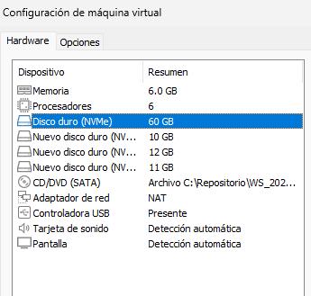

Disk Identification and Online Status:
- We initialized the Disk Management console (diskmgmt.msc) within the Windows environment.
- We identified the new drives, which appeared as “Unknown” and “Not Initialized.”
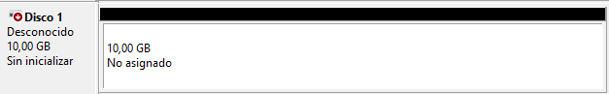
- We proceeded to initialize the disks by selecting the GPT (GUID Partition Table) partition style for all four units.
- This was performed through the initialization wizard that triggers automatically when new drives are detected by the console.
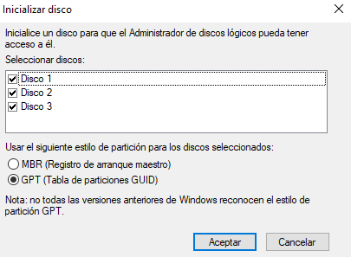

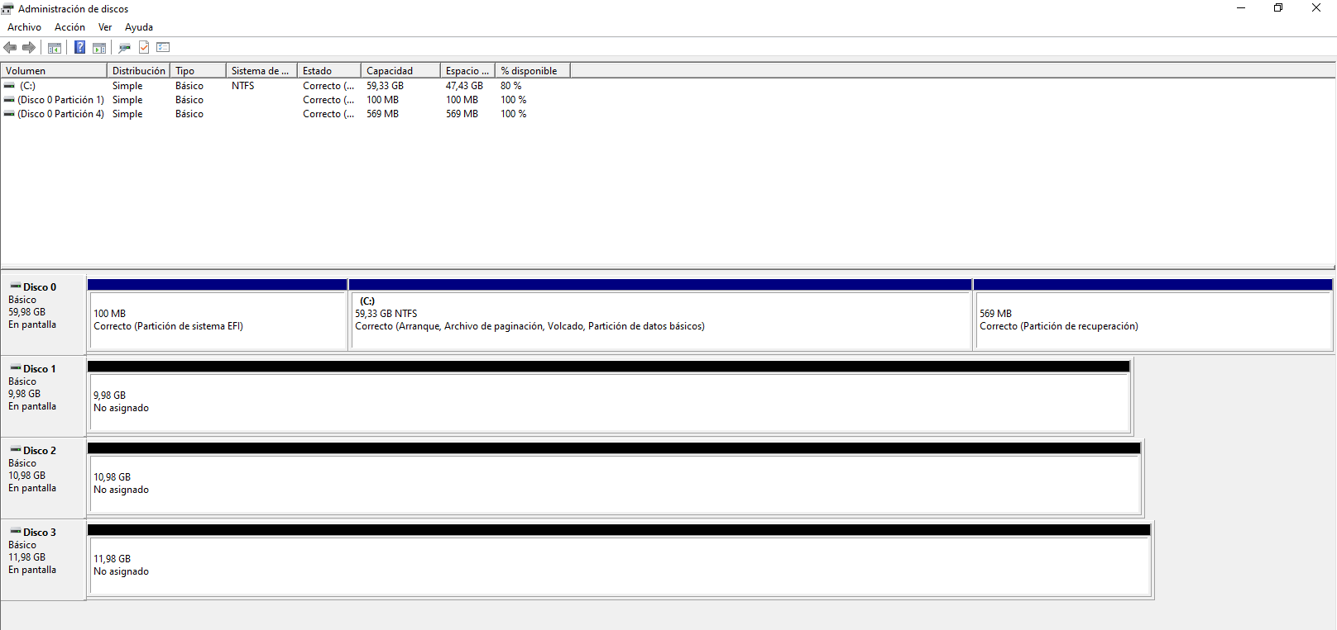

Phase II. RAID 1 Implementation (Mirroring)

Volume Selection and Disk Mapping:
- We initiated the New Mirrored Volume wizard by right-clicking on the unallocated space of Disk 1.
- During the disk selection step, we added Disk 2 to the selected list, ensuring that both physical units were paired to form the redundant set
- We defined the partition size as 1 GB.
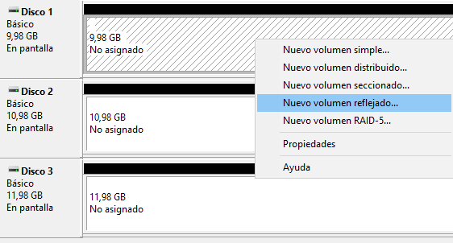
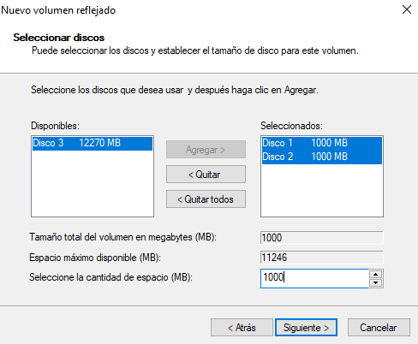

Logical Identification and NTFS Formatting:
- We assigned a specific drive letter to the new volume for system-wide access.
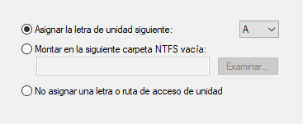
- Subsequently, we performed a Quick Format using the NTFS filesystem, labeling the volume to clearly identify it within the File Explorer.
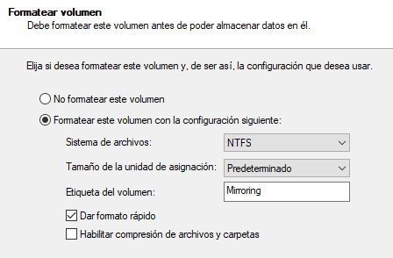

Dynamic Conversion:
- Upon proceeding, the system issued a warning stating that the selected basic disks would be converted to Dynamic Disks.
- We accepted this prompt to allow the operating system to manage the multi-disk logical structure.
- Explanation:
  - Conversion to dynamic storage is a mechanical necessity for software RAID in Windows.
  - Unlike basic disks, dynamic disks use a hidden database to track volume layout across multiple physical spindles.
  - In a RAID 1 setup, the total usable capacity is equal to the size of a single disk, as the second disk is dedicated entirely to redundancy.
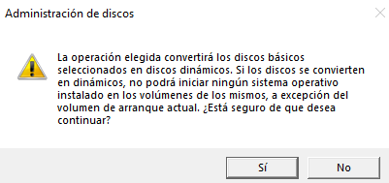

Visual Verification and Synchronization:
- We monitored the Disk Management console and confirmed the appearance of a red-colored bar spanning across both Disk 1 and Disk 2.
- We waited for the status to change from “Resynching” to “Healthy,” indicating that the mirror was fully synchronized and active.
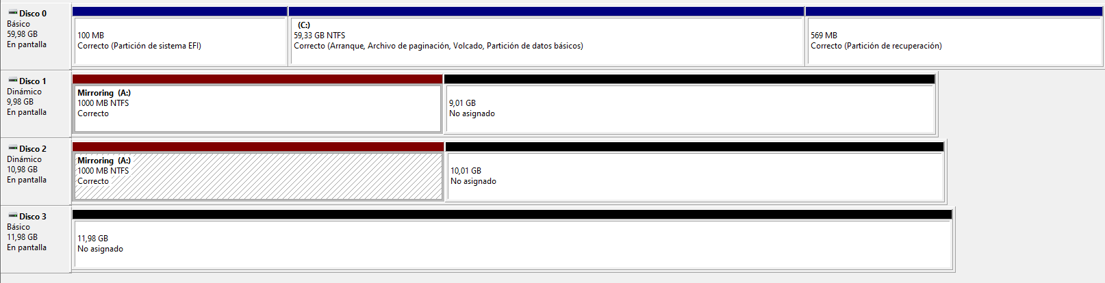

Phase III. RAID 5 Configuration (Parity)

Volume Initialization and Disk Requirement:
- We initiated the New RAID-5 Volume wizard by right-clicking on the unallocated space of an available disk.
- During the selection process, we added Disk 1, Disk 2, and Disk 3 to the volume set, as the system requires a minimum of three physical units to enable this specific configuration.
- We defined the size for the volume, noting that the total usable capacity was restricted to the sum of n-1 disks. The Logical Disk Manager automatically reserved the equivalent space of one full disk to store the parity metadata across the array.
- Usable capacity (n-1):
  - If there are 3 disks of 1 TB usable capacity = 2 TB.
  - The “lost” space is not located on a specific disk.
  - It is distributed as parity blocks across all disks.
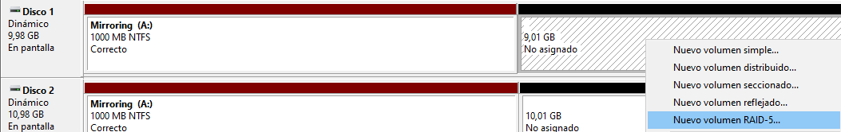
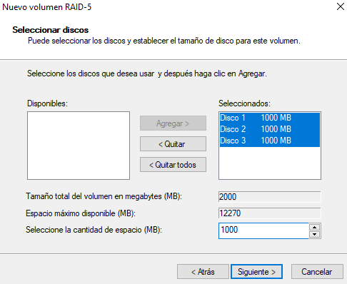
File System Application (NTFS):
- We assigned a new drive letter and proceeded to format the logical volume using the NTFS filesystem.
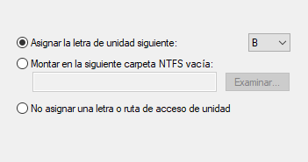
- We performed a quick format to initialize the volume for immediate use within the Windows environment.
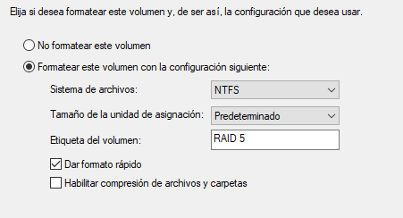

Synchronization and Health Monitoring:
- We verified the successful creation of the volume by observing a cyan (light blue) bar appearing across the three selected disks in the management console.
- We monitored the “Resynching” status, ensuring the array reached a “Healthy” state before performing any data operations.
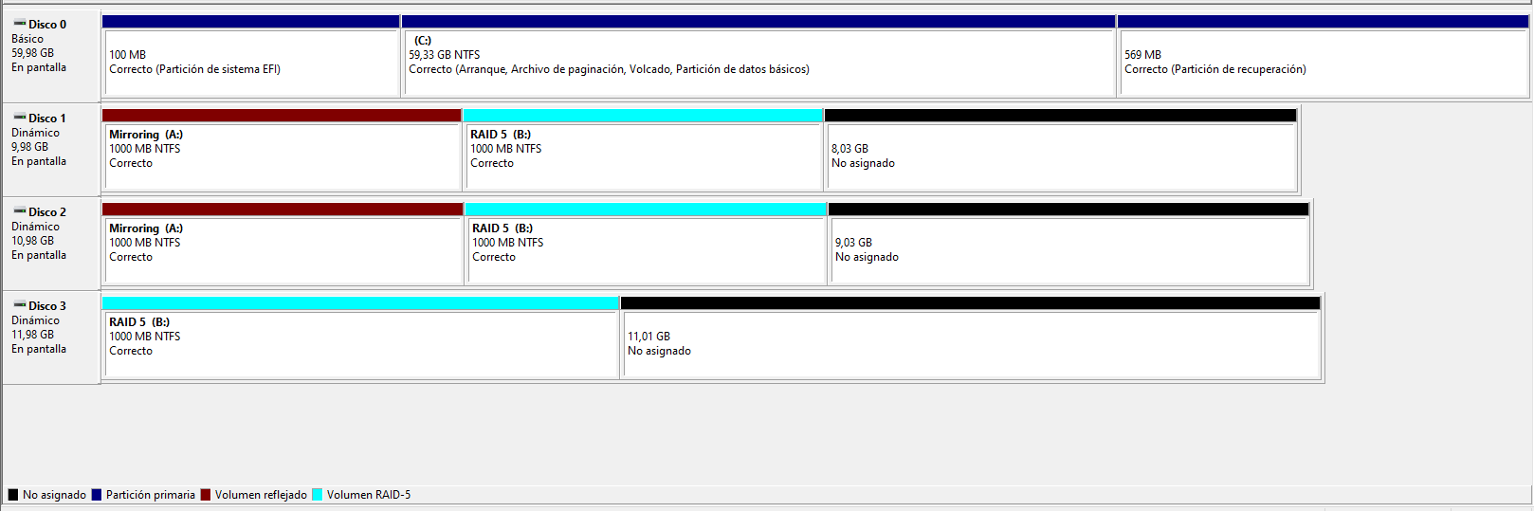
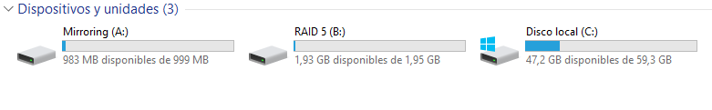

Phase IV. Spanned Volume Setup

Execution:
- We initialized the New Spanned Volume wizard from the Disk Management console.
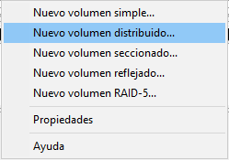
- We selected Disk 2 and Disk 3 to be aggregated into a single logical entity.
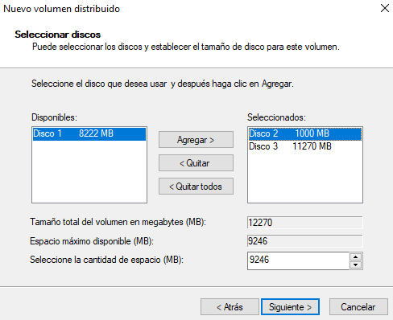

- We assigned the drive letter G: for identification within the filesystem hierarchy.
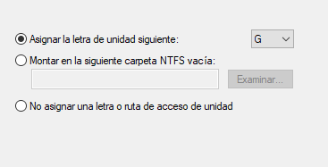
- We performed a quick format using the NTFS filesystem to prepare the volume for data storage.
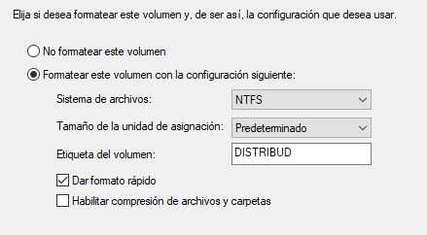

- We verified the creation of the volume, which appears as a single drive spanning across the two physical disks.
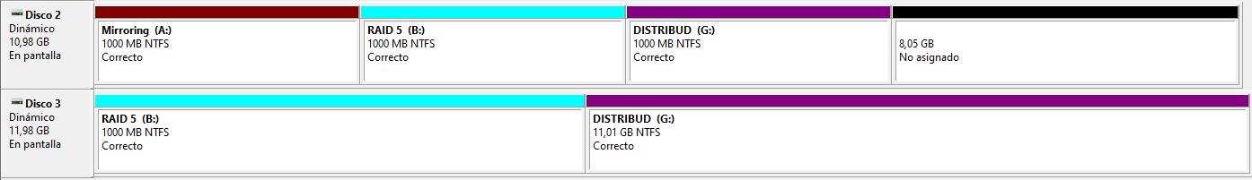
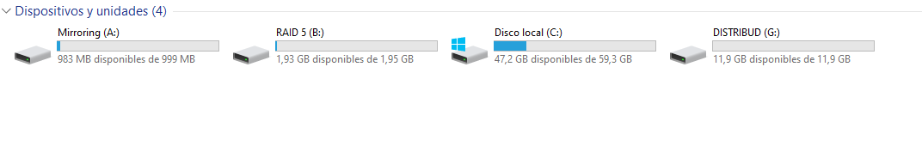

Phase V. RAID 0 Deployment (Striping)

Volume Initiation and Member Selection:
- We launched the New Striped Volume wizard by right-clicking on the unallocated space of a dynamic disk.
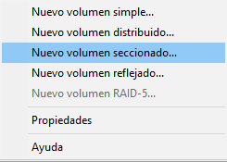
- We selected Disk 1 and Disk 2 to participate in the array, ensuring that an equal amount of space was allocated from each physical unit.
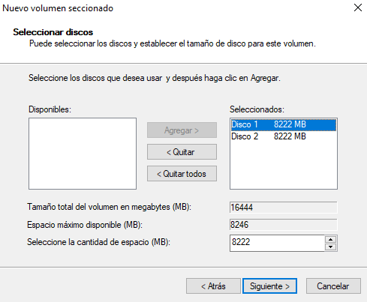

Logical Identification and Performance Formatting:
- We assigned a unique drive letter to the volume and performed a quick format using the NTFS filesystem.
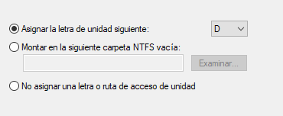
- We labeled the drive “High_Performance” to distinguish its specific use case within the storage hierarchy.
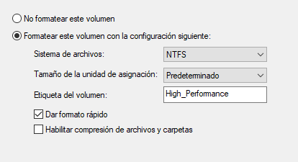

Visualization and Status Confirmation:
- We confirmed the successful deployment by identifying a purple-colored bar spanning across the participating disks in the management console. We verified that the status was listed as “Healthy” across all members of the striped set.
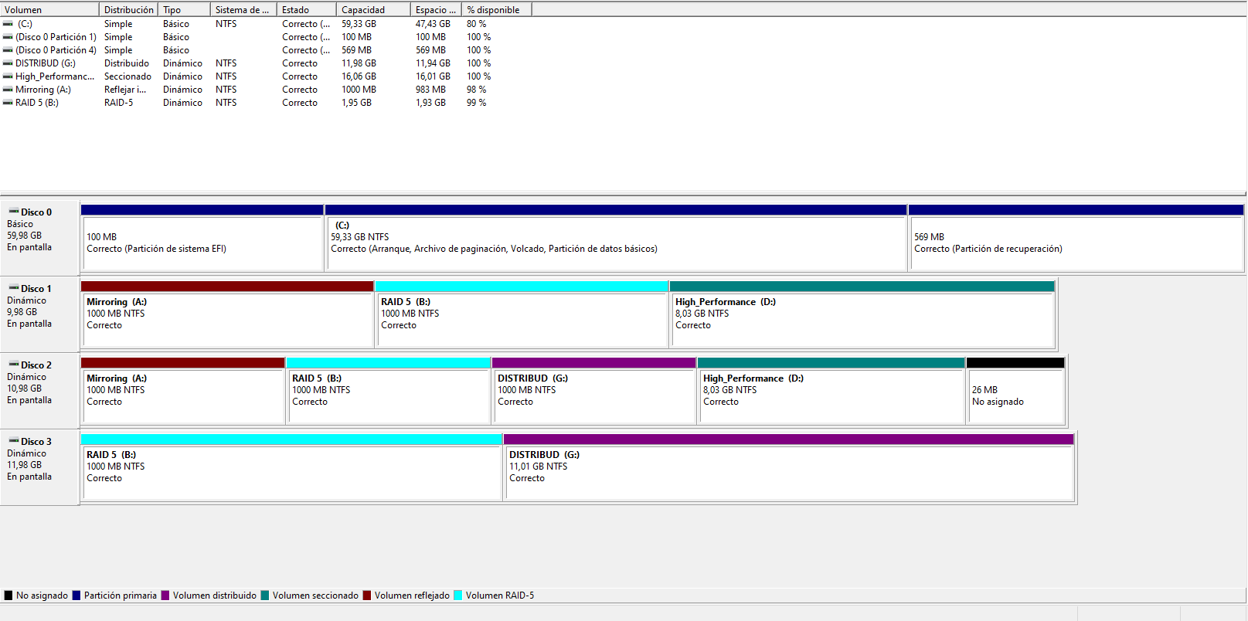
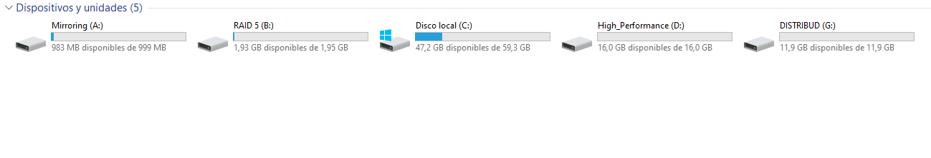

Pashe VI. RAID 1 (Mirroring) in Windows 10

Confirm both physical disks are detected and added to the pool, and their status is online/healthy.
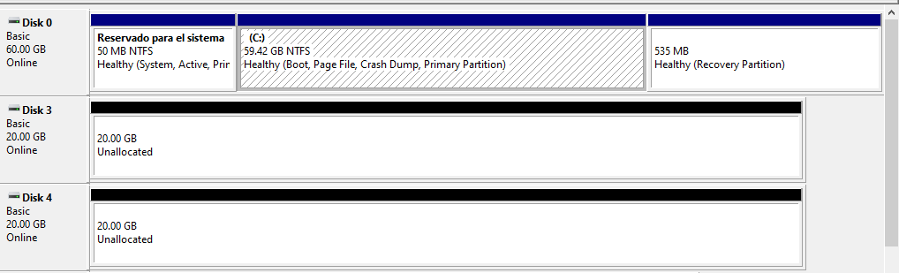
Adding devices:
- Two 20 GB disks are added to the storage pool to be used in the RAID configuration, making them available for volume creation and redundancy or striping depending on the selected RAID level.
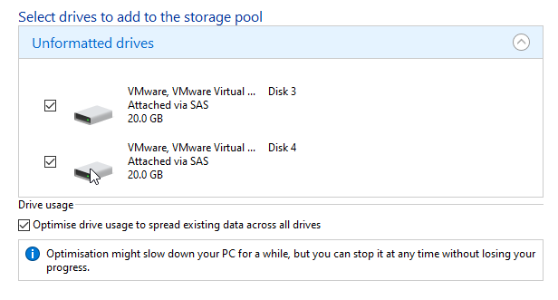

Configuration of the Storage Space:
- We click on “Create Storage Space” to start the wizard that allows us to configure the RAID type, select the disks, and define the storage layout.
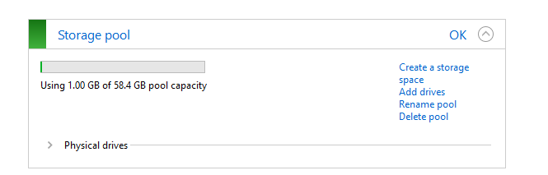
- Here we assign a name, a drive letter or label, and select the storage layout type. In this case, a two-way mirror (RAID 1) is chosen to ensure data redundancy by duplicating the information across two disks.
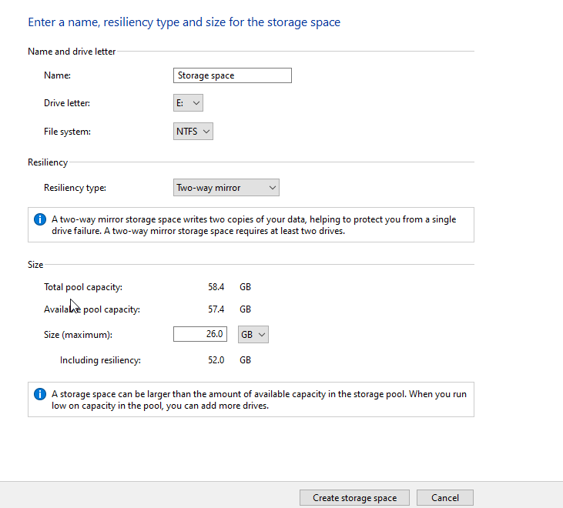
We verify that the configuration is correct, ensuring both disks are selected, the mirror layout is properly applied, and the storage space is ready to be created without errors.
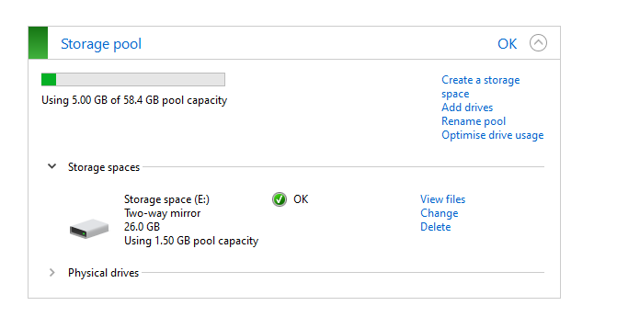
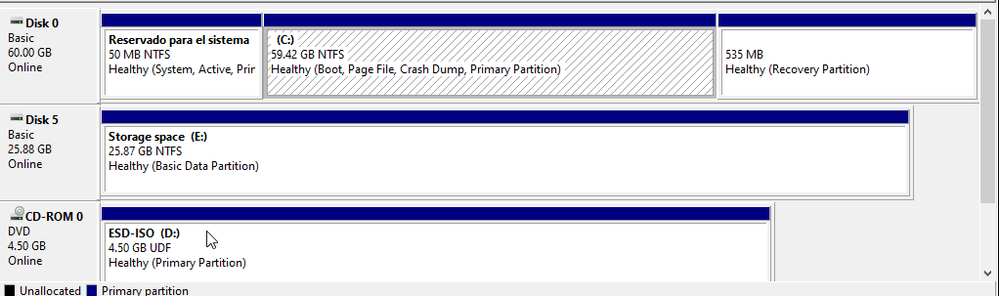

Conclusion

In this laboratory, various advanced storage solutions were successfully configured in Windows Server, transforming basic disks into dynamic ones to enable professional management features.
Through the implementation of mirrored (RAID 1), striped (RAID 0), and parity (RAID 5) volumes, it was validated how software-defined storage allows the infrastructure to be adapted to specific needs for redundancy, capacity, and access speed.
Importance of RAID:
- Fault Tolerance:
  - Configurations like RAID 1 and RAID 5 provide an essential safety net, allowing the operating system to continue functioning without data loss in the event of a physical disk failure.
- Performance Scaling:
  - The use of RAID 0 (striping) significantly increases read and write speeds by distributing the data load across multiple drives simultaneously.
- Space Optimization:
  - Creating spanned volumes allows for the fusion of fragmented or non-contiguous spaces from different physical disks into a single logical unit, maximizing usable capacity.
- Business Continuity:
  - RAID 5 offers a professional balance between security and cost, allowing information from a lost drive to be reconstructed using distributed parity bits.

