516-DaríoNL-PAR401-Sniffers
TAJAMAR | MADRID | 22/02/2026
Operations with Sniffers
PAR – Unit 4 - SNIFFERS

Index
Objectives 3
¿What is a sniffer? 3
Inventory 4
Execution 5
Part I 5
Preparation and Environment Setup 6
Wireshark (Windows) 8
NetworkMiner (Windows) 18
Microsoft Network Monitor 20
Wireshark (Ubuntu) 24
NetworkMiner Installation via Wine (Ubuntu) 25
Part II 27
Command-Line Analysis with tcpdump (Ubuntu) 28
Command-Line Analysis with WinDump (Windows) 33
Part III 39
Native Traffic Capture with netsh trace 39
Part IV 44
Advanced Network Monitoring with ntopng 45
Conclusion 51

Objectives

The main purpose of this practice is to familiarize with the most common network sniffers used in network management and to determine the necessary conditions for effective network monitoring.
We will learn to work with capture files in standard formats, search for specific information within those files, and develop a strong awareness of the professional ethics required when intercepting data.
Additionally, the practice aims to demonstrate real-world protocol behaviour, such as name resolution processes in Windows environments, through hands-on analysis.

¿What is a sniffer?

A sniffer, also known as a network analyser or packet interceptor, is a specialized tool used in network management to capture and monitor data traffic as it flows across a digital network.
By intercepting and logging the packets passing through a network interface, these tools allow administrators to analyse protocol behaviour, troubleshoot connectivity issues, and search for specific information within standard capture formats.
While they are essential for professional network diagnostics and learning about system conditions, their use requires a strong commitment to professional ethics due to their ability to intercept private communications.

Inventory

For the realization of the laboratory, we have used:
- Hardware:
  - Host PC.
- Software:
  - Sniffers:
    - WinPcap.
    - Wireshark.
    - Microsoft Network Monitor.
    - NetworkMiner.
    - TCPDUMP / Windump.
    - Npcap.
    - Ntopng.
    - netsh trace.
  - VMware:
    - Ubuntu Desktop 24.04.2.
    - Windows 11.

Execution

Part I

In this first part of our lab, we will dive into the world of graphical network sniffers.
We will explore how to install, configure, and utilize some of the most widely used tools in the industry to intercept and analyse network traffic.
Our focus will be on mastering the interface of:
- Wireshark.
- Microsoft Network Monitor.
- NetworkMiner.
By the end of this section, we will have a solid grasp of how data travels across different operating systems and how to filter that data to find exactly what we need.

Preparation and Environment Setup

Virtual Machines:
- We utilize a Windows virtual machine and an Ubuntu virtual machine to observe protocol behaviour across different operating systems.
Core Libraries:
- Before installing specific sniffers on Windows, we install WinPcap (or its modern successor, Npcap), which provides the necessary architecture for packet capture.
- https://www.winpcap.org/
Software Deployment:
- Wireshark:
  - We install the open-source version on Windows and via the standard repositories on Ubuntu.
  - https://www.wireshark.org/
- Microsoft Network Monitor:
  - We deploy this proprietary tool on the Windows machine.
  - https://www.microsoft.com/en-us/download/details.aspx?id=4865
- NetworkMiner:
  - We install this freeware on Windows.
  - As an advanced configuration, we utilize Wine to attempt its execution within the Ubuntu environment.
  - https://www.netresec.com/?page=NetworkMiner

Installation on Windows:
We have to execute the installations and we follow the assistant.
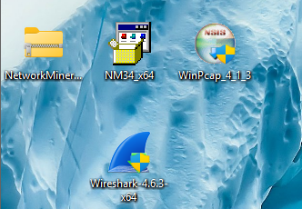
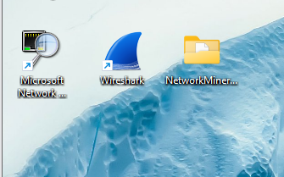
Installation on Ubuntu:
We have to install Wireshark using…
- sudo apt install wireshark
- First, we have to do an update and an upgrade.
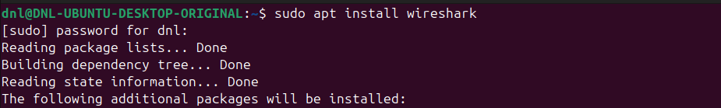

Wireshark (Windows)

We utilize Wireshark as our primary multi-platform tool for deep packet inspection.
To start we have to open Wireshark and select our Ethernet/Wi-Fi interface.
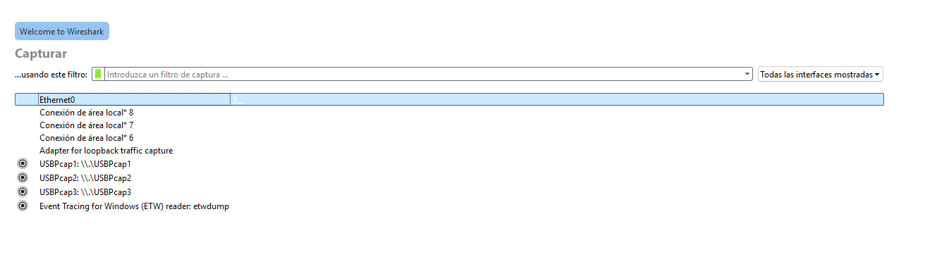

Traffic Generation

nslookup google.com (DNS traffic).
ping 8.8.8.8 (ICMP traffic).
Access http://neverssl.com in the browser (HTTP traffic).
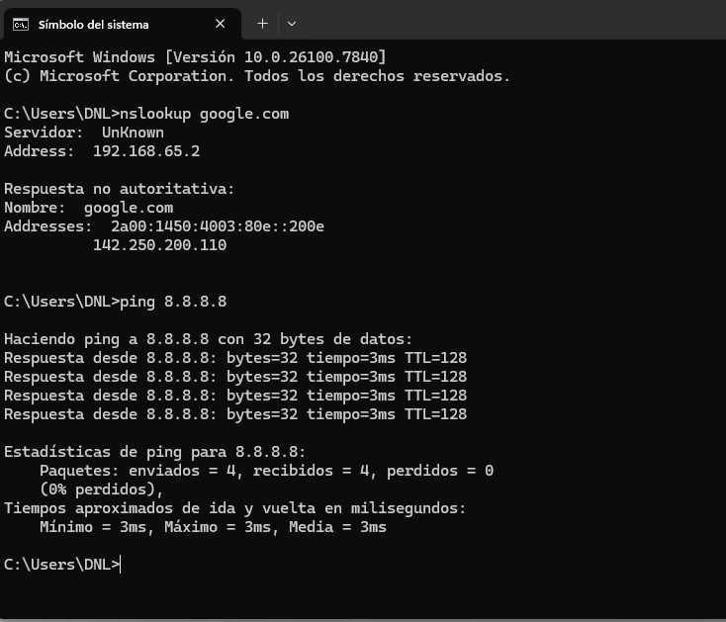
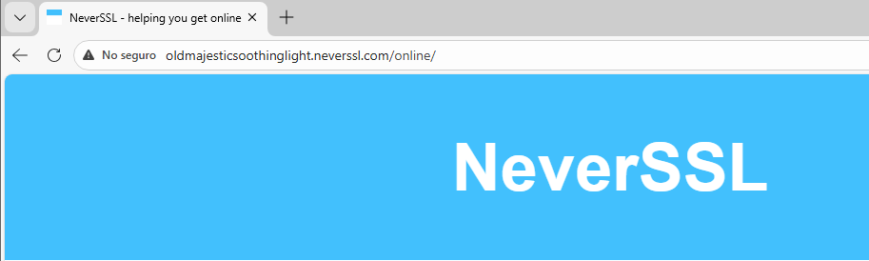

Advanced Filtering

Now are going to enter these filters one by one in the filter bar and observe the results.
DNS Analysis:
- We applied the dns filter to observe the name resolution process.
- As seen in our capture, we identified Standard queries for domains such as google.com originating from our host (192.168.65.146) and the corresponding Standard query responses from the DNS server (192.168.65.2).

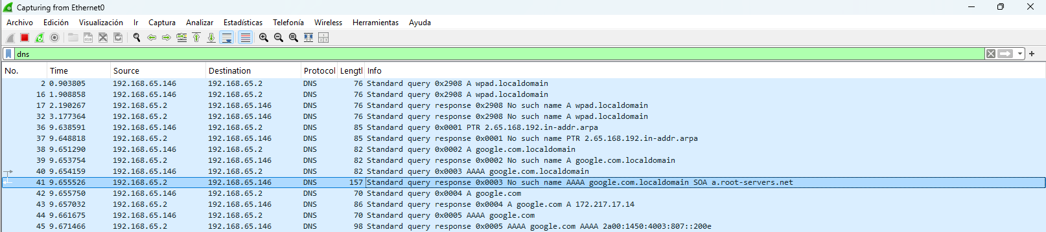

ICMP analysis:
We initiated a capture on the Ethernet0 interface to observe the behaviour of the Internet Control Message Protocol (ICMP).
By applying the icmp filter, we isolated a sequence of connectivity tests between our local host and an external server:
- Connectivity Test:
  - We observed a series of Echo (ping) requests sent from our source IP (192.168.65.146) to the destination (8.8.8.8), followed by their respective Echo (ping) replies.
- Sequence Integrity:
  - The capture shows a consistent flow of traffic with matching identifiers (id=0x0001) and incrementing sequence numbers, confirming a stable and successful network connection.

- IPv4 Header Analysis:
  - We analysed the Internet Protocol Version 4 header for Frame 335 (an Echo reply) to understand how the data is encapsulated and routed:
  - Version & Header Length:
    - The packet uses IPv4 (Version 4) with a header length of 20 bytes, which is the standard size when no optional fields are present.
  - Differentiated Services Field:
    - The value is 0x00, indicating that no specific Quality of Service (QoS) priority was assigned to this traffic.
  - Identification & Fragmentation:
    - The packet has a unique identification of 0x39a5 (14757).
    - The flags are set to 0x0, and the fragment offset is 0, meaning this packet is not a fragment.
  - Time to Live (TTL):
    - The TTL is set to 128, a typical default value for Windows-based systems, ensuring the packet does not circulate indefinitely if a routing loop occurs.
  - Protocol:
    - The header specifies protocol 1 (ICMP), which tells the receiving host to pass the payload to the ICMP process.
  - Source and Destination:
    - We verified the packet's origin at 8.8.8.8 and its delivery to our local address 192.168.65.146.
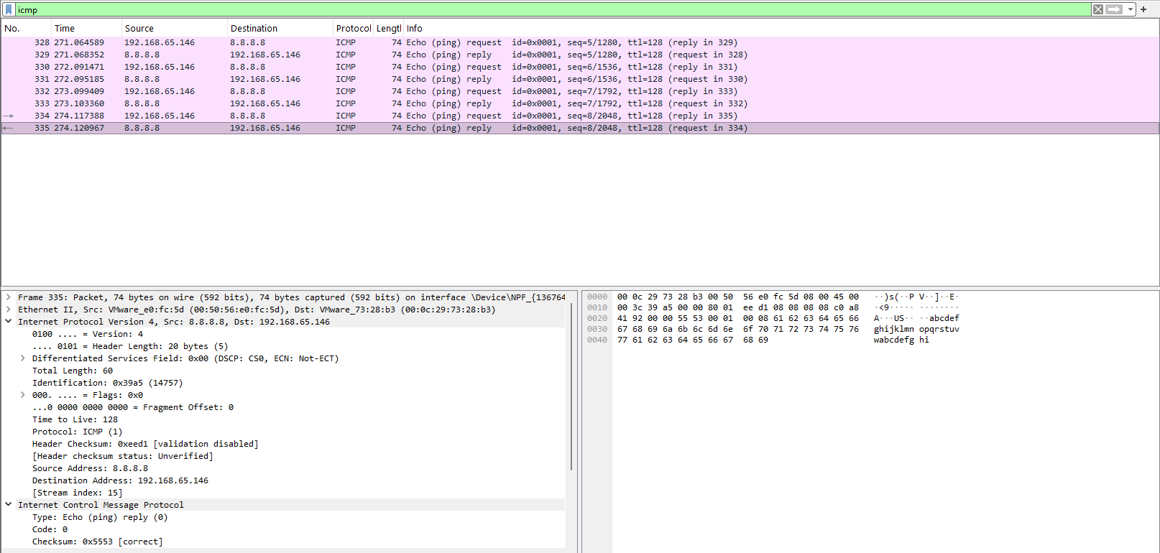

Analysis of HTTP Traffic:
http.request.method == "GET"
We analysed the Hypertext Transfer Protocol (HTTP) through a captured GET request to examine application-layer data and encapsulation.
- Request Details (Frame 3082):
  - Method:
    - A GET request was used to fetch /favicon.ico using HTTP/1.1.
  - Host:
    - The target was identified as…
    - freshsplendidtranscendentverse.neverssl.com.
  - User-Agent:
    - The client identified as a Windows system using a Chrome/145.0.0.0 browser.
  - Referer:
    - The request originated from…
    - http://freshsplendidtranscendentverse.neverssl.com/online/.

- Network Encapsulation:
  - Transport (TCP):
    - Communication occurred between local Source Port 51861 and Destination Port 80.
  - Network (IPv4):
    - Source: 192.168.65.146.
    - Destination: 34.223.124.45.
    - Flags: The Don't fragment bit was set (0x2).
    - TTL: The value was 128, consistent with the Windows network stack.

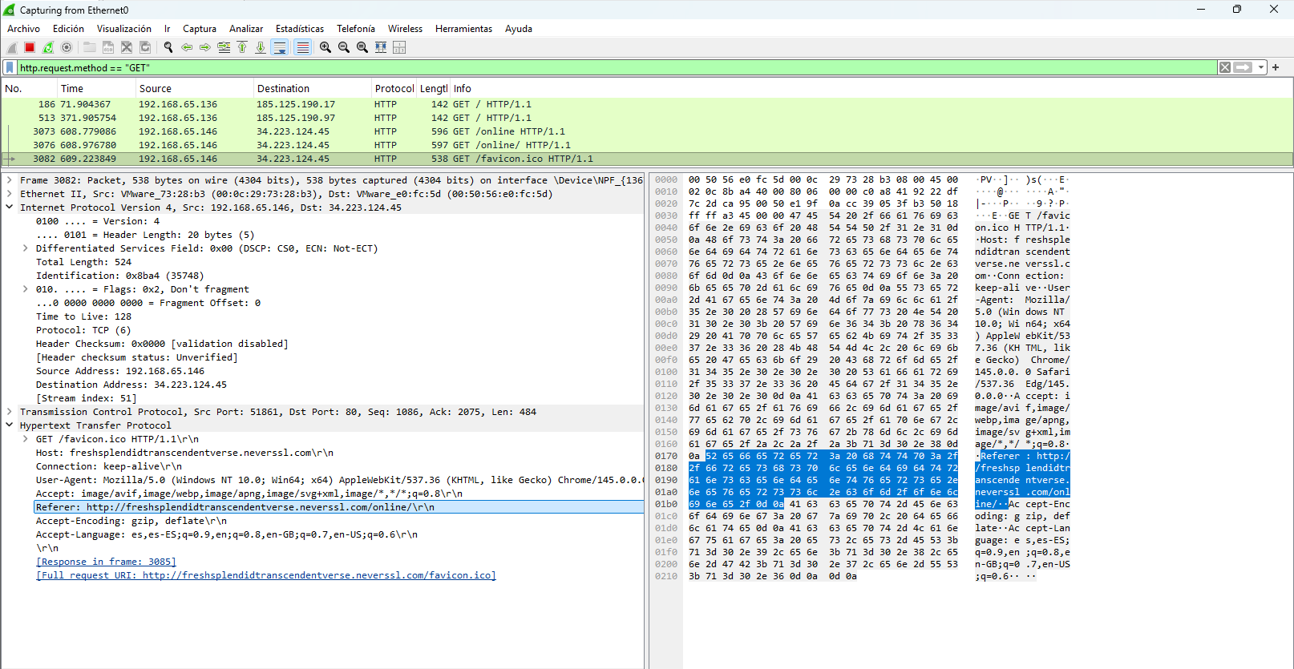

NetworkMiner (Windows)

We execute the sniffer like administrator.
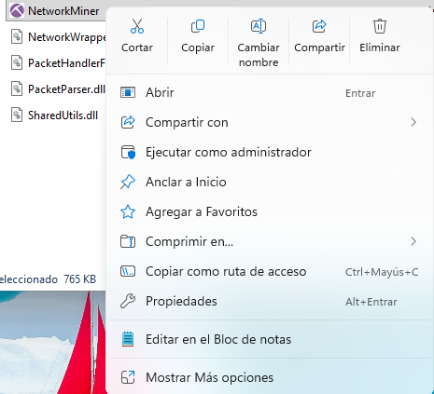
Next, we are going to select the network interface.
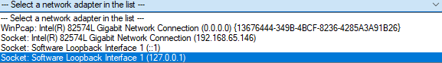
Generating Process Traffic:
- Terminal and run ping 8.8.8.8
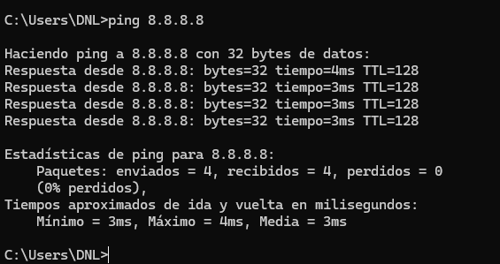

Capture of icmp:
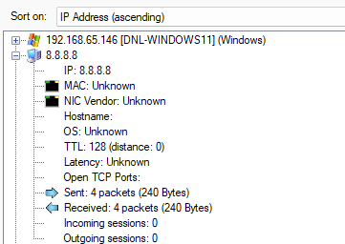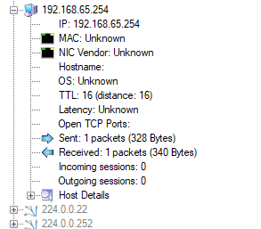

Microsoft Network Monitor

In this stage, we utilized Microsoft Network Monitor 3.4 to analyse network traffic from a process-centric perspective.
This tool provides a unique view by mapping frames directly to the local applications generating them.
Implementation Steps:
- We followed these procedures to execute the capture and analysis:
- Session Initiation:
  - We created a "New Capture" tab and selected the active network interface to begin real-time data collection.
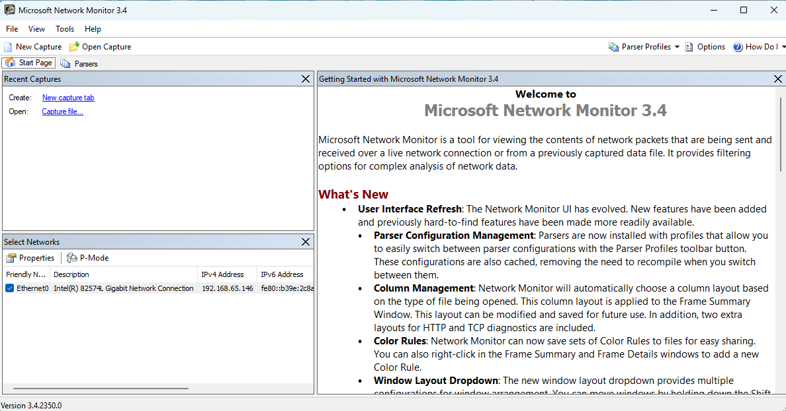

- Process-Level Mapping:
  - While the capture was active, we generated traffic by browsing and using system utilities.
  - We monitored the "Network Conversations" pane on the left, which automatically grouped packets by their originating process (e.g., msedge.exe, svchost.exe, or system).
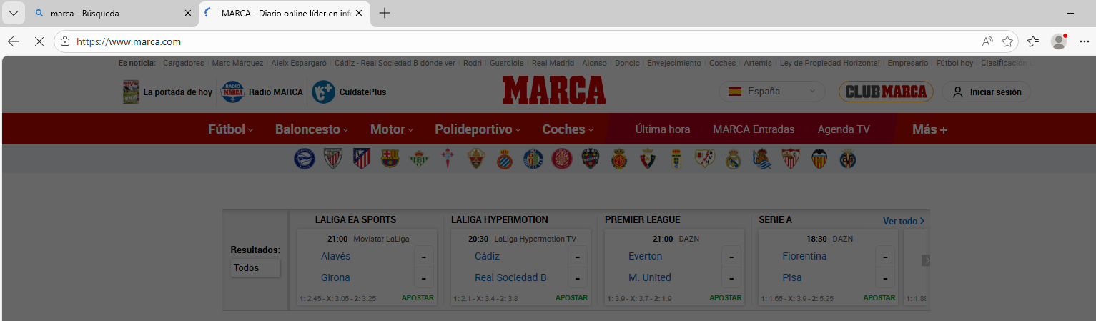
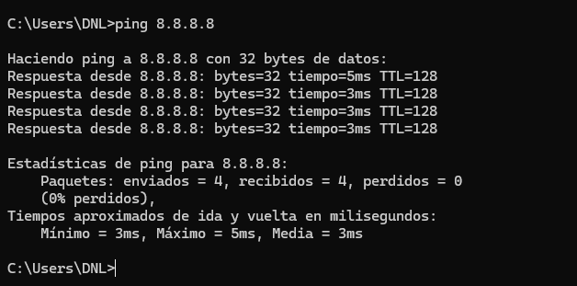
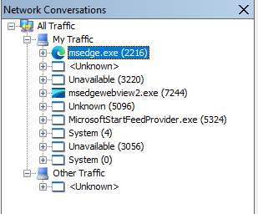
- Frame Inspection:
  - We selected specific frames from the "Frame Summary" to inspect their structure.
  - We used the "Frame Details" pane to view the protocol stack and the "Hex Details" to see the raw data bytes.
  - Analysis of Microsoft Network Monitor Capture:
    - Process Mapping:
      - We identified msedge.exe (PID 2216) as the primary traffic driver in the Network Conversations tree.
    - Protocol Stack (Frame 13689):
      - We verified the encapsulation sequence:
      - Ethernet II IPv4 TCP.
    - Packet Function:
      - The frame was an ACK on port 443, maintaining an encrypted session with 185.43.181.50.
    - Traffic Nature:
      - We observed a high frequency of TLS records, indicating active encrypted exchange.
    - Hex/Data View:
      - We inspected the Hex Details, finding readable headers but ciphertext payloads, confirming application-layer encryption.

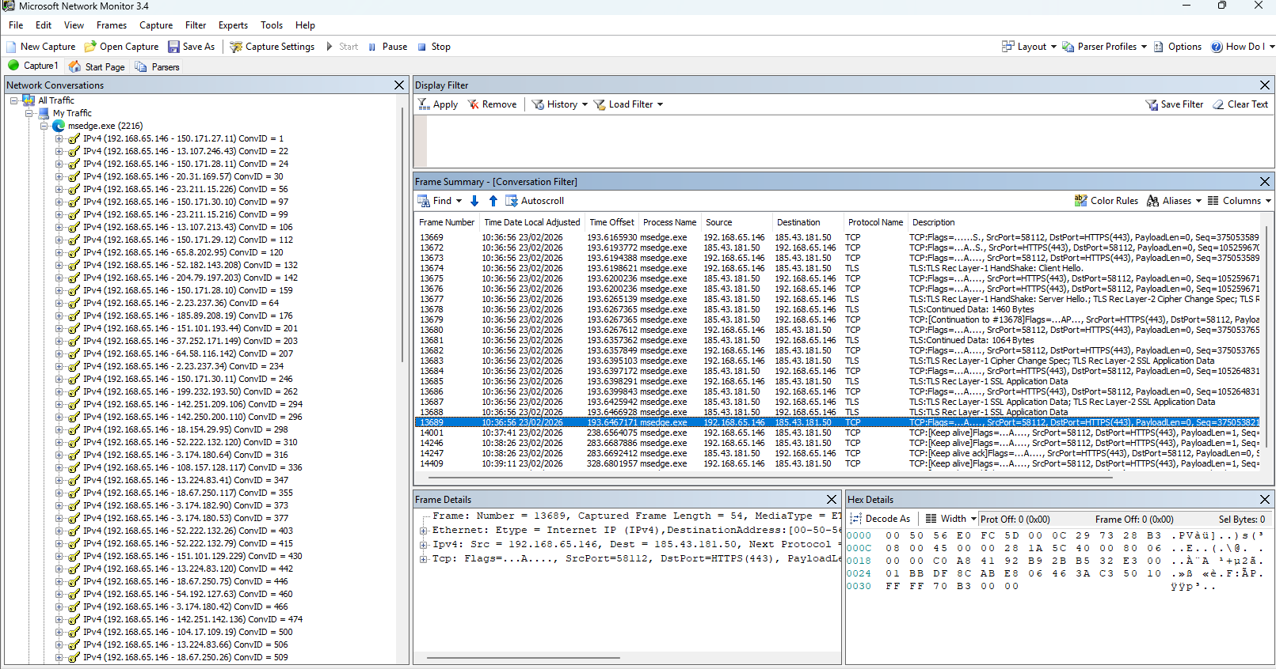

Wireshark (Ubuntu)

We are not going to work here, because is the same, this section is only for demonstrate that is possible to use it in Ubuntu.
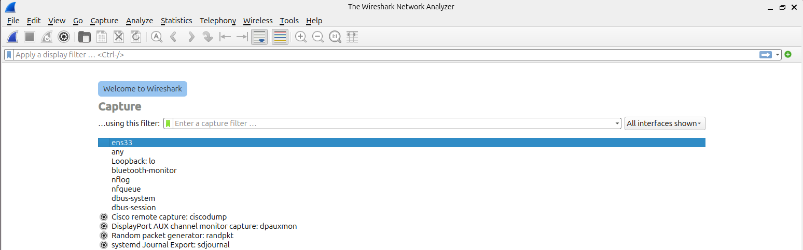

NetworkMiner Installation via Wine (Ubuntu)

In this section, we demonstrate the feasibility of executing Windows-native forensic tools within a GNU/Linux environment.
As the functional analysis of the tool was previously conducted in Windows, we focus here on the compatibility layer setup.
Install Wine:
- sudo apt install wine64
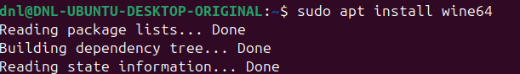
We download the NetworkMiner .zip file:
- From the official source, extract it, and navigate to the directory.
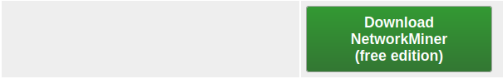
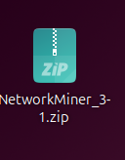

Prepare the Software:
- unzip … -d NetworkMiner
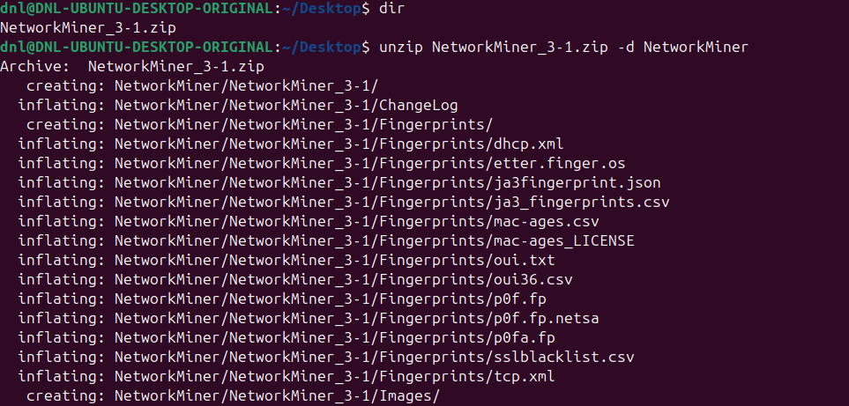
Execute the Application:
- cd NetworkMiner
- wine NetworkMiner.exe
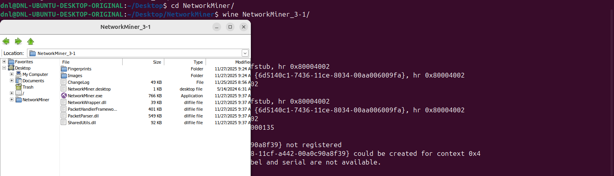
As established, we utilize this setup only to demonstrate cross-platform feasibility.
We will not perform further analysis here to avoid redundancy, as the tool's behaviour is identical to the Windows version.

Part II

In this phase, the laboratory moves from graphical tools to command-line network listeners, emphasizing precision, control, and efficiency in traffic analysis.
The objective is to master direct packet interception and filtering using lightweight utilities.
The practice introduces three tools:
- tcpdump
  - Native to GNU/Linux environments.
- WinDump
  - Windows equivalent of tcpdump.

Command-Line Analysis with tcpdump (Ubuntu)

In this section, we transition to tcpdump, a powerful command-line packet analyser.
We focus on executing targeted captures to minimize data noise and improve analysis efficiency.

Identification of Network Interfaces

Before capturing, we must identify the available network adapters.
We execute ip link to list the interfaces.
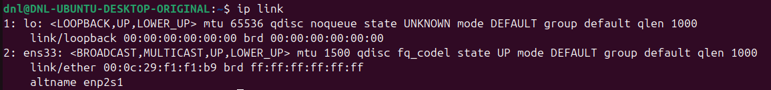
We identified the active interface (ens33) to be used as the target for our subsequent listening operations.

Basic Traffic Capture

A general capture was performed to verify the tool's ability to intercept packets in real-time.
The command sudo tcpdump -i [interface] was executed.
We have to open our browser.
A live capture was initiated on the primary interface.
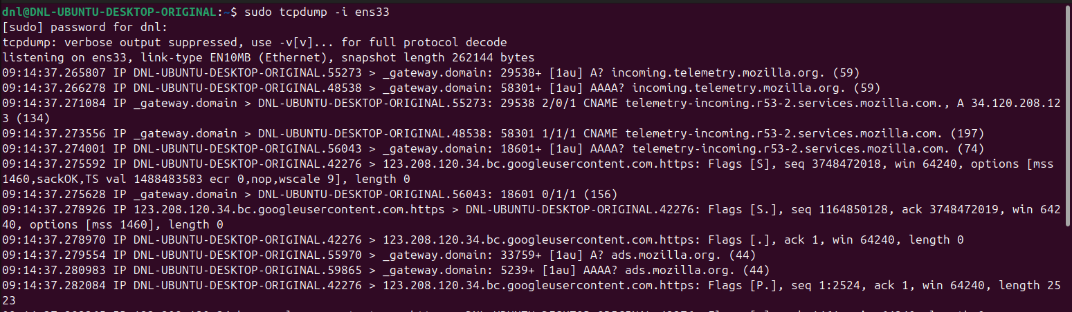
We observed the continuous stream of packets, including source/destination IP addresses and timestamps, confirming that the tool is correctly interfacing with the network stack.
The capture shows standard outbound DNS resolution followed by successful HTTPS connections to Mozilla/Google-hosted infrastructure, consistent with browser telemetry or background services.
No anomalous flags, malformed packets, or suspicious patterns are visible in the shown segment.

Implementing Advanced Filters

To find specific information within the traffic, we apply logic-based filters directly in the command syntax.
Filtering by Host:
- To capture traffic specifically involving a known host (our host), we use:
  - sudo tcpdump -i [interface] host [our IP]
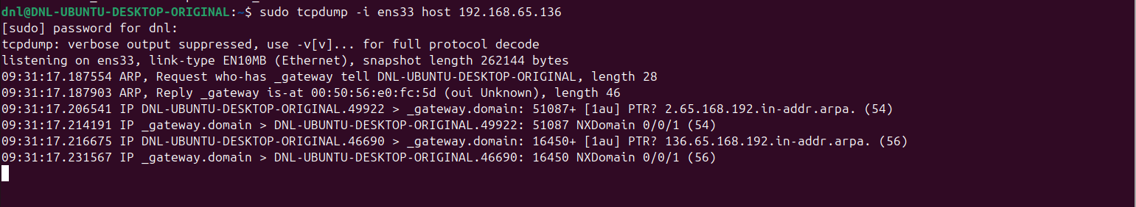
- We isolated all bidirectional traffic for the specified IP address.
- This allowed us to monitor the host's activity without the interference of background broadcast or multicast traffic.

Protocol-Specific Monitoring (Web and DNS):
- To monitor HTTP traffic, we execute:
  - sudo tcpdump tcp and port 80
  - http://neverssl.com
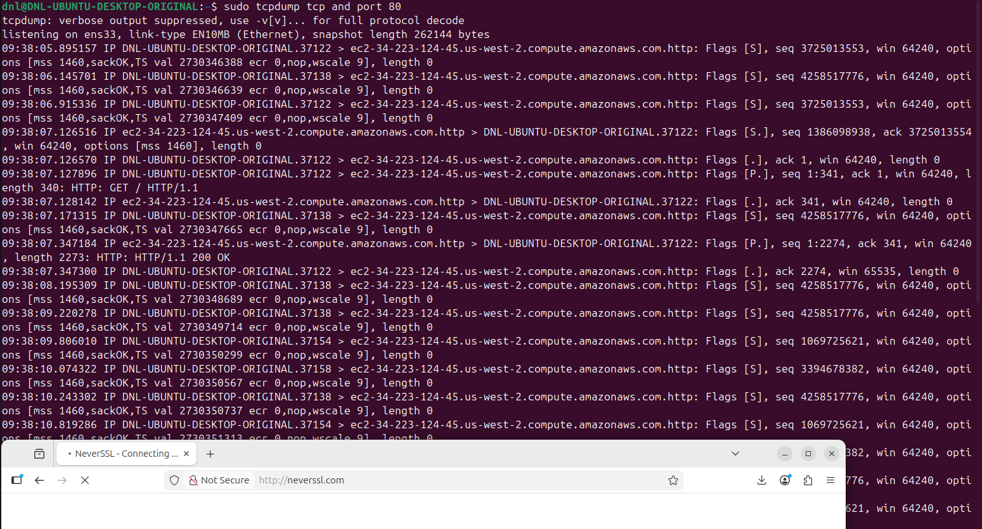

- To capture name resolution queries, we execute:
  - sudo tcpdump udp and dst port 53
  - nslookup google.com
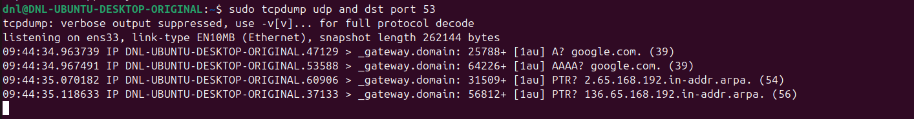
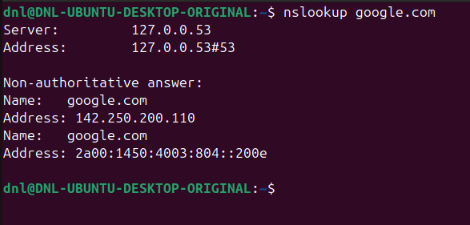
- We filtered the capture to isolate specific application-layer protocols.
- For web traffic, we observed TCP segments on port 80.
- For DNS, we tracked outgoing UDP requests to the DNS server's destination port 53.
Summary of Results:
- By utilizing tcpdump, we achieved a lightweight and highly specific capture environment.
- We verified that command-line filters provide the same granularity as graphical tools like Wireshark but with lower system overhead, making it ideal for remote server monitoring.

Command-Line Analysis with WinDump (Windows)

Following our work with tcpdump on Ubuntu, we implemented WinDump to perform similar command-line captures within the Windows environment.
Since WinDump is the Windows port of tcpdump, it allows us to maintain a consistent workflow across different operating systems.

Prerequisites and Setup

For this part is needed the software of Npcap.
https://npcap.com/#download
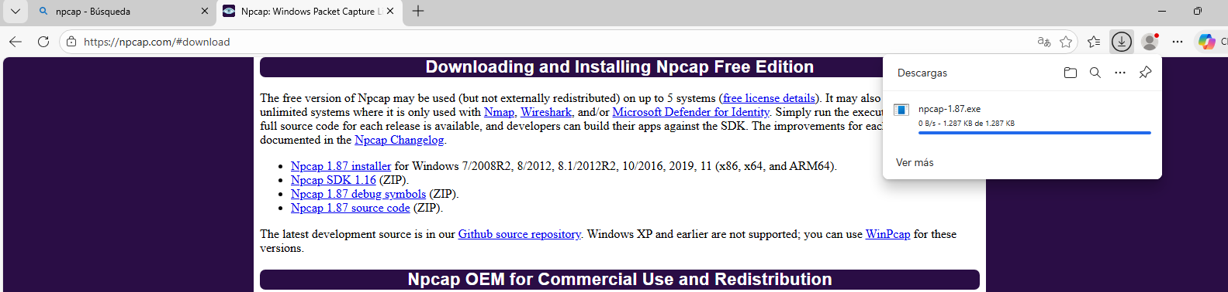
And is needed the installation of Windump.
https://www.winpcap.org/windump/
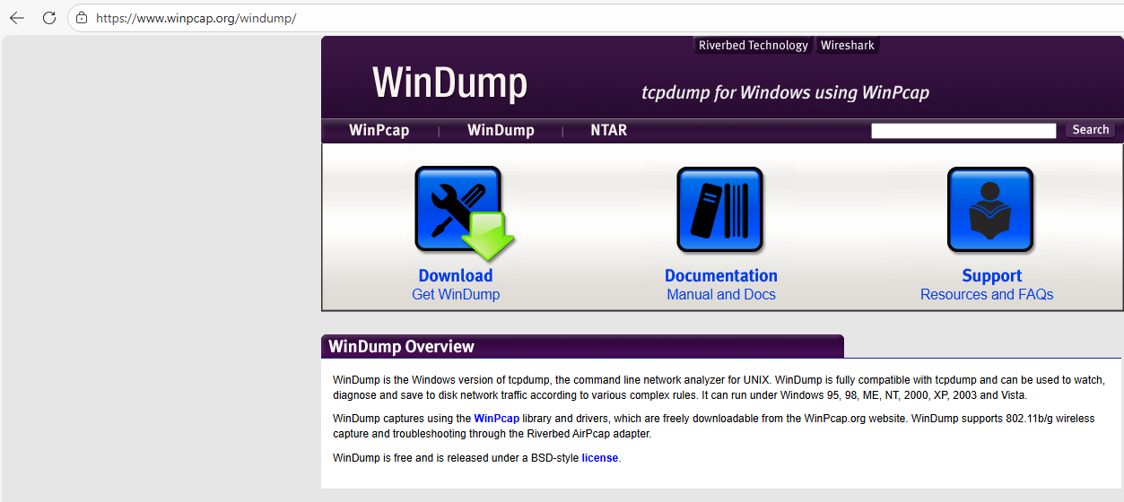

Identification of Interfaces

Unlike Linux where interfaces are named (e.g., eth0), Windows often uses complex identifiers.
- Access to the application.
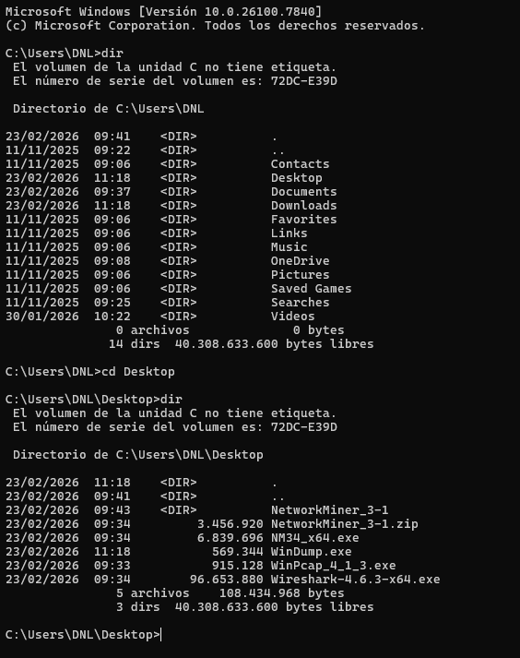
- The command windump -D was executed to list all available network adapters.
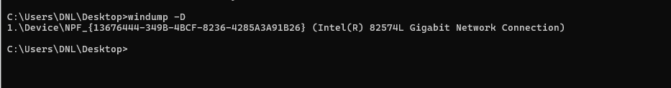
- We identified the numeric index corresponding to our primary network interface (1) to ensure we were listening on the correct hardware path.

Executing Targeted Captures

We applied the same filtering logic used in the Linux environment to observe traffic parity.
Interface Selection:
- We initiated a capture using:
  - windump -i [number]
  - Where the number corresponded to the index found in the previous step.
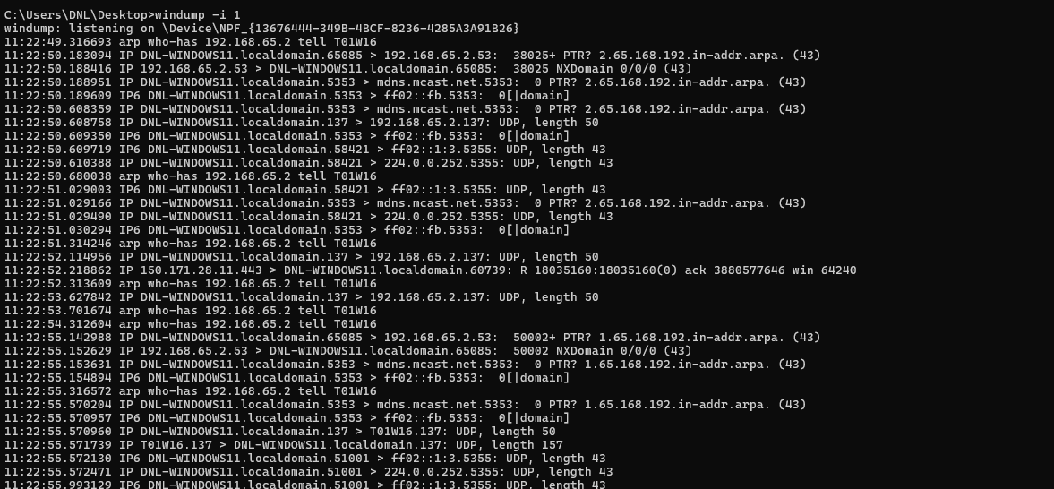

Filtering by Protocol:
- Web Traffic:
  - windump -i 1 tcp port 80
  - http://neverssl.com
  - To isolate unencrypted HTTP communications.
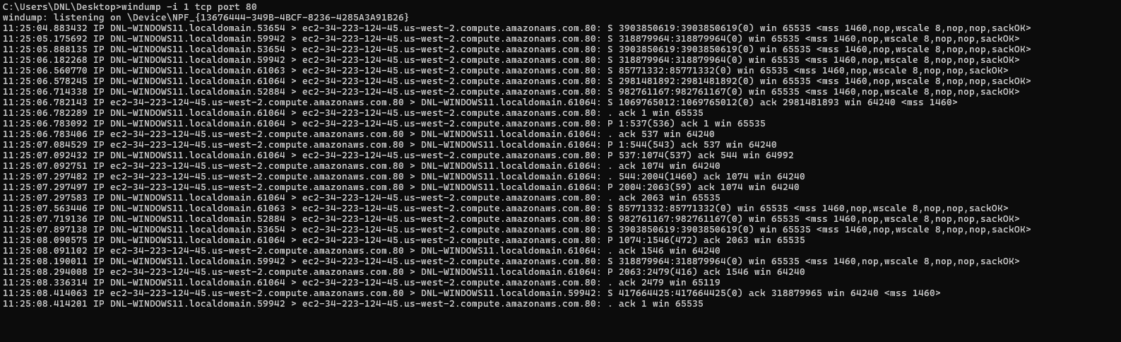
- DNS Queries:
  - windump -i 1 udp port 53
  - nslookup google.com
  - To monitor name resolution requests.
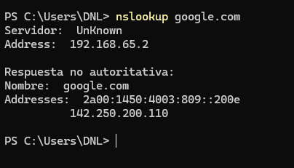
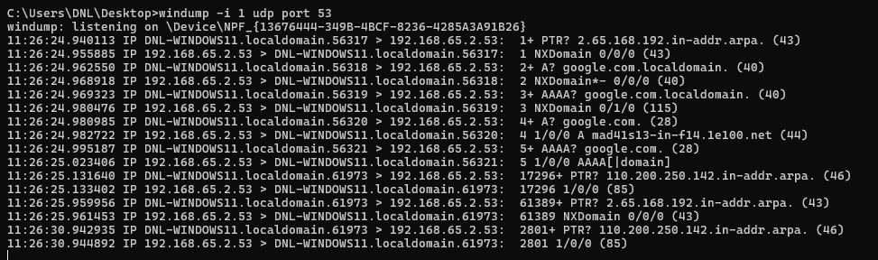

Observations and Comparison:
- We confirmed that the command syntax and output format are nearly identical to tcpdump, facilitating a seamless transition for administrators working in mixed-OS environments.
- We noted that WinDump provides a lightweight alternative for packet inspection on Windows servers where a graphical interface or the installation of Wireshark might not be feasible or desired.

Part III

In this third phase of the laboratory, we focus on advanced network sniffing techniques using native Windows utilities.
The primary goal is to perform traffic captures without the need for third-party software, leveraging the built-in capabilities of the operating system to troubleshoot and analyse network behaviour.

Native Traffic Capture with netsh trace

Implementation and execution:
- Directory Setup:
  - We create a dedicated storage folder, such as C:\SYSADMIT, to hold the resulting diagnostic files.
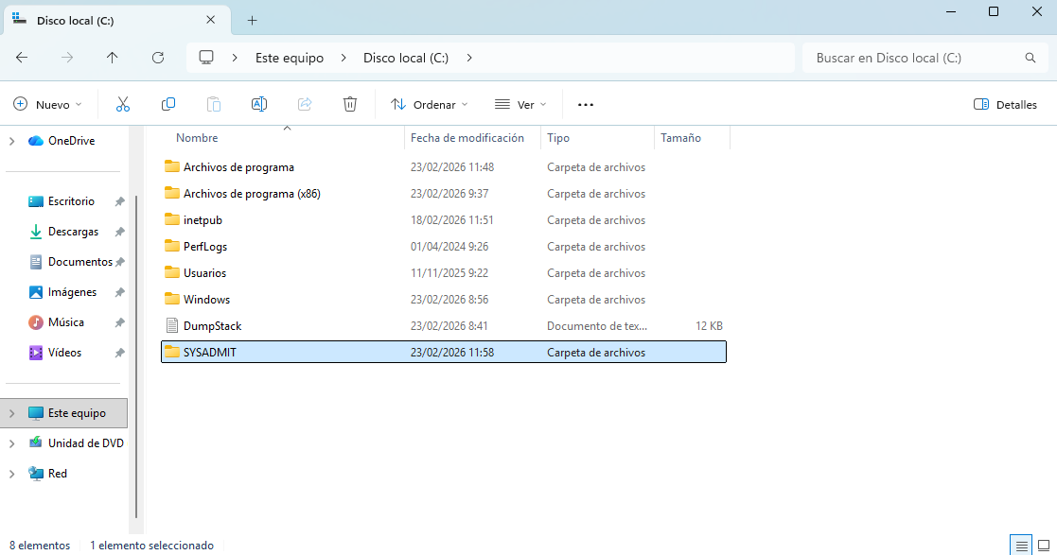

- Starting the Trace:
  - We initiate the capture using the following parameters:
    - netsh trace start persistent=yes capture=yes tracefile=C:\SYSADMIT\Trazas-Red.etl
  - Persistent Mode:
    - By setting persistent=yes, we ensure the capture remains active even across system reboots until manually stopped.
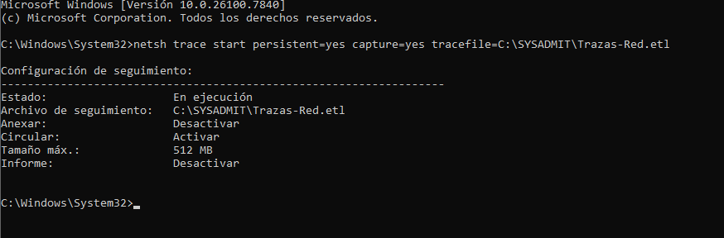
- Status Verification:
  - We monitor the capture progress using netsh trace show status.
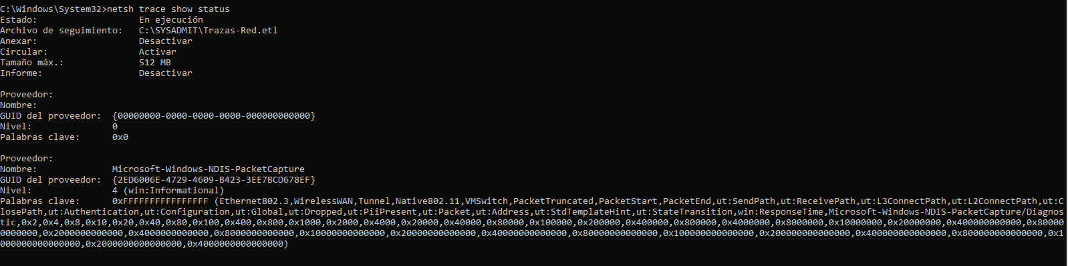

- Stopping the Trace:
  - Once the necessary traffic is collected, we conclude the operation with netsh trace stop.
  - (We will generate traffic as ping, browse and nslookup).
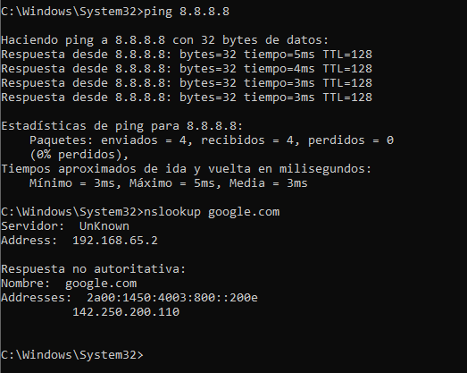
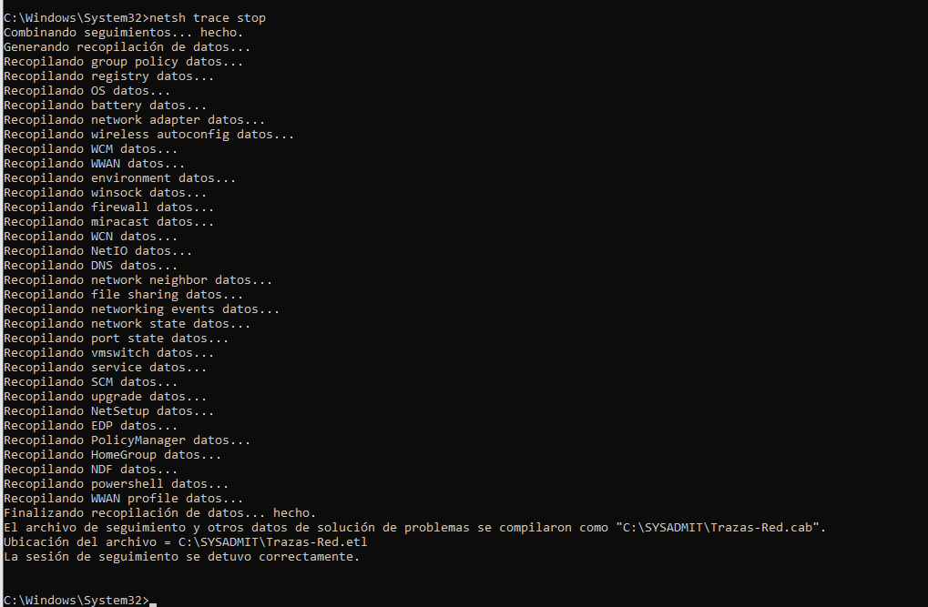

Analysis of Generated Artifacts

The operation results in two primary files that contain vital diagnostic information:
- ETL File (Event Trace Log):
  - This file contains the raw network traces.
  - We analyse it using a cmdlet, which allows for deep packet inspection and filtering (or instal Message Analyzer).
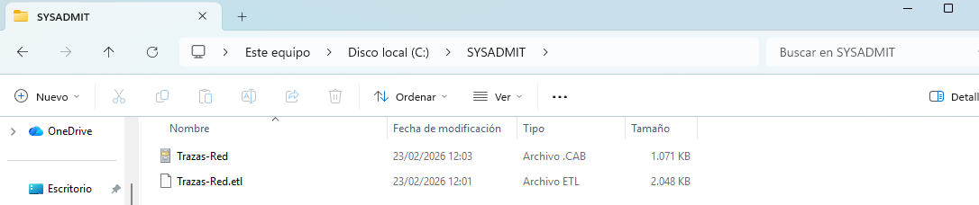
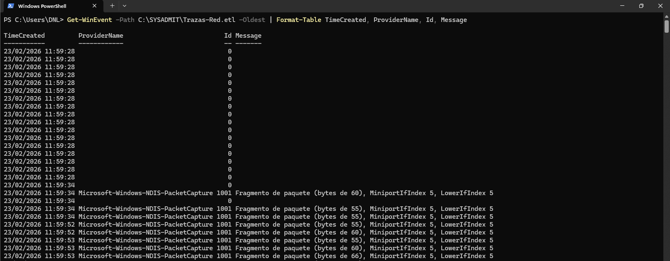

- CAB File:
  - This compressed archive contains various reports in TXT, XML, and EVTX formats.
  - Decompress:
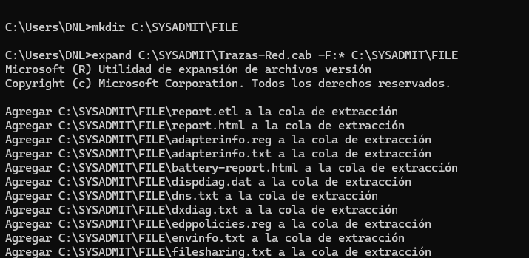
  - report.html:
    - We use this file as a central index to navigate through detailed configuration reports including DNS information, firewall rules, and adapter settings.
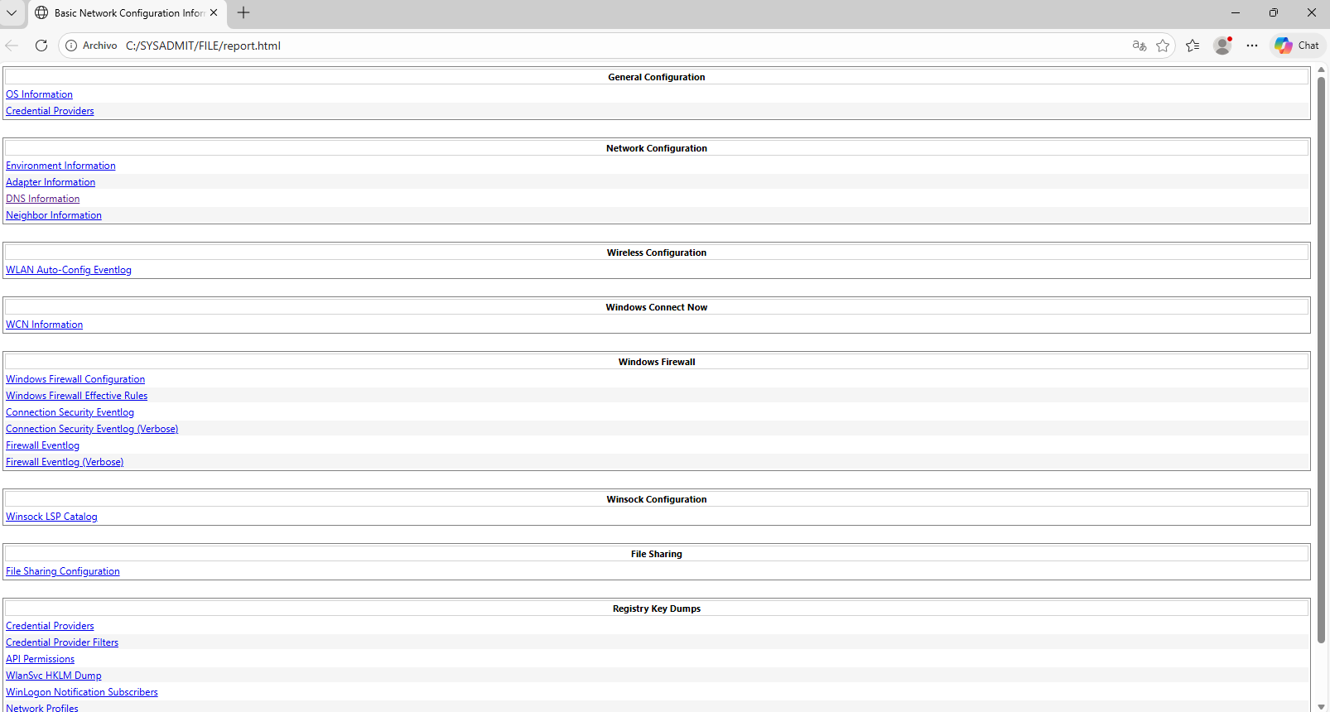

Part IV

In this final phase, we transition from packet-level sniffers to a high-level network monitoring solution.
We utilize ntopng, an open-source traffic analysis tool that provides a real-time web interface for monitoring network usage, similar to the Unix "top" command but focused on network flows.

Advanced Network Monitoring with ntopng

Deployment and Configuration on Ubuntu Server

We performed the installation on an Ubuntu Server environment to leverage its efficiency as a dedicated monitoring node.
Installation Process:
- Since ntopng is not available in the default Ubuntu repositories, we manually added the official ntop repository.
- Repository Setup:
  - We downloaded and installed the repository package:
    - wget https://packages.ntop.org/apt/24.04/all/apt-ntop.deb
    - sudo dpkg -i apt-ntop*.deb
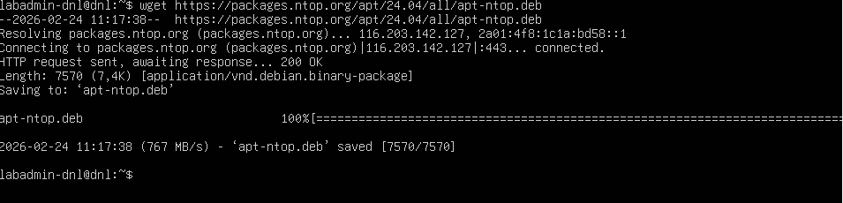
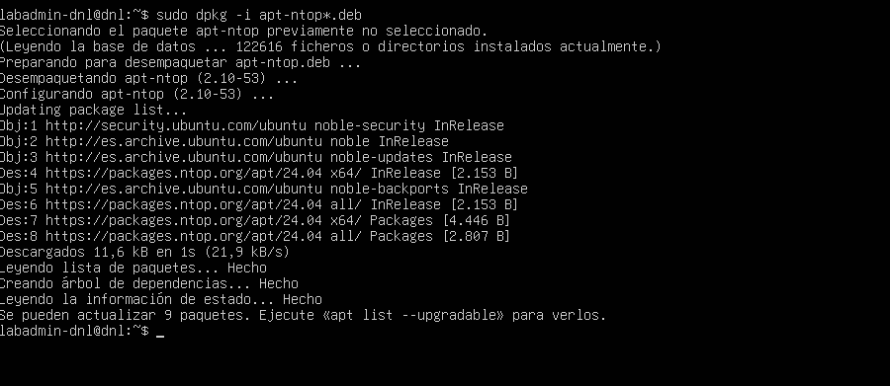

- Software Installation:
  - We updated our local package index and installed the core suite:
    - sudo apt update
    - sudo apt install pfring-dkms nprobe ntopng n2disk cento
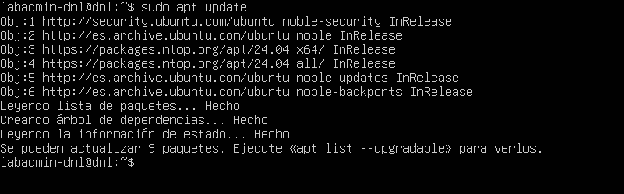
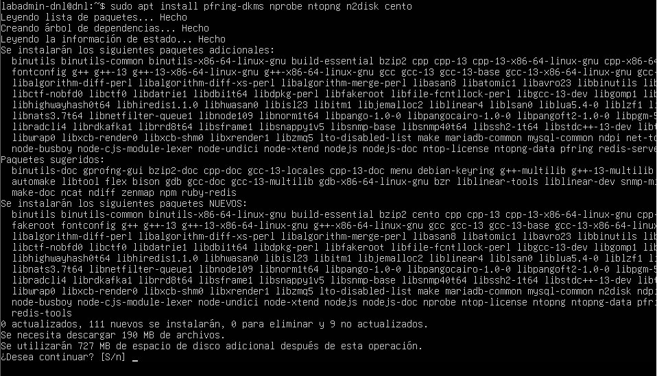

System Configuration and Service Startup

Main Configuration Adjustment:
- Accessing the configuration file was performed with the command:
  - sudo nano /etc/ntopng/ntopng.conf
- The PID (Process ID) file location was defined as:
  - -G=/var/run/ntopng.pid
  - To manage the service process effectively.
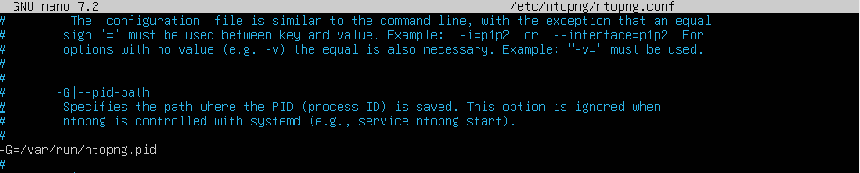
- Interface Selection:
  - The network interface used for monitoring was specified using the -i=ens33 parameter.
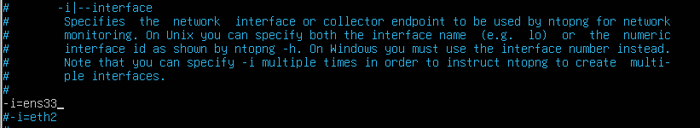
- Web Port:
  - The embedded web server was set to listen on HTTP port 3000 via the -w=3000 directive.
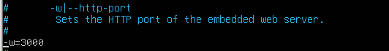

Defining Local Network Scope:
- A secondary file was created and edited using:
  - sudo nano /etc/ntopng/ntopng.start
- The local IP range was added to the configuration:
  - --local-networks "192.168.0.0/24"
  - To ensure the tool distinguishes between internal and external traffic.
- The active monitoring interface was confirmed by adding:
  - --interface 1
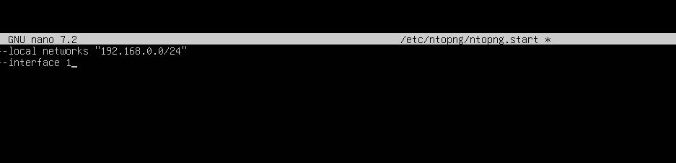
Activating the Monitor:
- Applying the new settings required a service restart using:
  - sudo systemctl start ntopng
- Persistent monitoring was ensured by enabling the service to launch automatically during the boot sequence with:
  - sudo systemctl enable ntopng
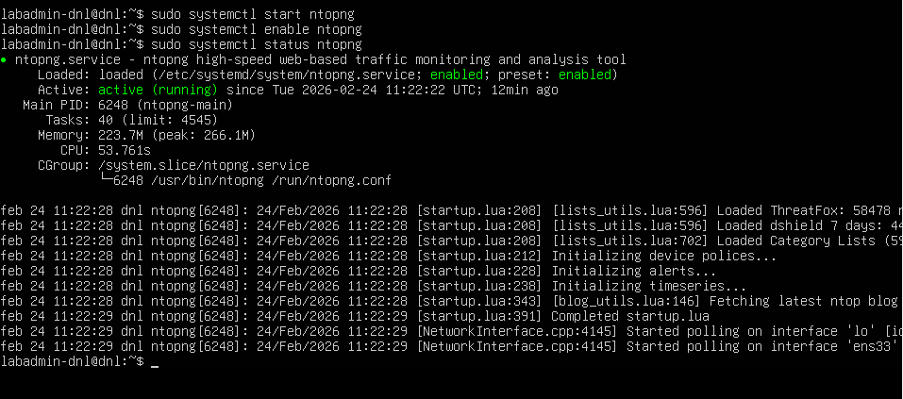

Web Interface and Real-Time Monitoring

With the service active, we accessed the analytical dashboard to observe live traffic.
Access to http://[server-ip]:3000 via a web browser.
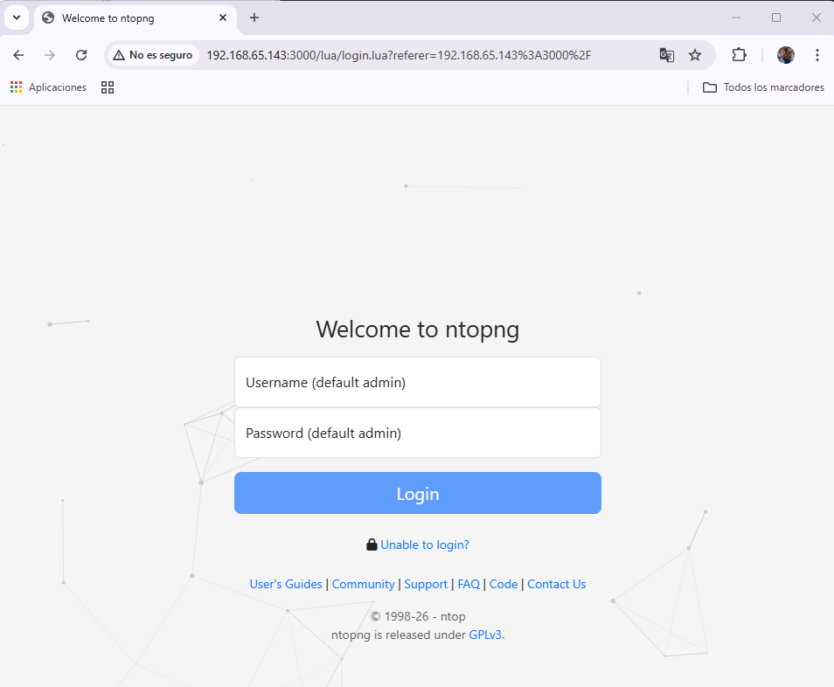
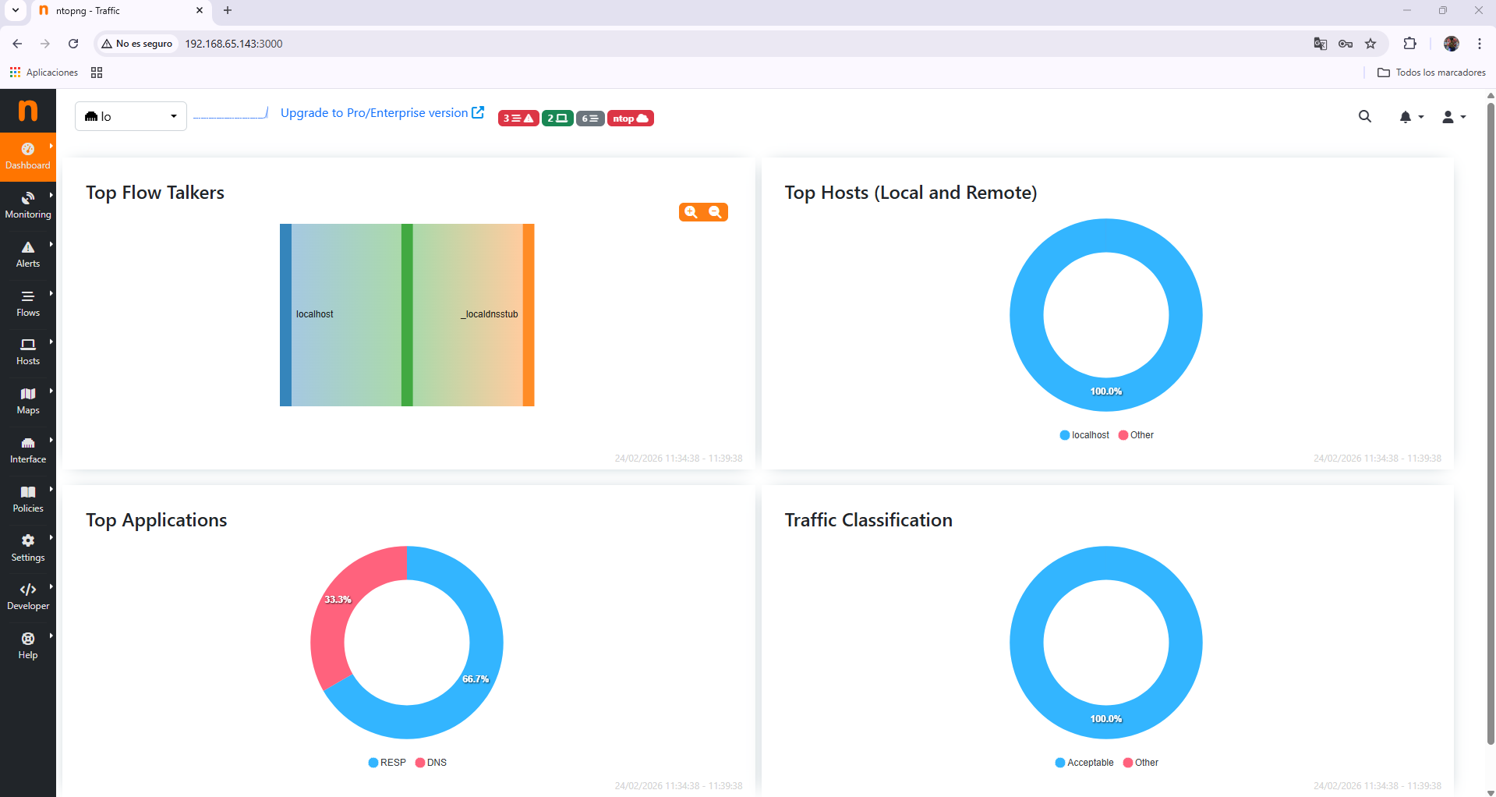

Conclusion: Analytical Capabilities of ntopng

The deployment of ntopng provides a high-level perspective of network behavior that complements the packet-level detail found in tools like Wireshark.
The following capabilities summarize what can be achieved with this platform:
- Real-Time Flow Monitoring:
  - The web interface allows for the continuous observation of network usage, showing active communication flows in a format similar to the Unix "top" command.
- Traffic Characterization:
  - The tool identifies and categorizes network traffic, making it possible to distinguish between local and external data exchanges based on the defined IP ranges.
- Performance Metrics:
  - It provides immediate visibility into bandwidth consumption by specific hosts or protocols, facilitating the identification of network bottlenecks or unusual activity.
- Multi-Platform Flexibility:
  - While implemented here on Ubuntu Server, the availability of versions for Windows and other Unix-based systems ensures a standardized monitoring workflow across diverse infrastructures.
- Scalability:
  - By utilizing a web server listening on a specific port (e.g., 3000), the network status becomes accessible remotely, allowing administrators to audit the network without requiring direct console access to the monitoring node.

Conclusion

The completion of this four-part laboratory has provided a comprehensive mastery of network traffic analysis across multiple environments and toolsets.
The following points summarize the professional knowledge and technical skills acquired:
- Strategic Tool Selection:
  - We established that tool choice depends on the environment; Wireshark provides depth for debugging, while tcpdump and WinDump offer lightweight efficiency for terminal-based management.
- Layered Network Visibility:
  - The workflow demonstrated visibility at every level, from hardware identification with Fing and protocol forensics in NetworkMiner to real-time flow analysis via ntopng.
- Native Diagnostic Power:
  - Utilizing netsh trace proved that critical troubleshooting and standardized reporting (ETL/CAB) can be performed using built-in Windows utilities without third-party software.
- Cross-Platform Parity:
  - Implementing tools across Windows and Ubuntu including the use of Wine confirmed our ability to maintain a consistent monitoring standard in heterogeneous infrastructures.
- Professional Ethics:
  - The practice reinforced that packet interception is a high-responsibility task, requiring strict adherence to authorized monitoring scopes and the protection of data privacy.

