516-DaríoNL-ISO304-Repair
TAJAMAR | MADRID | 18/03/2026
Multi Disk
ISO – Unit 3 – Multi Disk

Contenido
Introduction 3
Roadmap 4
Theoretical Introduction 5
GParted: The Disk Surgeon 5
The Multi-Disk Installation Strategy 5
Inventory 6
Execution 7
Phase 0: Virtual Hardware Preparation 7
Phase 1: Partition Design (GParted) 9
Initializing the Raw Hardware 9
The Multi-Disk Allocation Map 10
Phase 2: Primary Installation & Data Generation 14
Verification of disks in the installed OS 22
Phase 3: Critical Restructuring and Reinstalation 23
Phase 5: Final Audit 26
Conclusion 27
Executive Summary of the Process 27
Technical Evaluation of Multi-Disk Installations 27
Integrity of Persistent Data 28

Introduction

The objective of this lab is to explore the Linux file system hierarchy and block device management through a multi-disk installation strategy.
Unlike a standard single-drive setup, we will implement physical segmentation of the system directories to demonstrate modularity and data security.
By executing a “clean-break” scenario (installing, intentionally modifying the partition structure, and then reinstalling) we will validate how separating the user environment (/home) from the operating system (/) allows for seamless OS upgrades or recoveries without risking personal data loss.

Roadmap

Phase 0: Virtual Hardware Preparation.
- Configuring a VM with three independent Virtual Hard Disks.
- 4GB, 15GB, and 3GB.
Phase 1: Partition Design (GParted).
- Visual orchestration of the disks via Live CD to define the roles of each unit before deployment.
Phase 2: Primary Installation & Data Generation.
- Manual installation of Ubuntu (assign each file at the correct partition) and the creation of a “control file” within the user’s home directory.
Phase 3: Critical Restructuring and Reinstalation
- Booting back into the Live CD to “break” the system by deleting /var and relocating the swap partition.
- Running the installer again on the modified structure, using the “No Format” technique to preserve the existing /home.
Phase 5: Final Audit.
- Verifying data persistence through terminal commands and disk mapping.

Theoretical Introduction

GParted: The Disk Surgeon

GParted (GNOME Partition Editor) is the industry-standard tool for graphical partition manipulation.
In this lab, it is vital because it allows us to:
- Visualize disk geometry before the installer takes control.
- Assign Labels and File Systems (Ext4, Swap) with granular precision.
- Modify the partition table (deleting or moving volumes) without the restrictions of a running operating system.

The Multi-Disk Installation Strategy

Installing Linux across multiple physical disks is not just about capacity.
It is a Systems Architecture strategy:
Directory | Lab Role | Technical Justification
/boot | Bootloader | Contains the Kernel. Isolated to prevent main disk failures from blocking the boot process.
/ (Root) | System | The OS environment. Can be wiped/formatted during major upgrades without collateral damage.
/home | User Data | The “trunk of the car.” By residing on a separate physical disk (HD3), it survives even if the OS disk is destroyed.
swap | Virtual RAM | Temporary overflow for RAM. Its location is flexible and does not affect user data.

Inventory

For the realization of the laboratory we have used:
- Hardware:
  - Host PC.
- Software:
  - VM of VMware:
    - Live CD Ubuntu 24.04.2.
    - Live CD Ubuntu 20.04.2.
  - GParted.

Execution

Phase 0: Virtual Hardware Preparation

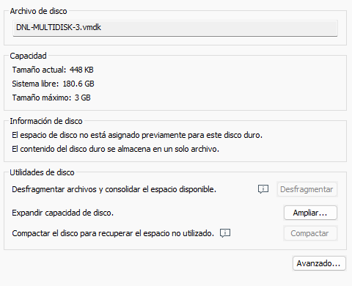
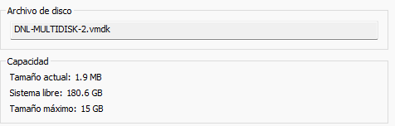
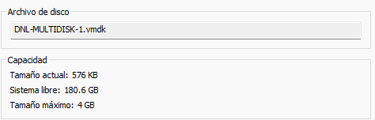
We prepared the MV discs, and execute the Live CD of Ubuntu.
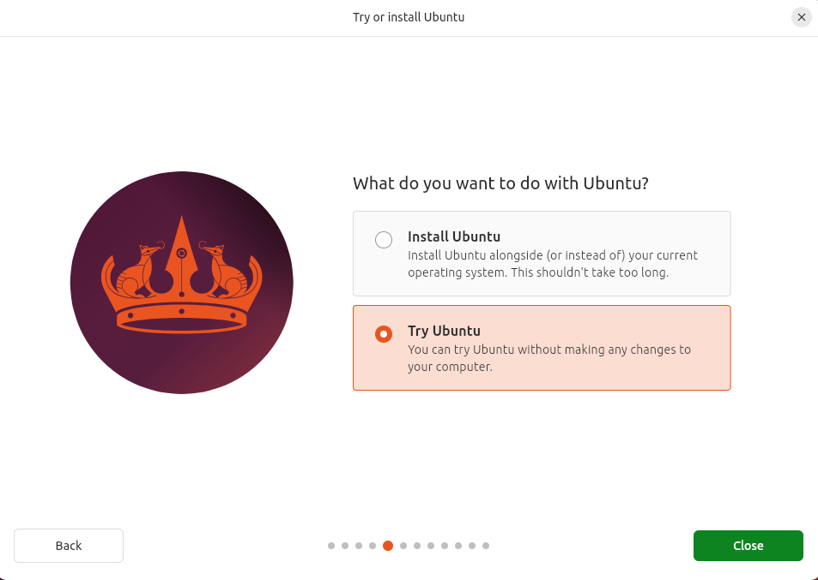

Phase 1: Partition Design (GParted)

Before the installation begins, we use GParted to perform “pre-operative” surgery on our storage.
This ensures that the Linux installer follows our specific map rather than choosing its own defaults.

Initializing the Raw Hardware

For each of the three virtual disks, we must first “initialize” them.
This involves creating a Partition Table (MBR because our system is BIOS).
Without this step, the disks are just raw space that the installer cannot organize.
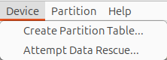
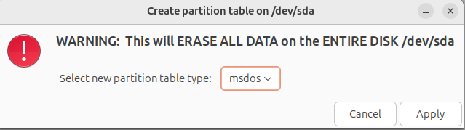

The Multi-Disk Allocation Map

We will carve out the following specific volumes across our hardware:
- HD1 (4 GB) - The Boot & System Utility Hub:
  - /boot (200 MB):
    - This small, dedicated slice holds the Linux Kernel and GRUB bootloader files.
    - Isolating it ensures the system can always find its “start” instructions.
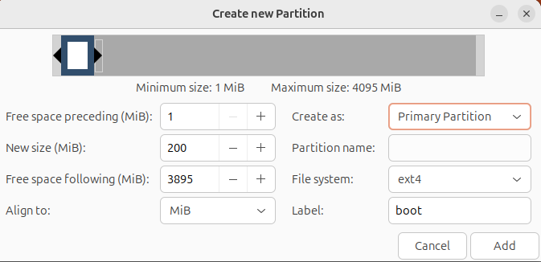
  - /var (2 GB):
    - This partition acts as a repository for variable data (logs, spool files, and databases).
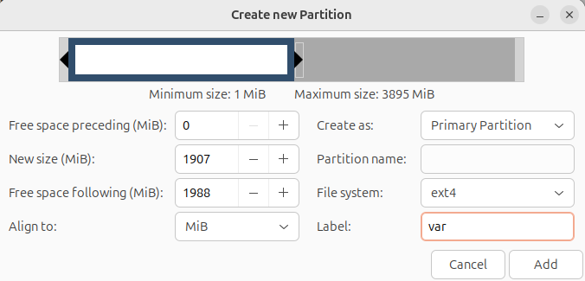

  - Swap (256 MB):
    - Set up within a Logical Partition, this serves as the system's “emergency” virtual memory.
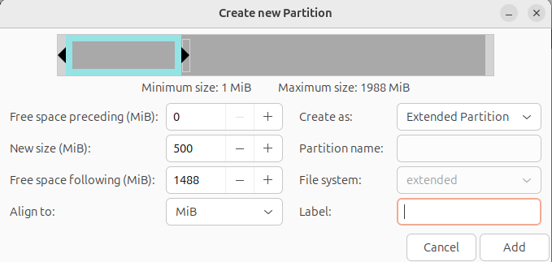
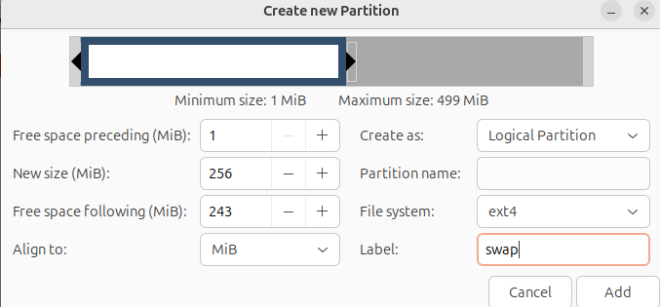
  - Note:
    - We leave the remaining space unallocated for future flexibility.
We have to apply the operations.
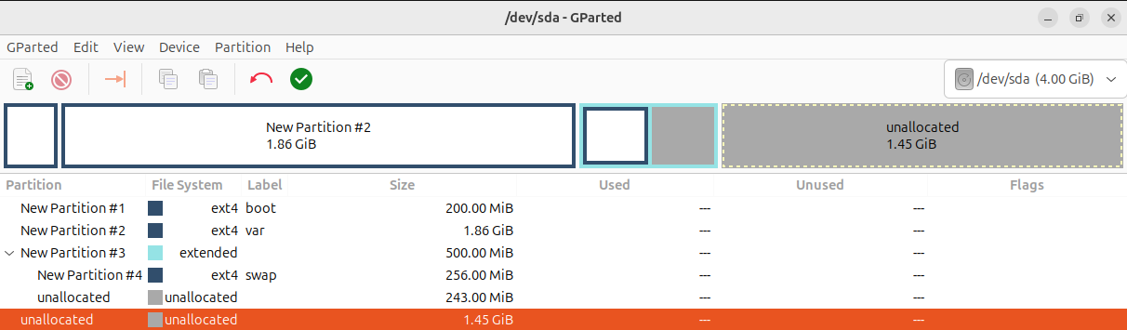

- HD2 (15 GB) - The OS Core:
  - Root ( / ):
    - This is the “brain” of the operation.
    - It will house the entire operating system, applications, and libraries, excluding the directories we’ve moved to other disks.
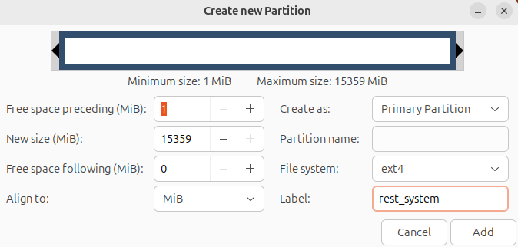

- HD3 (3 GB) - The User Sanctuary:
  - /home (1 GB):
    - We will create a 1 GB partition specifically for user documents and settings.
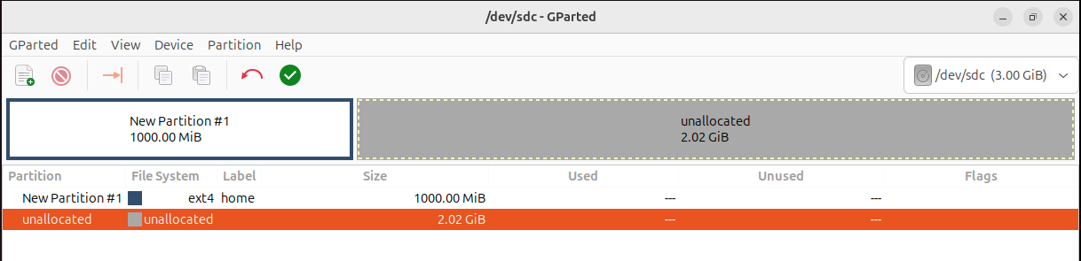
- Strategic Gap:
  - By only using 1 GB out of the 3 GB available, we leave unallocated space that will be used in Phase 4 to relocate the swap partition, proving that we can move system components without touching our private data.

Phase 2: Primary Installation & Data Generation

After creating the partition scheme using GParted, the installation of Ubuntu is started.
The process continues normally through the initial setup steps until reaching the disk configuration stage.
At this point, when the system prompts for how to manage disk partitioning, the manual option is selected instead of automatic partitioning.
This ensures that the previously defined partitions are used correctly according to the required structure, allowing precise control over mount points and disk usage.
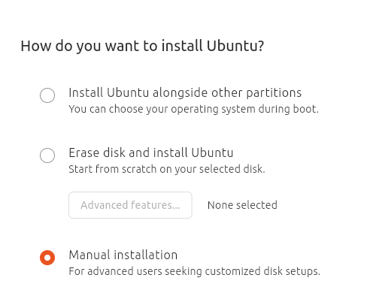

The following scheme defines how the Ubuntu system is distributed across multiple disks to achieve better organization, isolation of critical components, and flexibility for future changes.
Each disk is assigned a specific role, separating system boot files, core operating system data, and user information.
This structure improves system stability and simplifies maintenance by preventing different types of data from interfering with each other.
Procces:
- Select partition.
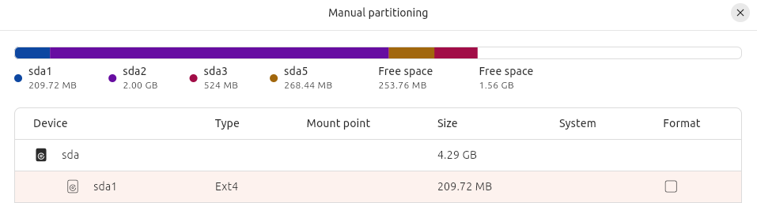
- “Change”.

- Select mount point.
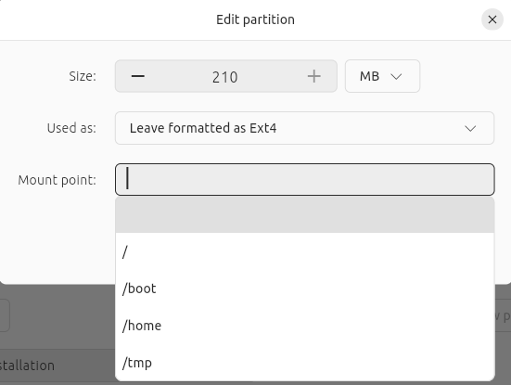
Partition Scheme Overview:
- HD1 (4 GB):
  - /boot (200 MB).
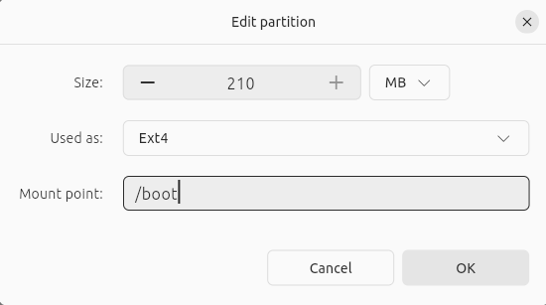
  - /var (2 GB).
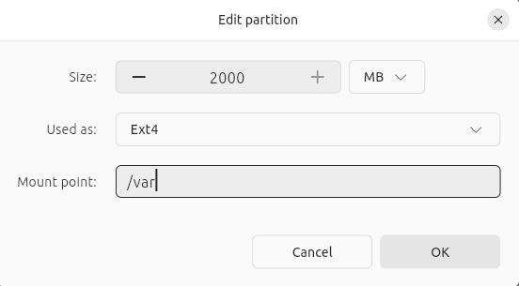
  - swap (256 MB, logical partition).
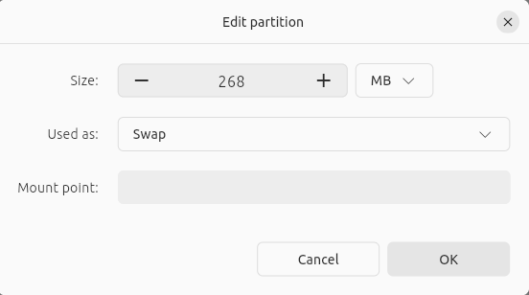

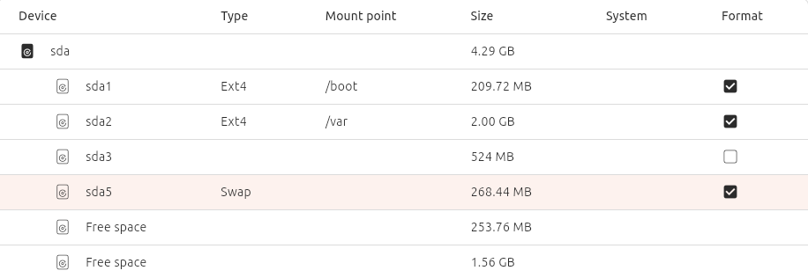

- HD2 (15 GB):
  - / (root)
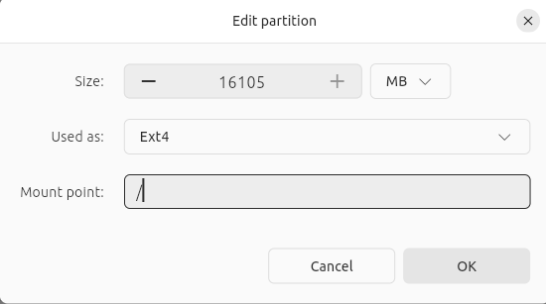
- HD3 (3 GB) – User Data:
  - /home (1 GB)
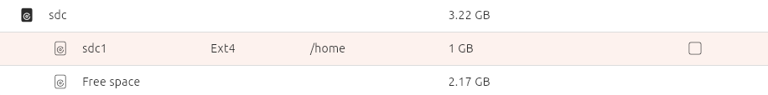
Bootloader in HD1:
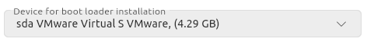

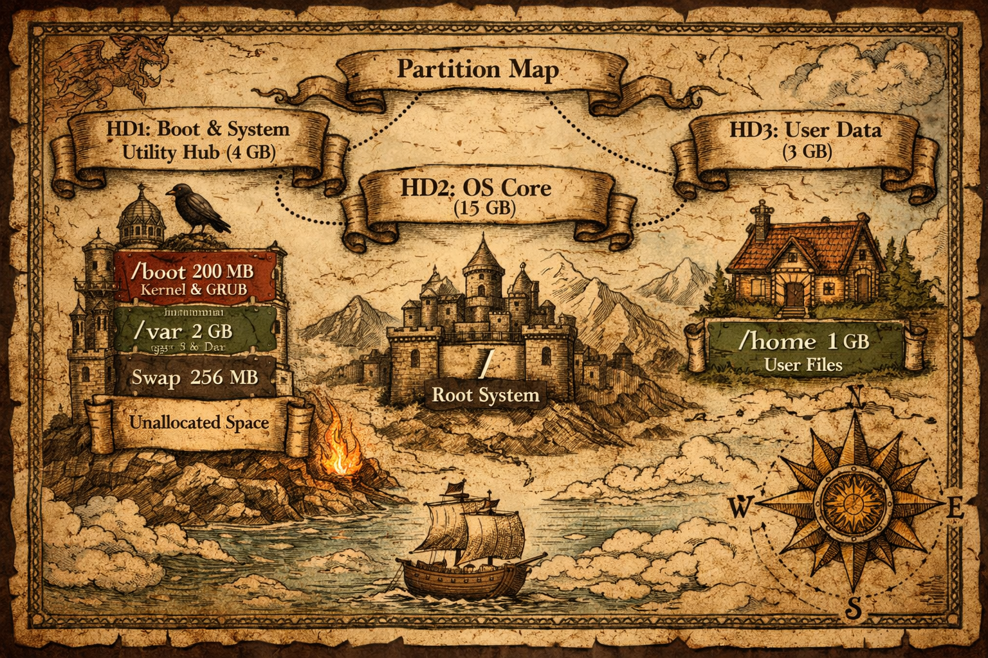

Now we must finish the isntalation.
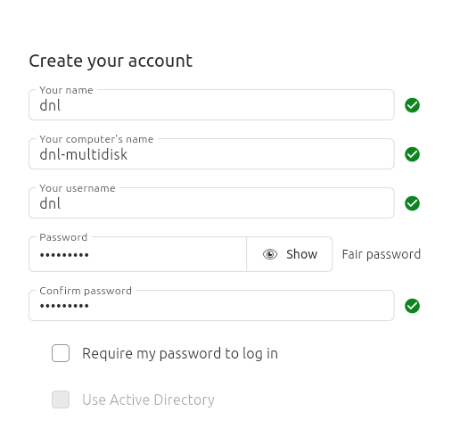

I have switched the installation to Ubuntu 20.04.2 and allocated a significant amount of disk space, setting 20 GB for each of the three drives.
While I am aware that the laboratory requirements don't strictly call for such a large capacity, I decided to go with this setup after encountering several installation errors in previous attempts.
Since this is a lab environment and I wanted to ensure a smooth, error-free process without storage bottlenecks, I opted for these more generous partitions to guarantee stability.
Please note that the provided documentation follows the original requirements regarding the partition structure, as the configuration process remains exactly the same, only with increased storage capacity.

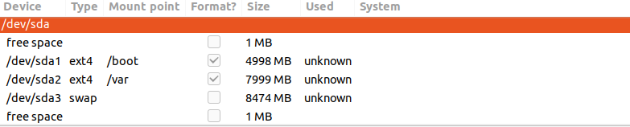
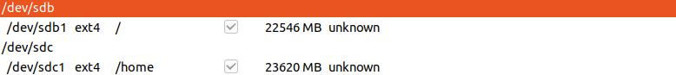

Verification of disks in the installed OS

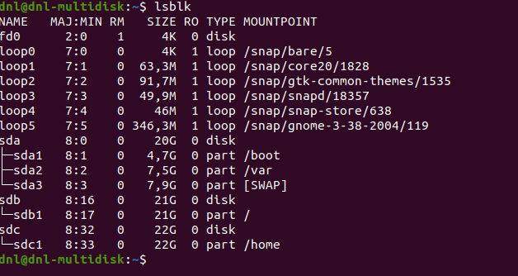
Creating the control file in /home:
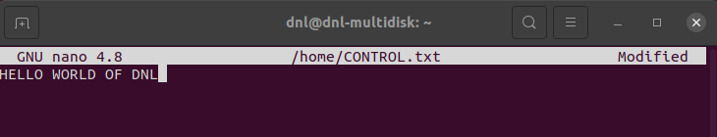
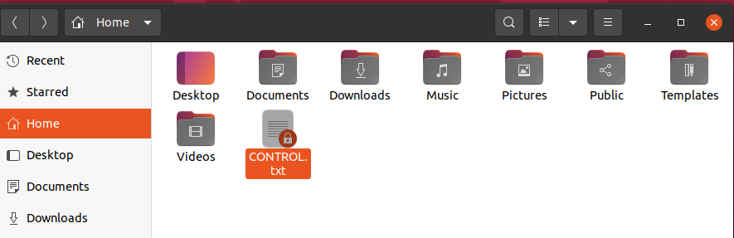

Phase 3: Critical Restructuring and Reinstalation

Now we will perform a clean reinstallation by booting from the installation media (CD/ISO).
During this process, we must implement the following adjustments to the partition scheme:
- Integration of /var into the Root partition (/):
  - The /var directory will no longer be on a separate partition.
  - It will be automatically handled within the main root partition on HD2 to avoid space-related bottlenecks.
- Relocation of the Swap area:
  - The swap partition will be reassigned to HD3.
- Maintenance of /home:
  - The /home partition remains on HD3 as originally planned, ensuring user data remains logically separated.
This approach maintains the pedagogical goal of a multi-disk setup while adopting a more robust configuration for the laboratory environment.
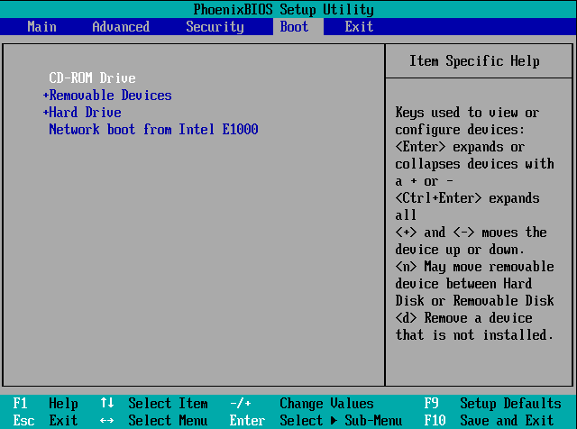

We use the manual instalation.
In HD1 we only maintain /boot (we need to reasign the partition) and he have to format it.
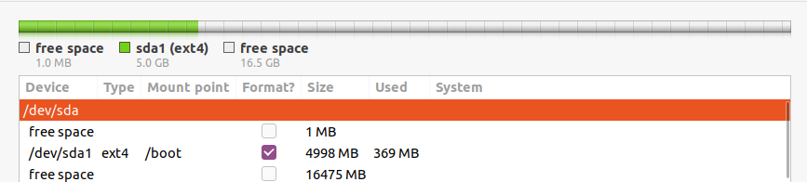
In HD2 we reasing the root partition and he have to format it.
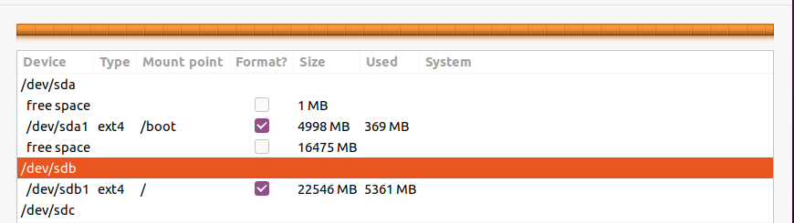
In HD3 we assign the /home partition but we DO NOT HAVE to format it.
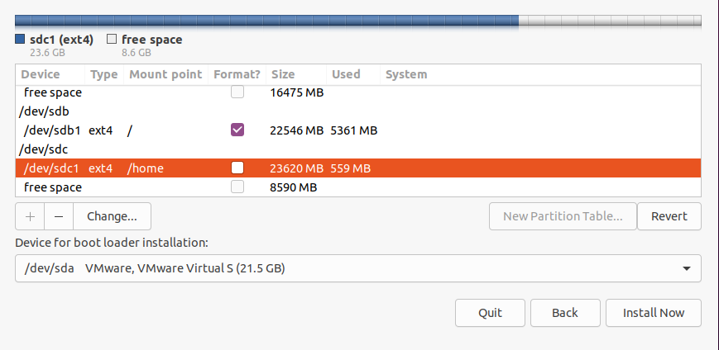

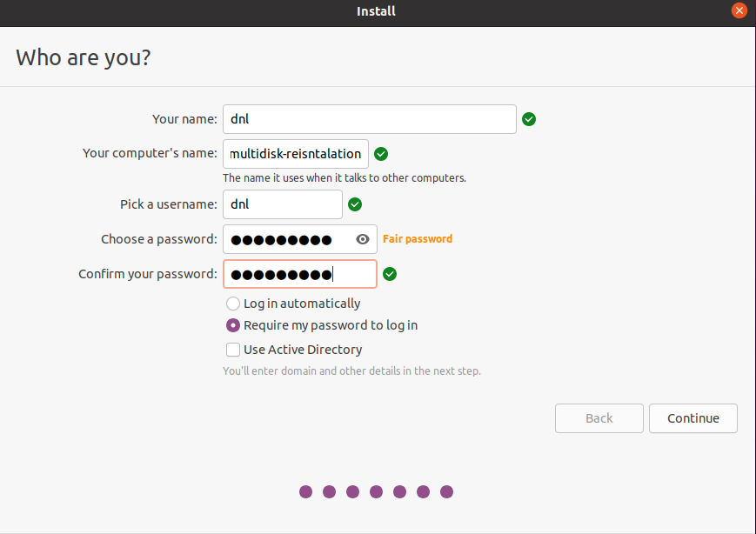

Phase 5: Final Audit

To conclude the laboratory exercise, we have performed a final verification of the installed operating system.
Although we modified the physical disk structure to resolve previous installation errors, we ensured that the home directory and user data remained untouched during the final adjustments.
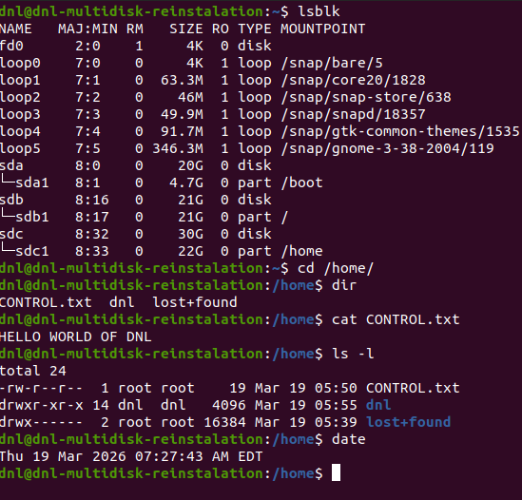
I have forgotten to add swap in HD3, but is the same than incluiding in a partition of HD1.
Now swap is in / because we do not have specific a partition for it, like we wanted to do with /var.

Conclusion

Executive Summary of the Process

The laboratory was conducted in several distinct phases to achieve a stable multi-disk environment.
Initially, a manual partitioning scheme was attempted following the original requirements; however, due to storage constraints and installation errors, the process was adapted by migrating to Ubuntu 20.04.2 and increasing the disk capacity to 20 GB per drive.
The final configuration involved booting from the installation media, integrating the /var directory into the root partition for better space management, and reassigning the Swap area to the third drive (HD3), all while maintaining the integrity of the existing user data.

Technical Evaluation of Multi-Disk Installations

A multi-disk installation offers significant advantages in terms of system resilience and modularity.
By isolating the /boot, root (/), and /home directories across different physical or virtual volumes, the system gains a layer of protection against file system corruption.
If the operating system partition fails or requires a complete reinstallation, the other volumes remain independent, preventing a localized error from causing a total loss of data.

Integrity of Persistent Data

A key highlight of this laboratory was the successful preservation of the /home directory.
Because the partition on HD3 was manually assigned as a mount point without selecting the “format” option, the existing file system and user configurations remained completely intact.
This demonstrates one of the greatest strengths of the Linux filesystem hierarchy:
- The ability to decouple the operating system from user data, allowing for seamless upgrades or system recoveries without compromising personal files.

