# Deploying the game

Open the game in the Unity Editor (Version 2021.1.1f1) and go to File->Build Settings.

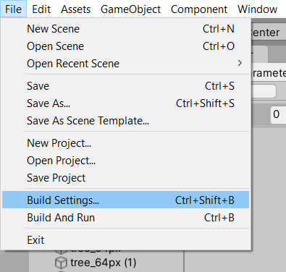

In the newly opened Build Settings window, that should be configured according to the graphic below, click on build. You will be prompted to select a folder for deployment.

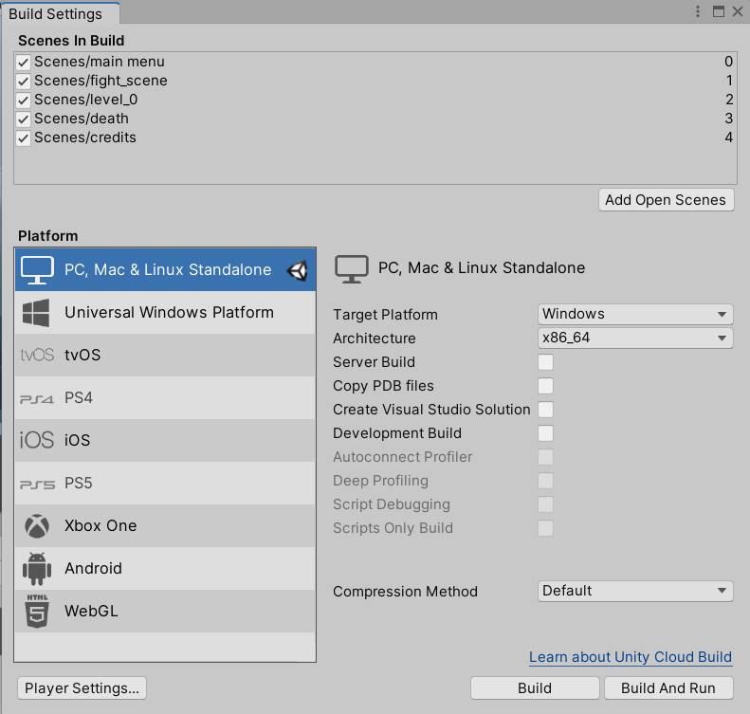

When the game was built successfully, you can start it by clicking on “Ring Retrieve Simulator.exe” in the build directory.