

Ring retrieve simulator

ITP SS2021



Group 02

Bruckner dario, fohleitner Dominik, isufi amareldo, jevtic aleksandar, reichert georg

Table of contents

Introduction 2

Controls 2

Mouse 2

Movement 2

Interaction 2

In-game menu 3

Combat 3

# Introduction

Welcome to the *Ring retrieve Simulator*, a 2D turn-based side-scroll RPG for the heroes of this world, and those who strive to become one of them. In this short manual we will explain the basic functionality of the game and provide you with the knowledge you need to survive the dangerous task of ring retrieval.

# Controls

## Mouse

Most of the games functionality is controlled by the mouse. Use the left mouse button to klick on a button in the game. The right mouse button is not used. After starting the game, let’s try this newly acquired skill of button-clicking out. Click on >>New Game<< to start a new game.

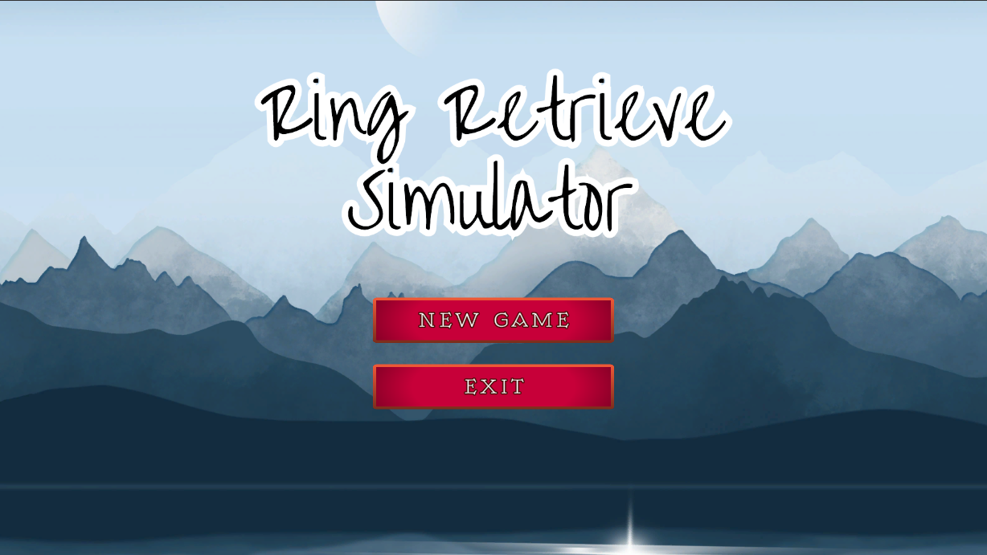

## Movement

The player character can be controlled with the left and right arrow keys or a joystick. To jump, use spacebar.

## Interaction

Most interactions with your environment, like picking up an item or starting a fight, happen automatically. To talk to Non-Player-Characters (NPCs), move close to them and press E. Try it with the guard, you should find him by running a few steps to the right.

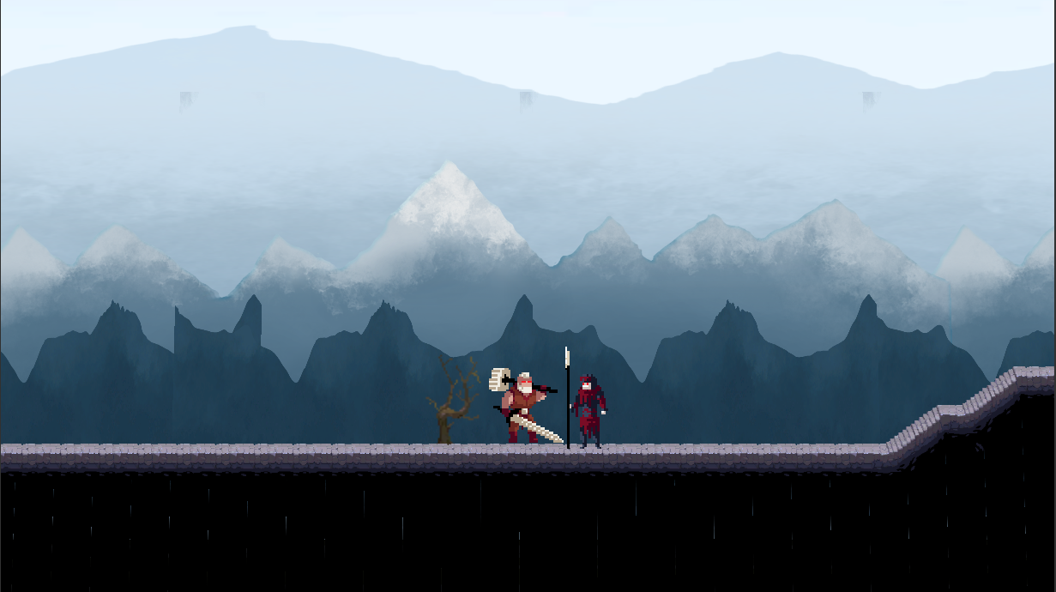 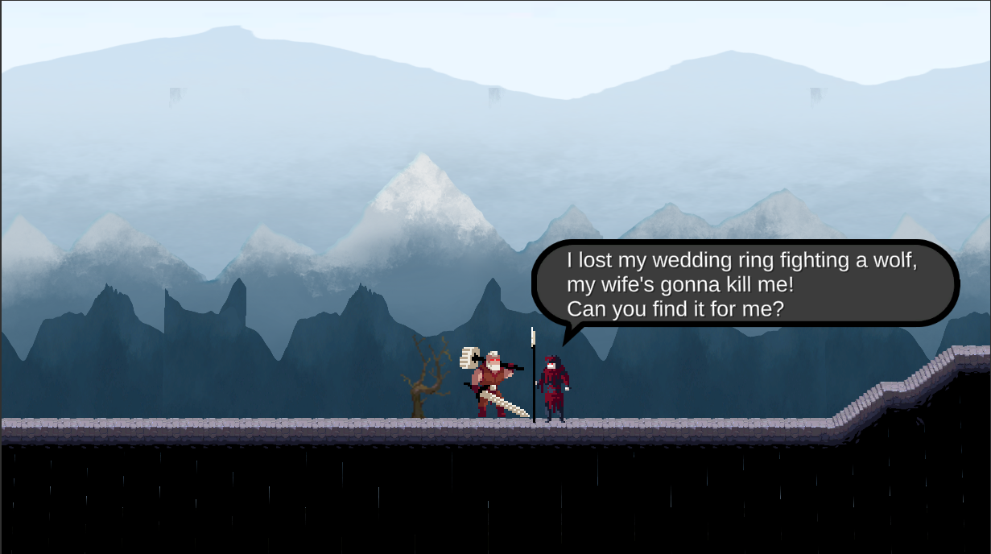

E

## In-game menu

To load the in-game menu, use ESC while you are in world exploration mode. You can use this menu to check your parties HP- and MP-status, to use items, and to quit the game.

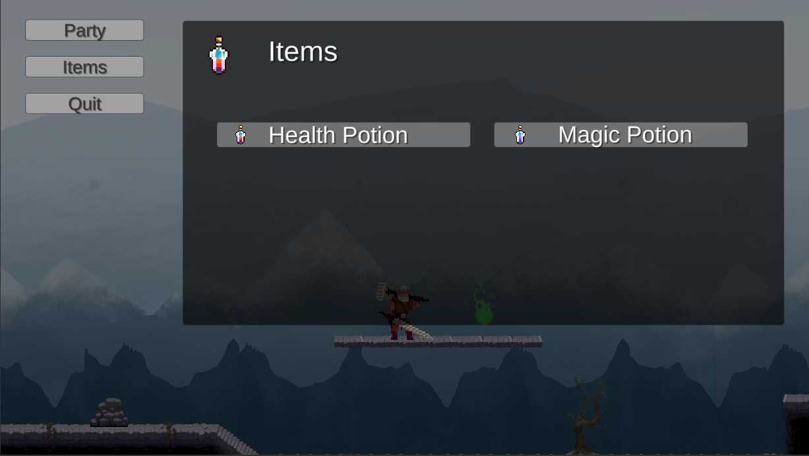

# Combat

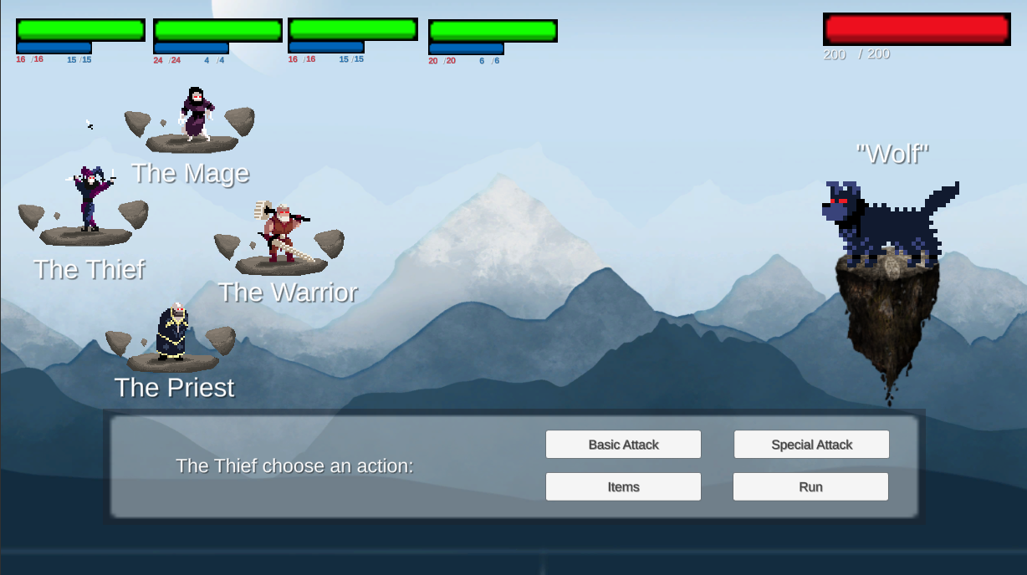

Each character has an HP- and an MP-bar, and a basic attack plus one or more special attacks/abilities that cost MP to use. Items can also be used during combat. The Priest can cast a heal-spell to heal the wounds of members of the party.