Appendix B: Introduction to HTML and CSS

This appendix uses the ModelibraWicketCss project from the Modelibra repository at JavaForge to explain the basics of HTML [HTML] and CSS (Cascading Style Sheets) [CSS] in a step by step manner. The project has multiple spirals that are located in the spirals directory of the Eclipse project. The first spiral is repesented by the page00.html file. In Eclipse, you can open the same file twice (select the file,pop up the menu and use the Open With menu item), once with the Web Browser choice and again with the Text Editor selection.

page00.html: Text

Web Browser


Figure A.00. Text

Text Editor

<html>

<head>
<title>Page 00</title>
</head>

<body>

I am an associate professor in the Business School at the Laval University (Université Laval), Quebec, Canada. I received a B.Sc. in informatics from the University of Sarajevo in 1976, an M.Sc. in computer science from the University of Maryland in 1982, and a Ph.D. in management information systems from the University of Minnesota in 1986. My main research interests are in the spiral development of dynamic web applications using Open Source Software (OSS), Java, databases, CSS, XML, design patterns and frameworks. My teaching interests are in presenting spirals of my research using pedagogical patterns.

</body>

</html>

Explanation

An HTML declaration of a web page begins with the <html> tag and ends with the </html> tag. An HTML element, here named html, consists of the begin tag and the end tag. This tag matching is important if we want to promote the HTML code into the XHTML [XHTML] code. Also, in XHTML element names are written in lower case letters.

The head element serves the purpose of informing a web browser about properties of the web page. The body element represents the page content that will appear in the web browser.

page01.html: Paragraphs

Web Browser


Figure A.01. Two paragraphs as one

Text Editor

<html>

<head>
<title>Page 01</title>
</head>

<body>

I am an associate professor in the Business School at the Laval University (Université Laval),Quebec, Canada. I received a B.Sc. in informatics from the University of Sarajevo in 1976, an M.Sc. in computer science from the University of Maryland in 1982, and a Ph.D. in management information systems from the University of Minnesota in 1986. My main research interests are in the spiral development of dynamic web applications using Open Source Software (OSS), Java, databases, CSS, XML, design patterns and frameworks. My teaching interests are in presenting spirals of my research using pedagogical patterns.

I am also a full ("redovni") professor at the Department of Computer Science, Faculty of Electrical Engineering, University of Sarajevo, Bosnia and Herzegovina. This is my return to the roots where it all started.

</body>

</html>

Explanation

Although the HTML code has two paragraphs they are collapsed into one paragraph when they are displayed. In order to format the text, we need to use the formatting tags.

page02.html: Two paragraphs

Web Browser


Figure A.02. Two paragraphs

Text Editor

<html>

<head>
<title>Page 02</title>
</head>

<body>

<p>
I am an associate professor in the Business School at the Laval University (Université Laval), Quebec, Canada. I received a B.Sc. in informatics from the University of Sarajevo in 1976, an M.Sc. in computer science from the University of Maryland in 1982, and a Ph.D. in management information systems from the University of Minnesota in 1986. My main research interests are in the spiral development of dynamic web applications using Open Source Software (OSS), Java, databases, CSS, XML, design patterns and frameworks. My teaching interests are in presenting spirals of my research using pedagogical patterns.
</p>
<p>
I am also a full ("redovni") professor at the Department of Computer Science, Faculty of Electrical Engineering, University of Sarajevo, Bosnia and Herzegovina. This is my return to the roots where it all started.
</p>

</body>

</html>

Explanation

The p HTML element is used to border a paragraph.

page03.html: Page sections

Web Browser

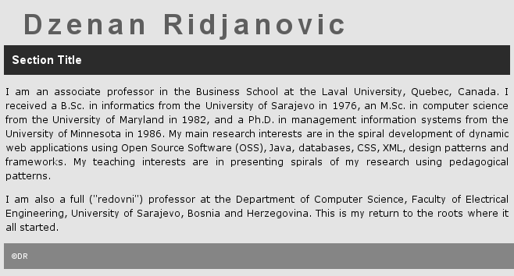
Figure A.03. Three main sections

Text Editor

<?xml version="1.0" encoding="UTF-8"?>
<!DOCTYPE html PUBLIC "-//W3C//DTD XHTML 1.0 Strict//EN"
"http://www.w3.org/TR/xhtml1/DTD/xhtml1-strict.dtd">

<html>

<head>
<title>Page 03</title>
<meta http-equiv="Content-Type" content="text/html; charset=iso-8859-1" />
<link rel="stylesheet" type="text/css" media="screen" href="../css/app.css" />
<link rel="stylesheet" type="text/css" media="screen" href="../css/layout.css" />
<link rel="stylesheet" type="text/css" media="screen"
href="../css/layout2c.css" />
<link rel="stylesheet" type="text/css" media="screen" href="../css/page.css" />
<link rel="stylesheet" type="text/css" media="screen"
href="../css/section.css" />
</head>

<body>

<div class="north">
<span class="app-title">Dzenan Ridjanovic</span>
</div>

<div class="content">
<div class="section-title">
Section Title
</div>
<div>
<p>
I am an associate professor in the Business School at the Laval University, Quebec, Canada. I received a B.Sc. in informatics from the University of Sarajevo in 1976, an M.Sc. in computer science from the University of Maryland in 1982, and a Ph.D. in management information systems from the University of Minnesota in 1986. My main research interests are in the spiral development of dynamic web applications using Open Source Software (OSS), Java, databases, CSS, XML, design patterns and frameworks. My teaching interests are in presenting spirals of my research using pedagogical patterns.
</p>
<p>
I am also a full ("redovni") professor at the Department of Computer Science, Faculty of Electrical Engineering, University of Sarajevo, Bosnia and Herzegovina. This is my return to the roots where it all started.
</p>
</div>
</div>

<div class="south">
&copy;DR
</div>

</body>

</html>

CSS

/* app.css */

.app-title {
font-family: arial, sans-serif;
font-size: 36px;
font-weight: bold;
letter-spacing: 6px;
color: #336799;
padding: 12px 12px 6px 18px;
background: #d7e9f7;
}

/* layout.css */

.north {
color: #708491;
padding: 6px;
background: #d7e9f7;
}

.south {
clear: both;
font-family: arial, sans-serif;
font-size: 10px;
font-weight: bold;
color: #fffff0;
background: #4b91d1;
padding: 10px;
}

/* layout2c.css */

.content {
float: left;
width: 72%;
}

/* page.css */

body {
font-family: verdana, arial, helvetica, sans-serif;
font-size: 12px;
background: #d7e9f7;

width:900px;
margin-left: auto;
margin-right: auto;
padding:10px;
}

p {
line-height: 1.5em;
text-align: justify;
margin-left: 2px;
margin-right: 2px;
}

Explanation

The HTML code for the web page starts with the mandatory declaration for an XML document [XML]. Since XHTML is a class of XML documents, it is recommended to start a web page with that declaration. The second declaration is for the strict XHTML definition of the web page [DOCTYPE].

After the title element in the head element, the meta tag is used [Meta]. The meta information is used here to tell a web browser what "character set" to use.

The link elements reference CSS files where declarations are made how the page will look like. Only the CSS files used in this page are shown. Also, not all content from these files is presented in the CSS section above. Only declarations used in this web page are shown.

The CSS statement is made up of a selector and a list of property name & value pairs separated by a semi-colon. The selector is either an HTML element name or a user defined class selector. The CSS property name and value are separated by a colon, and the list of pairs is surrounded by curly braces.

The body of the page is divided into sections. Each section is defined by the div element. If a div tag has the class attribute (nothing to do with the Java class concept), a value of the class attribute refers to the class selector in one of the linked CSS files, which determines how the content of this div element will be presented. A value of the class attribute must be in quotes to follow one of the XHTML syntax requirements. The web page is divided into the “north”, “content” and “south” sections. The “content” section has a title section and a text section, which does not have any attributes, with two paragraphs.

The div element includes a paragraph break. In addition, attributes of the div tag describe the style of the section embedded in the begin and end div tags. The style of the “north” section of the page is defined by the north class selector in the layout.css file. A user defined selector starts with a dot.

.north {
color: #708491;
padding: 6px;
background: #d7e9f7;
}

There are three CSS properties in the north class selector: color, padding and background. The title of the page is located within the span tags. The style of the title is determined by the class attribute of the span element with the “app-title” value. The class selector with the same name can be found in the app.css file.

.app-title {
font-family: arial, sans-serif;
font-size: 36px;
font-weight: bold;
letter-spacing: 6px;
color: #336799;
padding: 12px 12px 6px 18px;
background: #d7e9f7;
}

The primary difference between the span and div elements is that the span element does not do any formatting of it's own. The div element includes a paragraph break, while the span element defines a style of its content by its attributes.

If there is no a dot in front of the selector, the selector defines a style for the HTML element. For example, a paragraph style is determined by the p selector in the page.css file.

p {
line-height: 1.5em;
text-align: justify;
margin-left: 2px;
margin-right: 2px;
}

page04.html: Page layout

Web Browser

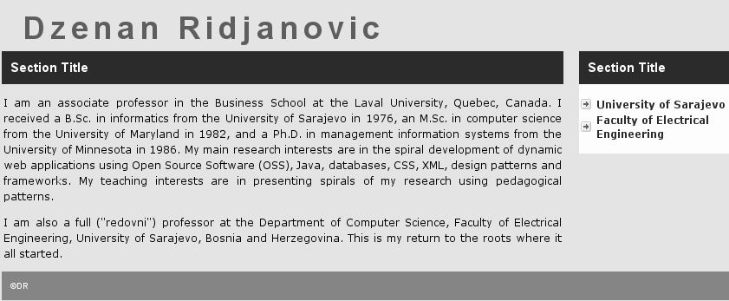
Figure A.04. Two columns page

Text Editor

<head>
<title>Page 04</title>
<meta http-equiv="Content-Type" content="text/html; charset=iso-8859-1" />
<link rel="stylesheet" type="text/css" media="screen" href="../css/app.css" />
<link rel="stylesheet" type="text/css" media="screen" href="../css/layout.css" />
<link rel="stylesheet" type="text/css" media="screen"
href="../css/layout2c.css" />
<link rel="stylesheet" type="text/css" media="screen" href="../css/link.css" />
<link rel="stylesheet" type="text/css" media="screen" href="../css/list.css" />
<link rel="stylesheet" type="text/css" media="screen" href="../css/page.css" />
<link rel="stylesheet" type="text/css" media="screen"
href="../css/section.css" />
</head>

<body>

<div class="north">
<span class="app-title">Dzenan Ridjanovic</span>
</div>

<div class="content">
<div class="section-title">
Section Title
</div>
<div>
<p>
I am an associate professor in the Business School at the Laval
...
</p>
<p>
I am also a full ("redovni") professor at the Department of Computer
...
</p>
</div>
</div>

<div class="sidebar">
<div class="section-title">
Section Title
</div>

<div class="link">
<ul>
<li>
<a href="http://www.unsa.ba/">
University of Sarajevo
</a>
</li>
<li>
<a href="http://www.etf.unsa.ba/">
Faculty of Electrical Engineering
</a>
</li>
</ul>
</div>
</div>

<div class="south">
&copy;DR
</div>

</body>

CSS

/* layout2c.css */

.content {
float: left;
width: 72%;
}

.sidebar {
float: right;
width: 26%;
background: #fffff0;
}

/* list.css */

ul {
list-style: none;
padding: 2px;
text-align: left;
}

li {
padding-top: 1px;
padding-bottom: 1px;
padding-left: 18px;
}

.link li {
background: url(img/arrow-right.gif) no-repeat 0 50%;
padding-top: 1px;
padding-bottom: 1px;
padding-left: 18px;
}

/* link.css */

a:link {
text-decoration: none;
font-weight: bold;
color: #003366;
}

a:visited {
text-decoration: none;
font-weight: bold;
color: #c50000;
}

a:hover {
text-decoration: none;
color: #ffffee;
background: #336799;
}

a:active {
text-decoration: none;
color: #ff9911;
}

Explanation

The middle part of the web page is divided in two columns. On the left there is the “content” section and on the right the “sidebar” section. It is the float property that determines the position of the section with its container. If there is no enough space on a line for the floating element, it will move down to the next line. The width property defines the size of the two columns of the page. The width is a % of the container's width.

The side bar has two web links (the a element) that are line items (the li element) of the unordered list (the ul element). It is the class attribute with the “link” value that determines the right arrow image in front of the web link. The link class selector is located in the list.css file. The styles of both the ul and li elements are defined as HTML element selectors in the same file.

The a element is defined in the link.css file by the so called pseudo classes. A web link that is unvisited, visited, when you mouse over it (hovered), or active (selected) has a different style.

page05.html: Image, menu

Web Browser

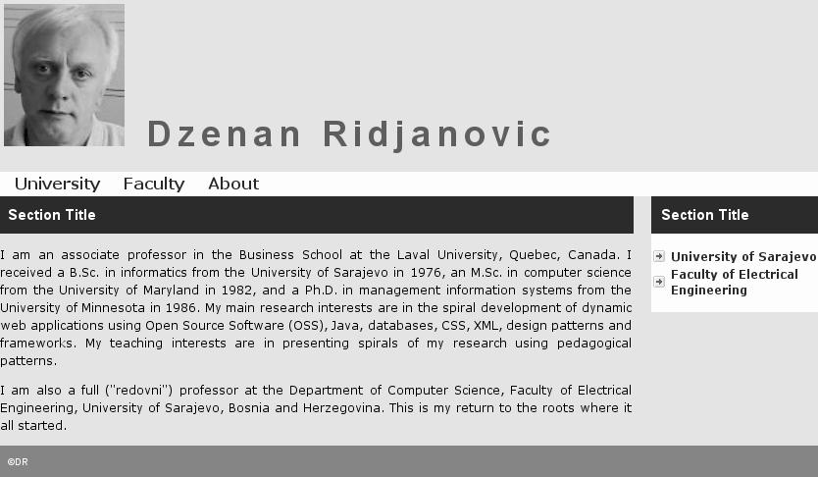
Figure A.05. Image and menu

Text Editor

<head>
<title>Page 05</title>
<meta http-equiv="Content-Type" content="text/html; charset=iso-8859-1" />
<link rel="stylesheet" type="text/css" media="screen" href="../css/app.css" />
<link rel="stylesheet" type="text/css" media="screen" href="../css/layout.css" />
<link rel="stylesheet" type="text/css" media="screen"
href="../css/layout2c.css" />
<link rel="stylesheet" type="text/css" media="screen" href="../css/link.css" />
<link rel="stylesheet" type="text/css" media="screen" href="../css/list.css" />
<link rel="stylesheet" type="text/css" media="screen" href="../css/menu.css" />
<link rel="stylesheet" type="text/css" media="screen" href="../css/page.css" />
<link rel="stylesheet" type="text/css" media="screen"
href="../css/section.css" />
</head>

<body>

<div class="north">
<img src="../img/dr.jpg" alt="Dzenan Ridjanovic" />
<span class="app-title">Dzenan Ridjanovic</span>
</div>

<div class="menu">
<ul>
<li>
<a href="http://www.ulaval.ca/">
University
</a>
<a href="http://www.fsa.ulaval.ca/">
Faculty
</a>
<a href="http://drdb.fsa.ulaval.ca/dr/doc/drcv.pdf">
About
</a>
</li>
</ul>
</div>

<div class="content">
<div class="section-title">
Section Title
</div>
<div>
...
</div>
</div>

<div class="sidebar">
<div class="section-title">
Section Title
</div>

<div class="link">
...
</div>
</div>

<div class="south">
&copy;DR
</div>

</body>

CSS

/* menu.css */

.menu {
margin: 0px;
padding: 0px 0px 9px 3px;
background: #fffff0;
}

.menu li {
margin: 0px;
padding: 0px;
display: inline;
list-style-type: none;
}

.menu a {
float: left;
line-height: 14px;
font-weight: bold;
font-size: 16px;
padding: 2px 12px 6px 12px;
text-decoration: none;
color: #003366;
}

.menu a:visited {
color: #c50000;
}

.menu a:hover {
color: #ffffee;
background: #336799;
}

Explanation

There is an image in the “north” section of the page. The image is the dr.jpg file that comes from the img directory of the Eclipse project, different from the img subdirectory of the css directory. The img subdirectory of the css directory is used only for images referenced in CSS selectors.

The “menu” class attribute references the menu class selector in the menu.css file. This class selector defines the styles of the li list element and the a link element including the visited and hover states. These styles are valid only if the corresponding HTML elements are used in a block (for example a div element) that has the class attribute with the “menu” value.

page06.html: Box, target

Web Browser

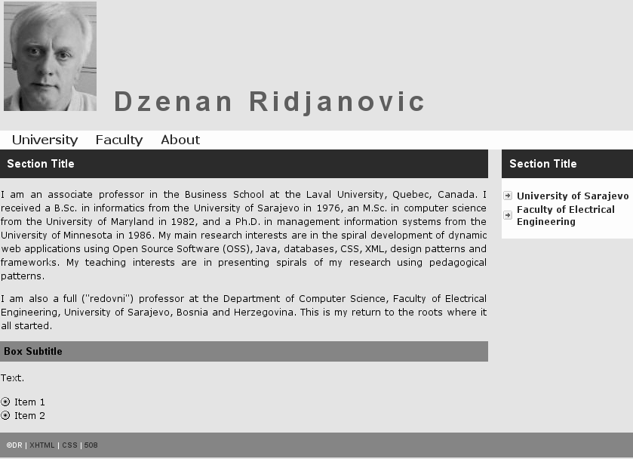
Figure A.06. Box section and target list

Text Editor

<head>
<title>Page 06</title>
<meta http-equiv="Content-Type" content="text/html; charset=iso-8859-1" />
<link rel="stylesheet" type="text/css" media="screen" href="../css/app.css" />
<link rel="stylesheet" type="text/css" media="screen" href="../css/box.css" />
<link rel="stylesheet" type="text/css" media="screen" href="../css/layout.css" />
<link rel="stylesheet" type="text/css" media="screen"
href="../css/layout2c.css" />
<link rel="stylesheet" type="text/css" media="screen" href="../css/link.css" />
<link rel="stylesheet" type="text/css" media="screen" href="../css/list.css" />
<link rel="stylesheet" type="text/css" media="screen" href="../css/menu.css" />
<link rel="stylesheet" type="text/css" media="screen" href="../css/page.css" />
<link rel="stylesheet" type="text/css" media="screen"
href="../css/section.css" />
</head>

<body>

<div class="north">
...
</div>

<div class="menu">
...
</div>

<div class="content">
<div class="section-title">
Section Title
</div>
<div>
...
</div>

<div class="box-subtitle">
Box Subtitle
</div>
<p>
Text.
</p>
<div class="target">
<ul>
<li>
Item 1
</li>
<li>
Item 2
</li>
</ul>
</div>
</div>

<div class="sidebar">
...
</div>

<div class="south">
&copy;DR |
<a href="http://validator.w3.org/" title="Validate a page">XHTML</a> |
<a href="http://jigsaw.w3.org/css-validator/" title="Validate CSS">CSS</a> |
<a href="http://bobby.watchfire.com/">508</a>
</div>

</body>

CSS

/* box.css */

.box-title {
font-family: arial, sans-serif;
font-size: 14px;
font-weight: bold;
color: #fffff0;
padding: 8px;
background: #336799;
}

.box-subtitle {
font-family: arial, sans-serif;
font-size: 13px;
font-weight: bold;
color: #000000;
padding: 6px;
background: #4b91d1;
}

/* list.css */

ul {
list-style: none;
padding: 2px;
text-align: left;
}

li {
padding-top: 1px;
padding-bottom: 1px;
padding-left: 18px;
}

.link li {
background: url(img/arrow-right.gif) no-repeat 0 50%;
padding-top: 1px;
padding-bottom: 1px;
padding-left: 18px;
}

.target li {
background: url(img/target.gif) no-repeat 0 50%;
padding-top: 1px;
padding-bottom: 1px;
padding-left: 18px;
}

Explanation

There is a new subsection in the “content” section. The title style of the subsection is defined by the “box-subtitle” class attribute. The attribute refers to the box-subtitle class selector in the box.css file. You may replace the “box-subtitle” attribute by the “box-title” attribute to see a difference in style.

The list of items, which appears after the paragraph text in the box section, is styled with the “target” class attribute. This attribute refers to the target class selector in the list.css file. In addition to the li selector, there is the target class selector that brings the target.gif image in front of the list item. The image is located in the img subdirectory of the css directory of the project.

There are three new links in the “south” section of the page. They may be used to validate if the page supports well XHTML, CSS, quality, accessibility and privacy standards.

page07.html: Message, definition

Web Browser

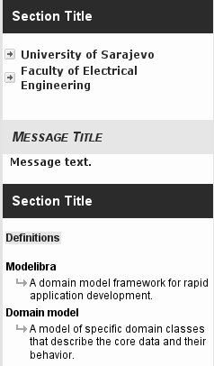
Figure A.07. Sidebar with the message section and the definition section

Text Editor

<div class="sidebar">
<div class="section-title">
Section Title
</div>

<div class="link">
...
</div>

<br/>
<div class="msg-title">
Message Title
</div>
<div class="msg-text">
Message text.
</div>
<br/>

<div class="section-title">
Section Title
</div>
<div>
<p>
<span class="marker">Definitions</span>
</p>
</div>
<div class="def">
<dl>
<dt>
Modelibra
</dt>
<dd>
A domain model framework for rapid application development.
</dd>
<dt>
Domain model
</dt>
<dd>
A model of specific domain classes that describe the core data
and their behavior.
</dd>
</dl>
</div>
<br/>

</div>

CSS

/* msg.css */

.msg-title {
font-family: arial, sans-serif;
font-size: 15px;
font-weight: bold;
font-style: italic;
font-variant: small-caps;
color: #003366;
padding: 10px;
background: #ffe4b5;
}

.msg-text {
color: #a30000;
background: #fffff0;
font-weight: bold;
text-align: left;
line-height: 1.4em;
padding: 0px 4px 0px 8px;
}

/* marker.css */

.marker {
font-family: arial, sans-serif;
font-size: 12px;
font-weight: bold;
color: #003366;
background: #ffe4b5;
padding-left: 1px;
padding-right: 1px;
margin-left: 1px;
margin-right: 1px;
}

/* def.css */

dl {
list-style: none;
padding: 0px;
font-family: arial, sans-serif;
text-align: left;
}

dt {
font-weight: bold;
padding: 4px;
}

dd {
line-height: 1.2em;
margin-left: 15px;
padding-left: 15px;
}

.def dd {
background: #fffff0 url(img/arrow-down-right.gif) no-repeat 0 2px;
}

Explanation

The sidebar has two new sections: the message section and the section with definitions. The message title is styled with the “msg-title” class attribute. The message text appears as defined by the “msg-text” class attribute. Both attributes are defined in the msg.css file by their corresponding class selectors.

A definition list contains definition terms and definition descriptions. The definition description is styled with the “def” class attribute. The class attribute references the def class selector in the def.css file. There are two declarations for the definition description: the dd selector and the the def class selector. The dd selector defines the definition description globally, while the def class selector defines the definition description locally, when the dd element is used in the div element that has the def class attribute.

A marker is used just in front of the definition list to indicate that the definition list will follow. The “marker” class attribute of the span element refers to the marker class selector in the marker.css file.

page08.html: Table, quote

Web Browser

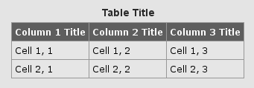
Figure A.08.a. Table


Figure A.08.b. Quote

Text Editor

<div class="content">
...
<table>
<caption>Table Title</caption>
<tr>
<th>Column 1 Title</th>
<th>Column 2 Title</th>
<th>Column 3 Title</th>
</tr>
<tr>
<td>Cell 1, 1</td>
<td>Cell 1, 2</td>
<td>Cell 1, 3</td>
</tr>
<tr>
<td>Cell 2, 1</td>
<td>Cell 2, 2</td>
<td>Cell 2, 3</td>
</tr>
</table>

</div>

<div class="sidebar">
...
<div class="section-title">
Section Title
</div>
<p class="center">
<span class="button">Quote</span>
</p>
<blockquote>
<div class="quote">
"One lesson I learned as a graduate student is the best way to
finish the dissertation is to do something every day that gets
you closer to being done."
</div>
<div class="author">&mdash;Ronald T. Azuma</div>
</blockquote>
...
</div>

CSS

/* table.css */

table {
border-top: 1px solid #999;
border-left: 1px solid #999;
border-collapse: collapse;
margin-left: auto;
margin-right: auto;
}

caption {
font-family: arial, sans-serif;
font-size: 14px;
font-weight: bold;
color: #003366;
padding: 6px;
margin-left: auto;
margin-right: auto;
}

th, td {
padding: 4px;
border-right: 1px solid #999;
border-bottom: 1px solid #999;
}

th {
font-family: Verdana, sans-serif;
font-weight: bold;
color: #ffffff;
background: #336799;
}

td {
background: #ffe4b5;
}

/* cite.css */

cite {
font-style: italic;
font-weight: bold;
color: #ff9911;
background: #fffff0;
}

blockquote {
text-align: center;
margin: 0;
padding: 0;
font-family: georgia, serif;
font-size: 150%;
letter-spacing: -1px;
line-height: 1em;
color: #555555;
background: #fffff0;
}

.quote {
margin: 0;
padding: 20px 20px 10px 20px;
}

.author {
margin: 0;
padding: 0 0 10px 0;
color: #999999;
font-size: 60%;
}

/* link.css */

...

.button {
padding: 1px;
background: #ffcc99;
border-right: 1px solid #999;
border-bottom: 1px solid #999;
border-style: outset;
border-color: #d7b9c9;
font-weight: bold;
text-align: center;
}

.button img {
border: 0;
}

/* section.css */

...

.center {
text-align: center;
}

Explanation

The content section has a table with a title, two rows and three columns. Table HTML elements are table, caption (title), tr (table row), th (table header) and td (table data or cell). In the table.css file there are selectors for table elements. Since there are no class selectors for a table, there are no class attributes in a table HTML definition.

The cite.css file is a mixture of selectors for HTML elements (cite and blockquote; only the blockquote selector is used) and class selectors for element attributes (quote and author).

The “button” class attribute is used to make a quote title look like a button. The button selector is located in the link.css file. Also, the title is centered by using the “center” class attribute that references the center class selector from the section.css file.

page09.html: Slide

Web Browser

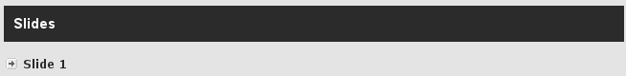
Figure A.09.a. Slide link in page09.html

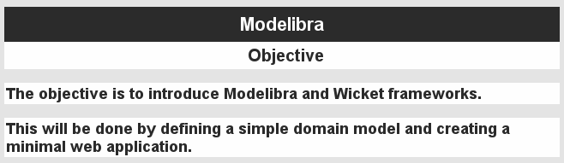
Figure A.09.b. Slide in slide01.html

Text Editor

...
<div class="section-title">
Slides
</div>
<div class="link">
<ul>
<li>
<a href="slide/slide01.html">
Slide 1
</a>
</li>
</ul>
</div>
...

<?xml version="1.0" encoding="UTF-8"?>
<!DOCTYPE html PUBLIC "-//W3C//DTD XHTML 1.0 Strict//EN"
"http://www.w3.org/TR/xhtml1/DTD/xhtml1-strict.dtd">

<html>

<head>
<title>Slide 01</title>
<meta http-equiv="Content-Type" content="text/html; charset=iso-8859-1" />
<link rel="stylesheet" type="text/css" media="screen"
href="../../css/layout2c.css" />
<link rel="stylesheet" type="text/css" media="screen"
href="../../css/page.css" />
<link rel="stylesheet" type="text/css" media="screen"
href="../../css/slide.css" />
</head>

<body>

<div class="content">
<div class="slide-title">
Modelibra
</div>
<div class="slide-subtitle">
Objective
</div>

<br/>
<div class="slide-point">
The objective is to introduce Modelibra and Wicket frameworks.
</div>

<br/>
<div class="slide-point">
This will be done by defining a simple domain model and creating a minimal
web application.
</div>
</div>

</body>

</html>

CSS

/* slide.css */

.slide-title {
font-family: arial, sans-serif;
font-size: 22px;
font-weight: bold;
text-align: center;
color: #ffffff;
padding: 8px;
background: #003366;
}

.slide-subtitle {
font-family: arial, sans-serif;
font-size: 20px;
font-weight: bold;
text-align: center;
color: #003366;
padding: 4px;
padding-left: 14px;
background: white;
}

.slide-point {
font-family: arial, sans-serif;
font-size: 18px;
font-weight: bold;
color: #003366;
padding: 2px;
background: white;
}

Explanation

At the end of the “content” section in page09.html there is a slide section with a link to the slide01.html page. The slide is presented according to CSS declarations in the slide.css file. There are three class selectors for a slide title, a slide subtitle and a slide point. The “content” section of the slide01.html page has four subsections: for the slide title, the slide subtitle and two points. The corresponding class attributes are used to style the title, the subtitle and the points.

Other Spirals
There are more spirals in the ModelibraWicketCss project. You can study them on your own. The last spiral shows a web page with various features found in professionally looking web sites. You are encouraged to play with the content of CSS files to find a look that you like the most and that you may decide to use in your web pages. Feel free to add new CSS files and improve the existing ones. I would appreciate if you could send me your new look in a zipped Eclipse project. The best of those I intend to add to the Modelibra repository.

The CSS design used in Modelibra has been mostly influenced by the work of Dan Cederholm [SimpleBits]. Other HTML and CSS sites that I have found useful are: [Guide], [Standards], [Style],

Web Links
[CSS] Cascading Style Sheets
http://www.w3schools.com/css/default.asp

[DOCTYPE] Fix Your Site With the Right DOCTYPE!
http://www.alistapart.com/stories/doctype/

[Guide] Guide for the Unglued
http://www.thenoodleincident.com/tutorials/css/index.html

[HTML] HTML
http://www.w3schools.com/html/

[List] A List Apart
http://www.alistapart.com/

[Meta] How To Use HTML Meta Tags
http://searchenginewatch.com/showPage.html?page=2167931

[SimpleBits] SimpleBits
http://www.simplebits.com/

[Standards] Web Standards Project
http://www.webstandards.org/

[Style] HTML with Style
http://www.webreference.com/html/

[XHTML] XHTML Tutorial
http://www.w3schools.com/xhtml/

[XML] XML Tutorial
http://www.w3schools.com/xml/default.asp

[Zen] Zen Garden
http://www.csszengarden.com/

