Conversational Business Intelligence:
A Natural-Language SQL Agent over a Superstore Data Warehouse
Submission Documentation — Final Exam
Course: IT 501 Business Intelligence
Student Name: Dario Karadzin
Student ID: 22003553
Dataset: Superstore Sales (Kaggle)
Date: 2026-09-06
GitHub Repository: https://github.com/DarioKaradzin/BusinessIntelligenceProject
Presentation Link: [insert link]
Video Recording Link: [insert link]
Contents

1. Executive Summary
Objective: This project designs and implements an AI-assisted Business Intelligence solution that lets a non-technical user answer questions about retail sales in plain English, without writing SQL. The Superstore dataset is modelled as a star-schema data warehouse in Supabase (PostgreSQL); an MCP-connected agent (Antigravity CLI) translates natural-language questions into SQL and runs them against the warehouse; and Apache Superset provides interactive dashboards on top of the same data.
Key Outcome: The finished system turns 9,994 rows of raw Superstore order lines into a clean, queryable warehouse feeding three themed Superset dashboards and a conversational SQL agent that reliably answers business questions (an 8/8 pass rate on the golden-query evaluation). It demonstrates how an AI agent plus a governed schema can remove the technical barrier between a business user and their data.

2. Technical Setup and Data Architecture
Dataset Source: Superstore Sales — https://www.kaggle.com/datasets/vivek468/superstore-dataset-final. The dataset contains 9,994 order-line records spanning 2014–2017, covering orders, customers, products, geography and shipping across the United States.

Schema Design
The raw flat CSV was decomposed into a Kimball star schema: a single central fact table, fact_sales, at the grain of one order line, surrounded by five dimension tables. The entity-relationship diagram below shows the fact and its foreign-key relationships to each dimension.
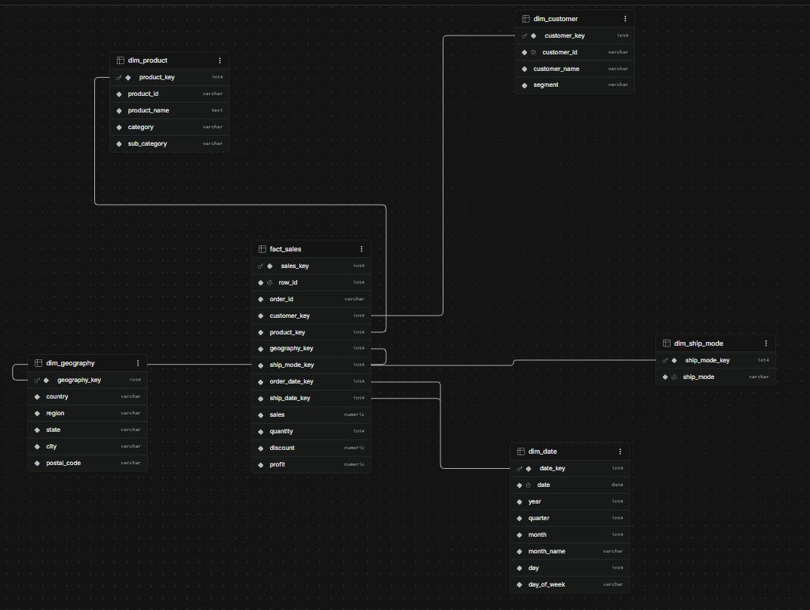
Figure 1: Star-schema ERD in Supabase — fact_sales joined to the five dimensions

Normalization Strategy
All descriptive, slowly-changing attributes were separated out of the flat file into dimension tables — dim_customer, dim_product, dim_geography, dim_ship_mode and dim_date — leaving only foreign keys and additive numeric measures (sales, quantity, discount, profit) on fact_sales. This removes the repetition inherent in the raw CSV (a customer's name and segment are stored once, not on every line), speeds up analytical aggregations, and produces a clean role-playing date dimension that the fact references twice — once as the order date and once as the ship date.

Data Integrity (Primary & Foreign Keys)
- fact_sales — PK sales_key; degenerate dimension order_id; FKs: customer_key, product_key, geography_key, ship_mode_key, order_date_key, ship_date_key.
- dim_customer — PK customer_key (customer_id, customer_name, segment)
- dim_product — PK product_key (product_id, product_name, category, sub_category)
- dim_geography — PK geography_key (country, region, state, city, postal_code)
- dim_ship_mode — PK ship_mode_key (ship_mode)
- dim_date — PK date_key (date, year, quarter, month, month_name, day, day_of_week)
Each dimension joins one-to-one to the fact on its surrogate key, so a correct join preserves the fact grain at exactly 9,994 rows — a property used later to validate every query.

Environment Setup
Antigravity CLI (agy) with the Gemini 3.5 Flash model as the AI agent; Supabase (hosted PostgreSQL, eu-central-1) as the cloud data warehouse, reached over the IPv4 session pooler; Apache Superset v4 via Docker (running locally on port 8088); the Model Context Protocol via a supabase MCP server and a superset-mcp server; and Python 3 with psycopg2 for the ETL pipeline (build_star_schema.py). The screenshot below shows the agent building and loading the star schema.
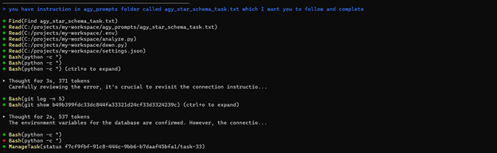
Figure 2: Antigravity CLI building the star-schema ETL pipeline

3. AI Agent Implementation
GitHub Repository: https://github.com/DarioKaradzin/BusinessIntelligenceProject

Agent Architecture
The user interacts only with the Antigravity CLI in natural language. The agent, governed by the project's AGENTS.md file, generates SQL and calls the supabase MCP server to execute it against the star schema; results return to the agent, which explains them. Apache Superset connects to the same Supabase warehouse to render the dashboards. The superset-mcp server additionally lets the agent create datasets, charts and dashboards programmatically.
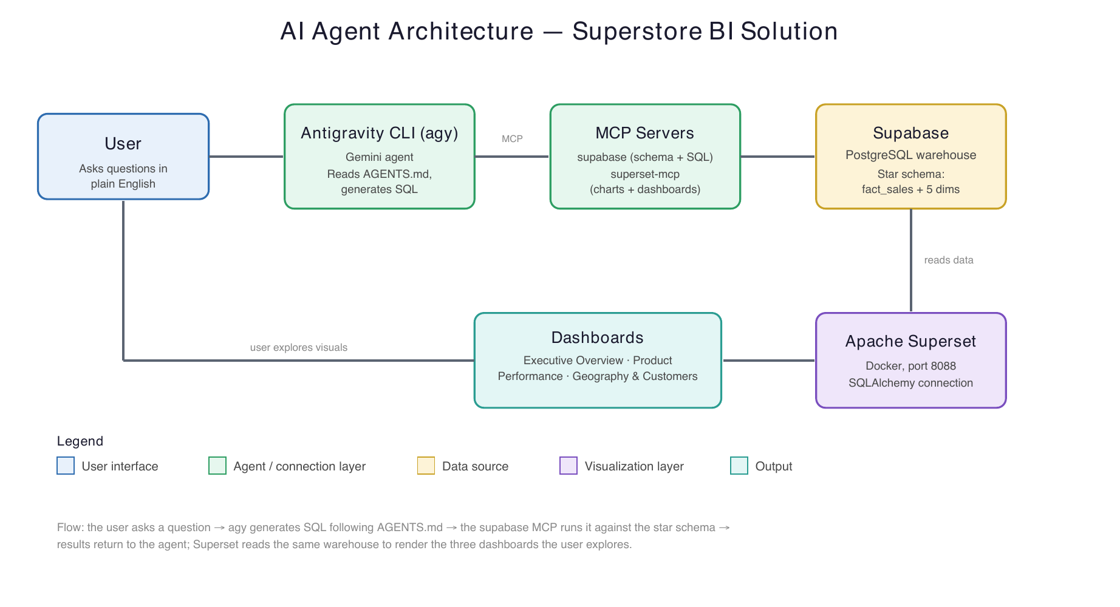
Figure 3: Agent / MCP / database interaction flow

System Prompting
The agent's behaviour is governed by a system-instructions file (AGENTS.md) placed at the project root, which Antigravity automatically loads into every prompt in the workspace. It defines the agent's role, the full schema and canonical join keys, and a set of SQL-generation rules. The core rules are:
- Read-only: generate only SELECT statements; never modify data.
- Always take measures from fact_sales; descriptive attributes live in the
dimensions, so join to obtain them (never assume they are on the fact).
- Join on surrogate keys, but GROUP BY / filter on the readable columns.
- Count orders with COUNT(DISTINCT order_id), not COUNT(*), because an order
spans several line rows.
- Profit margin = SUM(profit) / NULLIF(SUM(sales), 0) (guard divide-by-zero).
- Use ILIKE for text; always LIMIT "top N" queries; state any assumptions
(the data spans 2014-2017) rather than guessing.

MCP Configuration
Two MCP servers are configured in settings.json. The supabase MCP server connects directly to the Supabase PostgreSQL instance and exposes the full live schema — table names, column names, data types and primary/foreign-key relationships — so the agent can introspect the database at runtime and generate contextually accurate SQL rather than relying on hard-coded table structures. The superset-mcp server connects to the local Apache Superset instance and exposes dataset, chart and dashboard management tools.
{
"mcpServers": {
"supabase": { "command": "npx", "args": ["-y", "@modelcontextprotocol/server-supabase"], ... },
"superset-mcp": { "command": "npx", "args": ["-y", "superset-mcp"],
"env": { "SUPERSET_BASE_URL": "http://localhost:8088", ... } }
}
}
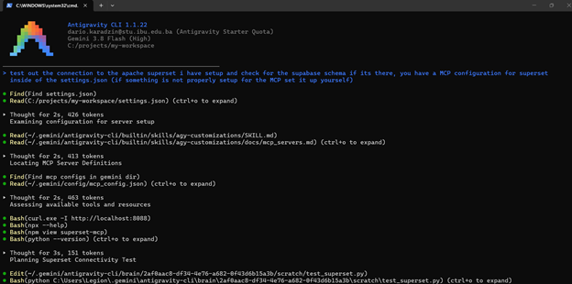
Figure 4: Configuring and verifying the superset-mcp server via Antigravity CLI

Error Handling
A representative example of the agent recovering from a failed query. Asked for sales by category, the agent first tried to group by an attribute that does not exist on the fact table:
-- First attempt (failed):
SELECT category, SUM(sales) FROM public.fact_sales GROUP BY category;
-- ERROR: column "category" does not exist
The agent recognised that category is an attribute of dim_product rather than fact_sales, added the appropriate join, and re-ran the corrected query, which returned the correct per-category totals:
-- Corrected (succeeded):
SELECT p.category, ROUND(SUM(f.sales)::numeric,2) AS total_sales
FROM public.fact_sales f
JOIN public.dim_product p ON f.product_key = p.product_key
GROUP BY p.category
ORDER BY total_sales DESC;
-- Technology 836,154 | Furniture 741,999 | Office Supplies 719,047
This is exactly the class of mistake the AGENTS.md rule “always measure from fact_sales and join the dimensions for descriptive attributes” is designed to prevent, and it shows the agent correcting itself using the live schema exposed through the MCP server.

4. BI Dashboarding (Superset)

Connectivity
Apache Superset was connected to the Supabase PostgreSQL instance through the Superset “Connect a database” wizard using a SQLAlchemy URI against the Supabase session pooler (aws-0-eu-central-1.pooler.supabase.com:5432). The star-schema tables were registered as datasets, and a virtual dataset, sales_analysis, joins the fact to all dimensions to serve as the single analysis-ready source for the charts.

Metrics Definitions
- total_sales = SUM(sales)
- total_profit = SUM(profit)
- total_quantity = SUM(quantity)
- order_count = COUNT(DISTINCT order_id)
- profit_margin = SUM(profit) / NULLIF(SUM(sales), 0)
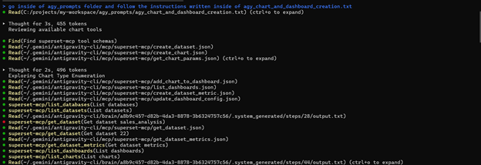
Figure 5: Agent creating charts and dashboards through the superset-mcp tools

Visualizations
Three themed dashboards were built on the sales_analysis dataset, each with a time-range filter on order date and a category filter.
Executive Overview
Headline KPIs — total sales $2,297,200.86, total profit $286,397.02, profit margin 12.47% and 5,009 orders — alongside the monthly sales-and-profit trend and breakdowns of sales by category, region and customer segment.
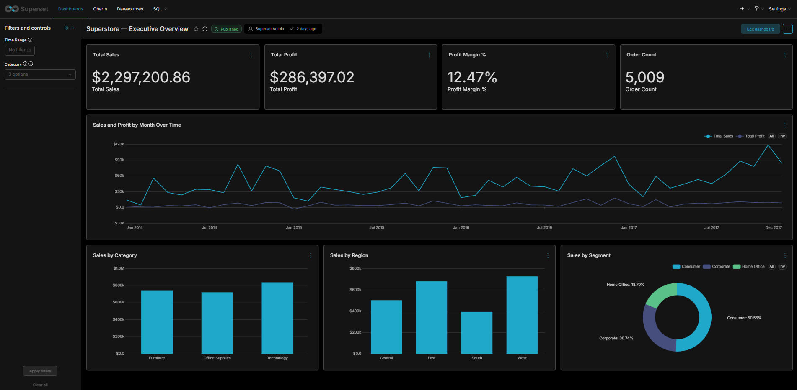
Figure 6: Superstore — Executive Overview dashboard
Product Performance
Profit by sub-category (highlighting the loss-making Tables, Bookcases and Supplies), a discount-versus-profit scatter, the top ten products by sales, and profit margin percentage by category.
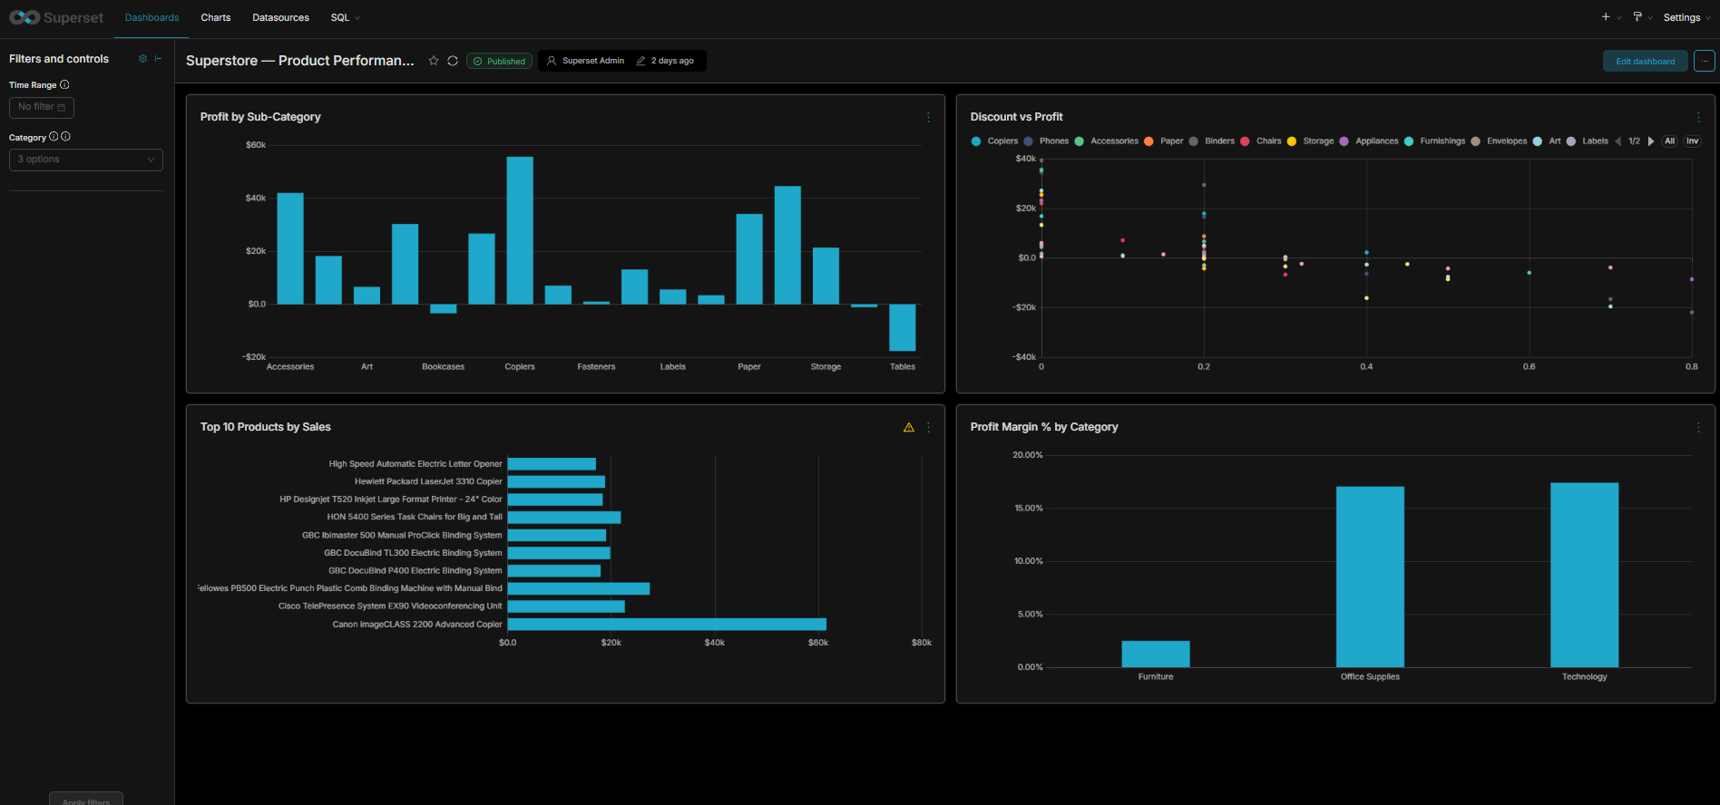
Figure 7: Superstore — Product Performance dashboard
Geography & Customers
A US choropleth of sales by state, sales by region, the top ten customers by sales, and order count by ship mode.
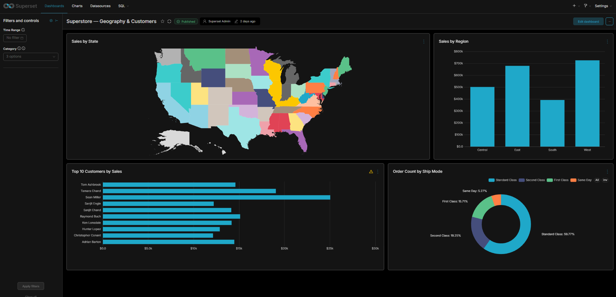
Figure 8: Superstore — Geography & Customers dashboard

5. Final Presentation and Demo
Business Value Analysis: This solution removes the need for business users to write SQL or understand the database schema. A non-technical sales or operations manager can simply ask the agent a question — “which sub-categories are losing money?” — and receive an immediate, accurate answer drawn from live warehouse data, while the Superset dashboards give always-on visibility into sales, profit, geography and shipping. The primary target users are non-technical managers and operations staff who need reliable insight without depending on a data-engineering team.
Architectural Overview: Supabase was chosen for its managed PostgreSQL offering with built-in connection pooling and a free tier — a warehouse reachable by both the agent (via MCP) and Superset (via SQLAlchemy) with no infrastructure to run. MCP was selected because it gives the LLM a standard, secure interface to the database: the supabase server introspects the live schema automatically, so the agent always has accurate table metadata without any custom API. Apache Superset was chosen as the visualization layer because it is open-source, natively supports PostgreSQL, offers a wide range of chart types, and self-hosts cleanly via Docker.
Video Demo Link: [insert link]
Presentation Link: [insert link]
Reflection on Technical Challenges: The most significant technical challenge was establishing a reliable connection to Supabase. The direct database host (db.<project-ref>.supabase.co) is IPv6-only and would not resolve on the working network, causing the agent's initial connection attempts to fail at DNS resolution rather than authentication. The fix was to switch to Supabase's IPv4 session pooler (aws-0-eu-central-1.pooler.supabase.com, user postgres.<project-ref>). A second, related issue was that the database password contained reserved URI characters (‘!’, ‘@’, ‘#’) which broke the SQLAlchemy connection string until they were percent-encoded. Diagnosing both required understanding Supabase's direct-versus-pooled connection modes and how connection URIs are parsed — a good illustration of the kind of real-world configuration problem the agent and I worked through together.

6. Business Insights
Three insights emerged during development that were not obvious from the raw data and only surfaced through the agent's queries and the dashboards.

Insight 1 — Discounting is the primary driver of losses
Order lines that lost money carry an average discount of roughly 48%, versus only about 8% on profitable lines. The issue is not which products sell, but how deeply they are discounted — heavy discounting, not product mix, is what turns a sale into a loss.

Insight 2 — A profitable-looking category hides a loss leader
Furniture appears healthy at the category level, but the Tables sub-category alone loses about $17,725 — more than the Bookcases and Supplies sub-categories combined. Category-level reporting completely masks this; only drilling into sub-categories reveals it.

Insight 3 — Margins are thin and concentrated in Furniture
Furniture runs a profit margin of only about 2.5%, while Technology and Office Supplies each run around 17%. Roughly a third of the product range therefore contributes very little profit despite generating substantial sales, suggesting a pricing or cost problem specific to Furniture.

7. Golden Queries for BI Agent Evaluation
To evaluate the SQL-generation capability of the BI agent, a suite of eight Golden Queries was created — each a natural-language business question paired with its expected SQL. These serve as a benchmark for validating AI-generated SQL against the star schema. All eight were executed against the warehouse and returned the expected results (an 8/8 pass rate).
# | Business Question | Expected SQL Query
1 | What were our total sales and profit in 2017? | SELECT ROUND(SUM(f.sales)::numeric,2) AS total_sales,  ROUND(SUM(f.profit)::numeric,2) AS total_profit  FROM public.fact_sales f  JOIN public.dim_date d ON f.order_date_key = d.date_key  WHERE d.year = 2017;
2 | Which product sub-categories are losing us money? | SELECT p.sub_category, ROUND(SUM(f.profit)::numeric,2) AS total_profit  FROM public.fact_sales f  JOIN public.dim_product p ON f.product_key = p.product_key  GROUP BY p.sub_category  HAVING SUM(f.profit) < 0  ORDER BY total_profit ASC;
3 | Who are our top 5 customers by total sales? | SELECT c.customer_name, ROUND(SUM(f.sales)::numeric,2) AS total_sales  FROM public.fact_sales f  JOIN public.dim_customer c ON f.customer_key = c.customer_key  GROUP BY c.customer_name  ORDER BY total_sales DESC  LIMIT 5;
4 | What is the profit margin for each product category? | SELECT p.category,  ROUND((SUM(f.profit)/NULLIF(SUM(f.sales),0))::numeric,4) AS profit_margin  FROM public.fact_sales f  JOIN public.dim_product p ON f.product_key = p.product_key  GROUP BY p.category  ORDER BY profit_margin DESC;
5 | Which region generates the most sales? | SELECT g.region, ROUND(SUM(f.sales)::numeric,2) AS total_sales  FROM public.fact_sales f  JOIN public.dim_geography g ON f.geography_key = g.geography_key  GROUP BY g.region  ORDER BY total_sales DESC;
6 | Show me monthly sales over time. | SELECT d.year, d.month, d.month_name,  ROUND(SUM(f.sales)::numeric,2) AS total_sales  FROM public.fact_sales f  JOIN public.dim_date d ON f.order_date_key = d.date_key  GROUP BY d.year, d.month, d.month_name  ORDER BY d.year, d.month;
7 | Average discount on loss-making vs profitable order lines? | SELECT CASE WHEN f.profit < 0 THEN 'loss' ELSE 'profit' END AS outcome,  COUNT(*) AS line_count,  ROUND(AVG(f.discount)::numeric,4) AS avg_discount  FROM public.fact_sales f  GROUP BY 1 ORDER BY outcome;
8 | How many distinct orders use each ship mode? | SELECT s.ship_mode, COUNT(DISTINCT f.order_id) AS order_count  FROM public.fact_sales f  JOIN public.dim_ship_mode s ON f.ship_mode_key = s.ship_mode_key  GROUP BY s.ship_mode  ORDER BY order_count DESC;
Table 1: Golden Queries
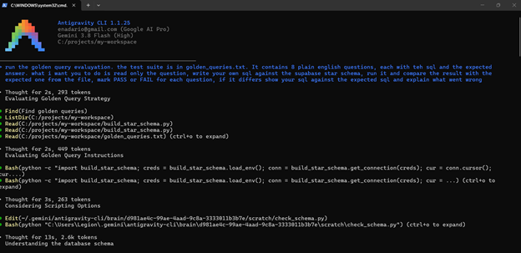
Figure 9: Antigravity CLI running the golden-query evaluation

