Name: Dario Karadžin
eMail: dario.karadzin@stu.ibu.edu.ba

Predictive Financial Risk & Fraud
Credit Card Fraud Detection using Machine Learning

Abstract
Credit card fraud detection is a challenging task due to the extreme class imbalance present in real-world transaction data, where fraudulent transactions account for only 0.17% of all cases. This study analyzes a publicly available credit card dataset containing over 280,000 transactions with features primarily derived from Principal Component Analysis (PCA), along with transaction amount and time.
The Amount and Time features were standardized and the dataset was split into training and testing sets using an 80/20 ratio. Three machine learning models were implemented and evaluated: Logistic Regression, Random Forest, and XGBoost. To address class imbalance, probability threshold tuning and selected resampling techniques were applied. Model performance was evaluated using precision, recall, F1-score, ROC-AUC, and confusion matrices.
The results show that Logistic Regression achieved high recall but low precision, while Random Forest improved overall performance at the cost of significantly longer training time. XGBoost produced the best balance between performance and efficiency, achieving the best results with substantially faster training. These findings highlight the effectiveness of gradient boosting methods for fraud detection in highly imbalanced datasets.

1. Introduction
Credit card fraud detection is a critical task in financial security, as fraudulent transactions cause billions in global losses each year and continue to rise with the growth of online commerce. Fraud detection is a challenging machine learning problem due to the highly imbalanced nature of transaction datasets, where fraudulent transactions typically represent less than 0.2% of all records (Dal Pozzolo et al., 2015). Imbalanced classification refers to scenarios in which one class (fraud) is significantly underrepresented compared to the other (legitimate transactions), leading traditional machine learning models to bias toward predicting the majority class. To address this, modern fraud detection research combines resampling strategies, feature engineering, and specialized algorithms designed to improve minority-class detection performance (Kaur & Singh, 2021).
In many publicly available datasets, including the popular European Credit Card Fraud dataset, sensitive transaction features undergo PCA (Principal Component Analysis) transformation to preserve privacy while retaining statistical structure. PCA does this by turning the original features into a smaller set of new variables that retain the most important patterns in the data (Jolliffe & Cadima, 2016), allowing researchers to study fraud behavior without exposing confidential information. Ongoing research explores advanced techniques such as ensemble methods, deep learning, and anomaly detection models, which have shown promise in identifying subtle fraud behaviors (Ramya & Umadevi, 2022).
Despite significant progress, accurately detecting fraud in real time remains challenging due to class imbalance, constantly evolving fraud techniques, and the need for models that operate efficiently at scale (Zhang et al., 2023). This project will address these challenges by developing and evaluating several machine learning models for credit card fraud detection, comparing classification algorithms, and examining how different resampling methods and evaluation metrics affect performance. By testing multiple approaches on an imbalanced dataset, this project aims to identify practical and effective strategies for improving fraud detection accuracy.

2. Literature Review
Research on credit card fraud detection spans machine learning, anomaly detection, and deep learning. Early work by Bhattacharyya et al. (2011) applied logistic regression, random forests, and support vector machines to real-world transaction data, showing that ensemble methods significantly outperform linear models. Their study highlighted the importance of cost-sensitive metrics such as recall and AUC-ROC, which later became standard in fraud detection research.
Dal Pozzolo et al. (2015) investigated the challenges of extreme class imbalance and proposed evaluation strategies tailored to fraud detection. Their work demonstrated that typical accuracy scores are misleading and emphasized metrics focusing on the minority class, such as precision-recall curves. They also showed that undersampling the majority class can improve detection rates, laying the foundation for many modern resampling methods.
More recent research has focused on improving fraud detection using advanced algorithms. Carcillo et al. (2019) explored real-world fraud detection pipelines in partnership with industry, demonstrating that incremental and adaptive learning models are more effective than static models due to changing fraud patterns. They highlighted the importance of continuously updated models and data streams.
Kaur and Singh (2021) evaluated machine learning techniques such as decision trees, logistic regression, and SVM combined with SMOTE oversampling. They found that SMOTE significantly boosts performance by generating synthetic minority samples, improving recall while maintaining precision. Similarly, Ramya and Umadevi (2022) applied deep learning techniques, including autoencoders and LSTM networks, showing that deep architectures can capture subtle temporal and structural anomalies better than traditional models.
Zhang et al. (2023) introduced a hybrid model combining gradient boosting with anomaly detection, demonstrating improved robustness against evolving fraud strategies. They also emphasized feature engineering and temporal patterns in transactions. Another recent study by Al-Amri et al. (2021) reviewed machine learning and deep learning techniques for anomaly detection, highlighting effective approaches for detecting rare events like credit card fraud and stressing the importance of feature selection and scalable models.
Sahin and Duman (2011) experimented with cost-sensitive classification, adjusting misclassification penalties to reduce false negatives. Their findings showed that cost-sensitive boosting significantly reduces the risk of undetected fraud. Jurgovsky et al. (2018) analyzed sequence modeling using LSTM networks for transaction sequences, finding that temporal behavior modeling provides strong improvements compared to static classification.
Finally, Panigrahy et al. (2022) compared tree-based ensemble methods such as XGBoost and LightGBM, highlighting their superior performance due to their ability to handle nonlinear interactions.

2.1. Summary of Literature Review
Across these studies, some clear patterns emerge. Ensemble methods and deep learning consistently outperform traditional algorithms, and effectively handling class imbalance through resampling, cost-sensitive learning, or anomaly detection proves crucial. Additionally, modeling temporal patterns or using adaptive approaches helps make fraud detection more robust against constantly changing strategies. Most research relies on the European credit card fraud dataset or similar transaction data, evaluating models using metrics like recall, precision, AUC-ROC, and F1-score.
This project builds on these findings by testing multiple classification methods and applying techniques such as undersampling and SMOTE to address imbalance. Unlike many earlier studies that focus on only one model or one resampling method, this project compares several models and resampling approaches together, giving a clearer picture of which combinations work best for fraud detection.

Table 2.1
Summary of Reviewed Papers
Paper | Year |  | Purpose | Methods | Findings
Bhattacharyya et al. | 2011 |  | Compare ML models for fraud detection | LR, RF, SVM | Ensemble models perform best
Dal Pozzolo et al. | 2015 |  | Address extreme imbalance | Undersampling, PR-metrics | Sampling improves minority detection
Zareapoor & Seeja | 2015 |  | Explore unsupervised fraud detection | Clustering | Useful when labels are limited
Jurgovsky et al. | 2018 |  | Model transaction sequences | LSTM | Temporal modeling improves accuracy
Sahin & Duman | 2019 |  | Reduce false negatives | Cost-sensitive boosting | Lower FN rates with weighted models
Carcillo et al. | 2019 |  | Industrial fraud detection pipeline | Adaptive learning | Continuous updating improves results
Kaur & Singh | 2021 |  | Combine ML with SMOTE | SVM, DT, SMOTE | SMOTE significantly improves recall
Panigrahy et al. | 2022 |  | Compare ensemble models | XGBoost, LightGBM | Gradient boosting superior
Ramya & Umadevi | 2022 |  | Deep-learning detection | Autoencoders, LSTM | Deep models detect subtle patterns
Zhang et al. | 2023 |  | Hybrid detection | GBDT + anomaly detection | Robust to evolving fraud strategies

3. Materials and Methodology

3.1. Dataset Description
The dataset used in this study is the Credit Card Fraud Detection dataset (available on Kaggle: https://www.kaggle.com/datasets/mlg-ulb/creditcardfraud), which contains transactions made by European cardholders in September 2013. It is publicly available on Kaggle and widely used for anomaly detection research. The dataset consists of 284,807 total transactions of which only 492 are fraudulent, creating a very large class imbalance. This makes the dataset very difficult to train on since models will often heavily bias the non-fraudulent class and struggle to correctly identify fraud cases. This also makes standard classification metrics like accuracy redundant, because, for instance, if a model were to flag every transaction as valid, it would have an accuracy of 99.83%, but it wouldn’t detect any fraud cases, making it very misleading.
The model consists of 31 features, those being:
- Time: The number of seconds elapsed between this transaction and the first transaction in the dataset.
- Amont: The transaction amount in Euros.
- V1-V28: Anonymized features resulting from a Principal Component Analysis (PCA) transformation. These variables likely represented sensitive information, such as credit card numbers, purchase locations, or CVC codes, but had to be anonymized for confidentiality.
- Class(Target Variable): Indicates whether a transaction was fraudulent (0 = valid, 1 = fraudulent)
The key challenges of this dataset are its heavy class imbalance, high dimensionality, and anonymized features, which are not humanly interpretable.

3.2 Applied Methodology
The methodology of this project was structured around building, optimizing, and evaluating several machine learning models for credit card fraud detection using an extremely imbalanced dataset. The steps included data preprocessing, resampling techniques to address imbalance, model training, hyperparameter and threshold tuning, and feature-importance analysis. Throughout the study, evaluation was based on Precision, Recall, F1-score, ROC-AUC, and PR-AUC, which provide more meaningful insights than accuracy for fraud-detection problems (Saito & Rehmsmeier, 2015).
Before training, the Time and Amount features were scaled using standardization, as many models are sensitive to uneven feature magnitudes. No additional feature engineering was applied, as the dataset already consisted of PCA-transformed components (V1–V28), as mentioned in the dataset section (Jolliffe & Cadima, 2016; Kaggle, 2018). A standard 80/20 train-test split was used for evaluating models.

# Load dataset
df = pd.read_csv(r"C:\Users\Legion\Desktop\MachineLearningProject\data
\creditcard.csv")

# Scale numerical columns
df['scaled_amount'] = StandardScaler().fit_transform(df[['Amount']])
df['scaled_time'] = StandardScaler().fit_transform(df[['Time']])

df = df.drop(columns=['Amount', 'Time'])

# Split features and labels
X = df.drop('Class', axis=1)
y = df['Class']

# Train/test split
X_train, X_test, y_train, y_test = train_test_split(
X, y, test_size=0.2, random_state=42, stratify=y
)
This code was used across all of the models.

3.2.1 Logistic Regression
Logistic Regression was implemented as an interpretable baseline classifier. The model was first trained on the original imbalanced dataset using scaled features. Because Logistic Regression outputs probabilities, decision-threshold tuning was an essential component of the methodology. We experimented with default and optimized thresholds to improve the balance between false positives and false negatives.
In addition, two resampling techniques were applied to observe their influence on model behavior:
- Random undersampling, which reduced the majority class to match the number of fraud cases.
- SMOTE, which generated synthetic minority samples (Chawla et al., 2002).
These methods were used independently to determine whether the model could be improved through data balancing. Logistic Regression was also trained with class weighting to counteract the class imbalance (Bhattacharyya et al., 2011).

3.2.2 Random Forest
Random Forest was chosen as a non-linear, ensemble-based model capable of capturing interactions between features (Breiman, 2001). The model was trained using 300 trees and class-balanced sample weighting to mitigate the skewed distribution. Feature selection was also applied within the Random Forest model to examine how reducing the number of input variables affected overall performance.
Experiments were conducted using the top 20, 15, 10, and 5 features ranked by importance. This allowed us to examine the model’s robustness and determine whether a reduced feature set could still achieve strong performance, a relevant question for real-world deployment, where computational efficiency may be critical.
Hyperparameter tuning was also conducted, focusing on maximum tree depth, minimum samples per split, and the number of estimators. However, the Random Forest model proved to be computationally slow: some configurations required several hours to complete even a single training cycle. Because of this, the number of tuning iterations was limited, and very large ensembles (e.g., 800 trees) were tested separately to determine whether additional trees improved performance. Threshold tuning was applied after each configuration to identify the probability cutoff that maximized the F1-score.

3.2.3 XGBoost
XGBoost was implemented as the third and final model due to its strong reputation in structured-data classification tasks and its ability to handle non-linear relationships while remaining computationally efficient (Zhang et al., 2023). The baseline model was trained using 300 estimators, a depth of 5, a learning rate of 0.05, and subsampling ratios of 0.9. To address the class imbalance explicitly, the scale_pos_weight parameter was set to the ratio of non-fraud to fraud transactions in the training data.
More extensive hyperparameter tuning was conducted for XGBoost than for Random Forest, made possible by the model’s significantly shorter training times. RandomizedSearchCV was used to explore variations in maximum depth, learning rate, minimum child weight, gamma regularization, and updated scale_pos_weight values. A total of 20 random parameter combinations were tested using 3-fold cross-validation, resulting in 60 model fits.
As with the other models, probability-threshold tuning was applied to optimize the F1-score. Feature importances were also analyzed and compared with Random Forest to understand how boosting and bagging approaches differ in their treatment of predictive variables (Panigrahy et al., 2022).

4. Results & Discussion
This section presents the results of all three models evaluated in the study, Logistic Regression, Random Forest, and XGBoost, along with the effects of class-imbalance handling, feature selection, hyperparameter tuning, and threshold optimization. Each model was first assessed in its baseline configuration, followed by systematic tuning to improve performance. The findings focus on metrics most relevant to fraud detection, including Precision, Recall, F1-score, ROC-AUC, and PR-AUC (Saito & Rehmsmeier, 2015). The following subsections detail the performance of each model, the impact of different techniques on their predictive ability, and the comparative strengths observed throughout the analysis.

4.1 Logistic Regression
The baseline Logistic Regression model performed as expected on the imbalanced dataset, achieving a high recall but an extremely low precision (about 6%), with fraud cases frequently over-predicted. This behavior is typical for Logistic Regression when used on an imbalanced dataset. This imbalance caused a substantial number of false positives, resulting in a suboptimal F1-score.
When testing with cross validation, all the models had very similar results to the initial one, confirming that these are the definitive results of the baseline Logistic Regression model.
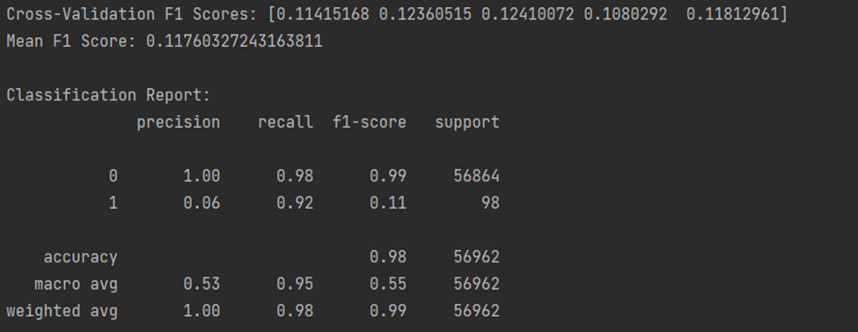
Figure 4.1 Results for baseline Logistic Regression
The use of SMOTE led to a slight improvement in precision, while undersampling intensified the model’s tendency to overfit the minority class, resulting in even lower precision. Class weighting produced moderate improvements but still struggled to achieve a meaningful balance between correctly identifying fraud and avoiding excessive false positives.
The most significant improvement occurred through threshold tuning. After systematically evaluating thresholds , the optimal threshold was found to be a staggeringly high 99.9974%, dramatically shifting the model’s decision boundary. At this threshold, Logistic Regression achieved:
- Precision: 78.10%
- Recall: 83.67%
- F1-score: 80.79%
This showed that Logistic Regression, despite its simplicity and inability to model non-linear relationships, can perform surprisingly well when its decision threshold is heavily calibrated to the specific needs of the task.
thresholds = np.arange(0.9999, 1.000001, 0.000001)
print("Threshold | Precision | Recall | F1")
for t in thresholds:
y_pred_t = (y_prob >= t).astype(int)
p = precision_score(y_test, y_pred_t) * 100
r = recall_score(y_test, y_pred_t) * 100
f = f1_score(y_test, y_pred_t) * 100
print(f"{t*100:.4f}% {p:.2f}% {r:.2f}% {f:.2f}%")
Code used for threshold tuning
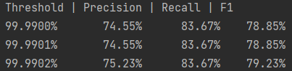
Figure 4.2 Results obtained from threshold tuning in Logistic Regression

4.2 Random Forest
Random Forest produced a substantial improvement in performance compared to Logistic Regression, with the baseline model managing to achieve an F1-score of 84%, prior to any adjustments.
With class weight adjustments and threshold tuning Random Forest managed to achieve an F1-score of 89%, but when testing with different training and test samples it hovered more closely around the 86-88 percentile range. It achieved this at a threshold of 0.27 with a ROC-AUC of 0.962 and a PR-AUC of 0.863, very satisfactory, especially with just mild tuning.
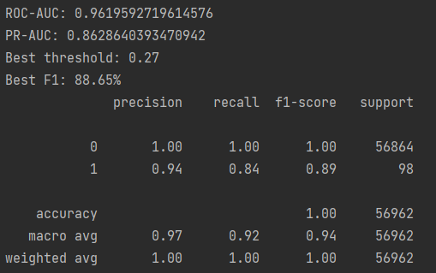
Figure 4.3 Results obtained from Random Forest

Feature selection experiments using the top 20, 15, 10, and 5 features showed only a slight decline in F1-score as the number of features decreased. This demonstrated that the model remained robust and retained strong predictive performance even when operating with significantly fewer inputs. The model consistently went down by about 1-2% for each 5 features removed, still remaining at a surprisingly good 83% F1-score even at only the top 5 features being used.
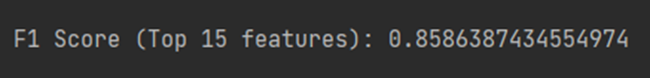
Figure 4.4 Feature selection results in Random Forest
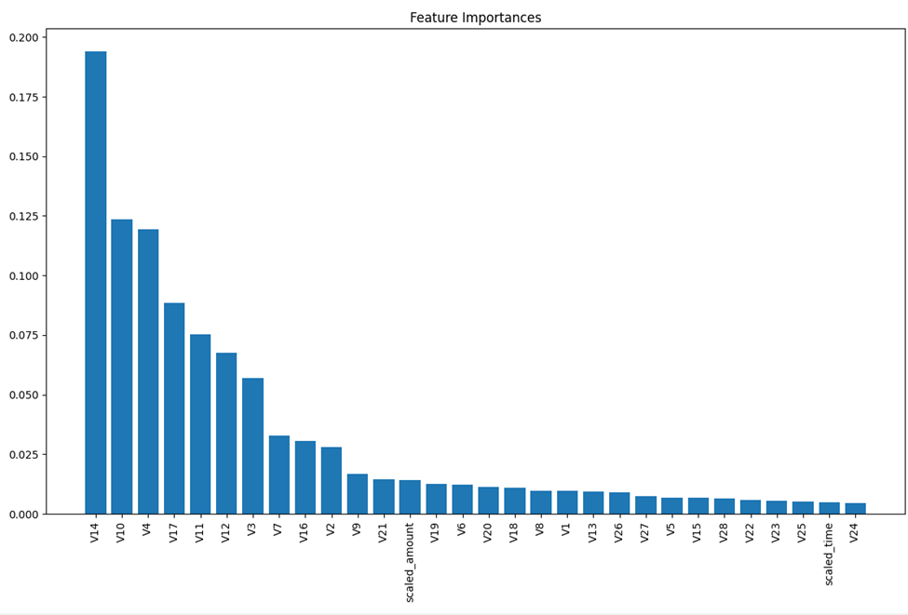
Figure 4.5 Graph of Feature Importances in Random Forest

Hyperparameter tuning produced mixed results. Some configurations delivered strong recall but poor precision, while others improved precision at the cost of recall. Increasing the number of trees beyond 300, to 500 or 800 trees, did not yield significant performance gains and only increased computational time, confirming that the model had reached diminishing returns.
Training time became a practical limitation, with some tuning iterations requiring multiple hours to complete. This ultimately made Random Forest the least efficient model in the study despite its strong predictive performance.
param_dist = {
'n_estimators': [300],
'max_depth': [10, 20, None],
'max_features': ['sqrt', 'log2', 0.5],
'min_samples_split': [2, 5, 10],
'min_samples_leaf': [1, 2, 4],
'class_weight': ['balanced', 'balanced_subsample']
}
rf = RandomForestClassifier(random_state=42, n_jobs=-1)
rf_search = RandomizedSearchCV(
estimator=rf,
param_distributions=param_dist,
n_iter=15,
scoring='f1',
cv=2,
verbose=2,
random_state=42,
n_jobs=-1
)
When testing with limited hyperparameter tuning, results varied, but the best results stayed fairly consistent with the original model (being at around an 86-88 percentile range), but with interestingly different thresholds, with one model achieving an F1-Score of 86%, but with an optimal threshold of 0.68.

4.3 XGBoost
XGBoost demonstrated consistently strong results right from the start. The baseline model with only threshold tuning achieved:
- F1-score: ~86%
- ROC-AUC: 0.981
- PR-AUC: 0.864
Although it found these values at a very high threshold of 0.92, indicating that it needed a lot of confidence before guessing fraudulent cases.
Hyperparameter tuning provided improvements. The best-performing model used deeper trees (max_depth = 6), a higher learning rate (0.1), stronger regularization (min_child_weight = 7, gamma = 0.2), and an increased scale_pos_weight value (~866).
After applying threshold tuning to this optimized model, the threshold required for optimal performance decreased substantially, from the original 0.92 to 0.77, indicating that the model became better calibrated and required less extreme confidence before predicting fraud.
The tuned model achieved:
- F1-score: ~88%
- PR-AUC: 0.882
xgb = XGBClassifier(
objective="binary:logistic",
eval_metric="logloss",
tree_method="hist",
n_jobs=-1
)

param_dist = {
"n_estimators": [200, 300, 400],
"max_depth": [3, 4, 5, 6],
"learning_rate": [0.01, 0.03, 0.05, 0.1],
"subsample": [0.6, 0.7, 0.8, 1.0],
"colsample_bytree": [0.6, 0.7, 0.8, 1.0],
"min_child_weight": [1, 3, 5, 7],
"gamma": [0, 0.05, 0.1, 0.2],
"scale_pos_weight": [imbalance_ratio, imbalance_ratio/2, imbalance_ratio*1.5]
}

search = RandomizedSearchCV(
xgb,
param_dist,
n_iter=20,
scoring="roc_auc",
cv=3,
verbose=2,
n_jobs=-1,
random_state=42
)

Figure 4.6 Best Hyperparameter results - XGBoost
After finding the optimal model, We evaluated its performance across 10 different stratified train-test splits to verify its stability and robustness. The model consistently maintained high F1-scores, ROC-AUC, and PR-AUC values across all splits, with it achieving maximum scores of:
- F1-score: 91%
- PR-AUC: 0.8903
- ROC-AUC: 0.9959
on split 3, demonstrating that the improvements from hyperparameter and threshold tuning were not due to random chance.
Looking at feature importances, we can see some similarities between Random Forest and XGBoost, with V14 standing out as the most important feature, followed by V10. The main difference is that, apart from the top four features, XGBoost seems to treat the rest as almost irrelevant, with V14 dominating far more than in Random Forest
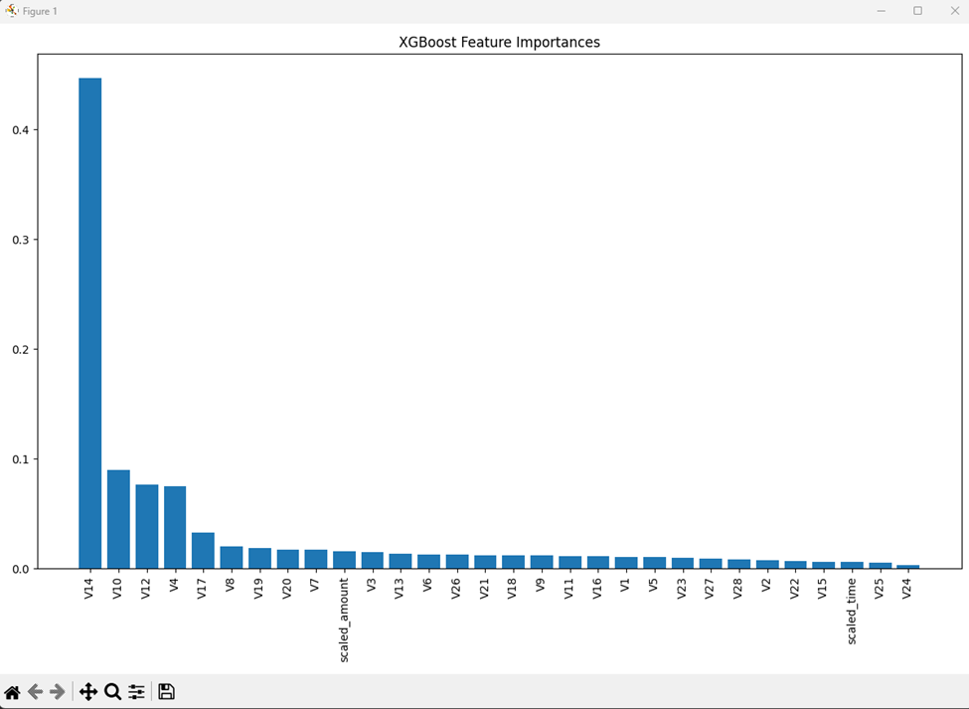
Figure 4.7 Graph of Feature Importances - XGBoost

8. Conclusion
This project investigated several machine learning approaches for credit card fraud detection using an extremely imbalanced dataset. The study applied Logistic Regression, Random Forest, and XGBoost, along with resampling techniques, feature selection, hyperparameter tuning, and threshold adjustment, with the goal of identifying the most effective model for detecting fraudulent transactions. Evaluation was based on metrics specifically suited to imbalanced classification problems, including Precision, Recall, F1-score, ROC-AUC, and PR-AUC.
The results demonstrated that while Logistic Regression performed poorly under default settings, its performance improved dramatically once the decision threshold was optimized, showing that even as a simple model it can still produce satisfactory results. Random Forest delivered strong results and proved remarkably robust to feature reduction, but its extremely high computational cost limited the extent of hyperparameter tuning. XGBoost consistently achieved strong performance, and after tuning, it produced the best results while maintaining efficient training times.
Overall, the findings indicate that XGBoost represents the most effective and practical model for this fraud-detection task, offering the best balance between predictive performance and computational efficiency. Random Forest also performed strongly but required considerably more resources, while Logistic Regression, though simple, demonstrated the importance of threshold calibration in addressing class imbalance.
There were several limitations to the study. The dataset remained highly imbalanced, and resampling methods had limited effects. Computational constraints restricted the depth of Random Forest tuning. Furthermore, only supervised models were considered, despite the fact that fraud detection is often well suited to anomaly-detection or semi-supervised approaches.
Future work could expand this project by evaluating alternative models such as LightGBM or CatBoost, exploring unsupervised anomaly-detection techniques, or incorporating financial risk into the learning objective through cost-sensitive modeling. Another valuable direction would be to test model generalization across multiple fraud datasets or across time, as the patterns of fraudulent behavior naturally evolve. By pursuing these directions, the robustness and real-world applicability of fraud-detection models could be further enhanced.

References
Kaggle. (2018). Credit Card Fraud Detection. Retrieved from https://www.kaggle.com/datasets/mlg-ulb/creditcardfraud
Hosmer, D. W., Lemeshow, S., & Sturdivant, R. X. (2013). Applied Logistic Regression (3rd ed.). Wiley.
Breiman, L. (2001). Random forests. Machine Learning, 45(1), 5–32.

Chawla, N. V., Bowyer, K. W., Hall, L. O., & Kegelmeyer, W. P. (2002). SMOTE: Synthetic Minority Over-sampling Technique. Journal of Artificial Intelligence Research, 16, 321–357. https://doi.org/10.1613/jair.953
Al-Amri, R., Murugesan, R. K., Man, M., Abdulateef, A. F., Al-Sharafi, M. A., & Alkahtani, A. A. (2021). A review of machine learning and deep learning techniques for anomaly detection in IoT data. Applied Sciences, 11(12), 5320. https://doi.org/10.3390/app11125320
Bhattacharyya, S., Jha, S., Tharakunnel, K., & Westland, J. C. (2011). Data mining for credit card fraud: A comparative study. Decision Support Systems, 50(3), 602–613. https://doi.org/10.1016/j.dss.2010.08.008
Carcillo, F., Dal Pozzolo, A., Le Borgne, Y. A., Caelen, O., Mazzer, Y., & Bontempi, G. (2019). Scarff: A scalable framework for streaming credit card fraud detection with Spark. Information Fusion, 41, 182–194. https://doi.org/10.1016/j.inffus.2017.09.005
Dal Pozzolo, A., Boracchi, G., Caelen, O., Alippi, C., & Bontempi, G. (2015). Credit card fraud detection: A realistic modeling and a novel learning strategy. IEEE Transactions on Neural Networks and Learning Systems, 29(8), 3784–3797. Retrieved from https://boracchi.faculty.polimi.it/docs/2017_FraudsTNNLS.pdf
Jolliffe, I. T., & Cadima, J. (2016). Principal component analysis: A review and recent developments. Philosophical Transactions of the Royal Society A, 374(2065), 20150202. https://doi.org/10.1098/rsta.2015.0202
Jurgovsky, J., Granitzer, M., Ziegler, K., Calabretto, S., Portier, P. E., He-Guelton, L., & Caelen, O. (2018). Sequence classification for credit-card fraud detection. Expert Systems with Applications, 100, 234–245. https://doi.org/10.1016/j.eswa.2018.01.037
Kaur, H., & Singh, J. (2021). A comprehensive study of oversampling techniques for credit card fraud detection. International Journal of System Assurance Engineering and Management, 12, 231–243. https://doi.org/10.1007/s13198-021-01072-1
Panigrahy, R. K., Borah, S., & Sahoo, M. N. (2022). Credit card fraud detection: A comparative analysis of ensemble models. International Journal of Information Management Data Insights, 2(2), 100084. https://doi.org/10.1016/j.jjimei.2022.100084
Ramya, R., & Umadevi, G. (2022). Credit card fraud detection using deep learning techniques: A review. Materials Today: Proceedings, 51, 2053–2059. https://doi.org/10.1016/j.matpr.2021.10.102
ahin, Y. G., & Duman, E. (2011). Detecting credit card fraud by decision trees and support vector machines. In Proceedings of the International MultiConference of Engineers and Computer Scientists (IMECS), Vol. 1 (pp. 442–447). International Association of Engineers. https://www.iaeng.org/publication/IMECS2011/IMECS2011_pp442-447.pdf
Zhang, Y., Cao, J., Wang, K., & Li, M. (2023). Hybrid fraud detection with gradient boosting and anomaly detection. Expert Systems with Applications, 226, 120252. https://doi.org/10.1016/j.eswa.2023.120252
Saito, T., & Rehmsmeier, M. (2015). The precision–recall plot is more informative than the ROC plot when evaluating binary classifiers on imbalanced datasets. PLoS ONE, 10(3), e0118432.

