**Fitness Tracker App - Software Engineering Project**

**1. High-Level Plan**

**Development Approach: Agile**

We will follow an **Agile Development Process** with at least **two releases**. The plan consists of a **Product Roadmap** and a **Release Plan**.

**Product Roadmap**

|  |  |  |
| --- | --- | --- |
| **Phase** | **Features & Milestones** | **Estimated Completion** |
| Phase 1 | Project planning, gathering requirements, creating UML diagrams | April 2nd |
| Phase 2 | Core backend development (User authentication, data storage) | April 15th |
| Phase 3 | Core frontend development (Basic UI, User Dashboard) | April 30th |
| Phase 4 | First Release: Basic working version (Login, CRUD tracking) | May 11th |
| Phase 5 | Implement advanced features (Workout plans, progress tracking) | May 25th |
| Phase 6 | Add notification and gamification features (Achievements, badges, notifications) | June 5th |
| Phase 7 | Final Release: Testing, deployment, and final documentation | June 15th |

**Release Plan**

**Release 1 (May 11th)**

* User Authentication (Login, Registration, Profile Setup)
* Basic Workout & Activity Tracking (Add, Edit, Delete logs)
* Dashboard to view workouts

**Release 2 (June 15th)**

* Goal setting and tracking
* Notifications and reminders
* Unit testing & deployment

**2. Functional and Non-Functional Requirements (User Stories)**

**Functional Requirements**

**User Authentication & Account Management**

1. As a user, I want to create an account so that I can log in securely.
2. As a user, I want to log in using my email and password.
3. As a user, I want to be able to change my password
4. As a user, I want to log out of my account securely.
5. As a user, I want to delete my account if I no longer wish to use the app.

**Workout Tracking**

1. As a user, I want to log my daily workouts.
2. As a user, I want to categorize workouts (e.g., cardio, strength, flexibility).
3. As a user, I want to track calories burned per workout.
4. As a user, I want to view my workout history.
5. As a user, I want to edit or delete a logged workout.

**Goal Setting & Progress Tracking**

1. As a user, I want to set fitness goals (e.g., weight loss, muscle gain).
2. As a user, I want to track my body measurements (weight, BMI, muscle mass, etc.).
3. As a user, I want to track my progress toward my goals.

**Gamification Features**

1. As a user, I want to earn achievements for reaching milestones.
2. As a user, I want to receive notifications about challenges and progress.
3. As a user, I want to receive badges for consistency streaks (e.g., 7-day streak).

**Non-Functional Requirements**

1. The system should be able to handle at least 100 concurrent users.
2. The system should encrypt user data to ensure security.
3. The mobile app should be responsive and work on both Android and iOS.
4. The application should load within 3 seconds.
5. The backend should use RESTful API architecture for communication.
6. The app should support dark mode.
7. The system should have a help and support section for users.

**3. Activity, class and sequence diagrams**

**Activity diagrams**

1. User log-in/registration

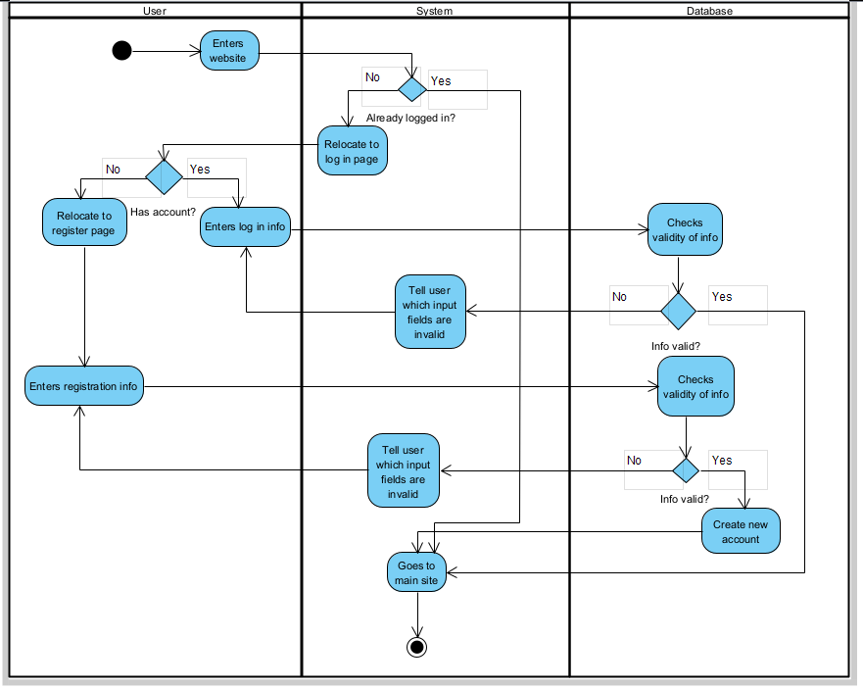

1. Creating new workout

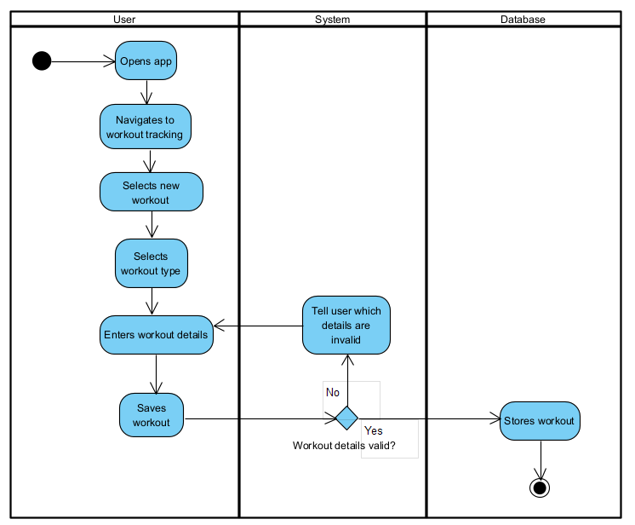

1. Editing/Deleting workout

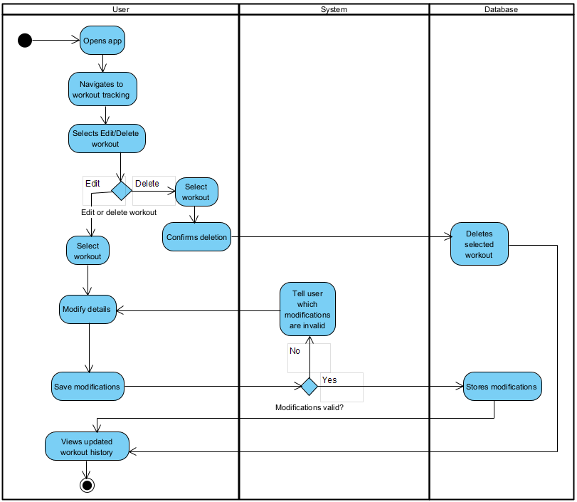

1. Creating new goal and progress tracking

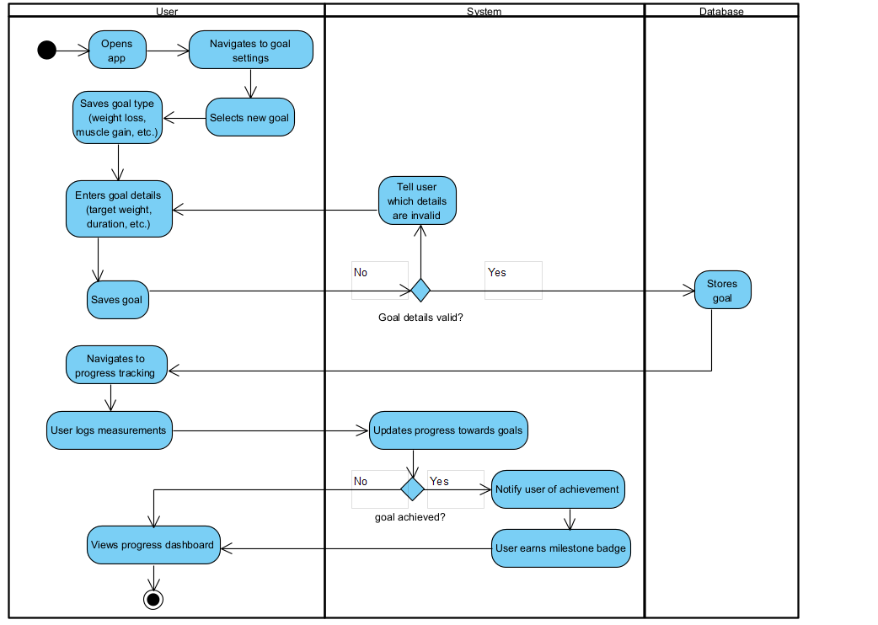

**Sequence UML diagrams**

* 1. Register and login

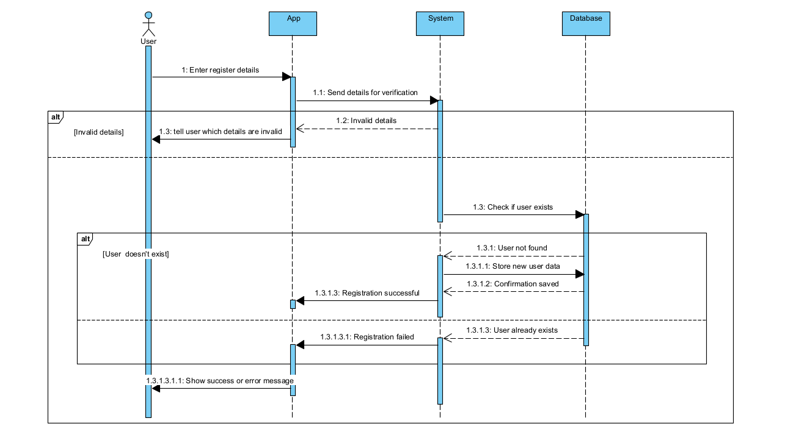

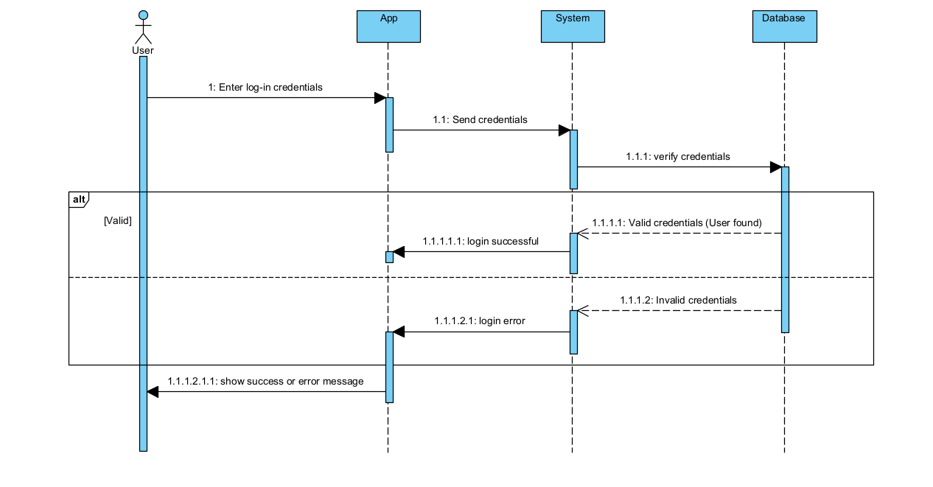

* 1. Workout logging and edit/delete workout
* Workout log

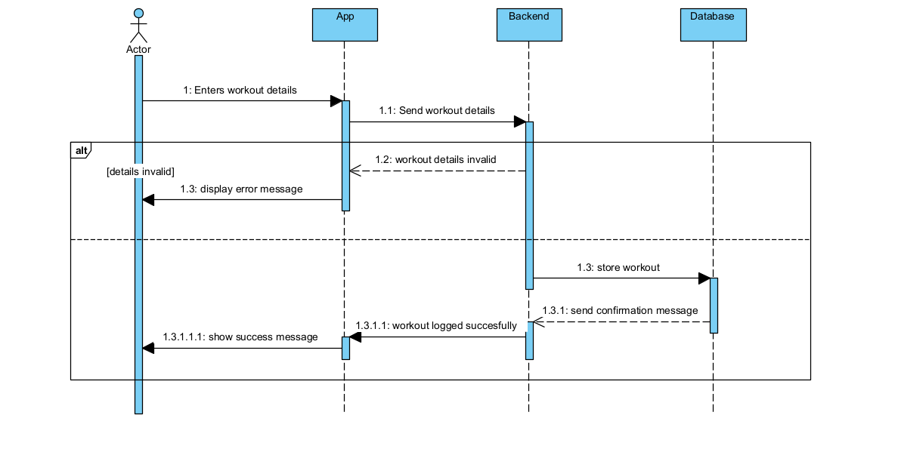

* Workout edit/delete

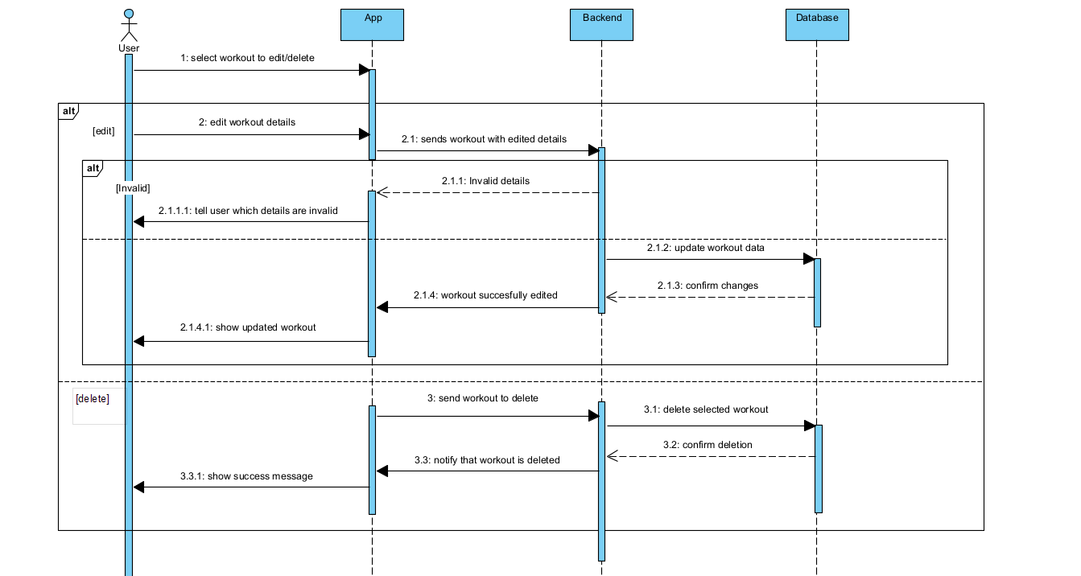

* 1. Goal setting and progress making

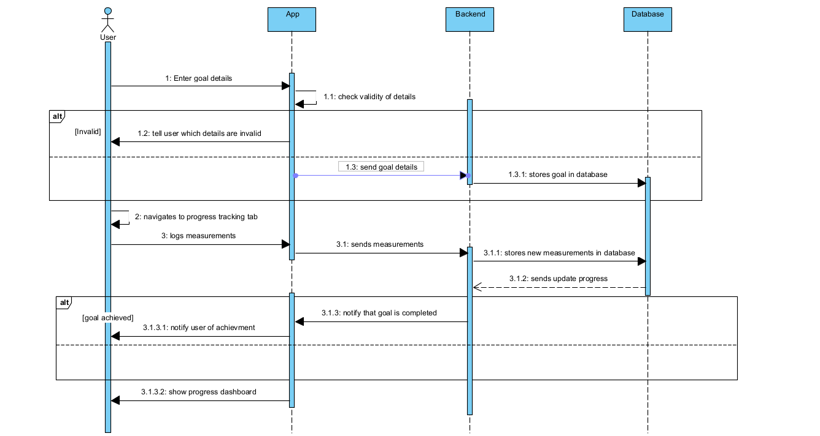

**Class diagram**

