**Tutorial – Implementing YANG modules on ODL**

1. **Get Ubuntu OS with an IDE and all requirements running on VirtualBox**
   1. Make sure to assign enough resources to your VM (e.g. 4 CPUs, 8GB Ram, at least 30GB disk space)
   2. Set up a shared folder and clipboard via settings of the VM and the following commands inside the Terminal of the running VM (restart VM afterwards):
      1. sudo apt-get install virtualbox-guest-dkms (clipboard)
      2. sudo mount -t vboxsf share ~/host (folder; follow tutorial on <https://forums.virtualbox.org/viewtopic.php?t=15868>)
   3. Install latest JDK, Eclipse (or your preferred IDE) and the YANG IDE for Eclipse (https://github.com/xored/yang-ide/wiki/Installing).
   4. Download latest release of ODL (or whatever release you need) and set your JAVA_HOME in your .bashrc (export JAVA_HOME="/usr/lib/jvm/java-8-openjdk-amd64/").
   5. Optional: You might want to install OpenDaylight User Interface (DLUX) by feature:install odl-dlux-all while ODL is running and libcontainer (http://libcontainer.sourceforge.net/) to add multiple JARs to your Eclipse projects.
   6. Install GIT and Maven using sudo apt-get install git and sudo apt-get install git.
   7. Get the right settings.xml for maven into your folder ~/.m2/ by:

wget -q -O - https://raw.githubusercontent.com/opendaylight/odlparent/master/settings.xml > ~/.m2/settings.xml

**Maven command to create a new empty project** (check for latest archetype versions in the catalog)

mvn archetype:generate -DarchetypeGroupId=org.opendaylight.controller -DarchetypeArtifactId=opendaylight-startup-archetype \

-DarchetypeRepository=http://nexus.opendaylight.org/content/repositories/opendaylight.snapshot/ \

-DarchetypeCatalog=http://nexus.opendaylight.org/content/repositories/opendaylight.snapshot/archetype-catalog.xml \

-DarchetypeVersion=1.3.0-SNAPSHOT

NETCONF testtool verifying:  
ssh admin@localhost -p (PORT NO; e.g. 17830) -s -oHostKeyAlgorithms=+ssh-dss netconf

Link to MD-SAL:Startup Project Tutorial:

<https://wiki.opendaylight.org/view/OpenDaylight_Controller:MD-SAL:Startup_Project_Archetype>

Link to Application Development Tutorial:

**Note:** If you’re following this tutorial, make sure, you won’t grep an old Snapshot-Version.  
 Don’t remove any auto-generated comments in the beginning of Java-Classes.

https://wiki.opendaylight.org/view/Controller_Core_Functionality_Tutorials:Application_Development_Tutorial#Setup_Development_Environment

Link to walkthrough for that Tutorial:

<https://www.youtube.com/watch?v=2wTEuNyxspY&index=13&list=PL8F5jrwEpGAiJG252ShQudYeodGSsks2l>

How to Debug Karaf:

<https://youtu.be/EfK-_NA7jqU?t=30m50s>

**How to work on existing ODL projects:**

Search on git/github for the module you are looking for: <https://git.opendaylight.org/gerrit/p/> or <https://github.com/opendaylight>

git clone <https://git.opendaylight.org/gerrit/yang-push>

cd yang-push/

mvn clean install

Then go to Eclipse and import as existing Maven project. After some time, errors inside workspace may occur that will even after a ‘mvn clean install’ persist. To fix this issue, delete your project from eclipse (do not remove it from your disk) and then re-import it again as existing Maven project.

Data Store:

<https://youtu.be/yDTiL8R-PAw?t=2m3s>

Ignores some style checks like ‘is the following statement less than 40 characters’

No testing will be done

mvn clean install -Dcheckstyle.skip=true -DskipTests

Maybe you have to run it a few times, for no reason.

no-snapshot-updates

mvn –nsu clean install

How to remove Java home warning on karaf startup:   
Add *export JAVA_HOME="/usr/lib/jvm/java-8-openjdk-amd64/"* (or your individual path) to */home/{user}/.bashrc*

_________

ODL-Toaster Tutorial is currently offline:

Jun 14, 2016 8:13 AM: ’Remove toaster, as this is an outdated version, latest is actually still in controller.’

_____________

In case there are some BUILD FAILURES due to imports try:

* delete the folders below ~/.m2/
* delete projects (e.g. ‘hello’)
* get new repository (mvn archetype:generate…)

Maven Import of YANG Projects in Eclipse:

* Import all POM-files end edit the java files in the separate projects, so that Eclipse interprets them as Java-projects.

Shows installed features called ‘hello’

**ODL Commands**

feature:list -i | grep hello

feature:info odl-hello-ui

To test your own provider, use following command from time to time:

log:display | grep yangpushserver

and look for something like following:

yangpushserverProvider Session initiated.

This will provide more detailed log (As usual also stored in karaf.log):

log:set TRACE

Test ‘hello world’ RPC using **POSTMAN**:

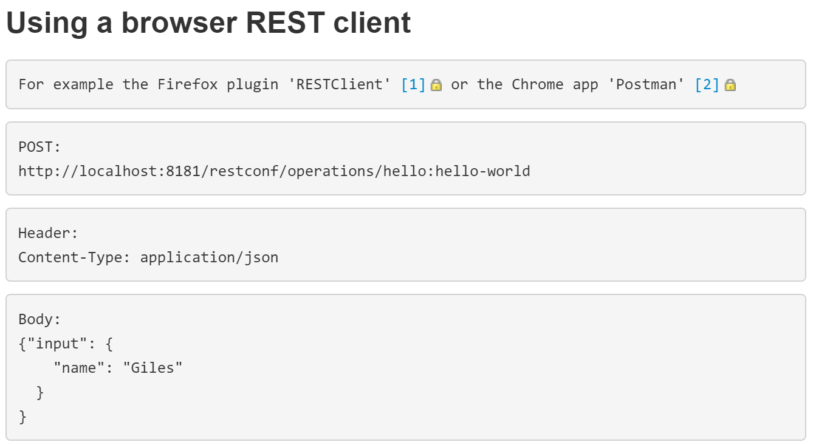

_____________

Helpful links:

|  |  |
| --- | --- |
| https://maven.apache.org/guides/introduction/introduction-to-dependency-mechanism.html |  |
| <https://nexus.opendaylight.org/content/repositories/public> |  |

<https://github.com/opendaylight/controller/tree/stable/boron>

**How to add features to your ODL distribution** (e.g. odl-netconf-mdsal aka. NETCONF northbound support **+** odl-netconf-connector-all for odl-inventory)

1. Go to features/src/main/features/features.xml in your projects directory
2. Look for your desired feature on <https://nexus.opendaylight.org/content/repositories/opendaylight.snapshot/org/opendaylight/>

and add it as repository to your features.xml as follows:  
<repository>mvn:org.opendaylight.netconf/features-netconf/{{VERSION}}/xml/features</repository>  
<repository>mvn:org.opendaylight.netconf/features-netconf-connector/1.2.0-SNAPSHOT/xml/features</repository>

1. Go to your features/pom.xml and add a version for your new feature under <properties> like:  
   <netconf.version>1.2.0-SNAPSHOT</netconf.version>
2. Now just add the dependency for your new feature under <dependencyManagement> like:

<dependency>

<groupId>org.opendaylight.netconf</groupId>

<artifactId>netconf-artifacts</artifactId>

<version>${netconf.version}</version>

<type>pom</type>

<scope>import</scope>

</dependency>  
 <dependency>

<groupId>org.opendaylight.netconf</groupId>

<artifactId>sal-netconf-connector</artifactId>

<version>1.5.0-SNAPSHOT</version>

<type>pom</type>

<scope>import</scope>

</dependency>  
And under <dependencies> further below like:  
 <dependency>

<groupId>org.opendaylight.netconf</groupId>

<artifactId>features-netconf</artifactId>

<classifier>features</classifier>

<type>xml</type>

<scope>runtime</scope>

</dependency>  
 <dependency>

<groupId>org.opendaylight.netconf</groupId>

<artifactId>features-netconf-connector</artifactId>

<classifier>features</classifier>

<type>xml</type>

<scope>runtime</scope>

</dependency>

**Restconf: Change event notification subscription** (<https://wiki.opendaylight.org/view/OpenDaylight_Controller:MD-SAL:Restconf:Change_event_notification_subscription>) required feature in ODL is called odl-mdsal-remoterpc-connector.

You probably have to upload huge files (>100MB && <1GB) to github, in case you want to collaborate with other people. This short video may help a lot:

<https://www.youtube.com/watch?v=uLR1RNqJ1Mw>

More basics for github:

<https://help.github.com/articles/adding-an-existing-project-to-github-using-the-command-line/>

**Opendaylight Logfile:**

Normally saved in the file ‘karaf.log’ under /PROJECTNAME/karaf/target/assembly/data/log

Try to connect to NETCONF md-sal northbound SSH server, you can do it like this:

ssh -oHostKeyAlgorithms=+ssh-dss admin@127.0.0.1 -p 2830 -s netconf

You send your hello message to server. This should be just fine:

<?xml version="1.0" encoding="UTF-8" standalone="no"?>

<hello xmlns="urn:ietf:params:xml:ns:netconf:base:1.0">

<capabilities>

<capability>urn:ietf:params:netconf:base:1.0</capability>

</capabilities>

</hello>]]>]]>

And then finally you will send your RPC. So you type:

<rpc xmlns="urn:ietf:params:xml:ns:netconf:base:1.0" message-id="101">

<establish-subscription xmlns="urn:ietf:params:xml:ns:yang:ietf-event-notifications">

<encoding>encode-xml</encoding>

<stream>push-update</stream>

<period xmlns="urn:ietf:params:xml:ns:yang:ietf-yang-push">30</period>

</establish-subscription>

</rpc>]]>]]>

**When using NCClient to communicate with ODLs Netconf northbound server with settings like above make sure the payload of the messages you send include** ]]>]]> **as well.** (Delimiter to indicate end of message; usually already provided by NCClient?)

To register change listeners for MD-SALs data store do the following:

// Inside of onSessionInitiated of your Provider  
DOMDataBroker db = session.getService(DOMDataBroker.class);   
// Getting the actual service that allows to register for data tree change events  
DOMDataTreeChangeService changeService = (DOMDataTreeChangeService) db.getSupportedExtensions().get(DOMDataTreeChangeService.class);  
  
changeService.registerDataTreeChangeListener(new DOMDataTreeIdentifier(LogicalDatastoreType.OPERATIONAL, yiid), this);