Experience on Elicited Risk: Hypothesis and Data Analysis

Dario Trujano-Ochoa and Nir Chemaya

3/22/2022

# Data description

This dataset contains the result from 6 experimental sessions.

## Risk elicited

In this study, the Eckle and Grossman risk elicitation task was implemented before and after the participants experience 24 realizations of the tasks. These correspond with **Gamble.1** and **Gamble.2** variables. Next table show the 6 gambles presented to the participants; events **odd** and **even** are equally probable and they had to choose only one gamble.

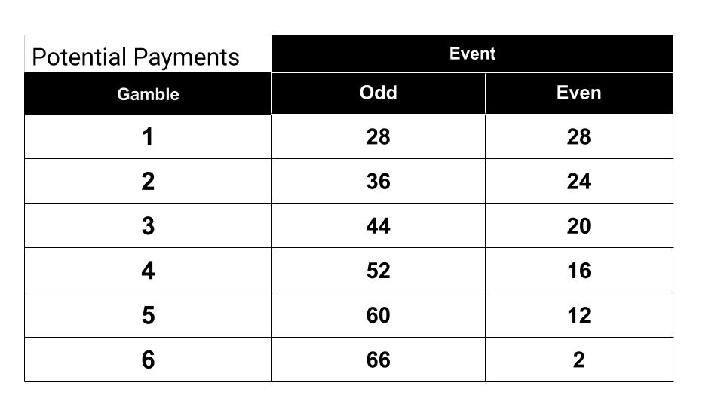

Payoff table of the gambles as presented to the participants.

Notice the expected payoff is increasing from Gamble 1 to 5, and then it decreases to 34 (the same as gamble 4), but in this case choosing gamble 6 clearly elicits risk loving preferences.

## Experience periods

The 24 experience periods correspond to realization of a gamble chosen. In the first 12, a gamble was pre-selected (variables **R1** to **R12**) and the participants throw two dice to determine the events (variables **E1** to **E12**) and wrote down the corresponding payoff (variables **P1** to **P12**). In the last 12, a gamble was chosen by the participants (variables **F1** to **F12**) and the participants throw two dice to determine the events (variables **EF1** to **EF12**) and wrote down the corresponding payoff (variables **PF1** to **PF12**). The 24 periods of realizations didn’t affected the final payoff, but one of them (**Period.to.review**) was selected to check if they wrote down the correct payoff and then earned an extra dollar (**Correct.Payoff**).

# Hypothesis

## Participants display larger levels of risk tolerance

### G2 - G1

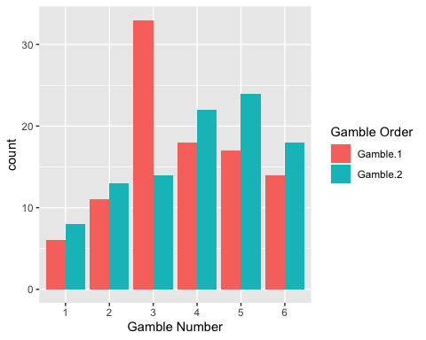

The direction of the change is driven mostly by people choosing gamble 3 at the beginning and moving upwards.

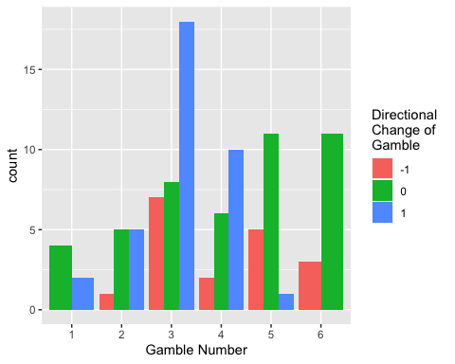

When analyzing the magnitude of the direction, it is clear that the main effect is driven by people moving from gamble 3 to gamble 4 (11 participants), and from gamble 4 to gamble 5 (8 participants).

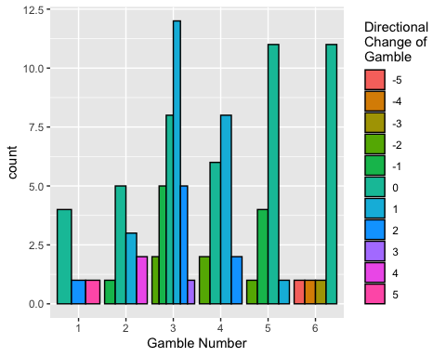

The Wilcox test shows that the difference is significant at 5% when analyzing the hypothesis that Gamble 2 is greater.

wilcox.test(x = ExperienceRisk$simple_diff,alternative = "greater")

##   
## Wilcoxon signed rank test with continuity correction  
##   
## data: ExperienceRisk$simple_diff  
## V = 952, p-value = 0.03143  
## alternative hypothesis: true location is greater than 0

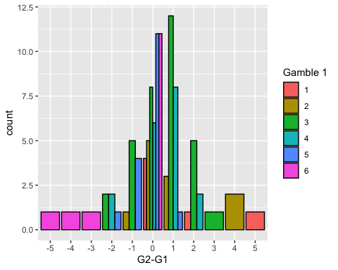

### EP1 - EP2

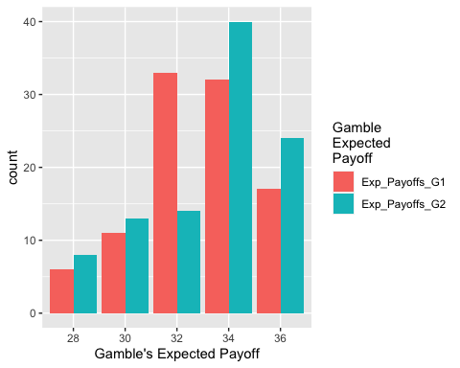

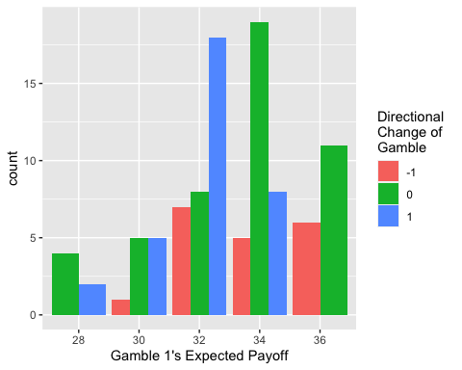

The Wilcox test shows that the difference is significant at 10% when analyzing the hypothesis that Gamble 2 is greater.

wilcox.test(x = ExperienceRisk$diff_Exp_Payoffs,alternative = "greater")

##   
## Wilcoxon signed rank test with continuity correction  
##   
## data: ExperienceRisk$diff_Exp_Payoffs  
## V = 843.5, p-value = 0.07127  
## alternative hypothesis: true location is greater than 0

ExperienceRisk %>% tabyl(Gamble.1,Gamble.2)

## Gamble.1 1 2 3 4 5 6  
## 1 4 0 1 0 0 1  
## 2 1 5 3 0 0 2  
## 3 2 5 8 12 5 1  
## 4 0 2 0 6 8 2  
## 5 0 0 1 4 11 1  
## 6 1 1 1 0 0 11

## Effects of history

It seems that the final average payoff in the previous periods is not explaining the change in risk attitudes.

ggplot(data = ExperienceRisk) +   
 geom_point(aes(x=mean_payoff_periods,y=simple_diff))

## Warning: Removed 2 rows containing missing values (geom_point).

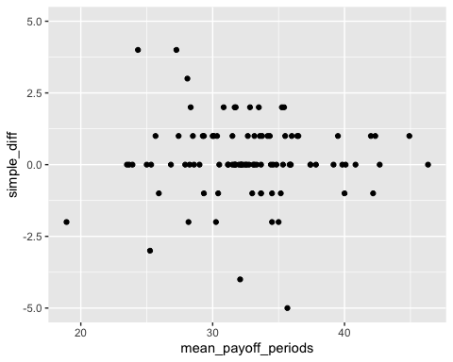

m1 <- lm(diff_Exp_Payoffs ~   
 mean_payoff_periods,  
 data = ExperienceRisk %>% filter(CR.Payoff!=0) )  
summary(m1)

##   
## Call:  
## lm(formula = diff_Exp_Payoffs ~ mean_payoff_periods, data = ExperienceRisk %>%   
## filter(CR.Payoff != 0))  
##   
## Residuals:  
## Min 1Q Median 3Q Max   
## -4.5889 -0.5784 -0.4768 1.4713 3.4895   
##   
## Coefficients:  
## Estimate Std. Error t value Pr(>|t|)  
## (Intercept) 1.06255 1.35849 0.782 0.437  
## mean_payoff_periods -0.01681 0.04063 -0.414 0.680  
##   
## Residual standard error: 1.753 on 73 degrees of freedom  
## (2 observations deleted due to missingness)  
## Multiple R-squared: 0.00234, Adjusted R-squared: -0.01133   
## F-statistic: 0.1712 on 1 and 73 DF, p-value: 0.6802

### Larger number of Even events will make people changing downwards

#### Gamble 1 - Gamble 2

There is no significant effect of the overall number of events on the difference between Gamble 1 and 2.

ggplot(data = ExperienceRisk) +   
 geom_point(aes(x=numEven_all,y=simple_diff))

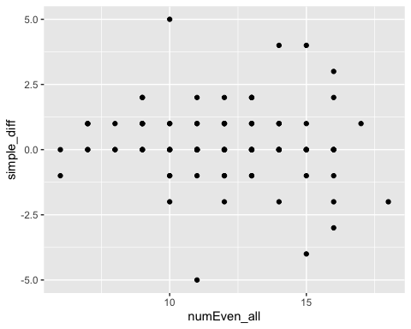

m1 <- lm(simple_diff ~   
 numEven_all,  
 data = ExperienceRisk)  
summary(m1)

##   
## Call:  
## lm(formula = simple_diff ~ numEven_all, data = ExperienceRisk)  
##   
## Residuals:  
## Min 1Q Median 3Q Max   
## -5.2898 -0.3865 -0.1448 0.7102 4.6619   
##   
## Coefficients:  
## Estimate Std. Error t value Pr(>|t|)  
## (Intercept) 0.82157 0.65065 1.263 0.210  
## numEven_all -0.04834 0.05300 -0.912 0.364  
##   
## Residual standard error: 1.416 on 97 degrees of freedom  
## Multiple R-squared: 0.008505, Adjusted R-squared: -0.001716   
## F-statistic: 0.8321 on 1 and 97 DF, p-value: 0.3639

This can be also be seen in the correlation:

cor.test(ExperienceRisk$mean_payoff_periods,ExperienceRisk$simple_diff,use = "na.or.complete")

##   
## Pearson's product-moment correlation  
##   
## data: ExperienceRisk$mean_payoff_periods and ExperienceRisk$simple_diff  
## t = -0.25392, df = 95, p-value = 0.8001  
## alternative hypothesis: true correlation is not equal to 0  
## 95 percent confidence interval:  
## -0.2243226 0.1743083  
## sample estimates:  
## cor   
## -0.02604243

This also happens for people that had more than 18 correct answers out of the 24 experience trials. The final sample was 73 and control for people that didn’t put attention, and the first session where the realization were too fast and people didn’t have enough time to record their answers.

m1 <- lm(simple_diff ~   
 numEven_all,  
 data = ExperienceRisk %>% filter(sum_correct_payoffs>18) )  
summary(m1)

##   
## Call:  
## lm(formula = simple_diff ~ numEven_all, data = ExperienceRisk %>%   
## filter(sum_correct_payoffs > 18))  
##   
## Residuals:  
## Min 1Q Median 3Q Max   
## -5.0565 -0.0634 -0.0531 0.9401 3.9504   
##   
## Coefficients:  
## Estimate Std. Error t value Pr(>|t|)  
## (Intercept) 0.075413 0.663716 0.114 0.910  
## numEven_all -0.001718 0.053839 -0.032 0.975  
##   
## Residual standard error: 1.299 on 71 degrees of freedom  
## Multiple R-squared: 1.434e-05, Adjusted R-squared: -0.01407   
## F-statistic: 0.001018 on 1 and 71 DF, p-value: 0.9746

#### Excpected Payoff 1 - Expected Payoff 2

There is also no significant effect of the overall number of events on the difference between Expected Payoffs in Gamble 1 and 2.

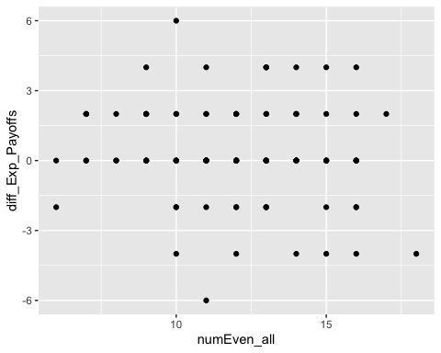

##   
## Call:  
## lm(formula = diff_Exp_Payoffs ~ numEven_all, data = ExperienceRisk)  
##   
## Residuals:  
## Min 1Q Median 3Q Max   
## -6.4129 -0.5960 -0.2298 1.4498 5.4955   
##   
## Coefficients:  
## Estimate Std. Error t value Pr(>|t|)  
## (Intercept) 1.41982 0.96026 1.479 0.142  
## numEven_all -0.09154 0.07822 -1.170 0.245  
##   
## Residual standard error: 2.09 on 97 degrees of freedom  
## Multiple R-squared: 0.01392, Adjusted R-squared: 0.003758   
## F-statistic: 1.37 on 1 and 97 DF, p-value: 0.2447

### Reinforcement

The final average payment might not be that informative. It is possible that the same final payment could have been reached with two different histories. Even when the final average is informative about the magnitude and frequency of reinforcements for risk behavior: higher final payment are achieved by risk takers with good luck, and lower final payments are due to risk takers with bad luck.

## CR predicting more changes

ExperienceRisk %>%   
 mutate(G1 = factor(Gamble.1),  
 CRT = factor(CR.Payoff)) %>%   
 tabyl(G1,CRT)

## G1 0 1 2 3  
## 1 1 2 2 1  
## 2 2 4 2 3  
## 3 11 7 5 10  
## 4 3 4 4 7  
## 5 1 2 4 10  
## 6 4 3 1 6

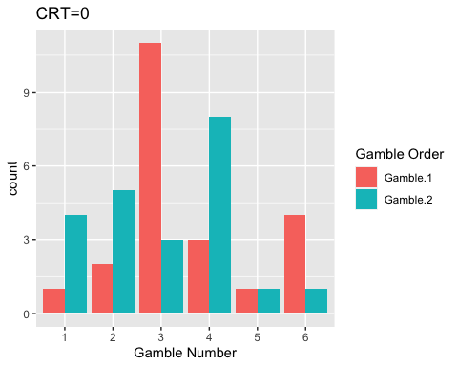

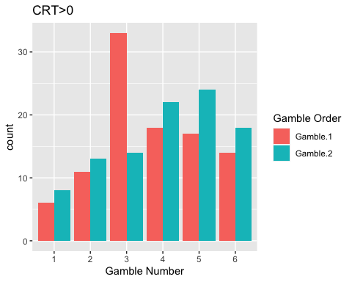

### G2 - G1

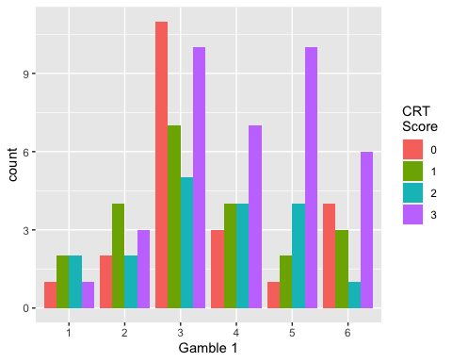

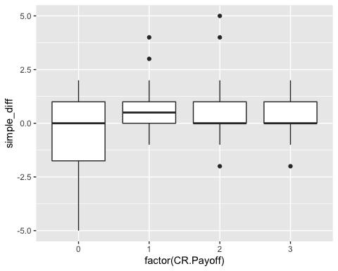

##   
## Call:  
## lm(formula = simple_diff ~ CR.Payoff > 0, data = ExperienceRisk)  
##   
## Residuals:  
## Min 1Q Median 3Q Max   
## -4.4091 -0.4805 -0.4805 0.5195 4.5195   
##   
## Coefficients:  
## Estimate Std. Error t value Pr(>|t|)   
## (Intercept) -0.5909 0.2876 -2.054 0.04262 *   
## CR.Payoff > 0TRUE 1.0714 0.3261 3.285 0.00142 **  
## ---  
## Signif. codes: 0 '***' 0.001 '**' 0.01 '*' 0.05 '.' 0.1 ' ' 1  
##   
## Residual standard error: 1.349 on 97 degrees of freedom  
## Multiple R-squared: 0.1001, Adjusted R-squared: 0.09085   
## F-statistic: 10.79 on 1 and 97 DF, p-value: 0.001419

There is an effect of the CR when considering a dummy for having achieved at least one point in the test. If people got at least one point, they will increase by one the number of the gamble they chose. This effect in not longer significant if the regression include all the levels of CRT as regressors.

##   
## Call:  
## lm(formula = simple_diff ~ CR.Payoff, data = ExperienceRisk)  
##   
## Residuals:  
## Min 1Q Median 3Q Max   
## -4.9463 -0.4667 -0.1197 0.7068 4.7068   
##   
## Coefficients:  
## Estimate Std. Error t value Pr(>|t|)  
## (Intercept) -0.05375 0.24828 -0.216 0.829  
## CR.Payoff 0.17350 0.11955 1.451 0.150  
##   
## Residual standard error: 1.407 on 97 degrees of freedom  
## Multiple R-squared: 0.02125, Adjusted R-squared: 0.01116   
## F-statistic: 2.106 on 1 and 97 DF, p-value: 0.1499

### EP2 - EP1

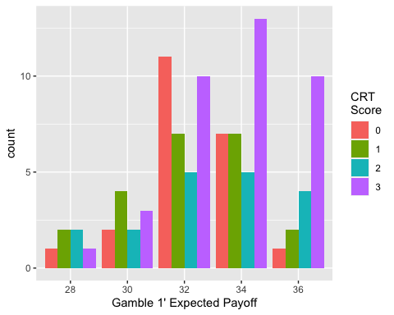

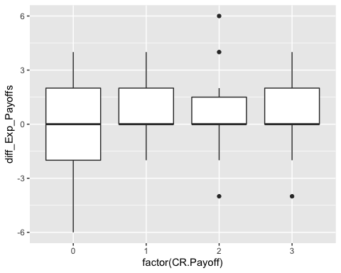

##   
## Call:  
## lm(formula = diff_Exp_Payoffs ~ CR.Payoff > 0, data = ExperienceRisk)  
##   
## Residuals:  
## Min 1Q Median 3Q Max   
## -5.3636 -0.5974 -0.5974 1.4026 5.4026   
##   
## Coefficients:  
## Estimate Std. Error t value Pr(>|t|)   
## (Intercept) -0.6364 0.4349 -1.463 0.147   
## CR.Payoff > 0TRUE 1.2338 0.4931 2.502 0.014 *  
## ---  
## Signif. codes: 0 '***' 0.001 '**' 0.01 '*' 0.05 '.' 0.1 ' ' 1  
##   
## Residual standard error: 2.04 on 97 degrees of freedom  
## Multiple R-squared: 0.06062, Adjusted R-squared: 0.05094   
## F-statistic: 6.26 on 1 and 97 DF, p-value: 0.01403

Like in the difference between the gamble chosen first and second, there is an effect of the CR when considering a dummy for having achieved at least one point in the test. If people got at least one point, they will increase by one the number of the gamble they chose.

## Gender differences

Male and Female participants moved in the expected direction; both moved towards higher gambles. However, both distributions are different.

The distribution of gamble choices among men changes towards gamble 6; risk loving. At the beginning, before the experience the distribution was more or less homogeneous between gambles 3 to 6.

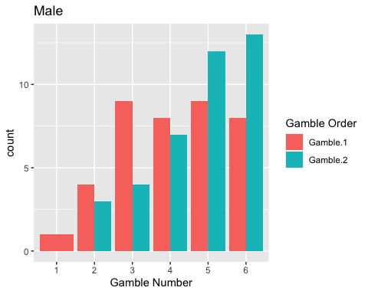

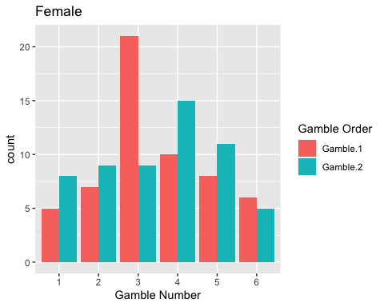

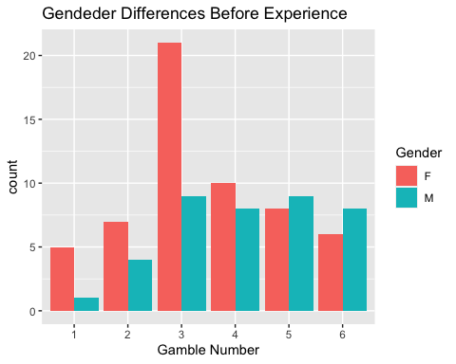

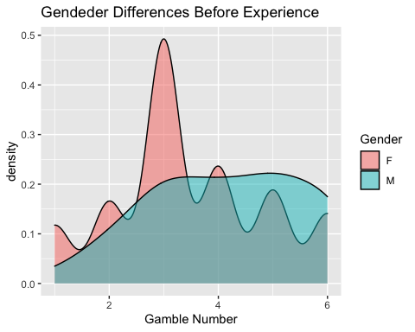

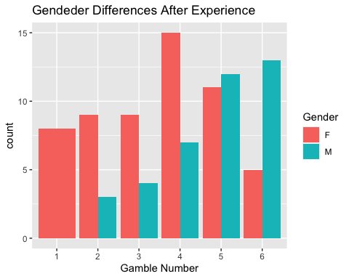

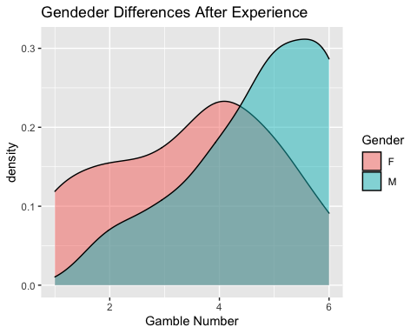

## Regression

### G2- G1

### EP2- EP1

# CRT = 0

ggplot(data = ExperienceRisk %>%   
 filter(CR.Payoff!=0) %>%   
 select(Gamble.1,Gamble.2) %>%   
 gather("Gamble_Order","Gamble") ) +   
 geom_bar(aes(x = factor(Gamble),fill = Gamble_Order),position="dodge")+  
 labs(x = "Gamble Number", fill = "Gamble Order",title="Distribution when CRT is not cero")

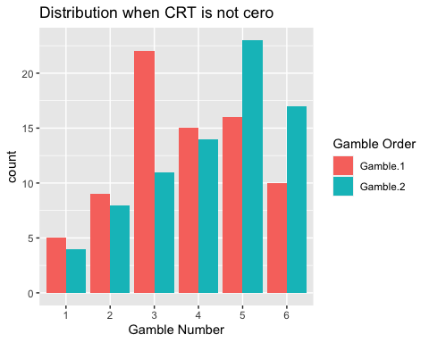

ggplot(data = ExperienceRisk %>%   
 select(Gamble.1,CR.Payoff) ) +   
 geom_bar(aes(x = factor(Gamble.1),  
 fill = factor(CR.Payoff)),  
 position="dodge") +  
 labs(x = "Gamble Number",   
 fill = "Cognitive Test",  
 title ="Distribution of First Gamble when CRT is not cero")

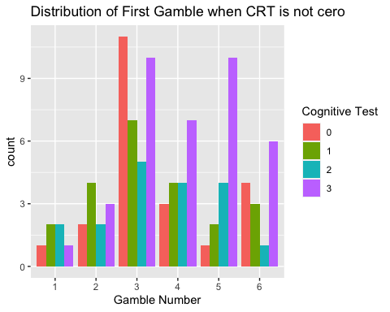

ggplot(data = ExperienceRisk %>%   
 select(Gamble.2,CR.Payoff) ) +   
 geom_bar(aes(x = factor(Gamble.2),  
 fill = factor(CR.Payoff)),  
 position="dodge") +  
 labs(x = "Gamble Number",   
 fill = "Cognitive Test",  
 title ="Distribution of Second Gamble when CRT is not cero")

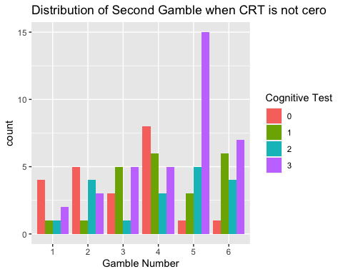

ggplot(data = ExperienceRisk %>%   
 select(simple_diff,CR.Payoff) ) +   
 geom_density(aes(x = simple_diff,  
 fill = factor(CR.Payoff==0)),  
 alpha=0.5)+  
 labs(x = "G2-G1",   
 fill = "CRT=0",  
 title="Distribution of Change when CRT is not cero")

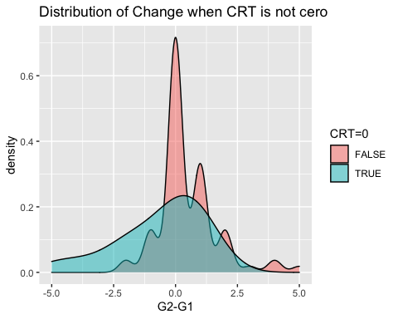

## effect of history

ggplot(data = ExperienceRisk %>%   
 filter(CR.Payoff!=0) ) +   
 geom_point(aes(x=mean_payoff_periods,y=simple_diff))

## Warning: Removed 2 rows containing missing values (geom_point).

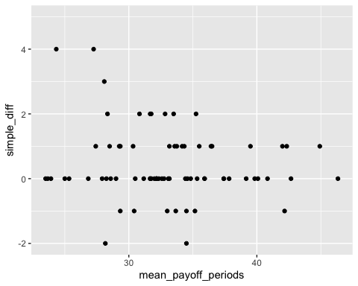

# Follow-up survey

ggplot(data = ExperienceRisk %>%   
 filter(!is.na(max_exp_gamble)))+  
 geom_bar(aes(x= factor(max_exp_gamble)))+  
 labs(x="Gamble",title = "Which gamble has the highest expected payoff?")

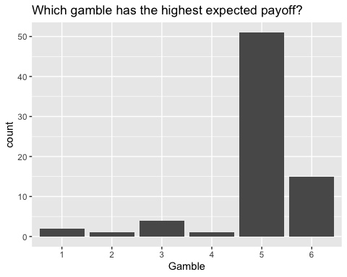

ggplot(data = ExperienceRisk %>%   
 filter(!is.na(guess_average_5_highest)))+  
 geom_bar(aes(x= factor(guess_average_5_highest)))+  
 labs(x="Gamble",title = "What is your guess about the average guess about \nhow many people in the experiment noticed that Row 5 has the highest expected value?")

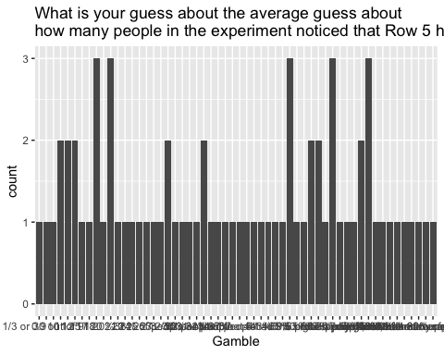

ggplot(data = ExperienceRisk %>%   
 filter(!is.na(guess_gamble_most_chosen)))+  
 geom_bar(aes(x= factor(guess_gamble_most_chosen)))+  
 labs(x="Gamble",title = "Which gamble was chosen most commonly in the last section of the experiment \n (the final decision after you had some experience with the task)?")

