NAME: D.SHIVAGANESH

Roll number: 2420030035

Subject: Computer Networks

Constructing different VLANs (Virtual Local Area Networks) and configuring trunking using Cisco Packet Tracer involves a few steps

Trunking is used in a network to allow multiple VLANs to communicate across network devices (like switches) over a single physical link. It enables the transportation of traffic from different VLANs over the same link, reducing the need for multiple physical connections and ensuring that VLAN segmentation is maintained across the network

Step 1: Setting Up the Network Topology

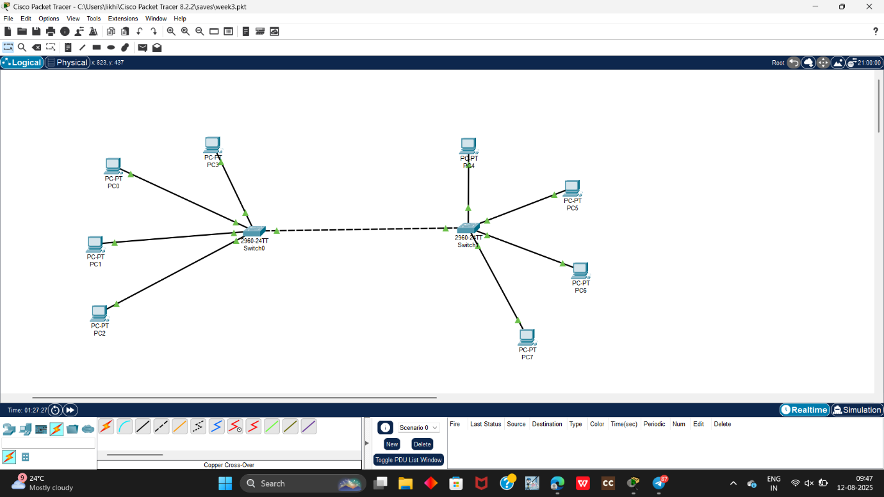

Devices:

* Switch 1 (81)
* Switch 2 (52)
* PC1 and PC2 connected to
* PC3 and PC4 connected to $1
* PC5 and PC& connected to 82
* PC7 and PCB connected to 82
* VLAN 10 IP range 192.168.10.0/24
* VLAN 20 IP range 192.168.20.0/24

**Trunk Ports:**

* Fa0/24 on both $1 and 52

**Configuration Steps**

Step 1: Setting Up the Network Topology

* Add Devices in Packet Tracer.
* Drag and drop two switches (S1 and 52).
* Add PCs and connect them to the switches using copper straight-through cables.
* Connect fa0/24 of $1 to fa0/24 of S2 using a cross-over cable.

**Switch 0 Configuration**

* Switch-enable
* Switch #configure terminal
* Enter configuration commands, one per line. End with CNTL/Z

Create VLAN 10

* Switch(config)#vlan 10
* Switch(config-vlan)#name VLAN10
* Switch(config-vlan)#exit

Create VLAN 20

* Switch(config)#vlan 20
* Switch(config-vlan)#name VLAN20
* Switch(config-vlan)#exit

**Set a Port to Trunk Mode SO**

* Switch (config)#interface fa0/24
* Switch(config-if)#switchport mode trunk
* Switch(config-if)#exit
* 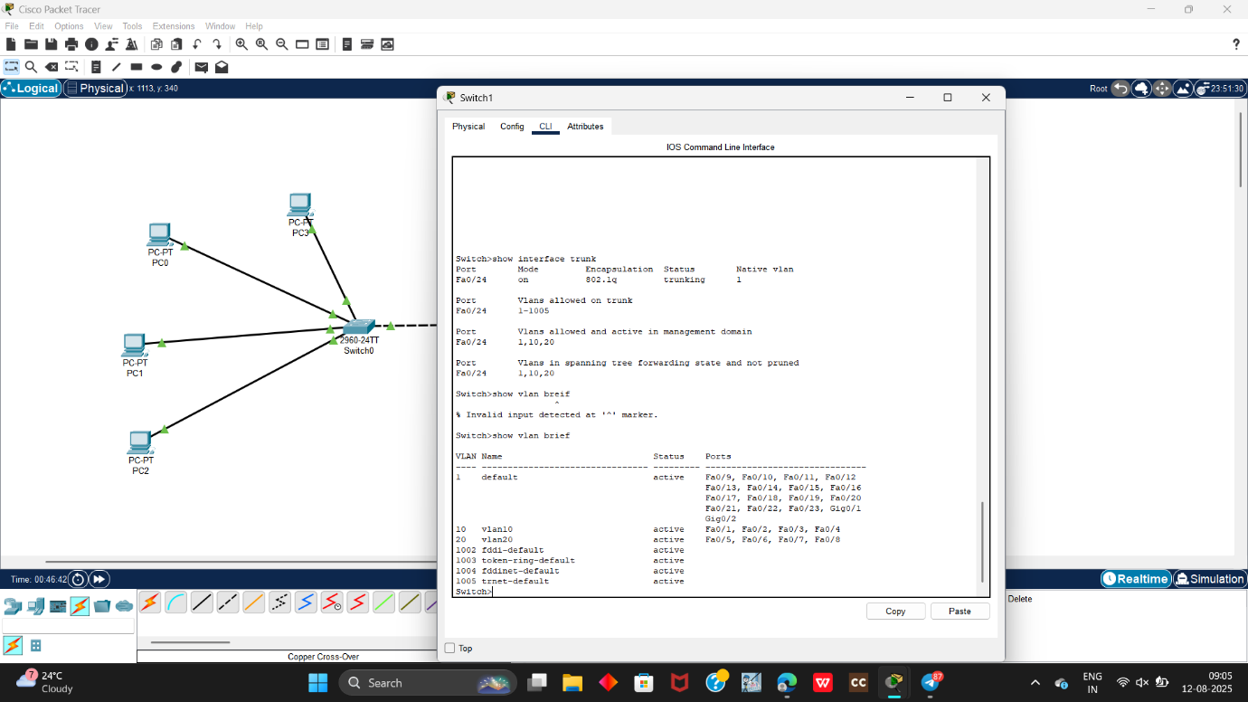

**Switch 1 Configuration**

* Switch-enable
* Switch #configure terminal
* Enter configuration commands, one per line. End with CNTL/Z

Create VLAN 10

* Switch(config)#vlan 10
* Switch(config-vlan)#name VLAN10 Switch(config-vlan)#exit

Create VLAN 20

* Switch(config)#vlan 20
* Switch(config-vlan)#name VLAN20
* Switch(config-vlan)#exit

**Set a Port to Trunk Mode SO**

* Switch (config)#interface fa0/24
* Switch(config-if)#switchport mode trunk
* Switch(config-if)#exit
* 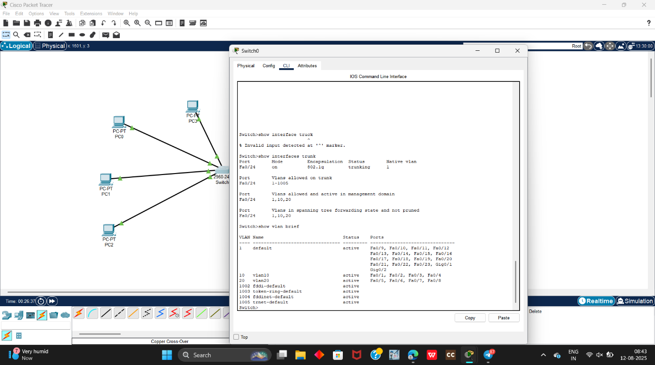

**1 Assign IP Addresses to PCs**:

* PC1: 192.168.10 1/24
* PC2: 192.168.10.2/24
* PC3: 192.168.20.1/24
* PC4:192.168.20 2/24
* PC5: 192.168.10.3/24
* PC6: 192.168.10.4/24
* PC7.192.168.20.3/24
* PC8: 192.168.20 4/24

Test Connectivity within VLANS:

* Ping from PC1 to PC2 (both in VLAN 10)
* Ping from PC3 to PC4 (both in VLAN 20)
* Ping from PC5to PC6(both in VLAN 10, across switches)
* Ping from PC7 to PC8(both in VLAN 20 across switches)
* 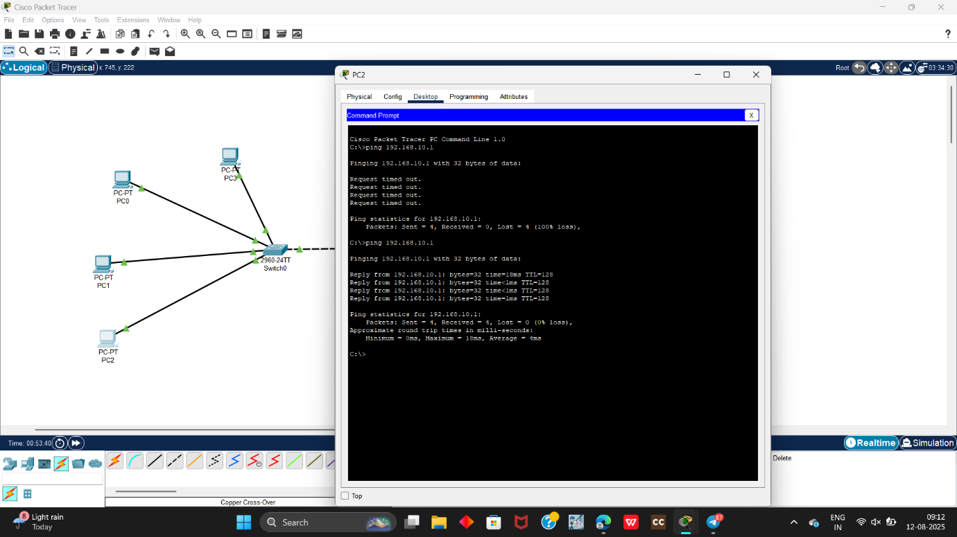

Finally we have been excuted the task and ping command