Name: D.Venkta sai Dhanush

Reg no: 22BCE20023

Saturday Task:

1. import com.mongodb.\*;

import com.mongodb.client.\*;

import com.mongodb.client.MongoClient;

import com.mongodb.client.model.Filters;

import com.mongodb.client.model.Sorts;

import java.util.ArrayList;

import org.bson.Document;

public class Task1a {

public static void main(String[] args) {

MongoClient mongoClient = MongoClients.create("mongodb://localhost:27017");

MongoDatabase database = mongoClient.getDatabase("Saturday");

database.createCollection("Student");

MongoCollection<Document> collection = database.getCollection("Student");

Document document1 = new Document("FirstName","Dhanush")

.append("LastName", "Darisi")

.append("mark", 95)

.append("age", 19);

collection.insertOne(document1);

Document document2 = new Document("FirstName","Dharma")

.append("LastName", "Garipally")

.append("mark", 90)

.append("age", 20);

collection.insertOne(document2);

Document document3 = new Document("FirstName","Shiv")

.append("LastName", "kailash")

.append("mark", 87)

.append("age", 19);

collection.insertOne(document3);

Document document4 = new Document("FirstName","Manish")

.append("LastName", "Sharma")

.append("mark", 92)

.append("age", 20);

collection.insertOne(document4);

Document document5 = new Document("FirstName","Mani")

.append("LastName", "Sharma")

.append("mark", 95)

.append("age", 20);

collection.insertOne(document5);

Document highestMark = collection.find()

.sort(Sorts.descending("mark"))

.first();

//System.out.println(highestMark);

if(highestMark != null){

int highest = highestMark.getInteger("mark");

ArrayList<Document> highestMarkDocuments = collection.find(Filters.eq("mark", highest))

.sort(Sorts.ascending("firstName"))

.into(new java.util.ArrayList<>());

for (Document doc : highestMarkDocuments) {

System.out.println(doc.toJson());

}

}

else {

System.out.println("No documents found in the collection.");

}

}

}

Output:



2. import com.mongodb.\*;

import com.mongodb.client.\*;

import com.mongodb.client.MongoClient;

import com.mongodb.client.model.Filters;

import com.mongodb.client.model.Sorts;

import org.bson.Document;

import org.bson.conversions.Bson;

public class Task1b {

public static void main(String[] args) {

MongoClient mongoClient = MongoClients.create("mongodb://localhost:27017");

MongoDatabase database = mongoClient.getDatabase("Saturday");

database.createCollection("Employee");

MongoCollection<Document> collection = database.getCollection("Employee");

Document document1 = new Document("Name","Ram")

.append("age", 25)

.append("salary", 10000);

Document document2 = new Document("Name","Rahul")

.append("age", 30)

.append("salary", 15000);

Document document3 = new Document("Name","Rakesh")

.append("age", 31)

.append("salary", 25000);

Document document4 = new Document("Name","Avik")

.append("age", 35)

.append("salary", 20000);

Document document5 = new Document("Name","Ajay")

.append("age", 30)

.append("salary", 25000);

Document document6 = new Document("Name","Harsha")

.append("age", 39)

.append("salary", 35000);

collection.insertOne(document1);

collection.insertOne(document2);

collection.insertOne(document3);

collection.insertOne(document4);

collection.insertOne(document5);

collection.insertOne(document6);

Bson filter = Filters.and(Filters.gt("age", 30), Filters.lt("age", 40));

Bson sort = Sorts.ascending("salary");

FindIterable<Document> iterDoc = collection.find(filter)

.sort(sort)

.limit(1);

for (Document doc : iterDoc) {

System.out.println(doc.toJson());

}

}

}

Output:



MongoDB Task:

1. db.products.find({$or:[{price:699},{storage:1024}]},{name:1,price:1,storage:1})

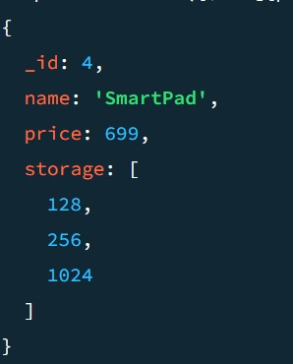

1. db.products.find({$and:[{"spec.cpu":{$gte:3}},{isodate:{$ne:"2011-09-01"}}]})

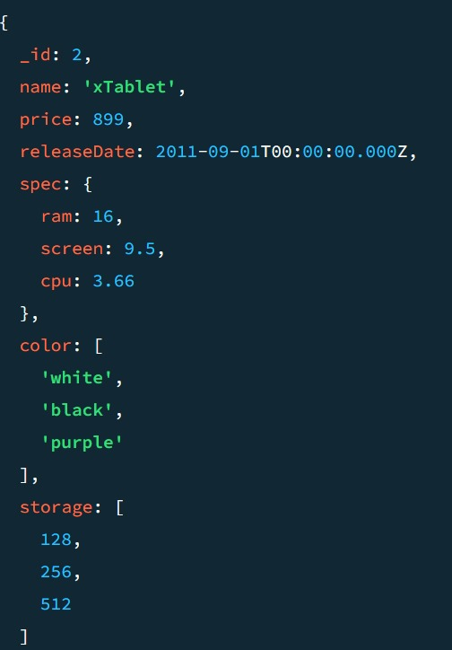

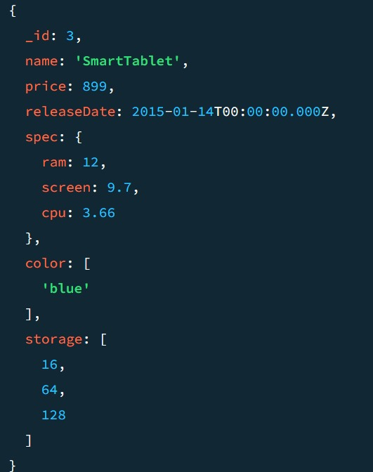

1. db.product.find({$and:[{color:{$ne:"blue"}},{price:{$ne:899}}]})

no output

1. db.products.find({color:{$nin:["gold"]}},{name:1,"spec.screen":1,color:1})

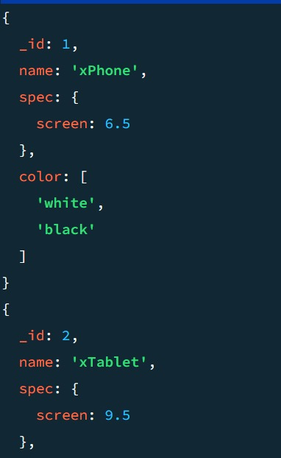

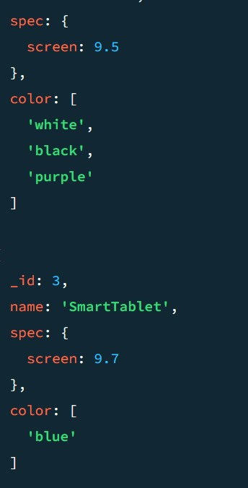

1. db.products.find({$or:[{"spec.screen":{gt:7}},{color:{$in:["white"]}}]})

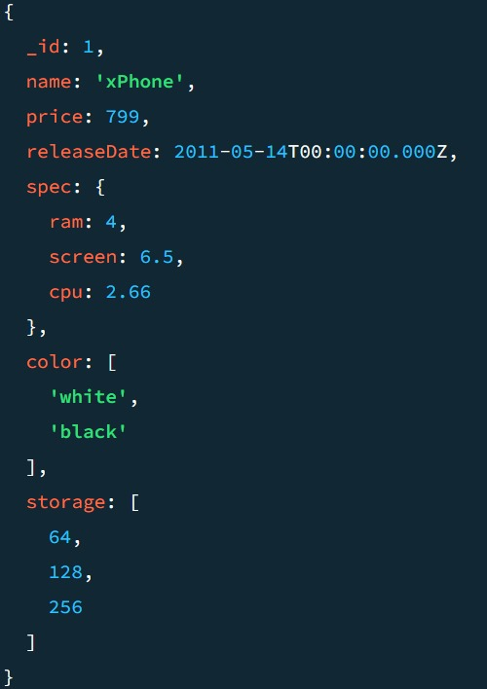

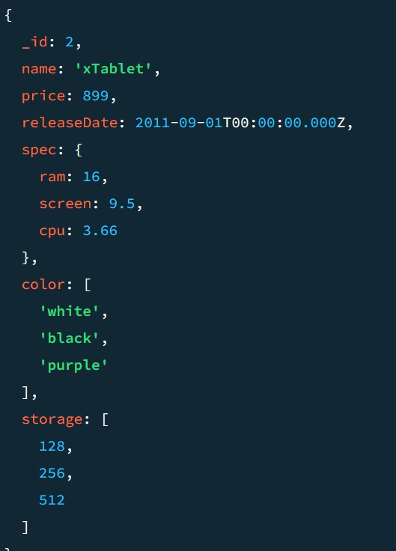

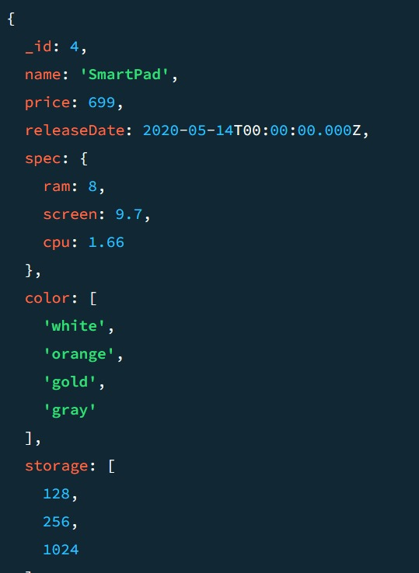

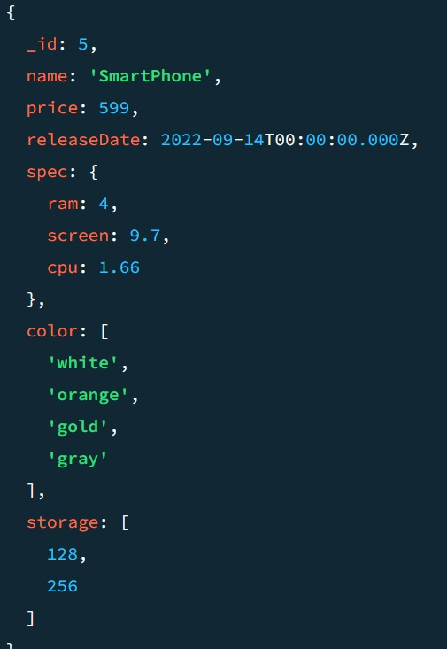

1. db.products.find({$and:[{price:{$exists:true}},{color:{$nin:["gray"]}}]})

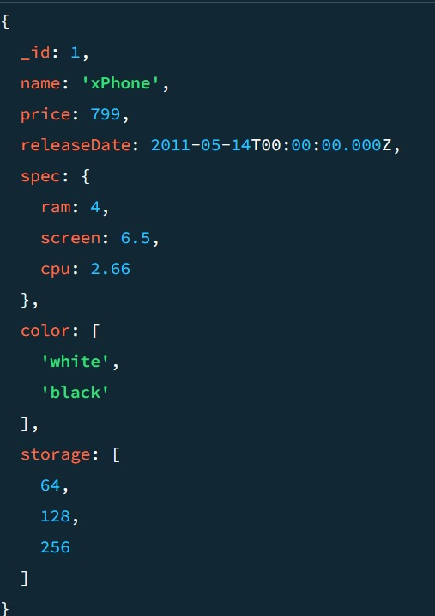

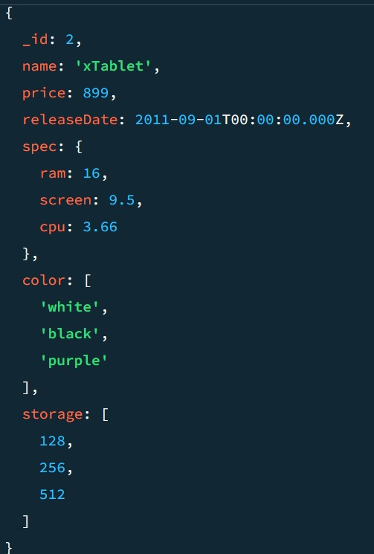

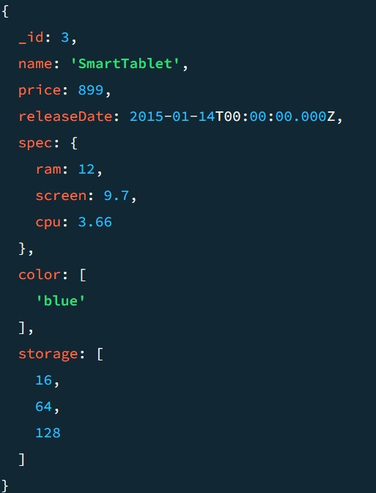

1. db.products.find({$nor:[{price:{gt:600,lt:900}},{color:{$in:["white","black"]}}]})

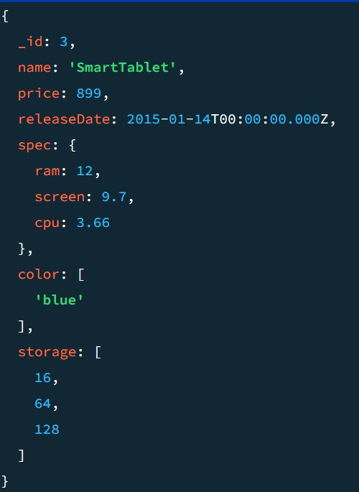

1. db.products.find({$or:[{"spec.cpu":{gt:2}},{"spec.ram":{gt:4,lt:12}}]})

No Output

1. db.products.find({$and:[{price:{$ne:699}},{$or:[{"spec.ram":{gt:4,lt:8}},{storage:16}]}]})

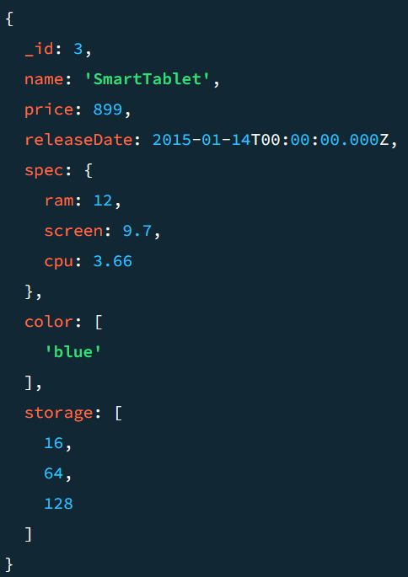

1. db.products.find({$and:[{price:{$exists:false}},{"spec.screen":{lt:10}}]},{name:1})

No Output

1. db.products.find({$and:[{color:{$ne:"blue"}},{price:{$ne:899}}]},{name:1,price:1})

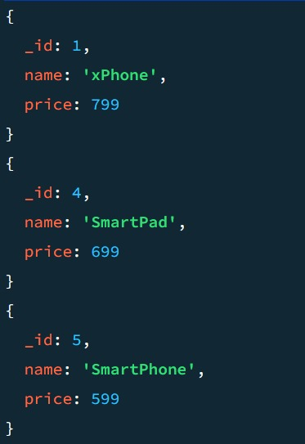

1. db.products.find({$or:[{price:{$in:[599,899]}},{ram:4}] },{name:1,price:1})

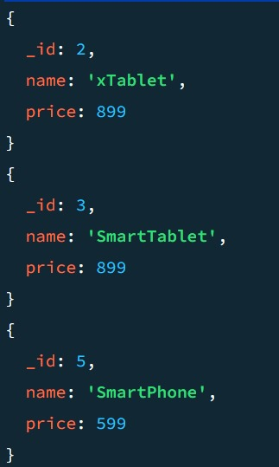

1. db.products.find({$and:[{color:"blue"},{storage:{$gt:128}}]},{name:1,price:1})

No Output

1. db.products.find({$and:[{"spec.screen":{$lte:9.5}},{ram:{$nin:[4,8]}}]},{name:1,price:1})

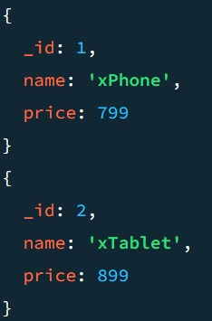

1. db.products.find({"spec.cpu":{gte:2.66,lte:3.66}})

No output

1. db.products.find({$or:[{color:"white"},{storage:{gte:128}}]})

