# CREDIT CARD FRAUD DETECTION

## PHASE 5:SUBMISSION

###### DATASET LINK:“https://www.kaggle.com/datasets/mlg-ulb/creditcardfraud”

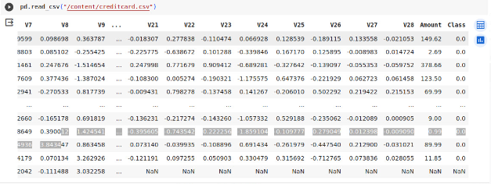

Now we can perform ,

###### PERCENTAGE OF TOTAL NOT FRAUD TRANSACTION

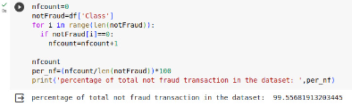

###### PERCENTAGE OF TOTAL FRAUD TRANSACTION

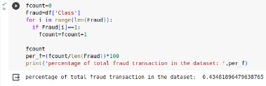

###### FRAUD AND GENUINE TRANSACTION



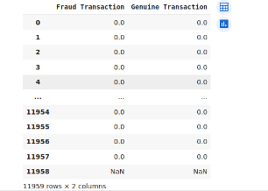

###### CALCULATING TIME VS AMOUNT

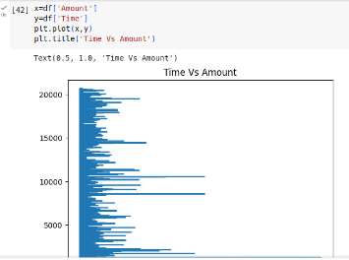

###### CALCULATING AMOUNT DISTRIBUTION

plt.figure(figsize=(10,8),)

plt.title('Amount Distribution')

sns.distplot(df['Amount'],color='red');

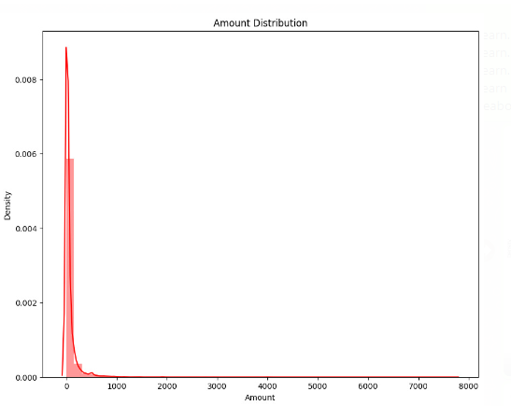

###### OUTLIERS

fig, ax=plt.subplots(figsize=(16,8))

ax.scatter(df['Amount'],df['Time'])

ax.set_xlabel('Amount')

ax.set_ylabel('Time')

plt.show()

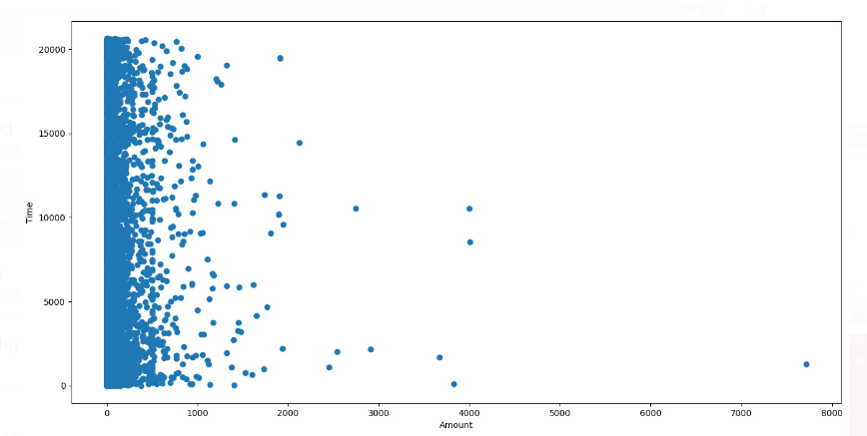

###### CORRELATION_METRICS

correlation_metrics=df.corr()

fig=plt.figure(figsize=(14,9))

sns.heatmap(correlation_metrics,vmax=.9,square=True)

plt.show()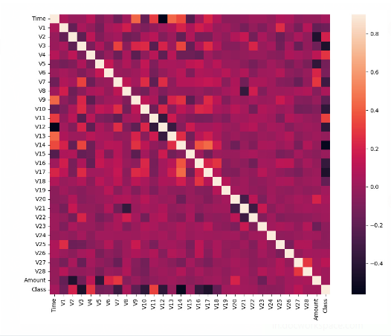

##### ACCURACY SCORE

import pandas as pd

from sklearn.model_selection import train_test_split

from sklearn.linear_model import LogisticRegression

from sklearn.metrics import accuracy_score

# Load the dataset

df = pd.read_csv("creditcard.csv")

# Split the dataset into training and testing data

X_train, X_test, y_train, y_test = train_test_split(df.drop(columns=["Class"]), df["Class"], test_size=0.25, random_state=42)

# Create a LogisticRegression model

model = LogisticRegression()

# Train the model

model.fit(X_train, y_train)

# Reshape the X_test variable to a 2D array

X_test = X_test.reshape(-1, 1)

# Make predictions on the test data

y_pred = model.predict(X_test)

# Calculate the accuracy score

accuracy = accuracy_score(y_test, y_pred)

print("Accuracy score:", accuracy)

OUTPUT:



##### CONCLUSION:

* Credit card fraud detection is a complex but essential task for protecting consumers and financial institutions. Machine learning algorithms are particularly well-suited for fraud detection, as they can learn to identify patterns in transaction data that are associated with fraud.
* In conclusion, credit card fraud detection is an important area of research and development, as fraudsters continue to develop new methods. By using a variety of techniques and by continually adapting their systems, financial institutions can help to protect their customers and reduce the risk of fraud.