# CREDICT CARD FRAUD DETECTION

## Overview of our work:

* Credit card fraud detection is the process of identifying and preventing fraudulent credit card transactions. It is an important task for banks and other financial institutions, as it can help to protect consumers from financial losses and reduce the costs associated with fraud.

## A protocol for designing the credit card fraud detection by using data science by the following steps:

* Collect and prepare the data. This includes collecting historical transaction data, both fraudulent and non-fraudulent, and cleaning and labeling the data.
* Explore the data. Use data visualization and statistical analysis to understand the data and identify any patterns or trends that may be indicative of fraud.
* Feature engineering. Create new features from the existing data that may be more informative for the machine learning model. For example, you could create a feature that represents the average transaction amount for a given cardholder over the past week.
* Choose a machine learning algorithm. There are many different machine learning algorithms that can be used for credit card fraud detection, such as logistic regression, decision trees, random forests, and support vector machines. Choose an algorithm that is appropriate for the size and complexity of your dataset.
* Train and evaluate the model. Once you have chosen an algorithm, train the model on your dataset and evaluate its performance on a held-out test set.
* Deploy the model. Once you are satisfied with the performance of the model, you can deploy it to production. This may involve integrating the model into a credit card processing system or a fraud detection platform.

## Data science techniques that can be used for credit card fraud detection:

* Machine learning algorithms. Machine learning algorithms can be used to build models that can predict whether a transaction is fraudulent or not. Some common machine learning algorithms used for credit card fraud detection include logistic regression, decision trees, random forests, and support vector machines.
* Anomaly detection. Anomaly detection is a technique that can be used to identify outliers in data. This can be useful for credit card fraud detection, as fraudulent transactions often exhibit unusual patterns.
* Natural language processing (NLP). NLP can be used to extract information from text data, such as the merchant name and description, and use this information to predict whether a transaction is fraudulent. For example, an NLP model could be trained to identify transactions that are associated with known fraudulent merchants.

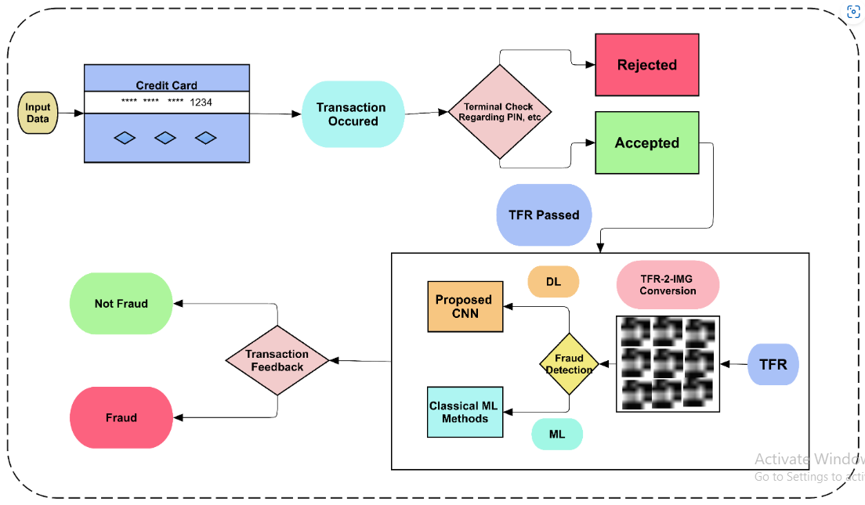

#### ARCHITECTURE DIAGRAM FOR CREDIT CARD FRAUD DETECTION

## Conclusion:

* conclusion, credit card fraud detection is an important part of protecting consumers and businesses from financial losses. By using data science and machine learning techniques, we can develop systems that can accurately detect fraudulent transactions in real time. By carefully designing and deploying these systems, we can help to make the credit card payment system safer for everyone.