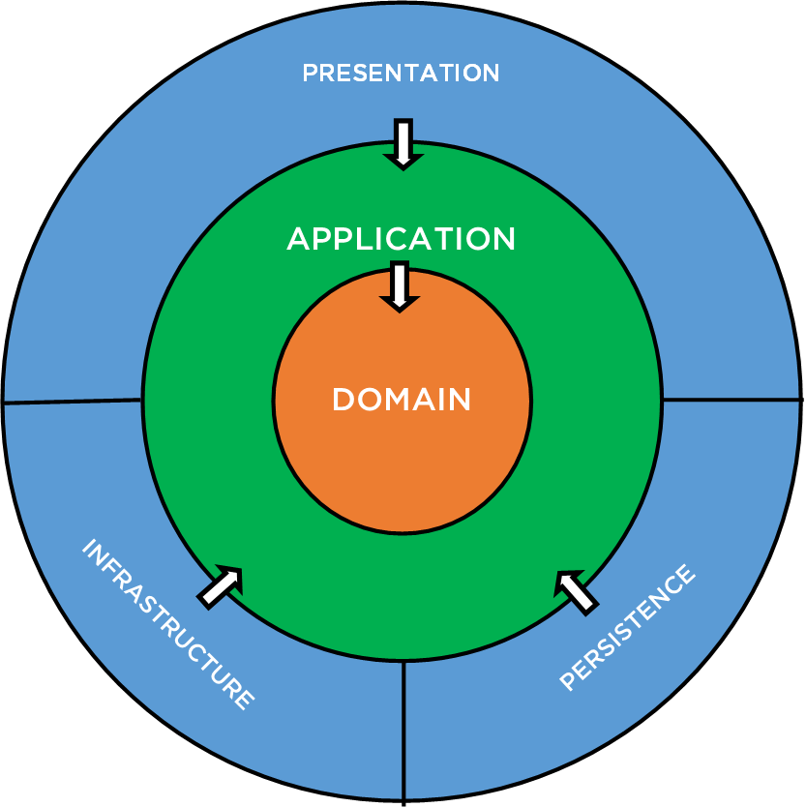

docs (Solution Folder and Physical Folder)

LICENSE (Solution Folder and Physical Folder)

src (Solution Folder and Physical Folder)

tests (Solution Folder and Physical Folder)

docs

ReadMe.docs

src

Core (Solution Folder)

Framework (Solution Folder and Physical Folder)

Infrastructure (Solution Folder)

Persistence (Solution Folder)

Presentation (Solution Folder)

Core

Application (Class Library)

Constants (Class Library)

Domain (Class Library)

Resources (Class Library)

**ViewModels** / Dtos (Class Library)

Framework

Dtat (Class Library)

Dtat.Seedwork.Abstractions (Class Library)

Dtat.StateMachine (Class Library)

Dtat.StateMachine.Abstractions (Class Library)

Infrastructure

Infrastructure (Class Library)

Persistence

Persistence (Class Library)

Presentation

Api (ASP.NET Core Web API)

**Server** (**ASP.NET Core Razor Pages** / MVC)

**Project Dependencies:**

Dtat

Dtat.Seedwork.Abstractions

Dtat.StateMachine.Abstractions

Dtat.StateMachine

Dtat.StateMachine.Abstractions

Resources

Constants

Domain

Dtat

Constants

Resources

Dtat.Seedwork.Abstractions

Application

Domain

Infrastructure

Domain

ViewModels

Domain

Constants

Resources

Persistence

Dtat

Domain

Constants

NuGets:

Microsoft.EntityFrameworkCore.Tools

Microsoft.EntityFrameworkCore.Proxies

Microsoft.EntityFrameworkCore.Sqlite

Microsoft.EntityFrameworkCore.SqlServer

Server

Dtat

Domain

Constants

Resources

ViewModels

Persistence

NuGets:

System.Drawing.Common

Microsoft.EntityFrameworkCore.Design

Microsoft.AspNetCore.Authentication.Google