AzureDay Hackathon
OPS Path

Hackathon Guide with Answers
March 2017

Contents
Contents 2
Azure Resource Manager Hackathon 1
Azure Resource Manager Hackathon answers 10

Azure Resource Manager Hackathon

Overview
Contoso has asked you to define an Azure Resource Manager template that can deploy their application CloudShop and its associated database using Azure Virtual Machines.

Requirements
- Microsoft Azure subscription
- Local machine or a virtual machine configured with:
  - Visual Studio 2015 Community Edition
  - Azure SDK 2.9+ for Visual Studio
    - https://www.microsoft.com/en-us/download/details.aspx?id=51657
  - Azure PowerShell (installed as part of Azure SDK)
  - Reboot after installing the Azure SDK

Lab structure
This lab has two sets of instructions. The first is a high-level set of instructions that is designed for students that have previous experience authoring templates in Azure. The second is a traditional hands-on lab guide that is designed for users that are new to Azure Resource Manger template authoring.

Help references
Authoring ARM Templates | https://azure.microsoft.com/en-us/documentation/articles/resource-group-authoring-templates/
Azure Resource Manager templates with VS 2015 | http://blogs.msdn.com/b/kaevans/archive/2015/07/06/azure-resource-manager-templates-with-visual-studio-2015.aspx
Virtual Machine Scale Set Samples | https://github.com/gbowerman/azure-myriad
Azure Quick Start Templates | https://github.com/Azure/azure-quickstart-templates
Network Security Groups | https://azure.microsoft.com/en-us/documentation/articles/virtual-networks-nsg/

Exercise 0: Environment setup

Overview
In this lab, you will create a developer environment and download the required files for this course if you do not already have one that meets the requirements.

Prerequisites
- Microsoft Azure subscription: http://azure.microsoft.com/en-us/pricing/free-trial/
- Client computer with Windows 7 or later with Visual Studio 2015 - SDK 2.9.1
  - Ensure you reboot after installing the SDK or Azure PowerShell will not work correctly

Task 1: Configure a Development Environment
If you do not have a machine setup with Visual Studio 2015 Community and Azure SDK 2.9 complete this task.
- Create a virtual machine in Azure using the Visual Studio Community 2015 Update 3 and SDK 2.9.1 on Windows Server 2012 R2 image.
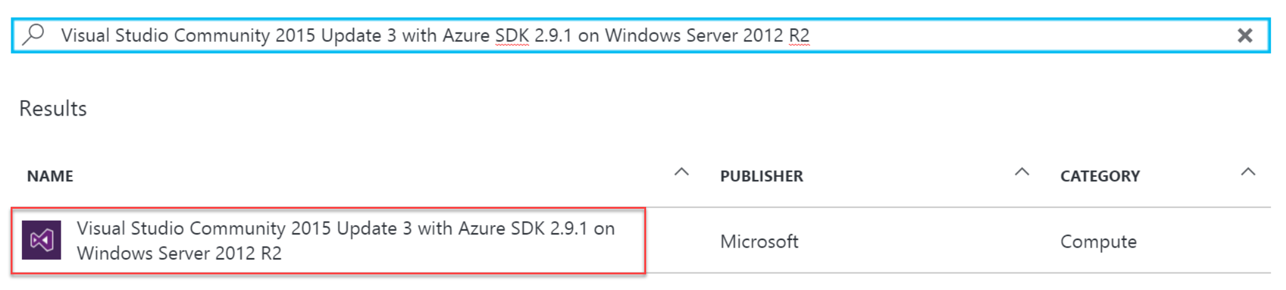
It is highly recommended to use a DS2_V2 or D2_V2 instance size for this VM

Task 2: Disable IE Enhanced Security
Note: Sometimes this image has IE ESC disabled, sometimes it does not.
- On the new VM you just created click the Server Manager icon.


Click Local Server
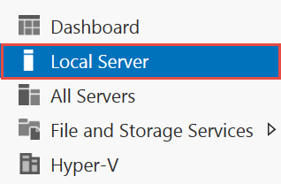

- On the right side of the pane, click On by IE Enhanced Security Configuration.

- Change to Off for Administrators and click OK.
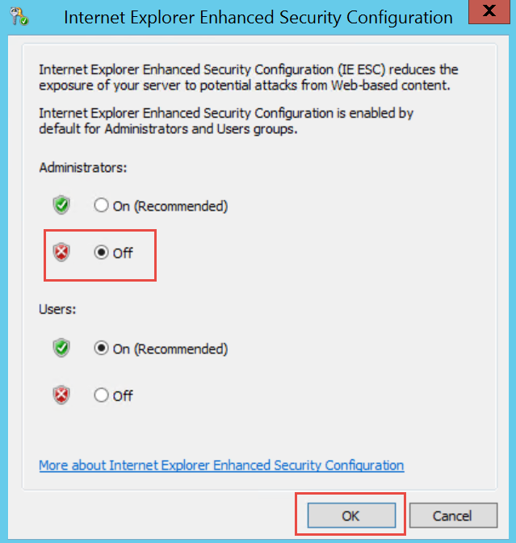

Task 3: Validate Connectivity to Azure
- From within the virtual machine, Launch Visual Studio 2015 and validate that you can login with your Microsoft Account when prompted.
  - Note: The current version Visual Studio required launching by clicking “Start Experimental version of Visual Studio 2015, then logging in, then restarting by clicking Visual Studio 2015.

- Validate connectivity to your Azure subscription. Launch Visual Studio, open Server Explorer from the View menu, and ensure that you can connect to your Azure subscription.

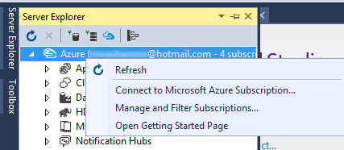

Download the exercise files
- Download the exercise files for the hackathon (from within the virtual machine).
  - Create a new folder on your computer named C:\Hackathon
  - Download the support files (.zip format), https://opsgilityweb.blob.core.windows.net/20160629-arm-hackathon/Azure_DSC.zip to the new folder.
  - Extract the contents to the same folder.
Tip: In the labs when adding resources to the Azure Resource Manager template, ensure there are no spaces at the end of the resource names. Visual Studio will include the space in all of the code it generates.

Exercise 1: Configure Automation Account
Contoso has asked you to create an Azure Resource Manager template that will configure the network for a proof of concept deployment of their new application CloudShop. Before creating the ARM Template, you must first create and configure an Azure Automation account using the Azure Portal.

Task 1: Create Azure Automation Account
Tasks to complete
- Create Automation Account in Azure portal
- Upload the Web and SQL .ps1 files
- Compile the files so they are available to virtual machines that check-in
Exit criteria
- You log into the portal and verify creation of the Azure Automation account, taking note of the Registration URL, Registration Keys, and the names of the nodes you compiled.

Exercise 2: Define the network foundation
Contoso has asked you to create an Azure Resource Manager template that will configure the network for a proof of concept deployment of their new application CloudShop.

Task 1: Define the network foundation

Tasks to complete
- Create a new Azure Resource Manager template that creates a virtual network.
- Validate the JSON file with http://jsonlint.com.
- Deploy the virtual network to an Azure subscription.

Exit criteria
- You navigated to http://jsonlint.com, pasted the contents of your azuredeploy.json file into the text box, and clicked Validate.
Note: In future lab steps if you have errors deploying a template, repeat this process and check for validation errors.

- A template deployed to your Azure subscription that has the following virtual network characteristics.
  - Address space: 10.0.0.0/16
  - Subnet: FrontEndNet – 10.0.0.0/24
  - Subnet: DatabaseNet – 10.0.1.0/24

Exercise 3: Extend with compute
The next task is to update the template by adding a storage account, a public IP, and virtual machines for the web server(s) and a SQL server. The servers will be automatically configured using a PowerShell DSC script supplied to you by the infrastructure team.

Task 1: Add storage and a location parameter

Tasks to complete
- Add a new storage account to the template. All virtual machines in the template will use this storage account.
- Create a location parameter for the template that all resources in the template use. Update the existing virtual network to use this parameter and as you add new resources to the template that require a location, update them to reference this parameter.
- Deploy the updated template.

Exit criteria
- A new storage account in the template.
- A location parameter that defines the list of regions the template can deploy to.
- The new storage account should be deployed to your subscription after deployment.

Task 2: Add a virtual machine for the web server

Tasks to complete
- Add the following resources to the template
  - A Windows virtual machine for the web front end
  - Public IP with a unique DNS name linked to the NIC of the web VM.
  - Azure DSC Extension
    - DSC Extension named hackathonDSC for the web servers that use the CloudShopWeb.WebServer configuration node of your Automation account.

Exit criteria
- The template should accept parameters for the Registration URL, Registration Key, and Configuration Node name(s) of the Automation account.
  - The scripts for the DSC Configurations are located in C:\Hackathon
- The web site should load when you browse the DNS name for the public IP.

Task 3: Add a virtual machine for the SQL Server

Tasks to complete
- Add the following resources to the template
  - A Windows virtual machine
  - Azure DSC Extension
    - DSC Extension named hackathonDSCSql for the SQL database that configures the SQL Server and restores the AdventureWorks database.
    - The scripts for the DSC Configurations are located in C:\Hackathon
    - Add a dependency on the DSC extension for the web tier to the DSC extension for the SQL server. This allows for the virtual machines to be provisioned in parallel but the customizations to be orchestrated.

Exit criteria
- SQL Server virtual machine
  - Should have a parameter that specifies the size of the virtual machine. The default value should be Standard_D2.
    - Standard_D1, Standard_D2, Standard_D3, Standard_D4, Standard_D5
  - Should accept a parameter named hackathonSqlVMSKU that allows the user to specify the SQL Server SKU using one of the following values. The default value should be Web.
    - Web, Standard, Enterprise
  - The image configuration should use the following:
    - Image Publisher: MicrosoftSQLServer
    - Image Offer: SQL2014-WS2012R2
  - The virtual machine should have 4 x 1 TB disks attached to it formatted a 4 TB volume using Windows Storage Spaces.
  - The SQL Server should have the default path for data, logs, and backup referring to the F: drive and the database should be restored to the F: drive.
  - SQL Server should be in mixed authentication mode.

Exercise 4: Lock down the environment
In this portion of the exercise, you will deploy a network security group to restrict the network attack surface for the deployment.

Task 1: Restrict traffic to the web server

Tasks to complete
- Create and deploy a network security group that allows the following traffic on the FrontEndNet subnet.
  - Source: INTERNET, Destination port: 80

Exit criteria
- Validate restrictions by connecting to the web server using a web browser. Traffic should be allowed in and the site should load. Attempt to connect using remote desktop, click Connect in the portal. This connection should fail.

Task 2: Update the network security group to allow Windows Remote Desktop

Tasks to complete
- Update the network security group on the deployed resources to allow the remote desktop protocol (port 3389).

Exit Criteria
- Access to the web front end should be successful by clicking Connect in the Azure Preview Portal.

Exercise 5: Scale out the deployment
In this portion of the exercise, you will use the Azure Virtual Machine Scale Sets feature to scale out the web front end and the storage sub system.
Note: This is an advanced configuration based on a new feature (scale sets). It is recommended that unless you have configured scale sets before that you jump to the answers section of the lab to complete this exercise.

Task 1: Parameterize the size of the environment and add load balancing

Tasks to complete
- Add a new parameter called instanceCount to the template. This variable should define how many web servers should be created.
- Add a new resource that can create up to five storage accounts.
- Add a load balancer resource and associate it with the public IP.
- Add the virtual machine scale set configuration that will use the storage accounts and creates a number of virtual machines based on the instanceCount parameter.
- Remove the existing virtual machine and network adapter because they are replaced by the scale set.

Exit criteria
- The scale set should provision the number of virtual machines based on the instanceCount parameter.
- The virtual machines provisioned by the scale set should execute the same DSC script used in the initial web server configuration.

Azure Resource Manager Hackathon answers

Overview
This portion of the lab is designed to help you if you are blocked or have limited experience with Azure Resource Manager.

Exercise 1: Configure Automation Account

Overview
In this exercise, you will create and configure an Azure Automation account in the Azure Portal before configuring and deploying the resources of your ARM template.

Task1: Create Automation Account
- Browse to the Azure Portal and authenticate at https://portal.azure.com/
- Click +New and type Automation in the search box. Choose Automation from the results.
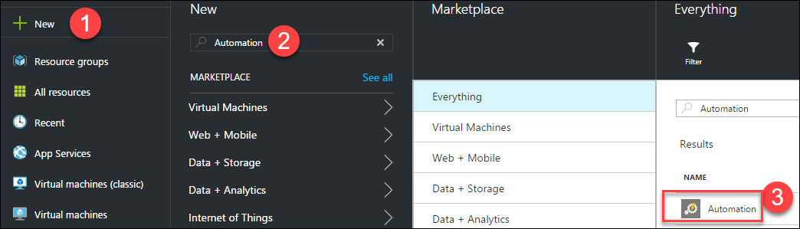
- Click Create on the Automation blade so that the Add Automation Account blade is displayed. Specify the following information and click Create.
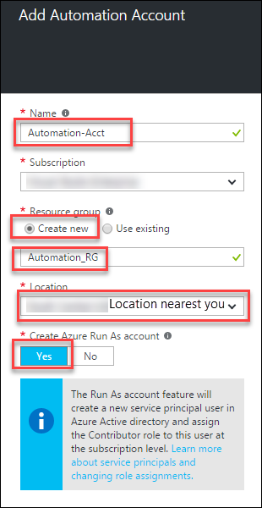

Note: At the time of this writing the portal had a UI bug that did not allow the creation of the automation account (name validation error). If this is still a bug when you are creating the account, use PowerShell instead. Example code below:
New-AzureRmAutomationAccount -ResourceGroupName "Automation_RG" -Name "Automation-Acct" -Location "East US 2"

Task 2: Upload DSC Configurations into Automation account
- Click Resource groups > Automation_RG > Automation-Acct and click the DSC Configuration tile
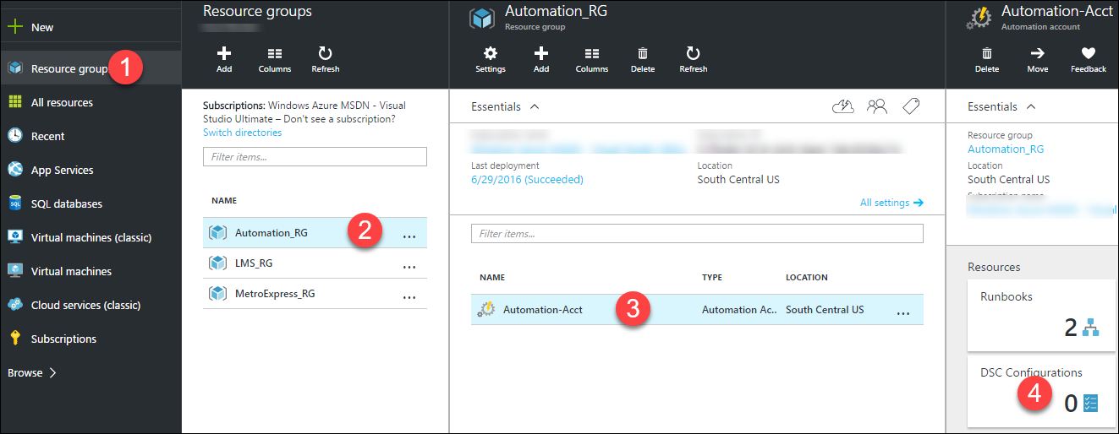
- Click Add a configuration to upload C:\Hackathon\CloudShopSQL.ps1 and C:\Hackathon\CloudShopWeb.ps1
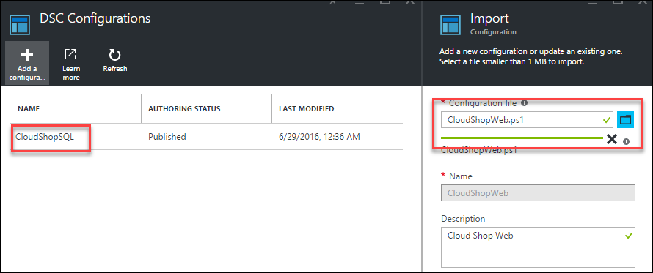
- After importing the .ps1 files, click the CloudShopSQL DSC Configuration and click Compile on the toolbar (click Yes on the overwrite prompt). Do the same for CloudShopWeb
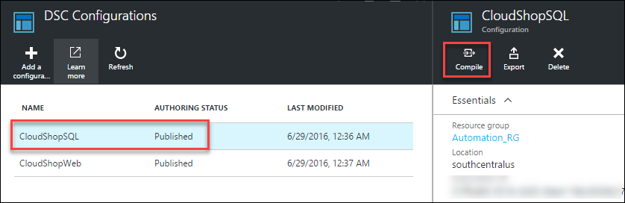

Summary
In this exercise you configured an Automation account, and configured DSC configuration scripts that will be leveraged by the virtual machine resources.

Exercise 2: Define the network foundation

Overview
Your first ARM template task is to create a virtual network template using Visual Studio and deploy it to your Azure account.

Task 1: Deploy a virtual network with a template
- Open Visual Studio. The shortcut should be available on the desktop, and if it is not click the Windows icon in the bottom left corner and type in Visual Studio. You should see the start icon.

- Choose File, New Project, and then choose Cloud, and then Azure Resource Group.
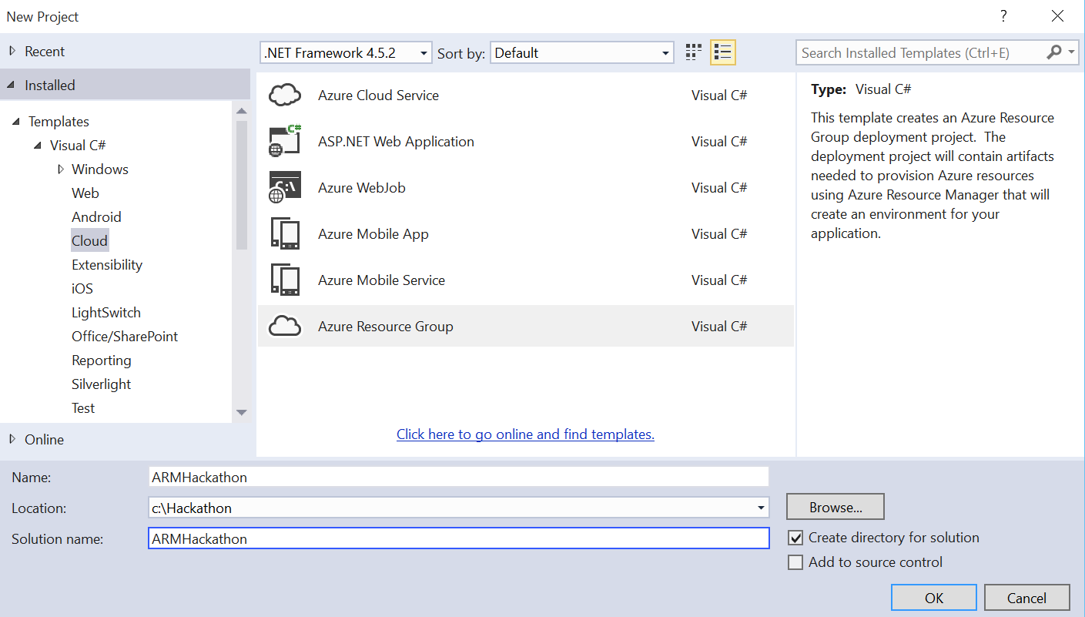

- Name the project ARMHackathon, specify C:\Hackathon for the location, and click OK.
- On the Select Azure Template dialog box, choose Blank Template and click OK. Scroll down to the end to select this option.

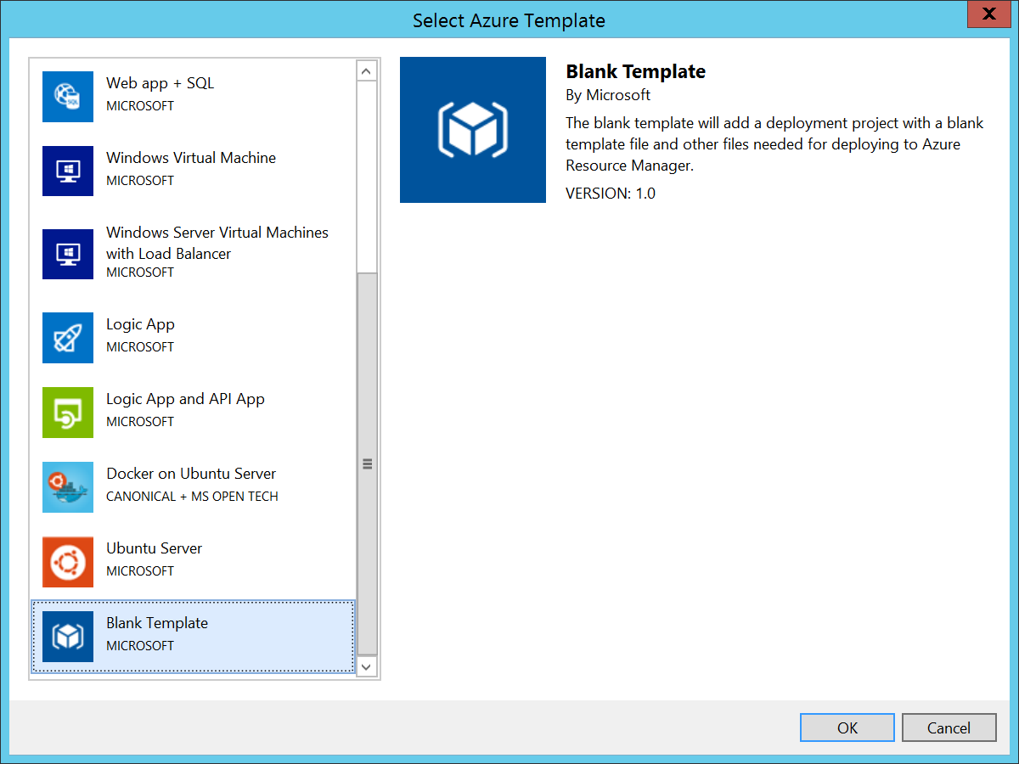

- In the Solution Explorer, open the azuredeploy.json file from the Templates folder.
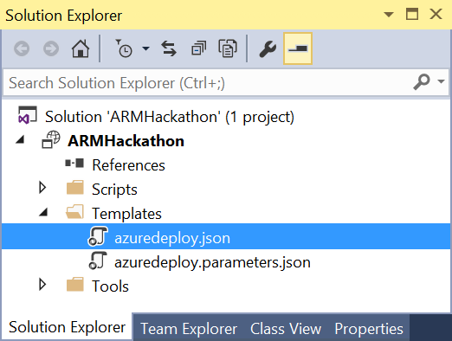

- The file should contain four different sections: parameters, variables, resources, and outputs. On the left side a new window called JSON Outline should have been opened as well. If this was not the case, go to the View menu, select Other Windows, and choose JSON Outline. The window should look like the following image.
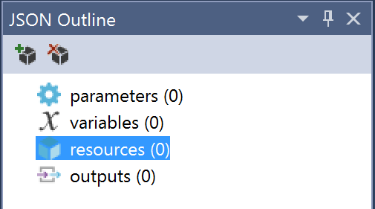

- On the JSON Outline window, click Add Resource in the upper-left corner or right-click the resources and choose Add New Resource.
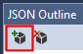

- On the Add Resource dialog box, choose Virtual Network, enter hackathonVnet in the Name field, and click Add.
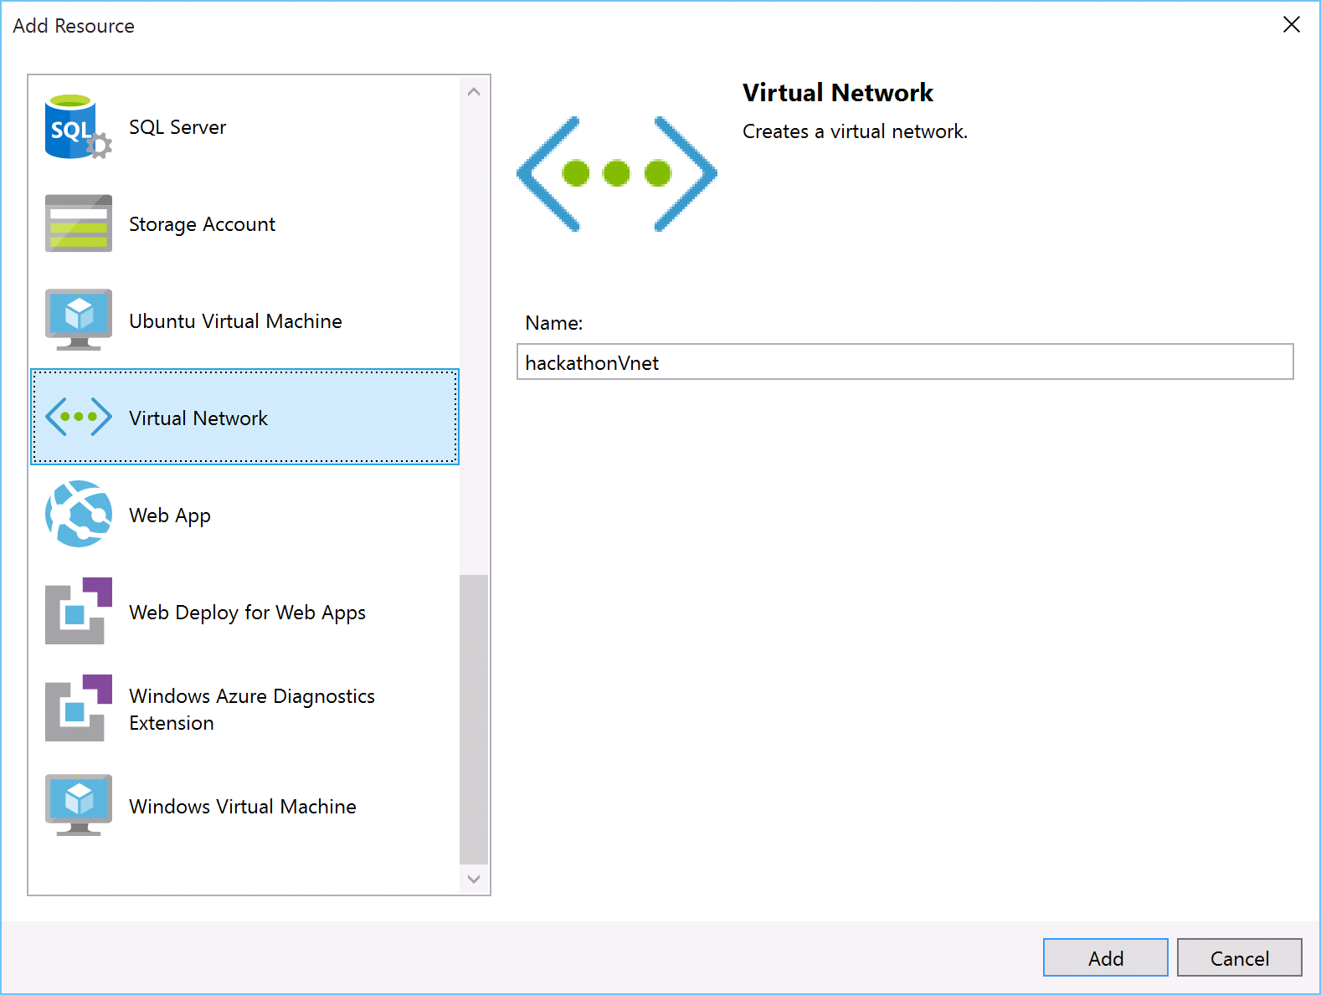

- Go to the azuredeploy.json file, and inspect its content. Review the variables section. It should look like the following file.
"variables": {
"hackathonVnetPrefix": "10.0.0.0/16",
"hackathonVnetSubnet1Name": "Subnet-1",
"hackathonVnetSubnet1Prefix": "10.0.0.0/24",
"hackathonVnetSubnet2Name": "Subnet-2",
"hackathonVnetSubnet2Prefix": "10.0.1.0/24"
}

- Change the name of Subnet-1 to FrontEndNet, and the name of Subnet-2 to DatabaseNet.
"hackathonVnetSubnet1Name": "FrontEndNet",
"hackathonVnetSubnet2Name": "DatabaseNet",

- Launch a browser and navigate to http://jsonlint.com. Copy the entire contents of azuredeploy.json, paste it in the text box, and click Validate.
Note: In future lab steps if you have errors deploying a template, repeat this process and check for validation errors.

- Deploy the template by right-clicking the ARMHackathon project, and choosing Deploy > New Deployment.
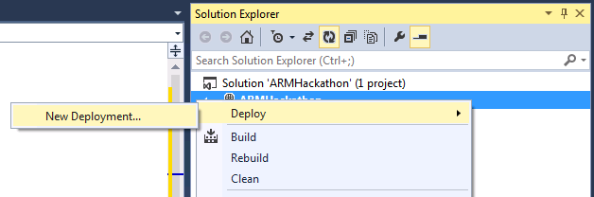

- If you did not sign in to your Microsoft Azure account already, you will be asked to do so now.
- Fill in the email address associated with the Azure account and click Continue.
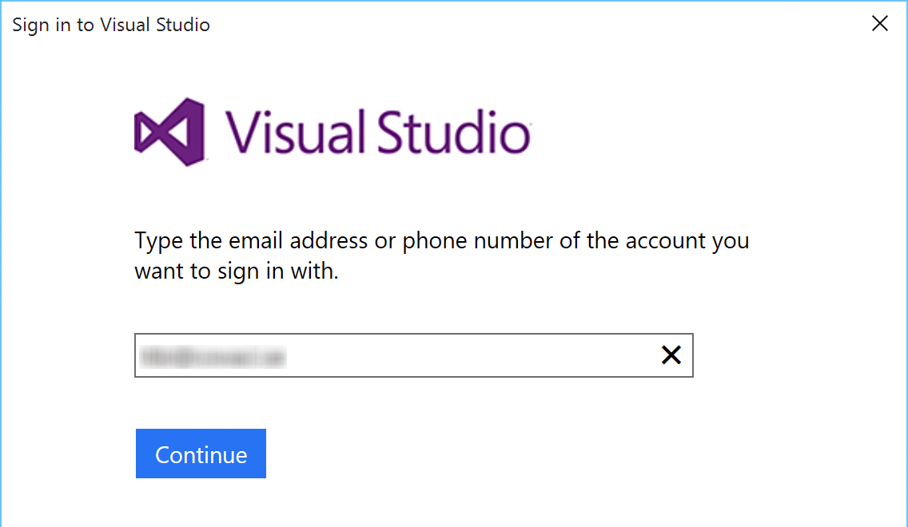

- You might have to choose between a Work/School account and a Microsoft account. Microsoft account refers to a LiveId account. Depending on what kind of account you have, you should choose one or the other.
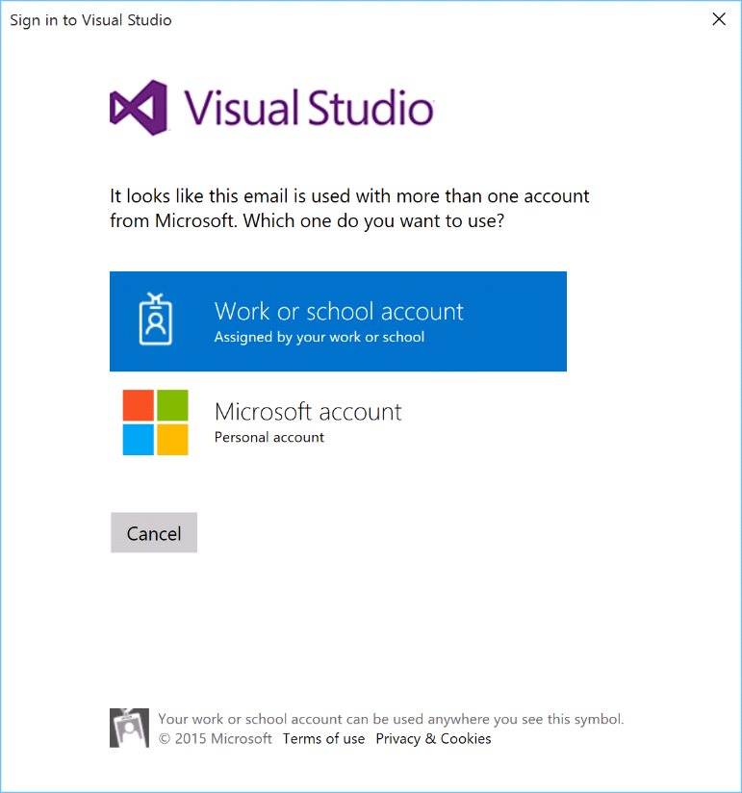
- Enter your password and click Sign In.
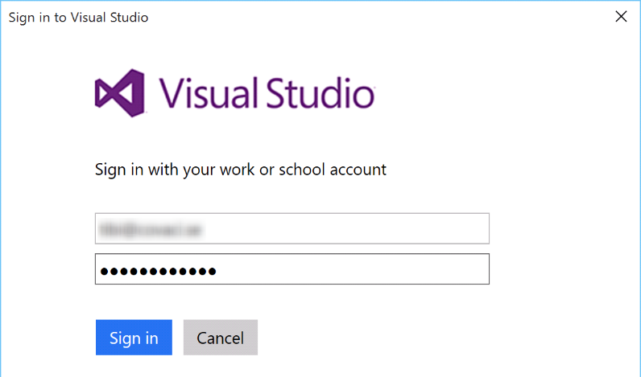

- If you have several subscriptions, choose the one that you want your VNet to be deployed to, and on the Resource group choose Create New.
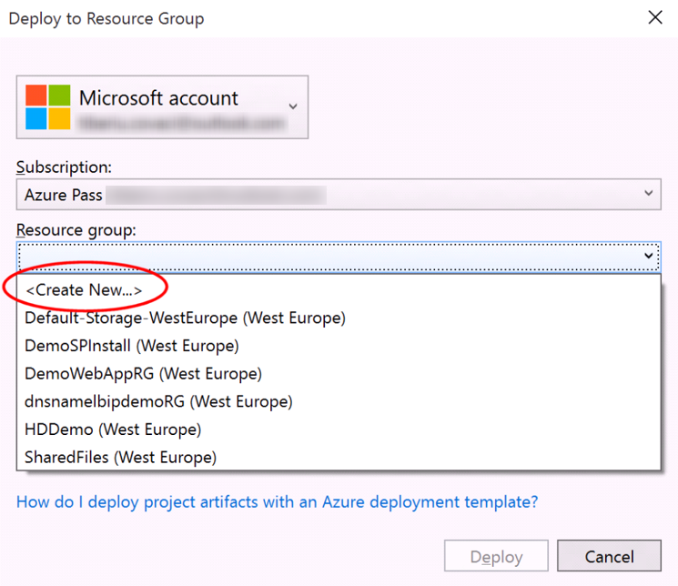

- On the Create Resource Group dialog box, accept the default value for the name; and for the location, choose the closest location to you, and click Create.
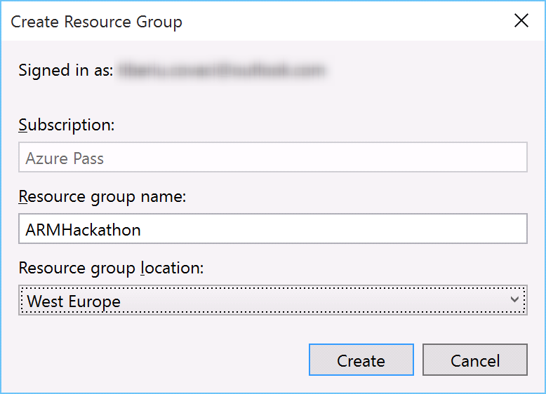

- When you are back on the Deploy to Resource Group dialog box, click Deploy. After about a minute, your virtual network will be deployed to Azure.
- View the created resource group and virtual network in the Azure Management Portal by clicking Resource Groups and clicking the name of your resource group.
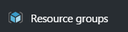

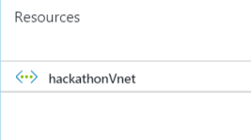

Summary
In this exercise, you have created a new virtual network with two different subnets. To verify this, sign in to the Microsoft Azure portal and go to Virtual Networks. Your new network should be listed there.

Exercise 3: Extend with Compute

Overview
In this task you will continue the work you started in the previous task by creating a storage account and adding virtual machines for the web application and for the database, and then configuring the machines for the roles.

Task 1: Add an Azure storage account
- On the JSON Outline window, click Add Resource in the upper-left corner, or right-click the resources and choose Add New Resource.
- Add a new Storage Account resource to the template named hackstorage.
Note: The template generated in the Azure SDK appends a unique value (13 characters in length) to the storage account name. Ensure the name specified is 11 characters or less in length.
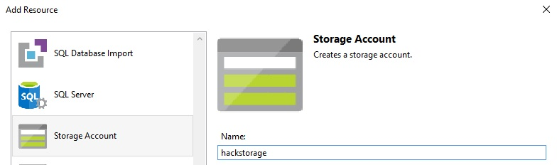

Task 2: Add a virtual machine and configure as a web server
- Add a new Windows Virtual Machine called hackathonVM and choose hackstorage as the Storage Account and FrontEndNet subnet as the Virtual network/subnet. The FrontEndNet is the value of hackathonVnetSubnet1Name variable.
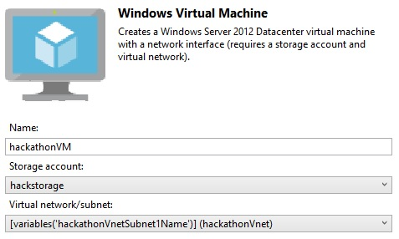

- A Network Interface named hackathonVMNic was automatically added to the configuration when the virtual machine resource was added to connect the virtual machine to the virtual network. Add a public IP address called hackathonPublicIP to the hackathonVMNic. This will allow you to connect to the machine using remote desktop client, or to access the web server.
- You will now manually add a resource to the azuredeploy.json file to account for the Azure Automation DSC Extension (at the time of this writing, VS 2015 tools do not support adding an Azure Automation DSC Extension). Append the json below the properties of the virtual machine resource (after appending a comma).
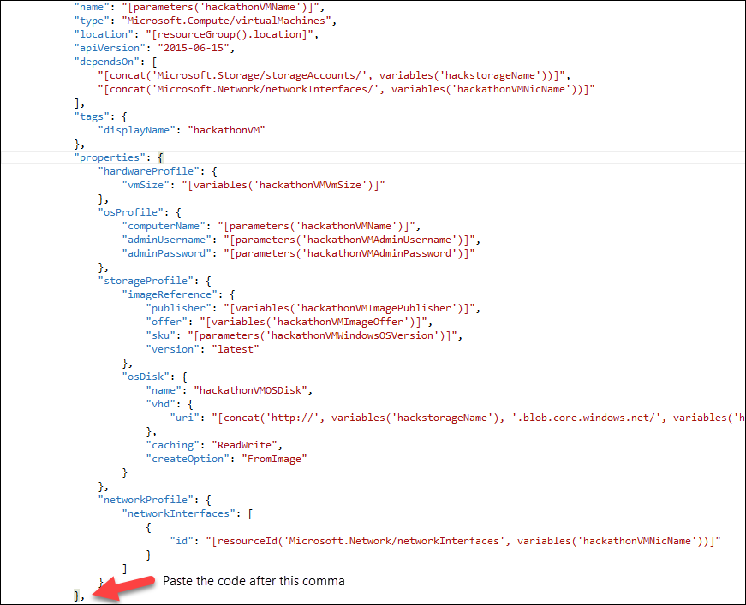
"resources": [
{
"name": "hackathonDSC",
"type": "extensions",
"location": "[resourceGroup().location]",
"apiVersion": "2015-06-15",
"dependsOn": [
"[concat('Microsoft.Compute/virtualMachines/', parameters('hackathonVMName'))]"
],
"tags": {
"displayName": "hackathonDSC"
},
"properties": {
"publisher": "Microsoft.Powershell",
"type": "DSC",
"typeHandlerVersion": "2.19",
"autoUpgradeMinorVersion": true,
"protectedSettings": {
"Items": {
"registrationKeyPrivate": "[parameters('registrationKey')]"
}
},
"settings": {
"ModulesUrl": "https://opsgilityweb.blob.core.windows.net/20160629-arm-hackathon/RegistrationMetaConfigV2.zip",
"ConfigurationFunction": "RegistrationMetaConfigV2.ps1\\RegistrationMetaConfigV2",
"Properties": [
{
"Name": "RegistrationKey",
"Value": {
"UserName": "PLACEHOLDER_DONOTUSE",
"Password": "PrivateSettingsRef:registrationKeyPrivate"
},
"TypeName": "System.Management.Automation.PSCredential"
},
{
"Name": "RegistrationUrl",
"Value": "[parameters('registrationUrl')]",
"TypeName": "System.String"
},
{
"Name": "NodeConfigurationName",
"Value": "[parameters('nodeConfigurationName')]",
"TypeName": "System.String"
},
{
"Name": "ConfigurationMode",
"Value": "[parameters('configurationMode')]",
"TypeName": "System.String"
},
{
"Name": "ConfigurationModeFrequencyMins",
"Value": "[parameters('configurationModeFrequencyMins')]",
"TypeName": "System.Int32"
},
{
"Name": "RefreshFrequencyMins",
"Value": "[parameters('refreshFrequencyMins')]",
"TypeName": "System.Int32"
},
{
"Name": "RebootNodeIfNeeded",
"Value": "[parameters('rebootNodeIfNeeded')]",
"TypeName": "System.Boolean"
},
{
"Name": "ActionAfterReboot",
"Value": "[parameters('actionAfterReboot')]",
"TypeName": "System.String"
},
{
"Name": "AllowModuleOverwrite",
"Value": "[parameters('allowModuleOverwrite')]",
"TypeName": "System.Boolean"
},
{
"Name": "Timestamp",
"Value": "[parameters('timestamp')]",
"TypeName": "System.String"
}
]
}
}
}
]
- Once you insert the code above, you will notice that the parameters referenced are undefined.
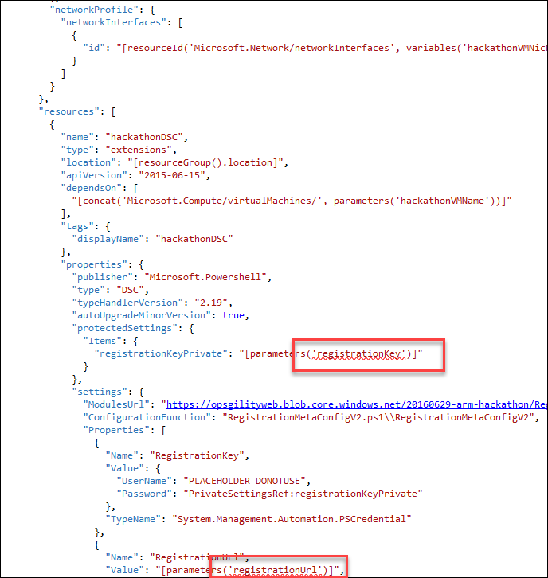
- You will now append the following parameters to your json template (after the hackathonPublicIPDnsName parameter)
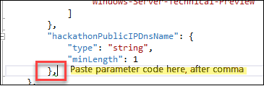
"registrationKey": {
"type": "string",
"metadata": {
"description": "Registration key of Automation account"
}
},
"registrationUrl": {
"type": "string",
"metadata": {
"description": "Registration URL of Automation account"
}
},
"nodeConfigurationName": {
"type": "string",
"metadata": {
"description": "Name of configuration to apply"
}
},
"rebootNodeIfNeeded": {
"type": "bool",
"metadata": {
"description": "Reboot if needed"
}
},
"allowModuleOverwrite": {
"type": "bool",
"metadata": {
"description": "Allow Module Overwrite"
}
},
"configurationMode": {
"type": "string",
"defaultValue": "ApplyAndMonitor",
"allowedValues": [
"ApplyAndMonitor",
"ApplyOnly",
"ApplyandAutoCorrect"
],
"metadata": {
"description": "Configuration Mode"
}
},
"configurationModeFrequencyMins": {
"type": "int",
"metadata": {
"description": "Allow Module Overwrite"
}
},
"refreshFrequencyMins": {
"type": "int",
"metadata": {
"description": "Refresh frequency in minutes"
}
},
"actionAfterReboot": {
"type": "string",
"defaultValue": "ContinueConfiguration",
"allowedValues": [
"ContinueConfiguration",
"StopConfiguration"
],
"metadata": {
"description": "Action after reboot"
}
},
"timestamp": {
"type": "string",
"metadata": {
"description": "Time stamp MM/dd/YYYY H:mm:ss"
}
}
- In the “variables” section, change the value of hackathonVMVmSize" to "Standard_A1".
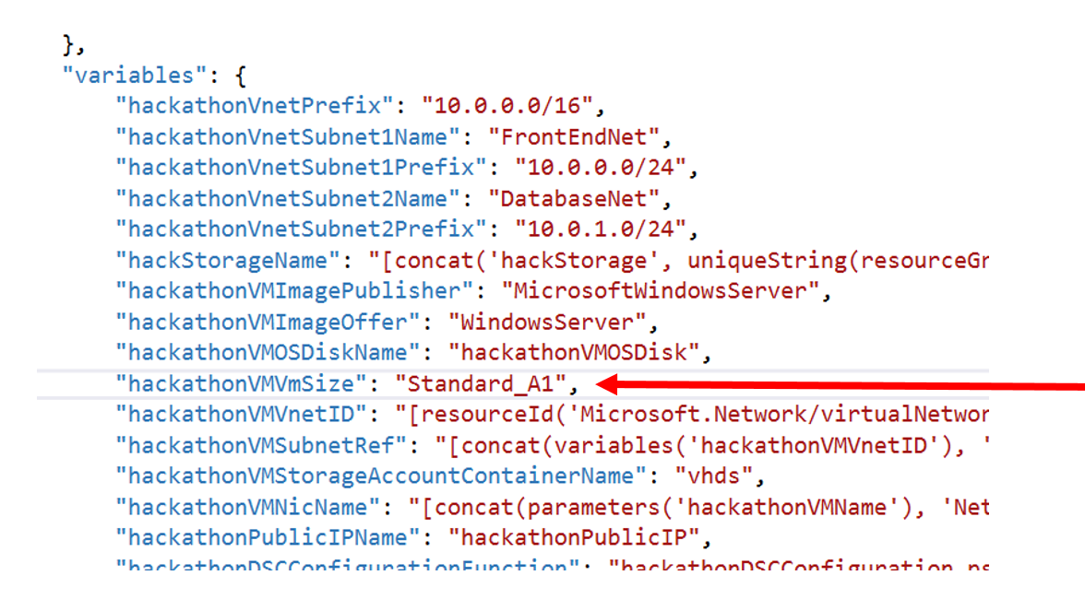
- Save your changes to the azuredeploy.json template file.

Task 3: Add a Windows virtual machine for the database server
- Add another virtual machine to the template by clicking Add Resource and then selecting Windows Virtual Machine.
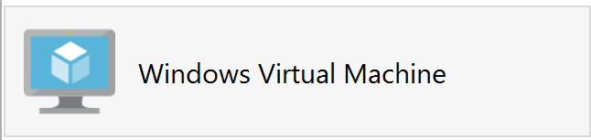
- Name this virtual machine resource hackathonSqlVM and reference the parameters hackStorage and hackathonVnetSubnet2Name respectively.
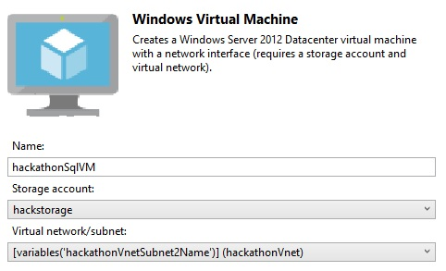

- Navigate to the variables section and find the following variables:
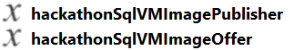

- Modify the following hackathonSqlVMImagePublisher and hackathonSqlVMImageOffer variables to the following SQL Server image values:
"hackathonSqlVMImagePublisher": "MicrosoftSQLServer",
"hackathonSqlVMImageOffer": "SQL2014SP1-WS2012R2",

- Find the hackathonSqlVMWindowsOSVersion parameter.


- Replace the hackathonSqlVMWindowsOSVersion parameter with the following:
"hackathonSqlVMSKU": {
"type": "string",
"defaultValue": "Web",
"allowedValues": [
"Web",
"Standard",
"Enterprise"
]
}
- Click the hackathonSqlVM resource to move to its properties.
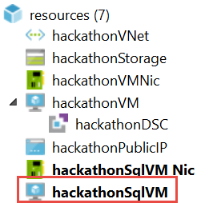
- Update the SKU property to point to the new parameter: hackathonSqlVMSKU.
"sku": "[parameters('hackathonSqlVMSKU')]",

- Navigate to the parameters section of the template and add a new parameter called vmSizeSQL to define the size of the virtual machine.
Tip: Do not forget the preceding comma.
"vmSizeSql": {
"type": "string",
"defaultValue": "Standard_D1",
"allowedValues": [
"Standard_D1",
"Standard_D2",
"Standard_D3",
"Standard_D4",
"Standard_D5"
]
}
- Navigate to the resources section for the hackathonSqlVM. Find the hardwareProfile section and replace the vmSize property with the following:
"vmSize": "[parameters('vmSizeSql')]"

- Next, add two data disks to the hackathonSqlVM by first adding the storage paths as variables in the variables section of the template.
"dataDisk1VhdName": "[concat('http://',variables('hackStorageName'),'.blob.core.windows.net/','vhds','/','dataDisk1.vhd')]",
"dataDisk2VhdName": "[concat('http://',variables('hackStorageName'),'.blob.core.windows.net/','vhds','/','dataDisk2.vhd')]"
Do not forget to add a comma after the last variable first.
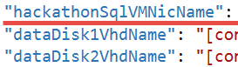
- In order to deploy two 1 TB disks, add the following section to the properties, storage profile section of the hackathonSqlVM (right after osDisk).
Tip: Do not forget to add a comma at the end of the osDisk section.
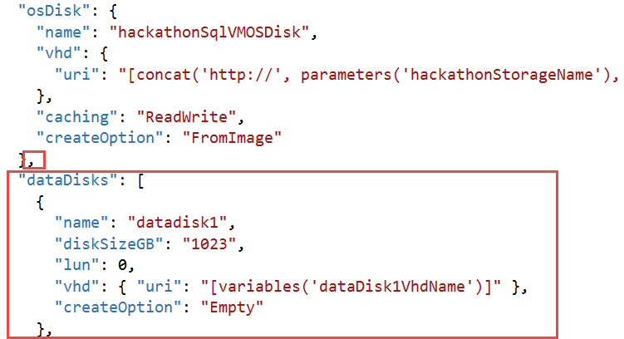
"dataDisks": [
{
"name": "datadisk1",
"diskSizeGB": "1023",
"lun": 0,
"vhd": { "uri": "[variables('dataDisk1VhdName')]" },
"createOption": "Empty"
},
{
"name": "datadisk2",
"diskSizeGB": "1023",
"lun": 1,
"vhd": {"uri": "[variables('dataDisk2VhdName')]"},
"createOption": "Empty"
}]

- You will now manually add a resource to the azuredeploy.json file to account for the Azure Automation DSC Extension (at the time of this writing VS 2015 tools do not support adding an Azure Automation DSC Extension). Append the json below the properties of the virtual machine resource (after appending a comma).
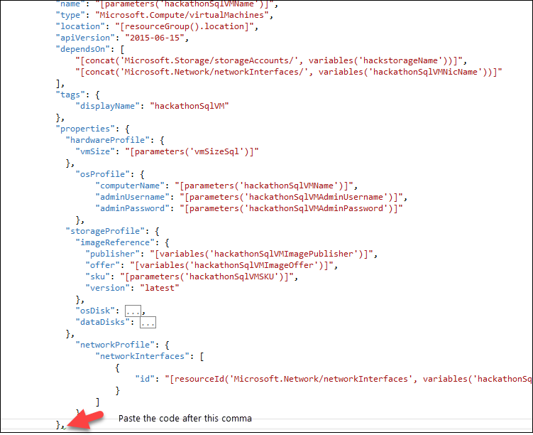
"resources": [
{
"name": "hackathonDSCSql",
"type": "extensions",
"location": "[resourceGroup().location]",
"apiVersion": "2015-06-15",
"dependsOn": [
"[concat('Microsoft.Compute/virtualMachines/', parameters('hackathonSqlVMName'))]"
],
"tags": {
"displayName": "hackathonDSCSql"
},
"properties": {
"publisher": "Microsoft.Powershell",
"type": "DSC",
"typeHandlerVersion": "2.19",
"autoUpgradeMinorVersion": true,
"protectedSettings": {
"Items": {
"registrationKeyPrivate": "[parameters('registrationKey')]"
}
},
"settings": {
"ModulesUrl": "https://opsgilityweb.blob.core.windows.net/20160629-arm-hackathon/RegistrationMetaConfigV2.zip",
"ConfigurationFunction": "RegistrationMetaConfigV2.ps1\\RegistrationMetaConfigV2",
"Properties": [
{
"Name": "RegistrationKey",
"Value": {
"UserName": "PLACEHOLDER_DONOTUSE",
"Password": "PrivateSettingsRef:registrationKeyPrivate"
},
"TypeName": "System.Management.Automation.PSCredential"
},
{
"Name": "RegistrationUrl",
"Value": "[parameters('registrationUrl')]",
"TypeName": "System.String"
},
{
"Name": "NodeConfigurationName",
"Value": "[parameters('sqlnodeConfigurationName')]",
"TypeName": "System.String"
},
{
"Name": "ConfigurationMode",
"Value": "[parameters('configurationMode')]",
"TypeName": "System.String"
},
{
"Name": "ConfigurationModeFrequencyMins",
"Value": "[parameters('configurationModeFrequencyMins')]",
"TypeName": "System.Int32"
},
{
"Name": "RefreshFrequencyMins",
"Value": "[parameters('refreshFrequencyMins')]",
"TypeName": "System.Int32"
},
{
"Name": "RebootNodeIfNeeded",
"Value": "[parameters('rebootNodeIfNeeded')]",
"TypeName": "System.Boolean"
},
{
"Name": "ActionAfterReboot",
"Value": "[parameters('actionAfterReboot')]",
"TypeName": "System.String"
},
{
"Name": "AllowModuleOverwrite",
"Value": "[parameters('allowModuleOverwrite')]",
"TypeName": "System.Boolean"
},
{
"Name": "Timestamp",
"Value": "[parameters('timestamp')]",
"TypeName": "System.String"
}
]
}
}
}
]

- We do need to create a new parameter that will be different for the SQL VM. In the parameters section duplicate the nodeConfigurationName parameter and change its name to sqlnodeConfigurationName
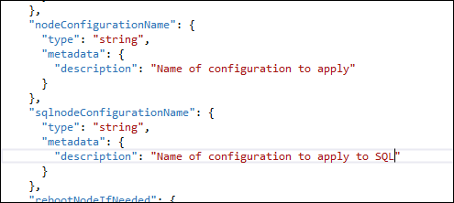

- Save your changes to the azuredeploy.json template file.

Task 4: Deploy your updated template to Azure
- Before deploying your updated template, you should make note of your Automation key and registration URL. In the Azure Portal, click Resource groups > Automation_RG > Automation-Acct, and then click the Key icon
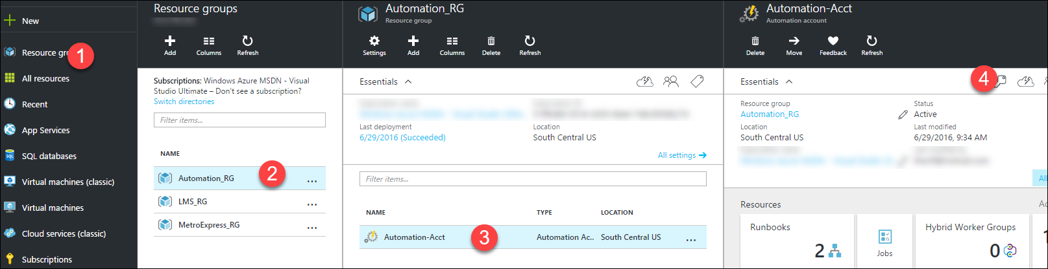
- The information you will need to deploy your template is on the Manage Keys blade
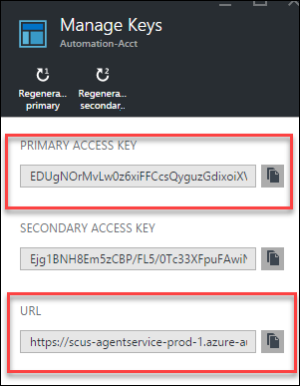
- You will also need the name of your Node Configurations
- CloudShopSQL.SQLSERVER
- CloudShopWeb.WebServer
These values from the .ps1 scripts that you uploaded in exercise 1.
Example below:
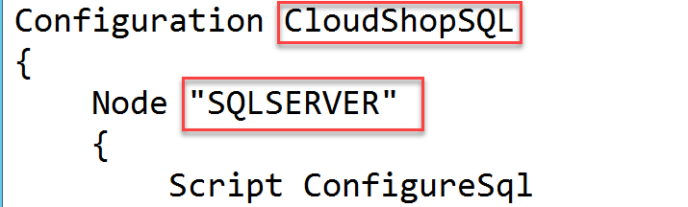
- From within Visual Studio create a new deployment (specify the same Resource group as before ARMHackathon).
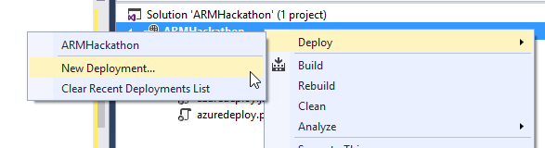
- On the Deploy to Resource Group dialog box, click Edit Parameters and populate the empty values.
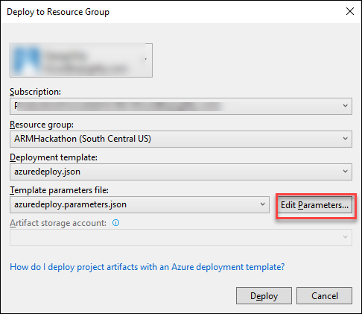

- hackathonPublicIPDnsName: Choose a unique looking DNS name
- hackathonVMName: armweb
- hackathonSQLVMName: armsql
- hackathonVMAdminUserName: demouser
- hackathonVMAdminPassword: demo@pass123
- hackathonVMSQLAdminUserName: demouser
- hackathonVMSQLAdminPassword: demo@pass123
- registrationKey: Automation account key
- registrationUrl: Automation registration Url
- nodeConfigurationName: CloudShopWeb.WebServer
- sqlnodeConfigurationName: CloudShopSQL.SQLSERVER
- rebootNodeIfNeeded: True
- allowModuleOverwrite: True
- configurationModeFrequencyMins: 15,
- refreshFrequencyMins: 30,
- timestamp: <enter current value in format like screenshot below>
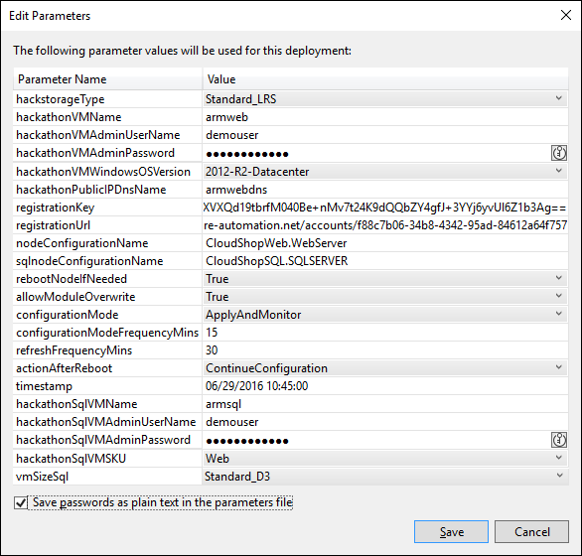

Note: The deployment may take 20 to 30 minutes to complete.

Extension Troubleshooting tip: If you make a mistake with either of the Azure DSC extensions and need to redeploy, open the virtual machine in the portal, under all settings, click extensions and remove the failed extension before deploying.
- Launch the Azure Management Portal http://portal.azure.com and navigate to the resource group you deployed to. Click the virtual machine for the web server and then click the public IP.
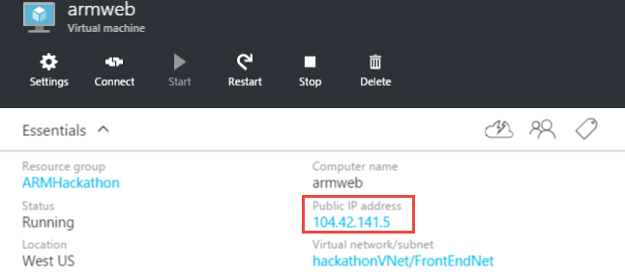

- Copy the DNS Name and navigate to it in the browser.
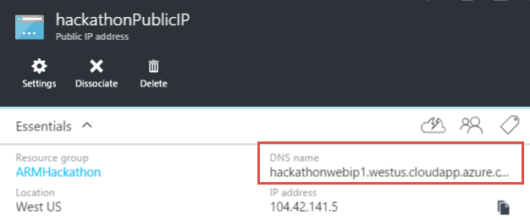
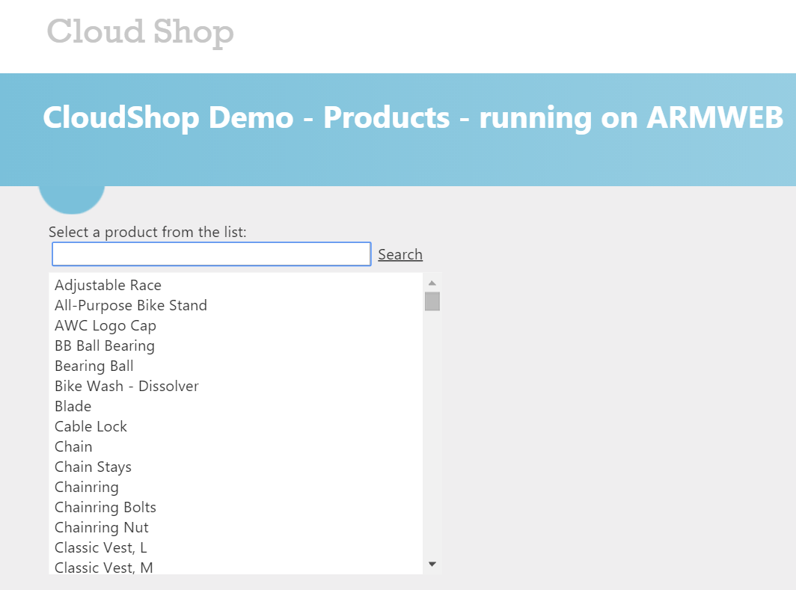
- You should also verify that your VMs are registered as DSC Nodes in your Automation account. In the Azure Portal, click Resource groups > Automation_RG > Automation-Acct, and then click the DSC Nodes tile
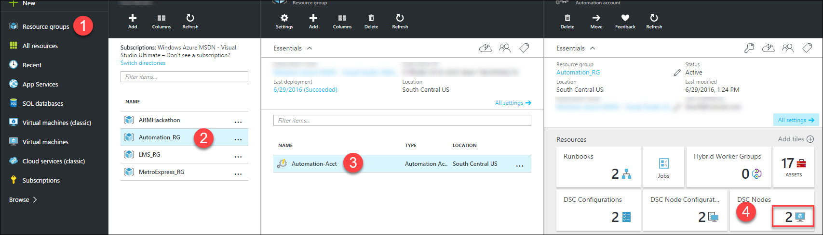
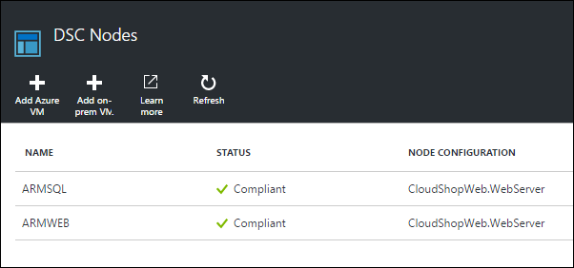

Summary
In this lab, you provisioned two virtual machines that were customized with the PowerShell DSC extension to automatically deploy a web application and a SQL Server database.

Exercise 4: Lock down the environment

Overview
In this portion of the exercise, you will deploy a network security group to restrict the network attack surface for the deployment.

Task 1: Restrict traffic to the web server
- Add the following at the beginning of the JSON template as the first item under the resources node. This will deploy the network security group resource and add a rule so that the only port open on the public IP is port 80.

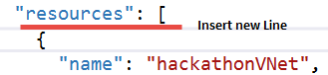
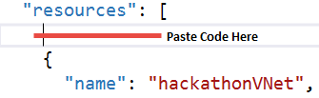
{
"apiVersion": "2016-03-30",
"type": "Microsoft.Network/networkSecurityGroups",
"name": "hackathonNetworkSecurityGroup",
"location": "[resourceGroup().location]",
"properties": {
"securityRules": [
{
"name": "webrule",
"properties": {
"description": "This rule allows traffic in on port 80",
"protocol": "Tcp",
"sourcePortRange": "*",
"destinationPortRange": "80",
"sourceAddressPrefix": "INTERNET",
"destinationAddressPrefix": "10.0.0.0/24",
"access": "Allow",
"priority": 100,
"direction": "Inbound"
}
}
]
}
},

- Click the hackathonVNet resource to go to its configuration.
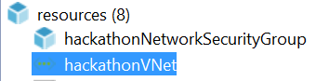

- Associate the network security group with the hackathonVnetSubnet1Name subnet by adding a comma at the end of the addressPrefix block, and pasting in the networkSecurityGroup reference.
"networkSecurityGroup": {
"id": "[resourceId('Microsoft.Network/networkSecurityGroups', 'hackathonNetworkSecurityGroup')]"
}
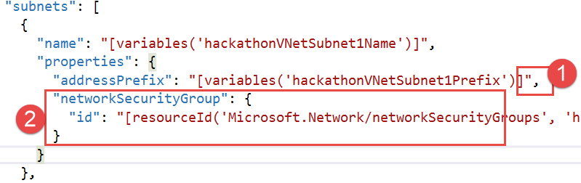

- Update the virtual network to have a dependency on the network security group.
- Click the hackathonVNet resource to view the configuration.
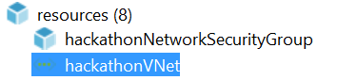
- Change the dependsOn configuration to refer back to the network security group.
"dependsOn": [
"[resourceId('Microsoft.Network/networkSecurityGroups', 'hackathonNetworkSecurityGroup')]"
],

- Right-click the Visual Studio project and select Deploy from the context menu, followed by New Deployment. Click Deploy to update the existing deployment with the network security group.

- To validate the network security group is working:
  - Browse to the public IP or DNS name of the web server. The site should load because traffic is allowed on port 80.
  - Connect to the web virtual machine by clicking Connect in the preview portal. This should fail because port 3389 is not allowed in.

Task 2: Update the network security group to allow Windows Remote Desktop
- Add a new rule to the network security group to allow in traffic on port 3389 Remote Desktop Protocol (RDP) by adding a comma at the end of the web rule and add the following code:
{
"name": "rdprule",
"properties": {
"description": "This rule allows traffic on port 3389 from the web",
"protocol": "Tcp",
"sourcePortRange": "*",
"destinationPortRange": "3389",
"sourceAddressPrefix": "INTERNET",
"destinationAddressPrefix": "10.0.0.0/24",
"access": "Allow",
"priority": 200,
"direction": "Inbound"
}
}

- Deploy the updated rule and test RDP connectivity again.
- Open the Azure Preview Portal, and navigate to the resource group containing your deployment.
- Click the hackathonNetworkSecurityGroup in the resources summary.
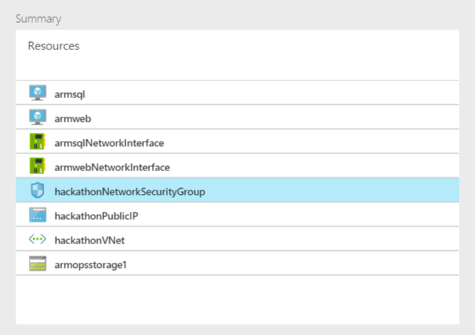
- Examine the created rule.
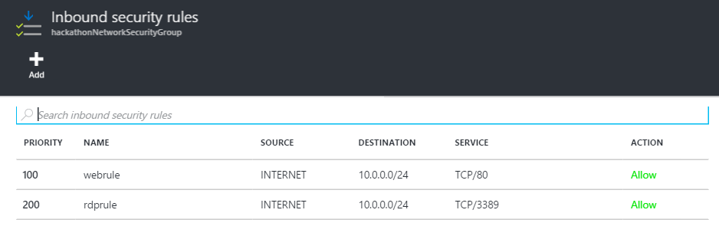

Summary
In this lab, you created a network security group and applied it to the resource group to further constrain traffic to the network.

Exercise 5: Scale out the deployment

Overview
In this exercise, you will configure the template to scale out the web front end using a scalable number of virtual machines and storage accounts. For this, you will use the load balancer and the scale sets feature.

Task 1: Parameterize and scale out the environment
- Add the following variables to the end of the variables section of the azuredeploy.json file:
Tip: Do not forget to put a comma after the previous variables.

"vmSSName": "webset",
"publicIPAddressID": "[resourceId('Microsoft.Network/publicIPAddresses',variables('hackathonPublicIPName'))]",
"lbName": "loadBalancer1",
"lbID": "[resourceId('Microsoft.Network/loadBalancers',variables('lbName'))]",
"lbFEName": "loadBalancerFrontEnd",
"lbWebProbeName": "loadBalancerWebProbe",
"lbBEAddressPool": "loadBalancerBEAddressPool",
"lbFEIPConfigID": "[concat(variables('lbID'),'/frontendIPConfigurations/',variables('lbFEName'))]",
"lbBEAddressPoolID": "[concat(variables('lbID'),'/backendAddressPools/',variables('lbBEAddressPool'))]",
"lbWebProbeID": "[concat(variables('lbID'),'/probes/',variables('lbWebProbeName'))]",
"storageAccountPrefix": [
"a",
"g",
"m",
"s",
"y"
]

- Add the following parameters to the end of the parameters section of the azuredeploy.json file (do not forget to add the comma after the last parameter).
"instanceCount": {
"type": "string",
"metadata": {
"description": "Number of VM instances"
}
},
"newStorageAccountSuffix": {
"type": "string",
"metadata": {
"description": "The Prefix for the names of the new storage accounts created"
}
}

- Add a new storage account resource using the copy function by pasting the following code as the first resource in the list.
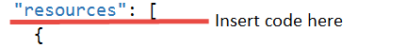
{
"type": "Microsoft.Storage/storageAccounts",
"name": "[concat(variables('StorageAccountPrefix')[copyIndex()],parameters('newStorageAccountSuffix'))]",
"apiVersion": "2015-06-15",
"copy": {
"name": "storageLoop",
"count": 5
},
"location": "[resourceGroup().location]",
"properties": {
"accountType": "[parameters('hackStorageType')]"
}
},

Note: This code will create five storage accounts. The virtual machine scale set will distribute the virtual machine disks across the storage accounts to ensure the VMs do not run out of IO capacity.

- Add a load balancer resource by pasting the following code as the first resource in the list.
{
"apiVersion": "2016-03-30",
"name": "[variables('lbName')]",
"type": "Microsoft.Network/loadBalancers",
"location": "[resourceGroup().location]",
"dependsOn": [
"[concat('Microsoft.Network/publicIPAddresses/',variables('hackathonPublicIPName'))]"
],
"properties": {
"frontendIPConfigurations": [
{
"name": "[variables('lbFEName')]",
"properties": {
"publicIPAddress": {
"id": "[variables('publicIPAddressID')]"
}
}
}
],
"backendAddressPools": [
{
"name": "[variables('lbBEAddressPool')]"
}
],
"loadBalancingRules": [
{
"name": "weblb",
"properties": {
"frontendIPConfiguration": {
"id": "[variables('lbFEIPConfigID')]"
},
"backendAddressPool": {
"id": "[variables('lbBEAddressPoolID')]"
},
"probe": {
"id": "[variables('lbWebProbeID')]"
},
"protocol": "Tcp",
"frontendPort": 80,
"backendPort": 80,
"enableFloatingIP": false
}
}
],
"probes": [
{
"name": "[variables('lbWebProbeName')]",
"properties": {
"protocol": "Http",
"port": 80,
"intervalInSeconds": 15,
"numberOfProbes": 5,
"requestPath": "/"
}
}
]
}
},
Note: This code creates a load balancer resource that is listening on port 80.

- Add the virtual machine scale set to the resources section using the following configuration:

{
"type": "Microsoft.Compute/virtualMachineScaleSets",
"apiVersion": "2015-06-15",
"name": "[variables('vmSSName')]",
"location": "[resourceGroup().location]",
"tags": {
"vmsstag1": "Myriad"
},
"dependsOn": [
"[concat('Microsoft.Storage/storageAccounts/a',parameters('newStorageAccountSuffix'))]",
"[concat('Microsoft.Storage/storageAccounts/g',parameters('newStorageAccountSuffix'))]",
"[concat('Microsoft.Storage/storageAccounts/m',parameters('newStorageAccountSuffix'))]",
"[concat('Microsoft.Storage/storageAccounts/s',parameters('newStorageAccountSuffix'))]",
"[concat('Microsoft.Storage/storageAccounts/y',parameters('newStorageAccountSuffix'))]",
"[concat('Microsoft.Network/loadBalancers/',variables('lbName'))]",
"[concat('Microsoft.Network/virtualNetworks/','hackathonVnet')]"
],
"sku": {
"name": "Standard_A2",
"tier": "Standard",
"capacity": "[parameters('instanceCount')]"
},
"properties": {
"upgradePolicy": {
"mode": "Manual"
},
"virtualMachineProfile": {
"storageProfile": {
"osDisk": {
"vhdContainers": [
"[concat('https://a',parameters('newStorageAccountSuffix'),'.blob.core.windows.net/vmss')]",
"[concat('https://g',parameters('newStorageAccountSuffix'),'.blob.core.windows.net/vmss')]",
"[concat('https://m',parameters('newStorageAccountSuffix'),'.blob.core.windows.net/vmss')]",
"[concat('https://s',parameters('newStorageAccountSuffix'),'.blob.core.windows.net/vmss')]",
"[concat('https://y',parameters('newStorageAccountSuffix'),'.blob.core.windows.net/vmss')]"
],
"name": "vmssosdisk",
"caching": "ReadOnly",
"createOption": "FromImage"
},
"imageReference": {
"publisher": "[variables('hackathonVMImagePublisher')]",
"offer": "[variables('hackathonVMImageOffer')]",
"sku": "[parameters('hackathonVMWindowsOSVersion')]",
"version": "latest"
}
},
"osProfile": {
"computerNamePrefix": "[variables('vmSSName')]",
"adminUsername": "[parameters('hackathonVMAdminUserName')]",
"adminPassword": "[parameters('hackathonVMAdminPassword')]"
},
"networkProfile": {
"networkInterfaceConfigurations": [
{
"name": "nic1",
"properties": {
"primary": true,
"ipConfigurations": [
{
"name": "ip1",
"properties": {
"subnet": {
"id": "[variables('hackathonVMSubnetRef')]"
},
"loadBalancerBackendAddressPools": [
{ "id": "[variables('lbBEAddressPoolID')]" }
]
}
}
]
}
}
]
},
"extensionProfile": {
"extensions": [
{
"name": "hackathonDSC",
"properties": {
"publisher": "Microsoft.Powershell",
"type": "DSC",
"typeHandlerVersion": "2.19",
"autoUpgradeMinorVersion": true,
"protectedSettings": {
"Items": {
"registrationKeyPrivate": "[parameters('registrationKey')]"
}
},
"settings": {
"ModulesUrl": "https://opsgilityweb.blob.core.windows.net/20160629-arm-hackathon/RegistrationMetaConfigV2.zip",
"ConfigurationFunction": "RegistrationMetaConfigV2.ps1\\RegistrationMetaConfigV2",
"Properties": [
{
"Name": "RegistrationKey",
"Value": {
"UserName": "PLACEHOLDER_DONOTUSE",
"Password": "PrivateSettingsRef:registrationKeyPrivate"
},
"TypeName": "System.Management.Automation.PSCredential"
},
{
"Name": "RegistrationUrl",
"Value": "[parameters('registrationUrl')]",
"TypeName": "System.String"
},
{
"Name": "NodeConfigurationName",
"Value": "CloudShopWeb.WebServer",
"TypeName": "System.String"
},
{
"Name": "ConfigurationMode",
"Value": "[parameters('configurationMode')]",
"TypeName": "System.String"
},
{
"Name": "ConfigurationModeFrequencyMins",
"Value": "[parameters('configurationModeFrequencyMins')]",
"TypeName": "System.Int32"
},
{
"Name": "RefreshFrequencyMins",
"Value": "[parameters('refreshFrequencyMins')]",
"TypeName": "System.Int32"
},
{
"Name": "RebootNodeIfNeeded",
"Value": "[parameters('rebootNodeIfNeeded')]",
"TypeName": "System.Boolean"
},
{
"Name": "ActionAfterReboot",
"Value": "[parameters('actionAfterReboot')]",
"TypeName": "System.String"
},
{
"Name": "AllowModuleOverwrite",
"Value": "[parameters('allowModuleOverwrite')]",
"TypeName": "System.Boolean"
},
{
"Name": "Timestamp",
"Value": "[parameters('timestamp')]",
"TypeName": "System.String"
}
]
}
}
}
]
}
}
}
},
This code creates a virtual machine scale sets resource that will create as many instances of the virtual machine as specified in the instanceCount parameter. The DSC extension will execute on each VM when it is created to configure the cloud shop web application. The scale set will distribute the VM disks across the previously created storage accounts.

- Delete the existing hackathonVM and the hackathonVMNic resources by right-clicking each resource and clicking Delete.
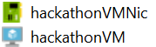
This VM and NIC will be replaced by the VMs in the scale set.

- Delete the existing deployment (to save on core quota) by opening the Azure portal (portal.azure.com) in your browser.
- Click Resource groups.
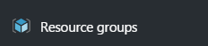
- Click the ARMHackathon resource group (or whatever you named your deployment).
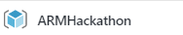
- Click Delete, and then confirm by typing in the name of the resource group.
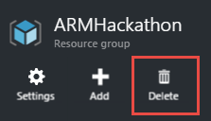
- Create a new deployment and choose a new resource group. Name the new resource group ARMHackathonScaleSet.
- Choose any of the template parameters files, and click Edit Parameters.
- Provide a unique value for the hackathonPublicIPDnsName and newStorageAccountSuffix parameters. Enter a value of 2 for the instanceCount. Click Save and then Deploy.
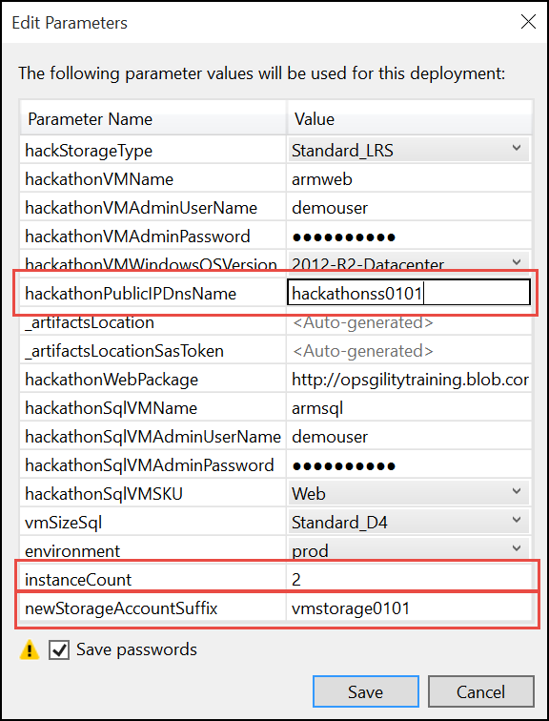

Note: The deployment may take 20 to 30 minutes to complete. If Visual Studio fails monitoring the solution with an error about the SAS Token expiring you can open the resource group in the Portal and you can monitor the deployment by clicking the link under the Last Deployment lab on the essentials pane.

- Within the Azure Management Portal, open the resource group and click the hackathonPublicIP resource.


- Copy the DNS name and navigate to it in a browser to validate that the load balancer and the scale set are working. Click Refresh several times and the page should flip from WEBSET-0 to WEBSET-1.
