**NAME: ASIF ERFAN KHAN**

**ROLL NUMBER: 546**

**COURSE: MSc CS**

**SUBJECT: ANALYSIS OF ALGORITHM AND RESEARCH COMPUTING**

**PRACTICAL: 1-8**

|  |  |  |  |  |
| --- | --- | --- | --- | --- |
|  |  | **INDEX** |  |  |
| **NO** | **DATE** | **TITLE** | **PAGE NO.** | **SIGN** |
|  |  |  |  |  |
| 1 |  | Randomized Selection Algorithm | 3 |  |
| 2 |  | Heap Sort Algorithm | 5 |  |
| 3 |  | Radix Sort Algorithm | 8 |  |
| 4 |  | Bucket Sort Algorithm | 11 |  |
| 5 |  | Floyd - Warshall Algorithm | 14 |  |
| 6 |  | Counting Sort Algorithm | 19 |  |
| 7 |  | Set Covering Problem | 22 |  |
| 8 |  | Subset Sum Problem | 24 |  |

**PRACTICAL 1**

**Q.1) Write a Program for Randomized Selection Algorithm**

from random import randrange

def partition(x, pivot_index = 0):

i = 0

if pivot_index !=0: x[0],x[pivot_index] = x[pivot_index],x[0]

for j in range(len(x)-1):

if x[j+1] < x[0]:

x[j+1],x[i+1] = x[i+1],x[j+1]

i += 1

x[0],x[i] = x[i],x[0]

return x,i

def RSelect(x,k):

if len(x) == 1:

return x[0]

else:

xpart = partition(x,randrange(len(x)))

x = xpart[0] # partitioned array

j = xpart[1] # pivot index

if j == k:

return x[j]

elif j > k:

return RSelect(x[:j],k)

else:

k = k - j - 1

return RSelect(x[(j+1):], k)

x = [3,1,8,4,7,9]

for i in range(len(x)):

print (RSelect(x,i)),

OUTPUT:

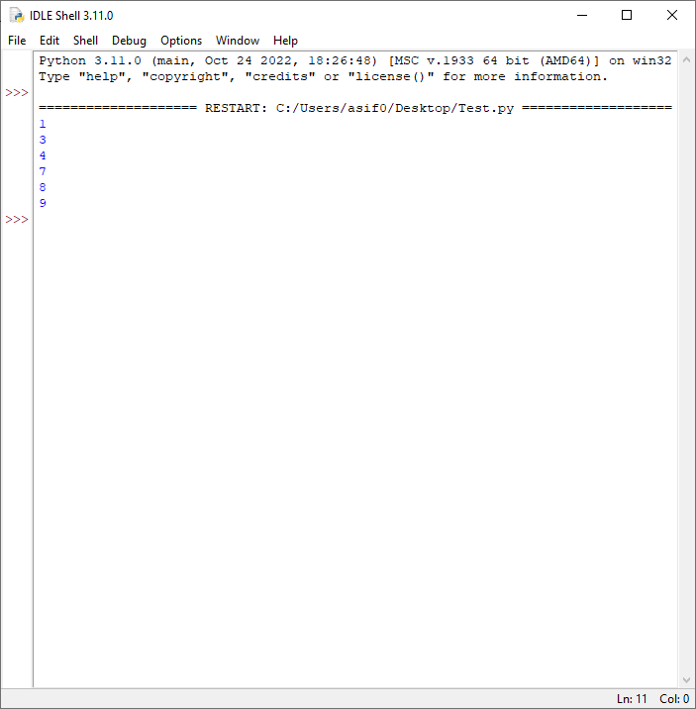

**PRACTICAL 2**

**Q.2) Write a Program for Heap Sort Algorithm**

# Python program for implementation of heap Sort

# To heapify subtree rooted at index i.

# n is size of heap

def heapify(arr, N, i):

largest = i # Initialize largest as root

l = 2 * i + 1 # left = 2*i + 1

r = 2 * i + 2 # right = 2*i + 2

# See if left child of root exists and is

# greater than root

if l < N and arr[largest] < arr[l]:

largest = l

# See if right child of root exists and is

# greater than root

if r < N and arr[largest] < arr[r]:

largest = r

# Change root, if needed

if largest != i:

arr[i], arr[largest] = arr[largest], arr[i] # swap

# Heapify the root.

heapify(arr, N, largest)

# The main function to sort an array of given size

def heapSort(arr):

N = len(arr)

# Build a maxheap.

for i in range(N//2 - 1, -1, -1):

heapify(arr, N, i)

# One by one extract elements

for i in range(N-1, 0, -1):

arr[i], arr[0] = arr[0], arr[i] # swap

heapify(arr, i, 0)

# Driver's code

if __name__ == '__main__':

arr = [12, 11, 13, 5, 6, 7]

# Function call

heapSort(arr)

N = len(arr)

print("Sorted array is")

for i in range(N):

print("%d" % arr[i], end=" ")

OUTPUT:

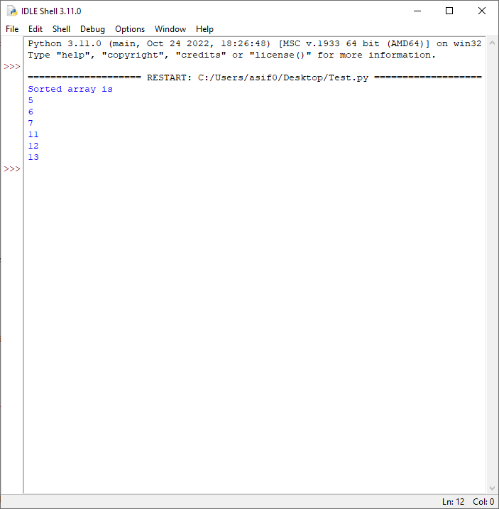

**PRACTICAL 3**

**3) Write a Program to perform Radix Sort Algorithm**

# Python program for implementation of Radix Sort

# A function to do counting sort of arr[] according to

# the digit represented by exp.

def countingSort(arr, exp1):

n = len(arr)

# The output array elements that will have sorted arr

output = [0] * (n)

# initialize count array as 0

count = [0] * (10)

# Store count of occurrences in count[]

for i in range(0, n):

index = arr[i] // exp1

count[index % 10] += 1

# Change count[i] so that count[i] now contains actual

# position of this digit in output array

for i in range(1, 10):

count[i] += count[i - 1]

# Build the output array

i = n - 1

while i >= 0:

index = arr[i] // exp1

output[count[index % 10] - 1] = arr[i]

count[index % 10] -= 1

i -= 1

# Copying the output array to arr[],

# so that arr now contains sorted numbers

i = 0

for i in range(0, len(arr)):

arr[i] = output[i]

# Method to do Radix Sort

def radixSort(arr):

# Find the maximum number to know number of digits

max1 = max(arr)

# Do counting sort for every digit. Note that instead

# of passing digit number, exp is passed. exp is 10^i

# where i is current digit number

exp = 1

while max1 / exp >= 1:

countingSort(arr, exp)

exp *= 10

# Driver code

arr = [170, 45, 75, 90, 802, 24, 2, 66]

# Function Call

radixSort(arr)

for i in range(len(arr)):

print(arr[i],end=" ")

OUTPUT:

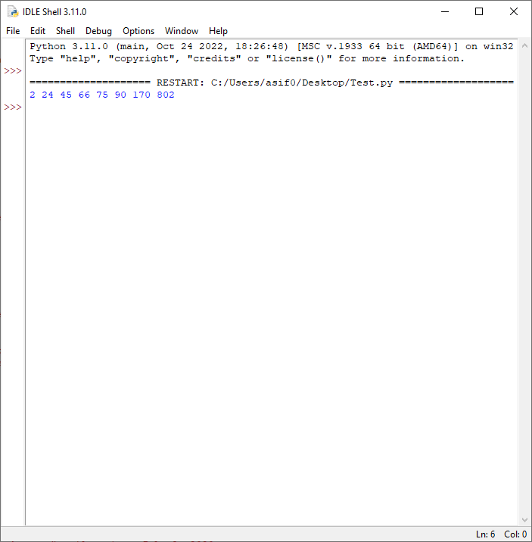

**PRACTICAL 4**

**4) Write a Program to Perform Bucket Sort Algorithm**

# Python3 program to sort an array

# using bucket sort

def insertionSort(b):

for i in range(1, len(b)):

up = b[i]

j = i - 1

while j >= 0 and b[j] > up:

b[j + 1] = b[j]

j -= 1

b[j + 1] = up

return b

def bucketSort(x):

arr = []

slot_num = 10 # 10 means 10 slots, each

# slot's size is 0.1

for i in range(slot_num):

arr.append([])

# Put array elements in different buckets

for j in x:

index_b = int(slot_num * j)

arr[index_b].append(j)

# Sort individual buckets

for i in range(slot_num):

arr[i] = insertionSort(arr[i])

# concatenate the result

k = 0

for i in range(slot_num):

for j in range(len(arr[i])):

x[k] = arr[i][j]

k += 1

return x

# Driver Code

x = [0.897, 0.565, 0.656,

0.1234, 0.665, 0.3434]

print("Sorted Array is")

print(bucketSort(x))

OUTPUT: 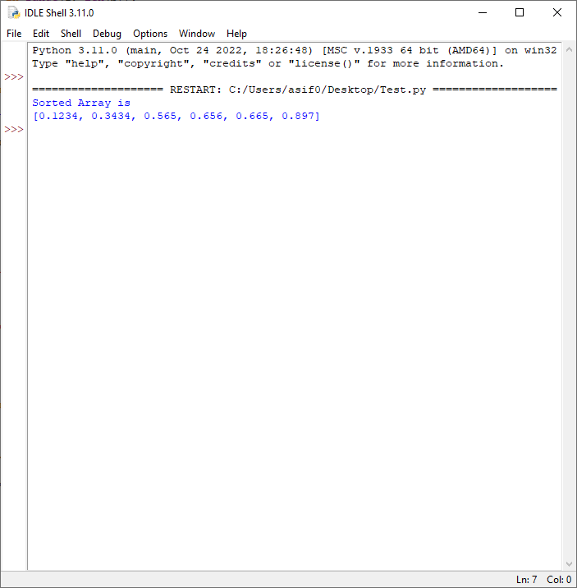

**PRACTICAL 5**

**5) Write a Program to Perform Folyd-Warshall algorithm**

# Python3 Program for Floyd Warshall Algorithm

# Number of vertices in the graph

V = 4

# Define infinity as the large

# enough value. This value will be

# used for vertices not connected to each other

INF = 99999

# Solves all pair shortest path

# via Floyd Warshall Algorithm

def floydWarshall(graph):

""" dist[][] will be the output

matrix that will finally

have the shortest distances

between every pair of vertices """

""" initializing the solution matrix

same as input graph matrix

OR we can say that the initial

values of shortest distances

are based on shortest paths considering no

intermediate vertices """

dist = list(map(lambda i: list(map(lambda j: j, i)), graph))

""" Add all vertices one by one

to the set of intermediate

vertices.

---> Before start of an iteration,

we have shortest distances

between all pairs of vertices

such that the shortest

distances consider only the

vertices in the set

{0, 1, 2, .. k-1} as intermediate vertices.

----> After the end of a

iteration, vertex no. k is

added to the set of intermediate

vertices and the

set becomes {0, 1, 2, .. k}

"""

for k in range(V):

# pick all vertices as source one by one

for i in range(V):

# Pick all vertices as destination for the

# above picked source

for j in range(V):

# If vertex k is on the shortest path from

# i to j, then update the value of dist[i][j]

dist[i][j] = min(dist[i][j],

dist[i][k] + dist[k][j]

)

printSolution(dist)

# A utility function to print the solution

def printSolution(dist):

print("Following matrix shows the shortest distances\

between every pair of vertices")

for i in range(V):

for j in range(V):

if(dist[i][j] == INF):

print("%7s" % ("INF"), end=" ")

else:

print("%7d\t" % (dist[i][j]), end=' ')

if j == V-1:

print()

# Driver's code

if __name__ == "__main__":

"""

10

(0)------->(3)

| /|\

5 | |

| | 1

\|/ |

(1)------->(2)

3 """

graph = [[0, 5, INF, 10],

[INF, 0, 3, INF],

[INF, INF, 0, 1],

[INF, INF, INF, 0]

]

# Function call

floydWarshall(graph)

OUTPUT: 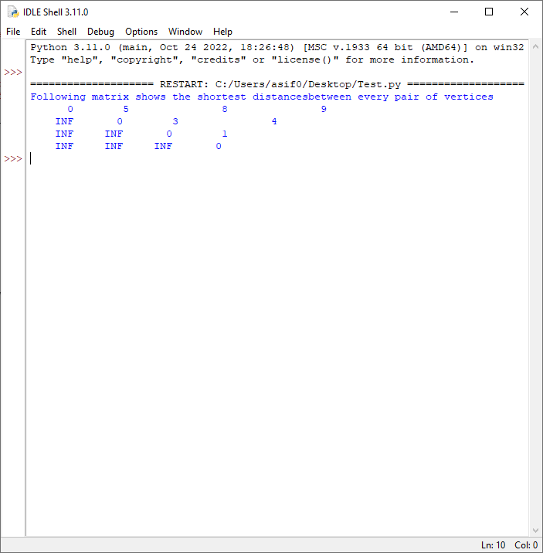

**PRACTICAL 6**

**6) Write a Program for Counting Sort Algorithm in python**

# Python3 program for counting sort

# The main function that sort the given string arr[] in

# alphabetical order

def countSort(arr):

# The output character array that will have sorted arr

output = [0 for i in range(len(arr))]

# Create a count array to store count of individual

# characters and initialize count array as 0

count = [0 for i in range(256)]

# For storing the resulting answer since the

# string is immutable

ans = ["" for _ in arr]

# Store count of each character

for i in arr:

count[ord(i)] += 1

# Change count[i] so that count[i] now contains actual

# position of this character in output array

for i in range(256):

count[i] += count[i-1]

# Build the output character array

for i in range(len(arr)):

output[count[ord(arr[i])]-1] = arr[i]

count[ord(arr[i])] -= 1

# Copy the output array to arr, so that arr now

# contains sorted characters

for i in range(len(arr)):

ans[i] = output[i]

return ans

# Driver code

if __name__ == '__main__':

arr = "geeksforgeeks"

ans = countSort(arr)

print("Sorted character array is % s" % ("".join(ans)))

OUTPUT:

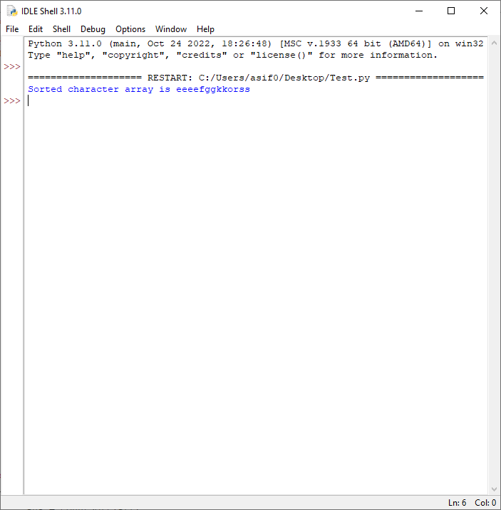

**PRACTICAL 7**

**7) Write a program for Set Covering Problem**

def set_cover(universe, subsets):

"""Find a family of subsets that covers the universal set"""

elements = set(e for s in subsets for e in s)

# Check the subsets cover the universe

if elements != universe:

return None

covered = set()

cover = []

# Greedily add the subsets with the most uncovered points

while covered != elements:

subset = max(subsets, key=lambda s: len(s - covered))

cover.append(subset)

covered |= subset

return cover

def main():

universe = set(range(1, 11))

subsets = [set([1, 2, 3, 8, 9, 10]),

set([1, 2, 3, 4, 5]),

set([4, 5, 7]),

set([5, 6, 7]),

set([6, 7, 8, 9, 10])]

cover = set_cover(universe, subsets)

print(cover)

if __name__ == '__main__':

main()

OUTPUT:

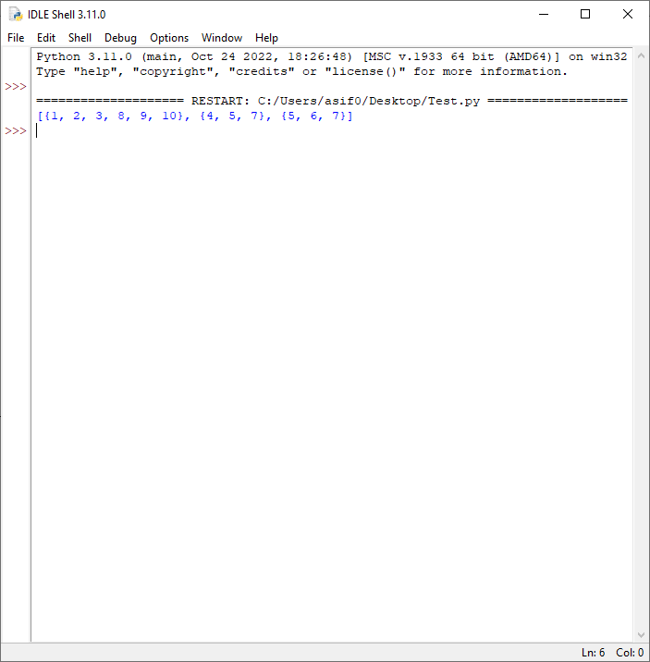

**PRACTICAL 8**

**8) Write a Program for found a subset with given sum**

# A recursive solution for subset sum

# problem

# Returns true if there is a subset

# of set[] with sun equal to given sum

def isSubsetSum(set,n, sum) :

# Base Cases

if (sum == 0) :

return True

if (n == 0 and sum != 0) :

return False

# If last element is greater than

# sum, then ignore it

if (set[n - 1] > sum) :

return isSubsetSum(set, n - 1, sum);

# else, check if sum can be obtained

# by any of the following

# (a) including the last element

# (b) excluding the last element

return isSubsetSum(set, n-1, sum) or isSubsetSum(set, n-1, sum-set[n-1])

# Driver program to test above function

set = [3, 34, 4, 12, 5, 2]

sum = 9

n = len(set)

if (isSubsetSum(set, n, sum) == True) :

print("Found a subset with given sum")

else :

print("No subset with given sum")

OUTPUT:

