**HANOI UNIVERSITY OF SCIENCE AND TECHNOLOGY**

**School of Information and Communications Technology**

**Software Design Documentation**

AIMS Software

**Course: Software Design and Construction**

**Team**

**Lecturer**

**: 5**

**: Nguyen Thi Thu Trang**

**Member:**

|  |  |  |  |  |
| --- | --- | --- | --- | --- |
|  | **Full name** | **Student ID** | **Email** | **Class** |
| **1** | **Nguyễn Hữu Đức** | **20215353** | **Duc.NH215353@sis.hust.edu.vn** | **IT1** |
| **2** | **Nguyễn Mạnh Đức** | **20215350** | **Duc.NM215350@sis.hust.edu.vn** | **IT1** |
| **3** | **Nguyễn Văn Đức** | **20204530** | **Duc.NV204530@sis.hust.edu.vn** | **IT1** |
| **4** | **Nguyễn Trọng Đức** | **20215356** | **Duc.NT215356@sis.hust.edu.vn** | **IT1** |
| **5** | **Trần Tiến Đức** | **20204643** | **Duc.TT204643@sis.hust.edu.vn** | **IT1** |

Hanoi, 10/2024

**Table of Contents**

1. Introduction 3
   1. Objective 3
   2. Scope 3
   3. Glossary 3
   4. References 3
2. Overall description 3
   1. General Overview 3
   2. Assumptions/Constraints/Risks 4
      1. Assumptions 4
      2. Constraints 4
      3. Risks 4
3. System Architecture and Architecture Design 4
   1. Architectural Patterns 4
   2. Interaction Diagrams 4
   3. Analysis Class Diagram 7

3.5. Security Software Architecture 9

1. Detailed Design 9
   1. User Interface Design 9
      1. Screen Configuration Standardization 9
      2. Screen Transition Diagrams 10
      3. Screen Specifications 10
   2. Data Modeling 15
      1. Conceptual Data Modeling 15
      2. Database Design 16
   3. Non-Database Management System Files 23
   4. Class Design 23
      1. General Class Diagram 23
      2. Class Diagrams 24
      3. Class Design 24
2. Design Considerations 25
   1. Goals and Guidelines 25
   2. Architectual Strategies 25
   3. Coupling and Cohesion 25
   4. Design Principles 25
   5. Design Patterns 25

# Introduction

# Objective

This SDD is a comprehensive and detailed blueprint for the development of AIMS software. It serves as a centralized repository of design decisions, architectural considerations, and implementation strategies. The SDD ensures that developers, testers, and project managers, have a shared understanding of the software's structure, functionality, and components.

# Scope

The product that the SDD refers to is AIMS Software (An Internet Media Store Software). AIMS is a desktop e-commerce software supporting online transactions of a media store. It helps the product managers completing their work in managing products of the store, also assists administrators controlling information of their users. The software at the same time is used by customers for selecting the products they want to purchase, placing and paying the orders.

# Glossary

|  |  |  |  |  |
| --- | --- | --- | --- | --- |
| **No** | **Term** | **Explanation** | **Example** | **Note** |
| 1 | product | The item that store sells in general | Customers can see detail of a product by clicking at the item. |  |
| 2 | price | The amount of money charged for a product | The price of the product may change depending on market demand. |  |
| 3 | value | The perceived worth of a product, determined by factors such as quality, demand and customer satisfaction | The price of the product must always be between 30% and 150% of the product value. |  |
| 4 | order | A request to supply products in the store | To place a successful order,  customers need to proceed with payment. |  |
| 5 | invoice | A statement listing products provided and their prices, along with customer and order’s related information | The software displays and temporarily save invoice information. |  |

# References

* AIMS – Problem Statement v2.0 – Nguyen Thi Thu Trang, HUST

# Overall description

# General Overview

The system is involved by 3 main actors, with detail described in general use case diagram. This diagram is also used in the SRS of AIMS Software.

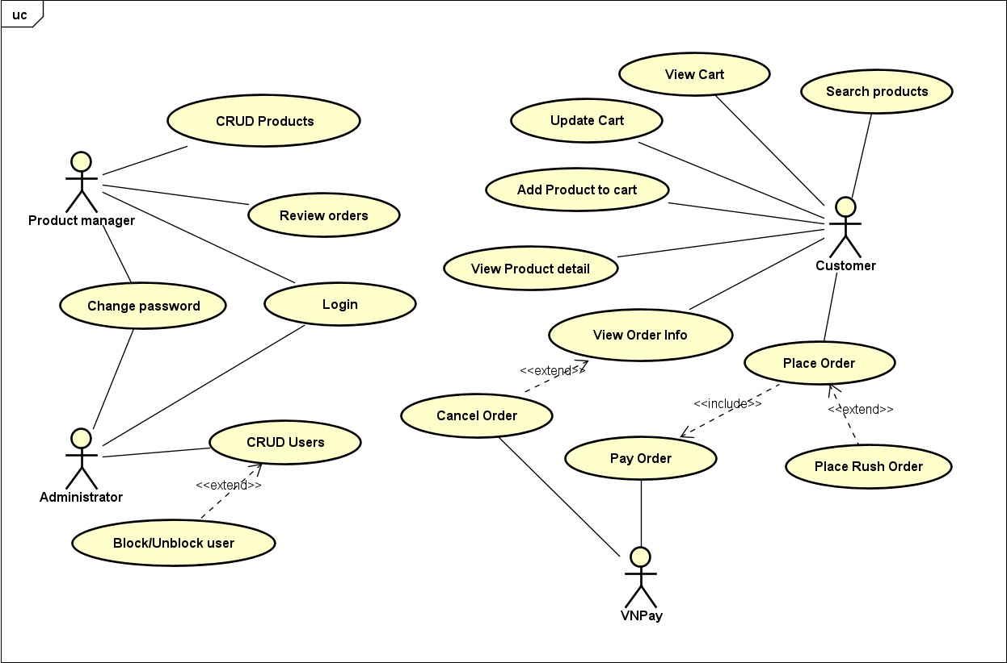

# Assumptions/Constraints/Risks

# Assumptions

AIMS software has an use case relating to another subsystem. To be more specific, UC “Pay order” interacts with VNPay – a platform for mobile banking and money transactions.

# Constraints

The software requires Internet connection to work effectively with some functions.

# Risks

As mentioned before, due to the dependency with VNPay, the software could not work well if the connection to that subsystem is malfunctioning.

# System Architecture and Architecture Design

# Architectural Patterns

<Not specify in this lab yet>

* 1. **Interaction Diagrams** There are 3 main order-related use cases:

UC Place Order:

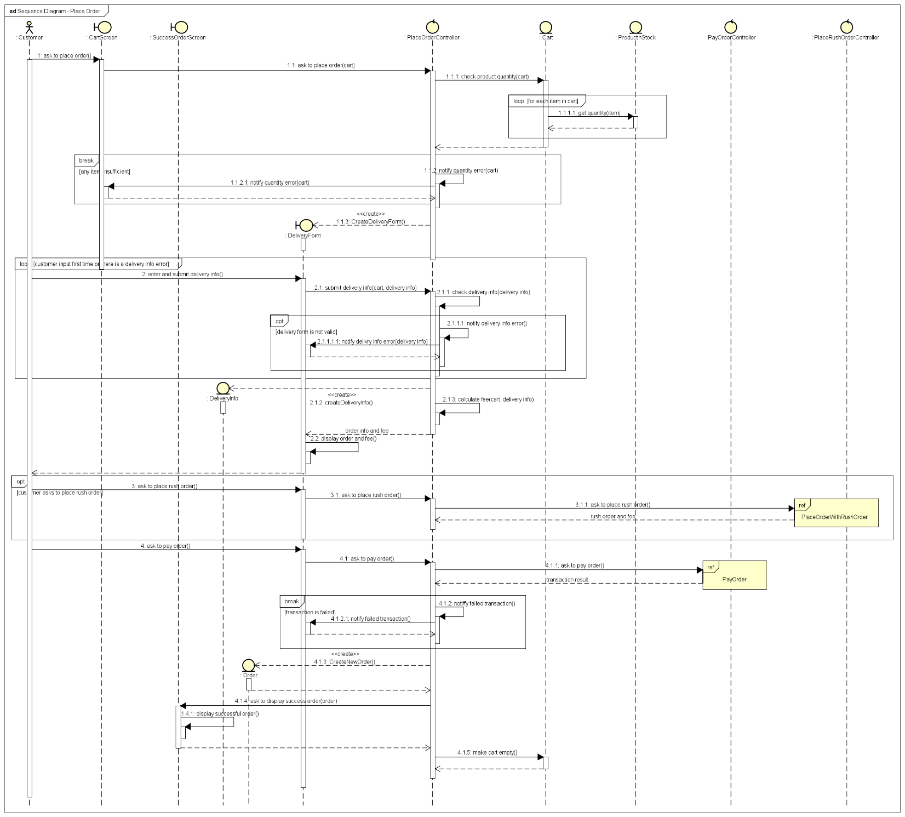

UC Place Rush Order:

UC Pay Order:

# Analysis Class Diagram

UC Place Order:

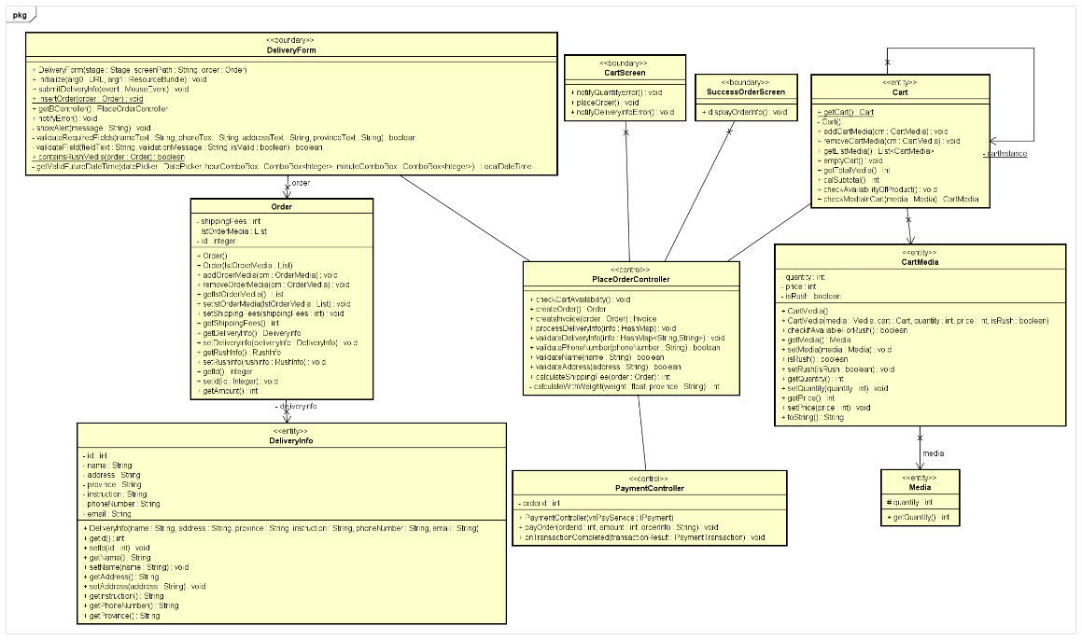

UC Place Rush Order:

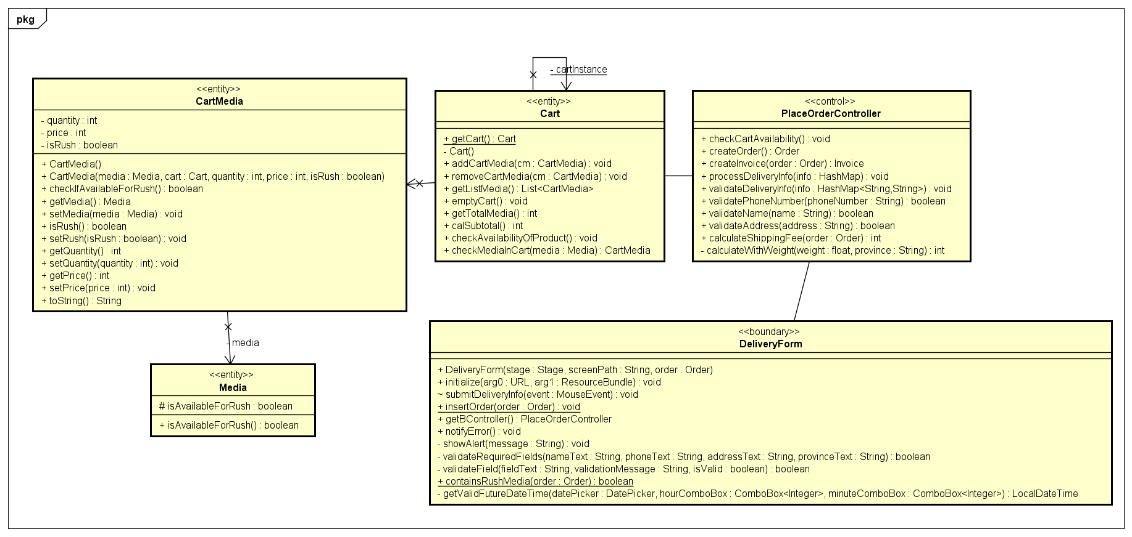

UC Pay Order:

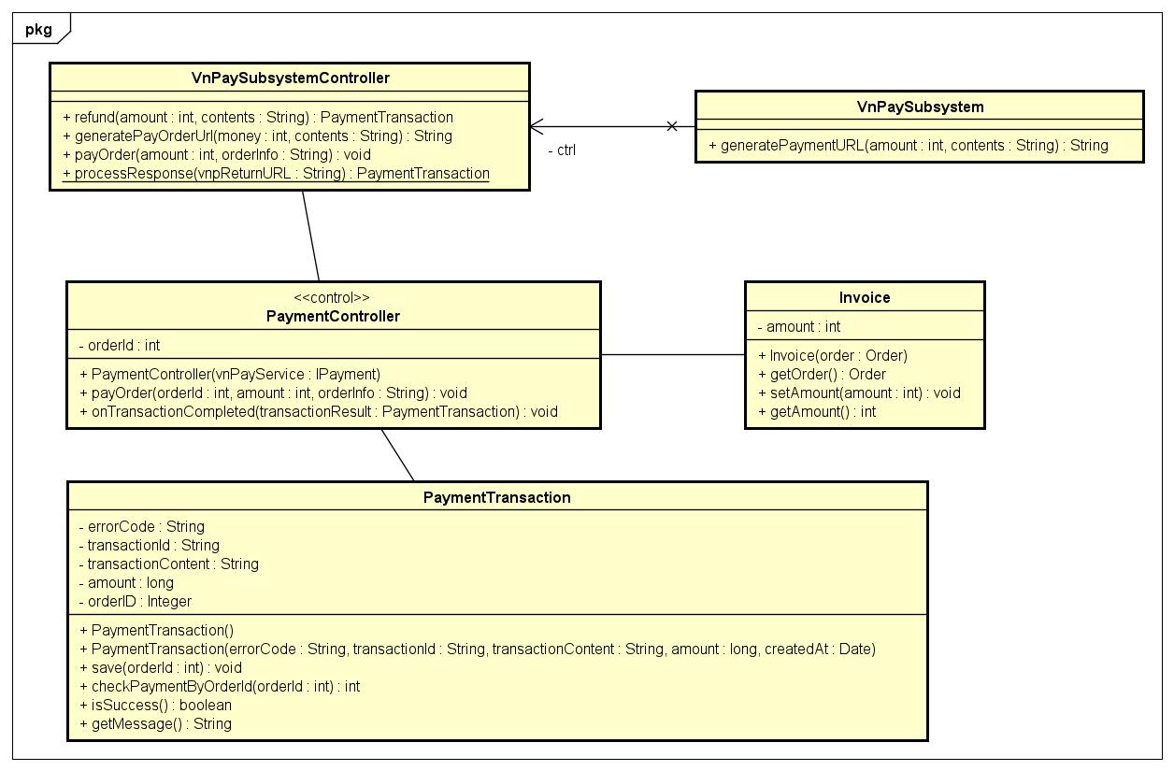

# Unified Analysis Class Diagram

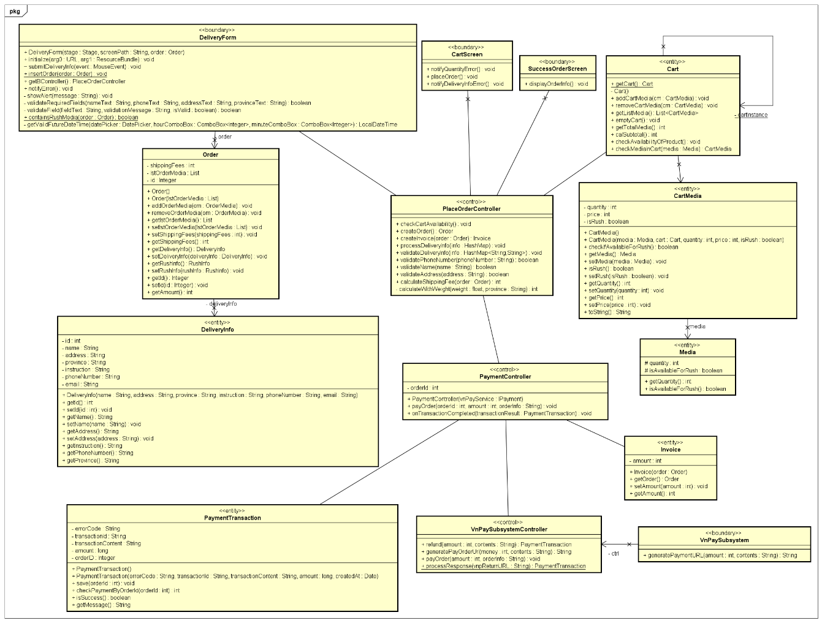

# Security Software Architecture

With the scope of order related use cases, there is no architecture for security for AIMS software.

# Detailed Design

# User Interface Design

# Screen Configuration Standardization

* Display:

Number of colors supported: 16,777,216 colors. Resolution: 1366 × 768 pixels.

* Screen:

Location of standard buttons: Mostly at the bottom (vertically) and in the middle (horizontally) of the frame.

Location of the messages: Starting from the top vertically and in the middle horizontally of the frame down to the bottom.

Display of the screen title: The title is located at the top left of the frame.

Consistency in expression of alphanumeric numbers: comma for separator of thousand while strings only consist of characters, digits, commas, dots, spaces, underscores, and hyphen symbol.

* Control:

Size of the text: mostly medium size (mostly 24px). Font: Inter. Color: #000000

Input check process: Should check if it is empty or not. Next, check if the input is in the correct format or not.

Sequence of moving the focus: There will be some stack frames as some forms are displayed in a popup. At that time, the main screen cannot be operated while the pop up is shown. After the opening screen, the first screen (home screen) will appear.

* Direct input from the keyboard:

There will be no shortcuts. There are back buttons to move back to the previous screen.

* Error:

A message will be given to notify the users what is the problem.

# Screen Transition Diagrams

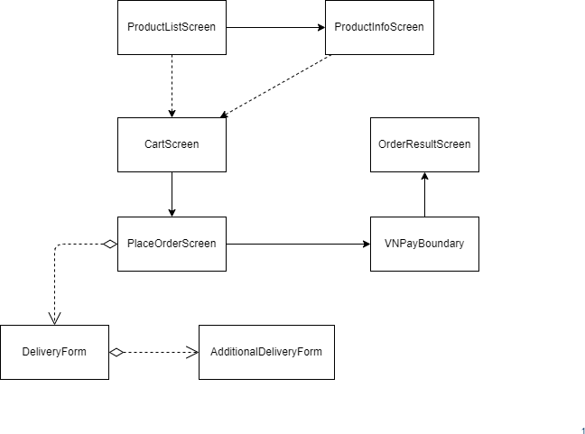

# Screen Specifications

Product list screen:

|  |  |  |  |  |  |
| --- | --- | --- | --- | --- | --- |
| AIMS Software | | Date of creation | Approved by | Reviewed by | Person in charge |
| Screen specification | Product list screen | 20/10/2024 |  |  | Nguyễn Hữu Đức |
|  | | Control | Operation | Function | |
| Area for displaying items of the store | Initial | Display the media with corresponding information | |
| Search bar | Click/use keyboard | Field for input search keyword for finding media | |
| Cart icon | Click | Display cart screen | |
| Back icon button | Click | Display previous screen | |
| Add to cart button | Click | Add the corresponding media to cart | |

|  |  |  |  |  |
| --- | --- | --- | --- | --- |
| Screen name | Product list screen |  | | |
| Item name | Number of digits (bytes) | Type | Field attribute | Remark |
| Media title | 256 | String | Black | Left-justified |
| Media price | 10 | Numeral | Black | Left-justified |
| Quantity available | 5 | Numeral | Black | Left-justified |

Cart screen:

|  |  |  |  |  |  |
| --- | --- | --- | --- | --- | --- |
| AIMS Software | | Date of creation | Approved by | Reviewed by | Person in charge |
| Screen specification | Cart screen | 20/10/2024 |  |  | Nguyễn Hữu Đức |

|  |  |  |  |  |
| --- | --- | --- | --- | --- |
|  | Control | | Operation | Function |
| Area  displaying in the cart | for items | Initial | Display the media with corresponding information |
| Area | for |  |  |
| displaying |  | Initial | Display the subtotal |
| subtotal |  |  |  |
| Rush delivery checkbox | | Click | Request rush delivery for product |
| Delete button | | Click | Remove item from the cart |
| Back icon button | | Click | Display previous screen |
| Quantity adjust | | Click/use | Adjust the quantity of items in |
| buttons and field | | keyboard | the cart |

|  |  |  |  |  |
| --- | --- | --- | --- | --- |
| Screen name | Cart screen |  | | |
| Item name | Number of digits (bytes) | Type | Field attribute | Remark |
| Media title | 256 | String | Blue | Left-justified |
| Media price | 10 | Numeral | Blue | Right-justified |
| Quantity in cart | 5 | Numeral | Black | Left-justified |
| Subtotal | 10 | Numeral | Blue | Right-justified |
| VAT | 10 | Numeral | Blue | Right-justified |

Delivery form:

|  |  |  |  |  |  |
| --- | --- | --- | --- | --- | --- |
| AIMS Software | | Date of creation | Approved by | Reviewed by | Person in charge |
| Screen specification | Delivery form | 20/10/2024 |  |  | Nguyễn Hữu Đức |
|  | | Control | Operation | Function | |
| Area for displaying fields of the form | Initial | Required input for delivery information | |
| Rush delivery checkbox | Click | Request rush delivery for current order | |
| Confirm button | Click | Process to submit the form | |
| Back icon button | Click | Display previous screen | |

|  |  |  |  |  |
| --- | --- | --- | --- | --- |
| Screen name | Delivery form |  | | |
| Item name | Number of digits (bytes) | Type | Field attribute | Remark |

|  |  |  |  |  |
| --- | --- | --- | --- | --- |
| Name | 256 | String | Black | Left-justified |
| Phone number | 10 | String | Black | Left-justified |
| City | 256 | String | Black | Left-justified |
| Address | 256 | String | Black | Left-justified |
| Shipping intructions | 1024 | String | Black | Left-justified |

Order info screen:

|  |  |  |  |  |  |
| --- | --- | --- | --- | --- | --- |
| AIMS Software | | Date of creation | Approved by | Reviewed by | Person in charge |
| Screen specification | Order Info screen | 20/10/2024 |  |  | Nguyễn Hữu Đức |
|  | | Control | Operation | Function | |
| Area for displaying items in the order | Initial | Display the media with corresponding information | |
| Area for displaying delivery info | Initial | Display the information for delivery | |
| Edit delivery info button | Click | Display delivery form to edit | |
| Back icon button | Click | Display previous screen | |

|  |  |  |  |
| --- | --- | --- | --- |
|  | Pay order button | Click | Process to pay the order |

|  |  |  |  |  |
| --- | --- | --- | --- | --- |
| Screen name | Order info screen |  | | |
| Item name | Number of digits (bytes) | Type | Field attribute | Remark |
| Name | 256 | String | Black | Left-justified |
| Phone number | 10 | String | Black | Left-justified |
| City | 256 | String | Black | Left-justified |
| Address | 256 | String | Black | Left-justified |
| Shipping instructions | 1024 | String | Black | Left-justified |
| Media title | 256 | String | Blue | Left-justified |
| Media price | 10 | Numeral | Blue | Center-justified |
| Quantity in order | 5 | Numeral | Black | Center-justified |
| Amount | 10 | Numeral | Black | Right-justified |
| Subtotal | 10 | Numeral | Black | Right-justified |
| Shipping fees | 10 | Numeral | Black | Right-justified |
| Total | 10 | Numeral | Red | Right-justified |

Payment Result screen:

|  |  |  |  |  |  |
| --- | --- | --- | --- | --- | --- |
| AIMS Software | | Date of creation | Approved by | Reviewed by | Person in charge |
| Screen specification | Payment Result screen | 20/10/2024 |  |  | Nguyễn Hữu Đức |
|  | | Control | Operation | Function | |
| Area for displaying payment info | Initial | Display the payment info | |
| Payment status text | Initial | Display the status of the payment/order | |
| Back icon button | Click | Display previous screen | |

|  |  |  |  |
| --- | --- | --- | --- |
|  | Return to home button | Click | Redirect the software to home screen |

|  |  |  |  |  |
| --- | --- | --- | --- | --- |
| Screen name | Payment Result screen |  | | |
| Item name | Number of digits (bytes) | Type | Field attribute | Remark |
| Status title | 256 | String | Blue | Left-justified |
| Payment info | 256 | String | Blue | Center-justified |

# Data Modeling

# Conceptual Data Modeling

Entity relationship diagram:

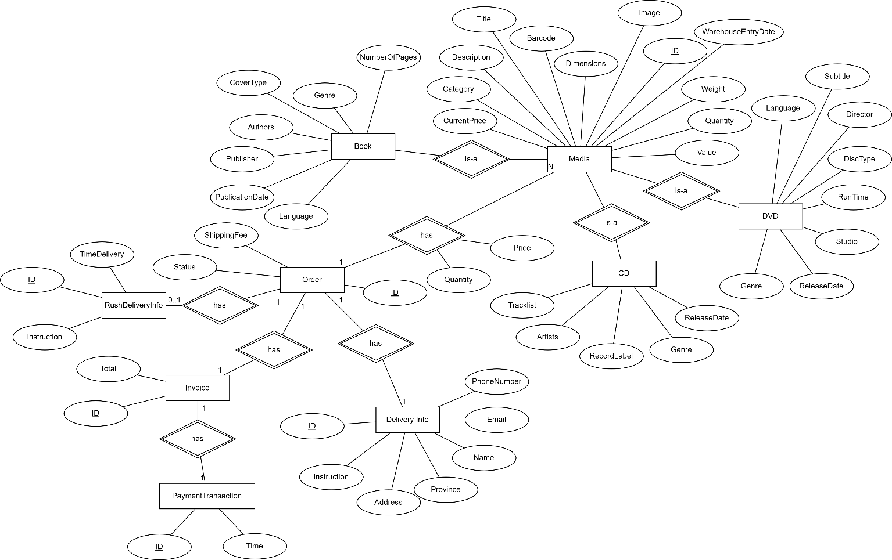

# Database Design

* + - 1. **Database Management System**

DBMS for AIMS software: MySQL

MySQL is an open-source relational database management system (RDBMS) developed by Oracle Corporation.

It uses Structured Query Language (SQL) for database management and is known for its reliability, speed and ease of use.

MySQL is widely used for various applications, from small websites to large-scale enterprise systems.

# Database Diagram

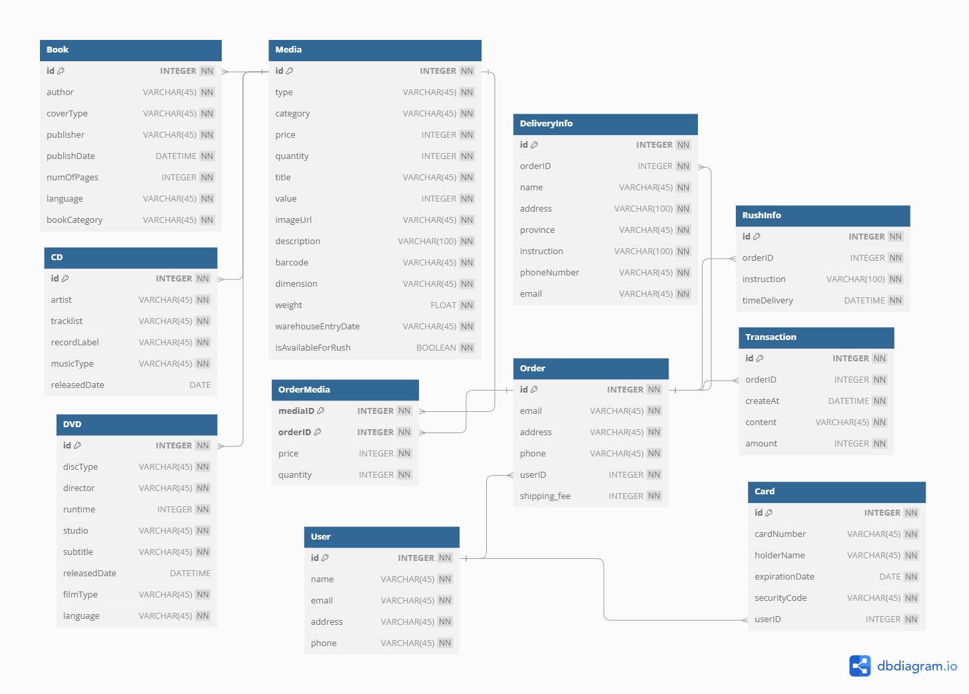

CREATE DATABASE IF NOT EXISTS `aims`

CREATE TABLE "aims"."Media"(  
 "id" INTEGER PRIMARY KEY AUTOINCREMENT NOT NULL,   
 "type" VARCHAR(45) NOT NULL,  
 "category" VARCHAR(45) NOT NULL,  
 "price" INTEGER NOT NULL,  
 "quantity" INTEGER NOT NULL,  
 "title" VARCHAR(45) NOT NULL,  
 "value" INTEGER NOT NULL,  
 "imageUrl" VARCHAR(45) NOT NULL,  
 "description" VARCHAR(100) NOT NULL,  
 "barcode" VARCHAR(45) NOT NULL,  
 "dimension" VARCHAR(45) NOT NULL,  
 "weight" FLOAT NOT NULL,  
 "warehouseEntryDate" VARCHAR(45) NOT NULL,  
 "isAvailableForRush" INTEGER NOT NULL  
);  
CREATE TABLE "aims"."CD"(  
 "id" INTEGER PRIMARY KEY NOT NULL,  
 "artist" VARCHAR(45) NOT NULL,  
 "tracklist" VARCHAR(45) NOT NULL,  
 "recordLabel" VARCHAR(45) NOT NULL,  
 "musicType" VARCHAR(45) NOT NULL,  
 "releasedDate" DATE,  
 CONSTRAINT "fk_cd_media"  
 FOREIGN KEY("id")  
 REFERENCES "Media"("id")  
);  
CREATE TABLE "aims"."Book"(  
 "id" INTEGER PRIMARY KEY AUTOINCREMENT NOT NULL,  
 "author" VARCHAR(45) NOT NULL,  
 "coverType" VARCHAR(45) NOT NULL,  
 "publisher" VARCHAR(45) NOT NULL,  
 "publishDate" DATETIME NOT NULL,  
 "numOfPages" INTEGER NOT NULL,  
 "language" VARCHAR(45) NOT NULL,  
 "bookCategory" VARCHAR(45) NOT NULL,  
 CONSTRAINT "fk_book_media"  
 FOREIGN KEY("id")  
 REFERENCES "Media"("id")  
);  
CREATE TABLE "aims"."User"(  
 "id" INTEGER PRIMARY KEY AUTOINCREMENT NOT NULL,  
 "name" VARCHAR(45) NOT NULL,  
 "email" VARCHAR(45) NOT NULL,  
 "address" VARCHAR(45) NOT NULL,  
 "phone" VARCHAR(45) NOT NULL  
);  
CREATE TABLE "aims"."DVD"(  
 "id" INTEGER PRIMARY KEY NOT NULL,  
 "discType" VARCHAR(45) NOT NULL,  
 "director" VARCHAR(45) NOT NULL,  
 "runtime" INTEGER NOT NULL,  
 "studio" VARCHAR(45) NOT NULL,  
 "subtitle" VARCHAR(45) NOT NULL,  
 "releasedDate" DATETIME,  
 "filmType" VARCHAR(45) NOT NULL,  
 "language" VARCHAR(45) NOT NULL,  
 CONSTRAINT "fk_dvd_media"  
 FOREIGN KEY("id")  
 REFERENCES "Media"("id")  
);  
CREATE TABLE "aims"."Order"(  
 "id" INTEGER PRIMARY KEY AUTOINCREMENT NOT NULL,  
 "email" VARCHAR(45) NOT NULL,  
 "address" VARCHAR(45) NOT NULL,  
 "phone" VARCHAR(45) NOT NULL,  
 "userID" INTEGER NOT NULL,  
 "shipping_fee" INTEGER NOT NULL,  
 CONSTRAINT "fk_order_user"  
 FOREIGN KEY("userID")  
 REFERENCES "User"("id")  
);  
CREATE INDEX "aims"."Order.fk_order_user_idx" ON "Order" ("userID");  
CREATE TABLE "aims"."OrderMedia"(  
 "mediaID" INTEGER NOT NULL,  
 "orderID" INTEGER NOT NULL,  
 "price" INTEGER NOT NULL,  
 "quantity" INTEGER NOT NULL,  
 PRIMARY KEY("mediaID","orderID"),  
 CONSTRAINT "fk_ordermedia_media"  
 FOREIGN KEY("mediaID")  
 REFERENCES "Media"("id"),  
 CONSTRAINT "fk_ordermedia_order"  
 FOREIGN KEY("orderID")  
 REFERENCES "Order"("id")  
);  
CREATE INDEX "aims"."OrderMedia.fk_ordermedia_order_idx" ON "OrderMedia" ("orderID");  
CREATE TABLE "aims"."Transaction"(  
 "id" INTEGER PRIMARY KEY AUTOINCREMENT NOT NULL,  
 "orderID" INTEGER NOT NULL,  
 "createAt" DATETIME NOT NULL,  
 "content" VARCHAR(45) NOT NULL,  
 "amount" INTEGER NOT NULL,  
 CONSTRAINT "fk_transaction_order"  
 FOREIGN KEY("orderID")  
 REFERENCES "Order"("id")  
);  
CREATE INDEX "aims"."Transaction.fk_transaction_order_idx" ON "Transaction" ("orderID");  
CREATE TABLE "aims"."Card"(  
 "id" INTEGER PRIMARY KEY NOT NULL,  
 "cardNumber" VARCHAR(45) NOT NULL,  
 "holderName" VARCHAR(45) NOT NULL,  
 "expirationDate" DATE NOT NULL,  
 "securityCode" VARCHAR(45) NOT NULL,  
 "userID" INTEGER NOT NULL,  
 CONSTRAINT "fk_card_user"  
 FOREIGN KEY("userID")  
 REFERENCES "User"("id")  
);  
CREATE INDEX "aims"."Card.fk_card_user_idx" ON "Card" ("userID");  
  
CREATE TABLE "aims"."DeliveryInfo"(  
 "id" INTEGER PRIMARY KEY AUTOINCREMENT NOT NULL,  
 "orderID" INTEGER NOT NULL,  
 "name" VARCHAR(45) NOT NULL,  
 "address" VARCHAR(100) NOT NULL,  
 "province" VARCHAR(45) NOT NULL,  
 "instruction" VARCHAR(100) NOT NULL,  
 "phoneNumber" VARCHAR(45) NOT NULL,  
 "email" VARCHAR(45) NOT NULL,  
 CONSTRAINT "fk_deliveryinfo_order"  
 FOREIGN KEY("orderID")  
 REFERENCES "Order"("id")  
);  
CREATE INDEX "aims"."DeliveryInfo.fk_deliveryinfo_order_idx" ON "DeliveryInfo" ("orderID");  
  
CREATE TABLE "aims"."RushInfo"(  
 "id" INTEGER PRIMARY KEY AUTOINCREMENT NOT NULL,  
 "orderID" INTEGER NOT NULL,  
 "instruction" VARCHAR(100) NOT NULL,  
 "timeDelivery" DATETIME NOT NULL,  
 CONSTRAINT "fk_rushinfo_order"  
 FOREIGN KEY("orderID")  
 REFERENCES "Order"("id")  
);  
CREATE INDEX "aims"."RushInfo.fk_rushinfo_order_idx" ON "RushInfo" ("orderID");

# Database Detail Design

Table: media

|  |  |  |  |  |  |  |  |
| --- | --- | --- | --- | --- | --- | --- | --- |
| # | PK | FK | Column name | Data type | Default value | Mandatory | Description |
| 1 | x |  | id | INT |  | Yes | ID, auto increment |
| 2 |  |  | title | VARCHAR(45) |  | Yes | Product name |
| 3 |  |  | description | VARCHAR(100) |  | No | Product description |
| 4 |  |  | type | VARCHAR(45) |  | Yes | Can be DVD, CD, Book |
| 5 |  |  | category | VARCHAR(45) |  | Yes | Can be story, adventure, … |
| 6 |  |  | barcode | VARCHAR(20) |  | Yes | Product identity code |
| 7 |  |  | dimensions | VARCHAR(20) |  | No | Size of product |
| 8 |  |  | warehouse_entry_d ate | DATETIME |  | No | Entry date of product |
| 9 |  |  | weight | FLOAT |  | No | Product weight |
| 10 |  |  | quantity | INT |  | Yes | Number of products available |
| 11 |  |  | value | FLOAT |  | Yes | Real value of product |
| 12 |  |  | price | FLOAT |  | Yes | Price at the time product shown on store |
| 13 |  |  | image_url | varchar(45) |  | Yes | Image of product |
| 14 |  |  | is_available_for_rush | INT |  | Yes | 1=TRUE, 0=FALSE |

Table: cd

|  |  |  |  |  |  |  |  |
| --- | --- | --- | --- | --- | --- | --- | --- |
| # | PK | FK | Column name | Data type | Default value | Mandatory | Description |
| 1 | x |  | id | INT |  | Yes | ID, auto increment |
| 2 |  |  | artists | VARCHAR(80) |  | No | CD’s list of artists |
| 3 |  |  | record_label | VARCHAR(45) |  | Yes | CD record label |
| 4 |  |  | genre | VARCHAR(45) |  | No | CD genre |
| 5 |  |  | tracklist | VARCHAR(45) |  | No | CD tracklist |
| 6 |  |  | release_date | DATETIME |  | No | CD release date |

Table: dvd

|  |  |  |  |  |  |  |  |
| --- | --- | --- | --- | --- | --- | --- | --- |
| # | PK | FK | Column name | Data type | Default value | Mandatory | Description |
| 1 | x |  | id | INT |  | Yes | ID, auto increment |
| 2 |  |  | genre | VARCHAR(45) |  | No | DVD genre |
| 3 |  |  | language | VARCHAR(45) |  | No | DVD language |
| 4 |  |  | director | VARCHAR(45) |  | No | DVD director |
| 5 |  |  | disc_type | VARCHAR(45) |  | No | DVD disc type |
| 6 |  |  | studio | VARCHAR(45) |  | No | DVD studio |
| 7 |  |  | subtitle | VARCHAR(200) |  | No | DVD subtitle |
| 8 |  |  | release_date | DATE |  | No | DVD release date |
| 9 |  |  | run_time | INT |  | No | DVD run timein minutes |

Table: book

|  |  |  |  |  |  |  |  |
| --- | --- | --- | --- | --- | --- | --- | --- |
| # | PK | FK | Column name | Data type | Default value | Mandatory | Description |
| 1 | x |  | id | INT |  | Yes | ID, auto increment |
| 2 |  |  | authors | VARCHAR(80) |  | No | Book’s list of authors |
| 3 |  |  | publisher | VARCHAR(45) |  | No | Book publisher |
| 4 |  |  | language | VARCHAR(45) |  | No | Book language |
| 5 |  |  | genre | VARCHAR(45) |  | No | Book genre |
| 6 |  |  | cover_type | VARCHAR(45) |  | No | Book cover type |
| 7 |  |  | publication_date | DATE |  | No | Book publication date |
| 8 |  |  | number_of_pages | INT |  | No | Book number of pages |

Table: order

|  |  |  |  |  |  |  |  |
| --- | --- | --- | --- | --- | --- | --- | --- |
| # | PK | FK | Column name | Data type | Default value | Mandatory | Description |
| 1 | x |  | id | INT |  | Yes | ID, auto increment |
| 2 |  |  | shipping_fee | DOUBLE |  | Yes | Order shipping fee |

Table: order_media

|  |  |  |  |  |  |  |  |
| --- | --- | --- | --- | --- | --- | --- | --- |
| # | PK | FK | Column name | Data type | Default value | Mandatory | Description |
| 1 | x |  | id | INT |  | Yes | ID, auto increment |
| 2 |  | x | media_id | VARCHAR(45) |  | Yes | Media ID |
| 3 |  | x | order_id | DOUBLE |  | Yes | Order ID |
| 4 |  |  | price | DOUBLE |  | Yes | Current price of the product |
| 5 |  |  | quantity | INT |  | Yes | Number of products purchased |
| 6 |  |  | is_rush | INT |  | Yes | 1=TRUE, 0=FALSE |

Table: delivery_info

|  |  |  |  |  |  |  |  |
| --- | --- | --- | --- | --- | --- | --- | --- |
| # | PK | FK | Column name | Data type | Default value | Mandatory | Description |
| 1 | x |  | id | INT |  | Yes | ID, auto increment |
| 2 |  | x | order_id | INT |  | Yes | Order ID |
| 3 |  |  | name | VARCHAR(45) |  | Yes | Name of customer |
| 4 |  |  | province | VARCHAR(45) |  | Yes | Province of delivery address |
| 5 |  |  | address | VARCHAR(100) |  | Yes | Delivery address |
| 6 |  |  | instruction | VARCHAR(100) |  | No | Delivery instruction |
| 7 |  |  | email | VARCHAR(45) |  | Yes | Customer email |
| 8 |  |  | phone_number | VARCHAR(45) |  | Yes | Customer phone number |

Table: rush_info

|  |  |  |  |  |  |  |  |
| --- | --- | --- | --- | --- | --- | --- | --- |
| # | PK | FK | Column name | Data type | Default value | Mandatory | Description |
| 1 | x |  | id | INT |  | Yes | ID, auto increment |
| 2 |  | x | order_id | INT |  | Yes | Order ID |
| 3 |  |  | instruction | VARCHAR(100) |  | No | Rush delivery instruction |
| 4 |  |  | time_delivery | DATETIME |  | Yes | Rush delivery time |

Table: transaction

|  |  |  |  |  |  |  |  |
| --- | --- | --- | --- | --- | --- | --- | --- |
| # | PK | FK | Column name | Data type | Default value | Mandatory | Description |
| 1 | x |  | id | INT |  | Yes | ID, auto increment |
| 2 |  | x | order_id | INT |  | Yes | Order ID |
| 3 |  |  | createAt | DATETIME |  | Yes | Created Date of transaction |
| 4 |  |  | content | STRING |  | Yes | Content of transaction |
| 5 |  |  | amount | INT |  | Yes | Amount of transaction |

Table: user

|  |  |  |  |  |  |  |  |
| --- | --- | --- | --- | --- | --- | --- | --- |
| # | PK | FK | Column name | Data type | Default value | Mandatory | Description |
| 1 | x |  | id | INT |  | Yes | ID, auto increment |
| 2 |  |  | name | VARCHAR(45) |  | Yes | Username |
| 3 |  |  | email | VARCHAR(45) |  | Yes | User’s email |
| 4 |  |  | address | VARCHAR(45) |  | Yes | User’s Address |
| 5 |  |  | phone | VARCHAR(45) |  | Yes | User’s Phone |

# Non-Database Management System Files

# Class Design

# General Class Diagram

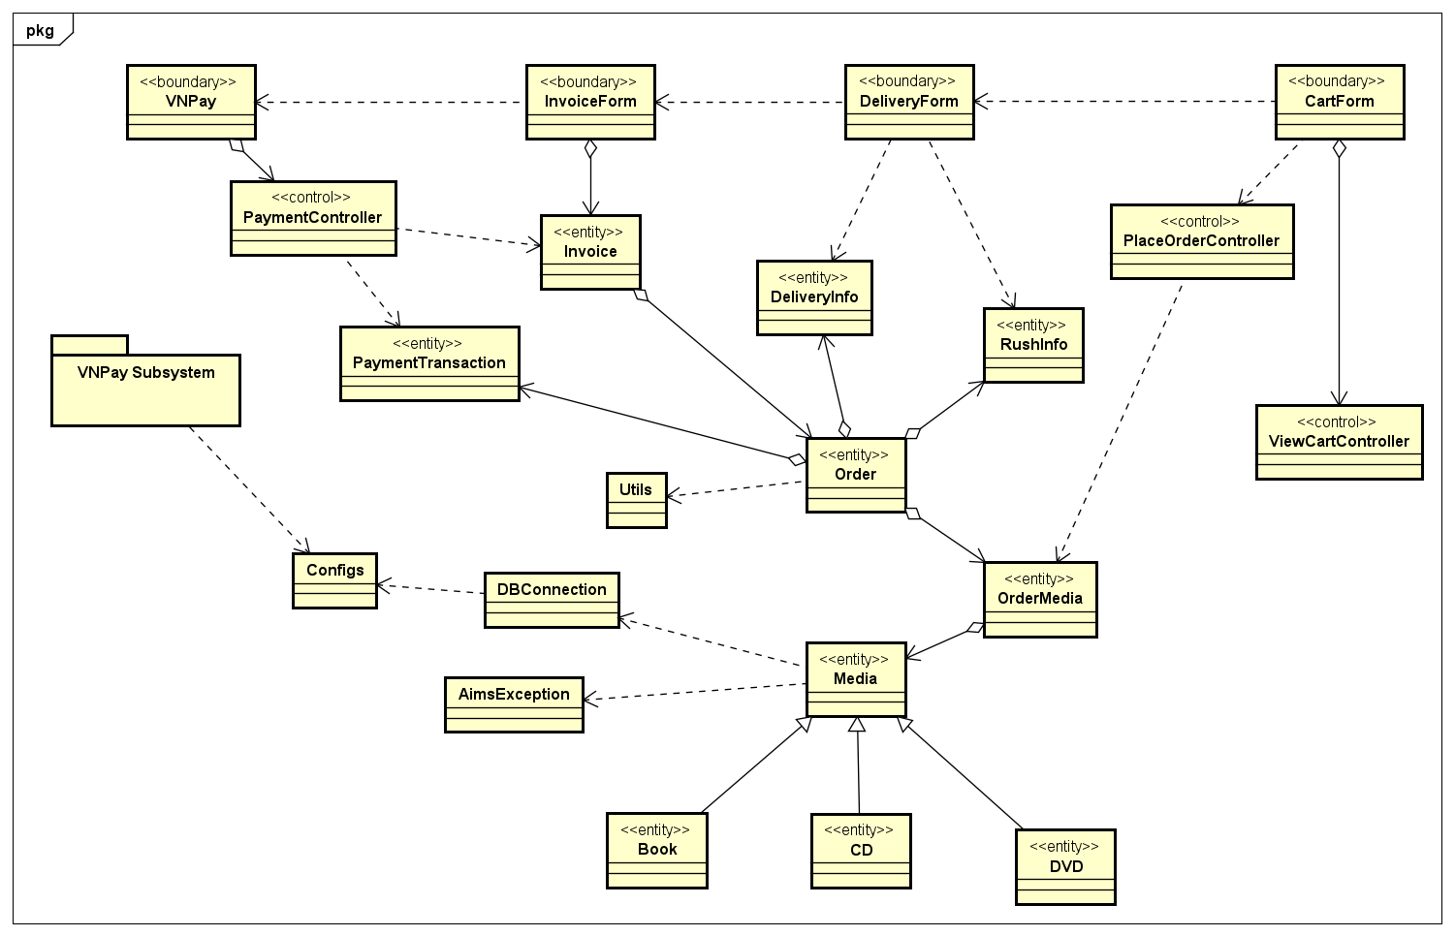

# Class Diagrams

<VNPay is considered as a ‘black box’ in this lab, so there is no information about this package yet>

# Class Design